AQA Biology

3.7.4 Populations in Ecosystems Booklet



Specification Section

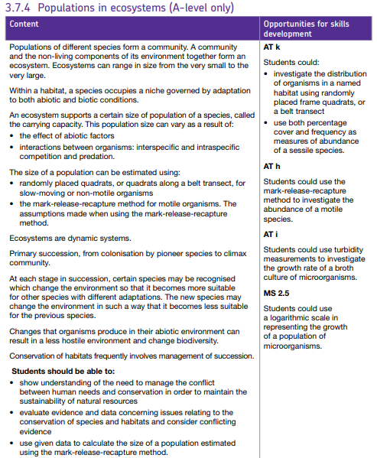

Key word list for 3.7.4
Word | Definition | Word | Definition
Population | A community of animals, plants, or humans of one species among whose members interbreeding occurs. | Transect | A straight line or narrow section through an object or natural feature or across the earth's surface, along which observations are made, or measurements taken.
Community | In ecology, a community is a group or association of populations of two or more different species occupying the same geographical area at the same time, also known as a biocoenosis. | Motile | Capable of motion.
Environment | Environment includes all elements, factors, and conditions that have some impact on growth and development of certain organism | Mark-Release-Recapture | Mark and recapture is a method commonly used in ecology to estimate an animal population's size where it is impractical to count every individual.
Ecosystem | An ecosystem is a community of living organisms in conjunction with the non-living components of their environment, interacting as a system. These biotic and abiotic components are linked together through nutrient cycles and energy flows. | Secondary Succession | Secondary succession is a process started by an event (e.g. forest fire, harvesting, hurricane, etc.) that reduces an already established ecosystem (e.g. a forest or a wheat field) to a smaller population of species, and as such secondary succession occurs on pre-existing
Habitat | A habitat (which is Latin for "it inhabits") is an ecological or environmental area that is inhabited by a particular species of animal, plant or other type of organism. | Primary Succession | Primary succession is one of two types of biological and ecological succession of plant life, occurring in an environment in which new substrate devoid of vegetation and other organisms usually lacking soil, such as a lava flow or area left from retreated glacier, is deposited.
Species (Notes two definitions) | The ecological species concept is a concept of species in which a species is a set of organisms adapted to a particular set of resources, called a niche, in the environment.  A biological species is a group of organisms that can reproduce with one another in nature and produce fertile offspring. | Pioneer species | The pioneer species are hardy species which are the first to colonize barren environments or previously biodiverse steady-state ecosystems that have been disrupted, such as by fire. Some lichens grow on rocks without soil, so may be among the first of life forms, and break down the rocks into soil for plants.
Niche | A role taken by a type of organism within its community.  "the niche left vacant by the disappearance of wolves" | Climax community | An ecological community in which populations of plants or animals remain stable and exist in balance with each other and their environment.
Adaptation | The process of change by which an organism or species becomes better suited to its environment. | Biodiversity | The variety of plant and animal life in the world or in a particular habitat, a high level of which is usually considered to be important and desirable.
Abiotic | Physical rather than biological; not derived from living organisms. | Conservation | Conservation biology is the management of nature and of Earth's biodiversity with the aim of protecting species, their habitats, and ecosystems from excessive rates of extinction and the erosion of biotic interactions.
Biotic | Relating to or resulting from living organisms. | Sustainability | how biological systems remain diverse and productive over time. For humans it is the potential for long-term maintenance of wellbeing, which in turn depends on the maintenance of the natural world and natural resources.
Carrying capacity | The number of a particular species which a region can support without environmental degradation. | Colonisation | Colonisation often refers to successful immigration where a population becomes integrated into a community, having resisted initial local extinction.
Interspecific | Existing or occurring between different species. | Logarithmic scale | A logarithmic scale (or log scale) is a way of displaying numerical data over a very wide range of values in a compact way—typically the largest numbers in the data are hundreds or even thousands of times larger than the smallest numbers. ... Rather, the numbers 10 and 100, and 100 and 1000 are equally spaced.
Intraspecific | Produced, occurring, or existing within a species or between individuals of a single species.  "intraspecific competition" | Percentage cover | Percent cover is a method of determining relative abundance based on the amount of space they take up. In this method, rather than counting the number of individuals you assign each species to a “percent cover class” based on a visual estimate of how much of the sample plot they occupy
Quadrat | A portable frame, typically with an internal grid, used to mark out a quadrat.  Or each of a number of small areas of habitat, typically of one square metre, selected at random to act as samples for assessing the local distribution of plants or animals. | Sessile species | Sessility is the biological property of an organism describing its lack of a means of self-locomotion. ... Sessile organisms can move via external forces (such as water currents) but are usually permanently attached to something. Organisms such as corals lay down their own substrate from which they grow.
In situ | IN the situation: research that is conducted in-situ happens in the field or directly in the environment that is being investigated.
Lesson 1 – Ecosystems & Niches
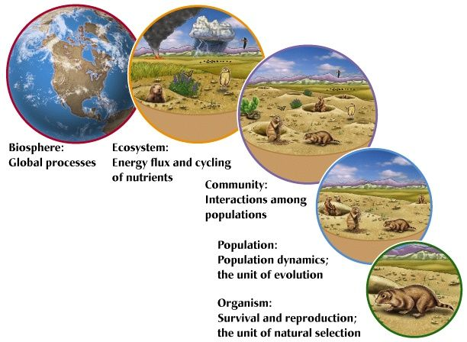
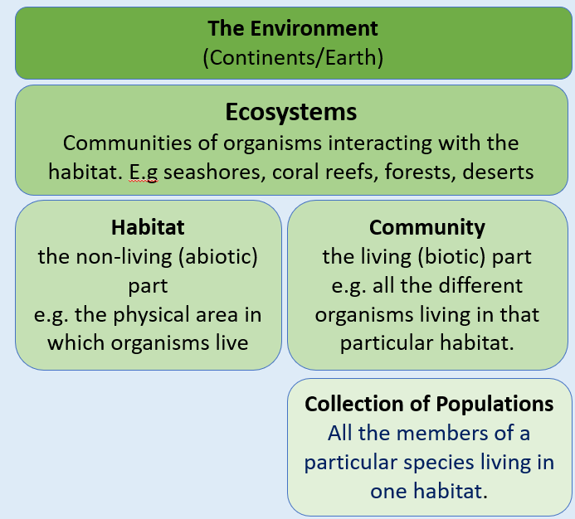
GCSE RECAP
A community is populations of different species living in the same environment or habitat. An ecosystem is all the organisms living in a community plus all the non-living abiotic conditions in the area (the habitat). They are affected by both biotic and abiotic factors. Biotic factors are caused by living organisms such as competition, predators or diseases and abiotic factors are caused by non-living components such as the temperature, weather, chemicals/pollution or the pH of soil. Each ecosystem on earth affects another, they do not work in isolation.
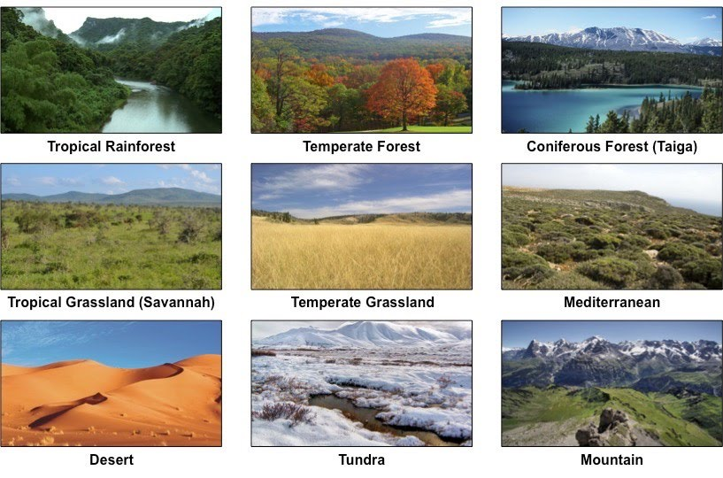
Ecosystems vary in size, they can be very local, e.g. a rotting branch or very large like an entire ocean. Neighbouring ecosystems can be described separately or combined and described as one.
Within habitats organisms are adapted to survive and they occupy their own niche.

Niches
Each species in an ecosystem occupies its niche. A niche is the role of a species within its ecosystem or community – what it eats, where it eats and when it eats. Niches can be abiotic or biotic and niches can be separated by time, location, or behaviour.
Biotic Examples – what it eats and what organisms eat it
Abiotic Examples – the temperature range an organism can tolerate, the time of day it is active (e.g. nocturnal)
Organisms that occupy the same niches will compete as if they are the same species because they are sharing resources. If no interbreeding occurs the species with the highest birth rate will take over the niche and the other species will be competed out unless one can adapt to change their niche e.g. eat a different food source.
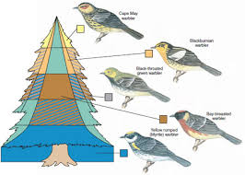
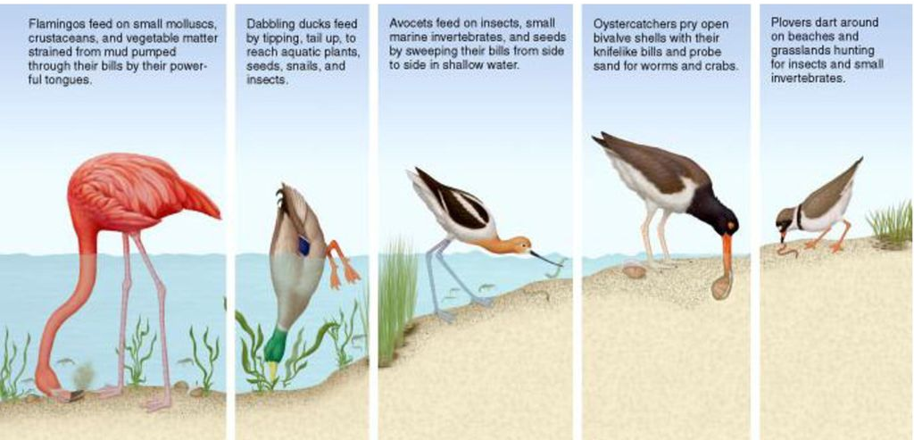
Examples:
Environment | Organisms | What makes the Niche different?
Flying predators feeding on small flying insects. | Swifts and Pipistrelle bats | Time: swifts hunt in the day, bats at night
Predators hunting grubs and small insects in trees. | Different species of Warblers | Spatial: Different Warblers are adapted to different temperatures and light intensities. Layer of the tree.
Herbivores scavenging for high protein fruit and seeds from trees with the ability to store these to survive a large seasonal glut of the food source. | Red and Grey Squirrels | No difference: Grey Squirrels are hardier so outcompete the red squirrels in most environments as they occupy the same Niche.
Top predators in the shore community (avian) who have omnivorous diets. | Flamingos, Ducks, Avocets, Oystercatchers, Plovers. | Behavioural: Each member of this community gathers food in a unique way.
Bats flying and catching insects using echolocation in wooded areas in Britain | Common pipistrelle bat and Soprano pipistrelle bat | Physiological: the two types of bats use different frequencies for their echolocation so they will identify different insects.

Problems with Investigating Niches
Experimental ecology is hard to do as the number of variables are very high and you can never replicate a proper ecosystem. Taking away variables does not mean you are controlling them and if these are influential, they might change your results.
The Experiment above shows how two bacterial species can show if they are competing because they share the same niche (competitive exclusion), or if they are uses resources differently so they have separate niches (resource partitioning).
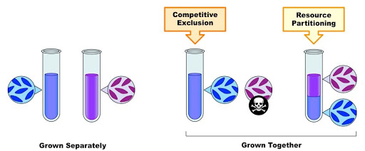
Problem: If the results show competitive exclusion other factors may create separate niches in a real ecosystem, For example, if the mix of substrates they have been given in this experiment does not contain something that one of the species could metabolise in the wild so competition has been forced. Ecological experiments do not always represent what would happen in nature.
Similarly if you are observing animals in the wild and you try to claim you can identify their niche because you observed them feeding in different ways or feeding at different times you cannot always guarantee that other factors/variables are affecting what you recorded in a small window of time with one population.
Animals become Adapted to their Niche
An adaptation is a feature that members of the same species have that increases their chance of survvial and reproduction in their habitat. Organisms in a species with better adaptations to their environment are more likely to survive and reproduce and pass on the alleles that code for these adaptations – this increases the frequency of these alleles in the population. This process of natural selection means those adaptations become more common in the population, this can eventualy lead to evolution of a species.
Every species has had to adapt to use the ecosystem in a way no other species can – this is how they are able to occupy their own unique niche. Organisms are adapted to both the biotic (e.g specific predators) and abiotic (e.g temperature or amount of water) conditions of their ecosystems.
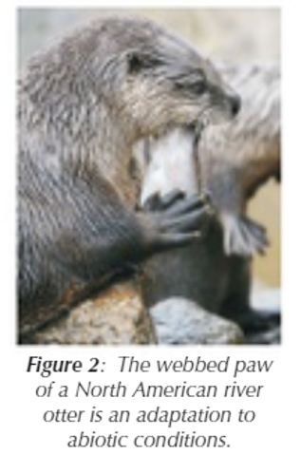
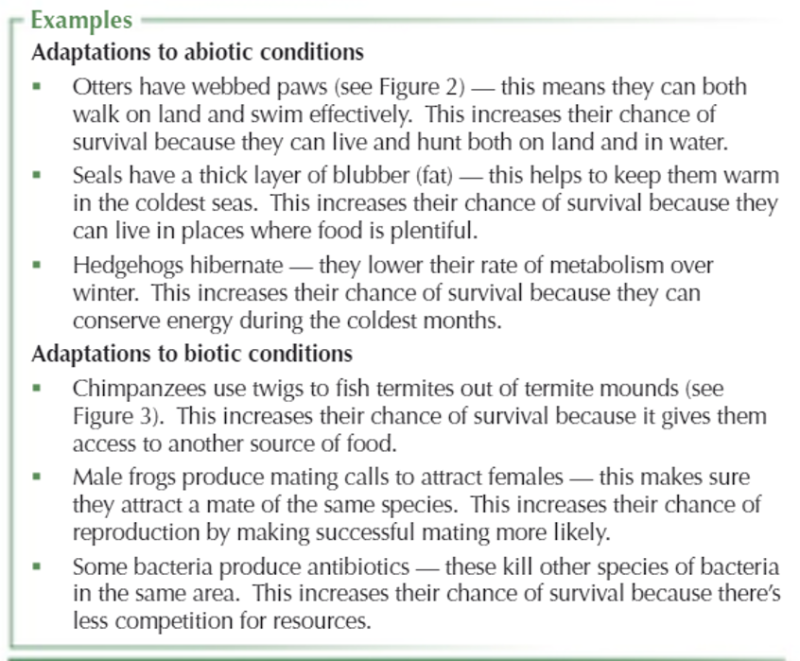
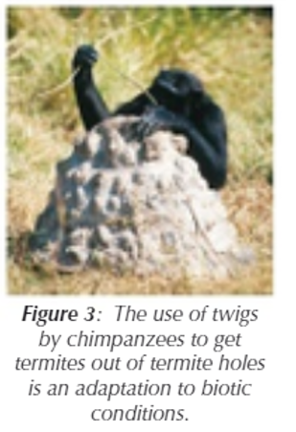

Recall Questions

- Explain the difference between community and population.

- What is an ecosystem?

- Name two ways in which an ecosystem is different to a community

- Give a biotic and an abiotic factor that can affect an ecosystem and its inhabitants.

- Write a definition for the term niche

- Why is it important the organisms occupy different niches?

- What is an adaptation and how do they occur?

- Give an example of two similar organisms and how they have adapted to occupy different niches.

- In what ways can niches differ?

- What is the problem with trying to demonstrate niche separation artificially?

Exam Questions
Q1. Mountains are harsh environments. The higher up the mountain, the lower the temperature becomes. The diagram shows a forest growing on the side of a mountain.
The upper boundary of the forest is called the tree line. Trees do not grow above the tree line.
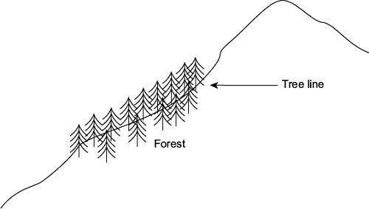
(a) (i) The position of the tree line is determined by abiotic factors.
What is meant by an abiotic factor?
______________________________________________________________
______________________________________________________________
(1)
(ii) Other than temperature, suggest one abiotic factor that is likely to affect the position of the tree line on the mountain.
______________________________________________________________
(1)
Q2. Zooplankton are very small animals which feed on algae (green protoctists) found in lakes. The chart shows the mean depth of zooplankton populations in four lakes, P to S, during the day and the night. It also shows the standard deviations of the means. The depth at which the light intensity is 1% of the surface light intensity is also shown.
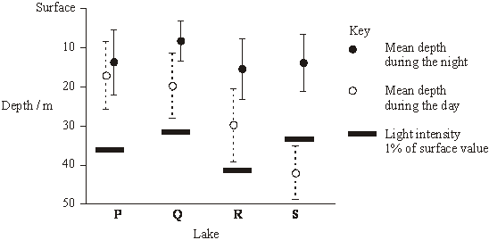

(a) Explain the evidence that the zooplankton feed at night.
___________________________________________________________________
___________________________________________________________________
___________________________________________________________________
___________________________________________________________________
(3)
(b) Predatory fish, which hunt by sight, are present in some of the lakes. These fish have been present in the lakes for different lengths of time.

Lake | Estimated length of time predatory fish have been present / years
P | 0
Q | 5
R | 25
S | Over 1000
(i) Describe the relationship between the depth of the zooplankton during the day and the length of time predators have been present in the lake.
______________________________________________________________
______________________________________________________________
(1)
(ii) Suggest how the differences in behaviour of the zooplankton populations in the four lakes might have evolved.
______________________________________________________________
______________________________________________________________
______________________________________________________________
______________________________________________________________
______________________________________________________________
______________________________________________________________
(3)

Q3.
(a) An ecosystem supports a certain size of population of a species.
Predation is one biotic factor that can cause the size of this population to change.
Give one other biotic factor that can cause the size of a population to change.
___________________________________________________________________
(1)
(b) Ecologists investigated predation by 555 domestic cats whose owners lived in different types of housing. They asked cat owners to record the number of mammals, birds and frogs that their cats brought home over a five-month period.
The graph shows their results.
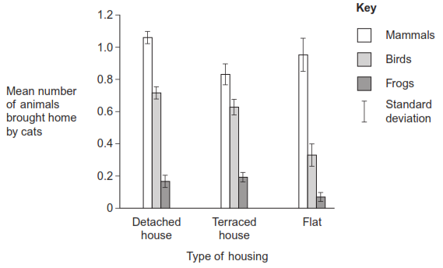
(i) What do these data suggest about predation by domestic cats?
______________________________________________________________
______________________________________________________________
______________________________________________________________
______________________________________________________________
(2)
(ii) Some scientists thought that the results of this investigation were not very reliable.
Suggest one reason why they might have thought that the results were not reliable.
______________________________________________________________
______________________________________________________________
______________________________________________________________
______________________________________________________________(2)
(c) The ecologists investigated the effect of putting a bell on a cat’s collar on its probability of catching prey. As in the first investigation, they asked cat owners to record the prey brought home by their cats. Half of the cats in this study had bells on their collars.
The graph shows the results.
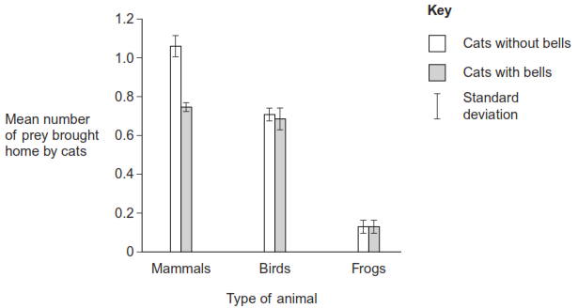
(i) What was the hypothesis that the ecologists were investigating?
______________________________________________________________
______________________________________________________________
(1)
(ii) What do these data suggest about the effect of putting a bell on a cat’s collar?
______________________________________________________________
______________________________________________________________
______________________________________________________________
______________________________________________________________
(2)
Q4.
(a) What is meant by a community?
___________________________________________________________________
___________________________________________________________________
___________________________________________________________________
___________________________________________________________________
(2)
Q5.
(a) Explain the meaning of these ecological terms.
Population __________________________________________________________
___________________________________________________________________
Community _________________________________________________________
___________________________________________________________________
(2)
(c) Explain how you would use a quadrat to estimate the number of dandelion plants in a field measuring 100 m by 150 m.
___________________________________________________________________
___________________________________________________________________
___________________________________________________________________
___________________________________________________________________
___________________________________________________________________
(3)
(d) Two similar species of birds (species A and species B) feed on slightly different sized insects and have slightly different temperature preferences. The diagram represents the response of each species to these factors.
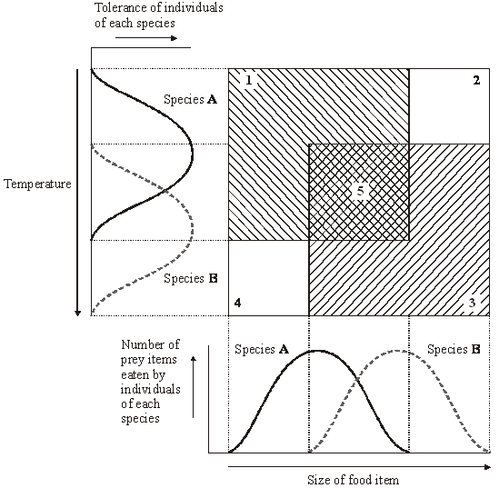
(i) Which of the numbered boxes describes conditions which represent

the niche of species A | ______
the niche of species B | ______
insects too small for species B and temperature too warm for species A; | ______
insects too large for species A and temperature too cool for species B? | ______
(2)
Q6.
Mayflies are insects which lay their eggs in streams and rivers. The nymphs which hatch from the eggs live in the water for several years.
Mayfly nymphs were collected by disturbing the gravel of a stream bed. A net placed immediately downstream caught any animals which were washed out of the gravel. Eight samples were collected from shallow, fast-flowing parts of the stream and eight from deeper, slow-flowing parts. Nymphs from two different families of mayfly were found. The results are given in the table.

 | Family Caenidae |  | Family Baetidae
 | Shallow water | Deep water | Shallow water | Deep water
Mean number of nymphs | 2.38 | 12.88 | 24.50 | 6.00
Standard deviation | 1.51 | 7.92 | 6.72 | 1.51
(a) Describe how you would have collected the samples in order to ensure they were representative of the habitats being investigated and could be compared with each other.
___________________________________________________________________
___________________________________________________________________
___________________________________________________________________
___________________________________________________________________
___________________________________________________________________
___________________________________________________________________
(3)
(b) Which one of the four samples showed the greatest variation within the sample? Give evidence from the table for your answer.
___________________________________________________________________
___________________________________________________________________
(1)

(c) The two families of mayfly nymph occupy different ecological niches.
(i) What is meant by the term ecological niche?
______________________________________________________________
______________________________________________________________
(1)
(ii) Describe the evidence in the table which suggests that the two families of mayflies occupy different ecological niches.
______________________________________________________________
______________________________________________________________
(1)
(iii) Explain the advantage to these two families of mayflies of occupying different ecological niches.
______________________________________________________________
______________________________________________________________
______________________________________________________________
______________________________________________________________
(2)
Q7.
(a) What term is used to describe populations of different species living in the same habitat?
___________________________________________________________________
(1)
(b) Different species occupy different ecological niches.
Explain the advantage of species occupying different niches.
___________________________________________________________________
___________________________________________________________________
(1)

Scientists recorded the number of water beetle species in 30 lakes. In each lake, they measured the pH of the water and recorded whether there were any fish present.
The graph shows their results.
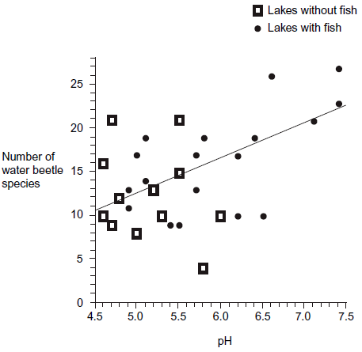
(c) A student concluded that a decrease in acidity caused an increase in the number of water beetle species.
Evaluate this conclusion.
___________________________________________________________________
___________________________________________________________________
___________________________________________________________________
___________________________________________________________________
___________________________________________________________________
___________________________________________________________________
(3)
(d) Explain how the presence of fish in a lake could cause an increase in the number of water beetle species.
___________________________________________________________________
___________________________________________________________________
(1)

Recall Question Answers

- Explain the difference between community and population.
A community is populations of different species living in the same environment or habitat. A population is a group of the same species living in the same environment or habitat.
- What is an ecosystem?
An ecosystem is all the organisms living in a community plus all the non-living abiotic conditions in the area (the habitat).
- Name two ways in which an ecosystem is different to a community
An ecosystem contains non-living elements
- Give a biotic and an abiotic factor that can affect an ecosystem and its inhabitants.
Biotic: competition, predation, pathogens. Abiotic: temperature, pH or soil or water, water availability
- Write a definition for the term niche
The role of a species within its ecosystem or community
- Why is it important the organisms occupy different niches?
To reduce competition and increase survival of both species
- What is an adaptation and how do they occur?
An adaptation is a feature that members of the same species have that increases their chance of survvial and reproduction in their habitat. Occur through natural selection: Organisms in a species with better adaptations to their environment are more likely to survive and reproduce and pass on the alleles that code for these adaptations – this increases the frequency of these alleles in the population.
- Give an example of two similar organisms and how they have adapted to occupy different niches.
Any from the table
- In what ways can niches differ?
Niches can be abiotic or biotic and niches can be separated by time, location, or behaviour.
- What is the problem with trying to demonstrate niche separation artificially?
The number of variables are very high and you can never replicate a proper ecosystem. Taking away variables does not mean you are controlling them and if these are influential, they might change your results.

Lesson 2 – Carrying Capacity
GCSE RECAP
Population = all the organisms of one species in a habitat. Populations of different species come together to make up a community.
Videos: Predator-Prey relationships: https://www.youtube.com/watch?v=dRFQ8rZCK6Q Predator-Prey Graphs: https://www.kayscience.com/vb16-predator-prey-relationship.html
Predator-Prey Relationships
Predators are organisms which hunt and kill their food (they are always carnivores). They are specially adapted to successfully capture and kill their prey. As such over time a complex predator-prey relationship builds up. If conditions favour the prey, such as plentiful food, the prey will reproduce and increase in number. This then creates a large supply of food for the predator, so it is more successful and breeds increasing its number. This increase in predators causes hunting of the prey, reducing their numbers. This in turn reduces the food supply for the predators so their numbers decrease. The cycle continues.

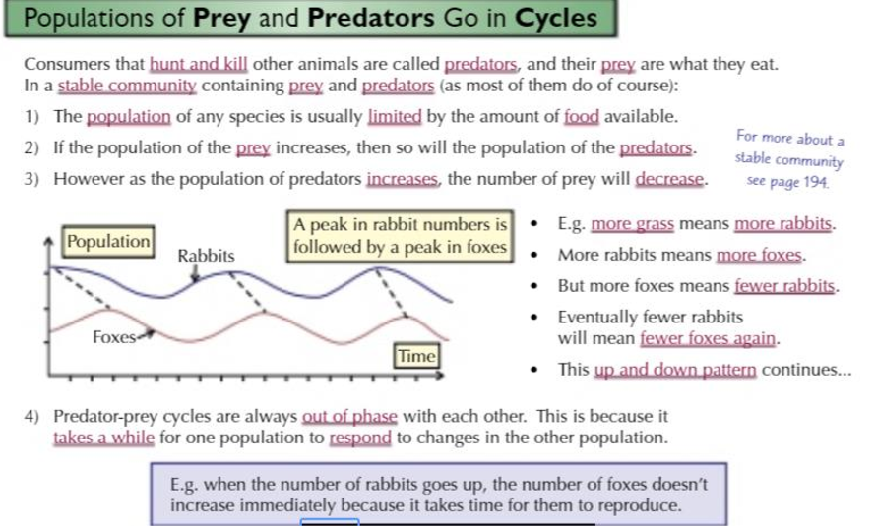
Biotic and abiotic factors can change the numbers of predators or prey which can then increase or decrease the population of predators or prey in the food chain. Competition between different types of species can also reduce their numbers – when they must share food and space the populations will be smaller than when they don’t have to compete with other species in the same area.

Abiotic factors like temperature, chemicals (weed killer/pesticide), pH and light intensity can also affect organisms like insects and the plants they live on.
A level Notes:
Population size is measured as the total number of organisms of one species in a habitat. Abiotic and biotic factors will affect the population size. An ecosystem can only support a certain population size that is stable. The maximum, stable population size of a species that an ecosystem can support is called the carrying capactiy (k). Because abiotic and biotic factors will affect the size of populations they also affect the carrying capacity of an ecosystem.
Abiotic factors which affect population size:
- Amount of light, water or space available
- Temperature
- Chemical composition of their surroundings e.g. soil pH or mineral composition
When abiotic conditions are ideal for a species, individuals grow and reproduce successfully so population size increases. When abiotic conditions are not suitable for a species, organisms can’t grow as fast and they can’t reproduce as successfully so population size would go down.
Biotic factors which affect population size:
1. Competition
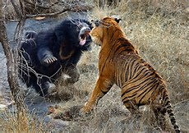
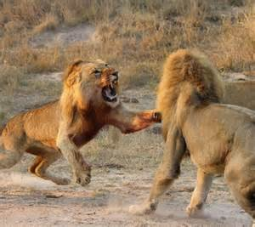
Competition between organisms (plants or animals) of the same species is called Intraspecific competition. (Intra prefix means “within” so within your own species)
Competition between organisms (plants or animals) of different species is called Interspecific competition.
Interspecific competition occurs when different populations compete for the same resources e.g. food. If they are having to share a food source there will be less available for both so their population sizes will be limited as they will not be getting enough energy to grow and reproduce. If one species becomes better adapted to the surroundings e.g. more able to find or catch food, it can outcompete the other and that population will decline and could be wiped out from the habitat.
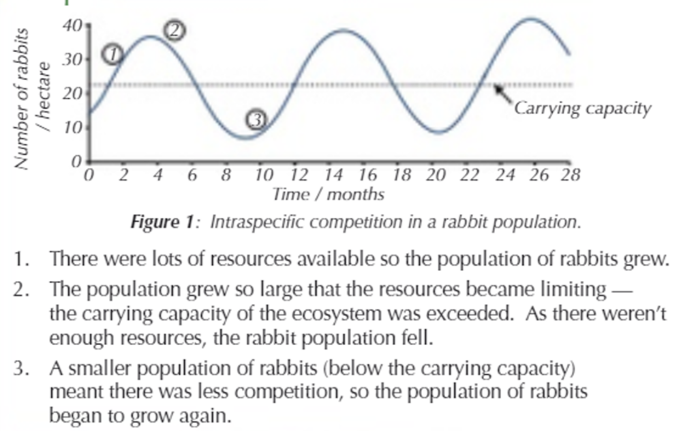
Intraspecific competition occurs when individuals in the same population compete the same resources. It can cause cyclical change in the population size around the populations carrying capacity – where the population grows and shrinks then grows again (see graph).

2. Predator-prey relationships
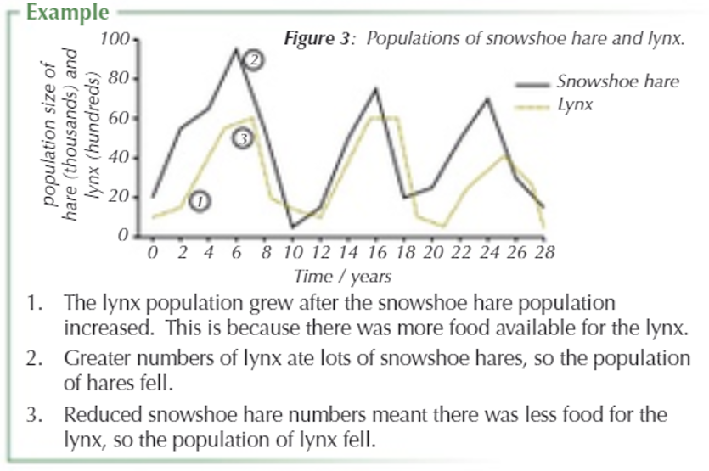
Predation just means an organism killing and eating another as a source of food. The population sizes of predators and prey are interlinked as one changes it causes a change in the other. The hare and lynx example are often used to demonstrate this, but this is because they live in a very specific habitat where there are not many other predators or prey, so the food chain/web is very small. Predator prey relationships are usually a lot more complicated as there are multiple food sources for predators and multiple predators for each prey species. There are other factors also involved e.g. the availability of food for the prey. In the lynx and hare situation the initial decline after the peak of the hare population is because there is less food available (due to overeating) this is then accelerated by lynx predation as they are weaker and easier to catch!
Collecting data and interpreting graphs based on observations of predator/prey relationships:
Advantages: real interactions in an ecosystem are investigated and higher organisms can be tracked more easily.
Disadvantages: Causal relations can only be inferred

Interpreting carrying capacity graphs
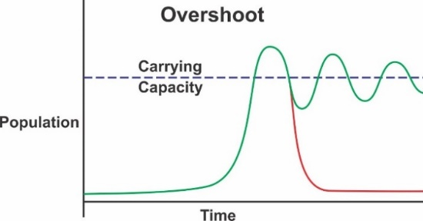
When the population of a species is below the carrying capacity, the number of individuals will expand exponentially until the carrying capacity is reached. In many systems this results in an overshoot and then a further decline in the population.
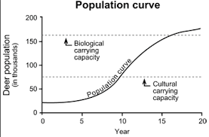
Graph (A) shows fluctuations that can occur in a stable ecosystem that may well flatten out with a very fixed carrying capacity.

Graph (B) shows that there may be different carrying capacities in an ecosystem depending on human interactions with the environment (cultural carrying capacity).
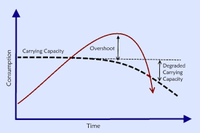
Graph (C) shows a dynamic carrying capacity that changes due to the consumption of a resource by the species being monitored. This is often seen in bacteria – see experiment section next!

Investigating Carrying capacity
Experiment:
With enough food and space, the size of a population of microorganisms e.g. bacteria will grow at a steady rate – you can grow bacteria in a liquid containing nutrients that bacteria need to grow known as a broth. A nutrient broth containing growing bacteria can be called a broth culture.
A broth culture containing lots of bacteria will appear cloudy (turbid) so you can track the growth of the bacteria by measuring the turbidity (cloudiness) using absorbance or transmission of light with a spectrophotometer.
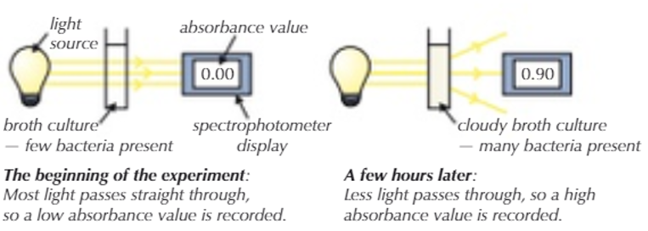
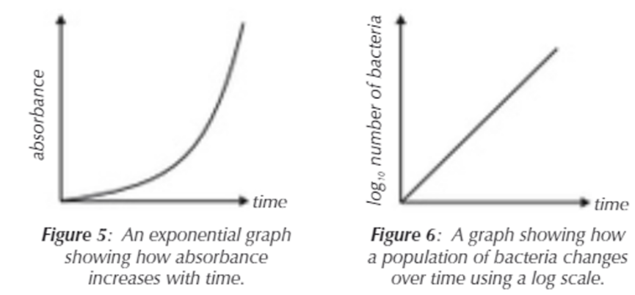
If you plot a graph of absorbance against time you can get an exponential graph (Fig 5) as the bacteria should double at regular intervals. As the absorbance is directly proportional to the number of bacteria in a sample you can convert the figures and draw a graph to show how the population of bacteria changes over time. You will need to use a log of the number of bacteria at each point and plot the graph using a log scale (See maths skills section). You can use the graph (Fig 6) to find the bacterial population at any given time on the x axis.
Advantages: causal effect of a factor on population size can be more easily identified
Disadvantages: hard to investigate realistic complicated systems as would be seen in nature.
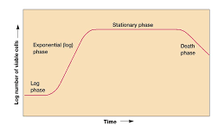
Interpreting bacterial growth graphs:
The graph shows a typical growth curve from bacteria in a closed system (for example a conical flask). There is a lag as the bacteria adapts in cellular machinery to the environment, then an exponential phase until a carrying capacity is reached. As this is a closed system, the nutrients are used up, waste builds up and population declines as the carrying capacity lowers – the death phase.

Maths Skills Link:
Video Explaining the Log Scale: https://www.youtube.com/watch?v=IzyItyUVTn0

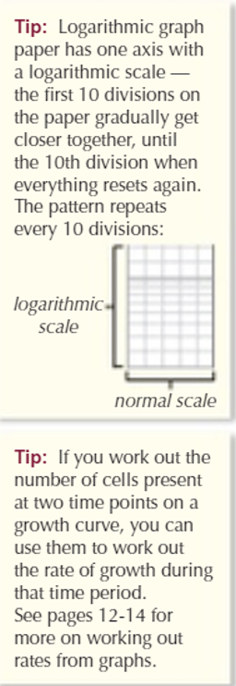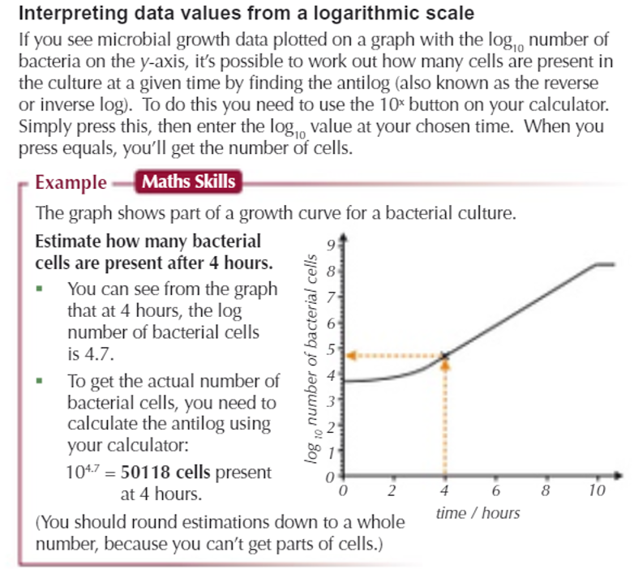
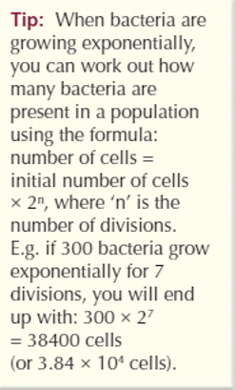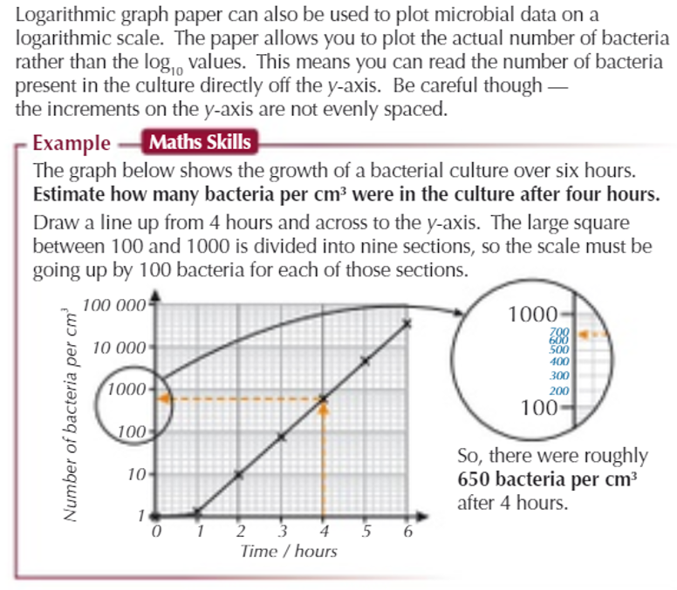
Recall Questions

- What factors can affect carrying capacity?
- What are the disadvantages of carrying out experiments into carrying capacity?
- What are the disadvantages of estimating a carrying capacity in an ecosystem?
- Why is the exponential phase of some graphs a straight line?
- What causes the death phase in closed system?
- What letter can the carrying capacity sometimes be shown as?
- What can interspecific competition result in?
- What happens when abiotic factors are ideal?
- What happens when abiotic factors are not ideal?
- What is intraspecific competition?
- What is the carrying capacity of a population?
- What is predation?
- How are the population sizes of predators and prey interlinked?
- What happens when the prey population increases?
- What happens when the predator population grows?

Exam Questions
Q10. The young of frogs and toads are called tadpoles. Ecologists investigated the effect of predation on three species of tadpole. They set up four artificial pond communities.
Each community contained
• 200 spadefoot toad tadpoles
• 300 spring peeper frog tadpoles
• 300 southern toad tadpoles.
The ecologists then added a different number of newts to each pond. Newts are predators. Figure 1 shows the effect of increasing the number of newts on the percentage survival of the tadpoles of each species.
Figure 1
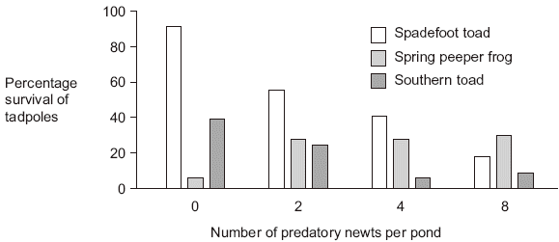

(a) (i) Describe the effect of an increase in the number of newts on the percentage survival of the tadpoles of each of the toad species.
______________________________________________________________
______________________________________________________________
______________________________________________________________
______________________________________________________________
______________________________________________________________
(2)
(ii) Suggest an explanation for the effect of an increase in the number of newts on the percentage survival of the tadpoles of spring peeper frogs.
______________________________________________________________
______________________________________________________________
______________________________________________________________
______________________________________________________________
______________________________________________________________
(2)
Figure 2 shows how the masses of the tadpoles were affected in each pond during the investigation.
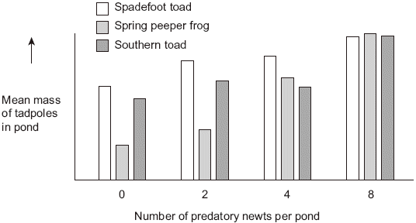
(b) Using the information provided in Figure 1 explain the results obtained in Figure 2.
___________________________________________________________________
___________________________________________________________________
___________________________________________________________________
___________________________________________________________________
___________________________________________________________________
(2)
Q11. A species of moth occurs in forests in Switzerland. The moth larvae feed on the needle-shaped leaves of larch trees that grow in the forests. The graph shows the numbers of larvae and the mean length of leaves over a period of 20 years.
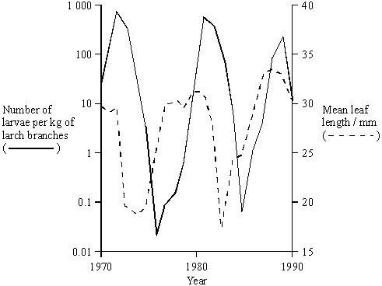
(i) Describe how the population size of a species of bird that fed mainly on the moth larvae would be likely to change between 1970 and 1980.
___________________________________________________________________
___________________________________________________________________
___________________________________________________________________
___________________________________________________________________
(2)
(ii) Larch trees lose their leaves in autumn. When numbers of larvae are large in one year, the leaves in the following year are shorter. Suggest an explanation for this.
___________________________________________________________________
___________________________________________________________________
___________________________________________________________________
___________________________________________________________________
(2)

Q2. (a) What term is used to describe populations of different species living in the same habitat?

___________________________________________________________________

(1)

(b) Different species occupy different ecological niches.

Explain the advantage of species occupying different niches.

___________________________________________________________________

___________________________________________________________________

(1)
Scientists recorded the number of water beetle species in 30 lakes. In each lake, they measured the pH of the water and recorded whether there were any fish present.
The graph shows their results.
(c) A student concluded that a decrease in acidity caused an increase in the number of water beetle species.
Evaluate this conclusion.
___________________________________________________________________
___________________________________________________________________
___________________________________________________________________
___________________________________________________________________
___________________________________________________________________
___________________________________________________________________ (3)
(d) Explain how the presence of fish in a lake could cause an increase in the number of water beetle species.
___________________________________________________________________
___________________________________________________________________
(1)
Q6. Lemmings are small mammals which live in the Arctic. Their main predator is the stoat, a small carnivorous mammal, which feeds almost entirely on lemmings. The graph shows the changes in the numbers of lemmings and stoats from 1988 to 2000.
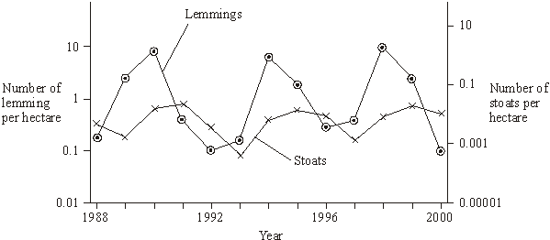
(a) Describe and explain the changes which occur in the lemming and stoat populations.
___________________________________________________________________
___________________________________________________________________
___________________________________________________________________
___________________________________________________________________
___________________________________________________________________
___________________________________________________________________
___________________________________________________________________
___________________________________________________________________
___________________________________________________________________
___________________________________________________________________
(6)
Q9. Yeast is a single-celled organism. A student investigated respiration in a population of yeast growing in a sealed container. His results are shown in the graph.
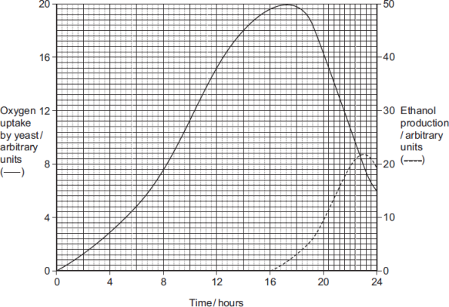
(a) Calculate the rate of oxygen uptake in arbitrary units per hour between 2 and 4 hours.
Answer ____________________ arbitrary units per hour
(1)
(b) (i) Use the information provided to explain the changes in oxygen uptake during this investigation.
______________________________________________________________
______________________________________________________________
______________________________________________________________
______________________________________________________________
______________________________________________________________
(3)
(ii) Use the information provided to explain the changes in production of ethanol during this investigation.
______________________________________________________________
______________________________________________________________
______________________________________________________________
______________________________________________________________ (2)

Recall Question Answers
- What factors can affect carrying capacity?
Abiotic - temperature, availability of resources etc and biotic – competition and predation
- What are the disadvantages of carrying out experiments into carrying capacity?
hard to investigate realistic complicated systems as would be seen in nature.
- What are the disadvantages of estimating a carrying capacity in an ecosystem from observations?
They are usually a lot more complicated as there are multiple factors so causality can only be inferred.
- Why is the exponential phase of some graphs a straight line?
As the bacteria can double at regular intervals making the absorbance directly proportional to the number of bacteria in
- What causes the death phase in closed system?
nutrients are used up and waste builds up so the carrying capacity lowers
- What letter can the carrying capacity sometimes be shown as?
k
- What can interspecific competition result in?
Reduced resources available to both populations. Less energy for growth and reproduction so the population size of both species decreases
- What happens when abiotic factors are ideal?
Organisms grow fast and reproduce successfully
- What happens when abiotic factors are not ideal?
Organisms cannot grow fast and reproduction decreases
- What is intraspecific competition?
When organisms of the same species compete for the same resources
- What is the carrying capacity of a population?
The maximum stable population size of a species
- What is predation?
Where an organism kills and eats another organism
- How are the population sizes of predators and prey interlinked?
As the population of one change, it causes the other population to change
- What happens when the prey population increases?
There is more food for predators, so the predator population grows
- What happens when the predator population grows?
More prey is eaten so the prey population decreases

Lesson 3 - Sampling Techniques
GCSE Recap:
Notes
- To study an ecosystem ecologists need to know the abundance (how many) and the distribution (where) of organisms in an area.
- Measuring these allows scientists to investigate how biotic and abiotic factors effect an ecosystem.
- It is impossible to measure the exact amount of organisms in large areas so ecologists use sampling techniques to estimate the actual number.
- Random sampling is a way of eliminating personal choice (bias) in the selection of a sample. For a sample to be random every part of your sample area should have an equal chance of being sampled every time you go to take a sample. Throwing a quadrat is not truly random as the whole area will not be equally as likely to be sampled it is restricted to your throw distance.
- There are two main sampling techniques; Quadrats and Transects.
Quadrats = random sampling
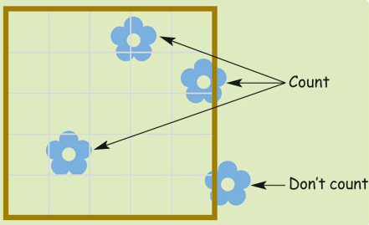
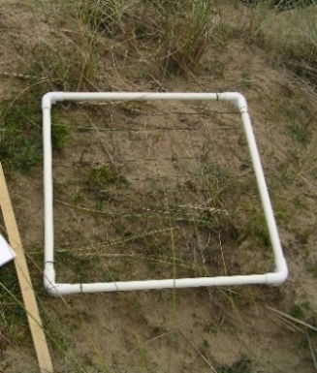
A quadrat is a simple square frame that is placed randomly on the ground to count the number of plant species. It is then moved to a different random location and the process is repeated.
Only species completely within the frame are counted each time.

- It is important that as many quadrats as possible are taken during the sampling to ensure the result are accurate. More quadrats would make a larger sample so the data would be more accurate.
- It is also important that they are placed randomly to avoid bias. This can be achieved using a grid system and a random number generator or picking numbers out of a hat to select coordinates.
- Once a large number of results have been recorded a mean can be calculated.
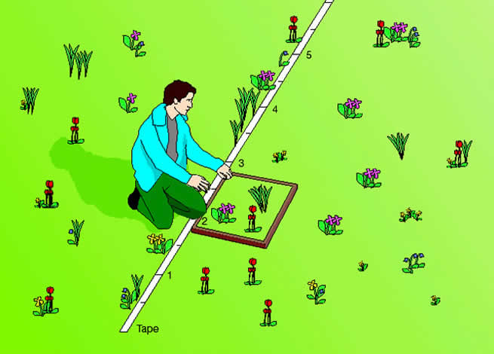
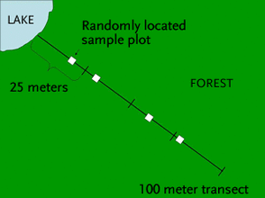
Transects = systematic sampling
Transects involve a tape measure being placed along a varied stretch of habitat (eg a coastline from sea to beach) and using a quadrat to record species at regular intervals along the line. Transects allow scientists to see how the distribution of a species changes as the habitat changes and is a useful way of investigating how abiotic factors affect a species.
Things to remember:
- Always include a way to randomly place quadrats when describing methods
- When should you use a transect and why
- What abiotic and biotic factors can affect plant growth: light, temperature, nutrients, water, pH of soil. competition, trampling by animals (including humans!)
- You don’t count organisms that are more than half out of the quadrat
- You can increase reliability/validity of results by using more quadrats as it measures a larger sample!
- You can increase reliability of transects by repeating them in similar areas
- You should always calculate a mean number of organisms per quadrat – the more quadrats you place before you take the mean the more reliable it will be
A level Notes: Sampling non-motile organisms
Quadrats are used to sample “non-motile” or “sessile” organisms i.e organisms that do not move like plants or animals which are fixed to a surface or move incredibly slowly e.g barnacles, limpets, snails etc. There are two ways of describing the amount of each species within a frame quadrat: percentage cover and frequency.
Percentage frequency
Percentage frequency is the probability that a species will be found within a single quadrat.
% frequency = number of quadrats in which the species is found total/number of quadrats
Example:
An investigation was made into the difference in vegetation between a grazed and an un-grazed section of the fixed dunes. A random sample using 30 frame quadrats is taken in each area. In the grazed area, bird's-foot trefoil was present in 18 of the 30 quadrats; in the un-grazed area, bird's-foot trefoil was present in 6 of the 30 quadrats.
% frequency in un-grazed area=1830×100=60%
% frequency in grazed area=630×100=20%
The number of quadrat samples taken affects the reliability of the results. The number must be large enough to minimise the effect of anomalies, but not too large that it cannot realistically be carried out in the time available. lt must also be sufficient for any statistical tests you are using.
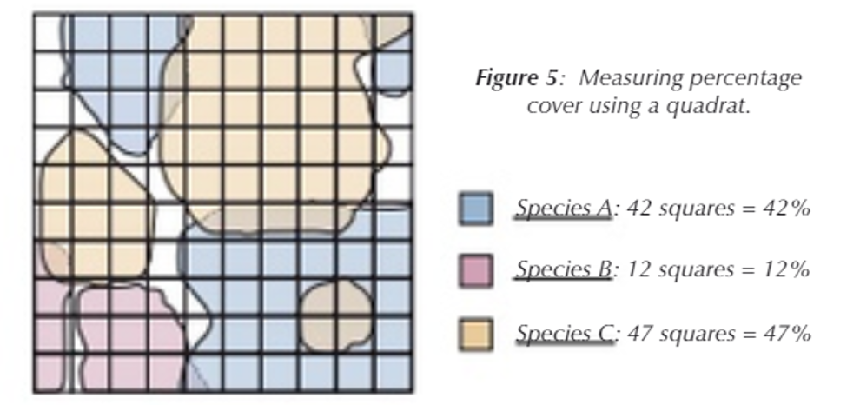
Percentage cover
Percentage cover is faster but is more subjective. Simply estimate what percentage of the area enclosed by the quadrat is occupied by each species. One drawback of this method is that plants in flower tend to be over-estimated while low-growing plants are under-estimated.
Local frequency is easiest to measure if you have a gridded quadrat of 10 x 10 squares. For each species, count the number of squares which are at least half-occupied. The final figure (which will vary between 1 and 100) is the local frequency. This method is more time consuming than estimating percentage cover, but the results should be more accurate, as there is less risk of over-estimating some plants and under-estimating others.
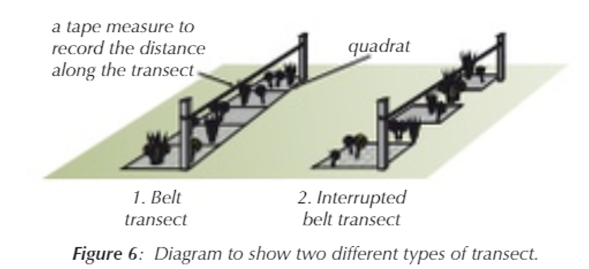
Transect Types
Transects are really used to investigate the distribution of organisms across an area where there is often a change in habitat or abiotic factor. There are two types: Belt transects where quadrats are placed next to each other or interrupted transects where quadrats are spaced at regular intervals. This is faster and allows greater distance to be covered but less informative. Measuring Abiotic Factors: pH of soil: https://www.youtube.com/watch?v=ATpRu6u0Y6w&t=2s pH of water: https://www.youtube.com/watch?v=RRR9GU4gtJk
Sampling motile organisms
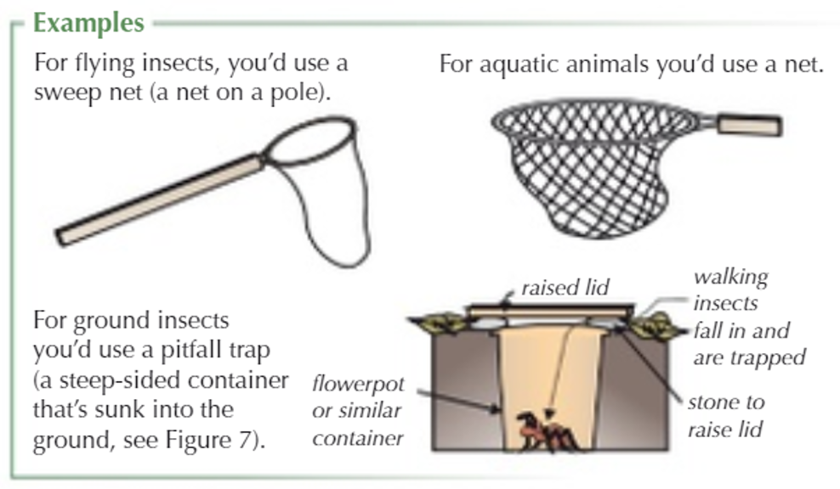
If you need to estimate populations of organisms in an area that move (are motile) you need to use equipment to capture them so that you can count them. The best method will depend on what organisms you are catching, where and over how long. It should also be ethical so as not to harm or stress the organisms too much – we will mention more about this later.
There is a range of equipment you can use including pooters (collects small insects by drawing them into a holding chamber by sucking on a mouthpiece), pitfall traps and sweep nets can be used for small insects, aquatic animals in larger nets, or Longworth traps (for larger mammals). Regardless of the equipment or environment the mark-release-recapture method is normally used to estimate the populations.
Longworth trap: https://www.youtube.com/watch?v=0X3eBU5TjeI&t=10s
Pit fall Trap: https://www.youtube.com/watch?v=nOaDCse5z5I
Sweep net: https://www.youtube.com/watch?v=c5dVt3n1_EE
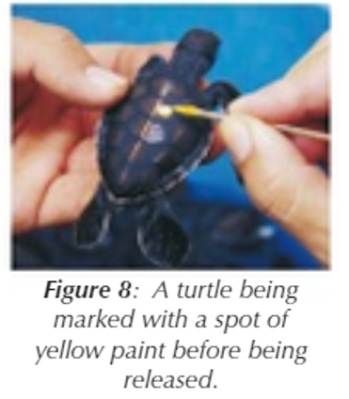
Pooter: https://www.youtube.com/watch?v=3zodNzjmKAI
Mark-release-recapture technique
The size of populations of invertebrates or small mammals in an area can be estimated using mark-release-recapture technique.
A sample of animals is captured, counted and marked in some way. These are then released and allowed to re-mix with the population. A second sample is taken later. The population can be estimated from the proportion of marked animals in the second sample.
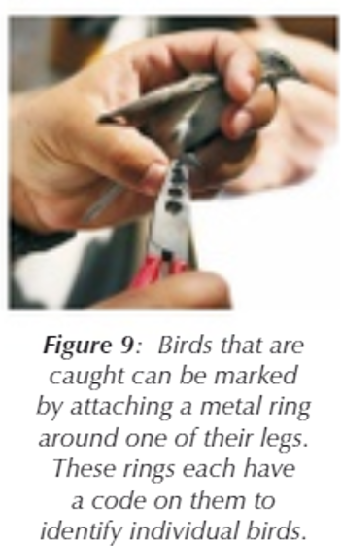
Method:
- Take a sample from the population using appropriate equipment and count them.
- Mark them in a harmless way e.g spot of paint (Figure 8) or using an identification tag (Figure 9)
- Release them back into their habitat - you now know how many marked animals there are in the population.
- Wait long enough for the marked animals to mix randomly with the rest of the population, at least 24hrs.
- Take a second sample in exactly the same way as the first. Record (a) the total number of animals in the second sample, and (b) the number of marked animals in the second sample (recaptures)
Video Example: https://www.youtube.com/watch?v=ekSjRsnhJrk
Calculation to estimate population size:
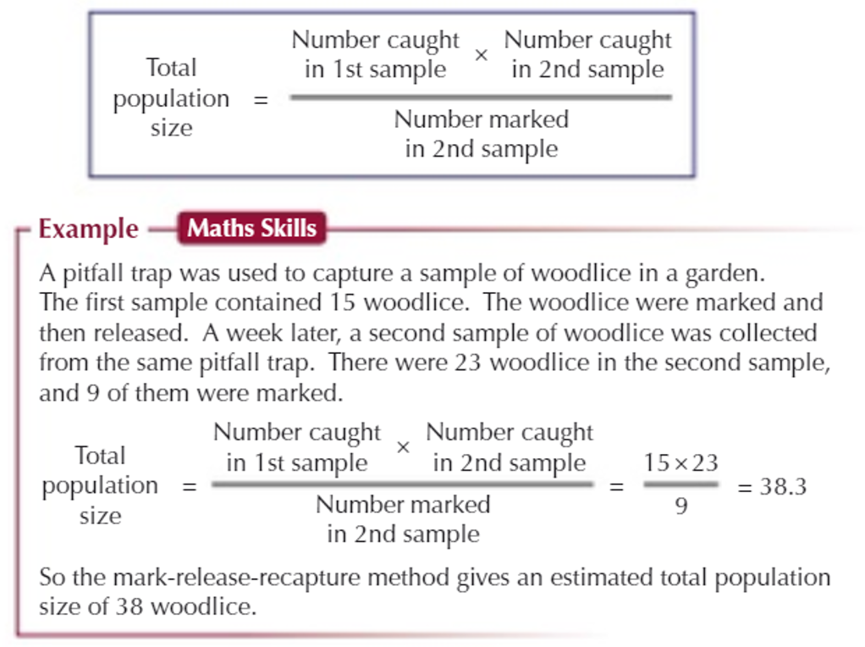
You can now calculate a population estimate. If the animals have been mixing randomly, then the proportion of marked to unmarked animals in the population should be the same as the proportion of marked to unmarked animals in the second sample.

This method relies on assumptions!
Several assumptions made when estimating the size of population by mark-recapture. Some are more realistic than others:
- The population is closed. In other words, there is no migration into or out of the population. In addition, it assumes there are no deaths or births in the time between the first and second capture.
Births and deaths can be either real or virtual. A real death happens when the animal actually dies while a virtual death means the animal is no longer available for sampling. Perhaps it has gone into hibernation or like a caterpillar has turned into a pupa.
- All members of the population mix randomly. In other words, each member of the population has an equal chance of capture. However, this may not be the case for everything. For example, male mice and voles are inquisitive and more likely to enter a trap then females. Lactating females are going to stay close to their nests, so you may effectively only be sampling from half the population.
- The marks do not rub off or tags are not lost/removed between captures.
- The mark does not harm the animal or affect its survival in another way. Does painting nail varnish onto a snail's shell make it more obvious to a predator like a bird?
Ethical considerations: Some people think that capturing is unethical as it may cause stress. Handling should be kept to a minimum and all organisms treated carefully and with respect. If animals are put under too much stress during capture it could reduce their chances of survival after release or cause them to be wary and avoid traps in the future so this can affect the accuracy of the estimations of population size.

Recall Questions
- How are plants generally sampled?
- What is percentage frequency?
- How do you measure percentage cover?
- What is an issue with using percentage cover instead of frequency?
- How does the number of quadrats taken affect the reliability of the results?
- Compare belt transects and an interrupted belt transects.
- What are abiotic factors?
- What are some common abiotic factors?
- How could you estimate the size of an animal population?
- What equipment can be used to collect live animal samples?
- What are the 5 steps of the mark-release-recapture method?
- What step is most important to ensure random mixing of the marked and non-marked populations?
- What is the formula to work out the total population of animals in a given area?
- What are the four assumptions when estimating animal population size?
- What issues might arise to affect your data?
- What are the ethical considerations that must be made when sampling animals?

Exam Questions

Q1. Lettuce is classified in the same family as dandelions. Dandelions commonly grow on roadside verges and may accidentally be sprayed with salt when salt is added to the road in winter.
Describe how you could use a transect to investigate whether the distribution of dandelions changed with increased distance from the road.
_______________________________________________________________________
_______________________________________________________________________
_______________________________________________________________________
_______________________________________________________________________
_______________________________________________________________________
_______________________________________________________________________
_______________________________________________________________________
_______________________________________________________________________
(4)
Q2.
(a) What is meant by an abiotic factor?
______________________________________________________________
______________________________________________________________
(1)
(b) Describe how you would collect the necessary data to estimate the size of a population by the mark-release-recapture technique.
___________________________________________________________________
___________________________________________________________________
___________________________________________________________________
___________________________________________________________________
___________________________________________________________________
___________________________________________________________________
(3)
Q4. Ecologists investigated changes in grassland communities on large islands off the coast of Scotland between 1975 and 2010. On each island, they used data from a number of sites to determine the change in mean species richness and the change in mean index of diversity.
(a) Table 1 shows plant species recorded at one site, on one island, in 1975.

Table 1
Species | Number of individuals
Hydrocotyle vulgaris | 3
Plantago maritima | 19
Ranunculus acris | 3
Hieracium pilosella | 3
Calliergon cuspidatum | 10
Prunella vulgaris | 16
Pseudoscleropodium purum | 6
Calculate the index of diversity for this site using the formula:
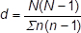
d = ___________
(2)

(b) Outline a method the ecologists could have used to determine the plant species richness at one site.
___________________________________________________________________
___________________________________________________________________
___________________________________________________________________
___________________________________________________________________
___________________________________________________________________
___________________________________________________________________
___________________________________________________________________
___________________________________________________________________
(3)

(c) Some of the ecologists’ results are shown in Table 2. They carried out a statistical test to find out whether any differences between the 1975 and 2010 means were significant. The values for P that they obtained are also shown in Table 2.
Table 2
Island | Change in mean species richness between 1975 and 2010 | Value of P | Change in mean index of diversity between 1975 and 2010 | Value of P
Islay | +8.89 | ≤0.001 | +0.22 | >0.05
Colonsay | +14.70 | ≤0.001 | +2.68 | ≤0.01
Harris | −5.13 | ≤0.001 | −2.44 | ≤0.01
Do these data show that there were any significant changes in the grassland communities on these islands? Give reasons for your answer.
___________________________________________________________________
___________________________________________________________________
___________________________________________________________________
___________________________________________________________________
___________________________________________________________________
___________________________________________________________________
___________________________________________________________________
___________________________________________________________________
(3)

Q5. Ecologists studied a community of fish in a lake.
(a) Explain what is meant by a community.
___________________________________________________________________
___________________________________________________________________
___________________________________________________________________
(1)
(b) (i) The ecologists could have used the mark-release-recapture method to estimate the number of one species of fish in the lake. Describe how.
______________________________________________________________
______________________________________________________________
______________________________________________________________
______________________________________________________________
______________________________________________________________
______________________________________________________________
(3)
(ii) This species of fish breeds at a certain time of the year. During this fish-breeding season, the mark-release-recapture technique might not give a reliable estimate.
Suggest one reason why.
______________________________________________________________
______________________________________________________________
______________________________________________________________
(1)
(c) The ecologists found that each species of fish had adaptations to its niche. One of these adaptations was the shape of its mouth.
Suggest how the shape of mouth is an adaptation to its niche.
___________________________________________________________________
___________________________________________________________________
___________________________________________________________________
___________________________________________________________________
___________________________________________________________________
(2)
Q6. Bees are flying insects that feed on nectar made in flowers. There are many different species of bee.
Scientists investigated how biodiversity of bees varied in three different habitats during a year. They collected bees from eight sites of each habitat four times per year for three years.
(a) What is meant by ‘species richness’?
___________________________________________________________________
___________________________________________________________________
___________________________________________________________________
___________________________________________________________________
___________________________________________________________________
___________________________________________________________________
___________________________________________________________________
(1)
(b) The scientists collected bees using a method that was ethical and allowed them to identify accurately the species to which each belonged.
In each case, suggest one consideration the scientists had taken into account to make sure their method
1. was ethical.
___________________________________________________________________
___________________________________________________________________
___________________________________________________________________
___________________________________________________________________
2. allowed them to identify accurately the species to which each belonged.
___________________________________________________________________
___________________________________________________________________
___________________________________________________________________
___________________________________________________________________
___________________________________________________________________
___________________________________________________________________
(2)
(c) Three of the bee species collected in the farmland areas were Peponapis pruinosa, Andrena chlorogaster and Andrena piperi.
What do these names suggest about the evolutionary relationships between these bee species? Explain your answer.
___________________________________________________________________
___________________________________________________________________
___________________________________________________________________
___________________________________________________________________
___________________________________________________________________
___________________________________________________________________
___________________________________________________________________
___________________________________________________________________
___________________________________________________________________
___________________________________________________________________
___________________________________________________________________
___________________________________________________________________
___________________________________________________________________
(2)

Recall Question Answers:
- How are plants generally sampled?
Using quadrats

- What is percentage frequency?
The probability that a species will be found within a single quadrat.
- How do you measure percentage cover?
Estimate what percentage of the area enclosed by the quadrat is occupied by each species.

- What is an issue with using percentage cover instead of frequency?
Percentage cover is more subjective so some plants can be over-estimated under-estimated.
- How does the number of quadrats taken affect the reliability of the results?
More quadrats makes the sample more reliable as it reduces the impact of anomalies

- Compare belt transects and an interrupted belt transects.
In belt transects quadrats are placed next to each but for interrupted transects quadrats are spaced at regular intervals not all the area is sampled. Interrupted transects are faster and allow more overall distance to be covered but could give less information.

- What are abiotic factors?
Non-living conditions in a habitat.

- What are some common abiotic factors?
- Wind speed
- Light intensity
- Humidity
- pH
- Temperature
- Oxygen content in water.

- How could you estimate the size of an animal population?
Using the mark-release-recapture method

- What equipment can be used to collect live animal samples?
1 - Pooter;
2 - Sweep nets;
3 - Pitfall traps;
4 – Longworth traps
5 – Nets (for aquatic organisms)

- What are the 5 steps of the mark-release-recapture method?
1. Take a sample from the population using appropriate equipment and count them.
2. Mark them in a harmless way
3. Release them back into their habitat
4. Wait long enough for the marked animals to mix randomly with the rest of the population
5. Take a second sample in exactly the same way as the first. Record (a) the total number of animals in the second sample, and (b) the number of marked animals in the second sample (recaptures)
- What step is most important to ensure random mixing of the marked and non-marked populations?
The wait between the recapture – at least 24hrs

- What is the formula to work out the total population of animals in a given area?

- What are the four assumptions when estimating animal population size?
• The population is closed - no migration, births or deaths
• All members of the population mix randomly.
• The marks do not rub off or tags are not lost/removed between captures.
•The mark does not affect the survival of the organisms

- What issues might arise to affect your data?
- Marks rub off
- Population is not mixed randomly
- Virtual deaths
- Factors that affect animal behaviour so sample not representative of whole population
- Marking affects survival of organisms

- What are the ethical considerations that must be made when sampling animals?
Reduce handling as much as possible and be careful to avoid causing animals unnecessary stress.

esson 4 - Succession
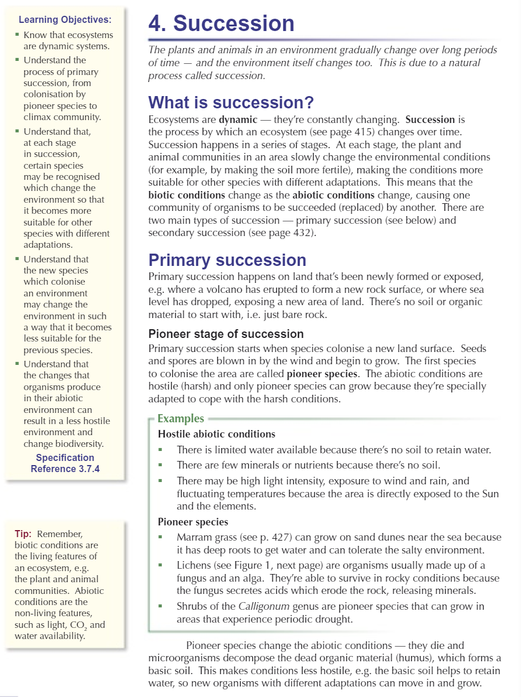
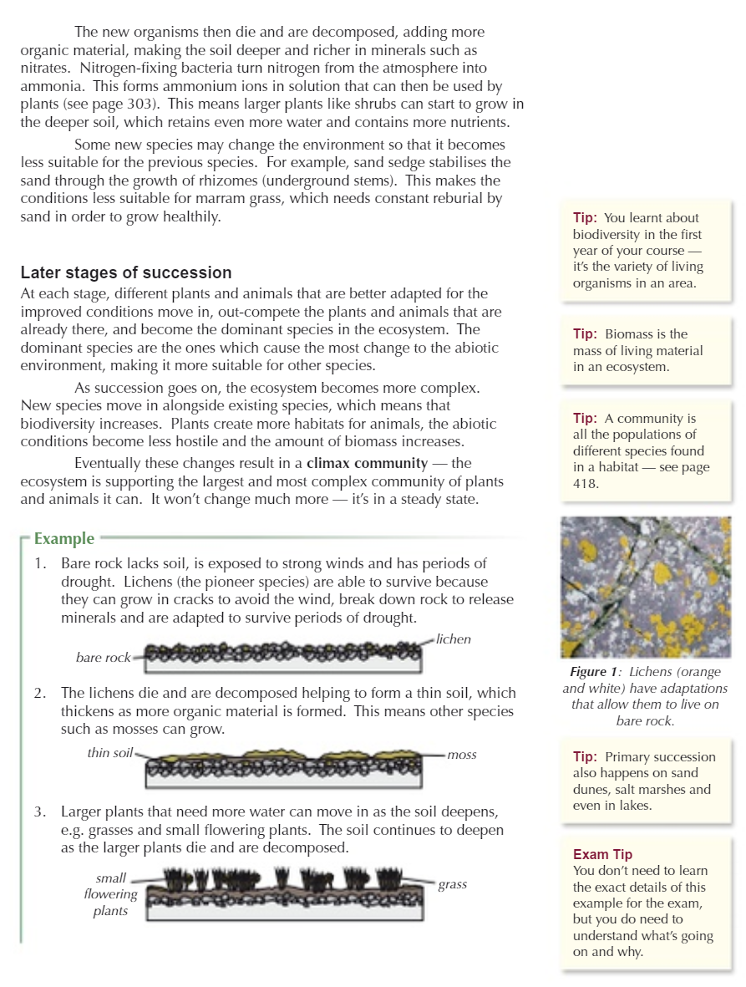

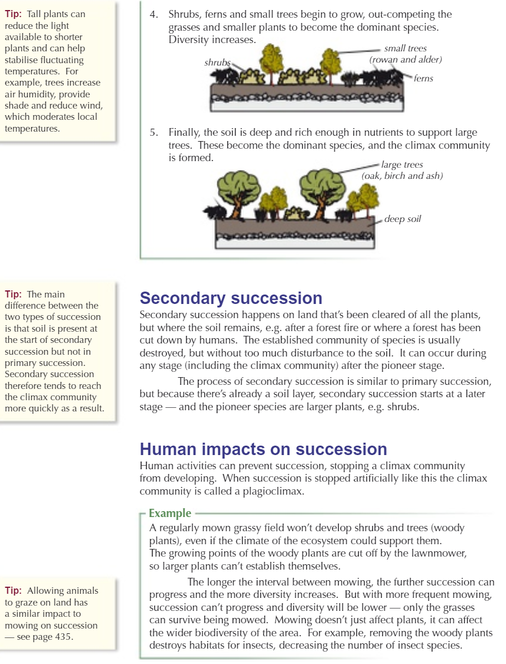

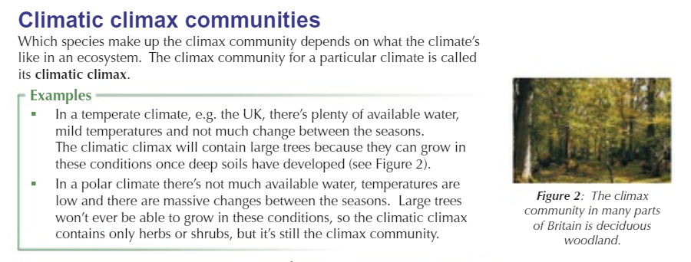
Some Extra Notes and Resources About Succession:
- At each stage in succession, certain species may be recognised which change the environment so that it becomes more suitable for other species with different adaptations. The new species may change the environment in such a way that it becomes less suitable for the previous species.
- The species living in a particular place gradually change over time as does the physical and chemical environment within that area.
- Succession takes place because through the processes of living, growing and reproducing, organisms interact with and affect the environment within an area, gradually changing it.
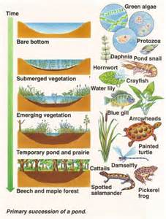
- Each species is adapted to thrive and compete best against other species under a very specific set of environmental conditions. If these conditions change, then the existing species will be outcompeted by a different set of species which are better adapted to the new conditions.
- The most often quoted examples of succession deal with plant succession. It is worth remembering that as plant communities change, so will the associated micro-organism, fungus and animal species. Succession involves the whole community, not just the plants.
- Change in the plant species present in an area is one of the driving forces behind changes in animal species. This is because each plant species will have associated animal species which feed on it. The presence of these herbivore species will then dictate which particular carnivores are present.
- The structure or 'architecture' of the plant communities will also influence the animal species which can live in the microhabitats provided by the plants.
- Changes in plant species also alter the fungal species present because many fungi are associated with particular plants. More info click here
- Succession is directional. Different stages in a particular habitat succession can usually be accurately predicted.
- Succession will not go any further than the climax community. This is the final stage.
- The actual species involved in a succession in a particular area are controlled by such factors as the geology and history of the area, the climate, microclimate, weather, soil type and other environmental factors. For example, the species involved in a succession from open freshwater to climax woodland in Central Africa, would be quite different to those which have been quoted in these pages as occurring in Britain. However, the processes involved would be the same.
- Succession occurs on many different timescales, ranging from a few days to hundreds of years. It may take hundreds of years for a climax woodland to develop, while the succession of invertebrates and fungi within a single cow pat (cow dung), may be over within as little as 3 months.

Recall Questions
- What is succession?
- What is secondary succession?
- What is a climax community?
- What are features of a climax community?
- What biotic and abiotic factors can limit the size of populations in a climax community?
- What is a pioneer species?
- How does primary succession start?
- Describe the abiotic conditions at the start of primary succession
- How can pioneer species grow in primary succession?
- How do pioneer species change the abiotic conditions?
- When the conditions are less hostile what happens (primary succession)?
- What are the main steps of succession?
- What are the pioneer species in secondary succession ?
- Define dominant species

Exam Questions
Q1.
(a) Explain what is meant by
(i) succession;
______________________________________________________________
______________________________________________________________
______________________________________________________________
(2)
(ii) a climax community.
______________________________________________________________
______________________________________________________________
(1)
Heather plants are small shrubs. Heather plants are the dominant species in the climax community of some moorlands. The structure and shape of a heather plant changes as it ages. This results in changes in the species composition of the community. A large area of moorland was burnt leaving bare ground. The table shows four stages of succession in this area.

Time after burning / years | Appearance of  heather plant | Mean  percentage  cover of heather | Other plant species present
4 |  | 10 | Many
12 |  | 90 | Few
19 |  | 75 | Several
24 |  | 30 | Many
(b) Explain why the number of other plant species decreases between 4 and 12 years after burning.
___________________________________________________________________
___________________________________________________________________ (2)
Q2. (a) The diagram shows a number of stages in an ecological succession in a lake.
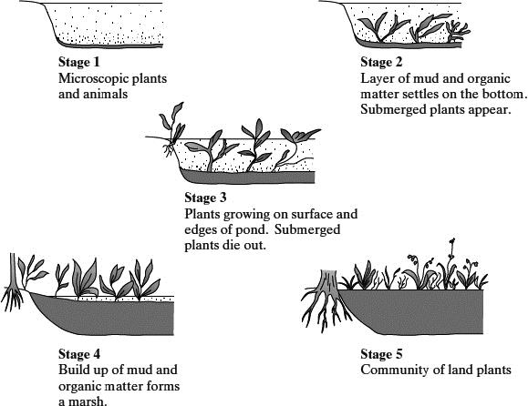
Explain how the diagrams illustrate the features of an ecological succession.
___________________________________________________________________
___________________________________________________________________
___________________________________________________________________
___________________________________________________________________
___________________________________________________________________
___________________________________________________________________
___________________________________________________________________
___________________________________________________________________
___________________________________________________________________
___________________________________________________________________
___________________________________________________________________
___________________________________________________________________
(6)

(b) Several small rivers flow into this lake. These rivers flow through forested areas.
Explain how deforestation might affect the process of succession in the lake.
___________________________________________________________________
___________________________________________________________________
___________________________________________________________________
___________________________________________________________________
(2)
(c) Stage 5 illustrates the final stage of succession which is known as the climax community. During this stage the number of different species in the habitat and the size of each population remain fairly constant. Explain what limits the size of populations in a climax community.
___________________________________________________________________
___________________________________________________________________
___________________________________________________________________
___________________________________________________________________
___________________________________________________________________
___________________________________________________________________
___________________________________________________________________
___________________________________________________________________
___________________________________________________________________
___________________________________________________________________
___________________________________________________________________
___________________________________________________________________
(5)

Q3. The photograph shows marram grass growing on a sand dune.
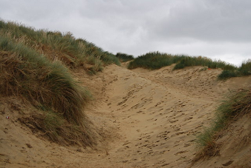
Marram grass on sand dune by Nigel Chadwick [CC-BY-SA], via Wikimedia Commons
(a) Describe how you would investigate the distribution of marram grass from one
side of the dune to the other.
___________________________________________________________________
___________________________________________________________________
___________________________________________________________________
___________________________________________________________________
___________________________________________________________________
___________________________________________________________________
(3)
(b) Marram grass is a pioneer species that grows on sand dunes. It has long roots and a vertically growing stem that grows up through the sand.
Sand dunes are easily damaged by visitors and are blown by the wind. Planting marram grass is useful in helping sand dune ecosystems to recover from damage.
Use your knowledge of succession to explain how.
___________________________________________________________________
___________________________________________________________________
___________________________________________________________________
___________________________________________________________________
___________________________________________________________________
(2)

Q4.
(a) What is meant by a community?
___________________________________________________________________
___________________________________________________________________
___________________________________________________________________
___________________________________________________________________
(2)
(b) A farmer stopped using a field for growing crops. Scientists studied succession in the field over the next 30 years. The graph shows the number of species of Hemiptera (an order of insects) present during that period.
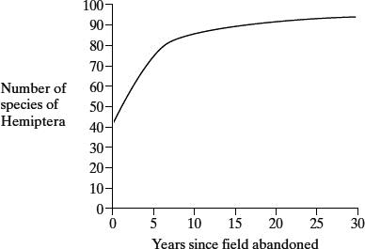
Explain the increase in the number of species of Hemiptera.
___________________________________________________________________
___________________________________________________________________
___________________________________________________________________
___________________________________________________________________
___________________________________________________________________
___________________________________________________________________
(3)
(c) To calculate a diversity index at a given time, it is necessary to know the number of insects in each population. Name one method that could be used to estimate the total number of insects in a population.
___________________________________________________________________
(1)

Q5. Ecologists studied a stream community before and after a flood. The flood reduced animal populations in the stream by 98%.
The table shows how the populations of six animal species found in the stream changed following the flooding.

Animal species | Number of days after flooding
Animal species | 1 | 5 | 13 | 22 | 35 | 49 | 63
Animal species | Mean number of organisms / thousands m⁻³
Baetis quilleri | 0.03 | 0.85 | 2.6 | 9.3 | 6.4 | 0.9 | 0.3
Leptohyphes packeri | 0.0 | 0.0 | 0.25 | 2.5 | 17.3 | 18.0 | 29.5
Helicopsyche mexicana | 0.0 | 0.02 | 0.2 | 0.1 | 0.07 | 0.03 | 0.01
Cryptolabis paradoxa | 0.0 | 13.3 | 21.3 | 55.8 | 62.9 | 168.7 | 182.6
Pentaneurini guttipennis | 0.1 | 0.5 | 0.6 | 1.8 | 1.0 | 0.6 | 0.25
Micropsectra klinki | 0.0 | 0.0 | 0.0 | 0.0 | 0.0 | 0.2 | 5.6
(a) Explain how the data in the table provides evidence of succession.
___________________________________________________________________
___________________________________________________________________
___________________________________________________________________
___________________________________________________________________
___________________________________________________________________
___________________________________________________________________
___________________________________________________________________
___________________________________________________________________
___________________________________________________________________
___________________________________________________________________
(5)
(b) The populations of Cryptolabis paradoxa and Leptohyphes packeri both increased between days 13 and 63.
Calculate how many times the population growth per day of Cryptolabis paradoxa is greater than that of Leptohyphes packeri between these days.
Answer = _____________________ (2)
(c) The stream eventually recovered to reach a climax community.
Give two features of a climax community.
1. _________________________________________________________________
___________________________________________________________________
2. _________________________________________________________________
___________________________________________________________________
(2)
Q6. Glaciers are masses of moving ice. When glaciers shrink, the thick covering of ice gradually disappears to leave behind bare land. Land exposed by a shrinking glacier in Alaska became covered by dense forest in 150 years.
(a) Explain how succession resulted in the formation of the forest.
___________________________________________________________________
___________________________________________________________________
___________________________________________________________________
___________________________________________________________________
___________________________________________________________________
___________________________________________________________________
___________________________________________________________________
___________________________________________________________________
(4)
(b) In areas of poor drainage the soil is waterlogged. In these areas the climax community is bog dominated by the moss, Sphagnum. Explain why bog is described as the climax community.
___________________________________________________________________
___________________________________________________________________
(1)
Q7. Biologists studied the process of succession in an area of wasteland over a period of ten years. They calculated the index of diversity of the area every year. After three years, the index of diversity was 1.6. After ten years, it had risen to 4.3.
(a) What information concerning the organisms present in the area is suggested by the increase in the index of diversity?
___________________________________________________________________
___________________________________________________________________
___________________________________________________________________ (2)
(b) The increase in the index of diversity is one indication that a biological succession is taking place in the area. Describe those features of a succession that would bring about an increase in the index of diversity.
___________________________________________________________________
___________________________________________________________________
___________________________________________________________________
___________________________________________________________________
___________________________________________________________________
___________________________________________________________________
___________________________________________________________________
(3)
Recall Question Answers
- What is succession? | A change in community over time either due to change in environmental / abiotic factors
- What is secondary succession? | Occurs on land that has been cleared of all plants, but where the soil remains
- What is a climax community? | A stable community where no further succession occurs unless conditions in the habitat change
- What are features of a climax community? | Stable community (same species present) over a long time  Abiotic factors are relatively constant over time  Populations stable around the carrying capacity
- What biotic and abiotic factors can limit the size of populations in a climax community? | - nutrient availability e.g nitrogen or phosphorous  - light intensity affecting the rate of photosynthesis  - pathogens/disease/predation killing (weaker) members  - space for niches  - competition (inter/intra specific) for resources
- What is a pioneer species? | The first species to colonise an area, tends to be very specialised
- How does primary succession start? | When species colonise a new land surface. seeds and spores are blown in by the wind and begin to grow
- Describe the abiotic conditions at the start of primary succession | hostile, there is no soil to retain water
- How can pioneer species grow in primary succession? | They are specially adapted to cope with the harsh conditions (extremes of temp, lack of soil, water and nutrients)
- How do pioneer species change the abiotic conditions? | They die and microorganisms decompose the dead organic material forming basic soil. So the conditions are less hostile
- When the conditions are less hostile what happens (primary succession)? | The basic soil retains water so new organisms with different adaptations move in and grow. These then die and decompose adding more organic material, making the soil deeper and richer in minerals
- What are the main steps of succession? | Pioneer species are adapted, pioneer species change environment (making it less hostile), new species can colonise due to change. Can outcompete previous species and succession continues – shown by increase in species diversity over time
- What are the pioneer species in secondary succession ? | Larger plants e.g shrubs
- Define dominant species | Outcompete the plants and animals that are already there as they are better adapted. They are the most abundant species.
Lesson 5 - Conservation
GCSE Recap

Video Links

Free Science Lessons: https://www.youtube.com/watch?v=d3m73r64N2I

Maintaining Biodiversity: https://www.youtube.com/watch?v=bs9e6ovISbs

Notes:

Remember: Biodiversity is the variety of all the different species of organisms on earth, or within an ecosystem. ​
​
It is important to maintain biodiversity because: ​
- We have a moral responsibility​ not to destroy the planet
- Animals and plants can be useful for the development of medicines​
- Aesthetic reasons​ (nature is beautiful)
- We need to conserve ecosystems so that the planet functions (i.e. we rely on microorganisms for the breakdown of waste/ recycling of nutrients).​
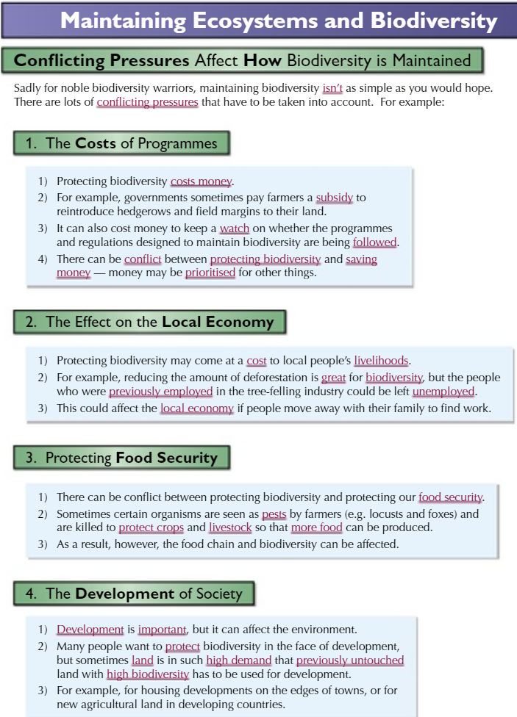
​
It is important to ensure that human developments and activities are sustainable in order to ensure that sufficient resources are available for future generations. Many human activities reduce biodiversity (deforestation, peat extraction, pollution) and only recently have measures been taken to try to stop this reduction.

What can we do to help maintain biodiversity?

- Have breeding programmes for endangered species
- Protect and regenerate rare habitats
- Reintroduce hedgerows in agricultural areas where farmers grow only one type of crop to increase biodiversity by increasing niche number
- Reduce deforestation and carbon dioxide emissions by governments
- Reduce, reuse and recycle resources rather than dumping waste in landfill

What is conservation?
Conservation is the protection and management of species and habitats in order to maintain biodiversity. There is often a conflict between human needs and conservation – careful management is needed to find a balance to maintain the sustainability of natural resources. Sustainable means that enough resources are taken to meet current needs of humans without reducing the ability to meet human needs in the future.
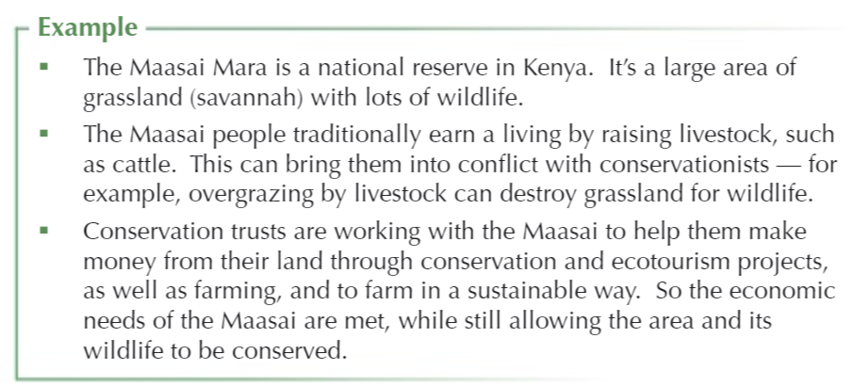
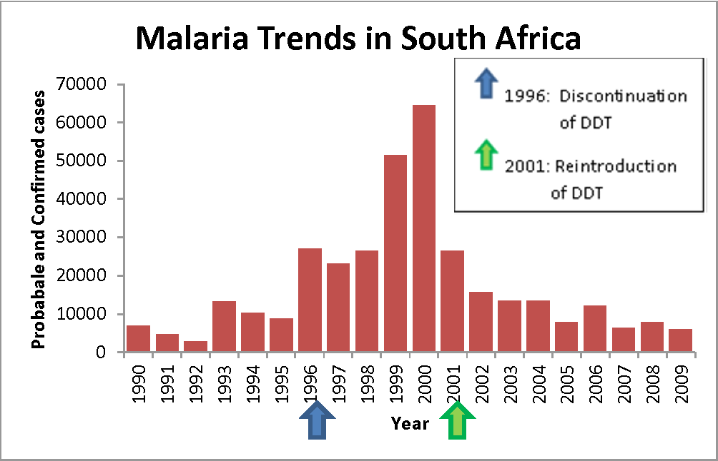
Example 2: Managing human needs does not just mean business for profit. In the 1960s and 70s a fantastic new pesticide was rediscovered that eliminated pests on crops and made crop production more efficient reducing the price of food around the world. This pesticide was called Dichlorodiphenyltrichloroethane or DDT. However, DDT accumulated in wildlife, moving up the food-chain and caused widespread damage to many large predators. It can also cause some harm to humans.
The use of this pesticide is complicated by the fact that it is extremely effective against Anopheles species of mosquito which carry the malarial parasite. Malaria has a global health burden of 228 million infections and around 400,000 deaths a year, mostly in sub-Saharan Africa, and mostly in under 5s.
There is a balance between the use of DDT and the conservation of the environment in this case.
Conservation Methods (you NEED to know about succession here but you could be given data on the others to interpret)
Conservation is dynamic process and methods need to adapt to changes caused naturally or humans that occur within ecosystems.
1 - Management of Succession
Conservation of habitats frequently involves the management of succession. If an area is left undisturbed, successional change will, in theory, eventually lead to the establishment of a stable climax community. Particular species and habitats present at earlier stage of succession will no longer be present. Maintaining a particular habitat may involve deliberate interference to prevent the ecosystem developing further. This could include animals grazing on moorland to prevent large shrubs or trees growing and keeping vegetation low or setting managed fires to allow secondary succession to occur so that pioneer plant species are being conserved as they will grow back first tree species will not have time to grow back before the next burning.
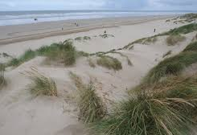 | 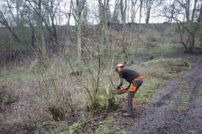
CASE STUDY: MORFA HARLECH SAND DUNES | CASE STUDY: WHITLEY COPSE
The sand dune system at Morfa Harlech in North Wales is of international importance supporting a range of plant communities from the naturally sparse vegetation of the strandline and the shifting dunes, to species rich mature dunes slacks and fixed dune grasslands. Maintaining this mosaic of habitats involves managing the process of succession to stop scrub encroachment in certain areas and thus maintain all successional phases.  Where natural processes such as mobility, erosion, wind scour and flooding are highly significant, scrub invasion is not an issue. Where slacks are more mature scrub can become a problem however and both cutting, and grazing by cattle or sheep, is used to maintain a plagioclimax. | Witley copse was an example of a neglected woodland. When left untouched, woodlands follow a similar pattern; a dense canopy of taller trees will develop, shading out any under growth and other plants which may grow on the woodland floor.  Coppicing woodland prevents over-shading from the canopy, great for ground layer plants such as bluebells, wood anemone, germander speedwell, marsh marigold and violets. After a few years, brambles and climbing plants such as honeysuckle take over, which are a great source of food and shelter for many birds and mammals. Coppicing mimics a natural process where large mature trees fall due to old age or wind blow, allowing light to reach the woodland floor and the opportunity for other species to thrive. Dormice in particular depend on the diverse type of woodland created by coppicing which results in a dense understory, providing bountiful food, shelter and a structure for them to travel through the woodlands by. As they are almost exclusively ‘arboreal’ (living in trees) travellers, they avoid setting foot on the ground at all costs.
2 – Seed banks
A seed bank is a store of seeds from lots of different plant species, they act as a back up for conservation of plant species in the wild so that plants can be reintroduced if they go extinct.
Seed banks are good because they can conserve a large number of species in a small space. However, seeds will not always be viable (will not be able to germinate) after long periods of time in storage so they have to be regularly tested.
Seed banks also store crop seeds to allow us to reintroduce genetic variation and varieties if inbreeding causes an issue for example: if a disease wipes out a particular genotype of crop – other varieties can be grown and crossbred to increase allele number and potentially help develop resistance.

3 – Captive Breeding Programmes
Captive breeding programmes involve breeding animals in controlled environments like zoos. This is mostly done for species that are endangered or extinct in the wild, the idea is that numbers can be increased and so the species will not be entirely extinct.
Problems – animals aren’t always as likely to breed in captivity as well as in the wild (e.g pandas) and reintroducing animals to the wild is difficult and not always ethical as they may not be able to look after themselves if they have spent time in captivity and may not be wary enough of humans to avoid poachers or local villages/towns where they may be killed. Reintroductions can also have effects on other species.
4 – Fishing quotas
Fishing quotas restrict the amount of a certain fish species that is allowed to be caught. It is often unpopular with fishermen as it affects their income as well as there being lots of demand for fish for food in many countries. Some ships fish over their quota then throw back the extra which are dead so they do not get fined. In order to make fishing truly sustainable international cooperation is needed for quotas to be effective where ships from different countries fish in the same area.
5 - Protected Areas
The IUCN (International Union for the Conservation of Nature) define a protected area as "a clearly defined geographical space, recognized, dedicated and managed, through legal or other effective means, to achieve the long-term conservation of nature with associated ecosystem services and cultural values”. In other words, protected areas are defined areas in which the natural environment is protected by people and/or the law so that people can benefit from it without destroying it through building, industry (e.g fracking) and farming.
Many parts of the UK have designated status – legal protection to conserve important habitats and species.
SITES OF SPECIAL SCIENTIFIC INTEREST (SSSI) | NATIONAL NATURE RESERVES (NNR) | MARINE CONSERVATION ZONES (MCZS)
SSSIs are the basic unit of UK protected area legislation and protect the best examples of flora, fauna, or geological or physiographical features. They primarily identify areas worthy of preservation but also give certain protection against damaging operations. There are over 6000 SSSIs in the UK. | NNRs protect areas of national significance for biological or earth science interest. They are managed to conserve their habitats and species but also to provide opportunities for research and education. There are nearly 400 nature reserves across the UK. | MCZs protect nationally important marine wildlife, habitats, geology and geomorphology and can be designated anywhere in English and Welsh inshore and UK offshore waters. In Scotland, Marine Protected Areas serve the same purpose.
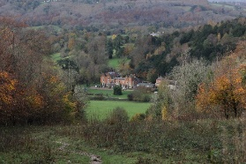Box Hill SSSI, Surrey | 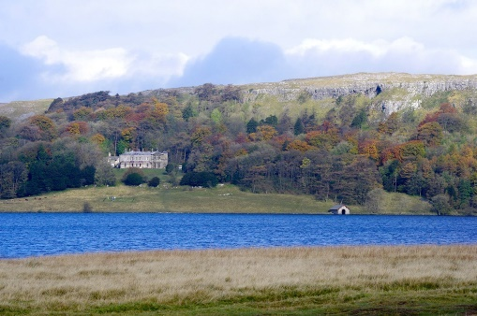Malham Tarn NNR | 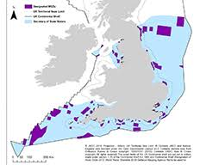
Recall Questions
- What is conservation?
- Give one reason why people don’t always agree with conservation measures
- How can reintroduction of hedgerows help conserve species?
- Why may you not want succession to take place?
- How can fire be used to prevent succession?
- How can mowing or grazing of animals be used to prevent succession
- Give an example of managing conservation other than managing succession
Exam Questions
Q1. A hedgerow is a line of shrubs and trees bordering a field, together with the herbaceous plants at their base. In the last 50 years farmers have removed many hedgerows.
(a) Explain two advantages for a farmer of removing hedgerows.
1. _________________________________________________________________
___________________________________________________________________
2. _________________________________________________________________
___________________________________________________________________
(2)
(b) In recent years some hedgerows have been replanted. Ground beetles, which are unable to fly, are predators of crop pests. The beetles overwinter in the shelter of grasses at the base of the hedgerow. In some large fields, a permanent strip of grass is left as shown in the diagram.
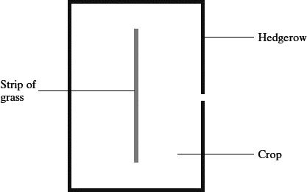
Suggest and explain the advantage of leaving the strip of grass in the middle of the field.
___________________________________________________________________
___________________________________________________________________
___________________________________________________________________
___________________________________________________________________ (2)
(c) Apart from providing a habitat for predators of crop pests, give two biological benefits of replanting hedgerows.
1. _________________________________________________________________
___________________________________________________________________
2. _________________________________________________________________
___________________________________________________________________
(2)
Q2. The National Vegetable Research Station stores a collection of seeds from many species and varieties of vegetables. These include old and rare varieties.
(a) Why is it important to keep seeds from old and rare varieties of vegetables?
___________________________________________________________________
___________________________________________________________________
___________________________________________________________________
___________________________________________________________________
(2)
(b) Every few years, seeds of each variety in the collection are germinated and grown into mature plants. New seeds obtained from these plants are added to the collection.
(i) Suggest why it is necessary to obtain new seeds every few years.
______________________________________________________________
______________________________________________________________
(1)
(ii) Within each variety, the scientists cross plants with different genotypes. Explain the advantage of this.
______________________________________________________________
______________________________________________________________
______________________________________________________________
______________________________________________________________
(2)

Q3. Ecologists investigated succession in some abandoned crop fields. The data that they collected are shown in the graph. The curves show the trends that occurred over a period of 60 years.
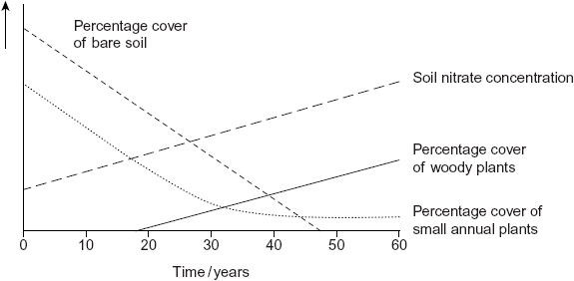
(a) The pioneer plants had different characteristics from the plants that colonised the fields after 50 years.
(i) The pioneer plants had seeds that germinate better when the temperature fluctuates.
Explain the advantage of this to these pioneer plants.
______________________________________________________________
______________________________________________________________
______________________________________________________________
______________________________________________________________
______________________________________________________________
(2)
(ii) Explain the advantage to a plant that colonises after 50 years of having a high rate of photosynthesis at low light intensities.
______________________________________________________________
______________________________________________________________
(1)
(b) Conservation of grassland habitats involves management of succession. Use the data in the graph to explain why.
___________________________________________________________________
___________________________________________________________________
___________________________________________________________________
___________________________________________________________________
(2)

Recall Question Answers
1. Conservation is the protection and management of species and habitats in order to maintain biodiversity.
2. Because there is often a conflict between human needs e.g income or food/resources and conservation
3. Increases biodiversity by increasing sources of food and habitat for animals. Allows animals to migrate
4. Sometimes succession needs to be prevented in order to preserve an ecosystem at a certain point, e.g. stopping moorland from progressing into a forest.
5. A managed fire is lit. After the fire, secondary succession occurs and pioneer plant species that are being conserved will grow back first and tree species will not have time to grow back before the next burning.
6. Grazing or regular mowing prevents large shrubs or trees growing and keeps vegetation low.
7. Seed banks, captive breeding, fishing quotas, protected areas.

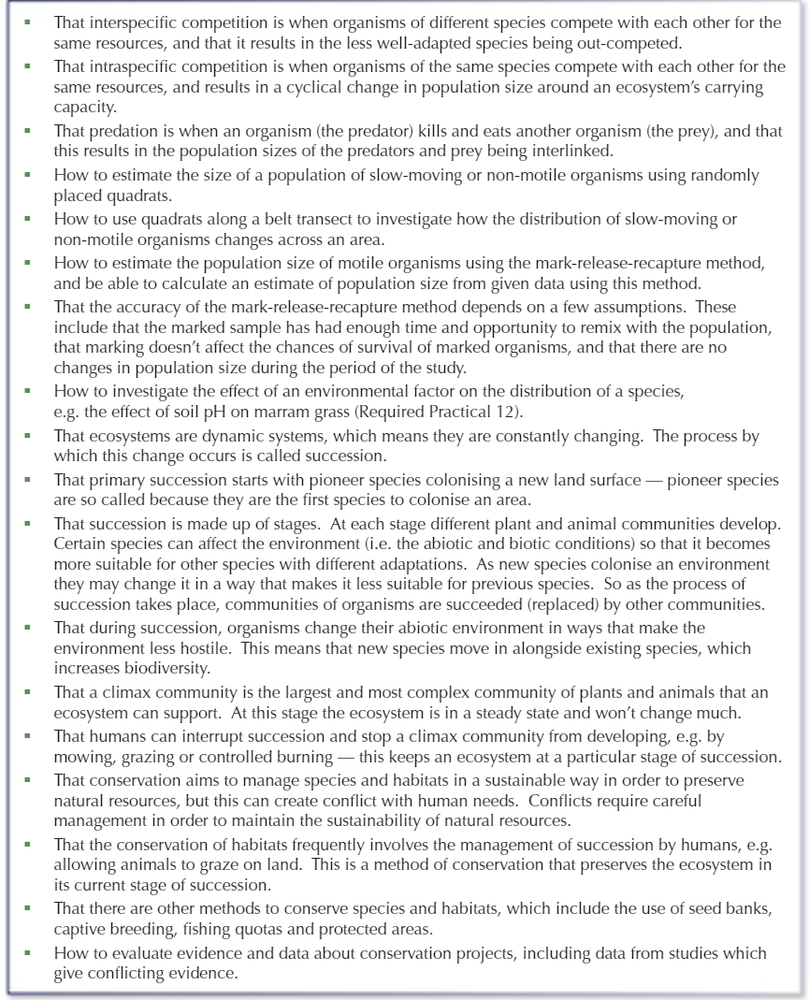
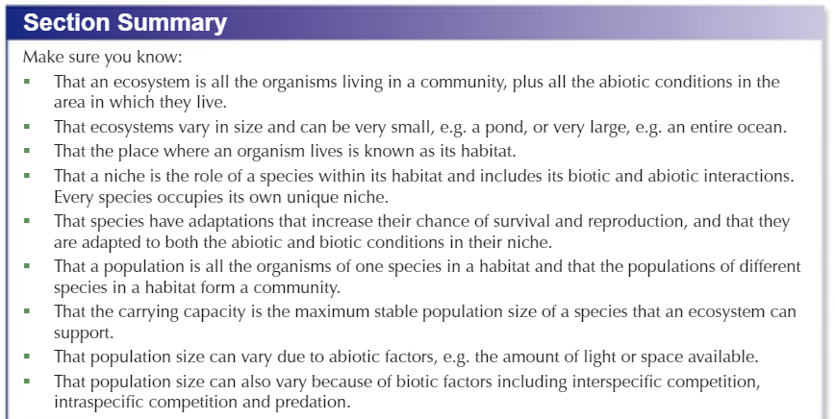

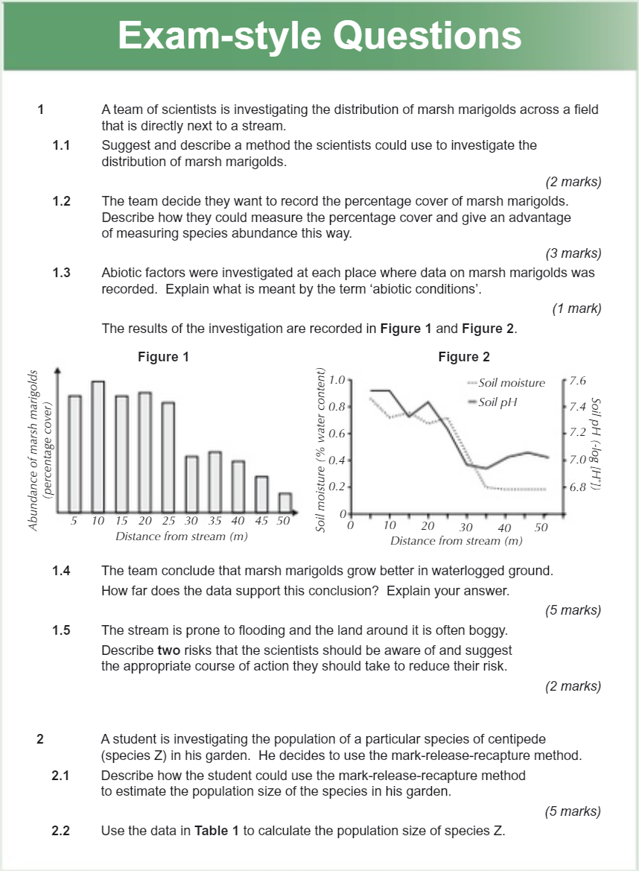

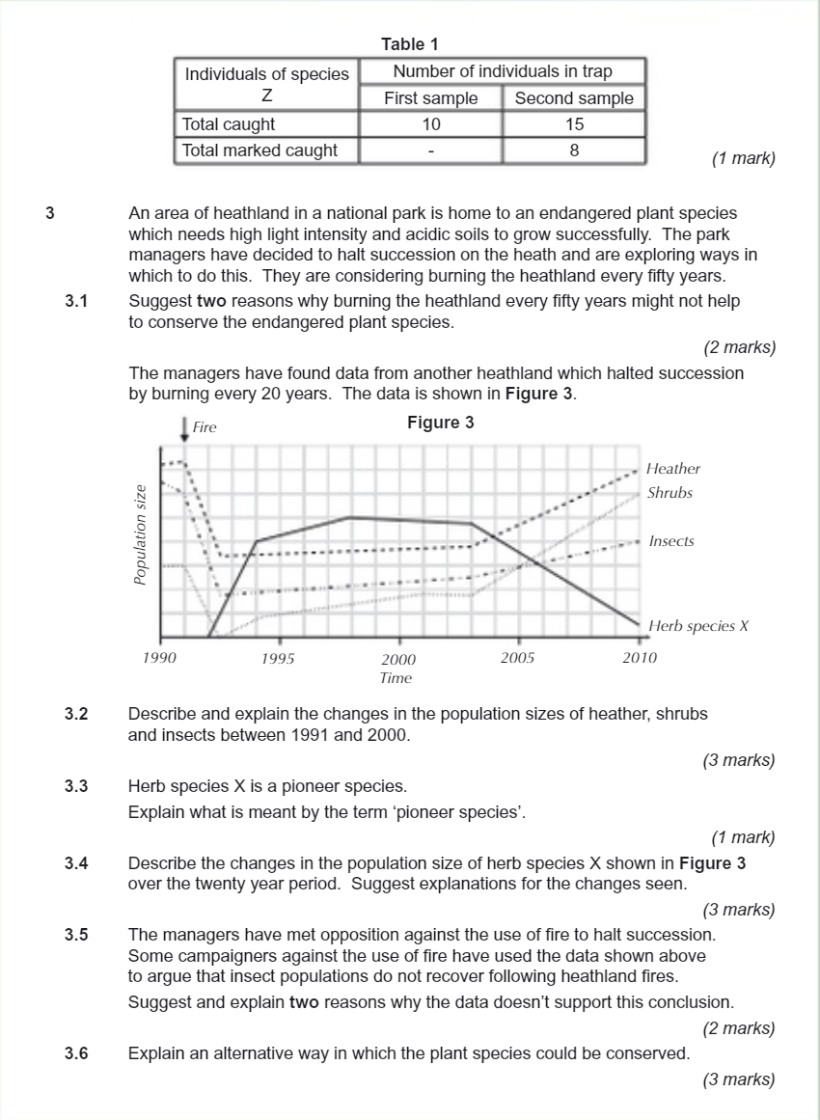
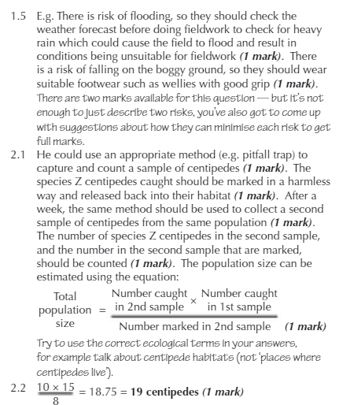
Answers:
