AQA Biology GCSE
Genetics II: Evolution
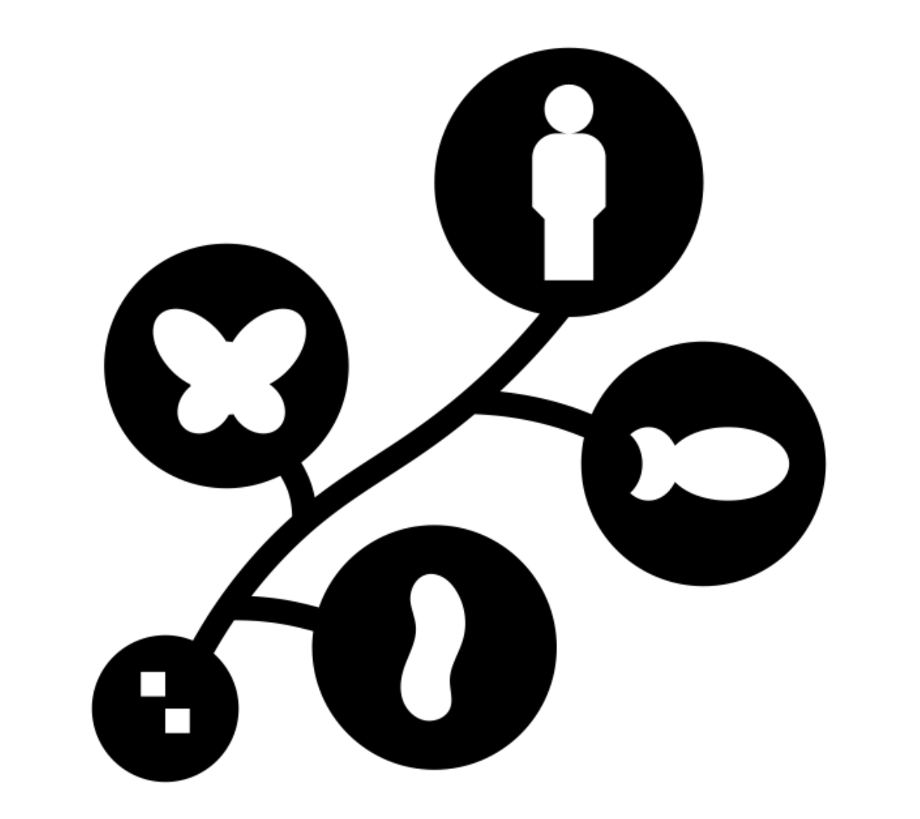

Name: ______________________

Week | Homework Task | SCAN CODE | Due
1 | Task 1: Watch the ‘Selective Breeding’ video, complete the quick quiz on Kay Science.com.  Task 2: Watch the video to revise then complete the worksheet on Diffusion, Osmosis & Active Transport and submit pictures of answers on MS Teams. | 
2 | Task 1: Watch the ‘Natural Selection’ video, complete the quick quiz on Kay Science.com.  Task 2: Watch the video to revise then complete the worksheet on Structure of the heart and submit pictures of answers on MS Teams. | 
3 | Task 1: Watch the ‘Genetic Engineering’ video, complete the quick quiz on Kay Science.com.  Task 2: Watch the video to revise then complete the worksheet on Respiration and Oxygen Debt and submit pictures of answers on MS Teams. | 
4 | Task 1: Complete any exam questions not finished in your booklet.  Task 2: Watch the video to revise then complete the worksheet on Photosynthesis & Leaf Structure and submit pictures of answers on MS Teams. | 

Key word list
Adaptation – A characteristic which allows an animal or plant species to survive better in its environment
Evolution - The change of inherited characteristics within a population over time through natural selection, which may result in the formation of a new species.
Gene - The basic unit of genetic material inherited from our parents. A gene is a section of DNA which controls part of a cell's chemistry - particularly protein production.
Genetic - To do with inheritance because of genes.
Genetic engineering - Process which involves the artificial transfer of genetic information from one donor cell or organism to another.
Genetically modified - Describes a cell or organism that has had its genetic code altered by adding a gene from another organism.
Insulin - A hormone that regulates the level of sugar in the blood and can be produced by genetically modified bacteria.
Mutation - A random and spontaneous change in the structure of a gene, chromosome or number of chromosomes.
Natural selection - Individuals with characteristics most suited to the environment, survive and pass on their genes to their offspring
Organism - Living entity, eg animals, plants or microorganisms.
Phenotype - The visible characteristics of an organism which occur as a result of its genes.
Plasmid - The small circular genetic material present in bacterial cells and used in DNA recombinant technology.
Population - A group of the same species in an area that can interbreed.
Selective breeding - An artificial process in which organisms with desired characteristics are chosen as parents for the next generation.
Species - A type of organism that is the basic unit of classification. Individuals are able to breed to produce fertile offspring.
Toxin - A type of natural poison produced by an organism, often as a form of protection.
Transgenic organism – an organism that has had a gene from a different organism inserted into its genome.
Variation - Differences in characteristics of individuals in a population
Vector - The way in which genetic material is transferred from a donor to a recipient e.g. plasmids and artificial chromosomes.
Yield - The mass of a crop produced.

Paper 2 - Genetics II Fact Sheet
Fold page here
To revise these facts, fold this sheet in half and try to write the answers down from memory. Repeat!
- What is variation within a population. | Differences in the characteristics of individuals in a population.
- Genes determine the phenotype of an organism – true or false? | False – the environment also plays a role.
- State three causes of variation in a population. | Variation may be due to differences in the genes inherited (genetic causes), the conditions in which organisms develop (environmental causes), or a combination of both genes and the environment.
- Within a population, there is normally very little genetic variation – true or false? | False – just look around you at humans!
- What causes variation within a population? | Mutations
- Define mutation | A mutation is a random and spontaneous change in the DNA that makes up a gene
- What effect will most genetic mutations have? | No effect
- List some variation due to genetic causes. | - Blood group  - Skin colour  - Natural eye colour  - Nose shape  - Biological sex  - Dimples.  - Lobed or lobe-less ear
- List some variation due to environmental causes. | - Scars  - Language and accent  - Flower colour in hydrageas as these plants produce blue flowers in acidic soil and pink flowers in alkaline soil.
- List some variation due to both environmental and genetic causes. | - Height – tall
- What is selective breeding? | Selective breeding (artificial selection) is the process by which humans breed plants and animals for particular genetic characteristics.
- Describe the process of selective breeding. | Selective breeding takes place over many generations. These are the main steps for both plants and animals:  - Select/decide which desired characteristics are important enough to select.  - Choose parent that show e characteristics from a mixed population. They are bred together.  - Choose the best offspring with the desired characteristics to produce the next generation.  - Repeat the process continuously over many generations, until all the offspring show the desired characteristics.
- What characteristics are animals selectively breed for? | - Animals which produce more meat or milk.  - Chickens that lay large eggs.  - Domestic dogs with a gentle nature.
- What characteristics are plants and crops selectively bred for? | - Disease resistance in food crops  - Wheat plants that produce lots of grain  - Large or unusual flowers
- What are the risks associated with selective breeding? | Selective breeding can lead to ‘inbreeding’ where some breeds are particularly prone to disease or inherited defects.
- What are the benefits of selective breeding? | Benefits of selective breeding include:  - New varieties may be economically important, by producing more or better-quality food.  Fold page here  - Animals can be selected that cannot cause harm, for example cattle without horns.
- State a drawback of selective breeding? | Inbreeding – some breeds are prone to disease or inherited defects (e.g. some pugs have breathing problems).
- What does the theory of evolution state? | Th theory of evolution states that all species of living things have evolved from simple life form that first developed more than three billion years ago.
- What is evolution? | A change in the inherited characteristics of a population over time through a process of natural selection which may result in the formation of a new species.
- How does evolution occur? | Through the process of natural selection
- Define 'natural selection'. | Organisms that have characteristics best suited to their environment, survive and reproduce, passing on their genes
- Would the best organism within a species to survive and reproduce be:  a) the strongest?  b) the one which reproduces the fastest?  c) the best adapted to the environment? | c)
- Define 'species'. | Organisms that can interbreed to produce fertile offspring.
- Name the person who first discovered inherited characteristics are determined by 'units' passed on unchanged. | Gregor Mendel
- Why were Mendel's ideas of inheritance not accepted during his time? | As chromosomes were not discovered/seen yet
- Name the person who proposed the theory of evolution. | Charles Darwin
- Name the person who suggested changes that occur in an organism during its lifetime can be inherited. | (Jean-Baptiste) Lamarck
- State three reasons why Darwin’s ideas were only slowly accepted. | 1. Conflict with the wild belief that God made all living things; 2. Insufficient evidence; 3. No mechanism to explain variation and inheritance
- Who worked with Darwin to develop the theory of evolution? | Alfred Russel Wallace
- Apart from evolution, what are two other studies Wallace worked on? | Warning colouration in animals + Theory of speciation
- What is speciation? | The process by which two species evolve from a single original species by natural selection
- What is antibiotic resistance? | Bacteria becoming resistant means it cannot be killed by a certain antibiotic
- What causes antibiotic resistance? | Random mutations in bacteria/Bacteria sharing resistant genes
- Describe the steps in which a bacteria strain develops resistance to an antibiotic. | 1. Mutation occurs in an individual bacterium within a population; 2. It survives and reproduces rapidly, making more bacteria with its resistant gene; 3. Overtime, all bacteria within the population have that gene
- Why can bacteria evolve quicker than other organisms? | Because bacteria can reproduce at a quick rate
- Suggest 3 methods to prevent and slow down the development of antibiotic-resistant strains. | 1. Do not overuse antibiotics; 2. Patients finish antibiotic course every time; 3. Restrict agricultural use of antibiotics  Fold page here
- Why must patients finish their course of antibiotics every time? | To ensure all bacteria are killed by the antibiotic, so none can survive to mutate and develop resistantce
- Suggest 3 ways in which a hospital can reduce the spread of antibiotic-resistant strains. | Only use antibiotics if really needed; Use strain-specific antibiotics; Maintain high hygiene standards (eg. wash hands between patient visits); Isolate patients infected with resistant strain; Visitors wash hands as they enter and leave
- Why is it difficult to develop new antibiotics to combat the appearance of new antibiotic-resistant strains of bacteria? | The development of new antibiotics is expensive and slow (won't be able to keep up)
- Define the process of genetic engineering. | Genetic engineering is the process which involves modifying the genome of an organism by introducing a gene from another organism to give a desired characteristic.
- Define genetically modified (GM) crops. | Crops that have their genes modified are called genetically modified (GM) crops. GM crops include ones that are resistant to insect or to herbicides. GM crops generally show increased yield.
- State three traits plants might be genetically engineered to have. | 1. Resistant to insect attack  2. Resistant to herbicides  3. Increased yields
- Give one example of the use of genetically engineered bacterial cells. | To produce useful substances such as human insulin to treat diabetes.
- Describe the main steps in the process of genetic engineering. (HT) | In genetic engineering:  - Enzymes are used to isolate the required gene; this gene is inserted into a vector, usually a bacterial plasmid or a virus.  - The vector is used to insert the gene into the required cells.  - Genes are transferred to the cells of animals, plants or microorganisms at an early stage in their development so that they develop with desired characteristics.
- How is a gene ‘cut out’ from the genome of one species and inserted into the genome of another? | Using enzymes
- Into what is the gene inserted? | A vector
- Give two examples of vectors used in genetic engineering. | A bacterial plasmid and a virus.
- What are the benefits of genetic engineering? | The benefits of genetic engineering include;  - Improved growth rates  - Increased yield  - Increased food quality  - Produce human proteins
- State three concerns around genetically engineering plants. | - Unknown effects on populations of wild flowers  - Unknown effects on populations of insects  - Some people feel the effects of eating GM crops on human health have not been fully explored
- What are fossils?  Fold page here | Remains of organisms from millions of years ago that are found preserved (in rocks, ice etc.)
- What are criterias for decay to occur? | Oxygen, bacteria (decomposers), correct temperature
- Describe the five steps of fossilisation by mineralisation. | 1. Organism dies and falls to the ground;  2. Flesh decays, leaving the skeleton behind;  3. Bones are covered in sand/soil;  4. Bones become mineralised and turns into rock (fossil);  5. Rock with fossil emerges due to geological movement (eg. earthquake) and erosion occurs to reveal fossil
- What are the three different types of fossils that can be formed? | Mineralised skeleton; Undecayed due to trapped in ice or amber; Preserved traces of organisms (eg. footprints, leaves)
- Give 4 reasons why the fossil record is incomplete. | 1. Many earliest life forms are soft-bodied;  2. Most organisms did not become fossilised;  3. Most early fossils were destroyed by geological activity;  4. Many fossils are not yet found
- How is the fossil record helpful? | It shows how much organisms have changed and developed over time, and can show the environment and climate then
- Define 'extinction'. | Permanent loss of all members of a species
- State three causes of extinction. | New predators; New diseases/pathogens; New/sucessful competitors
- What causes mass extinction? Suggest two examples of this cause. | Single catastrophic event that also affects climate over a long period (eg. asteroid collision, volcanic eruption)
- Suggest a chain of events initated by an asteroid collision that could lead to the extinction of dinosaurs. | Asteroid impact causes huge fires and earthquakes --> volcanic eruptions --> dust/ash cloud covers atmosphere --> less sunlight reaches the Earth surface --> temp drop massively + plants die --> loss of food source led to other animals' extinction
- What does classification of organisms mean? | Organisation of living things into groups based on their similarities
- Name the person who developed the classification system. | Carl Linnaeus
- State the 7 heirarchical levels of the Linnaean classification system. | Kingdom, phylum, class, order, family, genus, species
- Every organism has a scientific name using a binomial system. What does binomial mean? | Two names
- Which language does the binomial naming system use? | Latin
- The binomial name of an organism is made up of two words. What does each word represent of that organism? | The first word is the genus; second word is the species
- What are the three rules of writing a binomial scientific name of a species? | First letter of the genus should be in capital; First letter of the species should be in small letter; Both need to be in italics when printed or underlined when hand-written
- Why do we use the binomial naming system? | Every organisms' names would vary in different languages, but Latin is considered to be the old common language in which everyone can use/understand
- How many domains and kingdoms do scientists now consider in classification? | 3 domains; 6 kingdoms
- Based on what knowledge were the three domains set? | Different biochemistry of cell and ribosomes, and how cells reproduce differently
- What are the three domains? | Archaea, bacteria, eukaryota
- What are the six kingdoms? | Archaebacteria, eubacteria, protista, fungi, plants, animals
- How is classification helpful? | Helps us to understand evolutionary and ecological relationships
- Name the type of models that are used to show how different organisms are related. | Evolutionary trees
- How are evolutionary trees made? | By looking at similarities and differences between different groups of organisms
- What aspects of knowledge would be considered when suggesting evolutionary relationships? | Similarities and differences in physical structures, genetics and biochemistry

Once we have finished this topic use this table to decide which topics you need to revise!

Lesson | Exam Question Marks |  |  | 
Lesson 1 – Variation and Mutation

Lesson 2 – Selective Breeding

Lesson 3 – Evolution

Lesson 4 – Genetic Engineering

Lesson 5 – Fossils and Extinction

Lesson 6 – Evidence for Evolution

Lesson 7 – Classification

Lesson 8 – Evolutionary Trees


Lesson 1 – Variation and Mutation
Do Now: Instruction: Answer the following questions in your exercise book
- What is an organisms phenotype?
- What is an organisms genotype?
- What things can influence an organisms phenotype?
Video: Instruction: Scan the code above with your phone to watch the video on this topic
Notes: Instruction: Read the notes below.
Part 1 - Describe the genetic variation in a population
Every living organism has differences in their characteristics (phenotype), the differences between individuals are called variation. Variation can be caused by two key factors: differences in the genes inherited (genetic causes) or the environmental conditions in which organisms develop. Some variation is caused by a combination of both genes and the environment.
Characteristics caused by genes only: Blood group, Skin colour, Natural eye colour, Nose shape, Ear lobe shape.
Characteristic caused by environment only (rare): Scars, Language and accent.
Example of a characteristic caused by both: the maximum height a plant can grow is determined by its genes. But whether it actually grows that tall depends on its environment such as the amount of sunlight, water, or nutrients the plant has as it grows. This is the same for animals if they don’t receive the right nutrition when young.
Part 2 - Define genetic mutation and its effects on a population
A mutation is a random change to the structure of DNA that makes up a gene. They are natural, random and happen continuously (all the time). Changing the gene can cause a change to the protein that gene codes for.
Most mutations have very little or no effect on the phenotype of organisms. In rare circumstances, mutations can be harmful or result in a change to the phenotype of a species.
The number or chance of mutations can be increased by being exposed to mutagens such as toxic chemicals or ionising radiation e.g X rays or UV rays. These can cause mutations that can lead to cancer.
Recall Questions
Instruction: Answer these questions in your exercise book. Use the notes above to help you (like a comprehension)
- What is variation within a population.
- State three causes of variation in a population.
- What causes variation within a population?
- What are genetic mutations?
- What effect will most genetic mutations have?
- Give some examples of variation due to genetic causes.
- Give some examples variation due to environmental causes.
- List some variation due to both environmental and genetic causes.
Worksheet
Instruction: Answer one section in your exercise book. Start with the section you feel most comfortable with.
Basic:
- What is a mutation?
- Sometimes offspring will look different from its parents, like a zebra with no stripes. What are these changes called?
- What two factors can determine a person’s characteristics?
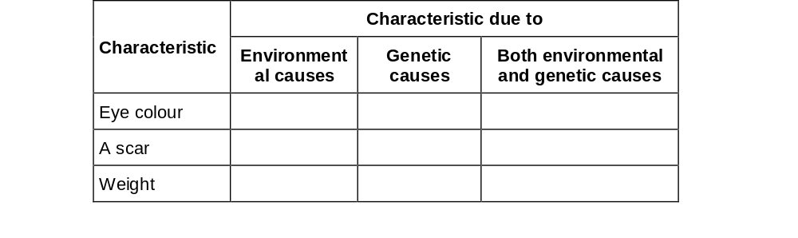
- Put a tick in the table for each characteristic:

- What is the scientific term used to describe a person’s characteristics?
- Mutations can happen spontaneously when a cell divides. What could be another cause of genetic mutation?
Medium:
- What is a mutation and what does it change?
- Potato plants grown from tubers from the same mother plant will all be genetically identical to each other, but they may not all grow to the same height. Explain why.

- Put a tick in the box which describes the most likely effect of a mutation:

- Explain why pregnant women should not normally have X-rays of the lower body.
- Penicillin is an antibiotic which stops bacteria from reproducing. In many hospitals there are now strains of penicillin resistant bacteria. Explain how variation could have produced these strains of penicillin resistant bacteria.
Hard:
- Suggest how an allele for resistance to antibiotics may have arisen in MRSA bacteria.
- Explain how a mutation can cause a phenotype to change.
- Suggest ways we can reduce the number of bacteria strains resistant to antibiotics.
- A poisonous chemical has been used to kill head lice for many years. Recently, the chemical has not been as successful at killing head lice. Many head lice now survive treatment with the chemical. Explain why some head lice are no longer killed by the chemical.
- Albino people are more likely than people with melanin to suffer mutations that cause cancer in their skin. Suggest why albino people have an increased chance of mutation in their skin cells

Exam Questions
Instruction: Answer these questions on this sheet – you can use the notes to help you but try and do them from memory first!
Q1. What is the cause of each variation in the table below?
Tick only one box in each row.

Variation | Cause of variation
Variation | Genes only | Environment only | Both genes and the environment
Brown eyes
Light brown skin colour
Short hair
(3)
Q2. Mutations often happen when cells divide.
Give one other cause of genetic mutations.
___________________________________________________________________
___________________________________________________________________ (1)
Q3. The figure below shows a carp.
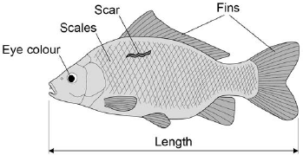
The characteristics of an animal can be a result of:
• only genetic causes
• only environmental causes
• both genetic and environmental causes.
(a) Give one characteristic shown in Figure 1 for each different cause.
Only genetic causes _________________________________________________
Only environmental causes ____________________________________________
Both genetic and environmental causes __________________________________ (3)
(b) A mutation causes a blue scale colour in some carp. What is a mutation?
___________________________________________________________________
___________________________________________________________________ (1)
(c) Suggest how a mutation could cause a different scale colour in carp.
___________________________________________________________________
___________________________________________________________________ (1)

Q4. The photographs show two varieties of moths, Xand Y. The moths belong to the same species.
The moths are resting on a tree trunk in open countryside.
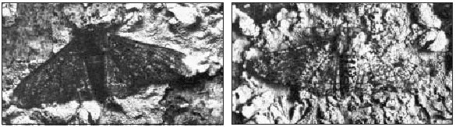
Moth X Moth Y
(i) The colour of the moths is controlled by a gene. The dark form was first produced by a mutation in the gene.
What chemical, found in a gene, is changed by a mutation? Draw a ring around your answer.
carbohydrate DNA fat protein
(1)
(ii) Some of the offspring from the original dark moth were also dark. What caused this?
______________________________________________________________
______________________________________________________________ (1)
Q5. Explain fully why pregnant women should not normally have X-rays of the lower body.
_______________________________________________________________________
_______________________________________________________________________
_______________________________________________________________________
_______________________________________________________________________ (2)

Lesson 2 – Selective Breeding
Do Now: Instruction: Answer the following questions in your exercise book
- What are the two factors that control phenotypes?
- How can someone be a carrier of a genetic disease?
- Name a recessive genetic disorder
Video: Instruction: Scan the code above with your phone to watch the video on this topic
Notes: Instruction: Read the notes below.
Part 1 - Define selective breeding
Selective breeding or artificial selection is the process of humans breeding plants and animals so they have particular genetic characteristics. Humans have been doing this for thousands of years since they first bred food crops from wild plants e.g wheat and bred domesticated animals from wild ones e.g. dogs from wolves.
Here are some examples of desired genetic characteristics, these are also seen as the advantages of selective breeding:
- Disease resistance in plants
- Large, or heavily scented flowers
- Increased food production (yield) in food crops or animals e.g eggs/milk/meat
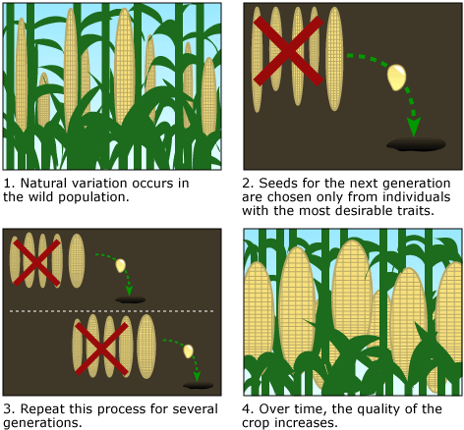
- Gentle nature of domestic animals e.g. Dogs
Part 2 - Describe how selective breeding is carried out

This is the process of selective breeding:
- Choose two individuals with the desired characteristic(s) from a mixed population.
- Allow them to breed, which produces offspring with a range of characteristics.
- Choose the few offspring with the (most) desired trait(s) and allow them to breed.
- Repeat this cross-breeding process over many generations until all the offspring show the desired characteristic.
Part 3 - Explain the impact of selective breeding of crops and domestication animals
There are advantages and disadvantages to selective breeding.
1. Selective breeding reduces genetic variation, this can make the organisms more likely to die out because they are:
- less likely to be able to cope with environmental change
- more susceptible to new diseases
2. Selective breeding causes inbreeding which makes organisms more prone to genetic/inherited diseases e.g deafness in dogs
Recall Questions: Answer these questions in your exercise book. Use the notes above to help you
- What is selective breeding?
- Describe the process of selective breeding.
- What characteristics are animals selectively breed for?
- What characteristics are plants and crops selectively bred for?
- What are the risks associated with selective breeding?
- What are the benefits of selective breeding?
- State a drawback of selective breeding?
Worksheet: Answer one section in your exercise book. Start with the section you feel most comfortable with.
Basic:
- Fill in the gaps:

Selective breeding is the process by which humans …………… plants and animals for desired ……………………….
- Number the steps of selective breeding in the correct order: 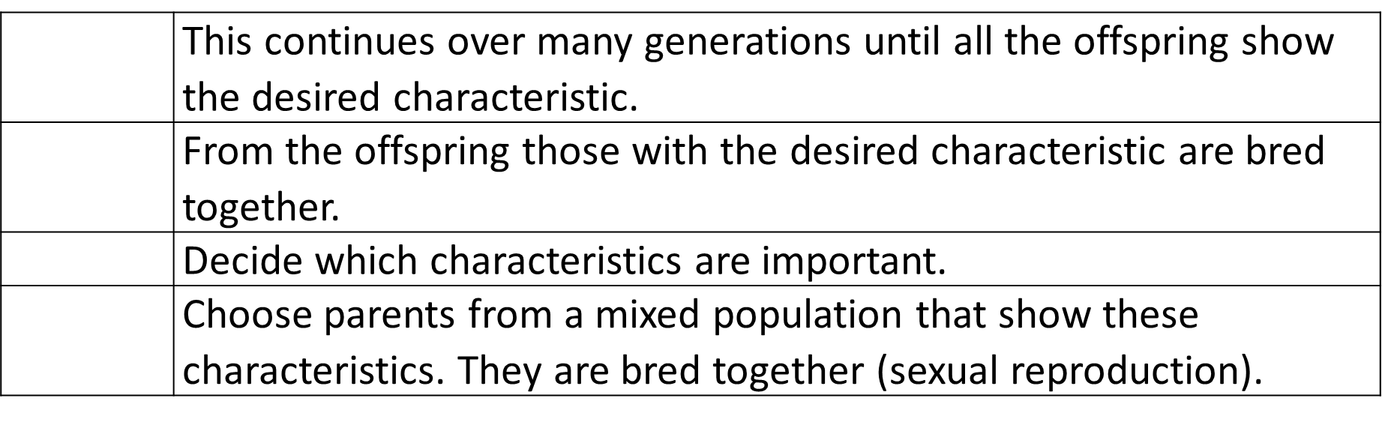
- What are the advantages of selective breeding?
- Give two desirable characteristics in crop plants
- Give a disadvantage of selective breeding.

Medium:

6. Explain how selective breeding has been used to produce docile pets.

7. Explain the reason for two desired characteristics farmers have bread into cows.

8. Describe one problem inbreeding causes

9. Many people have breathing problems because they are allergic to cats. The allergy is caused by a chemical called Fel D1. Different cats produce different amounts of Fel D1. A cat has been bred so that it does not produce Fel D1. The cat does not cause an allergic reaction. Explain how the cat has been produced using selective breeding.

Hard:

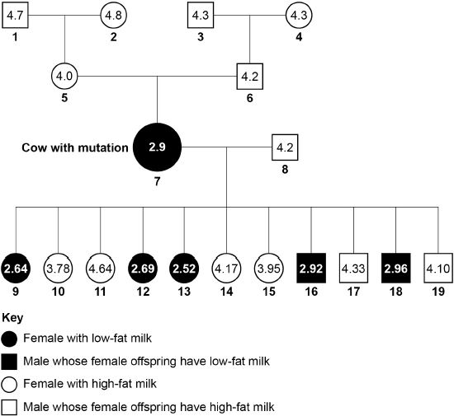
The family tree shows a family of cows and the % of fat in their milk. Cow number 7 had a mutation which caused it to produce low fat milk.

10. The low-fat allele is dominant. Cow 8 is homozygous, explain why cow 7 must be heterozygous.

11. Identify how many offspring from cows 7 and 8 would produce low fat milk. Use a Punnett square to help you.

D = dominant allele for making low-fat milk

d = recessive allele for making high-fat milk

12. The scientists want to produce a type of cattle that makes large volumes of low-fat milk. The scientists will need to use some of the cows shown in the family tree for selective breeding.
Describe how the scientists would do this.
Exam Questions: Answer these questions on this sheet – you can use the notes to help you but try from memory first!
Basic
Q1. Chickens can be bred either for meat or for laying eggs.
The diagram below gives some information about different types of chicken.
 | Chicken bred for meat | Chicken bred for laying eggs
 | 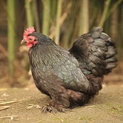 | 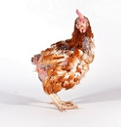
Average weight in kg | 1.8 | 0.7
Average number of eggs laid per week | 2 | 6
(e) Describe how selective breeding has been used to produce chickens bred for meat.
___________________________________________________________________
___________________________________________________________________
___________________________________________________________________
___________________________________________________________________
___________________________________________________________________ (3)
(f) Give one advantage of selective breeding to the farmer.
___________________________________________________________________
___________________________________________________________________ (1)
(g) Selective breeding can lead to disadvantages for the chickens.
What is a possible disadvantage of selective breeding for the chickens bred for meat in the diagram above?
Tick one box.

The chickens will be genetically identical | 
There will be less food to feed people
The chickens may weigh too much to be able to stand
The chickens will be kept in better conditions
Medium
Q1. Read the following.
In the 1950s farmers in India could not grow enough rice to feed the rapidly increasing population.
At the International Rice Research Institute (IRRI) scientists began a selective breeding programme with 10 000 different varieties of rice plants.
In 1966 the IRRI produced a new variety called IR8 which gave a yield of up to ten times the traditional varieties. IR8 has short stems and large rice grains.
IR8 was grown by farmers all over India so people had enough to eat.
(a) The IR8 variety of rice was produced by selective breeding.
Describe the steps the scientists would have taken to produce IR8
___________________________________________________________________
___________________________________________________________________
___________________________________________________________________
___________________________________________________________________
___________________________________________________________________
___________________________________________________________________
___________________________________________________________________
___________________________________________________________________
___________________________________________________________________
___________________________________________________________________ (4)
Q2. Farmers use selective breeding to control the characteristics in cows.
(a) Farmers selectively breed cows for many different reasons.
Suggest two characteristics that cows may be bred for.
Do not suggest coat colour.
1. _________________________________________________________________
___________________________________________________________________
2. _________________________________________________________________
___________________________________________________________________ (2)
(b) Selective breeding can lead to problems.
Suggest how problems caused by selective breeding in cows can have negative financial effects for the farmer.
___________________________________________________________________
___________________________________________________________________
___________________________________________________________________ (2)
Hard
Q1. Many different types of animals are produced using selective breeding.
Some cats are selectively bred so that they do not cause allergies in people.
(a) Selective breeding could cause problems of inbreeding in cats.
Describe one problem inbreeding causes.
___________________________________________________________________ (1)
(b) Many people have breathing problems because they are allergic to cats.
The allergy is caused by a chemical called Fel D1.
Different cats produce different amounts of Fel D1.
A cat has been bred so that it does not produce Fel D1.
The cat does not cause an allergic reaction. Explain how the cat has been produced using selective breeding.
___________________________________________________________________
___________________________________________________________________
___________________________________________________________________
___________________________________________________________________
___________________________________________________________________
___________________________________________________________________
___________________________________________________________________ (4)


Lesson 3 – Evolution
Do Now: Instruction: Answer the following questions in your exercise book
- What are differences between individuals called?

- What is a mutation?
- What effect do most mutations have on phenotypes?
Video: Instruction: Scan the codes above with your phone to watch the videos on this topic
Notes: Instruction: Read the notes below.
Part 1 - Describe the theory of evolution
Evolution is a change in the inherited characteristics of a population overtime. These changes happen through the process of natural selection. Natural selection is the process where organisms that are best adapted to their environment survive, reproduce and pass on those characteristics. Charles Darwin was the first to explain that evolution happens by natural selection. The theory of evolution by natural selection says that all species of living things have evolved from simple life forms that first developed more than three billion years ago.
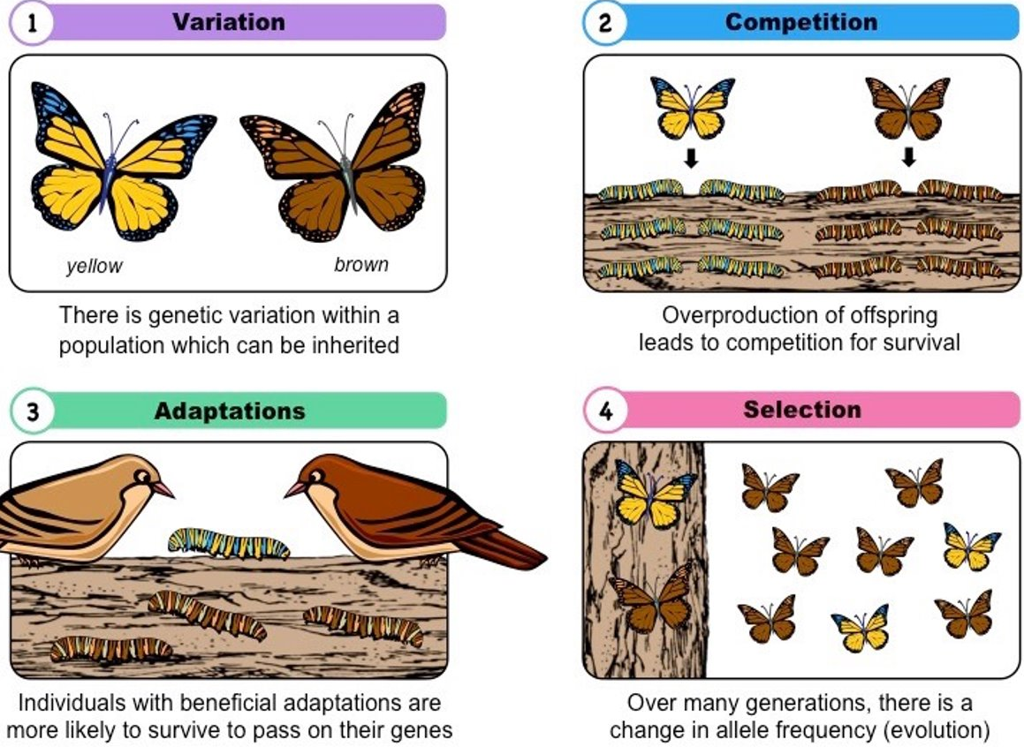
Part 2 - Explain how evolution occurs through natural selection of variants that give rise to new phenotypes

Natural selection is the process where nature selects what characteristics (controlled by genes) are best for organisms to survive in that particular environment, because they reproduce and pass on those genes. In simple terms, this is the survival of the fittest, where “fittest” refers to those best adapted to their environment, but not necessarily the strongest. Evolution occurs after natural selection has changed organisms slowly over many generations. This is the process:
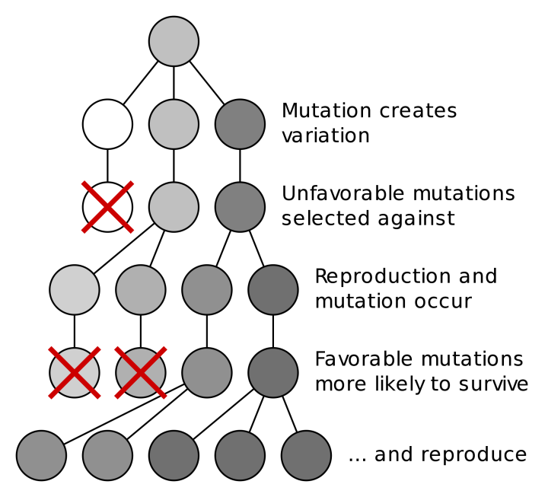
    - Variation is present in a population due to random mutation.
    - Some organisms may have phenotypes that make them adapted to their environment. This gives them a survival advantage due to their advantageous alleles.
    - Natural selection occurs: They are more likely to survive and reproduce, passing the favourable alleles on to their offspring. (Those without the favourable alleles are more likely to die before they could reproduce.)
    - Overtime, more individuals within the population have those favourable alleles.
    - If two populations become isolated from each other before natural selection occurs they may eventually evolve into a new species (speciation), where they can no longer interbreed to form fertile offspring.
Part 3 - Explain bacterial resistance to antibiotics as an example of natural selection
Just like amongst humans, there is variation amongst bacteria within a colony. Mutations in bacteria produce new strains. Some strains might be resistant to antibiotics. Bacteria becoming resistant to certain antibiotics is an example of evolution. It happens much faster than in animals because mutations occur much quicker in bacteria as they reproduce faster (binary fission).
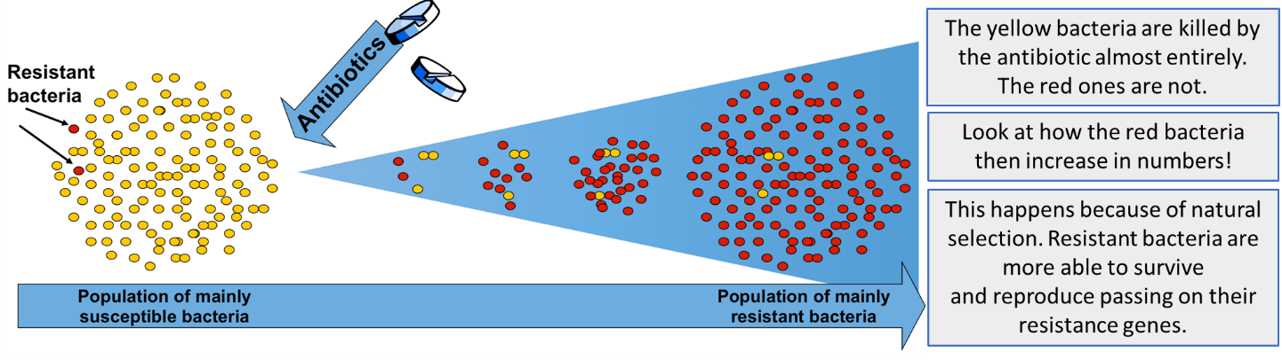
When bacteria are treated with an antibiotic, some cells contain a mutation which allows them to survive and reproduce. This causes the number of resistant bacteria to increase.

MRSA (methicillin-resistant staphylococcus aureus) is a bacteria known as a superbug. It is very dangerous because it is resistant to most antibiotics. Resistant bacteria are a large problem because it is a slow and expensive process to develop new antibiotics to fight them. Therefore, it is important that we know how to prevent more bacteria from developing antibiotic resistance and to prevent their spread:
- It is important to avoid over-use of antibiotics - doctors should not prescribe antibiotics inappropriately, such as treating non-serious or viral infections
- patients should complete their full course of antibiotics so all bacteria are killed and none survive to mutate and form resistant strains
- the agricultural use of antibiotics should be restricted as some bacteria may affect both animals and humans

Recall Questions
Instruction: Answer these questions in your exercise book. Use the notes above to help you (like a comprehension)
- What is evolution?
- How does evolution occur?
- Define 'natural selection'
- Would the best organism within a species to survive and reproduce be:
  - the strongest?
  - the one which reproduces the fastest?
  - the best adapted to the environment?
- Define 'species'.
- Name the person who proposed the theory of evolution.
- What is antibiotic resistance?
- Describe the steps in which a bacteria strain develops resistance to an antibiotic.
- Why can bacteria evolve quicker than other organisms?
- Suggest 3 methods to prevent and slow down the development of antibiotic-resistant strains.
- Why must patients finish their course of antibiotics every time?
Exam Questions: Answer these questions on this sheet – you can use the notes to help you but try from memory first!
Q1. Animals have adaptations that enable them to survive.
(a) The photograph shows an echidna.
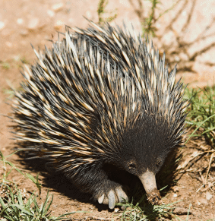
The echidna has pointed spines on its back.
Explain how these spines might help the echidna to survive.
___________________________________________
___________________________________________
___________________________________________
___________________________________________
_________________________________________ (2)
(b) Draw a ring around the correct answer to complete each sentence.

(i) Evolution can be explained by a theory called | genetic engineering  mutation  natural selection | .
(1)

(ii) This theory was suggested by a scientist called Charles | Darwin  Lamarck  Semmelweiss | .
(1)

(iii) This scientist said that all living things have evolved from | monkeys  dinosaurs  simple life forms | .
(1)
Q2. (a) What does the theory of evolution state?
___________________________________________________________________
___________________________________________________________________
___________________________________________________________________ (2)
Q3. Darwin suggested the theory of natural selection.
(a) Explain how natural selection occurs.
___________________________________________________________________
___________________________________________________________________
___________________________________________________________________
___________________________________________________________________
___________________________________________________________________
___________________________________________________________________
___________________________________________________________________ (3)
Q4. The Blue-moon butterfly lives on a small island called Samoa, in the Pacific Ocean.
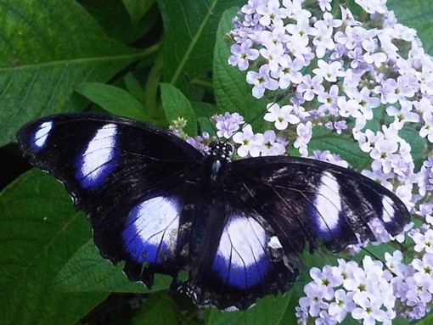
By Emoke Dénes [CC-BY-SA-2.5], via Wikimedia Commons
In 2006 Blue-moon butterflies almost became extinct.
Wolbachia bacteria killed males before they could hatch from eggs. Only females were resistant to the bacteria.
In 2006 the number of male Blue-moon butterflies had decreased to only 1 per cent of the population. Two years later, the number of males was equal to the number of females.
(a) Scientists believe that a change in a gene suddenly occurred to make some males resistant to the bacteria.
What scientific term describes a change in a gene?
___________________________________________________________________ (1)
Q5. (a) What does the theory of evolution state?
___________________________________________________________________
___________________________________________________________________
___________________________________________________________________
___________________________________________________________________
(2)
Q6. Tigers are large, striped animals that feed on deer. Tigers live and hunt in grassland and forest areas of Asia.
The image shows a tiger.
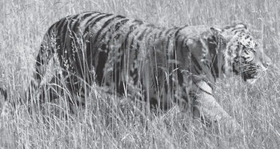
© Jupiterimages/PHOTOS.com/Thinkstock
The ancestor of the tiger did not have stripes.
Use your knowledge of Darwin’s theory of evolution to suggest how the tiger evolved to have stripes.
_______________________________________________________________________
_______________________________________________________________________
_______________________________________________________________________
_______________________________________________________________________
_______________________________________________________________________
_______________________________________________________________________
_______________________________________________________________________
_______________________________________________________________________ (4)

Lesson 4 – Genetic Engineering
Do Now: Instruction: Answer the following questions in your exercise book
- What are plasmids?
- What is a gene?
- Why do bacteria evolve faster than other organisms?
Video: Instruction: Scan the code above with your phone to watch the video on this topic
Notes: Instruction: Read the notes below.
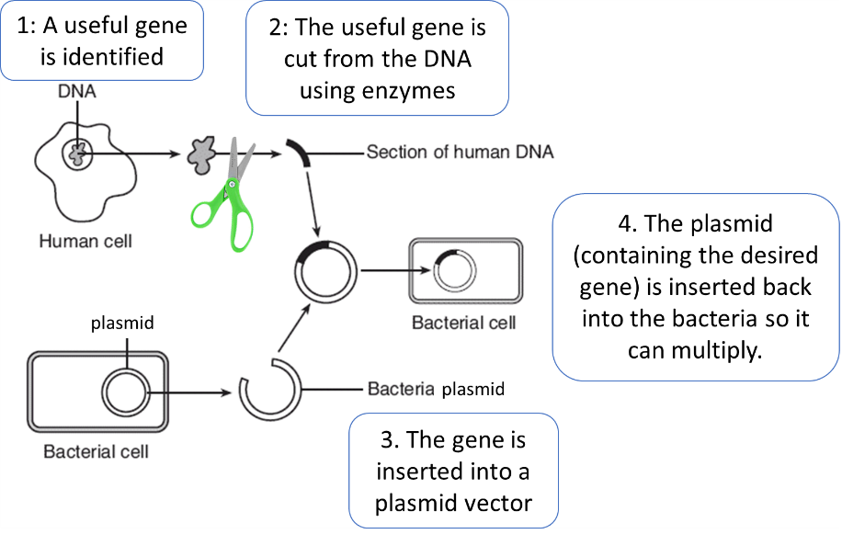
Part 1 - Define the term ‘genetic engineering’ (and explain the steps Higher Paper only)
Genetic engineering is a process a gene from one organism is inserted into the genome of another, so that it has a desired characteristic.
Enzymes are used to cut the desired gene out of the DNA, it is then placed into a vector (something that can insert the gene into the new organism). When using bacteria the vector is a plasmid but you could also use a virus. The bacteria have been genetically modified, the plasmid will be copied when the bacteria replicate and they will all produce the product of the gene. E.g insulin.
Genetic engineering can be carried out on any organism, if genetic engineering is carried out on animals and plants then it is done at an early stage so that all cells will contain the gene and they will develop the desired characteristic.
Organism which has been genetically modified | Benefit
Bacteria | To produce useful substances such as human insulin to treat diabetes
Food Crops | Improve yield (bigger better fruit) and be resistant to pests or diseases.  E.g. Bt Cotton produced to be resistant to specific caterpillar pest  E.g Golden Rice has been genetically modified with a gene taken from tomatoes to make beta-carotene, a pigment that is converted into vitamin A in the body. It is used to help prevent vitamin A deficiency and blindness in Africa and Asia.
Sheep | Sheep have been genetically engineered so that they can produce useful things in their milk, e.g. drugs to treat human diseases
Part 2 - Give examples of organisms which have been genetically modified and explain why.

Part 3 - Evaluate the use of GM organisms
Benefits of genetic engineering in medicine:
- Can produce large amounts of proteins like insulin and other drugs very fast
- Human insulin made this way will not be rejected by the body
- It could allow treatment for some human genetic disorders in the future
Disadvantages of genetic engineering in medicine:
- Genetic engineering is expensive.
Benefits of GM crops
- Genetically modifying crops to be resistant to pests and diseases allows plants to grow better and increases yield
- GM plants can be used to produce more food or more nutritious food in places where they cannot grow lots
- It can reduce the use of chemical pesticides
Disadvantages of GM crops
- Inserted genes could be transferred to wild/natural populations of plants which could affect biodiversity of plants and insects that feed on them. Especially resistance genes as it could stop farmers being able to control the growth of weeds and other plants
- Some people have objections to the use of GM crops as they believe it is not natural, they also believe the effect of eating GM crops on humans has not been studied well enough.

Recall Questions
Instruction: Answer these questions in your exercise book. Use the notes above to help you (like a comprehension)

- What is genetic engineering?
- Define genetically modified (GM) crops.
- State three characteristics plants might be genetically engineered to have.
- Give one example of the use of genetically engineered bacterial cells.
- How is a gene ‘cut out’ from the genome of one species and inserted into the genome of another?
- Into what is the gene inserted?
- Give two examples of vectors used in genetic engineering.
- What are the benefits of genetic engineering?
- State three concerns around genetically engineering plants.
- Describe the main steps in the process of genetic engineering. (HT)

Exam Questions: Answer these questions on this sheet – you can use the notes to help you but try from memory first!
Q1. Cow’s milk is different from human milk. Cow’s milk should not be given to young human babies.
Scientists in China have genetically engineered cows to produce human milk. Milk from these cows can be fed to young human babies.
(i) What is genetic engineering ?
Tick () one box.

Genes from one organism are transferred to a different organism | 
Cells are separated from an embryo and are transferred to host mothers
The nucleus from a body cell is transferred to an egg cell
(1)
(ii) Some people are worried about using milk from genetically engineered cows, to feed human babies.Give one reason why.
______________________________________________________________
______________________________________________________________
Q2. Dravet syndrome is caused by a genetic mutation. Dravet syndrome causes epileptic seizures.
(a) Mutations often happen when cells divide.
Give one other cause of genetic mutations.
___________________________________________________________________
___________________________________________________________________
(1)
(b) Scientists have transferred the mutated gene for Dravet syndrome into zebrafish using genetic engineering. This means the scientists could test a new drug to treat Dravet syndrome on the zebrafish.
Which two of the following are used during the process of genetic engineering? Tick two boxes.
Enzymes | 
Placebos
Vaccines
Vectors
White blood cells
(2)
Q3. Scientists have produced many different types of GM (genetically modified) food crops.
(a) Use words from the box to complete the sentence about genetic engineering.

 | clones | chromosomes | embryos | genes

GM crops are produced by cutting ........................................... out of the
........................................... of one plant and inserting them into the cells of a crop plant. (2)
(b) Read the information about GM food crops.
• Herbicide-resistant GM crops produce higher yields.
• Scientists are uncertain about how eating GM food affects our health.
• Insect-resistant GM crops reduce the total use of pesticides.
• GM crops might breed naturally with wild plants.
• Seeds for a GM crop can only be bought from one manufacturer.
• The numbers of bees will fall in areas where GM crops are grown.
Use this information to answer these questions.
(i) Give two reasons why some farmers are in favour of growing GM crops.
1 ............................................................................................................
...............................................................................................................
2 ............................................................................................................
............................................................................................................... (2)
(ii) Give two reasons why many people are against the growing of GM crops.
1 ............................................................................................................
...............................................................................................................
2 ............................................................................................................
............................................................................................................... (2)
Challenge Question
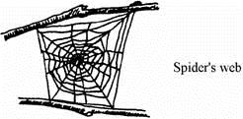
Spiders produce a protein thread which is extremely strong compared to man-made fibres of the same diameter.
Scientists can now use bacteria to produce the same protein.
How can they do this?
_______________________________________________________________________
_______________________________________________________________________
_______________________________________________________________________
_______________________________________________________________________ (3)

Lesson 5 – Extinction and Fossils
Do Now: Instruction: Answer the following questions in your exercise book

- Name abiotic factors that affect an ecosystem?
- Name some biotic factors that can affect individuals in an ecosystem?
- What is natural selection?
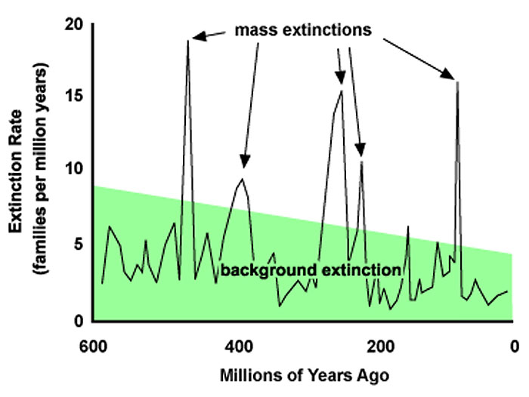
Video: Instruction: Scan the codes above with your phone to watch the videos on this topic
Notes: Instruction: Read the notes below.
Part 1 - Define the term ‘extinction’
Extinction is the permanent loss of all members of one species. A mass extinction is the loss of many or most species on Earth, and it usually happens over several million years. So far, there have been five mass extinction events, as seen on the five major peaks in the graph. A single catastrophic event is the more common cause of mass extinctions. The dinosaurs are believed to become extinct during one of the mass extinction events. One of the most supported theories is that an asteroid collision triggered it. The asteroid caused large climate changes including volcanoes which blocked out the sun and led to the ice age.
Part 2 - State factors that can contribute to the extinction of a species.
Extinctions can be caused by different factors, they cause extinction because the changes are fast and organisms do not have time to adapt or change (too fast for evolution to occur!)
Some can be abiotic (non-living) or physical changes to the environment e.g extreme climate changes or single catastrophic events like asteroids colliding with earth or volcanoes, earthquakes, droughts and floods.
Many more are biotic factors; these are similar to those we discussed in the ecology topic:
- new predators (including hunting by humans)
- new diseases
- competition from a new species for food
- shortage of food (prey runs out)
Part 3 - Describe how fossils are made
Fossils are remains or impressions of dead animals and plants from millions of years ago, which are found in sedimentary rocks. A lack of decay is key to forming fossils, so they need special conditions to form. The right amount of oxygen, temperature and bacteria are needed for decay to occur so these have to be absent to allow fossils to be formed.

There are 3 types of fossils:
Type | How are they formed | Picture
Parts of organisms Soft and hard parts preserved because no decay can take place | Could happen when dead organism is trapped in ice or in amber (tree sap) which hardens around them quickly | 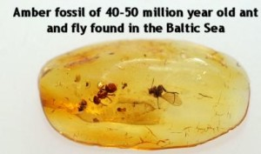
Dead organisms leave an imprint/impression made in mud | Overtime imprint dries out with the traces formed and hardened into rocks. Eg. Footprints, burrows, or leaves | 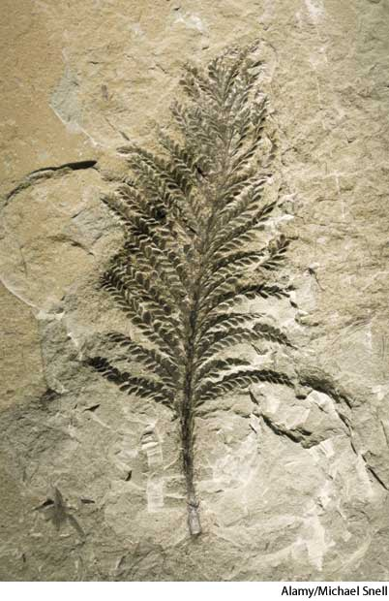
Hard parts of organisms that have been replaced by minerals | Bones and shells (hard parts) are replaced by minerals (mineralisation). This is the most common form e.g skeletons. | 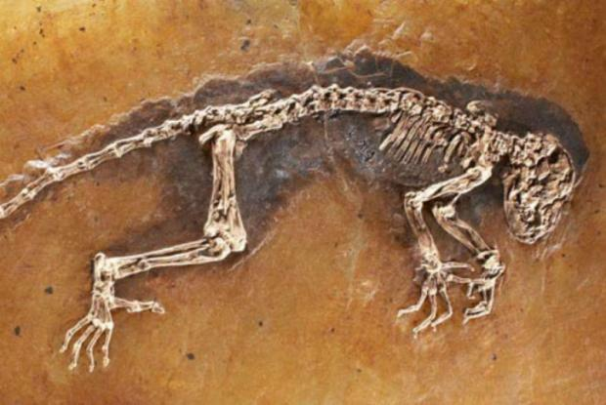
Process of fossilisation of skeletons
- Organism dies and the body is covered in sediment or mud
- Soft parts decay, leaving the bones behind as they take longer to decay
- Bones and hard parts do not decay
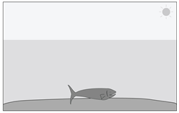
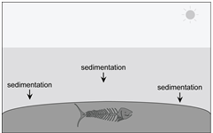
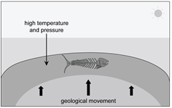
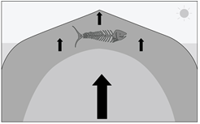
- The bones (hard parts) become mineralised (replaced by minerals) over millions of years and turn to rock

Recall Questions
Instruction: Answer these questions in your exercise book. Use the notes above to help you (like a comprehension)
- Define 'extinction'.
- State three biotic causes of extinction.
- What causes mass extinction? Suggest two examples of this cause.
- What are fossils?
- What are the three different types of fossils that can be formed?
- Describe the steps of fossilisation by mineralisation.
- Why can organisms be preserved in ice or amber?
- Why don’t fossils of dinosaurs contain feathers or skin?
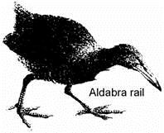
Exam Questions: Answer these questions on this sheet – you can use the notes to help you but try from memory first!
Q1. Flightless birds called Rails once inhabited 20 islands in the Pacific Ocean. During the last two centuries they have disappeared from 15 of these islands. The Aldabra Rail, shown below, is one of the few survivors. The island which it lives on is very remote.
Suggest three reasons why Rails have disappeared from 15 of the 20 islands they once inhabited.
1. _____________________________________________________________________
_______________________________________________________________________
2. _____________________________________________________________________
_______________________________________________________________________
3. _____________________________________________________________________
_______________________________________________________________________ (3)
Q2. Over millions of years:
• new groups of organisms have evolved
• other groups of organisms have become extinct.
(a) If an asteroid collided with the Earth, large amounts of dust and water vapour would be thrown up into the air. This would mean less light and heat would reach the Earth’s surface from the Sun.
(i) A reduced amount of light and heat could have caused the extinction of plants.
Suggest how.
______________________________________________________________
______________________________________________________________ (1)
(ii) How could the extinction of plants have caused the extinction of some animals?
______________________________________________________________
______________________________________________________________ (1)
(iii) Give two reasons, other than collision with an asteroid, why groups of animals may go extinct.
1. ____________________________________________________________
______________________________________________________________
2. ____________________________________________________________
______________________________________________________________ (2)
(b) The graph shows how the rate of extinction of groups of animals has varied over the past 300 million years.
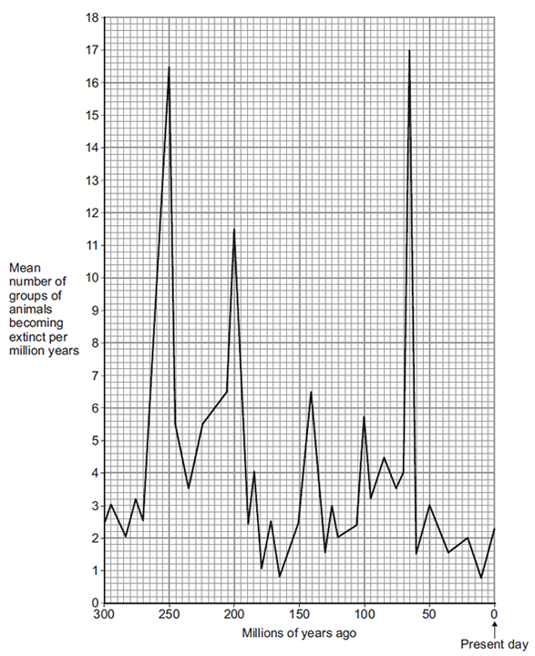
(i) If more than 10 groups of animals become extinct in a 1 million year period, scientists call this a ‘mass extinction’.
How many mass extinctions occurred over the past 300 million years?
____________________________________ (1)
(ii) How do we know what types of animals lived hundreds of millions of years ago?
______________________________________________________________
______________________________________________________________ (1)
Q3. Figure 1 shows photographs of fossils of extinct organisms.
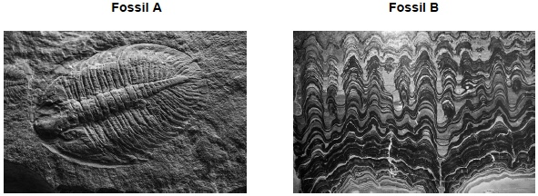
(a) What is a fossil?
___________________________________________________________________
___________________________________________________________________
___________________________________________________________________
___________________________________________________________________ (2)
(b) What does extinct mean?
___________________________________________________________________
___________________________________________________________________ (1)
Q4. The photograph shows a fossil of a prehistoric bird called Archaeopteryx.
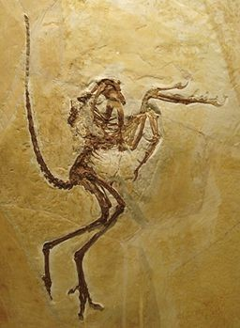
By Ghedoghedo (own work) [CC-BY-SA-3.0 (http://creativecommons.org/licenses/BY-SA-3.0)
(a) Describe three ways fossils can be made.
___________________________________________________
____________________________________________
_________________________________________________
___________________________________________________
________________________________________________
_____________________________________________________
_______________________________________________________________________________
(3)
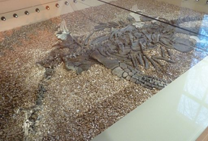
Q5. Figure 1 shows a fossil of a sea animal called a Plesiosaur. The Plesiosaur was alive about 135 million years ago.
By Andy Dingley (Own work) [CC-BY-SA-3.0 (http://creativecommons.org/licenses/by-sa/3.0)],
via Wikimedia Commons
(b) Plesiosaurs lived in the sea. There was mud at the bottom of the sea.
Suggest how the fossil shown in Figure 1 may have been formed after the animal died.
___________________________________________________________________
___________________________________________________________________
___________________________________________________________________
___________________________________________________________________
___________________________________________________________________
___________________________________________________________________
(3)
(c) Figure 2 shows what scientists think a living Plesiosaur may have looked like.
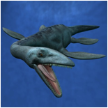
© Andreas Meyer/Hemera/Thinkstock
Scientists think that the Plesiosaur had smooth skin, with no scales. The scientists cannot be certain what the skin of a Plesiosaur was like.
Suggest why.
___________________________________________________________________
___________________________________________________________________ (1)


Lesson 6 – Evidence for Evolution
Do Now: Instruction: Answer the following questions in your exercise book
- What is evolution?
- What is a fossil?
- Who proposed the theory of evolution?
Video: Instruction: Scan the code above with your phone to watch the video on this topic
Notes: Instruction: Read the notes below.
Part 1 - State current sources of evidence to support the theory of evolution
Darwin’s theory of evolution by natural selection was initially rejected because:
- Most people at the time still believed that humans have been on earth since the beginning
- Not enough fossil evidence had been found at the time
- Mechanism of inheritance (genes/chromosomes) were not known about at the time.

But now the theory of evolution is widely accepted because multiple sources of evidence that are available:
- Fossils show change in characteristics over time and give evidence for older organisms being more simple
- Characteristics are known to be passed on to offspring in genes as science techniques advanced
- Knowledge of how antibiotic resistance evolves in bacteria
Part 2 - Describe how fossils can provide evidence for the theory of evolution
The process of evolution (slow changes over time) needs to be supported by evidence. Fossils are the remains of organisms from millions of years ago, preserved in rocks. Fossils are one of the most significant evidence to support the idea of evolution. Palaeontologists study the fossils, date them and put them in order. They reveal the gradual change of one type of plant or animal into another over time. This helps scientists to understand how they have changed since life developed on Earth, which can act as evidence for evolution by natural selection.
Dating of fossils can be done by working out the age of the rocks they were found in. This could be done through carbon dating.
Part 3 - Evaluate the limitations of using fossils as evidence for the theory of evolution
Even though fossils are a great way to support the theory of evolution, they are not always enough as we do not have a complete fossil record, this is because:
- Many early life forms were soft-bodied, which means they did not mineralise to form fossils
- Geological activity such as earthquakes destroyed lots of fossils and any imprints made are washed away easily.
- Most organisms did not become fossilised – the conditions for fossilisation are very rare
- Many undiscovered fossils – we do not know exactly how many fossils they are still buried.
Recall Questions: Answer these questions in your exercise book. Use the notes above to help you like comprehension
- State three reasons why Darwin’s ideas were only slowly accepted at the time.
- Give two pieces of current evidence for evolution
- How does the fossil record provide evidence for evolution?
- How can scientists date fossils?
- Give 4 reasons why the fossil record is incomplete.
Exam Questions: Answer these questions on this sheet – you can use the notes to help you but try from memory first!
Q1. Evolution is the development of new species over time. Evidence for evolution comes from fossils.
(a) (i) What is a fossil?
______________________________________________________________
______________________________________________________________
______________________________________________________________
______________________________________________________________ (2)
Q2. The drawing shows some of the fossils found in the layers of rock in two cliffs.
The two cliffs are on opposite sides of a large valley.
Geologists think that the valley has been carved out by rivers, and that the order of rock layers has not changed.
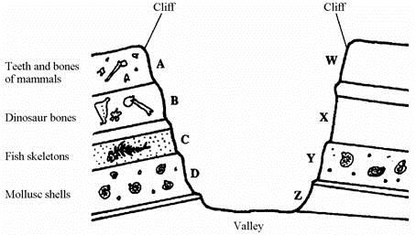
(a) (i) Which of the rock layers, A, B, C or D, is the oldest? _________________ (1)
(ii) Give the letters of two layers of rock on opposite sides of the valley that are the same age.
_______________ and _______________ (1)
(b) How do fossils provide evidence for the theory of evolution?
___________________________________________________________________
___________________________________________________________________
___________________________________________________________________ (2)

Q3. The diagrams show fossil animals found in rocks of different ages.
Scientists have used this information to work out how the modern horse evolved.
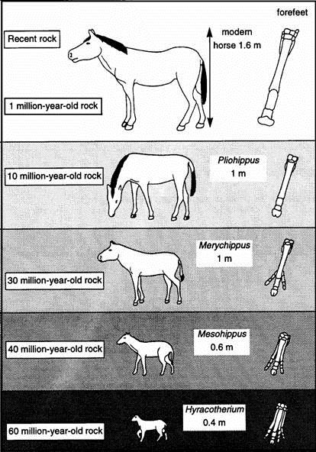
(a) Mesohippus became extinct over thirty million years ago. Use information from the diagrams to suggest two reasons why this happened.
1. _________________________________________________________________
___________________________________________________________________
2. _________________________________________________________________
___________________________________________________________________ (2)
(b) (i) How do scientists know how big these early horses were?
______________________________________________________________
______________________________________________________________ (1)
(ii) How do scientists know when they lived?
______________________________________________________________
______________________________________________________________ (1)
(c) Explain how the information in the diagrams supports the theory of evolution.
___________________________________________________________________
___________________________________________________________________
___________________________________________________________________
(3)
Q4. The photograph shows a fossil footprint. The fossil was found in a rock at the bottom of a shallow river.
Scientists believe this is the footprint of a dinosaur. The dinosaur was alive 110 million years ago.
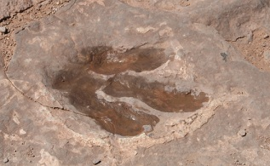
© Pearl Jackson/iStock
(a) (i) Suggest how the fossil shown in the photograph was formed.
______________________________________________________________
______________________________________________________________ (1)
(b) How can fossils give evidence for evolution?
___________________________________________________________________
___________________________________________________________________ (1)
(c) Scientists are uncertain about how life began on Earth.
Why?
___________________________________________________________________
___________________________________________________________________
(1)
Q5. Draw a ring around the correct answer to complete each sentence.

(i) Evolution can be explained by a theory called | genetic engineering  mutation  natural selection | .
(1)

(ii) This theory was suggested by a scientist called Charles | Darwin  Lamarck  Semmelweiss | .
(1)

(iii) This scientist said that all living things have evolved from | monkeys  dinosaurs  simple life forms | .
(1)
(b) Many religious people oppose the theory of evolution.
Give one reason why.
___________________________________________________________________
___________________________________________________________________
(1)

Q6. Figure 1 shows a photograph of a fossil of a trilobite.
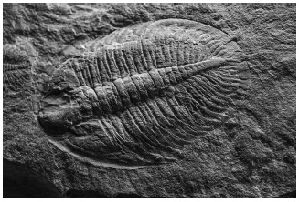
(a) Suggest how the fossil in Figure 1 was formed. Tick one box.

The organism left a footprint behind. | 
The organism was buried by rocks.
The organism was frozen in ice.
The organism was replaced by minerals.
(b) Hyoliths are another type of fossil. Hyoliths were discovered in the 1800s and thought to be a type of snail.
In 2017 scientists used modern techniques to place hyoliths into a different group.
Suggest a modern technique that the scientists may have used. Tick one box.

DNA analysis
Genetic modification
Light microscopy
Selective breeding
(c) How does the fossil record provide evidence for Darwin’s theory of evolution? Tick one box.

Dinosaurs became extinct 65 million years ago.
Fossils have been found in most countries of the world.
Older fossils have a simpler structure.
Trilobites belong to the arthropod group of animals.

Lesson 7 – Classification
Do Now: Instruction: Answer the following questions in your exercise book
- What is variation?

- What is the difference between prokaryotes and eukaryotes?
- What is a species?
Video: Instruction: Scan the codes above with your phone to watch the videos on this topic
Notes: Instruction: Read the notes below.
Part 1 - State that Carl Linneaus developed the first classification and binomial naming system
Classification is the organisation of living organisms into hierarchical (multi-level or tiered) groups according to similarities. Organisms are classified based on their structure and characteristics into a specific hierarchy called a taxonomy. The system was developed by Carl Linnaeus (a Swedish botanist) in the 1700s.
His system also allowed a binomial (two name) system for naming all species. The name is made up of two words – the genus and species names (the last two parts of their taxonomy). For example, when talking about human classification, we refer to humans as Homo sapiens. The names are in Latin, as it is considered as the universal scientific language, so this helps all scientists all around the world to use the same name for each species. The genus name also gives information on the ancestry of a species. There are some universal rules of writing binomial names:
- When typed, it needs to be in italics; when handwritten, it needs to be underlined
- The first letter of ‘genus’ must be in capital
- The first letter of ‘species’ must be in small letter

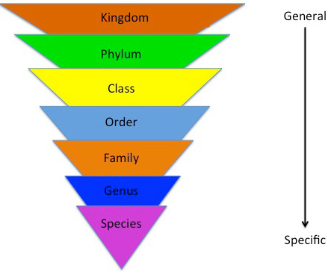
Part 2 - State the taxonomic order of the classification system
For example, humans are classified with the following taxonomy:
Classification | Human
Domain | Eukaryota
Kingdom | Animals
Phylum | Chordates
Class | Mammals
Order | Primates
Family | Hominids
Genus | Homo
Species | Sapiens
To help remember the taxonomic groups in order try the following: King Prawn Curry Or Fat Greasy Sausages
Part 3 - Explain why classification is useful and how modern technology helped improve it
Using classificaiton to group organisms is useful because it:
- Helps scientists to know which species are closely related
- Helps scientists to identify different organisms as separate species
- Helps scientists to monitor biodiversity (the number of different species in a habitat)
Linneaus’s classification system was updated by Carl Woese and other scientists as modern techniques developed our understanding of organisms. Originally there were five kingdoms, but with modern techniques revealed distinct enough differences within the prokaryote kingdom that it was split into two kingdoms: archaebacteria and eubacteria. These differences were identified due to improvements in microscopes like the electron microscope which made it easier to see the internal structures of prokaryotes. Understanding of biochemical processes and improvements in chemical analysis also helped to identify key differences. DNA analysis can now also be used to help classify organisms more accurately instead of grouping them based on just physical characteristics.
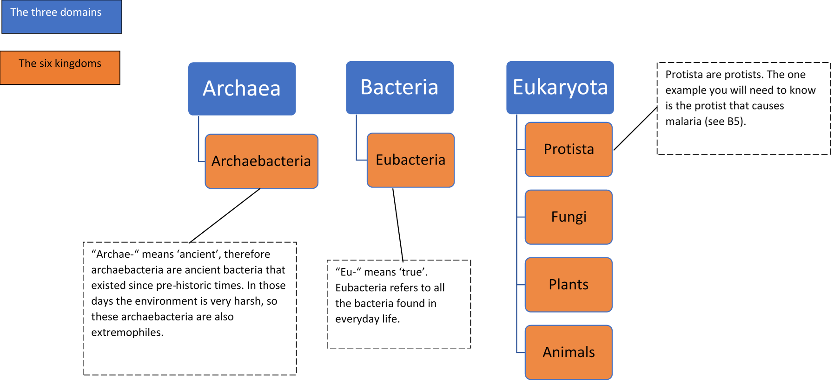Recall Questions
Primitive bacteria that existed in prehistoric times. They are often extremophiles
Instruction: Answer these questions in your exercise book. Use the notes above to help you like comprehension
- What does classification of organisms mean?
- Name the person who developed the classification system.
- State the 7 hierarchical levels of the Linnaean classification system.
- Every organism has a scientific name using a binomial system. What does binomial mean?
- Which language does the binomial naming system use?
- The binomial name of an organism is made up of two words. What does each word represent in the classification of that organism?
- What are the three rules of writing a binomial scientific name of a species?
- Why do we use the binomial naming system?
- How many domains and kingdoms do scientists now consider in classification?
- Who helped to develop the three domain system?
- What advances in biology helped to develop the classification system?
- What are the three domains?
- What are the six kingdoms?
- How is classification helpful?

Exam Questions: Answer these questions on this sheet – you can use the notes to help you but try from memory first!
Q1. Living things can be classified into groups.
(a) Scientists look at structures inside cells to classify living things.
Suggest one structure found in cells that can be used to classify living things.
___________________________________________________________________ (1)
(b) The table below shows one system for classifying humans.

X | Animalia
Phylum | Chordata
Class | Mammalia
Order | Primates
Family | Hominidae
Genus | Homo
Species | Sapiens
Who devised this system of classification?
Tick one box.

Darwin | 
Linnaeus
Wallace
Woese
(c) Look at the table above.
X is the largest category in this classification.
Name category X.
___________________________________________________________________ (1)
(d) Give the binomial name of humans.
Use information in the table above.
___________________________________________________________________ (1)
(e) Suggest one way that classification systems are useful to scientists.
___________________________________________________________________ (1)
Q2. Fall armyworms are native to America.
Fall armyworms eat corn plants.
(a) The binomial name for fall armyworms is Spodoptera frugiperda.
Fall armyworms belong to an order of insects called Lepidoptera.
The table shows a classification table for the fall armyworm.
Complete the table.

Classification group | Name
Kingdom
 | Arthropoda
 | Insecta
Order | Lepidoptera
Family | Noctuidae
 | frugiperda
(2)
Fall armyworms have been found in Africa.
(b) Fall armyworms:
• are not worms (annelids)
• are the caterpillars of moths (arthropods).
Describe one way scientists could tell if a new ‘worm’ they found should be classified as an annelid or as an arthropod.
___________________________________________________________________
___________________________________________________________________ (1)
Q3. All living organisms are classified into groups. Table 1 shows the classification of one species of wheat.

Kingdom | Plant
Phylum | Angiosperms
Class | Monocotyledons
Order | Commelinids
Family | Poaceae
Genus | Triticum
Species | spelta
(a) What is the binomial name for the wheat in Table 1?
Tick one box.

Angiosperm monocotyledons
Poaceae triticum
Species spelta
Triticum spelta
(1)
Q4. In the 18th century a binomial system of grouping similar organisms was developed.
Before the binomial system was developed the common briar rose had the following names:
• Rosa sylvestris inodora seu canina
• Rosa sylvestris alba cum rubore folio glabro.
In the binomial system, the same rose is called Rosa canina.
(a) One advantage of the binomial system is that the name is shorter than the names used before this system.
Suggest two other advantages of the binomial system.
1. _________________________________________________________________
___________________________________________________________________
2. _________________________________________________________________
___________________________________________________________________ (2)
(b) Classification systems have changed in the last 50 years.
Give one reason why we now have more information to classify organisms.
___________________________________________________________________
___________________________________________________________________ (1)
(c) ‘Archaea’ is one of the groups in the three-domain system of classification.
Give two features of the domain Archaea.
1. _________________________________________________________________
___________________________________________________________________
2. _________________________________________________________________
___________________________________________________________________ (2)

Q5. Scientists have removed microorganisms from inside rocks in caves in Mexico.
The microorganisms have been trapped there for between 10 000 and 50 000 years.
The caves are dark, very hot, humid and acidic.
(a) Why are these microorganisms called extremophiles?
Tick two boxes.

They are thousands of years old
They survive in high humidity
They survive in high temperatures
They survive in the dark
They survive inside rocks
They survive where it is acidic
(2)
(b) Carl Woese developed the ‘three-domain system’ of classification.
Describe the ‘three-domain system’ of classification.
___________________________________________________________________
___________________________________________________________________
___________________________________________________________________
___________________________________________________________________
___________________________________________________________________
___________________________________________________________________ (3)
(c) Most of the microorganisms from the caves were classified as belonging to the Archaea domain of the ‘three-domain system’.
Suggest why.
___________________________________________________________________
___________________________________________________________________
(1)


Lesson 8 – Evolutionary Trees
Do Now: Instruction: Answer the following questions in your exercise book
- What is evolution?
- What is a fossil?
- Who proposed the theory of evolution?
Video: Instruction: Scan the code above with your phone to watch the video on this topic
Notes: Instruction: Read the notes below.
Part 1 - Describe what an evolutionary tree shows and interpret them
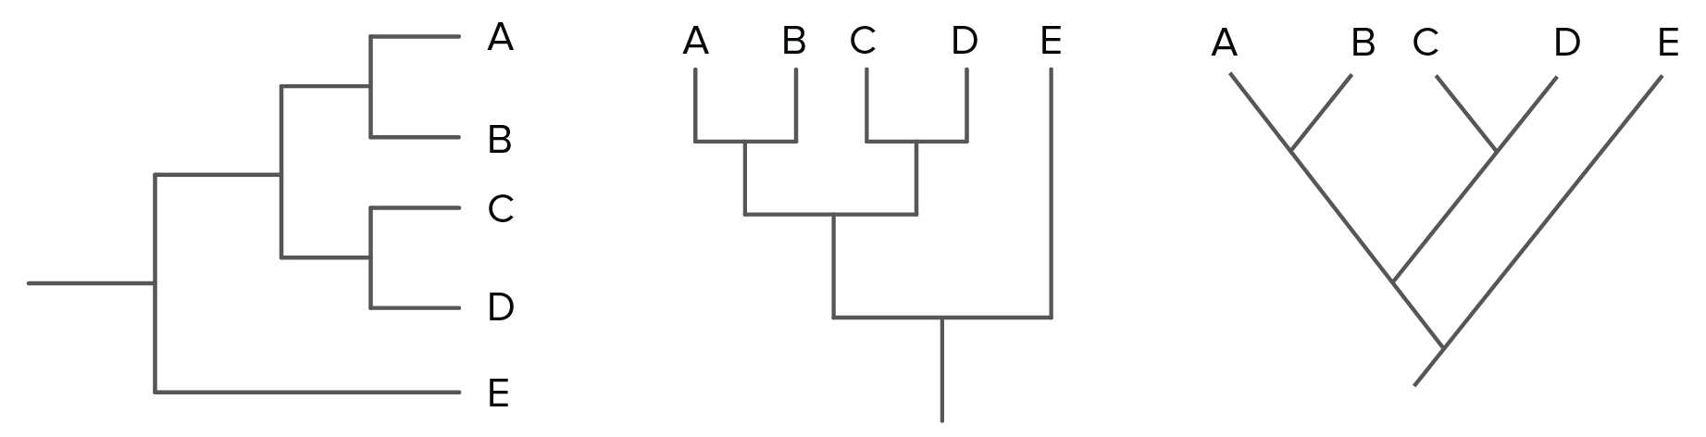
Evolutionary trees show evolutionary relationships between different groups of organisms. The closer the organisms are on the tree, the more closely related they are.
Organisms without many branches evolved early and are the most different
All organisms evolved from a single shared common ancestor
Nodes show shared or common ancestors
Although the above three trees look slightly different, they show the same relationships between organisms A-E. A is most closely related to B (because they share a branch and a common ancestor), C is most closely related to D (because they share a branch and a common ancestor), whereas E is not closely related to the others and evolved first. However, they all originated from the same common ancestor. For the third tree, it is worth noting it can also be called a phylogenetic tree. It is presented in such a way to also show the evolutionary timeline – the bottom of the tree is the beginning of time on Earth. As we go up the tree we become closer to the present time.
Part 2 - Explain how DNA improved evolutionary trees
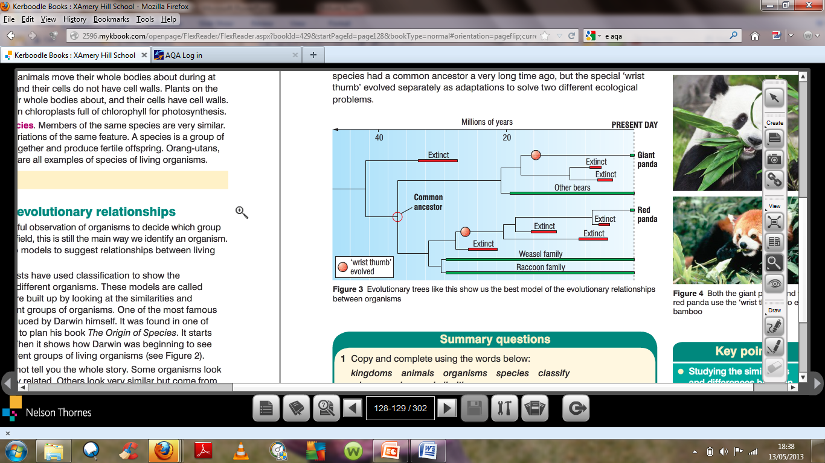
Darwin was limited as he did not know about genes. DNA evidence has improved evolutionary trees that were mostly based on physical characteristics and behaviour. It can be used to see how long ago different organisms had a similar ancestor, so how closely they are related.
An example: The red and giant panda were previously thought to be closely related (hence the names!). This is because both eat bamboo and both have a wrist thumb (a shared physical characteristic). However, based on their DNA, giant pandas were found to be more closely related to bears, and red pandas more closely related to racoons.
Recall Questions:
Instruction: Answer these questions on this sheet – you can use the notes to help you but try from memory first!
- Name the type of models that are used to show how different organisms are related.
- How are evolutionary trees made?
- What aspects of knowledge should be considered when suggesting evolutionary relationships?
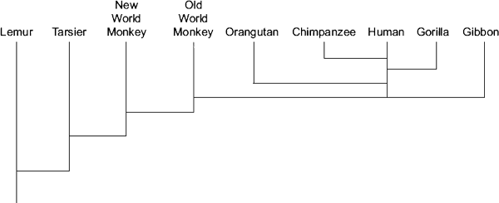
Worksheet
Remember: The further something is up the evolutionary tree, the more recently it evolved from the other species on the tree. Species which are more closely related share a same branch on the tree.
Easy:

1. The diagram shows the evolution of a group called the primates.
(a) Which primate evolved first?
(b) Name two primates that developed most recently from the same common ancestor as humans.
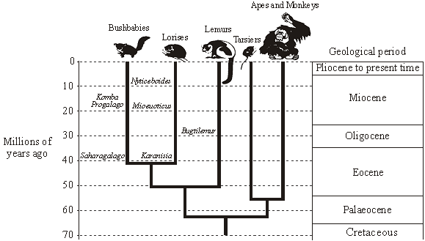
Medium:

2. The diagram shows an evolutionary tree for a group of animals called primates. The names of extinct animals are printed in italics e.g. Nycticeboides. The drawings show animals that are alive today.

(a) How many million years ago did Karanisia first appear?

(b) During which geological period did the Apes and Monkeys begin to evolve?

(c) Which group of primates alive today are the closest relatives of the Lorises?

Hard:
3. The diagram on the right shows an evolutionary tree for humans based on a study of fossils.
- When did Australopithecus afarensis first appear?

- Which species was the direct ancestor of Paranthropus boisei?

- Which species is most closely related to Homo habilis?

- About 250 fossils of Homo erectus have been found. About 50 of these fossils have been found in China. A
Chinese scientist has suggested the hypothesis that Chinese people evolved from Homo erectus. Most scientists do not agree with this hypothesis. Use the information above and information from the diagram to suggest two reasons why.

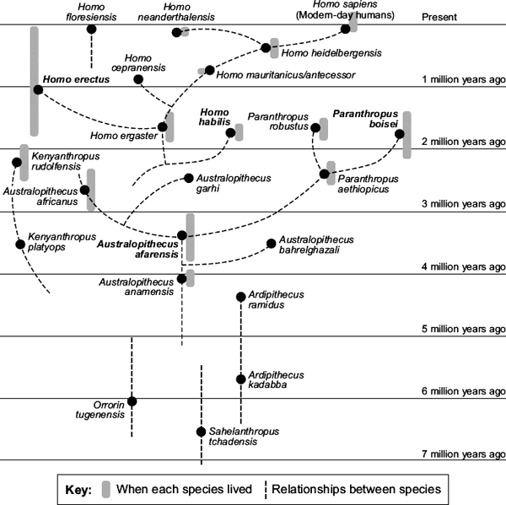

Exam Questions
Q1. Diagram 1 shows one model of the relationship between some animals.
Diagram 1
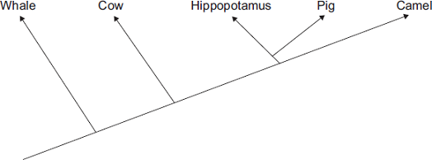
(i) Complete the sentence.
The model shown in Diagram 1 is an evolutionary _____________________ . (1)
(ii) Which two of the animals in Diagram 1 are most closely related?
_____________________________ and _____________________________ (1)
(iii) Diagram 2 shows a more recent model of the relationship between the animals.
Diagram 2
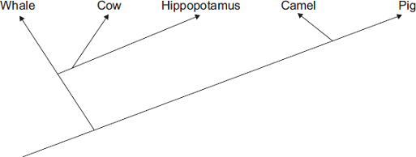
Suggest one reason why scientists have changed the model of the relationships between the animals shown in the diagram.
Draw a ring around the correct answer.

more powerful  computers | new evidence  from fossils | new species  discovered
(1)

Q2. Figure 1 shows an evolutionary tree for the ‘big cats’.
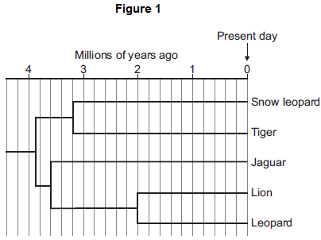
(i) How long ago did the lion evolve?
_______________ million years ago (1)
(ii) Which animal is the closest relative to the tiger?
______________________________________________________________ (1)
Q3. The diagram shows an evolutionary tree for the great apes.
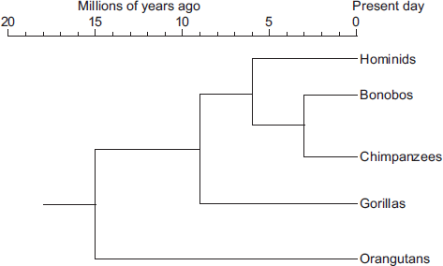
(a) (i) How many years ago did chimpanzees evolve?
____________________________ million years ago (1)
(ii) Which animal shown in the diagram is the most distant relative of hominids?
______________________________________________________________ (1)

Q4. The diagram below shows the evolutionary tree for some Galapagos finches.
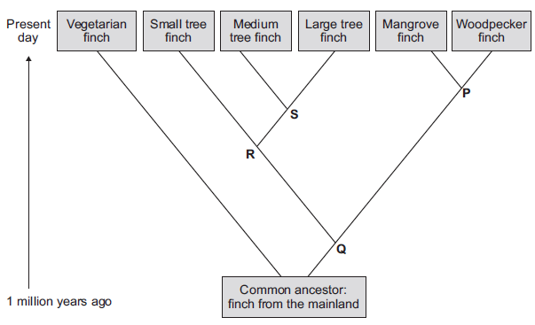
(i) Which type of present-day finch is least closely related to all the others?
............................................................................................................... (1)
(ii) Which branching point, P, Q, R or S, on the diagram above shows the most recent common ancestor of all the tree finches?
Write the correct answer in the box. 
(1)
(iii) Which two finches have the most recent common ancestor?
1 .............................................................................................................
2 ............................................................................................................. (1)
Q5. Figure 2 shows an evolutionary tree drawn from the fossil record in the 1970s.
The evolutionary tree is for a group of dinosaurs.
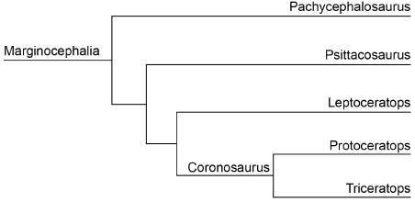
(a) Scientists in the 1970s did radiocarbon dating on all the fossils.
Which fossil gave the earliest radiocarbon date?
___________________________________________________________________ (1)
(b) Suggest which two types of dinosaur fossils showed the most similar features.
___________________________________________________________________ (1)
(c) Give one reason why this evolutionary tree might not be correct.
___________________________________________________________________
___________________________________________________________________ (1)
Q6. The diagram shows how and when some different types of animal are thought to have evolved.
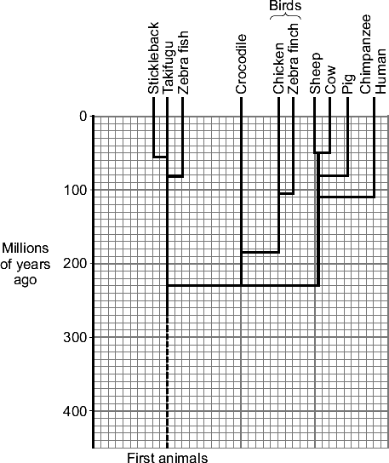
(i) Which animal is most closely related to birds?
______________________________________________________________ (1)
(ii) How long ago did pigs evolve?
______________________________________________________________ (1)

