AQA Biology
Year 12 A level
3.2.4 Immunity


Name: ______________________

Lesson | Exam Question Marks | Homework Checked | Date
Lesson 1 – Antigens and Phagocytosis
Lesson 2 –T cells and Cell mediated response
Lesson 3 – B cells and Humoral Response
Lesson 4 - Antibodies
Lesson 5 – Natural and Passive Immunity
Lesson 6 – HIV
Lesson 7 – Antibodies in Medicine

Specification Sections
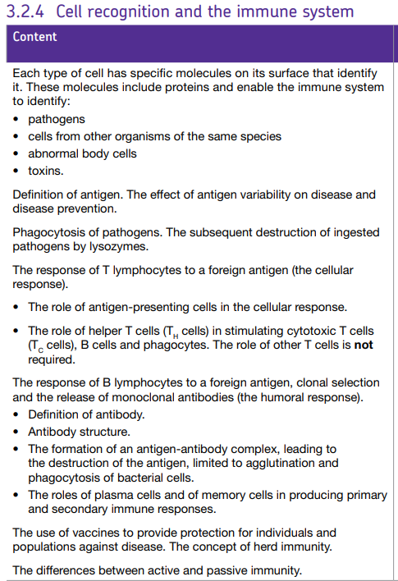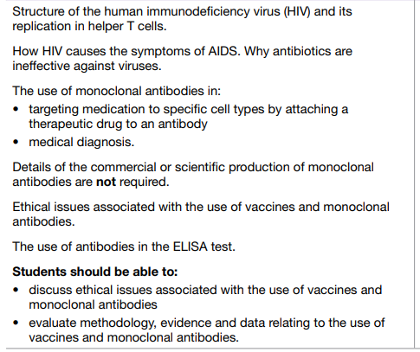

Key word list
Active immunity | Resistance to disease resulting from the activities of an individual’s own immune system whereby an antigen induces plasma cells to produce antibodies
AIDS | The disease caused by HIV.
Allergen | A normally harmless substance that causes the immune system to produce an immune response
Allergy | The response of the immune system to an allergen. E.g. hay fever
Antibiotic | A substance produced by a living organism that can destroy or inhibit the growth of microorganisms
Antibiotic resistance | The development in microorganisms of mechanisms that prevent antibiotics from killing them
Antibody | A protein produced by lymphocytes in response to the presence of the appropriate antigen
Antigen | A molecule that triggers an immune response by lymphocytes
Antigen-presentation | When an antigen-presenting cell e.g. phagocyte displays foreign antigens on their own cell-surface membrane.
Antigenic variability | Pathogen may mutate frequently so that its antigens change suddenly rather than gradually which means vaccines become ineffective because the new antigens on the pathogen are no longer recognized by the immune system.
Artificial immunity | A type of active immunity resulting from vaccination. It involves inducing an immune response in an individual without them suffering symptoms of the disease.
Attachment Protein | The capsid can have these which are essential to allow the virus to identify and attach to a host cell.
B cell  (B lymphocyte) | A type of white blood cell that is produced and matures within the bone marrow. They produce antibodies as part of their role in immunity
Cancer | A disease, resulting from mutations, that leads to uncontrolled cell division and the eventual formation of a group of abnormal cells called a tumour
Capsid | A protein coat which encloses the nucleic acid in a virus.
Carcinogen | A chemical, form of radiation or other agent that causes cancer
Carrier molecule (carrier protein) | A protein on the surface of a cell that helps to transport molecules and ions across plasma membrane
Cell-mediated immunity | The type of response when T lymphocytes respond to antigens that are presented on a body cell.
Clonal Selection | As the receptor on a helper T cell attaches to the antigen this activates the T cell to divide rapidly by mitosis and form a clone of genetically identical cells. These cloned T cells stimulate B cells to divide and form a clone of identical B cells all of which produce the antibody that is specific to the foreign antigen.
ELISA test | Enzyme linked immunosorbent assay which uses antibodies to detect the presence and quantity of a protein in a sample.
Enzyme | A protein or RNA that acts as a catalyst and so alters the speed of a biochemical reaction
Epidemiology | The study of the spread of disease and the factors that affect this spread
Foreign (non-self) | Not your own body’s cells and molecules.
Glycoprotein | Substance made up of a carbohydrate molecule and a protein molecule
Herd immunity | Arises when a sufficiently large proportion of the population has been vaccinated which makes it difficult for a pathogen to spread within that population.
HIV | Human immunodeficiency virus which causes the disease acquired immune deficiency syndrome (AIDS). It has a lipid envelope, attachment proteins, a capsid and two single strands or RNA and enzymes.
Humoral Immunity | The type of response which involves B lymphocytes and antibodies.
Immunity | The means by which the body protects itself from infection
Lymph | A slightly milky fluid found in lymph vessels and made up of tissue fluid, fats and lymphocytes
Lymphocytes | Types of white blood cell responsible for the immune response, they become activated in the presence of antigens
Lysosome | Contain enzymes called lysozymes which they release into the phagosome which hydrolyse the bacterium.
Memory B Cells | Some B cells develop into memory cells which can respond to future infections by the same pathogen by dividing rapidly and developing into plasma cells that produce antibodies as part of the secondary response.
Monoclonal antibodies | Antibodies produced by a single clone of cells.
Mutagen | Any agent that induces a mutation
Natural immunity | A type of active immunity resulting from an individual becoming infected with a disease under normal circumstances.
Passive immunity | Resistance to disease that is acquired from the introduction of antibodies from another individual, rather than an individual’s own immune system
Pathogen | Any microorganism that causes disease
Phagosome | A vesicle formed as the bacterium is engulfed by the phagocyte. The lysosome release their lysozymes into the phagosome.
Phagocyte | Type of white blood cell which carries out a non-specific immune response and ingests and breaks down pathogens by phagocytosis.
Phagocytosis | Mechanism by which cells engulf particles to form a vesicle or a vacuole
Plasma B Cells | When the B cell is activated to divide by mitosis it gives a clone of plasma cells which produce and secrete the specific antibody that exactly fits the antigen on the pathogen’s surface.
Plasmid | A small circular piece of DNA found in bacterial cells
Prokaryotic cell | A cell that does not have a nucleus or membrane bound organelles
Primary Response | Caused by initial response to the antigen which involves the production of antibodies and memory cells.
Retrovirus | A group of viruses which have the ability to make DNA from RNA because they have reverse transcriptase.
Reverse transcriptase | An enzyme in HIV which enables the production of DNA from RNA.
Secondary response | Caused by second exposure to the antigen. Memory cells are responsible for this response – they divide rapidly and develop into plasma cells (which secrete many antibodies quickly) and more memory cells.
Self | The body’s own cells and molecules.
Serum | Clear liquid that is left after blood has clotted and the clot has been removed (blood plasma without clotting factors)
Stem cell | Undifferentiated dividing cells that occur in embryos and in adult animal tissues that require constant replacement
T cell  (T lymphocyte) | A type of white blood cell that is produced in the bone marrow but matures in the thymus gland. Coordinates the immune response and kills infected cells
T_{C} cells (cytotoxic T cells) | Kill abnormal cells and body cells that are infected by pathogens by producing a protein called perforin which makes holes in the cell-surface membrane.
T_{H} cells (helper T cell) | Contain receptors which respond to a single antigen. Many different types of T cell, each one responds to a different antigen.
Vaccination | The introduction of a vaccine containing appropriate disease antigens into the body by injection or mouth in order to induce artificial immunity
Virus | Acellular, non-living particles that are smaller than bacteria. They contain DNA or RNA but can only multiply inside living host cells.
Vector | A carrier

Lesson 1 – Antigens and Phagocytosis
Notes:
Self vs. non-self
On the surface of all cells are chemical markers (for example, proteins) called antigens. Each antigen has its own unique shape. The more closely related 2 individuals are, the more antigens they have in common. This means that you and a brother, sister or parent will have more antigens in common than you and a distant cousin. Your body recognises the antigens on your cells as your own (self); anything with different antigens to you (non-self) stimulates an immune response. In an immune response, your body will recognise the antigen as foreign (and therefore bad) and will attack it.
Antigens
All cells have specific proteins on their surface membrane that identify it called antigens. An antigen is a protein found on the outside of cells, that triggers an immune response.
Antigens enable the immune system to identify:
  - pathogens (micro-organisms that cause disease)
  - cells from other organisms of the same species (e.g in transplanted organs)
  - abnormal body cells (e.g cancerous cells)
  - toxins (poisonous molecules often released by bacteria)
Phagocytes & White Blood Cells
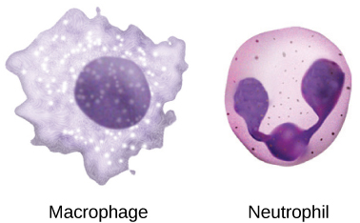
Phagocytes are made in the bone marrow, travel in capillaries but can squeeze through walls into tissues. They both patrol the body, searching for invaders (non-self antigens). There are two types: neutrophils and macrophages:
- Neutrophils: Engulf and digest pathogens (and dead human cells/debris)
- Macrophages: Can punch holes in the bacteria or stick proteins to the outside of the bacteria to make them more appealing for the neutrophils to destroy.

Phagocytosis Originates from Ancient Greek: Phagein = "to devour" + Kytos = "cell” + -osis = "process“
Definition: cellular process of engulfing solid particles using the cell membrane - carried out by phagocytes.
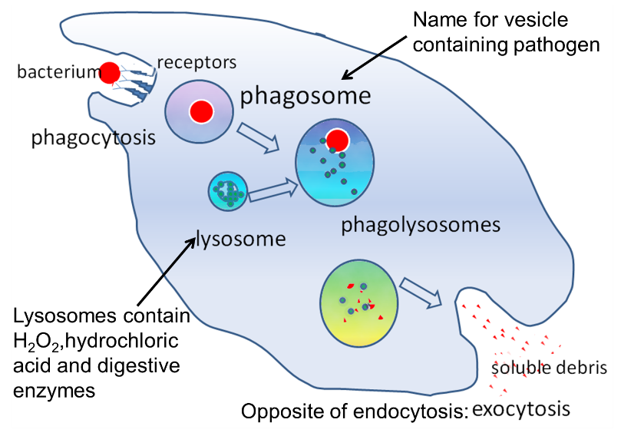
Process:
- Pathogen recognised as having foreign/non-self antigens. Pathogen attaches to the phagocyte by surface receptors
- The pathogen is engulfed by the phagocyte by endocytosis forming a phagosome.
- Lysosomes fuse to phagosome to form a phagolysosome and release H₂O₂, HCl, and digestive enzymes into phagosome to digest pathogen
- Harmless products removed (egested / excreted) by exocytosis or used by phagocyte
Recall Questions:
- What is a capsid?
- What are the attachment proteins on a virus?
- What is the envelope on a virus?
- Describe the basic structure of a virus
- What is an antigen?
- How does the human body distinguish between self & non-self cells?
- How does the body prevent attack by own immune system?
- Why must patients who receive organ donations, take anti-rejection medicines?
- Briefly, what is phagocytosis?
- How does a phagocyte use chemotaxis?
- What is phagocytosis?
- What is lysozyme?

Exam Questions:
Q1. (a) What is an antigen?
___________________________________________________________________
___________________________________________________________________ (2)
(b) What is an antibody?
___________________________________________________________________
___________________________________________________________________ (2)
Q2. (a) What is an antigen?
___________________________________________________________________
___________________________________________________________________
___________________________________________________________________ (2)
(c) The diagram shows some components of a human immunodeficiency virus (HIV).
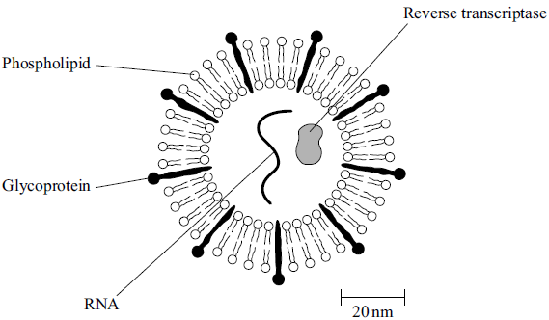
(i) Suggest which labelled component of the virus is most likely to act as an antigen. Give a reason for your answer.
Component ____________________________________________________
Reason _______________________________________________________
______________________________________________________________ (1)
(ii) A cell that HIV infects is 15 µm in diameter. Calculate how many times larger in diameter this cell is than an HIV particle. Show your working.

Answer ____________________ times larger
(2)
Q3. The table gives information about some components of a red blood cell.

Component | Glycoprotein | Phospholipid | Haemoglobin
Location in cell | on outer surface of plasma membrane | within plasma membrane | in cytoplasm
Suggest which component of an intact red blood cell is most likely to act as an antigen during a blood transfusion. Explain your answer.
Component _________________________________________________________
Explanation _________________________________________________________
___________________________________________________________________
___________________________________________________________________
(2)
Q4. (a) Describe how bacteria are destroyed by phagocytes.
___________________________________________________________________
___________________________________________________________________
___________________________________________________________________
___________________________________________________________________
___________________________________________________________________
___________________________________________________________________
(3)

(b) Give two structures a bacterial cell may have that a white blood cell does not have.
1. _________________________________________________________________
___________________________________________________________________
2. _________________________________________________________________
___________________________________________________________________
(2)
Q5. (a) What is a pathogen?
___________________________________________________________________
(1)
(b) When a pathogen enters the body it may be destroyed by phagocytosis.
Describe how.
___________________________________________________________________
___________________________________________________________________
___________________________________________________________________
___________________________________________________________________
___________________________________________________________________
___________________________________________________________________
___________________________________________________________________
___________________________________________________________________
(4)

Homework
Our body is defended against pathogens by _________________ blood cells. There are two types of white blood cells _________________ and _________________.
Non-specific defence mechanisms respond to all pathogens in the _________________ way. This is either a physical barrier to entry, e.g. _________________ or by engulfing and _________________ the pathogen in phagocytosis.
Specific defence mechanisms are slower to response put provide _________________ immunity. T lymphocytes are involved in _________________ responses (immunity involving body cells) whereas B lymphocytes are involved in _________________ responses (immunity involving body fluids). Lymphocytes are complementary, i.e. specific to a particular pathogen but are not made in response to a particular infection as 10 million different types _________________ exist in the body. Since there are so many types there are only_________________ numbers of each type but large numbers are needed to destroy pathogens. After a pathogen is detected large numbers of lymphocyte are built up to destroy it. This is why after you have been exposed to a pathogen there is a time _________________ before your body brings it under control.
- Non- specific
This response is the same for any _________________ . _________________ is an example of a non-specific defence mechanism.
1.1 Phagocytosis
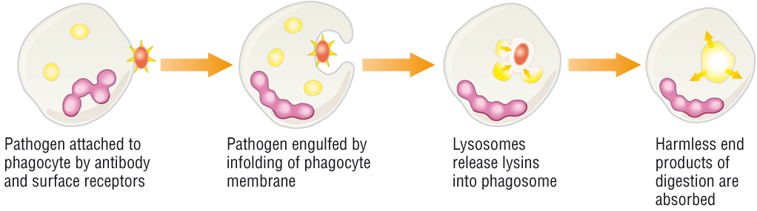
The diagram above shows the stages phagocytosis.
In phagocytosis the pathogen recognised as foreign. Pathogen attached to phagocyte by antibody and surface receptors. Pathogen is _________________ by phagocyte by endocytosis – invagination of plasma cell membrane to form a phagosome (a membrane bound vesicle containing the pathogen). Lysosomes (containing lysins & hydrolytic _________________) fuse to phagosome. Pathogen is _________________– harmless products removed (egested / excreted) or used by phagocyte. Phagocyte also displays antigenic components on external surface of plasma cell _________________ (antigen presentation) to start immune response.
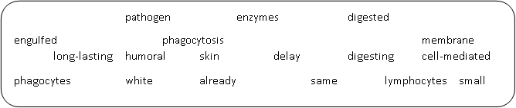
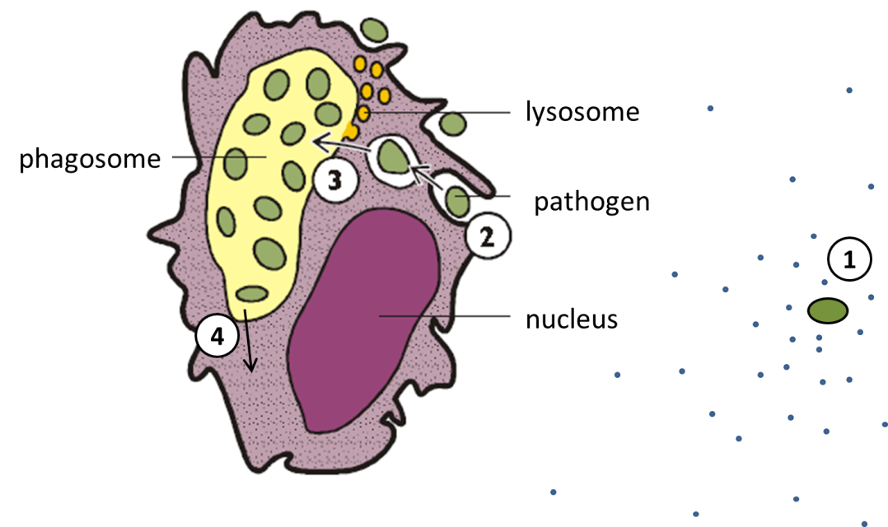
- Use the diagram above to describe the process of phagocytosis. You must use the terms:
antigen, concentration gradient, diffuse, engulf, fuse, hydrolysis, lysosome, lysozymes, pathogen, phagocyte, phagosome, vesicle
Stage | Description
1
2
3
4

Recall Question Answers:
Question | Answer
What is a capsid? | Protein coat around the core
What are the attachment proteins on a virus? | Attachment proteins stick out from the edge of the capsid of envelope, let the virus cling on to a suitable host cell
What is the envelope on a virus? | Extra outer layer stolen from the cell membrane of a previous host cell
Describe the basic structure of a virus | A strand of nucleic acid (DNA or RNA) enclosed within a protein coat
What is an antigen? | A molecule (usually protein) which triggers an immune response.
How does the human body distinguish between self & non-self cells? | Marker molecules (proteins) are present on the membrane of cells, enabling the body to recognise these as 'self' cells.
How does the body prevent attack by own immune system? | some of the membrane proteins on the surface of our cells mark the body cell as 'self'. they allow us to distinguish between our cells and invaders
Why must patients who receive organ donations, take anti-rejection medicines? | The organ has non-self antigens- which will trigger an immune response. The anti-rejection medicines prevent this response.
Briefly, what is phagocytosis? | When foreign cells are engulfed by phagocytes, digested by lysozymes released by lysosomes in the cell.
How does a phagocyte use chemotaxis? | Phagocytes are attracted to pathogens by chemicals released by the pathogen( phagocytes move down conc.gradient)
What is phagocytosis? | Phagocyte recognises the antigens on a pathogen. endocytosis. pathogen is contained in a phagocytic vacuole. lysosomes, containing digestive enzymes fuse with the vacuole, enzymes are released and they destroy the pathogen. phagocyte presents antigen on its surface
What is lysozyme? | Mucosal surfaces produce secretions that contain lysozyme. It kills bacteria by damaging their cell walls making them burst open

Lesson 2 – Cell Mediated Immune Response
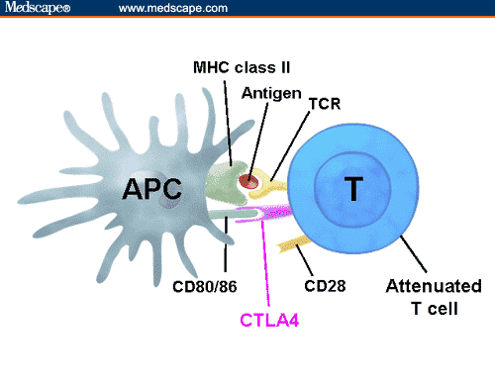
Notes:
Phagocytosis is a non-specific response and it is sometimes not enough to cope with large numbers of pathogens e.g the flu virus.
Phagocytes which engulf the virus present some of the pathogens antigens on their own cell membrane – they become antigen presenting cells (APCs). This activates T helper cells, which stimulate and recruits more phagocytes and T cells to assist in the immune response. This includes cytotoxic (killer) T cells which destroy infected or foreign cells by releasing chemicals e.g perforin (makes pores in the membrane) into the invaded cell.

Activated T cells can then also activate B cells causing them to divide by mitosis, this is the start of the humoral response – we will look at this in more detail in the next lesson.
Specific Immune Response:
Two parts:
- Cell-mediated response - Involves specialised white blood cells called T-lymphocytes which target pathogens inside and outside cells.
- Humoral response - Involves specialised white blood cells called B-lymphocytes which target pathogens by producing antibodies
Cell-mediated immune response
- APC’s can be either phagocytes or cells that have been invaded by the pathogen
- Once phagocytosis has taken place, pathogenic antigens are presented on the cell surface membrane
- T cells respond to the cell which is presenting the antigens
- T helper cells respond first – they have receptors which fit exactly to the presented antigens
- This activates the T cells and they begin to differentiate and recruit other T cells and activate B cells.
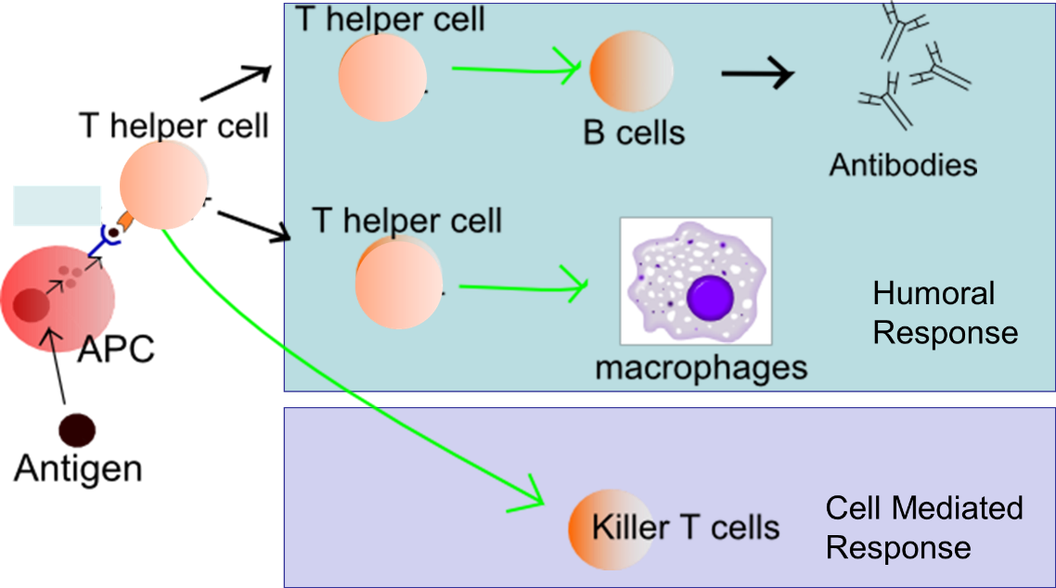

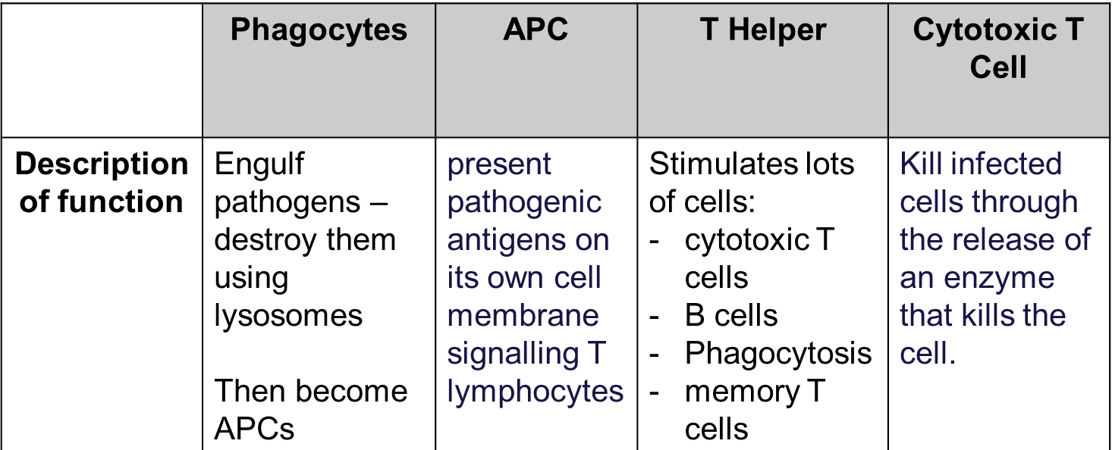
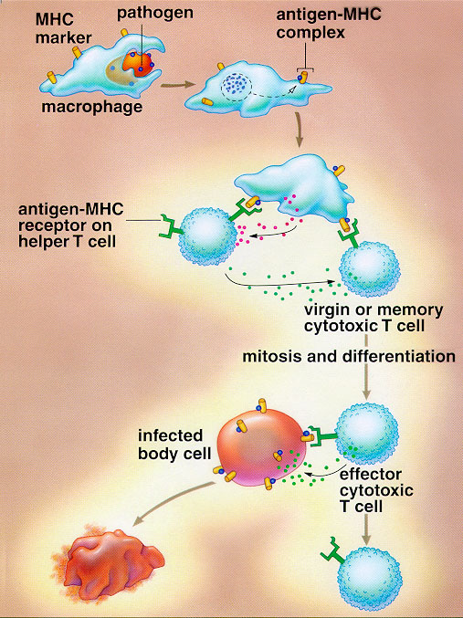
Task:

- Binding of T-helper cell stimulates T-cell clone
- Memory T-cell formed
- Phagocyte
- T-helper cell receptor
- Ingestion & processing of pathogen
- Antigen presented on cell-surface membrane
- T-killer cell
- Infected body cell killed by T-killer cell puncturing cell membrane

Recall Questions:
- What does the cellular immune response consist of?
- Describe the role of T-helper cells.
- Describe the role of T-cytotoxic cells.
- What do the receptors on T cells do?
- How are T cells activated?
- What do T helper cells do?

Exam Questions:
Q1. Explain the role of Antigen Presenting Cells (APC’s) in cell mediated immunity.
_________________________________________________________________
_________________________________________________________________
_______________________________________________________________(3)

Q2. What feature of the T helper cell allows it to identify specific foreign antigens?
_________________________________________________________________
_________________________________________________________________
_______________________________________________________________(2)
Q3. (a) What is a pathogen?
___________________________________________________________________ (1)
(b) When a pathogen enters the body it may be destroyed by phagocytosis.
Describe how.
___________________________________________________________________
___________________________________________________________________
___________________________________________________________________
___________________________________________________________________
___________________________________________________________________
___________________________________________________________________
___________________________________________________________________
___________________________________________________________________ (4)

Q4.
(a) Describe how bacteria are destroyed by phagocytes.
___________________________________________________________________
___________________________________________________________________
___________________________________________________________________
___________________________________________________________________
___________________________________________________________________
___________________________________________________________________
(3)
(b) Give two structures a bacterial cell may have that a white blood cell does not have.
1. _________________________________________________________________
___________________________________________________________________
2. _________________________________________________________________
___________________________________________________________________
(2)
Homework
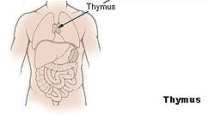
  - T Lymphocytes (T cells)

T cells are made in the _________________ gland. Immunity from T lymphocytes is cell-mediated so only responds to _________________ attached to the surface of body cells. Body cells invaded by a virus present the viral antigens on its own cell _________________, phagocytes that have engulfed a pathogen also present the pathogen’s antibodies on its own cell surface, and _________________ cells present antigens on their cell-surface membranes. A cell that presents antigens of other cells on its own surface are known as _________________ cells.

T _________________ cells have receptors that fit onto the specific antigen. This process is the signal for other T cells to _________________ by mitosis and produce many clones. These cloned T cells become _________________ cells which circulate in the blood and body fluids. These memory cells allow a rapid response against the same pathogen in the _________________. One way T cells kills infected cells is with a protein that makes _________________ in their cell-surface membranes. This makes the cell freely _________________ to all substances and so die. T cells also encourage phagocytes to engulf the pathogen by phagocytosis, and encourage B cells to _________________. T cells are most effective against _________________ because viruses live inside cells. A virus needs living cells to reproduce. When infected body cells are destroyed it is worth _________________ them to prevent the pathogen from multiplying.

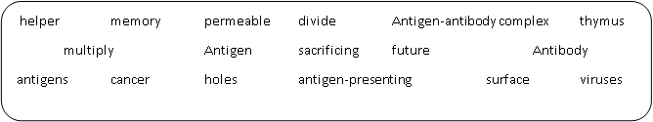
2. Produce a labelled, annotated diagram in the space below to show the linked processes of:
Phagocytosis, cell-mediated immunity,

Recall Question Answers:
Question | Answer
What does the cellular immune response consist of? | T cells- phagocytes, cell signals etc.
Describe the role of T-helper cells. | Recruit & signal to phagocytes AND activate B cells
Describe the role of T-cytotoxic cells. | Kill abnormal & foreign cells (produces proteins to do this e.g. perforin)
What do the receptors on T cells do? | bind to antigens displayed by antigen presenting cells
How are T cells activated? | When their receptors bind to complementary antigens on the surface of antigen presenting cells.
What do T helper cells do? | Binds to an antigen-presenting B cell and produces cytokines that stimulate B cell to divide and become capable of producing antibodies. they also enhance the activity of phagocytes
Lesson 3 – B cells and Humoral Response
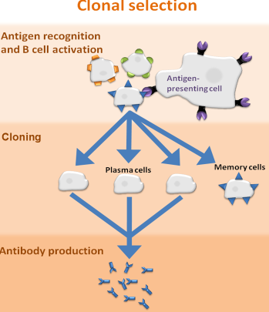
The B cells get the antigen from pathogens or APCs and presents the antigen on its cell surface membrane. T helper cells bind to this antigen to active the B cells. The B cells begin to divide by mitosis (clone themselves) to form plasma cells and memory cells this is known as clonal selection. Plasma cells produce antibodies that are complimentary to the antigens. (primary response)
The memory cells stay in the blood stream circulating. If they come into contact with the antigen again they divide to form plasma cells and memory cells again. (secondary immune response)

Primary vs Secondary immune response
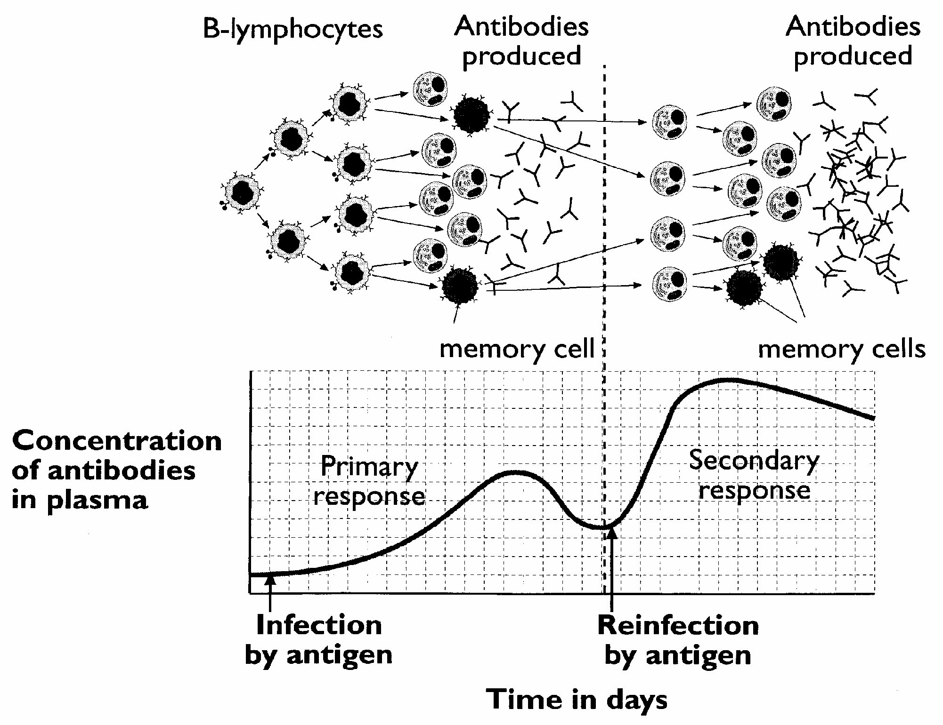
In the primary response there are not many initial B cells to make the antibody and the antibodies only survive in the bloodstream for a few days. In the secondary response they produce antibodies much more quickly and more new memory cells enter the bloodstream to provide long-term immunity from reinfection of the pathogen.

Recall Questions
- What are B cells?
- What is a B plasma cell?
- What is B cell division also known as
- What is a memory cell?
- What are B memory cells?
- What does the humoral immmune response consist of?
- Why is the primary response slow?
- Explain why the secondary response is quicker than the primary immune response.
- What is the primary immune response?
- What is the secondary response?
Exam Questions
Q1. Describe how B-lymphocytes respond when they are stimulated by antigens.
___________________________________________________________________
___________________________________________________________________
___________________________________________________________________
___________________________________________________________________
___________________________________________________________________
___________________________________________________________________
___________________________________________________________________
(4)
Q2. An antigen in a vaccine leads to the production of antibodies. Describe the part played by B lymphocytes in this process.
___________________________________________________________________
___________________________________________________________________
___________________________________________________________________
___________________________________________________________________
___________________________________________________________________
___________________________________________________________________
___________________________________________________________________
(4)
Q3. The drawings show the changes in a B lymphocyte after stimulation by specific antigens.
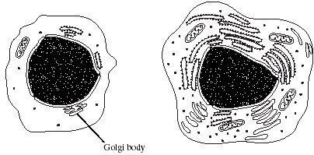
B lymphocyte before stimulation B lymphocyte after stimulation

(ii) Explain how the changes shown in the drawings are related to the function of B lymphocytes.
______________________________________________________________
______________________________________________________________
______________________________________________________________
______________________________________________________________
______________________________________________________________
______________________________________________________________
______________________________________________________________
______________________________________________________________
(4)
Q4. (b) Describe how presentation of a virus antigen leads to the secretion of an antibody against this virus antigen.
___________________________________________________________________
___________________________________________________________________
___________________________________________________________________
___________________________________________________________________
___________________________________________________________________
___________________________________________________________________
___________________________________________________________________
___________________________________________________________________
(3)
(c) Collagen is a protein produced by cells in joints, such as the knee.
Rheumatoid arthritis (RA) is an auto-immune disease. In an auto-immune disease, a person’s immune system attacks their own cells. RA causes pain, swelling and stiffness in the joints.
Scientists have found a virus that produces a protein very similar to human collagen. Suggest how the immune response to this viral protein can result in the development of RA.
___________________________________________________________________
___________________________________________________________________
___________________________________________________________________
___________________________________________________________________ (2)

Homework
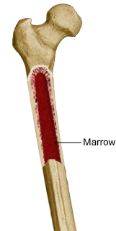
2.2 B Lymphocytes (B cells)

B cells are made in bone _________________. B cells are responsible for _________________ immunity. Body fluids are also known as _________________. Antibodies are soluble in body fluids and so are found in _________________ and tissue fluid. There are possibly 10 million types of B cell, each having a different_________________ that responds to a specific antigen. An antigen invading the blood or tissue fluid will have a _________________ B cell with an antibody on its surface that exactly fits the shape of the foreign antigen. The B cell then divides and multiplies by mitosis to make many new _________________. Each clone will develop in one of two types of cell; a plasma cell or a _________________ cells. Plasma cells make antibodies and can make 2000 every second in their short life of only a few _________________. The antibodies destroy pathogens and toxins they make. Plasma cells have an immediate effect known as a _________________ immune response. Memory cells can live for _________________circulating in the blood and tissue fluid. These calls do not produce antibodies. If the same antigen is encountered in the future they divide rapidly into _________________cells and more memory cells. Memory cells provide long-term immunity known as the _________________ immune response. The secondary response is more rapid and of greater _________________ than the primary one.
Draw a simple flow diagram to show the role of B cells in humoral immunity:

memory antibody clones complementary primary
intensity plasma decades secondary
humoral blood humour marrow days

- In the space below, draw a graph (time on x axis and antibody concentration on the y axis) to show how the the antibody concentration of the blood changes during after primary infection and then after secondary infection a few months later.

Recall Question Answers
Question | Answer
What are B cells? | lymphocytes that secrete antibodies in response to antigens. antibodies bind to the antigens on the cell surface membrane to form an antigen antibody complex. each b cell has a different shaped antibody which binds to only one specific antigen. they allow phagocytes to recognise and destroy the cell.
What is a B plasma cell? | A type of B cell which secrete LOTS of monoclonal antibodies (all complementary to a specific antigen)
What is B cell division also known as | Clonal selection
What is a memory cell? | Remain for years in the body, enabling an individual to respond more quickly to the same antigen in the future
What are B memory cells? | Record the specific antibodies needed to bind to the antigen. they remain or months or years in the body, enabling the individual to respond more quickly to the same antigen in the future.
What does the humoral immmune response consist of? | B cells- antibodies, clonal selection.
Why is the primary response slow? | there aren't many B cells that can make the antibody needed to bind to the antigen
Explain why the secondary response is quicker than the primary immune response. | B- memory cells are activated and divide into plasma cells, producing antibodies. T-memory cells are activated and produce T-cells to kill the pathogen. FEWER STEPS!
What is the primary immune response? | Immune response the first time the body is exposed to a particular foreign antigen. B cells take 10 to 17 days to produce sufficient antibody producing cells. the person is likely to suffer symptoms of the infection during this time
What is the secondary response? | if the same pathogen enters the body again the immune system will produce a quicker stronger immune response. the b memory cells produced in the primary response can differentiate immediately to produce plasma cells and release antibodies.
Lesson 4 Antibodies and Natural/Passive Immunity
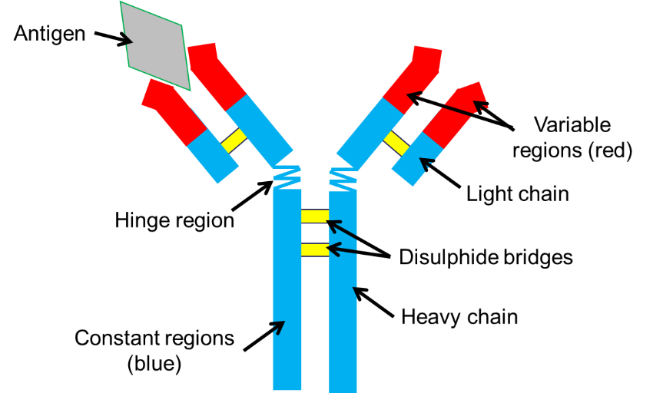
Antibodies are proteins which bind to antigens to form an antigen-antibody complex.
Antibody Structure:
Antibodies are proteins made up of four polypeptide chains (quaternary structure), 2 heavy and 2 light. Each chain has a variable region and a constant region. The chains are connected by disulphide bridges.
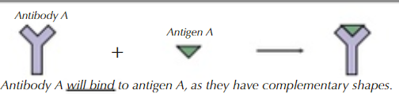
All antibodies have the same constant regions that allow then to bind to receptors on immune system cells. They have two variable regions which are the antigen binding sites so they will have a unique tertiary structure complementary to an antigen. One antibody can bind to two pathogens at once.

How antibodies work
Agglutination: Antibodies bind to antigens on pathogens and cause them to clump together, these clumps are then destroyed by phagocytosis. This makes it easier for phagocytes to engulf more pathogens at a time.
Neutralising Toxins: Some antibodies work by neutralising toxins released by pathogens
Preventing Viruses from Entering Host Cells: Viruses have spike proteins on their surface which recognise and bind to receptors on the surface of the host cell which allow them entry into the cell. Antibodies can bind to these on viruses and stop them attaching to their host cells.
Antigenic Variability
Memory cell function explains why we generally only catch chicken pox or measles once. The pathogens causing each of these diseases are of a single type and thus have the same Antigen, they are rapidly identified by the memory cells and a secondary immune response is triggered which quickly wipes out the virus.
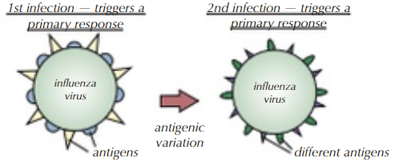
Some pathogens can form different strains (caused by mutations in genetic material) which often have different antigens – this is called antigenic variation. This means that if you are re-infected a second time the memory cells will not recognise the antigen and won’t be activated and the antibodies made last time won’t be complimentary so the body has to start again with the primary response so you still get symptoms.
Antigenic variation is common in influenza and HIV, they make it hard to produce vaccines against these pathogens. Every year a new flu vaccine has to be made that is most effective against the most recently circulating strain of the virus in the population.

Recall Questions
- What is an antibody?
- Describe the antibody structure
- State the variable region on an antibody
- Describe the importance of the variable region of an antibody.
- What is the constant region?
- How do antibodies help clear up an infection?

Exam Questions
Q1. The diagram shows an antibody molecule.
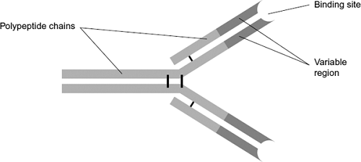
(a) What is the evidence from the diagram that this antibody has a quaternary structure?
___________________________________________________________________
___________________________________________________________________
(1)
(c) Scientists use this antibody to detect an antigen on the bacterium that causes stomach ulcers. Explain why the antibody will only detect this antigen.
___________________________________________________________________
___________________________________________________________________
___________________________________________________________________
___________________________________________________________________
___________________________________________________________________
___________________________________________________________________ (3)
Q2. (a) (i) What is an antibody?
______________________________________________________________
______________________________________________________________
______________________________________________________________ (2)
(ii) Describe how antibodies are produced in the body following a viral infection.
______________________________________________________________
______________________________________________________________
______________________________________________________________
______________________________________________________________
______________________________________________________________
______________________________________________________________
______________________________________________________________
______________________________________________________________
______________________________________________________________
______________________________________________________________
______________________________________________________________ (6)
Q3.
(a) NMO is a disease that leads to damage to nerve cells in the spinal cord.
A person with NMO produces anti-AQP4 antibody that attacks only these nerve cells.
Explain why the anti-AQP4 antibody only damages these cells.
___________________________________________________________________
___________________________________________________________________
___________________________________________________________________
___________________________________________________________________
___________________________________________________________________
___________________________________________________________________
___________________________________________________________________
___________________________________________________________________
(4)
Homework
Corona virus
In December 2019 a new Corona virus was identified in the Chinese city of Wuhan. Sufferers of this new virus were presenting with symptoms such as shortness of breath, a dry cough, fever and pneumonia. An autopsy of a recent victim showed high levels of alveolar damage including dead cells and proteins lining the alveoli and squamous epithelial cells peeling away. Blood tests of those infected with this new virus are showing many molecules associated with inflammation, overstimulation of cytotoxic T cells but also overall low levels of lymphocytes.
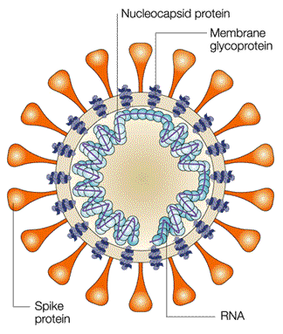
Epidemiologists are studying the spread of 2019-nCoV, as it has been named, and have determined it is likely to have originated from the seafood market in Wuhan. Through aerosol transmission, contact transmission and direct transmission Covid-19 disease has spread rapidly and cases have now been confirmed in over 30 countries
2019-nCoV is part of the Corona virus family and as such has the structure of a single strand of RNA surrounded by a protein envelope. (Figure 1)
Molecular biologists have sequenced the RNA strand and found it to contain 30,000 bases and it shows a strong genetic similarity to Chinese Horseshoe bat corona virus.
Structural biologists have used advanced imaging techniques to determine the intricate, three-dimensional structures of biological molecules found in the protein envelope.
Figure 1
The spike protein has been of special interest as it is thought to be the molecule used by the virus to gain entry to host cells. Analysis of the tertiary structure of the spike proteins has found it to be able to bind to ACE2 receptor proteins.
ACE2 receptors are transmembrane peptidase molecules found in the plasma membranes of human cells. It is expressed in many different tissues including lung, cardiac, kidney and gastrointestinal tissues.
When 2019-nCoV infects a cell, it hijacks the existing molecular machinery to create long chains of proteins required by the virus to generate even more copies of itself. These long viral proteins, however, only become functional when cut into smaller pieces by proteases. Thus, coronavirus proteases like that of 2019-nCoV play an integral role in propagating the virus.
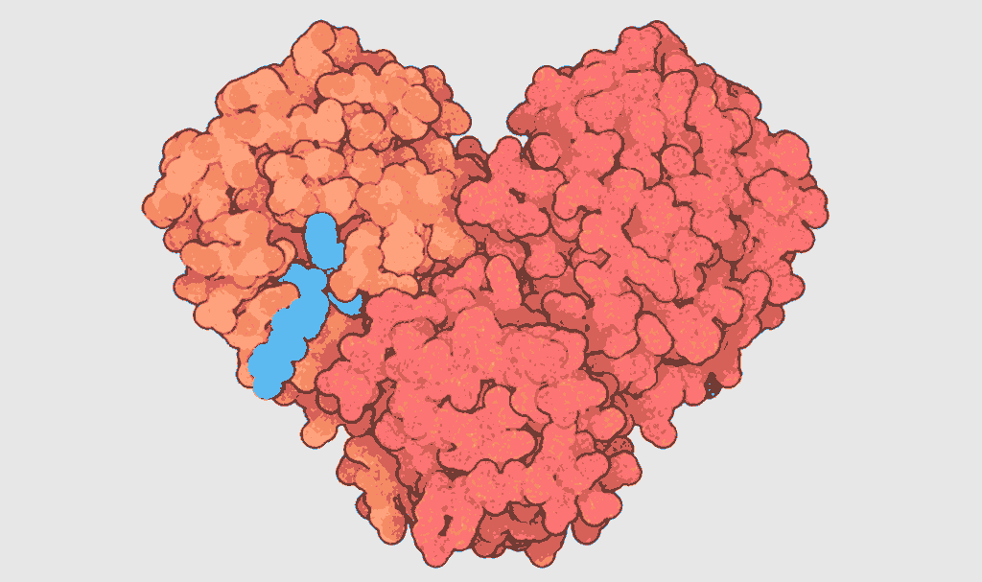
Figure 2
As seen in Figure 2, the protease’s distinctive heart shape is the result of two identical protein subunits (coloured orange and red) coming together to form a functional protease. Similar to a lock and its key, the protease’s activity is triggered by the binding of molecules to specific points on the protease called active sites (shown in blue). The binding of a substrate effectively switches the protease on, allowing it to cut the long viral protein strands into smaller chains.
Now scientists know the structure of these two important proteins (spike and protease) they can apply this knowledge in trying to create treatments and vaccines to this virus. Finding a protease inhibitor which will work effectively against this enzyme would be a first step in preventing the virus from replicating in the host cells. If a drug could be developed which would stop the spike protein binding to the ACE2 receptors this could stop the virus spreading to other cells.
Other Biologists are trying to create a vaccine against the spike proteins. The vaccine would need to contain a molecule which would induce the host to create antibodies against the spike proteins in a primary immune response. If the host were to then come into contact with 2019-nCoV they would mount a secondary immune response and hopefully show no symptoms of the virus.
Questions
- Why does a host increase their core temperature when infected with a pathogen?
- Why would the dead cells & proteins lining the alveoli cause the host issues?
- Which molecules are associated with inflammation? Which cells release these chemicals? What effect do they have on the body?
- What role do cytotoxic T cells play in the immune system?
- What is epidemiology?
- What are aerosol, direct & contact transmission?
- Name 3 differences between RNA & DNA
- Covid-19 is part of the corona virus family. What is the sequence of taxonomic groups used in classification (including family)?
- The RNA of Covid-19 has 30,000 bases – what is the maximum number of amino acids that could be coded for by this nucleic acid? Explain your answer.
- What is the level of protein structure being described as ‘intricate three dimensional structure’?
- What can you deduce about the structure of the spike protein from the fact it binds to the ACE2 receptor?
- What can you deduce about ACE2 receptors from the description ‘transmembrane peptidase’?
- ACE2 receptors are expressed in many types of tissue –what does express mean? How does it occur?
- Covid-19 ‘hijacks existing molecular machinery’ – what is this referring to?
- The Protease enzyme has 2 identical subunits – which level of protein structure is being described here?
- Scientists are trying to find suitable inhibitors of protease – what are the two methods of inhibition and how do they differ?
- Which cells produce antibodies?
- From memory sketch and label an antibody.
- How do primary and secondary immune responses differ? Why?

Recall Question Answers
What is an antibody? | Bind to antigens to form an antigen-antibody complex
Describe the antibody structure | Four polypeptide chains, 2 heavy and 2 light. each chain has a variable region and a constant region
State the variable region on an antibody | Form the antigen binding site. The shape is complementary to a particular antigen, its shape varies between antibodies
Describe the importance of the variable region of an antibody. | Has a unique protein structure, which provides specificity to one type of antigen.
What is the constant region? | Allow binding to receptors on immune system cells. It is the same in all antibodies.
How do antibodies help clear up an infection? | Agglutinating pathogens, neutralising toxins, preventing the pathogen binding to human cells

Lesson 5 Natural/Passive Immunity
Vaccines
A way of introducing antigens of a dead or weakened pathogen into the body to stimulate the production of antibodies and memory cells. One dose induces a primary immune response, multiple doses can increase the number of antibodies and memory cells in the blood stream through the secondary response. Vaccines are long lasting because they produce memory cells which can produce complimentary antibodies to the antigen. Many vaccines can contain multiple antigens to protect against different strains of pathogens (flu jab) or different diseases (e.g MMR).
Pathogens prepared for viruses are made harmless by:
- Killing but leaving antigens unaffected e.g. Cholera vaccine
- Weakening (attenuation - heating) but leaving antigens unaffected e.g.oral vaccine against polio
- Purified antigens removed from pathogen e.g. vaccine against hepatitis B
- Using inactivated toxins called toxoids that are harmless but trigger same immune response e.g Tetanus injection

BUT REMEMBER – because they contain foreign antigens there will still be a primary immune response which can have symptoms such as swelling, mild fever, runny nose etc. This is why some people have “cold-like” symptoms after a flu jab.

Ethical Issues with Vaccines
- All vaccines are tested on animals first (same as all drugs)
- Humans in clinical trials may put themselves at risk because they believe they may be “immune”
- Some people refuse vaccines over fears of side effects, they are protected by herd immunity in the same way that people who can’t get the vaccine.
- If there was a new disease, difficult decisions would be made about who would be the first to receive it.

Why don’t vaccinations fully eliminate diseases?
- Fails to induce immunity in some people (immunodeficiency)
- People get infected before enough Abs are generated by vaccine to afford protection (slow primary response)
- Antigenic variability – pathogens can mutate
- Many different strains – can’t vaccinate against all
- Objections to vaccinations based on moral, religious and ethical grounds

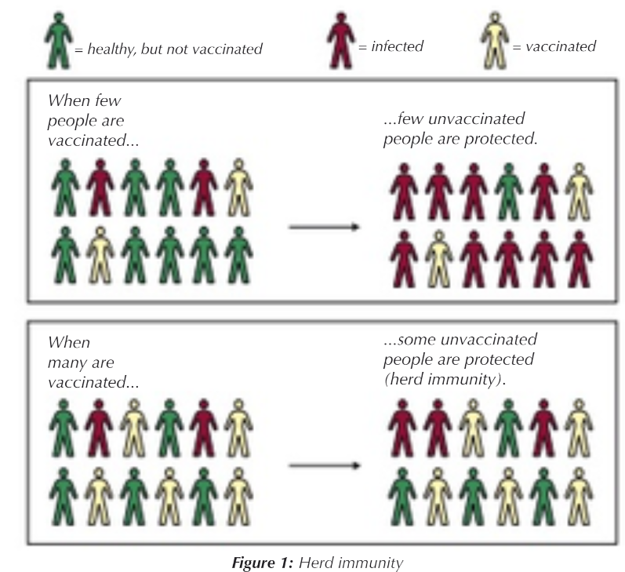
The Importance of Herd Immunity
‘Herd immunity’ is a concept used for vaccination, in which a population can be protected from a certain virus if a threshold of vaccination is reached.
Herd immunity is achieved by vaccinating a large amount of the population so that enough people are immune to the virus it cannot spread far through the population. This protects those who cannot have the vaccine for medical reasons.

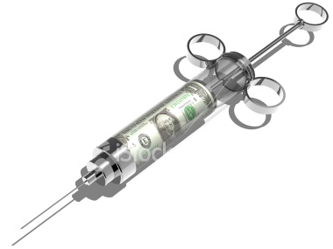
Active Immunity
- The body makes antibodies after being exposed to an antigen
- Natural active immunity – you become immune after catching the disease.
- Artificial active immunity- you become immune after being given a vaccination containing harmless dose of the antigen.
- Long term protection because memory cells produced.

Passive Immunity
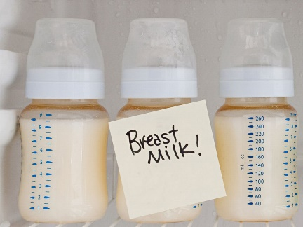
- The body is given the antibodies that have been made by a different organism.
- Natural passive immunity – a baby gets antibodies through placenta and in breast milk
- Artificial passive immunity - you are injected with antibodies e.g. if you get tetanus, you will be injected with antibodies against tetanus toxin.
- Short term as no immune response involved and no memory cells produced

Problems with Passive Immunity
- Maternal antibodies pass from placenta into foetal blood
- Breast feeding passes antibodies present in the colostrum (first milk produced after giving birth)
- Protection is temporary and only lasts few months after birth - Antibodies will be broken down in the spleen & liver, no memory cells are formed.

TASK: Complete the table to summarise the four two types of immunity
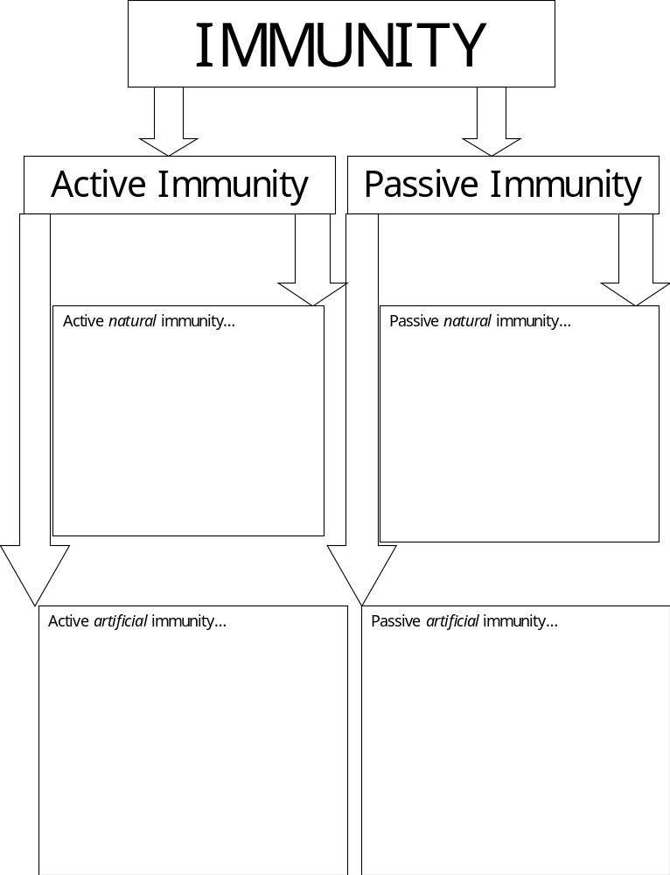

Recall Questions
- What is active natural immunity?
- What is passive immunity?
- Give 2 differences between passive & active immunity.
- What is a vaccine?
- What is herd immunity?
- What is natural active immunity?
- What is passive natural immunity?
- What does active immunity give you?
- What does passive immunity give you?

Exam Questions
Q1. Describe the difference between active and passive immunity.
___________________________________________________________________
___________________________________________________________________
___________________________________________________________________
___________________________________________________________________
___________________________________________________________________
___________________________________________________________________
___________________________________________________________________
___________________________________________________________________
___________________________________________________________________ (5)
Q2. What is vaccination?
___________________________________________________________________
___________________________________________________________________
___________________________________________________________________
__________________________________________________________________ (2)
Q3. (a) What is an antigen?
___________________________________________________________________
___________________________________________________________________
___________________________________________________________________
___________________________________________________________________ (2)
(b) A zookeeper was bitten by a snake. The bite contained venom which is a poison.
He was given an injection of antivenom. This antivenom contained antibodies against this snake venom.
The antivenom did not give the zookeeper lasting protection against this snake venom. Explain why.
___________________________________________________________________
___________________________________________________________________
___________________________________________________________________
___________________________________________________________________
___________________________________________________________________ (2)
Q4. The box jellyfish produces a poison (venom) which enters the blood when a person is stung. A person who has been stung can be treated with an injection of antivenom. This antivenom is produced by injecting small amounts of venom from box jellyfish into sheep, then extracting antibodies from the sheeps’ blood. These antibodies are then injected into the person who has been stung.
(a) If a sheep is injected with the box jellyfish venom on more than one occasion a higher yield of antivenom is obtained. Explain why.
___________________________________________________________________
___________________________________________________________________
___________________________________________________________________
___________________________________________________________________ (2)
(b) Injecting antivenom does not give a person lasting protection against the venom of box jellyfish. Explain why.
___________________________________________________________________
___________________________________________________________________
___________________________________________________________________
___________________________________________________________________ (2)
(c) Suggest one possible problem in injecting people with antivenom made in this way.
___________________________________________________________________
___________________________________________________________________ (1)
Q5.
(a) When a person is bitten by a venomous snake, the snake injects a toxin into the person. Antivenom is injected as treatment. Antivenom contains antibodies against the snake toxin. This treatment is an example of passive immunity.
Explain how the treatment with antivenom works and why it is essential to use passive immunity, rather than active immunity.
___________________________________________________________________
___________________________________________________________________
___________________________________________________________________
___________________________________________________________________
___________________________________________________________________
___________________________________________________________________
___________________________________________________________________
___________________________________________________________________
___________________________________________________________________ (2)
(b) To produce antivenom a mixture of venoms from several snakes of the same species is used.
Suggest why.
___________________________________________________________________
___________________________________________________________________
___________________________________________________________________
___________________________________________________________________
___________________________________________________________________
___________________________________________________________________
(2)

Homework
Vaccination
_____________ immunity produced by introducing ____________ from an outside source; this immunity is short lived since no B cells have been stimulated to continue to produce the antibodies. _______________ is produced by stimulating the body to produce its own antibodies; this is known as vaccination and is long-lasting. Vaccination involves the introduction of a dead or ______________ pathogen into the body. The __________ are recognised by the body and an immune response occurs. _______________ cells are made during this process which remain in the body. This means that if the person comes in to contact with the living pathogen in future then antibodies can be made ____________.

If you vaccinate every member of the population against a disease you should be able to eradicate it. However, so long as more than ~90% of the population is vaccinated then there will be far fewer cases because there are fewer _________ for the pathogen to live and reproduce in. This is known as ________ _______________.
Q1.In the early 1980s, before DNA analysis had been developed, scientists investigated the genetic variation of cheetahs living in captivity. They used skin grafts to do this. They carried out skin grafts on anaesthetised animals by
• removing a small piece of skin from one animal. This animal was the recipient.
• replacing the removed skin by a piece of skin taken from another animal. This animal was the donor.
• attaching the new piece of skin with stitches.
A graft may be accepted by the recipient. It will be rejected if the recipient’s immune system recognises the antigens on the skin as foreign.
Scientists carried out skin grafts between cheetahs living in captivity and domestic cats.
The table shows the data that they obtained.

 | Recipient of skin graft | Donor of  skin graft | Relationship | Time taken for the graft to be rejected / days
 | Domestic cat 1 | Domestic cat 2 | Unrelated | 13
 | Cheetah 1 | Domestic cat 3 | Unrelated | 12
 | Cheetah 1 | Cheetah 2 | Sisters | No rejection after 52 days
 | Cheetah 3 | Cheetah 4 | Unrelated | 49
 | Cheetah 5 | Cheetah 6 | Unrelated | No rejection after 78 days
 | Cheetah 7 | Cheetah 8 | Unrelated | No rejection after 41 days
 | Cheetah 9 | Cheetah 10 | Unrelated | No rejection after 24 days
 | Cheetah 11 | Cheetah 12 | Unrelated | No rejection after 14 days
 | Cheetah 13 | Cheetah 14 | Unrelated | No rejection after 44 days

The scientists also grafted skin from one area to another on the same animal. These grafts were not rejected.
(a) (i) The scientists grafted skin from a domestic cat to a cheetah. Suggest why.
.............................................................................................................................................................
.............................................................................................................................................................
(1)
(ii) They also grafted skin from one area to another on the same animal. Explain why.
.............................................................................................................................................................
.............................................................................................................................................................
(1)
(b) (i) Give three conclusions that you can make from the data in the table above about the time taken for rejection.
1...........................................................................................................................................................
..............................................................................................................................................................
2...........................................................................................................................................................
..............................................................................................................................................................
3...........................................................................................................................................................
.........................................................................................................................................................(3)
(ii) Give one reason why these conclusions may not be reliable.
..............................................................................................................................................................
.........................................................................................................................................................(1)
(iii) There are proteins on the skin of cheetahs that act as antigens. What do the data in the table suggest about these cheetah antigens?
..............................................................................................................................................................
.........................................................................................................................................................(1)
(iv) Antigens are proteins. Explain why a knowledge of antigens can show that animals are genetically similar.
.............................................................................................................................................................
.............................................................................................................................................................
.........................................................................................................................................................(2)
Q2.Scientists tested a claim that modified citrus pectin (MCP) increased the production of antibodies by the immune system.
• They divided a large number of mice into five groups.
• They gave the mice in each group a different amount of MCP in their food.
• The scientists then stimulated antibody production in the mice. They did this by injecting them with a solution containing sheep red blood cells.
The results are shown in the graph.
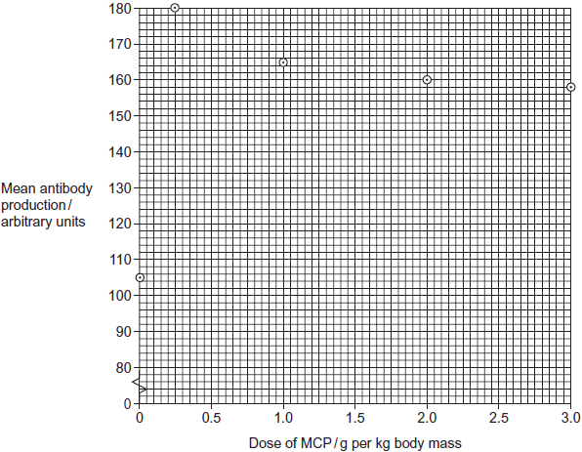
(a) The data obtained in this investigation have been plotted on a graph. How would you join the points? Give a reason for your answer.
.............................................................................................................................................................
.............................................................................................................................................................
.........................................................................................................................................................(1)
(b) Use the graph to describe the effect of MCP on mean antibody production.
.............................................................................................................................................................
.............................................................................................................................................................
.............................................................................................................................................................
........................................................................................................................................................ (2)
(c) Calculate the percentage increase in antibody production from when there was no MCP in the diet to when the dose is 1.0 g per kg.

Answer ....................................................%
(2)
(d) The dose of MCP given to the mice was calculated in g per kg body mass. Explain why the dose was calculated per unit mass.
.............................................................................................................................................................
.........................................................................................................................................................(1)

(e) Explain how antibodies were produced when the mice were injected with sheep red blood cells.
.............................................................................................................................................................
.............................................................................................................................................................
.............................................................................................................................................................
.............................................................................................................................................................
.........................................................................................................................................................(3)
(f) A newspaper suggested that these data show that taking MCP will give people increased resistance to disease. With reference to the data give two reasons why this conclusion may not be valid.
1...........................................................................................................................................................
.............................................................................................................................................................
2...........................................................................................................................................................
.........................................................................................................................................................(2)
Recall Question Answers

What is active natural immunity? | When a person is immune, after naturally contracting an infection.
What is passive immunity? | When a person is immune, by being given antibodies rather than making them. e.g. natural from breastfeeding.
Give 2 differences between passive & active immunity. | Active- lasts longer, memory cells are produced, response takes longer to happen, needs antigen to trigger response.
What is a vaccine? | A low dose of an inactive/dead pathogen are injected- contain antigens to trigger immune response, creating protective memory cells.
What is herd immunity? | If more members of a population have had a vaccine, more people are then protected as a disease can spread less rapidly, even if they haven't had the vaccine themselves.
What is natural active immunity? | When your immune system makes its own antibodies after being stimulated by an antigen (after catching a disease)
What is passive natural immunity? | When a baby receives antibodies from its mother through the placenta and in breast milk
What does active immunity give you? | Long term protection but it develops after a time lag
What does passive immunity give you? | Short term but immediate protection

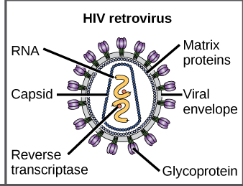
Lesson 6 HIV
HIV Structure
- Membrane Envelope – outer layer
- Capsid – protects genetic information
- RNA (can be DNA in others)
- Glycoprotein – antigens
- Reverse transcriptase enzyme – turns RNA in to DNA

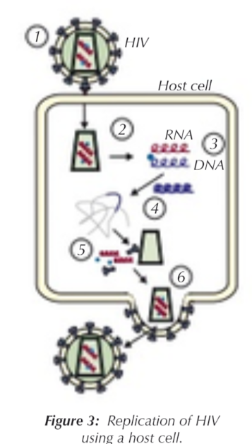
The human immunodeficiency viruses (HIV) are two species of Lentivirus (a subgroup of retrovirus) that infect humans. HIV works by infecting helper T cells (preventing humoral response). The virus replicates in the T cells using their cellular machinery, eventually the cells swell and burst (destroying the cell). Over time, the number of T cells decreases and eventually causes acquired immunodeficiency syndrome (AIDS). AIDS is a condition which is caused by failure of the immune system which allows opportunistic infections (infections that take advantage of the lowering of the body’s defences) and cancers to thrive in the body. People with HIV are said to be “HIV Positive”, they can be diagnosed through a low white blood cell count or through a test to check for presence of viral DNA.
How HIV replicates
1. Glycoprotein molecules on the virus surface bind to CD4 receptors on the surface of T helper cells. This allows the envelope surrounding the virus to fuse with the T helper cell membrane.
2. The capsid is released into the cell where it releases the RNA and reverse transcriptase
3. Reverse transcriptase is used to make DNA from the HIV RNA template
4. The DNA is inserted into the cell's DNA which gets replicated when cells replicate
5. DNA used to make HIV RNA and proteins at host ribosomes
6. Virus particles are assembled which bud off from the cell membrane and go on to infect other cells
Transmission of HIV
You can only be infected with HIV through another person with the virus. HIV is found in the blood and the sexual fluids of an infected person, and in the breast milk of an infected woman. Here are ways you can catch the virus:
- Having unprotected sex with an infected person.
- Close contact with an infected person’s blood e.g sharing of needles for drug use.
- Use of infected blood in a blood transfusion.
- Mother to child - a mother with HIV giving birth to a child (shared through the placenta) or a child drinking the mothers milk – this is knowns as vertical transmission. Babies must be tested at 18 months as it takes time for the virus to replicate and be detectable.

AIDS
People who are HIV positive contract AIDS when their numbers of helper-T cells reach a critical level. The immune systems cannot fight off simple/opportunistic infections that the body would usually defend against such as pneumonia and so these are often what kill the patient.
The initial symptoms of AIDS are lots of minor infections of mucosal membranes and recurring respiratory infections caused by a lower than normal number of T helper cells. It can take around 10 years (if undiagnosed or without any treatment) for an HIV positive patient to develop the symptoms of AIDS. This is because the virus can remain dormant as DNA in host cells.
Treatment:
Antiretroviral drugs are now available which (after 6 months) can reduce the viral load in the body to an “undetectable” level. This means that patients cannot pass on HIV to other people.
Antiretroviral drugs cannot remove the virus from the body – there is no cure once HIV is acquired. The drugs prevent/slow the replication of the virus in the body by blocking the reverse transcriptase enzyme. The best way to prevent transmission is to practice safe sex and discourage the use of needle sharing.
Pre-exposure prophylaxis (PrEP) is an HIV prevention strategy where HIV-negative individuals take anti-retrovirals before coming into contact with HIV to reduce their risk of becoming infected. PrEP has not been widely accepted around the world and isn’t currently available on the NHS, critics argue that many who use the drug see it as an excuse to engage in unsafe sexual practices, and that encouraging people to use PrEP is tantamount to giving them permission to have sex without condoms.
Two people have been “cured” of HIV using stem cell therapy where chemotherapy killed their white blood cells and they received a bone marrow transplant from someone with a naturally occurring CD4 mutation (so HIV can no longer bind and enter cells). This is still considered a cancer treatment and is too aggressive and expensive to be used as a regular HIV cure.

Exam Questions
Q1. The diagram shows a human immunodeficiency virus (HIV).
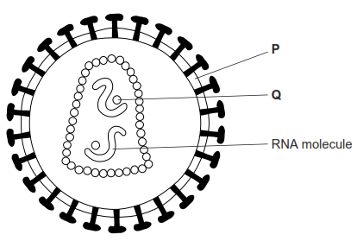
(a) (i) Name structure P and enzyme Q.
Structure P ____________________________________________________
Enzyme Q _____________________________________________________
(2)
(ii) What is the function of the RNA molecules in this virus?
______________________________________________________________
______________________________________________________________
(1)

(b) Describe how new viruses are produced after HIV has infected a T cell.
___________________________________________________________________
___________________________________________________________________
___________________________________________________________________
___________________________________________________________________
___________________________________________________________________
___________________________________________________________________ (3)
Q2.
(a) Describe how HIV is replicated after it has entered a human cell.
___________________________________________________________________
___________________________________________________________________
___________________________________________________________________
___________________________________________________________________
___________________________________________________________________
___________________________________________________________________
___________________________________________________________________
___________________________________________________________________ (4)
(b) The destruction of T-cells by HIV leads to the death of an infected person.
Explain how.
___________________________________________________________________
___________________________________________________________________
___________________________________________________________________
___________________________________________________________________
___________________________________________________________________ (2)
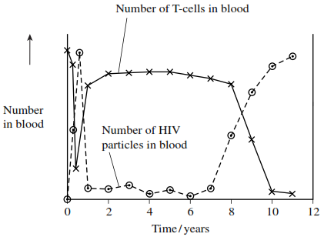
Q3. The graph shows changes in the number of T-cells and HIV particles in the blood of a person following infection.

(b) Explain why the number of HIV particles in the blood
(i) rises during the first few months after infection
______________________________________________________________
______________________________________________________________
______________________________________________________________
______________________________________________________________ (2)
(ii) remains low between 1 and 7 years after infection.
______________________________________________________________
______________________________________________________________ (1)
(c) This person developed a large number of infections about 9 years after he first became infected with HIV. Using information from the graph, explain why.
___________________________________________________________________
___________________________________________________________________
___________________________________________________________________
___________________________________________________________________
___________________________________________________________________
___________________________________________________________________
___________________________________________________________________
___________________________________________________________________ (4)
Q4.

The human immunodeficiency virus (HIV) leads to the development of
acquired immunodeficiency syndrome (AIDS). Eventually, people with
AIDS die because they are unable to produce an immune response
to pathogens.
 | Scientists are trying to develop an effective vaccine to protect people  against HIV. There are three main problems. HIV rapidly enters host  cells. HIV causes the death of T cells that activate B cells. HIV shows  a lot of antigenic variability. | 5
 | Scientists have experimented with different types of vaccine for HIV.  One type contains HIV in an inactivated form. A second type contains  attenuated HIV which replicates in the body but does not kill host cells.  A third type uses a different, non-pathogenic virus to carry genetic  information from HIV into the person's cells. This makes the person's  cells produce HIV proteins. So far, these types of vaccine have not  been considered safe to use in a mass vaccination programme. | 10  15
Use the information in the passage and your own knowledge to answer the following questions.
(a) People with AIDS die because they are unable to produce an immune response to pathogens (lines 2-4).
Explain why this leads to death.
___________________________________________________________________
___________________________________________________________________
___________________________________________________________________
___________________________________________________________________
___________________________________________________________________
___________________________________________________________________ (3)
(b) Explain why each of the following means that a vaccine might not be effective against HIV.
(i) HIV rapidly enters host cells (lines 6-7).
______________________________________________________________
______________________________________________________________
______________________________________________________________
______________________________________________________________
_____________________________________________________________ (2)
(ii) HIV shows a lot of antigenic variability (lines 7-8).
______________________________________________________________
______________________________________________________________
______________________________________________________________
______________________________________________________________
______________________________________________________________ (2)
(c) So far, these types of vaccine have not been considered safe to use in a mass vaccination programme (lines 14-15).
Suggest why they have not been considered safe.
___________________________________________________________________
___________________________________________________________________
___________________________________________________________________
___________________________________________________________________
___________________________________________________________________
___________________________________________________________________ (3)
Homework

The Story Behind the First AIDS Drug
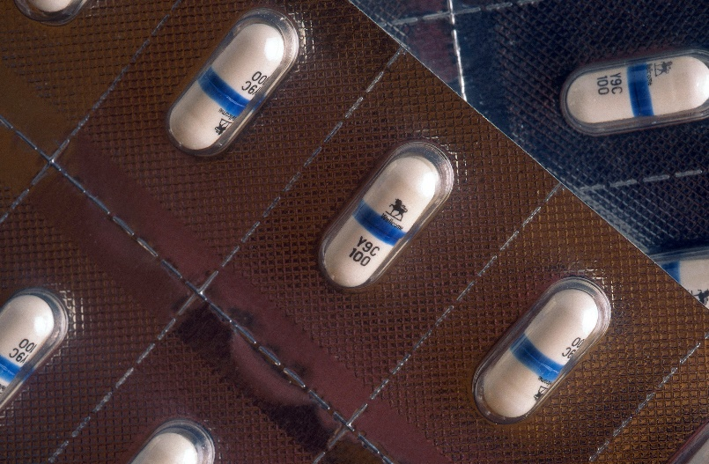

By Alice Park
March 19, 2017
Today, if someone is diagnosed with HIV, he or she can choose among 41 drugs that can treat the disease. And there’s a good chance that with the right combination, given at the right time, the drugs can keep HIV levels so low that the person never gets sick.
That wasn’t always the case. It took seven years after HIV was first discovered before the first drug to fight it was approved by the U.S. Food and Drug Administration (FDA). In those first anxious years of the epidemic, millions were infected. Only a few thousand had died at that point, but public health officials were racing to keep that death rate from spiking — the inevitable result if people who tested positive weren’t treated with something.
As it turned out, their first weapon against HIV wasn’t a new compound scientists had to develop from scratch — it was one that was already on the shelf, albeit abandoned. AZT, or azidothymidine, was originally developed in the 1960s by a U.S. researcher as way to thwart cancer; the compound was supposed to insert itself into the DNA of a cancer cell and mess with its ability to replicate and produce more tumor cells. But it didn’t work when it was tested in mice and was put aside.
Two decades later, after AIDS emerged as new infectious disease, the pharmaceutical company Burroughs Wellcome, already known for its antiviral drugs, began a massive test of potential anti-HIV agents, hoping to find anything that might work against this new viral foe. Among the things tested was something called Compound S, a re-made version of the original AZT. When it was throw into a dish with animal cells infected with HIV, it seemed to block the virus’ activity.
The company sent samples to the FDA and the National Cancer Institute, where Dr. Samuel Broder, who headed the agency, realized the significance of the discovery. But simply having a compound that could work against HIV wasn’t enough. In order to make it available to the estimated millions who were infected, researchers had to be sure that it was safe and that it would indeed stop HIV in some way, even if it didn’t cure people of their infection. At the time, such tests, overseen by the FDA, took eight to 10 years.
Patients couldn’t wait that long. Under enormous public pressure, the FDA’s review of AZT was fast tracked — some say at the expense of patients.
Scientists quickly injected AZT into patients. The first goal was to see whether it was safe — and, though it did cause side effects (including severe intestinal problems, damage to the immune system, nausea, vomiting and headaches) it was deemed relatively safe. But they also had to test the compound’s effectiveness. In order to do so, a controversial trial was launched with nearly 300 people who had been diagnosed with AIDS. The plan was to randomly assign the participants to take capsules of the agent or a sugar pill for six months. Neither the doctor nor the patient would know whether they were on the drug or not.
After 16 weeks, Burroughs Wellcome announced that they were stopping the trial because there was strong evidence that the compound appeared to be working. One group had only one death. Even in that short period, the other group had 19. The company reasoned that it wouldn’t be ethical to continue the trial and deprive one group of a potentially life-saving treatment.
Those results — and AZT — were heralded as a “breakthrough” and “the light at the end of the tunnel” by the company, and pushed the FDA approve the first AIDS medication on March 19, 1987, in a record 20 months.
But the study remains controversial. Reports surfaced soon after that the results may have been skewed since doctors weren’t provided with a standard way of treating the other problems associated with AIDS — pneumonia, diarrhea and other symptoms — which makes determining whether the AZT alone was responsible for the dramatic results nearly impossible. For example, some patients received blood transfusions to help their immune systems; introducing new, healthy blood and immune cells could have helped these patients battle the virus better. There were also stories of patients from the 12 centers where the study was conducted pooling their pills, to better the chances that they would get at least some of the drug rather than just placebos.
And there were still plenty of questions left unanswered about the drug when it was approved. How long did the apparent benefits last? Could people who weren’t sick yet still benefit? Did they benefit more than those further along in their disease?
Such uncertainty would not be acceptable with a traditional approval, but the urgent need to have something in hand to fight the growing epidemic forced FDA’s hand. The people in the trial were already pressuring the company and the FDA to simply release the drug — if there were something that worked against HIV, they said, then it was not ethical to withhold it.
The drug’s approval remains controversial to this day, but in a world where treatment options are so far advanced it can be hard to imagine the sense of urgency and the social pressure permeating the medical community at the time. AIDS was an impending wave that was about to crash on the shores of an unsuspecting — and woefully unprepared — populace. Having at least one drug that worked, in however limited a way, was seen as progress.
In the years since, it’s become clear that no single drug is the answer to fighting HIV. People taking AZT soon began showing rising virus levels — but the virus was no longer the same, having mutated to resist the drug. More drugs were needed, and AIDS advocates criticized the FDA for not moving quickly enough to approve additional medications. And side effects including heart problems, weight issues and more reminded people that anything designed to battle a virus like HIV was toxic.
Today, there are several classes of HIV drugs, each designed to block the virus at specific points in its life cycle. Used in combination, they have the best chance of keeping HIV at bay, lowering the virus’s ability to reproduce and infect, and ultimately, to cause death. These so-called antiretroviral drugs have made it possible for people diagnosed with HIV to live long and relatively healthy lives, as long they continue to take the medications.
And for most of these people, their therapy often still includes AZT.
AZT FACTS
Zidovudine (ZDV), also known as azidothymidine (AZT), is an antiretroviral medication used to prevent and treat HIV/AIDS. It is generally recommended for use with other antiretrovirals. It may be used to prevent mother-to-child spread during birth or after a needlestick injury.
ZDV is of the nucleoside analogue reverse-transcriptase inhibitor (NRTI) class. It works by inhibiting the enzyme reverse transcriptase that HIV uses to make DNA and therefore decreases replication of the virus.
Zidovudine was first described in 1964. It was approved in the United States in 1986 and was the first treatment for HIV. It is on the World Health Organization's List of Essential Medicines, the most effective and safe medicines needed in a health system.

Side Effects
Common side effects include headaches, fever, and nausea. Serious side effects include liver problems, muscle damage, and high blood lactate levels.
Early long-term higher-dose therapy with AZT was initially associated with side effects that sometimes-limited therapy, including anaemia, neutropenia, hepatotoxicity, cardiomyopathy, and myopathy. All of these conditions were generally found to be reversible upon reduction of AZT dosages. They have been attributed to several possible causes, including transient depletion of mitochondrial DNA and decreased sensitivity of the γ-DNA polymerase in some cell mitochondria.
Anaemia due to AZT was successfully treated using erythropoietin to stimulate red blood cell production.
Today, side-effects are much less common with the use of lower doses of AZT.

Viral resistance
Even at the highest doses that can be tolerated in patients, AZT is not potent enough to prevent all HIV replication and may only slow the replication of the virus and progression of the disease.
Prolonged AZT treatment can lead to HIV developing resistance to AZT by mutation of its reverse transcriptase. To slow the development of resistance, physicians generally recommend that AZT be given in combination with another reverse transcriptase inhibitor and an antiretroviral from another group, such as a protease inhibitor, non-nucleoside reverse transcriptase inhibitor, or integrase inhibitor; this type of therapy is known as HAART (Highly Active Anti Retroviral Therapy).

Questions
1. Suggest and explain why AZT does not destroy HIV in the body but stops or slows the development of AIDS (4 marks)

…………………………………………………………………………………………………………………………………………………………….

……………………………………………………………………………………………………………………………………………………………

……………………………………………………………………………………………………………………………………………………………

……………………………………………………………………………………………………………………………………………………………

…………………………………………………………………………………………………………………………………………………………….

2. Suggest and explain two advantages of using HAART (4 marks)

……………………………………………………………………………………

……………………………………………………………………………………

……………………………………………………………………………………

……………………………………………………………………………………

……………………………………………………………………………………

3. Suggest why high doses of AZT lead to muscle wastage (2 marks)

…………………………………………………………………………………………………………………………………………………………….

……………………………………………………………………………………………………………………………………………………………

……………………………………………………………………………………………………………………………………………………………

Recall Question Answers
How is HIV spread? | Through infected bodily fluids. via sex, sharing needles, direct blood to blood transfer and maternal transmission from mother to unborn child
How does the HIV virus replicate? | Attaches to receptor molecule on host cell membrane. capsid is released into cell and it uncoats and releases nucleic acid. reverse transcriptase is used to make a complementary strand of DNA from the viral RNA template. double stranded DNA is made and inserted into the human DNA (using integrase). host cell enzymes are used to make viral proteins from the viral DNA within the human DNA. the viral proteins are assembled into new viruses and releases from the cell via cell lysis
How does HIV invade T helper cells? | glycoprotein molecules on the virus surface bind to CD4 receptors on the surface of t helper cells this allows the envelope surrounding the virus to fuse with the T helper cell membrane, enabling the viral RNA to enter the cell
What are opportunistic infections? | Infections that occur when the body's defenses are weakened
What are the initial symptoms of AIDS? | Minor infections of mucosal membranes and recurring respiratory infections caused by a lower than normal number of T helper cells
When are people with HIV classed as having AIDS? | When symptoms of failing immune system start to appear or their T helper cell count drops below a certain level
What is AIDs? | When the immune system deteriorates and eventually falls
Which part of the immune system does HIV initially affect? | T-helper cells
Describe how HIV uses reverse transcriptase to replicate in host cells. | HIV attaches to the host cell, releasing the capsid containing viral RNA. Reverse transcriptase is then used to generate complementary DNA- inserted into human DNA and uses host enzymes to to create new proteins- new viruses which can affect more host cells.
Why should HIV testing not occur on a newborn baby? | Would give inaccurate results- need to wait 18 months before baby can be tested as HIV can pass from the mother into baby's bloodstream.
Explain why antibiotics cannot be used on HIV. | Antibiotics are specific to bacteria e.g. murein cell walls, so would be ineffective on viral structure.
Give a short summary of how HIV weakens immune system | HIV invades T helper cells, preventing the activation of macrophages, B cells and T killer cells, which weakens the immune response

Lesson 7 Antibodies in Medicine
Monoclonal Antibodies
Antibodies are produced by plasma cells which are all clones of one B-cell hence the name monoclonal (one clone).
They are useful because they can be produced outside the body and they are reactive with only one type of antigen.
They have three main medical uses:
- To target medication to specific cell types by attaching a therapeutic drug to an antibody (radioimmunotherapy)
- Pregnancy testing
- Medical diagnosis by identifying proteins or antigen presence using the ELISA test
Radioimmunotherapy
- Allows doctors to target radiation to specific sites.
- Links radioactive atoms to monoclonal antibodies that deliver the radioactivity by seeking out and latching onto proteins found on cancer cells.
- Doctors can concentrate radiation at tumour sites, reducing the amount of radiation that reaches healthy tissue.
- They can use it to find tumours that may have spread in the body to target therapy where it is needed.
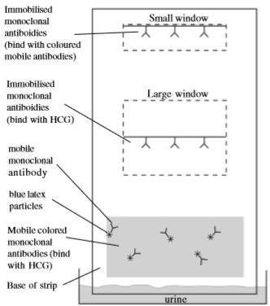
Pregnancy Tests
- Antibodies complimentary to hCG protein are bound to a coloured bead.
- hCG in urine binds to antibodies
- Urine moves up the strip carrying beads
- Immobilised antibodies which bind to hCG create first “blue line”
- Immobilised antibodies which bind to coloured beads create second “blue line” if hcG is present
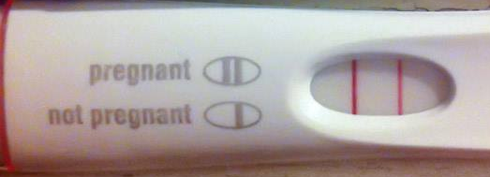

ELISA Tests
Enzyme Linked ImmunoSorbent Assay
Can be used to test for the presence of any antigen or antibody. E.g HIV diagnosis or allergies
An antibody is bound to an enzyme, this enzyme reacts with a substrate to produce a colour change. The antibody will be complementary and bind to the antigen or an antibody the test is designed to detect. There is a washing step which will remove any unbound antibodies (plus the attached enzyme) so the more antigen there is in the sample the more colour change there will be because the more enzymes will be present to react with the substrate.
There are two types: Direct - this just involves one antibody binding to an antigen – used to look for the presence of an antigen in a sample.
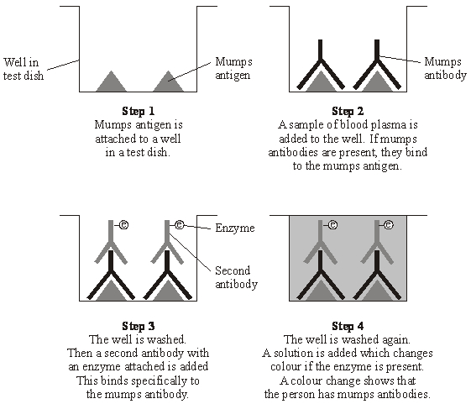
Indirect - this uses multiple antibodies. Antigens are immobilised and the sample being checked for antibodies is added, a wash step occurs before a second antibody is added which will bind to the antibodies attached to the antigens if present. This antibody has the enzyme bound that will change colour. An example of this can be seen in the mumps diagram.
Indirect ELISAs can be more sensitive than direct detection methods, but there is also the risk of cross-reactivity with the antigen, which could cause higher background readings. Indirect ELISAs also take longer due to the extra step. An advantage is that you can use the same secondary antibody (with the enzyme) for multiple different assays.
Recall Questions
- What are monoclonal antibodies?
- Describe how monoclonal antibodies can be used in anti-cancer drugs.
- What is an ELISA test?
- What is the main difference between a direct & an indirect ELISA test.

Exam Questions
Q1. Malaria is a disease caused by parasites belonging to the genus Plasmodium. Two species that cause malaria are Plasmodium falciparum and Plasmodium vivax.
A test strip that uses monoclonal antibodies can be used to determine whether a person is infected by Plasmodium. It can also be used to find which species of Plasmodium they are infected by.
• A sample of a person’s blood is mixed with a solution containing an antibody, A, that binds to a protein found in both species of Plasmodium. This antibody has a coloured dye attached.
• A test strip is then put into the mixture. The mixture moves up the test strip by capillary action to an absorbent pad.
• Three other antibodies, B, C and D are attached to the test strip. The position of these antibodies and what they bind to is shown in Figure 1.

Figure 1
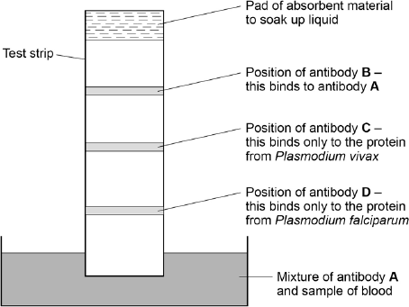
(a) Explain why antibody A attaches only to the protein found in species of Plasmodium.
___________________________________________________________________
___________________________________________________________________
___________________________________________________________________
___________________________________________________________________
(2)
(b) Antibody B is important if this test shows a person is not infected with Plasmodium. Explain why antibody B is important.
___________________________________________________________________
___________________________________________________________________
___________________________________________________________________
___________________________________________________________________ (2)
(c) One of these test strips was used to test a sample from a person thought to be infected with Plasmodium. Figure 2 shows the result.
Figure 2
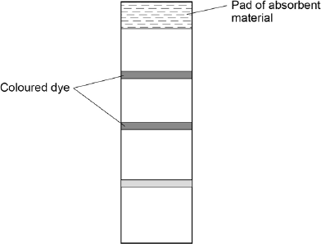
What can you conclude from this result?
Explain how you reached your conclusion.
___________________________________________________________________
___________________________________________________________________
___________________________________________________________________
___________________________________________________________________
___________________________________________________________________
___________________________________________________________________ (4)
Q2. Giardiasis is an intestinal disease. It is caused by the microorganism Giardia lamblia. The drawing shows some of the structures present in G. lamblia.
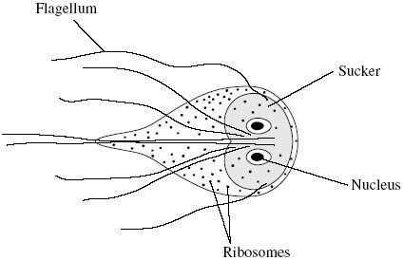
(a) Name one structure shown in the drawing which confirms that G. lamblia is a eukaryotic organism
________________________________
_________________________________
(1)

(b) A test has been developed to find out whether a person is infected with G. lamblia. The test is shown in the flow chart.
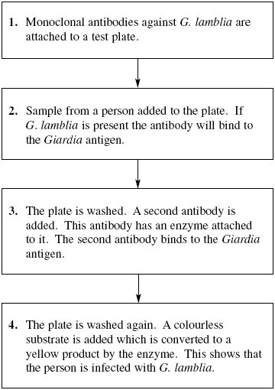
(i) Explain why the antibodies used in this test must be monoclonal antibodies.
______________________________________________________________
______________________________________________________________ (1)
(ii) Explain why the Giardia antigen binds to the antibody in step 2.
______________________________________________________________
______________________________________________________________ (1)
(iii) The plate must be washed at the start of step 4, otherwise a positive result could be obtained when the Giardia antigen is not present. Explain why a positive result could be obtained if the plate is not washed at the start of step 4.
______________________________________________________________
______________________________________________________________
______________________________________________________________ (2)
Q3. The figure below shows a test that has been developed to find out if a person has antibodies to the human immunodeficiency virus (HIV) antigen.

Step 1 | HIV antigens are attached to a test well in a dish.
Step 2 | A sample of blood plasma is added to the well.  If HIV antibodies are present, they bind to the HIV antigen.
Step 3 | The well is washed.  A second antibody with an enzyme attached is then added.  This binds specifically to the HIV antibody.
Step 4 | The well is washed again.  A yellow solution is added, which changes to blue if the enzyme is present. A blue colour shows that the person has HIV antibodies.
(a) This test only detects the presence of HIV antibodies. Give two reasons why it cannot be used to find out if a person has AIDS.
1. _________________________________________________________________
___________________________________________________________________
2. _________________________________________________________________
___________________________________________________________________
(2)
(b) The solution will remain yellow if a person is not infected with HIV. Explain why.
___________________________________________________________________
___________________________________________________________________
___________________________________________________________________
___________________________________________________________________
(2)
(c) A mother who was infected with HIV gave birth to a baby. The baby tested positive using this test. This does not prove the baby is infected with HIV.
Explain why.
___________________________________________________________________
___________________________________________________________________
___________________________________________________________________
___________________________________________________________________
(2)
(d) A control well is set up every time this test is used. This is treated in exactly the same way as the test wells, except that blood plasma is replaced by a salt solution.
Use information from the figure above to suggest two purposes of the control well.
1. _________________________________________________________________
___________________________________________________________________
2. _________________________________________________________________
___________________________________________________________________
(2)

Q4.
Read the following passage.

Pathogens affect humans. They also affect farm animals. Once pathogens have entered the body of an animal they can cause disease. Vets sometimes have difficulty identifying the disease from which a particular animal is suffering. Until recently, they have had to take blood samples and send them to a laboratory. The laboratory carries out tests on the sample.  New tests have been developed. Some of these new tests use monoclonal antibodies. Tests using monoclonal antibodies are fast, specific and allow vets to identify a disease while they are still on the farm.  Brucellosis is a disease of cattle. It is caused by bacteria. These bacteria can infect people who drink milk or eat dairy products from infected cattle. A test using monoclonal antibodies allows vets to identify cattle that are carriers. The carriers are cattle that carry the brucellosis bacteria but do not show any symptoms of the disease. |  | 5  10
Use the information from the passage and your own knowledge to answer the following questions.
(a) Other than bacteria, name one type of pathogen (line 1).
___________________________________________________________________
(1)
(b) Give two ways in which a pathogen may cause disease when it has entered the body (lines 1–2).
1. _________________________________________________________________
___________________________________________________________________
2. _________________________________________________________________
___________________________________________________________________
(2)
(c) Some new tests use monoclonal antibodies (lines 6–7).
(i) Explain why these antibodies are referred to as monoclonal.
______________________________________________________________
______________________________________________________________
______________________________________________________________
(1)

(ii) Tests using monoclonal antibodies are specific (line 7). Use your knowledge of protein structure to explain why.
______________________________________________________________
______________________________________________________________
______________________________________________________________
______________________________________________________________
______________________________________________________________
______________________________________________________________
(3)
(d) The tests using monoclonal antibodies allow vets to identify brucellosis while they are still on a farm. Explain the advantages of this.
___________________________________________________________________
___________________________________________________________________
___________________________________________________________________
___________________________________________________________________
___________________________________________________________________
___________________________________________________________________
(3)
Recall Question Answers

What are monoclonal antibodies? | Antibodies which are all made from identical B plasma cells- complementary to the same specific antigen.
Describe how monoclonal antibodies can be used in anti-cancer drugs. | Antibodies are specific to antigens on cancerous cells (tumour markers)- the drug binds& accumulates in specific area (much fewer side effects than conventional cancer treatments).
What is an ELISA test? | Where antibodies are attached to an enzyme, which produces a coloured substrate- used in diagnosis.
What is the main difference between a direct & an indirect ELISA test. | Direct- one type of antibody applied to sample/antigen. Indirect- many antibodies present.

