AQA Biology
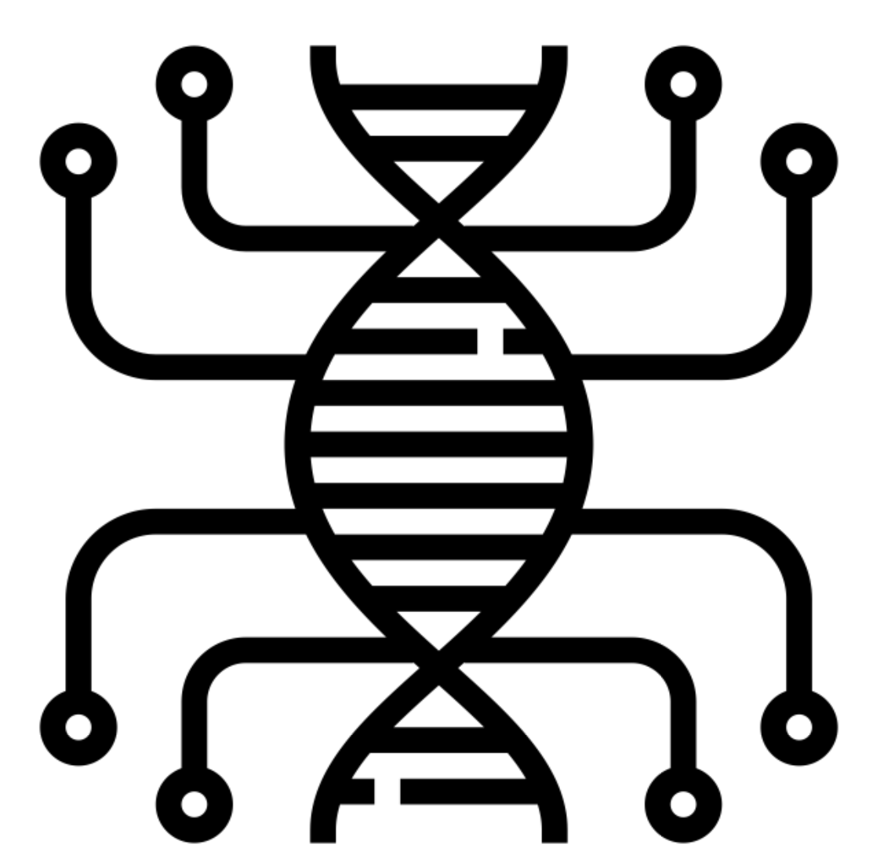

3.8.1 Gene Mutation
3.8.2 Control of Gene Expression

Name: ______________________

Lesson | Exam Question Marks | Homework Checked | Date
Lesson 1 - Mutation
Lesson 2 – Stem Cells
Lesson 3 – Regulation of Gene Expression I
Lesson 4 – Gene Expression and Cancer
Lesson 5 - Regulation of Gene Expression II
EOTT

Specification Section
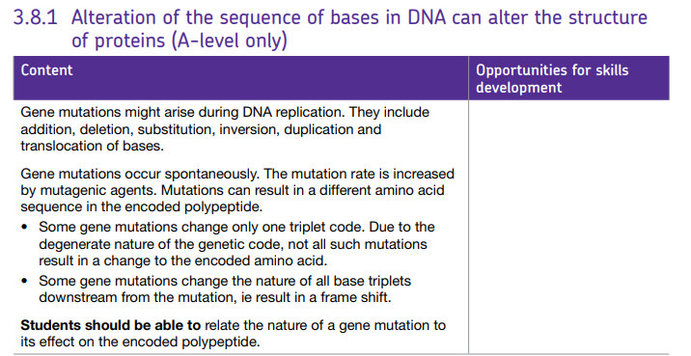
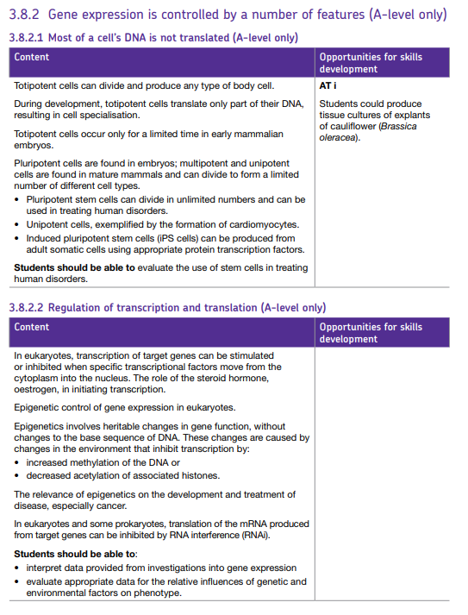
Key word list for 3.8.1-2
Word | Definition | Word | Definition
Mutation | the changing of the structure of a gene, resulting in a variant form that may be transmitted to subsequent generations, caused by the alteration of single base units in DNA, or the deletion, insertion, or rearrangement of larger sections of genes or chromosomes. | Stem cells | Stem cells are special human cells that have the ability to develop into many different cell types, from muscle cells to brain cells. In some cases, they also have the ability to repair damaged tissues.
Addition mutation | In genetics, an insertion (also called an insertion mutation) is the addition of one or more nucleotide base pairs into a DNA sequence | Transcriptional factors | Transcription factors are proteins possessing domains that bind to the DNA of promoter or enhancer regions of specific genes. They also possess a domain that interacts with RNA polymerase II or other transcription factors and consequently regulates the amount of messenger RNA (mRNA) produced by the gene
Deletion mutation | A deletion mutation is a mistake in the DNA replication process which removes nucleotides from the genome. A deletion mutation can remove a single nucleotide, or entire sequences of nucleotides. | Target genes | "Target Gene" often just means "Gene Of Interest", or the particular gene being studied or manipulated in an experiment. In the context of a "gene knockout", a "target gene" may be the gene that a "targeting vector" is designed to knock out (make non-functional, non-stable, or non-expressable)
Substitution mutation | A substitution is a mutation that exchanges one base for another (i.e., a change in a single "chemical letter" such as switching an A to a G). Such a substitution could: change a codon to one that encodes a different amino acid and cause a small change in the protein produced | Oestrogen | Estrogen, or oestrogen, is the primary female sex hormone. It is responsible for the development and regulation of the female reproductive system and secondary sex characteristics.
Inversion mutation | Inversion mutations occur when a section of DNA (or nucleotides) breaks away from a chromosome during the reproductive process and then reattaches to the chromosome in reversed order. | Epigenetic | The behavior of a person's genes doesn't just depend on the genes' DNA sequence - it's also affected by so-called epigenetic factors. Changes in these factors can play a critical role in disease.
Duplication mutation | Duplication is a type of mutation that involves the production of one or more copies of a gene, sequence of bases or region of a chromosome. | Methylation of DNA | DNA methylation is a biological process by which methyl groups are added to the DNA molecule. Methylation can change the activity of a DNA segment without changing the sequence. When located in a gene promoter, DNA methylation typically acts to repress gene transcription.
Frame shift | the addition or deletion of one or more nucleotides in a strand of DNA, which shifts the codon triplets of the genetic code of messenger RNA and causes a misreading during translation, resulting in an aberrant protein and therefore a mutation. | Acetylation of histones | Histone acetylation is a dynamic epigenetic modification that functions in the regulation of DNA-templated reactions, such as transcription. This lysine modification is reversibly controlled by histone (lysine) acetyltransferases and deacetylases. Acetylation of histones alters accessibility of chromatin and allows DNA binding proteins to interact with exposed sites to activate gene
Mutagenic agent | a mutagen is a physical or chemical agent that changes the genetic material, usually DNA, of an organism and thus increases the frequency of mutations above the natural background level. | RNAi (Interference RNA) | RNA interference (RNAi) is a biological process in which RNA molecules inhibit gene expression or translation, by neutralizing targeted mRNA molecules.
Triplet code | the standard version of the genetic code, in which a sequence of three nucleotides on a DNA or RNA molecule codes for a specific amino acid in protein synthesis. | Gene expression | Gene expression is the process by which information from a gene is used in the synthesis of a functional gene product. These products are often proteins, but in non-protein coding genes such as transfer RNA (tRNA) or small nuclear RNA (snRNA) genes, the product is a functional RNA.
Degenerate | "Degenerate" refers to redundancy in the genetic code. Amino acids, the building blocks of proteins, are encoded by codons of three nucleotide bases. Some amino acids are encoded by more than one codon, for example glutamic acid (GAA and GAG) | Benign | A benign tumor is not a malignant tumor, which is cancer. It does not invade nearby tissue or spread to other parts of the body the way cancer is.
Downstream | When considering double-stranded DNA, upstream is toward the 5' end of the coding strand for the gene in question and downstream is toward the 3' end. | Malignant | A term for diseases in which abnormal cells divide without control and can invade nearby tissues. Malignant cells can also spread to other parts of the body, often cancer.
Totipotent cells | Totipotency (Lat. totipotentia, "ability for all [things]") is the ability of a single cell to divide and produce all of the differentiated cells in an organism. Spores and zygotes are examples of totipotent cells. | Tumor Suppresor gene | Tumor suppressor genes are normal genes that slow down cell division, repair DNA mistakes, or tell cells when to die (a process known as apoptosis or programmed cell death). When tumor suppressor genes don't work properly, cells can grow out of control, which can lead to cancer.
Tissue culture | Tissue culture is the growth of tissues or cells in an artificial medium separate from the organism. This is typically facilitated via use of a liquid, semi-solid, or solid growth medium, such as broth or agar. | Oncogene | An oncogene is a gene that has the potential to cause cancer. In tumor cells, these genes are often mutated, or expressed at high levels. Most normal cells will undergo a programmed form of rapid cell death (apoptosis) when critical functions are altered and malfunctioning.
Pluripotent cells | Pluripotent stem cells are master cells. They’re able to make cells from all three basic body layers, so they can potentially produce any cell or tissue the body needs to repair itself. | Cardiomyocytes | Cardiac muscle cells or cardiomyocytes (also known as myocardiocytes or cardiac myocytes) are the muscle cells (myocytes) that make up the cardiac muscle (heart muscle).
Multipotent | Multipotent stem cells are cells that have the capacity to self-renew by dividing and to develop into multiple specialised cell types present in a specific tissue or organ. Most adult stem cells are multipotent stem cells. | iPS cells (Induced Multipotent Cells) | Induced Pluripotent Stem Cells (iPS) iPSC are derived from skin or blood cells that have been reprogrammed back into an embryonic-like pluripotent state that enables the development of an unlimited source of any type of human cell needed for therapeutic purposes.
Unipotent | A unipotent stem cell refers to a cell that can differentiate along only one lineage. The word 'uni' itself is derived from the Latin word 'unus,' meaning one | Stem cells | Stem cells are special human cells that have the ability to develop into many different cell types, from muscle cells to brain cells. In some cases, they also have the ability to repair damaged tissues.

Lesson 1 – Mutation
Notes:
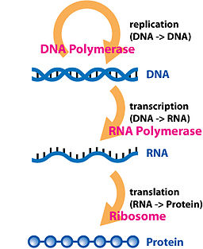
DNA stores the genetic information in a cell. This gets transcribed into the RNA and translated via the genetic code into proteins. All life on earth uses the same code, even the few viruses that have RNA as their genetic material.

Changes to exons in the DNA code result in changes to the protein if they change the amino acid that is coded for. The DNA code is degenerate, as more than one codon (triplet of bases) can code for the same amino acid, which means that if you change one base it may result in the SAME amino acid being coded for.

DNA is proofread by specialist proteins to stop mistakes being made during the cell cycle when the DNA is replicated (S phase). If this does not work and a change happens then we call this a mutation. Mutations happen randomly but the likelihood of one occurring can be increased by physical or chemical factors that affect DNA (e.g exposure to some type of ionising radiation or carcinogenic chemical e.g asbestos, alcohol, tobacco smoke) we call these mutagens or mutagenic agents.

The consequences of a mutation are that the DNA is passed on to the next generation of cells and there may be a change to the codon, which may change the amino acid. This could result in a faulty protein e.g a change in the base sequence may change the primary structure of the protein which could have knock on effects to the secondary and tertiary structure of the protein. If the protein is an enzyme the active site could change shape which would mean it could no longer form E-S complexes.

Not all mutations are negative, positive mutations which give organisms advantages that help them to increase their survival and reproduction rate compared to others in their species can lead to evolution.

Types of mutation:

Mutation Type | Image/Diagram
Substitution – where one or more bases are swapped for another  (can result in no change as amino acid sequence could stay the same – a silent mutation) | 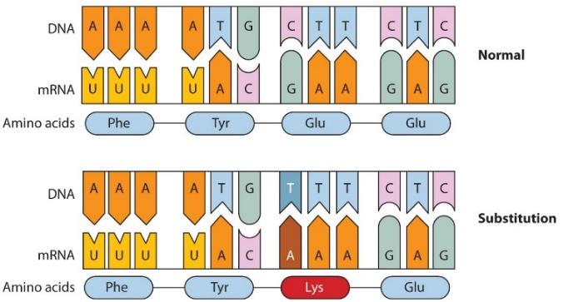
Inversion – a sequence of bases is reversed  (can result in no change as amino acid sequence could stay the same – a silent mutation) | 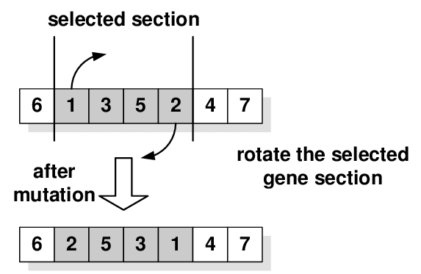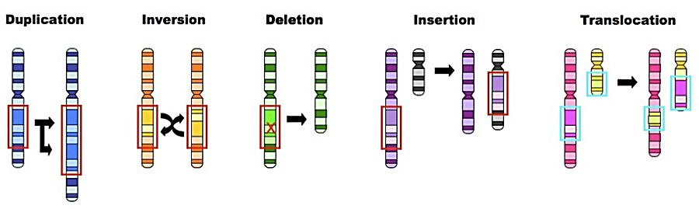
Insertion (addition) – one or more bases are added  (can cause a frame shift) | 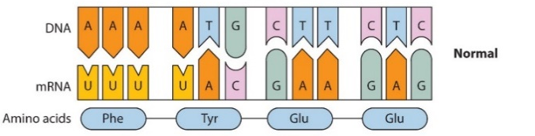  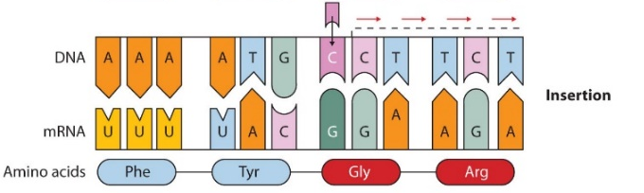
Deletion – one or more bases are removed  (can cause a frame shift) | 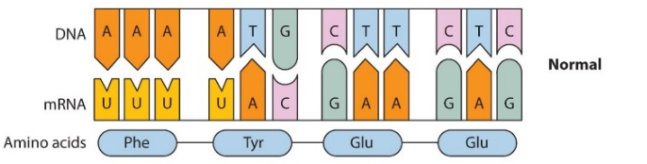  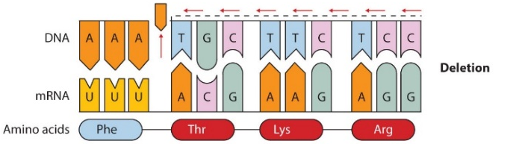
Duplication – one or more bases are repeated  (can cause a frame shift but can also result in increasing repeating subunits and cause genetic diseases e.g Huntington’s which is caused by a duplication mutation that increases the number of repeats of the base sequence CAG) | 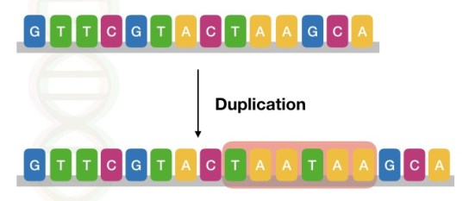
Translocation – a sequence of bases is moved from one location in the genome to another, this could be movement within the same chromosome or to a different chromosome.

This happens when something similar to crossing over occurs but between non-homologous chromosomes
Frame Shift Mutations (deletion, insertion, duplication)
These mutations can have a huge effect on the base sequence of a gene because they change the number of bases in the DNA code causing a shift to all the base triplets that follow (downstream) so that all codons after the mutation are changed and the DNA code will be transcribed differently. The two examples below show deletion and addition:
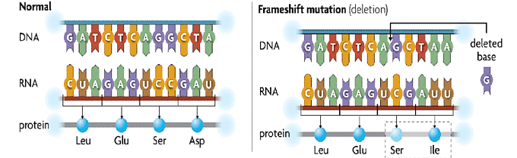
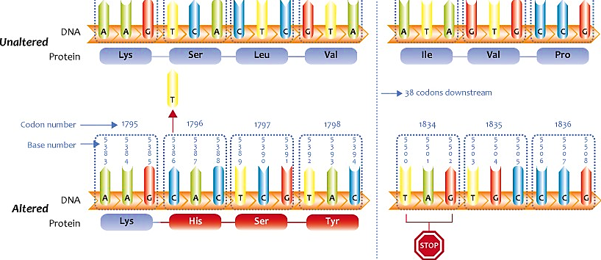
Recall Questions:
- Can you define what genetic material means?
- Why is it important that DNA is proofread and when does this occur?
- What is a mutation?
- Explain the term degenerate in terms of the genetic code.
- What do mutagenic agents do to the probability of mutations occurring?
- With no mutagenic agents present would you still get mutations? Why/why not?
- Explain a positive effect of mutations
- What is a substitution mutation?
- What is a deletion mutation?
- What is an insertion mutation?
- What is a duplication mutation?
- What is an inversion mutation?
- Which types of mutation is most likely to result in no amino acid change and why?
- Which two types of mutation can result in large changes to the amino acids that are coded for?
- Explain what a frame shift mutation does

Exam Questions:

Q1. Put a tick (✓) in the box next to the statement which describes incorrectly the effect of the mutation in an exon of a gene.

A substitution may not result in a change to the encoded amino acid. | 
An inversion will result in a change in the number of DNA bases.
A deletion will result in a frame shift.
An addition will result in a frame shift.
(1)
Q2. (a) What name is used for the non-coding sections of a gene?
___________________________________________________________________ (1)
Figure 1 shows a DNA base sequence. It also shows the effect of two mutations on this base sequence. Figure 2 shows DNA triplets that code for different amino acids.
Figure 1

Original DNA base sequence | A | T | T | G | G | C | G | T | G | T | C | T
Amino acid sequence
Mutation 1 DNA base sequence | A | T | T | G | G | A | G | T | G | T | C | T
Mutation 2 DNA base sequence | A | T | T | G | G | C | C | T | G | T | C | T

Figure 2

DNA triplets | Amino acid
GGT, GGC, GGA, GGG | Gly
GTT, GTA, GTG, GTC | Val
ATC, ATT, ATA | Ile
TCC, TCT, TCA, TCG | Ser
CTC, CTT, CTA, CTG | Leu
(b) Complete Figure 1 to show the sequence of amino acids coded for by the original DNA base sequence.
(1)
(c) Some gene mutations affect the amino acid sequence. Some mutations do not.
Use the information from Figure 1 and Figure 2 to explain
(i) whether mutation 1 affects the amino acid sequence
______________________________________________________________
______________________________________________________________
______________________________________________________________
______________________________________________________________
(2)
(ii) how mutation 2 could lead to the formation of a non-functional enzyme.
______________________________________________________________
______________________________________________________________
______________________________________________________________
______________________________________________________________
______________________________________________________________
______________________________________________________________
(3)
(d) Gene mutations occur spontaneously.
(i) During which part of the cell cycle are gene mutations most likely to occur?
______________________________________________________________
(1)
(ii) Suggest an explanation for your answer.
______________________________________________________________
_____________________________________________________________ (1)
Q3. State what is meant by gene mutation
___________________________________________________________________
___________________________________________________________________
(1)
Q4.
Phenylketonuria is a disease caused by mutations of the gene coding for the enzyme PAH. The table shows part of the DNA base sequence coding for PAH. It also shows a mutation of this sequence which leads to the production of non-functioning PAH.

DNA base sequence coding for PAH | C | A | G | T | T | C | G | C | T | A | C | G
DNA base sequence coding for non-functioning PAH | C | A | G | T | T | C | C | C | T | A | C | G
(a) (i) What is the maximum number of amino acids for which this base sequence could code?

(1)
(ii) Explain how this mutation leads to the formation of non-functioning PAH.
______________________________________________________________
______________________________________________________________
______________________________________________________________
______________________________________________________________
______________________________________________________________
______________________________________________________________
(3)
PAH catalyses a reaction at the start of two enzyme-controlled pathways.
The diagram shows these pathways.
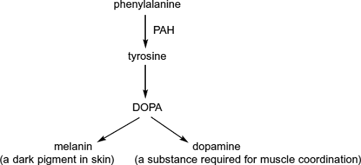
(b) Use the information in the diagram to give two symptoms you might expect to be visible in a person who produces non-functioning PAH.
1. _________________________________________________________________
2. _________________________________________________________________
(2)
(c) One mutation causing phenylketonuria was originally only found in one population in central Asia. It is now found in many different populations across Asia. Suggest how the spread of this mutation may have occurred.
___________________________________________________________________
___________________________________________________________________
___________________________________________________________________

Homework:

Complete the sentences using the words in bold
amino antigens blocking cancers chemicals deletion diversity DNA end energy enzymes expression fast faster frame gametes methylation missense mutations nonsense nucleotide oestrogen oncogenes polypeptide proteins proto-oncogenes rate replicate replication sequence silent slow slowly start tertiary triplet code tumour uncontrolled viruses

DNA mutations and DNA methylation
A mutation is the change in nucleotide sequence of DNA. It can occur in various different ways. When one ____________ is replaced by another it is called a substitution mutation. A change to a single base could result in:
- A ___________ mutation occurs when the base substitution results in a stop codon being transcribed on to mRNA. When this occurs when the _____________ chain is stopped prematurely and will often not function.
- A ___________mutation: occurs when the base substitution results in a different ______ acid being coded for. Since there is a different amino acid in the polypeptide, it may not function correctly as the intermolecular bonds that give the unique shape of the ___________ structure may be changed and hence the whole shape of the protein will be different.
- A _________ mutation: occurs when the substitution does not result in a different amino acid being coded for. The polypeptide will therefore contain the same ___________ of amino acids and so will still function correctly.
A _____________ of a base occurs when a nucleotide is lost. The polypeptide chain is often completely different due to the fact that there is a ________ shift. The reason for this is because the nucleotides are read in threes (the __________ _______) and so when a nucleotide is removed, the bases are read in different units of three. A deletion at the _________ of a polypeptide is more likely to have an effect than if it was at the ______. An addition mutation would have a similar effect to a deletion mutation.
Mutations can arise spontaneously but most commonly occur during DNA _____________. The _______ of gene mutation can be influenced by mutagenic agents, such as high _________ radiation, ______________ and ___________. Mutation can increase species ___________.
Answer the questions
- Transcribe the DNA sequence into mRNA then use the table to translate the mRNA into an amino acid sequence. If you use the single amino acid letter code it will spell a message.

TACGCATTACGATAATCACCAGCACTTCGATGAATT

AA code | AA single letter code | RNA codon
Ala | A | GCU
Cys | C | UGU
Asp | D | GAU
Glu | E | GAA
Phe | F | UUU
Gly | G | GGU
His | H | CAU
Ile | I | AUU
Lys | K | AAA
Leu | L | CUU
Met | M | AUG
Asn | N | AAU
Pro | P | CCU
Gln | Q | CAA
Arg | R | CGU
Ser | S | AGU
Thr | T | ACU
Val | V | GUU
Trp | W | UGG
Tyr | Y | UAU
2. Below are sequences of the same piece of DNA that contain different mutations. For each, describe what has happened to the DNA sequence and how this would this affect the protein.

Silent Mutation:
TACGCATTACGATAATCACCAGCACTCCGATGAATT

Deletion:
TACGATTACGATAATCACCAGCACTGCGATGAATT

Q2. The figure below shows part of a pre-mRNA molecule. Geneticists identified two mutations that can affect this pre-mRNA, as shown in the figure.

 | Base sequence coding  for amino acids | Base sequence removed  from pre-mRNA | Base sequence coding  for amino acids
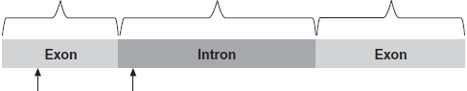

 | Mutation 1,  single base  deletion | Mutation 2,  single base  substitution

(a) Mutation 1 leads to the production of a non-functional protein.
Explain why.
...............................................................................................................
...............................................................................................................
...............................................................................................................
...............................................................................................................
...............................................................................................................
...............................................................................................................
...............................................................................................................
...............................................................................................................
(3)

(b) What effect might mutation 2 have on the protein produced?
Explain your answer.
...............................................................................................................
...............................................................................................................
...............................................................................................................
...............................................................................................................
(2)
Q4. Mitochondria contain the genes needed for the synthesis of the enzymes involved in the electron transport chain. One of these enzymes is cytochrome oxidase. If a mutation occurs during replication of the mitochondrial genes, functional cytochrome oxidase may not be produced.
Explain why mutation of a mitochondrial gene might result in no functional cytochrome oxidase being produced.
...............................................................................................................................
...............................................................................................................................
...............................................................................................................................
...............................................................................................................................
...............................................................................................................................
...............................................................................................................................
...............................................................................................................................
(Total 5 marks)
Q5. (a) CFTR is a transmembrane regulator protein. Its molecules have 1480 amino acids. People with cystic fibrosis produce defective CFTR protein which is missing one amino acid from its structure.
(i) What is the minimum number of bases on DNA which would code for the normal CFTR protein? Explain your answer.
Number of bases ...............................
.............................................................................................................
.............................................................................................................
.............................................................................................................
(2)
(ii) Which type of gene mutation produced the cystic fibrosis allele?
Explain your answer.
.............................................................................................................
.............................................................................................................
.............................................................................................................
(2)
Recall Question Answers

Can you define what genetic material means? | Chemical such as DNA and RNA which store the genetic information in a cell. This gets transcribed and translated via the genetic code into proteins.
Why is it important that DNA is proofread and when does this occur | In the S phase of the cell cycle. It allows for damaged DNA to be detected and repaired or the cell destroyed to prevent the error from passing on to other cells
What is a mutation? | Change to the base sequence of DNA. Caused by errors during DNA replication
Explain the term degenerate in terms of the genetic code. | Each amino acid is coded for by more than one codon
What do mutagenic agents do to the probability of mutations occurring? | Increase the probability
With no mutagenic agents present would you still get mutations? Why/why not? | Yes – because mutations can still occur randomly and spontaneously when the DNA is replicated
Explain a positive effect of mutations | Can produce phenotypes which help organisms to adapt to their environment allowing increased survival and reproduction causing evolution.
What is a substitution mutation? | Substitution - one base is substituted with another
What is a deletion mutation? | Deletion - one base is deleted
What is an insertion mutation? | Insertion - an extra base is added
What is an duplication mutation? | Duplication - one or more bases are repeated
What is an inversion mutation? | Inversion - a sequence of bases is reversed
Which types of mutation are most likely to result in no amino acid change and why? | Inversion and substitution, because they only change one base and the redundancy in the genetic code means that this may code for the same amino acid or only one amino acid is changed
Which two types of mutation can result in large changes to the amino acids that are coded for? | Deletion and insertion/addition as they can cause a frame shift
Explain what a frame shift mutation does | and this results in a different protein structure

Lesson 2 – Stem Cells
Notes:
Stem cells retain the ability to divide repeatedly and differentiate (become specialized) into a range of cell types (sometimes called potency/plasticity). Stem cells become specialized because they only transcribe and translate parts of their DNA, only some genes are “expressed” the rest are switched off. Which genes are expressed is determined by the conditions the cell is in, this causes proteins to be transcribed which modify the cell causing it to become specialized for a particular function. There are two broad categories of stems cell: adult and embryonic. Stem cells can be described as:

 |  |  | 
TOTIPOTENT STEM CELLS (OMNIPOTENT) | PLURIPOTENT STEM CELLS | MULTIPOTENT STEM CELLS | UNIPOTENT STEM CELLS
Cells that can differentiate into embryonic and extra-embryonic tissues. | Cells that can differentiate into any of the three germ layers (ectoderm, endoderm, mesoderm), so any tissue in the body. | These can divide to form different cell types but not all. | Cells that can only form one other type of cell.
They form the embryo and the placenta. | Occur in early embryos of mammals, cambium of plants. | Example is stem cells in bone marrow that form most cells of the immune system, red blood cells and platelets. | Example: Cardiomyocytes can divide to form other heart muscle cells.
All genes in the nucleus are able to be activated. | The vast majority of genes are still able to be activated. | Some genes have been switched off but they have the genes for some different cells still available. | Lots of genes have been switched off via regulation of transcription factors

Embryonic Stem Cells
As the name implies, they are taken from the embryo this is the only stage in human development where cells need to be totipotent as the embryo must divide to produce new cells which will eventually form all the specialized tissues in the body. In the very early embryo (8 cell to Morula) cells are totipotent. Cells collected from the inner mass of a blastocyst (4-7 days) are pluripotent as they have already begun to differentiate.
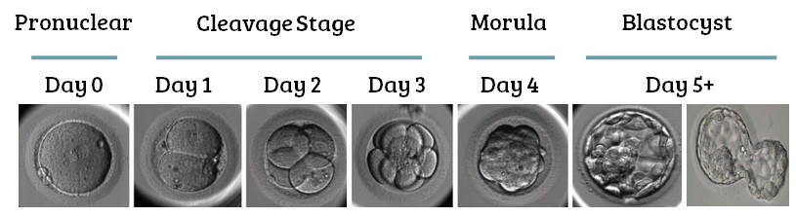
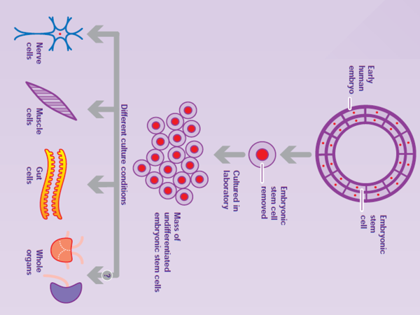
Due to their potency/plasticity embryonic stem cells can be used to grow new organs and tissues for treatment of a variety of conditions e.g Parkinson’s disease or spinal cord injuries. This could save or improve the quality of the lives of many people and reduce the need for organ donation in the future. However, their use is controversial, and research tightly regulated by the Human Fertilisation and Embryology Authority in the UK who decide on the maximum age of embryos allowed for research, prevent human cloning, and make sure the source of embryos is regulated.
Objections to use of embryonic stem cells in medicine:
- Unused IVF embryos can be donated to research instead of being destroyed. Some people object to this as it is the destruction of a potential foetus, some people believe that as fertilisation has happened the embryo has the right to life.
- Egg cells frozen for IVF which have not been fertilised can be stimulated to divide – this causes less objection as they would not survive after a few days if implanted into a womb and would not create a foetus.
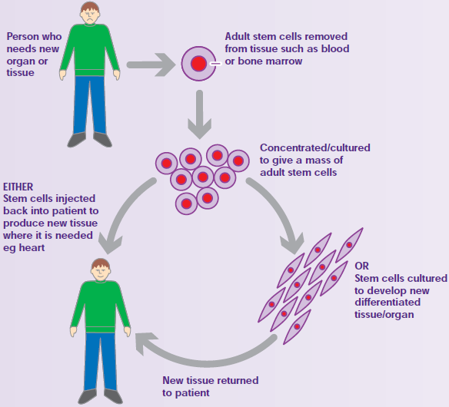
- It is possible to use adult stem cells for some treatments which people feel is more ethical, however they cannot develop into all the specialised cell types that embryonic stem cells can.

Adult Stem Cells
These are obtained from the body tissues of an adult. They are found in bone marrow and can be removed with a simple operation that carries little risk although it can be quite uncomfortable as the bone must be drilled into! Adult stem cells are multipotent so they cannot differentiate into as many cell types as embryonic stem cells can. Bone marrow transplants have already been successful to replace faulty bone marrow that produces abnormal blood cells e.g lukaemia, lymphoma, sickle-cell anaemia and SCID. Stem cells have also been used to treat paralysis caused by spinal cord injuries by replacing nerve tissue.

Induced Pluripotent Stem Cells (iPS Cells)
These stem cells are created in a lab from specialised adult cells after ‘reprogramming’ them to become pluripotent. The cells are made to express a series of transcription factors (proteins which control the expression of genes) which are normally expressed by pluripotent stem cells. They “switch on” genes that are normally expressed in cells that have pluripotency. This could allow adult cells to become as plastic as embryonic stem cells and could be obtained without the same ethical issues. It is also possible that they could be made from a patients own cells which would then be genetically identical to the patient – this would allow tissues/organs to be grown that wouldn’t be rejected and reduce the wait time for transplants.

Future Stem Cell Therapies
Clinical trials are already undergoing to look into the use of stem cells to replace diseased or damaged organs such as the bladder or to replace damaged tissue e.g in the trachea (a donor windpipe can be stripped of tissue and used as a cartilage base for stem cells to grow new tissue on) or damaged heart tissue after a heart attack or heart disease.
Recall Questions:
- What is differentiation?
- What are stem cells?
- What is totipotency?
- What is pluripotency?
- Where are totipotent stem cells present?
- Give an example of multipotent stems cell.
- How do stem cells become specialised?
- Which type of stems cells have their genes most restricted?
- What is a cardiomyocyte?
- What are adult stem cells?
- What are embryonic stem cells?
- What does iPC stand for?
- Why are there regulatory authorities for human embryo research?
- Give ethical issues raised by the use embryonic stem cells
- What are the advantages of patient stem cells over donor stem cells?
- How can stem cells be used in medicine?
- What are the potential benefits of stem cell therapies?
- What research are scientists doing for the use of stem cells as treatment?

Exam Questions:
Q1. SCID is a severe inherited disease. People who are affected have no immunity. Doctors carried out a trial using gene therapy to treat children with SCID. The doctors who carried out the trial obtained stem cells from each child’s umbilical cord.
(a) Give two characteristic features of stem cells.
1. _________________________________________________________________
___________________________________________________________________
2. _________________________________________________________________
___________________________________________________________________
(2)
The doctors mixed the stem cells with viruses. The viruses had been genetically modified to contain alleles of a gene producing full immunity. The doctors then injected this mixture into the child’s bone marrow.
The viruses that the doctors used had RNA as their genetic material. When these viruses infect cells, they pass their RNA and two viral enzymes into the host cells.
(b) One of the viral enzymes makes a DNA copy of the virus RNA. Name this enzyme.
___________________________________________________________________
(1)

Q2. Scientists have investigated the use of different types of stem cell to treat damage to the heart after a myocardial infarction. During a myocardial infarction, a number of different cell types in the heart die. This includes cardiomyocytes which are heart-muscle cells.
Embryonic pluripotent stem cells (ESCs) can divide and differentiate into a wide range of different cell types.
(a) Using the information given, suggest one reason why ESCs might be suitable to treat damage to the heart.
___________________________________________________________________
___________________________________________________________________
___________________________________________________________________
(1)
(b) ESCs have not yet been used to treat people who have had a myocardial infarction. This is because of concern that the use of ESCs might lead to more harm to the person. One way that ESCs might lead to more harm is by differentiating into the wrong types of cells.
Suggest one other way that putting ESCs into a person’s heart might lead to more harm to the person.
___________________________________________________________________
___________________________________________________________________
___________________________________________________________________
___________________________________________________________________
___________________________________________________________________
(2)
(c) Transplants of cardiomyocytes have been shown to increase the repair of heart tissue damaged by myocardial infarction.
One group of scientists investigated the hypothesis that these transplants work by stimulating growth of new blood vessels into damaged heart tissues. They obtained three groups of mice, A, B and C that had suffered myocardial infarctions.
• Group A were operated on but no transplant was given.
• Group B were operated on and given transplants containing cardiomyocytes and two other types of heart cell.
• Group C were operated on and given transplants containing the two other types of heart cells but no cardiomyocytes.
After a suitable time, the scientists measured the mean number of capillaries per mm² in sections taken from areas of the hearts of the mice affected by myocardial infarction.
Their results are shown in the graph below. The bars show ±2 standard deviations, which includes 95.4% of the data.
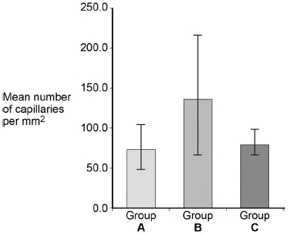
Group A was a control group. Explain two ways in which Group A acts as a control.
1. _________________________________________________________________
___________________________________________________________________
___________________________________________________________________
2. _________________________________________________________________
___________________________________________________________________
___________________________________________________________________
(2)
(d) What can you conclude from these data about the stimulation by cardiomyocytes on growth of new blood vessels into damaged heart tissues?
___________________________________________________________________
___________________________________________________________________
___________________________________________________________________
___________________________________________________________________
___________________________________________________________________
___________________________________________________________________
___________________________________________________________________
(3)
(e) Suggest how the growth of new blood vessels into damaged heart tissues could increase the rate of repair of tissues.
___________________________________________________________________
___________________________________________________________________
___________________________________________________________________
___________________________________________________________________
___________________________________________________________________
___________________________________________________________________
___________________________________________________________________
(3)

Q3. Induced pluripotent stem cells (iPS cells) are a new type of stem cell.

(a) To produce iPS cells, four genes that code for different transcription factors are added to the genome of somatic (body) cells. The transcription factors produced cause the somatic cells to be converted into iPS cells.

Suggest why it may be better to produce differentiated cells from iPS cells than from pluripotent stem cells
___________________________________________________________________
___________________________________________________________________
___________________________________________________________________
___________________________________________________________________
___________________________________________________________________
(2)

Homework:

Complete the sentences using the words in bold

1 adult adult cardiomyocytes embryos express foetus genes induced IVF ethical leukaemia multipotent myocardial infarction paralysis quality repair replace therapeutic totipotent totipotent type unipotent

Stem cells have the ability to express all _________ and therefore differentiate into different cell types. Specialised cells “switch off” the expression of some genes; the genes that are still expressed determine what ________ of cell it is. Stem cells are also able to continue to grow and __________ themselves, while specialised cells often cannot. There are five types of stems cell:
- _____________ stem cells are able to differentiate into any cell type. They are found in __________ (i.e. embryonic stem cells) and are only present for the first few cell divisions.
- _____________ stem cells are able to differentiate into many different cell types. They are formed in embryos from totipotent stem cells.
- _____________ stem cells can only differentiate into a small number of different cell types. Multipotent cells exist in mature animals (i.e. ________ stem cells).
- _____________ stem cells can only differentiate into one type of cell. They are also found in adult tissues. An example is _______________, which make up a lot of the tissue in the heart, can be produced from unipotent stem cells in the heart. This means that the heart is able to _________ itself by replacing old or damaged cells, although the extent to which this can happen is not yet understood.
- Using modern techniques it is possible to produce stem cells from specialised animal cells, these are known as ___________ pluripotent stem cells. This process involves ‘reprogramming’ the adult cells by making them __________ transcription factors that are normally only present in pluripotent cells, resulting in a whole host of genes being expressed.
_____________ cloning is a technique used to extract (or produce) and grow stem cells for the purpose of treating human disorders, such as genetic disorders or replacing damaged or diseased organs. Some examples of the use of stem cells include:
- Heart muscle cells to treat those damaged by ____________ _____________
- Beta cells of the pancreas to treat type ___ diabetes
- Blood cells to treat ___________ or inherited blood disorders
- Nerve cells to treat Parkinson’s disease or ___________ caused by spinal injury
The cells can either be extracted from 4/5 day old embryos produced during ______, or obtained from adult tissues. There are __________ issues around this, and particularly from the use of embryonic stem cells. The main argument for the use of stem cells is that they can save lives, prevent discomfort and improve __________ of life. The arguments against include the fact that an embryo could develop into a __________ and so has the right to life. There are fewer arguments against the use of _________ stem cells, and fewer still against the use of induced pluripotent stem cells.

Answer the question
- Outline the arguments for and against the use of stem cells for therapeutic cloning. [5]
……………………………………………………………………………………………..................................................
……………………………………………………………………………………………..................................................
……………………………………………………………………………………………..................................................
……………………………………………………………………………………………..................................................
……………………………………………………………………………………………..................................................
……………………………………………………………………………………………..................................................
……………………………………………………………………………………………..................................................
Recall Question Answers
What is differentiation ? | the process by which a cell becomes specialised
What are stem cells ? | unspecialised cells that can develop into other types of cells
What is totipotency ? | the ability of a stem cell to produce all cell types, including all the specialised cells in an organism and extra embryonic cells
What is pluripotency ? | the ability of a stem cell to produce all the specialised cells in an organism but not extra embryonic cells because the genes for these cell types have become inactivated
Where are totipotent stem cells present ? | in the first few cell divisions of an embryo
Give an example of multipotent stem cells | Bone marrow cells – can make many types of blood cell
How do stem cells become specialised ? | different genes in their DNA become active and get expressed. Transcription occurs at the active genes. mRNA from the active genes is translated on ribosomes to produce proteins. Protein modifies the cell and determines its structure and functions
Which type of stem cells have their genes most restricted? | Unipotent stem cells
What are cardiomycetes? | Heart muscle cells (unipotent stem cells)
What are adult stem cells? | from bone marrow, simple operation with very little risk but quite a lot of discomfort, aren't as flexible as embryonic stem cells, no risk of rejection if patient uses there own stem cells
What does iPC stand for? | Induced pluripotent stem cell
What are embryonic stem cells? | embryos created in a lab using IVF, when the embryos are 4 to 5 days old the stem cells are removed and the rest of the embryo is destroyed, are totipotent
Why are there regulatory authorities for human embryo research ? | decide on max age of embryo allowed for research, stopping of cloning, judging what is acceptable by following codes of practice, checking the source of the stem cell is acceptable
Give ethical issues raised by the use embryonic stem cells | embryos have the right to life as they are a genetically unique individual, cannot consent. some people have fewer objections to stem cells that have been artificially activated as the cells couldn't survive past a few days anyway
What are the advantages of patient stem cells over donor stem cells ? | Less risk of infection, no risk of rejection, no need to take immunosuppressant drugs as it is genetically identical to the patients cells
How can stem cells be used in medicine ? | To replace damaged organs/tissues
What are the potential benefits of stem cell therapies ? | They could save many lives as stem cells can be used to grow organs for people waiting for transplants. They could improve the quality of life for many people
What research are scientists doing for the use of stem cells as treatment ? | spinal cord injuries - stem cells could replace the damaged nerve tissue. heart disease and damage caused by heart attacks - stem cells could be used to replace damaged heart tissue

Lesson 3 – Regulation of Gene Expression I
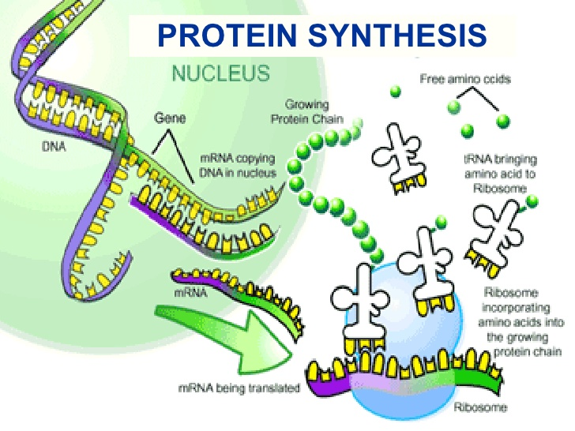
Notes:
Recap of Protein Synthesis:
- Transcription of the gene in the nucleus using RNA polymerase to convert DNA to mRNA
- Pre-mRNA strand is spliced introns removed
- mRNA leaves nucleus via nuclear pore
- mRNA binds to ribosome on the RER
- Translation of the mRNA into a polypeptide
- Modification, folding and packaging of the protein in the golgi.

A gene is expressed or ‘switched on’ when it is transcribed into mRNA and then translated into a protein. Only a few genes in a cell will be expressed at any one time – this is how cells differentiate and become specialised.

Transcription Factors:
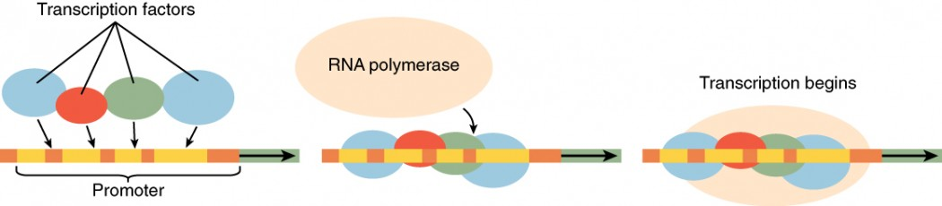
Before transcription can begin a gene needs to be stimulated by a regulatory protein, called transcription factor. Most eukaryotic genes are controlled by over 20 or 30 transcriptional factors interacting together. Transcription factors are proteins which travel into the nucleus and control the rate of transcription by either activating or repressing RNA polymerase. Each transcriptional factor binds to a specific region of the DNA before the gene known as the promoter region. The promoter region is the binding site of RNA polymerase and therefore is the starting point for transcription of that gene.

Transcription factors can turn genes on and off as they can either activate or block the functioning of RNA polymerase, repressors will bind to the promoter region and prevent the RNA polymerase from binding therefore stopping transcription of that gene.

Regulation of the transcription of these factors adds another layer of complexity to this system. Transcription factors can be switched off by an inhibitor molecule. This can bind to the transcriptional factor, preventing it from attaching to the promoter region. Without the transcriptional factor the gene may not be transcribed (if the TF is an activator) or the gene may be expressed (if the TF is a repressor).

There are other extracellular molecules that can act as transcriptions factors. A major class of these is the steroid hormones such as oestrogen.

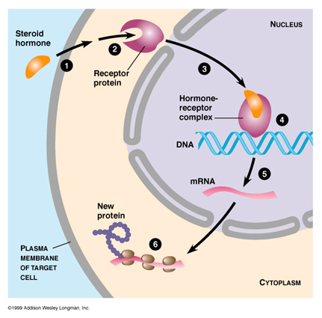
Oestrogen as a Transcription Factor
A hormone response element (HRE) is a short sequence of DNA within the promoter of a gene, that is able to bind to a specific hormone receptor complex and therefore regulate transcription.

1 – 2 To affect transcription oestrogen has to bind to a transcription factor called an oestrogen receptor forming an oestrogen-oestrogen receptor complex. (not all cells have these receptors so not all cells are affected by oestrogen)
3 The oestrogen-oestrogen receptor complex moves from the cytoplasm into the nucleus
4 The complex binds to the HRE in the promoter of the gene, activating or repressor transcription

Preventing Translation using interfering RNA (RNAi)
RNAi molecules are small lengths of non-coding RNA (they do not code for proteins). They regulate gene expression by affecting translation instead of transcription. They are double stranded (unlike other RNAs!) and stop mRNA that has been transcribed already from being translated into a protein. There are two types:
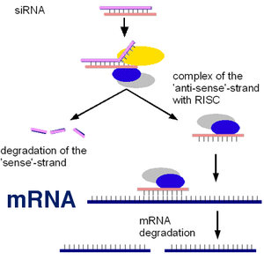
- Short interfering RNA (siRNA) – in animals only
- Micro RNA (miRNA) – in plants and animals

How they siRNAs and miRNAs (in plants) work:
- Double stranded siRNA associates with proteins in the cytoplasm and unwinds
- One of the siRNA strands is chosen and the other degrades (breaks down)
- Single strand of siRNA binds to the target mRNA (as it is complimentary to the base sequence in a section)
- The proteins associated with the siRNA cut the mRNA into small fragments so it can no longer be translated. The mRNA fragments then move into a processing body which degrades them.

This has the potential use for “gene silencing” of inherited genes which cause disorders. Patients could be treated with siRNA molecules that are complimentary to mRNA transcribed from faulty genes to prevent faulty proteins from being expressed.

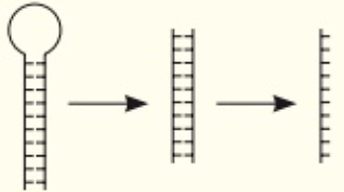
How do miRNAs work in mammals:
miRNAs are not fully complimentary to the target mRNA so they are often less specific and can target more than one mRNA molecule. miRNA has to go through processing stages in the cytoplasm to get to be a single strand like siRNAs: from a folded strand to a double strand then two single strands, one of these is degraded as with siRNA.

Once the miRNA is bound to the mRNA it does not cause degradation instead it simply blocks the translation by preventing ribosome from binding. The mRNA is then moved to a processing body where it can be stored (to be returned and translated another time) or degraded.

Recall Questions:
- What is gene expression controlled by?
- What are transcription factors?
- What is an activator?
- What is a repressor?
- Describe how oestrogen can affect transcription of a gene
- Explain why not all cells are affected by oestrogen
- What is siRNA and how does it work?
- Why might a mammalian miRNA molecule target a greater range of mRNA molecules than siRNA?

Exam Questions:
Q1. (a) What is meant by a genome?
___________________________________________________________________
___________________________________________________________________
(1)
Chromatin immunoprecipitation is one method to determine where a transcription factor binds to DNA. The principle behind this procedure is shown in the chart.
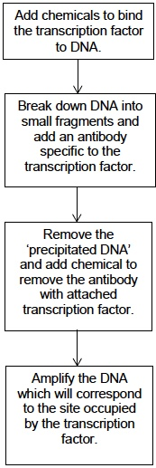
(b) Explain why the antibody binds to the transcription factor.
___________________________________________________________________
___________________________________________________________________
___________________________________________________________________
___________________________________________________________________ (2)
(c) Use the chart to explain what ‘precipitated DNA’ consists of.
___________________________________________________________________
___________________________________________________________________
(1)
Soybeans are used in a number of processed foods. However, soybeans contain a protein known as P34 that causes an allergic response in some people. Scientists have created transgenic soybeans that produce single-stranded cDNA, which prevents transcription of the P34 gene. They used recombinant plasmids as vectors to transform soybean cells. After they had screened these cells for production of the P34 protein, they cultured the transformed cells to form soybean plants.
(d) Suggest how single-stranded cDNA could prevent transcription of the P34 gene.
___________________________________________________________________
___________________________________________________________________
___________________________________________________________________
___________________________________________________________________
(1)
Q2. Interferon gamma is a substance secreted by some types of white blood cells, including helper T cells. It regulates the production of a number of proteins by target cells. Which protein is produced depends on the type of target cell.
The diagram shows how interferon gamma regulates three genes.
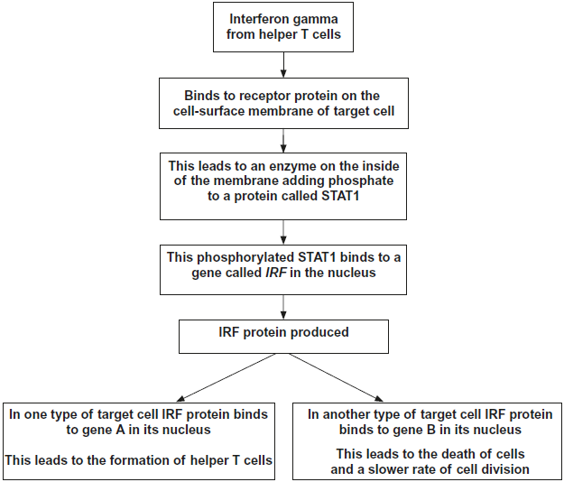
(a) Use information in the diagram to suggest how the binding of interferon gamma to its receptor protein leads to the production of phosphorylated STAT1.
___________________________________________________________________
___________________________________________________________________
___________________________________________________________________
___________________________________________________________________
(2)
(b) Name the two transcription factors in the diagram.
1. _________________________________________________________________
2. _________________________________________________________________
(2)
(c) The regulation of the formation of helper T cells by interferon gamma is an example of positive feedback.
Explain why it is an example of positive feedback.
___________________________________________________________________
___________________________________________________________________
___________________________________________________________________
___________________________________________________________________
(2)
Q3. Figure 1 shows part of a gene that is being transcribed.
Figure 1
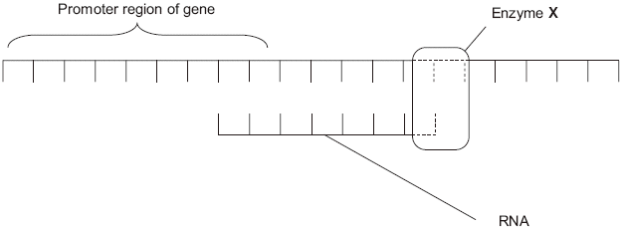
(a) Name enzyme X.
___________________________________________________________________
(1)

(b) (i) Oestrogen is a hormone that affects transcription. It forms a complex with a receptor in the cytoplasm of target cells. Explain how an activated oestrogen receptor affects the target cell.
______________________________________________________________
______________________________________________________________
______________________________________________________________
______________________________________________________________
(2)
(ii) Oestrogen only affects target cells. Explain why oestrogen does not affect other cells in the body.
______________________________________________________________
______________________________________________________________
(1)
(c) Some breast tumours are stimulated to grow by oestrogen. Tamoxifen is used to treat these breast tumours. In the liver, tamoxifen is converted into an active substance called endoxifen. Figure 2 shows a molecule of oestrogen and a molecule of endoxifen.
Figure 2
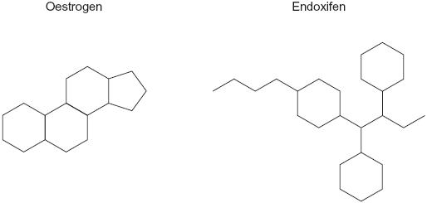
Use Figure 2 to suggest how endoxifen reduces the growth rate of these breast tumours.
___________________________________________________________________
___________________________________________________________________
___________________________________________________________________
___________________________________________________________________
(2)
Q4.
Human immunodeficiency virus (HIV) particles have a specific protein on their surface.This protein binds to a receptor on the plasma membrane of a human cell and allows HIV to enter. This HIV protein is found on the surface of human cells after they have become infected with HIV.
Scientists made siRNA to inhibit expression of a specific HIV gene inside a human cell. They attached this siRNA to a carrier molecule. The flow chart shows what happens when this carrier molecule reaches a human cell infected with HIV.
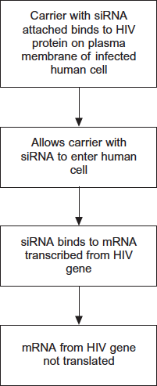
(a) When siRNA binds to mRNA, name the complementary base pairs holding the siRNA and mRNA together. One of the bases is named for you.
__________________________________with_____________________________
______________Adenine_____________with_____________________________
(1)
(b) This siRNA would only affect gene expression in cells infected with HIV.
Suggest two reasons why.
1. _________________________________________________________________
___________________________________________________________________
___________________________________________________________________
___________________________________________________________________
2. _________________________________________________________________
___________________________________________________________________
___________________________________________________________________
___________________________________________________________________
(4)

Homework:

Complete the sentences using the words in bold

acetylation attached binding base cancer chromatin complementary cut cytoplasm deacetylase disease DNA DNA double-stranded drugs genes grandparents inhibitor lifestyle lipid methylation mRNA offspring phosphate polymerase protein switched targetting transcription transcription transcription transcription factors translation translation

Not all genes are used all the time. Gene expression is controlled by ______________ ___________. For transcription to start, the gene needs to be stimulated by a transcription factor that moves from the ____________ into the nucleus. Each type of transcription factor has a site capable of binding to a specific region of ______. When it binds, transcription can is either allowed to begin (by allowing RNA polymerase to bind, for example), and so _______ forms and thus a polypeptide may be synthesised, or it is prevented (by blocking RNA polymerase from binding, for example). An _____________ molecule can bind to a transcription factor where it would bind to DNA. It therefore blocks the site at which it binds to DNA and so _______________ cannot occur. Oestrogen aids the action of a transcription factor and works as follows:
- Oestrogen is _______-soluble and can pass through the phospholipid bi-layer of the plasma membrane into the cytoplasm
- Once inside the cytoplasm it binds to a complementary __________ site on the transcription factor molecule
- When it does so the transcription factor changes shape and thus releases the inhibitor molecule from the ______ binding site
- The transcription factor can now bind to a specific region of DNA where it will stimulate _____________

Small interfering RNAs (siRNAs) act as another mechanism to prevent a protein being formed from a gene by breaking down mRNA before ______________. The effect of siRNA on gene expression is as follows:
- siRNA is a short _________-___________ RNA molecule, about 20 base pairs long. It is made by special genes that are transcribed as normal to make single-stranded RNA, which then folds back on itself by complementary base pairing to make a hairpin-like double-stranded molecule.
- In the cytoplasm siRNA binds to a __________ called the RNA-induced silencing complex (RISC).
- RISC breaks the double-stranded siRNA into its separate strands. One strand remains ____________ to the RISC protein, while the other strand is discarded.
- The RISC-RNA complex now binds to mRNA molecules in the cytoplasm by _____________ base pairing. Any mRNA molecules with a base sequence complementary to the 20-base siRNA sequence will bind.
- This binding causes RISC to ______ the mRNA molecule in two.
- This cleaved mRNA can no longer be used in _____________, and is broken down by nuclease enzymes.
siRNAs are used to identify ________ in a biological pathway: by adding siRNA that can block a particular gene, the affects of the gene can be deduced as a certain function will no longer take place. siRNA may also be used to block genes that are causing ___________.
Answer the questions

- Draw a series of labelled diagrams to show the action of oestrogen. [4]
Draw a series of labelled diagrams to show the mode of activation and action of siRNAs. [4]

Recall Question Answers:
What is gene expression controlled by? | altering the rate of transcription of genes
What are transcription factors? | proteins that bind to DNA and activate or deactivate genes increasing or decreasing the rate of transcription
What is an activator? | A transcription factor that increases the rate of transcription
What is a repressor? | A transcription factor that decreases the rate of transcription
Describe how oestrogen can affect transcription of a gene | Oestrogen binds to the oestrogen receptor forming a complex, this travels from the cytoplasm into the nucleus where it binds to the DNA (promoter region) at the start of the target gene
Explain why not all cells are affected by oestrogen | Because not all cell types have oestrogen receptors
What is siRNA and how does it work? | Double stranded siRNA associates with proteins in the cytoplasm and unwinds, one strand is selected and the other is degraded. The complex binds to the target mRNA as the siRNA is fully complimentary so base pairing occurs. The proteins in the complex cut the mRNA into fragments so they can no longer be transcribed. They are moved to a processing body and broken down.
Why might a mammalian miRNA molecule target a greater range of mRNA molecules than siRNA? | A mammalian miRNA is not fully complimentary to the target mRNA base sequence so it is less specific than an siRNA

Lesson 4 – Gene Expression and Cancer
Notes:
Once cells have divided enough to repair or replace a piece of tissue they stop. The rate of cell division can depend on the environment e.g nutrients and oxygen, hormones known as growth factors but also genes. Mutations in the genes that control cell division can cause cells to grow out of control if these cells pass the checkpoints in the cell cycle, despite having damaged DNA and do not get destroyed by the immune system.

Control of gene expression therefore also plays an important role in cancer. The rate of cell division is controlled by genes, if mutations occur in these genes then uncontrolled cell division can occur. Uncontrollable cell division causes the cells to keep on dividing and they layer on top of each other forming a tumour – a mass of abnormal cells. Tumours that invade and destroy surrounding tissues are called cancers. There are two types of genes that control cell division:

 |  | 
PROTO-ONCOGENES |  | TUMOUR SUPPRESSOR GENES
These genes can cause cancer when they are activated or turned on. | 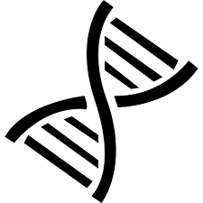 | These genes can cause cancer when they are inactivated or turned off.
Proto-oncogenes are genes that normally help cells grow. When they mutate they can become permanently activated. When this happens, the cell grows out of control, which can lead to cancer. A mutated proto-oncogene is known as an oncogene. |  | Tumour suppressor genes are genes that normally help cells slow down cell division, repair DNA mistakes, or tell cells when to die (a process known as apoptosis or programmed cell death). When tumour suppressor genes don't work properly, cells can grow out of control, which can lead to cancer.
For example, Ras is one of the on/off switches in a series of steps in a major pathway that eventually leads to cell growth. When Ras is mutated, it encodes for a protein that causes an uncontrolled growth-promoting signal. | 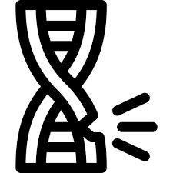 | For example, abnormalities of the TP53 gene (which codes for the p53 protein) have been found in more than half of human cancers. This protein acts as a tumour suppressor, which means that it regulates cell division by keeping cells from growing and dividing too fast or in an uncontrolled way..
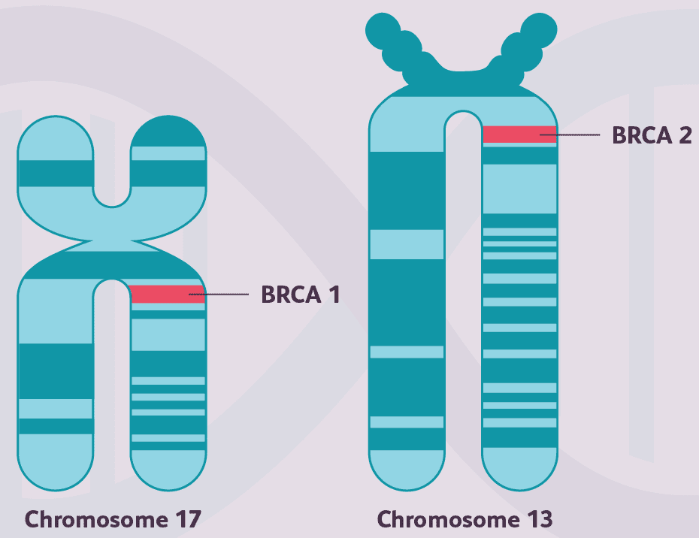
Mutations Causing Cancer
Mutations are changes to the base sequence of DNA, these can be caused by mutagens such as ionising radiation from UV rays or carcinogenic chemicals like those found in cigarette smoke. Some people can also inherit mutations in genes that make them more likely to suffer with some cancers.
Example: About 5-10% of breast cancer cases are thought to be hereditary (they are the result of gene changes passed on from a parent). The most common cause of hereditary breast cancer is an inherited mutation in the BRCA1 or BRCA2 gene. In normal cells, these genes help make proteins that repair damaged DNA. Mutated versions of these genes can lead to abnormal cell growth, which can lead to cancer.
- If you have inherited a mutated copy of either gene from a parent, you have a higher risk of breast cancer.
- Women with one of these mutations are more likely to be diagnosed with breast cancer at a younger age, as well as to have cancer in both breasts.
Tumours
Cancer cells are different to normal cells in their structure and function, they will either die through apoptosis or they can be destroyed by the immune system which recognises them as ‘foreign’ or different to normal body cells because they:
- Have large dark nuclei sometimes more than one
- Irregular shape
- Do not produce proteins needed to function properly
- Different antigens on their surface membrane
- Do not respond to the usual growth regulation process

Tumours need their own blood supply but often they suffer from low oxygen as the blood supply cannot satisfy the tumours oxygen demand as the rate of cell division is so high. There are two types of tumour:

Non-cancerous  Slow growing  Do not metastasize but can put pressure on organs or cause blockages  Cells have a normal shape | 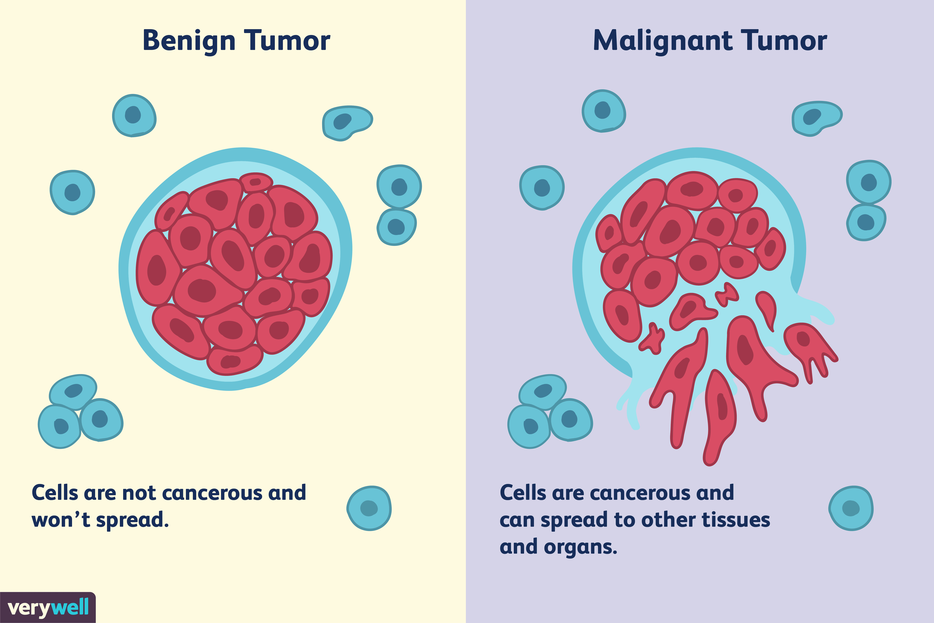 | Cancerous  Fast Growing  Invade and destroy other tissues and metastasize (spread) around the body in the lymphatic system  May have abnormal shape.

Oestrogen and Breast Cancer
Tumour suppressor gene
- Slows or inhibits cell division.
- If a mutation occurs it can become inactive
- Rate of cell division no longer regulated so it increases.
Increased exposure to oestrogen over an extended period of time is thought to increase a woman’s risk of developing breast cancer. There are a couple of reasons that some women may be exposed to more oestrogen than others:
- Taking birth control or HRT (drugs that contain oestrogen which help control menstruation or treat symptoms of the menopause)
- Starting menstruation early in life
- Starting menopause late in life

Risk of developing breast cancer also increases with age. As women age, the fat cells in their breasts tend to produce greater and greater amounts of an enzyme called aromatase. Aromatase promotes the production of oestrogen. Consequently, with age, the levels of oestrogen present in women's breasts increases. The exact cause is still not fully understood but there are some theories about how high oestrogen causes some breast cancers:
- Stimulates more breast tissue cells to divide increasing the chance of mutations
- Cancer cell replication could be further promoted by oestrogen causing faster tumour growth

Treating Cancer
Cancer treatments can control the rate of cell division in cancer cells by targeting the cell cycle to try and stop it. This will kill the tumour cells and prevent them from dividing further. However, the treatments are not able to distinguish between cancer cells and other normal body cells that divide a lot e.g hair cells, stem cells in bone marrow and cells that line the small intestine (this explains side effects of cancer treatment e.g hair loss!). Cancer cells have a faster rate of division, so these cells are more likely to be affected by the cancer treatment. Examples of cancer treatments include:
- Surgery is normally conducted where possible to remove a specific tumour if it hasn’t spread but this can lead to breakage and spreading of cells if not done carefully.
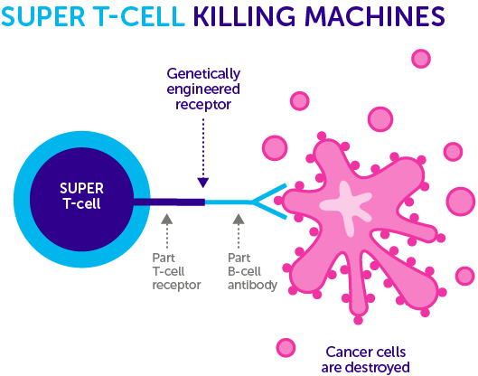
- Immunotherapy and targeted therapy can help direct treatments to cancerous cells to reduce side effects and damage to the body.
- Chemotherapy which prevents the synthesis of enzymes required for DNA replication. This stops the cell cycle before the S phase as it cannot take place. If DNA cannot be replicated cells will not be able to divide.
- Radiotherapy and some chemotherapy drugs can damage DNA, if DNA is damaged the cell will not pass the check points in S phase. This will force the cell to kill itself (apoptosis). Cells will not divide/mitosis is prevented
- Drugs which prevent spindle fibres from forming will prevent mitosis stage as one cell will contain double the DNA and one cell will contain no DNA. This prevents the cells from functioning or dividing again.

Recall Questions:
  - Define cancer
  - What type of tumour is non-cancerous?
  - What does metastasize mean?
  - Give two features of tumour cells
  - Describe the role of proto-oncogenes.
  - What can happen when a tumour suppressor gene is switched off?
  - Give an example of a tumour suppressor gene.
  - Give a difference between a benign tumour and a malignant tumour
  - Describe the effect of menopausal women taking HRT in terms of cancer risk

Exam Questions:
Q1. (a) Some tumours are benign and some are malignant.
(i) Give one way in which a benign tumour differs from a malignant tumour.
______________________________________________________________
(1)
(ii) Describe two ways in which both types of tumour may cause harm to the body.
1. ____________________________________________________________
______________________________________________________________
2. ____________________________________________________________
______________________________________________________________
(2)

Q2. The death rate from malignant skin tumours was investigated in the USA. The graph shows the results for fair-skinned men in different age groups.
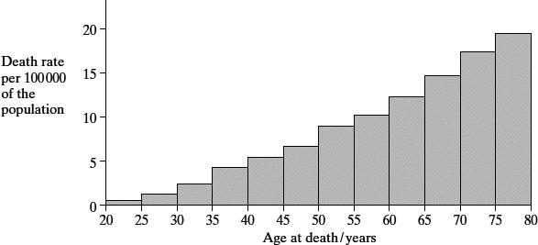
(a) Describe what is meant by a malignant tumour.
___________________________________________________________________
___________________________________________________________________
___________________________________________________________________
___________________________________________________________________
___________________________________________________________________
___________________________________________________________________
(3)

(b) Give one reason for the change in death rate from malignant skin tumours with increasing age.
___________________________________________________________________
___________________________________________________________________
(1)
(c) The data for fair-skinned and dark-skinned people were collected separately.
Explain why skin colour was a factor likely to affect the death rate.
___________________________________________________________________
___________________________________________________________________
___________________________________________________________________
___________________________________________________________________
(2)

Q3. Read the following passage.
Soon a single drop of blood might be enough to reveal, at a very early stage, if a patient has
cancer. It could also tell us what type of cancer it is and whether it is treatable. Fragments of
DNA from body cells are present in blood plasma. Some of these fragments may be from
cancer cells. The fragments can be detected by a new test in which a test strip containing
5 nucleic acid binds to sections of altered DNA.
Other cancer-detecting techniques involve removing a tissue sample from a patient. The
tissue sample is used to obtain mRNA. By examining the mRNA, scientists can discover
whether cancer is present.
Use information from the passage and your own knowledge to answer the questions.
(a) Describe how altered DNA may lead to cancer.
___________________________________________________________________
___________________________________________________________________
___________________________________________________________________
___________________________________________________________________
___________________________________________________________________
___________________________________________________________________
___________________________________________________________________
___________________________________________________________________
___________________________________________________________________
___________________________________________________________________
___________________________________________________________________
___________________________________________________________________
(6)
(b) Explain why fragments of DNA from cancer cells may be present in blood plasma
(lines 3-4).
___________________________________________________________________
___________________________________________________________________
___________________________________________________________________
___________________________________________________________________
(2)
(c) Explain why the nucleic acid on the test strip will only bind to altered DNA (lines 4-5).
___________________________________________________________________
___________________________________________________________________
___________________________________________________________________
___________________________________________________________________ (2)
(d) This test strip will allow cancers to be detected at a very early stage. Explain why cancer is more likely to be treated successfully if the disease is detected at a very early stage.
___________________________________________________________________
___________________________________________________________________
___________________________________________________________________
___________________________________________________________________
(2)
(e) Explain how examining mRNA (line 7) enables scientists to discover whether cancer is present.
___________________________________________________________________
___________________________________________________________________
___________________________________________________________________
___________________________________________________________________
___________________________________________________________________
___________________________________________________________________
(3)
Q4.
(a) (i) A mutation of a tumour suppressor gene can result in the formation of a tumour.
Explain how.
______________________________________________________________
______________________________________________________________
______________________________________________________________
______________________________________________________________
(2)
(ii) Not all mutations result in a change to the amino acid sequence of the encoded polypeptide.
Explain why.
______________________________________________________________
______________________________________________________________
______________________________________________________________
(1)

(b) Some cancer cells have a receptor protein in their cell-surface membrane that binds to a hormone called growth factor. This stimulates the cancer cells to divide.
Scientists have produced a monoclonal antibody that stops this stimulation.
Use your knowledge of monoclonal antibodies to suggest how this antibody stops the growth of a tumour.
___________________________________________________________________
___________________________________________________________________
___________________________________________________________________
___________________________________________________________________
___________________________________________________________________
___________________________________________________________________
(3)

Homework:

Complete the sentences using the words in bold
amino antigens blocking cancers chemicals deletion diversity DNA end energy enzymes expression fast faster frame gametes methylation missense mutations nonsense nucleotide oestrogen oncogenes polypeptide proteins proto-oncogenes rate replicate replication sequence silent slow slowly start tertiary triplet code tumour uncontrolled viruses

Tumour formation
If a cell begins to divide uncontrollably it forms a ___________. Tumours can be benign or malignant. Benign tumours grow __________ and do not invade other tissues. They are normally harmless but can damage tissues or organs by ____________ ducts or taking the space required by the organ. Malignant tumours are ________-growing and can spread to other parts of the body through the circulatory and lymphatic systems; they are ___________. Tumour cells tend to have an irregular shape, a large nucleus and different ___________ on their surface, and divide more rapidly than other body cells.
The rate of cell division is controlled by proteins (such as __________ and cell surface receptors), so can be influenced by gene mutations or DNA methylation. Mutations that occur in __________ can be inherited while those that occur in normal somatic (body) cells cannot. Daughter cells from mutated cells will also contain the mutation, resulting in further cell division. There are two main categories of genes that, when mutated, could result in _______________ cell division:
- _______-______________ normally act to encourage cell division. Mutations can turn them into __________ which results in cell division speeding up.
- Tumour suppressor genes normally act to ________ cell division. ____________ can make tumour suppressor genes inactivated so cell division is not inhibited.
Increased production of _____________ also increases the risk of developing breast cancer. Oestrogen stimulates cell division in breast cells. For every round of cell division the DNA must ___________, which increases the likelihood of mutations occurring. In addition, if the cells do become cancerous then the cells will divide even ___________ as a result of being exposed to oestrogen. It has also been suggested that oestrogen itself can cause _________ to mutate.

Recall Question Answers
Define cancer | Uncontrollable cell division creating tumours that invade and destroy surrounding tissues.
What type of tumour is non-cancerous? | Benign
What does metastasize mean? | Break off and spread around the body
Give two features of tumour cells | Dark nuclei, more than one nuclei, irregular shape, different antigens on surface, doesn’t make the right proteins
Describe the role of proto-oncogenes. | Proto-oncogenes are genes that normally help cells grow, they stimulate or activate cell division
What can happen when a tumour suppressor gene is switched off? | Uncontrollable cell division – tumour formation
Give an example of a tumour suppressor gene. | TP53 gene (which codes for the p53 protein. This protein acts as a tumour suppressor, which means that it regulates cell division by keeping cells from growing and dividing too fast or in an uncontrolled way.
Give a difference between a benign tumour and a malignant tumour | Benign are slow growing, they do not invade or destroy new tissues, they do not metastasize
Describe the effect of menopausal women taking HRT in terms of cancer risk | Increased exposure to oestrogen could lead to breast cancer as

Lesson 5 – Regulation of Gene Expression II
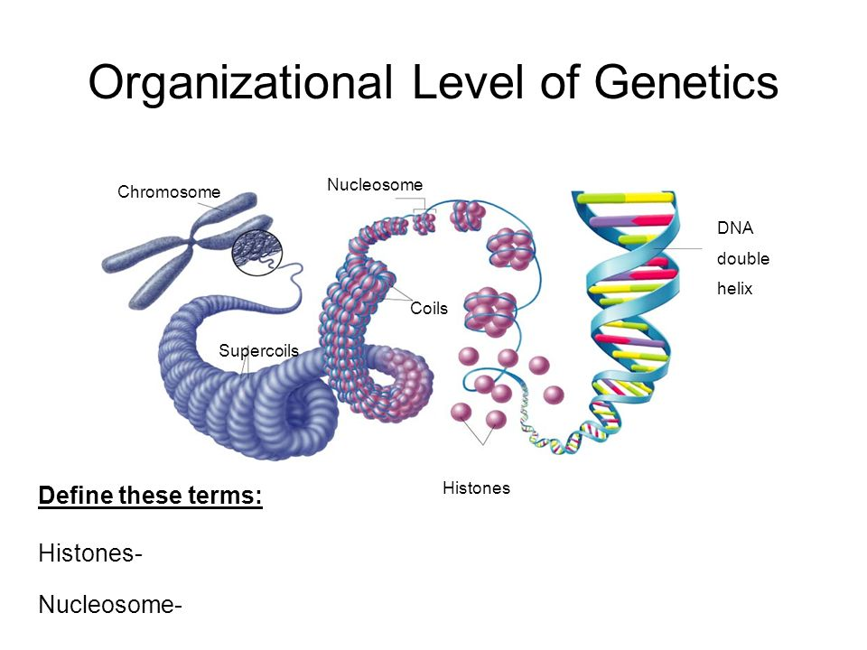
Notes:
Recap: DNA Structure
In eukaryotes DNA is held in the nucleus surrounding proteins called histones. They package and order the DNA into structural units called nucleosomes. The histones associate (bind to) the DNA and help the DNA to condense into chromatin. Condensed DNA (chromatin) that is tightly bound to histones cannot be transcribed, the unwinding allows access for transcription.
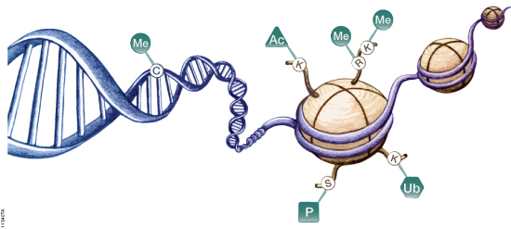
Genome vs Epigenome
Histones are covered in chemicals: “tags”. These tags are known as the epigenome – ‘epi’ comes from the Greek and means “on”. These tags determine the shape of the histone-DNA complex and they help to control the transcription of genes. Epigenetics is the study of inheritable changes in gene function that have not been caused by changes to the base sequence of DNA.

Genome | Epigenome
The sequence of bases in the entire DNA molecule of an organism – this sequence is fixed | The tags on the histone proteins which are associated with DNA – these tags can be changed easily
Sequence can only be changed by mutation | Tags can respond to external factors and change gene expression without affecting DNA sequence
Mutations in DNA sequence can be inherited | Epigenetic tags are often removed in gametes to allow embryos to be totipotent. But sometimes they remain allowing changes to gene expression caused by environmental influences can be inherited
Environmental factors can influence the genome by causing mutations, but these are specific | Environmental factors can influence the epigenome, but they can be wide ranging
Epigenetic Control of Gene Expression:
There are two ways that epigenetics can control gene expression using the epigenetic tags of methyl and acetyl groups:
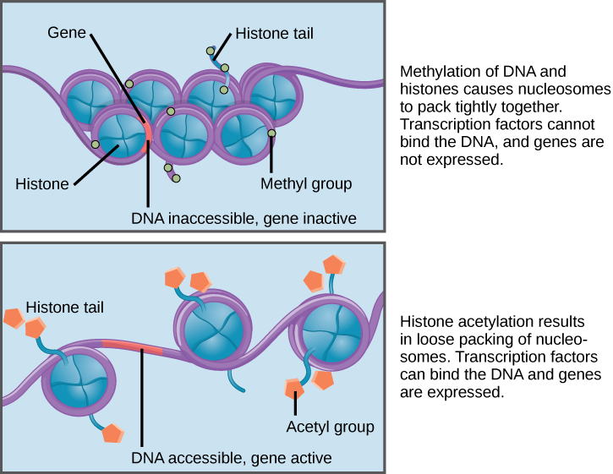
Increasing the methylation of DNA (adding a methyl group -CH₃ to DNA). This alters the DNA structure preventing transcription factors and enzymes from binding to it (i.e switching it off). DNA methyltransferase enzymes attach the methyl group to cytosine bases on the DNA molecule.
Acetylation of histones (adding or removing -COCH₃ group). When histones are acetylated the DNA loosens from the histones making it less condensed. This means the transcription factors and enzymes can bind to the DNA and transcribe it. When acetyl groups are removed from the histones the chromatin condenses and transcription factors and enzymes cannot access the DNA so it is not transcribed. Histone deacetylase (HDAC) enzymes are responsible for removing acetyl groups, while acetyltransferase enzymes add acetyl groups. There are several enzymes that control methylation and acetylation. They work together to increase or decrease expression of different genes. These have major roles in development of cancer, inheritance of certain environmental factors and development of other diseases.
Epigenetics and Disease
Abnormal methylation (too much or too little) of proto-oncogenes and tumour suppressor genes can cause abnormal cell growth and cancers to develop.
- Hypermethylation of tumour suppressor genes prevents them from being transcribed. The proteins they normally produce which slow down cell division will not be made. This can cause cells to divide uncontrollably by mitosis and form tumours.
- Hypomethylation of proto-oncogenes causes them to act as oncogenes and produce proteins that encourage cell division. This can stimulate cells to divide uncontrollably by mitosis and form tumours.
Epigenetics can be used to treat diseases as these changes are reversible unlike DNA sequence mutations. Any drugs which counteract epigenetic changes must be very specific to their target genes as some of these changes are necessary and important to normal function and happen in all cells in the body. Some examples:
- Drugs that stop DNA methylation can prevent genes from being switched off so they can be transcribed and produce proteins that when missing cause symptoms of the disease e.g Prader-Willi Syndrome, Fragile -X Syndrome, and Angelman Syndrome.
- HDAC inhibitor drugs such as romidepsin can be used to prevent decreased acetylation of histones which can stop some genes from being turned off. They work by inhibiting the activity of decacetylase enzymes so that the gene remain uncondensed and can be transcribed.
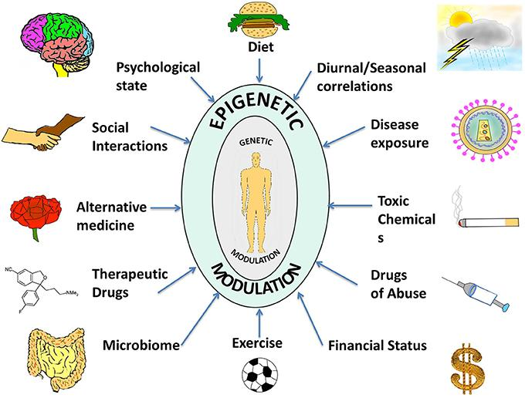
How environmental factors can affect epigenetics
Epigenetic changes in gene expression caused by a response to environmental changes e.g pollution, availability of food or drought (in plants) experienced by an organism have been shown to have been inherited and be present in the children and sometimes grandchildren of that organism.
There are many environmental influences that can affect the epigenome, see the diagram on the right.
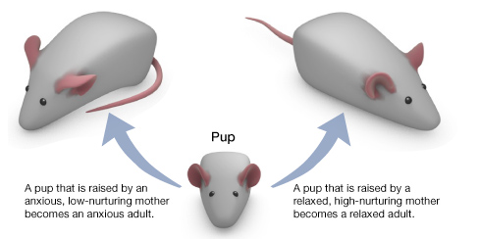
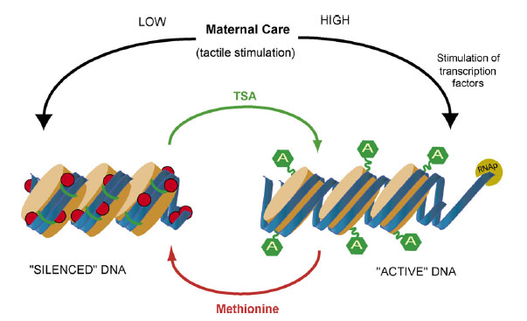
A good example has been demonstrated in rats. Some mother rats spend a lot of time licking, grooming, and nursing their pups. Others seem to ignore their pups. Highly nurtured rat pups tend to grow up to be calm adults, while rat pups who receive little nurturing tend to grow up to be anxious. It turns out that the difference between a calm and an anxious rat is not genetic, it's epigenetic. The nurturing behavior of a mother rat during the first week of life shapes her pups' epigenomes and this behaviour stays even after the rats become adults and affects whether they are high nurturing mothers or not when they have their own pups. This effect on the DNA was determined to be epigenetic not genetic as it was still seen in rats who were raised by “foster mums” who they shared no DNA with.
This was further evidence by the ability to reverse these traits in rats using drugs. You can take a low-nurtured rat, inject its brain with a drug (TSA) that removes methyl groups, and make it act just like a high-nurtured rat. The GR gene gets turned on, cells make more GR protein, and the rat takes on a more relaxed personality. You can also take a relaxed, high-nurtured rat, inject its brain with methionine (a source of methyl) and make it more anxious.
Inheriting epigenetic changes are an advantage as it allows the inheritance of behaviours which will make offspring automatically adapted/prepared to deal with the environmental changes when they are born.
Recall Questions:
  - What are histones?
  - What is the role of a histone?
  - What is epigenetics
  - Explain the main differences between the genome and the epigenome in terms of affect on the DNA and reversibility.
  - How does increased methylation of DNA repress a gene?
  - What enzyme is involved in methylation?
  - How does modification of histones affect gene expression?
  - How can epigenetic changes cause cancer?
  - How can drugs be used to reverse epigenetic changes?

Exam Questions:
Q1. (a) Define what is meant by epigenetics.
___________________________________________________________________
___________________________________________________________________
___________________________________________________________________
___________________________________________________________________
___________________________________________________________________
(2)
(b) In eukaryotes, transcription of target genes can be stimulated or inhibited when specific transcriptional factors move from the cytoplasm into the nucleus.
Oestrogen, methyl groups and acetyl groups are control factors that can play a role in initiating transcription.
Complete the table to show features of these control factors.
Put a tick (✔) in the box if the control factor shows the feature.

 | Feature
Control factor | Binds with DNA | Binds with protein
Oestrogen
Methyl groups
Acetyl groups
(2)
(c) Explain how increased methylation could lead to cancer.
___________________________________________________________________
___________________________________________________________________
___________________________________________________________________
___________________________________________________________________
___________________________________________________________________
___________________________________________________________________
___________________________________________________________________
___________________________________________________________________
(3)
(d) Give one way in which benign tumours differ from malignant tumours.
___________________________________________________________________
___________________________________________________________________
___________________________________________________________________
___________________________________________________________________
(1)
Q2. (b) Describe how alterations to tumour suppressor genes can lead to the development of tumours.
___________________________________________________________________
___________________________________________________________________
___________________________________________________________________
___________________________________________________________________
___________________________________________________________________
___________________________________________________________________
___________________________________________________________________
___________________________________________________________________
___________________________________________________________________
___________________________________________________________________
___________________________________________________________________
___________________________________________________________________
(3)

(c) A type of malignant tumour cell divides every 8 hours.
Starting with one of these cells, how many tumour cells will be present after 4 weeks?
Assume none of these cells will die.
Give your answer in standard form.
Answer = ____________________
(2)
(Total 6 marks)
Q3. Scientists found a correlation between prostate cancer and exposure to cadmium ions.
The scientists investigated the effects of cadmium ions on cells from a human prostate gland.
They grew a culture of these cells in liquid growth medium and removed samples at intervals.
For each sample they measured
• how much DNA was not methylated,
• the activity of the enzyme methyltransferase.
Methyltransferase is an enzyme that adds methyl groups to some of the bases in DNA.
The addition of a methyl group is called methylation.
(a) The scientists set up another culture as a control.
Describe how the scientists would have set up a control experiment for this investigation.
___________________________________________________________________
___________________________________________________________________
___________________________________________________________________
___________________________________________________________________
(2)

(b) Figures 1 and 2 show the scientists’ results.
Figure 1 Figure 2
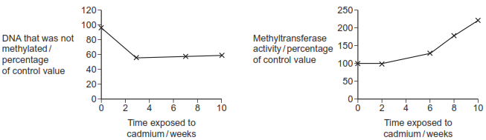
(i) The scientists expressed their results as percentages of the control values.
Suggest why.
______________________________________________________________
______________________________________________________________
(1)
(ii) Use information from Figure 1 to describe how exposure to cadmium ions affected the methylation of DNA.
______________________________________________________________
______________________________________________________________
(1)
(iii) Use information from Figure 2 to suggest what caused the change to the DNA shown in Figure 1.
______________________________________________________________
______________________________________________________________
(1)
(c) Prostate gland cells contain a tumour suppressor gene called p16.
During the investigation, the scientists also measured the amount of p16 protein produced.
Figure 3 shows their results.
Figure 3
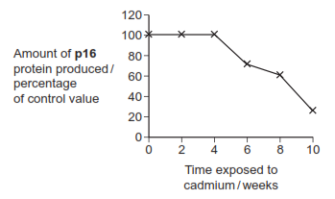
The scientists found that the promoter DNA of the p16 gene had become methylated. The promoter is the sequence of bases where the enzyme RNA-polymerase binds to a DNA molecule.
Explain how methylation of the promoter sequence of the p16 gene could cause the changes shown in Figure 3.
___________________________________________________________________
___________________________________________________________________
___________________________________________________________________
___________________________________________________________________
(2)
(d) Each week of the investigation, the scientists took samples of the cadmium-treated prostate cells from the laboratory cultures. They injected these cells into mice and monitored the mice for the growth of tumours.
It was only the samples taken in the tenth week that caused tumours to begin to grow in the mice.
Use information from Figures 1, 2 and 3 to suggest why.
___________________________________________________________________
___________________________________________________________________
___________________________________________________________________
___________________________________________________________________
___________________________________________________________________
___________________________________________________________________
___________________________________________________________________
___________________________________________________________________
(4)

Homework:

- https://learn.genetics.utah.edu/content/epigenetics/twins/ Watch twins video & answer the following questions:
  - What does the epigenome do?
  - What turn genes on and off?
  - What are imprinted genes?
  - What do the orange pin-heads represent?
- https://learn.genetics.utah.edu/content/epigenetics/control/ Write a brief explanation about how GFP protein (which glows) can be used to track epigenetic changes
- Read the nutrition & epigenome (sections 1-3). Write an explanation of how nutrition during pregnancy can cause epigenetic changes and how it can be reversed – give some examples of foods!

Wider Reading Recommendations:
- Nessa Carey’s amazing TED Talk: https://www.youtube.com/watch?v=9DAcJSAM_BA&feature=youtu.be
- OR her book: “The Epigenetics Revolution: How Modern Biology is Rewriting Our Understanding of Genetics, Disease and Inheritance” (which includes more info about the epigenetic effects of the Dutch Famine) and is free to read the first few pages on Kindle app!
- Tamed by Alice Roberts talks about the epigenetic effects which allowed us to tame wolves and eventually how this led to the domestication of dogs!

Recall Question Answers
What are histones ? | proteins that DNA wraps around to form chromatin which makes up chromosomes
What is the role of a histone? | To help structure the DNA to allow it to condense into chromatin
What is epigenetics | the study of inheritable changes in gene function that have not been caused by changes to the base sequence of DNA.
Explain the main differences between the genome and the epigenome in terms of effect on the DNA and reversibility. | Epigenetics does not affect the base sequence of DNA and its effects are reversible.
How does increased methylation of DNA repress a gene? | A methyl group is attached to the DNA coding for a gene at the CpG site (where C and G bases are next to each other). Increased methylation changes the DNA structure so that proteins needed cannot bind to a gene so it is not expressed
What is the enzyme involved in DNA methylation? | DNA Methyltransferase
How does epigenetic control work ? | By attaching or removing chemical groups to or from the DNA, this affects how easy it is for enzymes needed for transcription to bind and transcribe genes
Why do epigenetic changes occur? | In response to changes in the environment
How does increased methylation of DNA repress a gene? | A methyl group is attached to the DNA coding for a gene at the CpG site (where C and G bases are next to each other). Increased methylation changes the DNA structure so that proteins needed cannot bind to a gene so it is not expressed
How does modification of histones affect gene expression ? | When histones are acetylated, the chromatin is less condensed so transcription proteins can bind to the DNA allowing genes to be transcribed. When acetyl groups are removed, the chromatin is highly condensed so genes in the DNA cannot be transcribed
How can epigenetic changes cause cancer? | Hypermethylation of tumour suppressor genes can inhibit enzyme binding and cause them to not be transcribed so uncontrollable cell division occurs. Hypomethylation of proto-oncogenes causes them to be over activated and transcribed becoming oncogenes and promoting uncontrollable cell division
How can drugs be used to reverse epigenetic changes | Inhibiting DNA methylation can prevent genes from being switched off so they can be transcribed and produce proteins Inhibiting HDAC inhibitor drugs to prevent the deacetylation of histones by decacetylase enzymes so that the gene remain uncondensed and can be transcribed.
Why is it a benefit if epigenetic changes get passed on ? | certain genes that are activated or deactivated in the original cell will also be activated or deactivated in the daughter cells. so the daughter cells are equipped to deal with the changed environment

