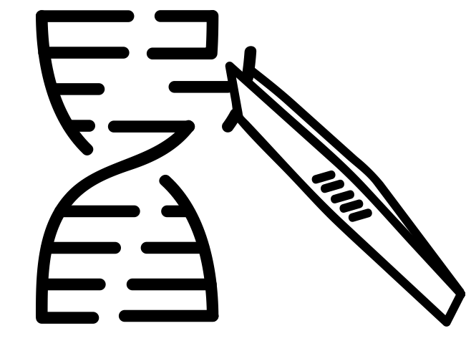
AQA Biology
Genetic Technologies

3.8.3 Using genome projects
3.8.4 Gene Technology

Name: ______________________

Lesson | Exam Question Marks | Homework Checked | Date
Lesson 1 – Genome Projects and Sequencing
Lesson 2 – Making DNA Fragments
Lesson 3 – In Vivo Gene Cloning
Lesson 4 – In Vitro Gene Cloning (PCR)
Lesson 5 – Genetic Fingerprinting
Lesson 5 – Gene Probes and Genetic Counselling
EOTT

Specification Section
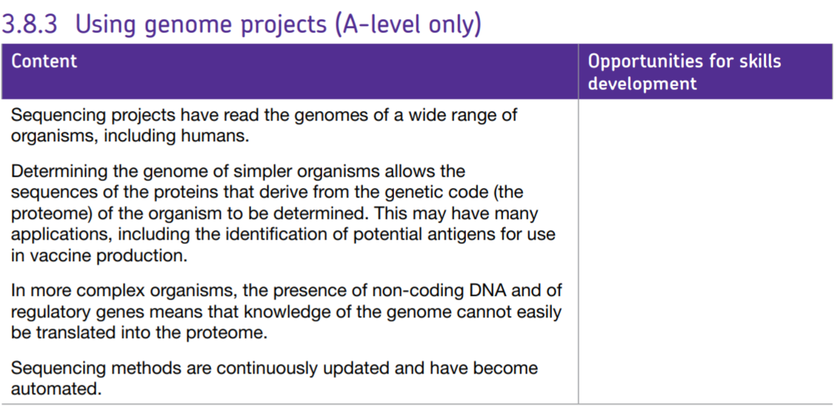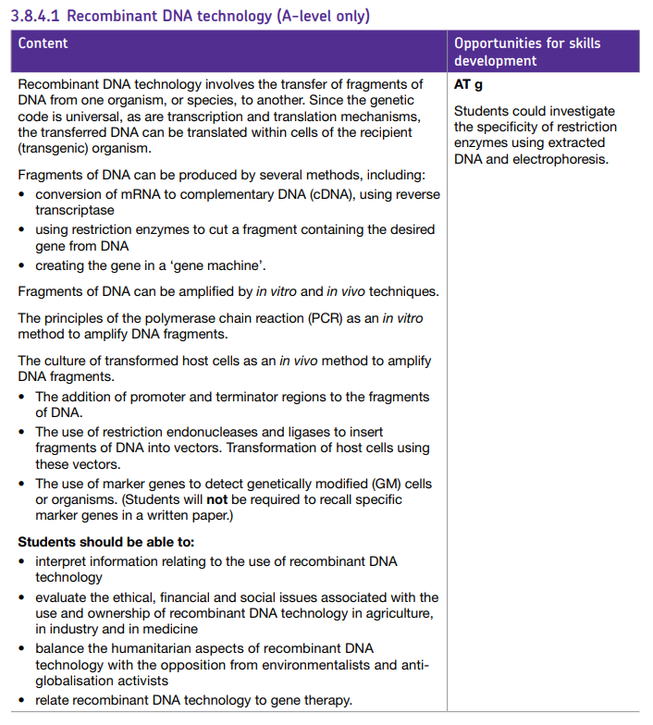
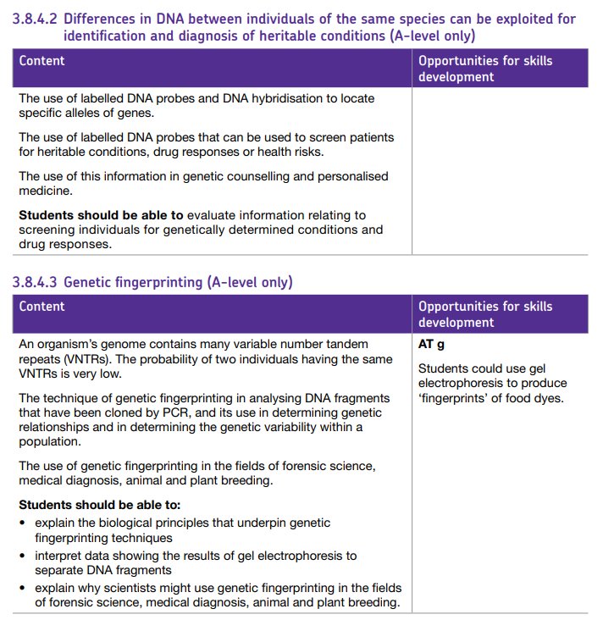

Key Words

Adenovirus | Viruses which infect the respiratory tract, by injecting their DNA into epithelial cells of the lungs, so are useful vectors for gene transfer
Annealing | Joining of the primers to their complementary bases at the end of the DNA fragment
Bacteriophage | A bacteriophage also known informally as a phage is a virus that infects and replicates within bacteria and archaea.
Cellular proteome | refers to the proteins produced by a given type of cell under a certain set of conditions.
CFTR | Cystic fibrosis trans-membrane-conductance regulator – chloride ion channel protein controls transport of Chloride ions across epithelial membranes.
Complementary DNA (cDNA) | DNA that is complementary to a given RNA which serves as a template for synthesis of the DNA in the presence of reverse transcriptase.
Complete proteome | The full range of proteins coded for by the genome. (Identified by gel electrophoresis and mass spectrometry).
Cycle sequencing | A modified automated version of the Sanger method (12000 bases per min). The four deoxynucleotides are fluorescently labelled, polymerisation in a single tube, resulting mixture separated using capillary electrophoresis in a single narrow tube gel, then read by laser beam. Colour sequence is converted to DNA sequence by computer.
DNA electrophoresis | Method of separating out negatively charged DNA fragments by applying a current. The smaller fragments will move quicker towards the positive anode.
DNA hybridisation | Combination of separated DNA strands with the probe, by binding it to the complementary bases on one of the strands.
DNA ligase | An enzyme which can join the phosphate-sugar framework of two sections of DNA eg joining sticky ends
DNA polymerase | An enzyme which manufactures DNA by joining nucleotides (using a complementary strand as a blueprint).
DNA probe | Short, single stranded length of DNA linked to an easily identifiable label eg radioactive or fluorescent probes
DNA sequencing | Methods to determine the exact sequence in which the nucleotides are lined up in a piece of DNA eg Sanger sequencing
Fragments of DNA | Parts of DNA formed from the break up of larger sections of whole genomes.
Gel electrophoresis | Method to separate the radioactively-labelled fragments of DNA after PCR by applying a voltage across a gel matrix, followed by detection using photographic film
Gene machine | A computer controlled device that can be programmed to produce short sequences of DNA.
Gene replacement | Defective gene is replaced with a healthy gene
Gene supplementation | One or more copies of the healthy gene (which are dominant alleles) are added alongside the defective gene, so the effect of the defective gene is masked
Gene therapy | Using defective gene replacement using genes cloned from healthy individuals
Gene transfer/cloning stages | Isolation of DNA; insertion into vector; transformation into host; identification by gene markers; growth/cloning of host cell population
Genetic counselling | Genetic counselling is a communication process with patients that involves discussing the chance of inherited conditions, helping patients to make informed choices about genetic testing and reproductive options, and providing support at a time that can be stressful and highly emotional.
Genetic fingerprinting | Technique to determine the genetic identity of an organism eg in forensics, paternity cases, diagnostics, breeding programmes in conservation. It depends on an organism’s genome containing repetitive, non-coding introns, which have core sequences unique to the individual.
Genetic screening | Checking for individuals in a family for a mutant allele eg sickle-cell anaemia
Genetic variability | Variation in the DNA of an organism.
Genetically modified organism (GMO) | An organism resulting from gene transfer from one organism to another, which has recombinant DNA
Germ-line gene therapy | Therapy involving replacing or supplementing the defective gene in the fertilized egg, so all of the cells in the new organism develop normally. Currently prohibited.
GM crops | Genetically modified crops changed by insertion of gene eg for resistance, over-fast softening of fruit
Human Genome Project | International scientific research project to determine the nitrogenous base pair sequence which make up human DNA, identifying and mapping all the genes of the human genome
In vitro | In vitro (meaning: in the glass) studies are performed with microorganisms, cells, or biological molecules outside their normal biological context.
In vivo | in vivo studies are those conducted in living organisms, including humans, and whole plants.
Labelled DNA probe | A known sequence of nucleotide bases from a DNA strand to detect a complementary sequence in the sample by means of base pairing
Liposome | A lipid molecule wrapped around a gene, used to allow it across the cell-surface membrane
Marker genes | Ways to identify whether a gene has been taken up by a bacterial cell eg using antibiotic resistance, fluorescence or specific enzyme presence.
Next Generation Sequencing (NGS) | Faster, more recent sequencing methods that are continually developing and becoming more efficient, powerful and cost effective.
Non-coding DNA | Non-coding DNA sequences are components of an organism's DNA that do not encode protein
Oligonucleotide | Short sequence of DNA
Palindromic sequence | nucleic acid sequence on double-stranded DNA or RNA where reading the 5' to 3' forward on one strand matches the sequence reading backward 5' to 3' on the complementary strand
Personalised medicine | Personalized medicine, precision medicine, or theranostics is a medical model that separates people into different groups—with medical decisions, practices, interventions and/or products being tailored to the individual patient based on their predicted response or risk of disease.
Plasmid | Plasmids are short circular sections of DNA that can be easily transfered from one bacteria to another.
Polymerase chain reaction | Automated method of in vitro cloning in which fragments of DNA are copied very quickly and many billions of times
Primer | A short sequence of nucleotides with a set of bases complementary to those at one end of each of the two DNA fragments
Promoter | Region of DNA required to allow transcription of the gene to take place.
Recombinant DNA | Recombinant DNA (rDNA) molecules are DNA molecules formed by laboratory methods of genetic recombination (such as molecular cloning) to bring together genetic material from multiple sources, creating sequences that would not otherwise be found in the genome.
Recombinant DNA Technology (genetic engineering) | Processes by which genes are manipulated, altered or transferred from organism to organism.
Replica plating | Method to identify bacterial cells with plasmids carrying antibiotic resistance genes by plating on antibiotic-rich medium
Restriction Enzyme (Restriction endonuclease) | Restriction endonuclease: An enzyme from bacteria that can recognize specific base sequences in DNA and cut (restrict) the DNA at that site (the restriction site).
Restriction mapping | Cutting DNA with a series of different restriction endonucleases (eg HindIII, BamHI, NotI), then separating the fragments. Distance between recognition sites can be discovered by the patterns of fragments produced.
Retrovirus | Eg HIV, a virus containing RNA as genetic material which can replicate by manufacturing complementary DNA.
Reverse Transcriptase | Reverse transcriptase, also called RNA-directed DNA polymerase, an enzyme encoded from the genetic material of retroviruses that catalyzes the transcription of retrovirus RNA (ribonucleic acid) into DNA (deoxyribonucleic acid)
Sanger Sequencing | Initial method of sequencing genomes that requires terminator nucleotides, free nucleotides, primers, DNA polymerase and result in multiple fragments of varying length, which allows the DNA sequence to be determined.
SCID | Severe Combined Immunodeficiency- an example of a genetic disorder which can be helped using gene therapy
Somatic-line gene therapy | Therapy involving targeting the damaged tissue itself, so needs to be repeated periodically as cells die and need replacement.
Sticky ends | The sequence of nucleotides exposed following an oblique ‘cut’ by a restriction endonuclease
Taq Polymerase | Heat stable enzyme that replicates DNA .
Terminator | Region of DNA required to stop transcription at the appropriate point
Thermocycler | A computer-controlled machine that varies temperatures precisely over a period of time
Transformation | Reintroduction of plasmids back into host bacterial cells, by mixing them in a medium containing Calcium ions to increase their permeability
Transgenic | relating to or denoting an organism that contains genetic material into which DNA from an unrelated organism has been artificially introduced.
Variable number tandem repeats (VNTRs) | A location in a genome where a short nucleotide sequence is organized as a tandem repeat.
Vector | A carrier eg a plasmid or virus
Whole-genome (shotgun) sequencing | Focuses on sequencing all of the DNA in an organism’s genome by cutting the DNA into many small, easily sequenced sections then uses computer algorithms to align overlapping segments to assemble the entire genome.

Lesson 1 – Genome Projects
Notes:
Genome Sequencing
The genome is all of the genetic information in an organism or cell. Genome projects use technology to determine the complete sequence of bases that make up the DNA of an organism.

Gene sequencing methods work by cutting the DNA molecule into fragments which are sequenced and then these are put back into the correct order to give the sequence of the whole genome. Genome projects have now sequenced the genomes of over 360,000 organisms from viruses and bacteria to humans. The 3 billion bases of the human genome were sequenced in a project that took over 10 years and was completed in 2003. The aim was to search for genes linked to different types of disease, to improve our understanding of and treatment of inherited disorders and now these sequences are being used to learn more about our evolution and to trace early human migration patterns.
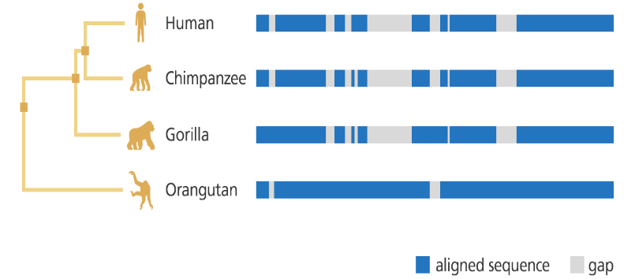
Once sequenced genomes can be compared within a particular species this can highlight disease risk (for example carriers of point mutations) or identify mutations which cause disease. Comparison of genomes between species can be used to explain the evolutionary relationships between species and used to build phylogenetic trees.
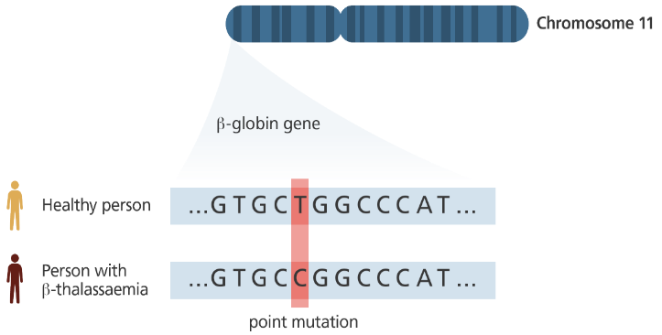
Sequencing of Proteomes
The sequencing of genomes can allow the proteome (the sequence of proteins coded for by the DNA base sequence of the genome) to be determined. This is only simple in organisms with small genomes such as bacteria and viruses. It has helped to identify antigens of viruses which can then be used to produce vaccines much faster, monitor mutations and variations as the pathogen evolves and identify antibiotic resistance mechanisms e.g the Covid-19 vaccine in 2020 which only had 30,000 RNA bases but the rapid sequencing and sharing of the genome around the world enabled the production of vaccines much faster than would be possible without this technology. Variants can also be monitored to help control the spread of infection.
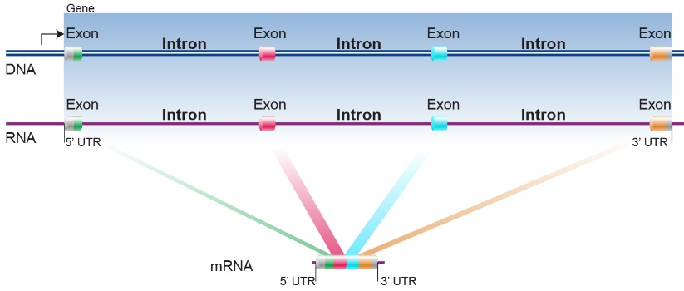
Large sections of the genome of complex organisms is made up of DNA which does not code for proteins (introns) – in humans it is 98.5%! This is often referred to as ‘junk’ DNA and contains regulatory genes (genes that determine when coding regions should be switched on or off), genes that code for tRNA and rRNA, and large repeating sequences left over from years of evolution and repeat infection with retroviruses.
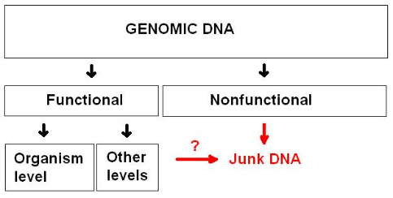
This means that the proteome of an organism is hard to determine from the genome as it is unknown which sections are exons. Work is still being done on the human genome – so far more than 30,000 human proteins have been identified.

Sequencing Methods
In the past sequencing methods were labour-intensive, expensive and could only be small scale. Now these techniques have been automated and made cheaper (human genome sequencing is only around £1000) so it is more cost-effective to do it on a large scale. Faster, more recent sequencing methods are continually developing and becoming more efficient, powerful and cost effective.

Sanger sequencing – In 1977 Fred Sanger developed the first method for sequencing fragments of DNA up to 900 base pairs. The fragments are then aligned based on portions that overlapped to assemble larger pieces of DNA – this method was used to sequence the Human Genome. The DNA sample had to be split into 4 and each portion replicated with a different radioactive nucleotides so the fragments could be detected then run on an electrophoresis gel and an x-ray taken of the gel by hand to view the fragments.
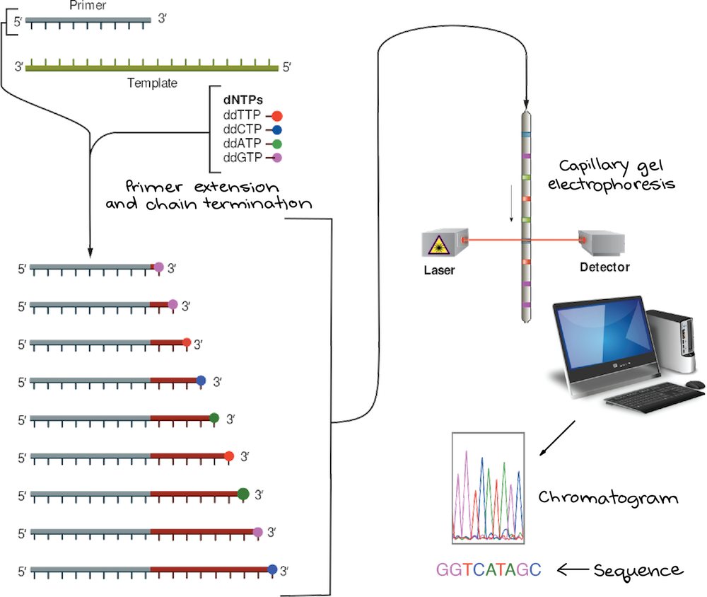
Cycle Sequencing is a modified, automated version of the Sanger method developed in 1986which can sequence 12,000 bases per minute!

A fluorescent dye is used rather than a radioactive label. This means ALL chains can run in the same sequence. They are separated using electrophoresis in a single narrow tube gel, then read by laser beam.

The fluorescent colour sequence is detected by the laser and converted to DNA sequence by a computer:

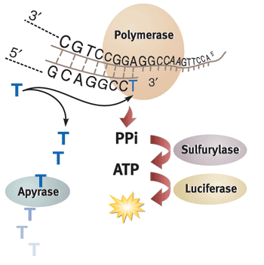

Other methods of superfast sequencing have been developed. In 1996 pyrosequencing was invented where a light emitting reaction linked to the DNA polymerase enzyme was detected by a computer. Each time a different base was added.
- It involves synthesising a complementary single strand of DNA to the strand being sequenced one base at a time
- Detecting the light emission is used to determine which base was added at each step.
- One million reads occur simultaneously, so a 10-hour run generates 400 million bases of sequencing information!

Recall Questions:
- What is the main aim of a genome project?
- What is the proteome of an organism?
- Why might genome sequencing be important to an evolutionary biologist who is investigating the relationship between different populations of lemur in Madagascar. How might this give her information on how they have evolved?
- Give a medical use for sequencing the proteome of a pathogen
- Explain why the proteome is easier to determine from a bacteria than it is from a eukaryotic organism
- How have sequencing methods improved since they were introduced?

Exam Questions:

1. What is the proteome of a cell?

___________________________________________________________________

___________________________________________________________________ (1)

2.
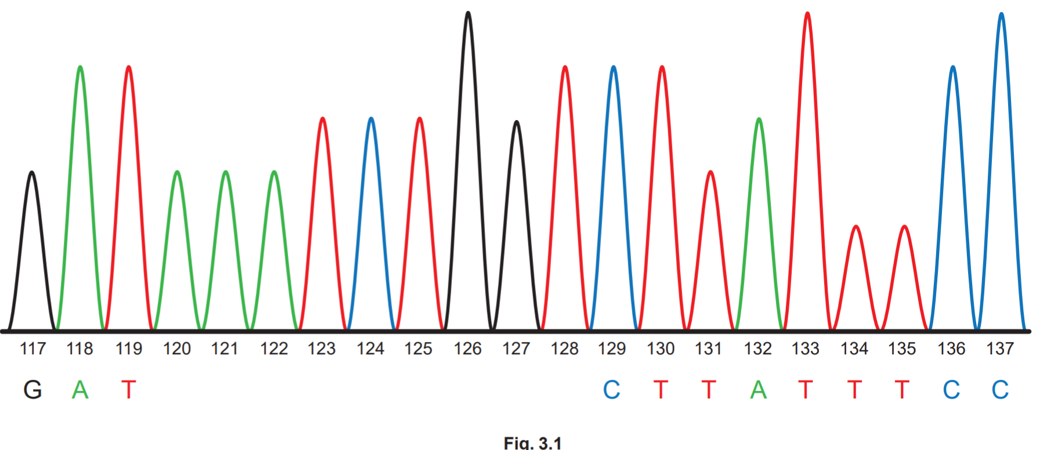
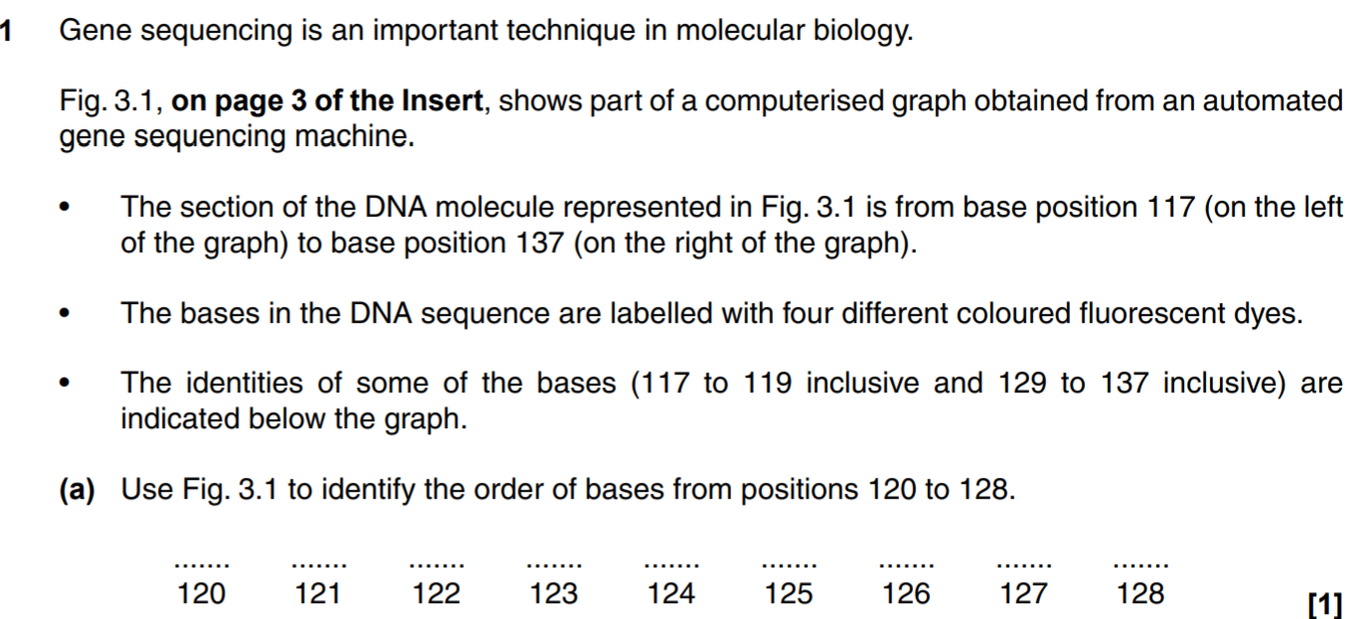
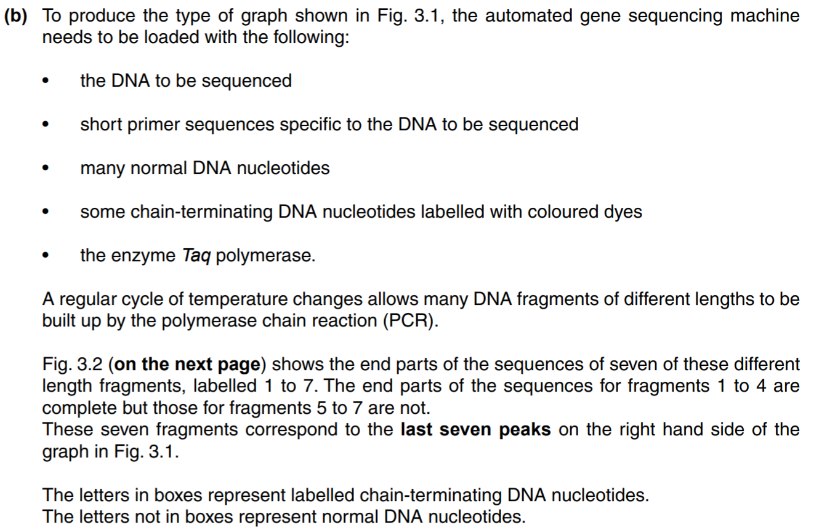
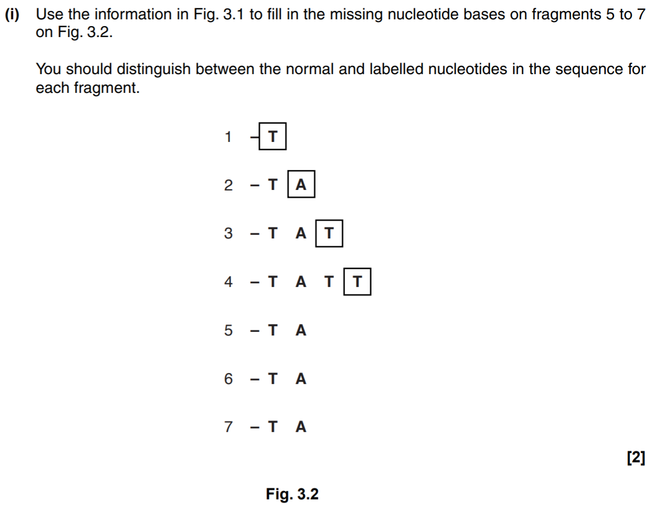

3.
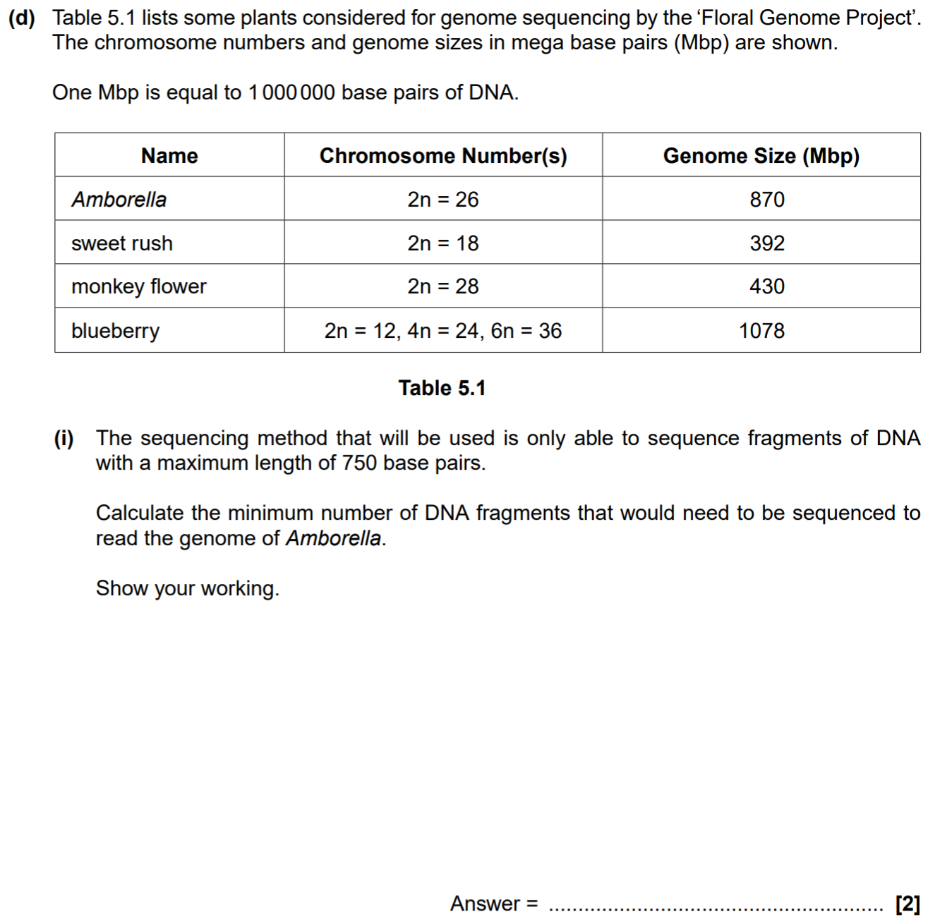

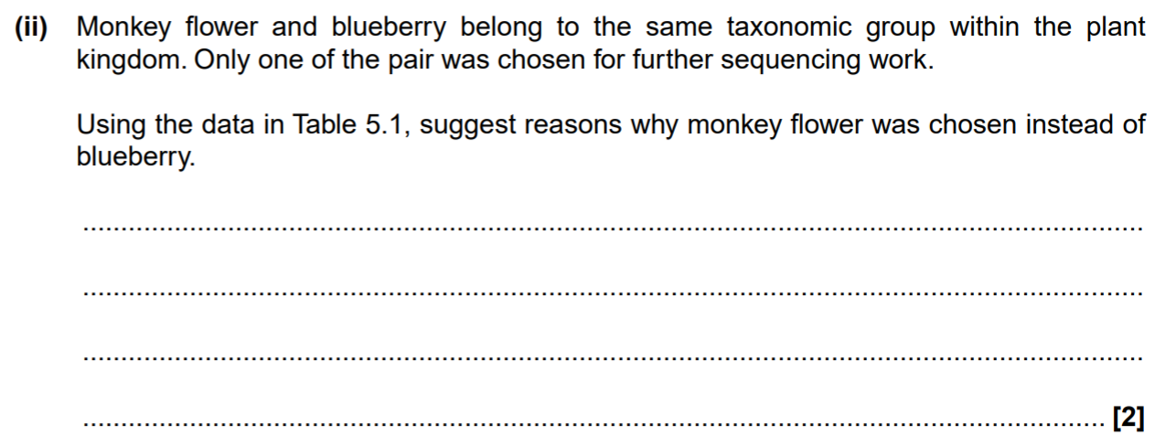
4. (a)
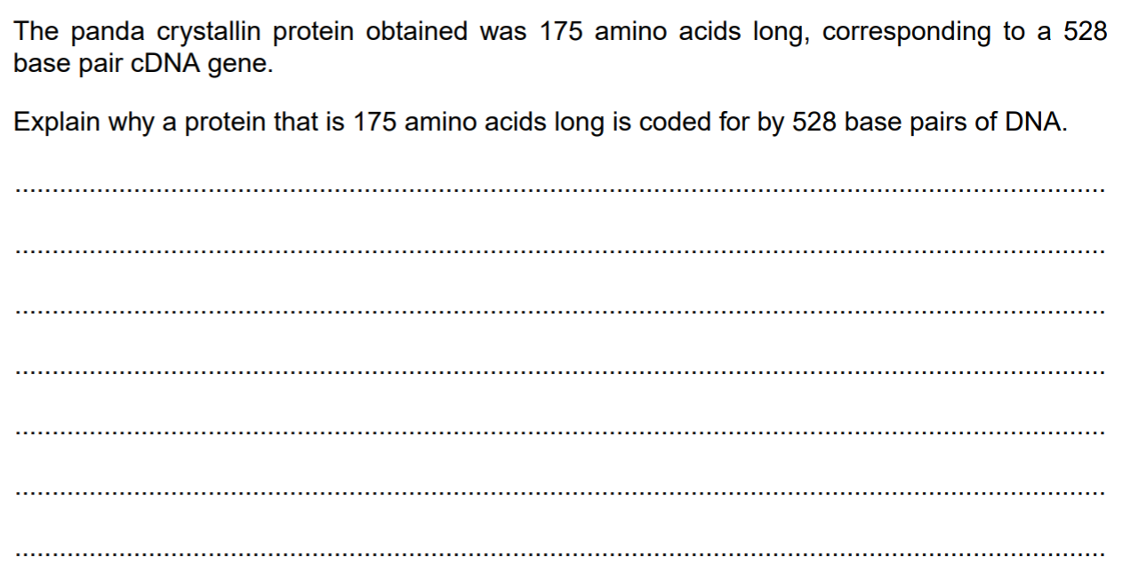(3)
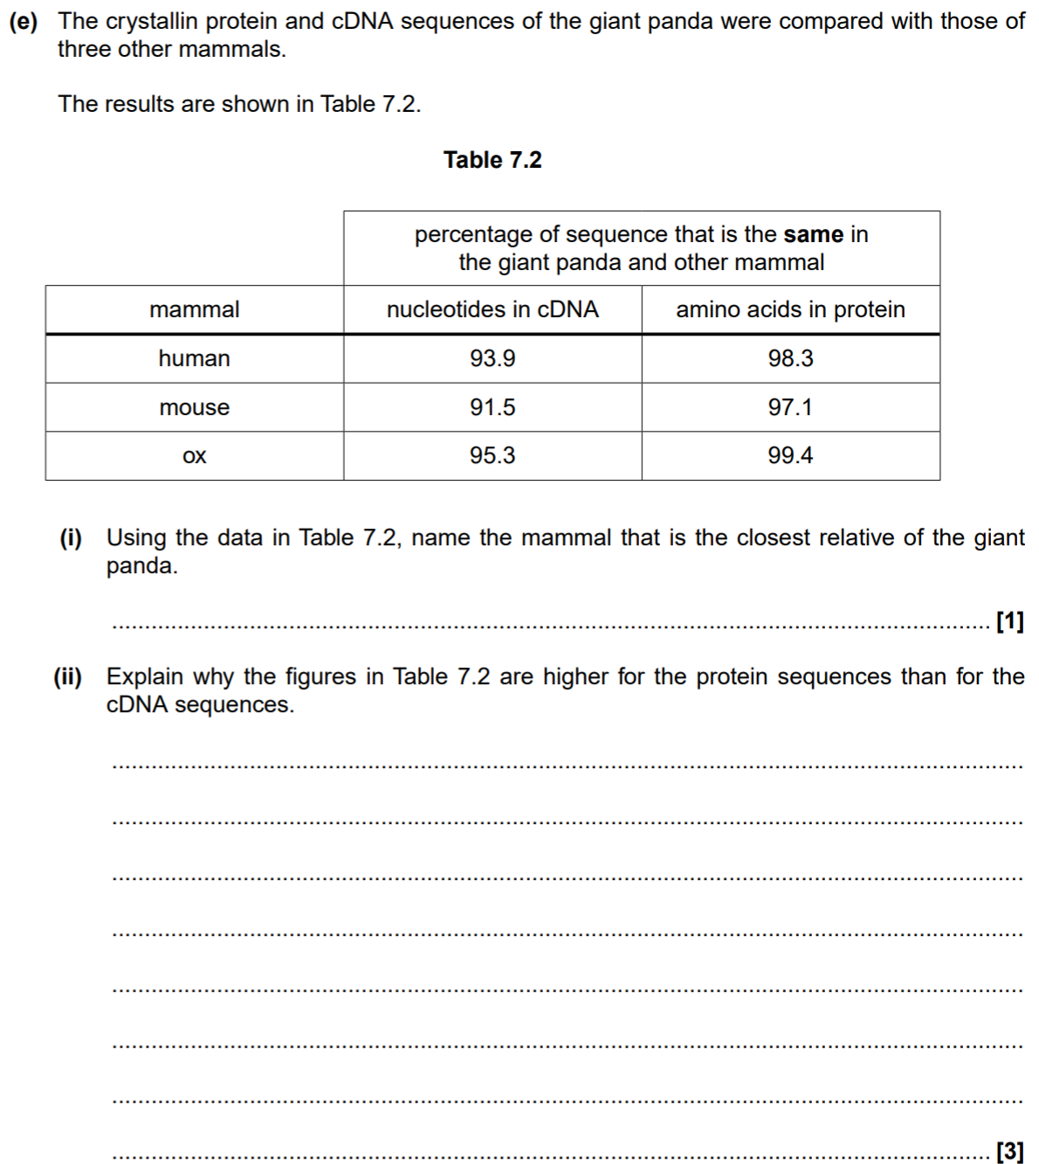

Homework: Pre-Reading GCSE Recap on Genetic Engineering

Video: Scan the code above with your phone to watch the video on this topic
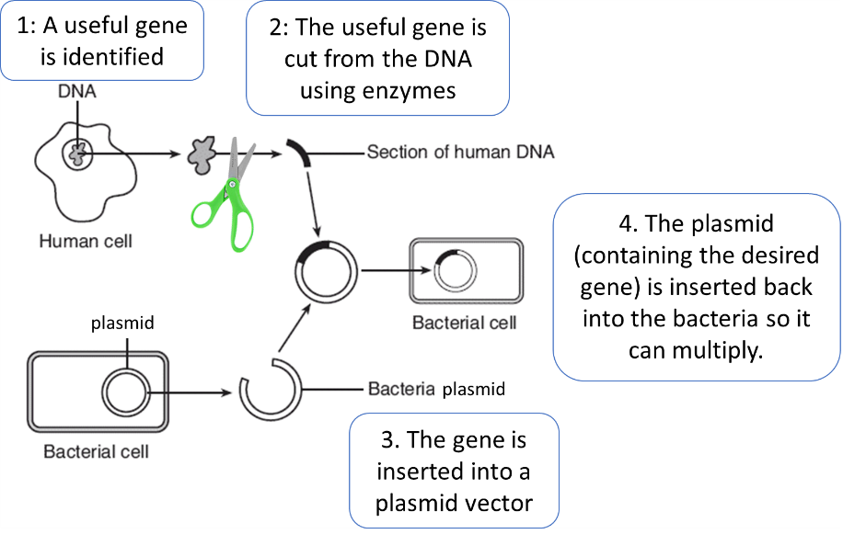
Notes:

Part 1 - Define the term ‘genetic engineering’
Genetic engineering is a process where a gene from one organism is inserted into the genome of another, so that it has a desired characteristic.
Enzymes are used to cut the desired gene out of the DNA, it is then placed into a vector (something that can insert the gene into the new organism). When using bacteria the vector is a plasmid but you could also use a virus.

The bacteria have been genetically modified, the plasmid will be copied when the bacteria replicate and they will all produce the product of the gene. E.g insulin.
Genetic engineering can be carried out on any organism, if genetic engineering is carried out on animals and plants then it is done at an early stage so that all cells will contain the gene and they will develop the desired characteristic.

Organism which has been genetically modified | Benefit
Bacteria | To produce useful substances such as human insulin to treat diabetes
Food Crops | Improve yield (bigger better fruit) and be resistant to pests or diseases.  E.g. Bt Cotton produced to be resistant to specific caterpillar pest  E.g Golden Rice has been genetically modified with a gene taken from tomatoes to make beta-carotene, a pigment that is converted into vitamin A in the body. It is used to help prevent vitamin A deficiency and blindness in Africa and Asia.
Sheep | Sheep have been genetically engineered so that they can produce useful things in their milk, e.g. drugs to treat human diseases
Part 2 - Give examples of organisms which have been genetically modified and explain why.

Part 3 - Evaluate the use of GM organisms
Benefits of genetic engineering in medicine:
- Can produce large amounts of proteins like insulin and other drugs very fast
- Human insulin made this way will not be rejected by the body
- It could allow treatment for some human genetic disorders in the future
Disadvantages of genetic engineering in medicine:
- Genetic engineering is expensive.
Benefits of GM crops
- Genetically modifying crops to be resistant to pests and diseases allows plants to grow better and increases yield
- GM plants can be used to produce more food or more nutritious food in places where they cannot grow lots
- It can reduce the use of chemical pesticides
Disadvantages of GM crops
- Inserted genes could be transferred to wild/natural populations of plants which could affect biodiversity of plants and insects that feed on them. Especially resistance genes as it could stop farmers being able to control the growth of weeds and other plants
- Some people have objections to the use of GM crops as they believe it is not natural, they also believe the effect of eating GM crops on humans has not been studied well enough.

Recall Questions – Practice answering these using the notes like a comprehension
- What is genetic engineering?
- Define genetically modified (GM) crops.
- State three characteristics plants might be genetically engineered to have.
- Give one example of the use of genetically engineered bacterial cells.
- How is a gene ‘cut out’ from the genome of one species and inserted into the genome of another?
- Into what is the gene inserted?
- Give two examples of vectors used in genetic engineering.
- What are the benefits of genetic engineering?
- State three concerns around genetically engineering plants.
- Describe the main steps in the process of genetic engineering.

Recall Question Answers:
Question | Answer
1. What is the main aim of a genome project? | To sequence the complete set of genetic material in an organism
2. What is the proteome of an organism? | The full number of different proteins the genome / DNA is able to code for
3. Why might genome sequencing be important to an evolutionary biologist who is investigating the relationship between different populations of lemur in Madagascar. How might this give her information on how they have evolved? | She can compare their genomes to look for variations. The more similarities between the genomes of the different populations the more closely related they are as they will share a more recent common ancestor. More differences suggest they evolved earlier.
4. Give a medical use for sequencing the proteome of a prokaryote | It can be used to identify the protein antigens on the surface of a pathogen which can help in the development of vaccines to prevent spread of the disease. Monitor mutations and variations as the pathogen evolves, identify antibiotic resistance mechanisms, help control the spread of infection.
5. Explain why the proteome is easier to determine from a bacteria than it is from a eukaryotic organism? | Bacteria do not have any regions of non coding dna/introns so all of their genome codes for proteins. In eukaryotes it is hard to find the sections that code for proteins among the non-coding regions.
6. How have sequencing methods improved since they were introduced? | Sequences are no longer labour intensive and can be done on a large scale – they are also more cost effective

Lesson 2 – Making DNA Fragments
Notes:
Creating DNA fragments (isolating sections of desired DNA) is part of many processes including:
- Sequencing
- Genetically modifying organisms
- Genetic fingerprinting (identification)

There are multiple methods that can be used to isolate a target gene:
- Using reverse transcriptases to make DNA from mRNA
- Use restriction enzymes to cut out a section of DNA from the genome
- Use a gene machine to build a section of DNA using nucleotides

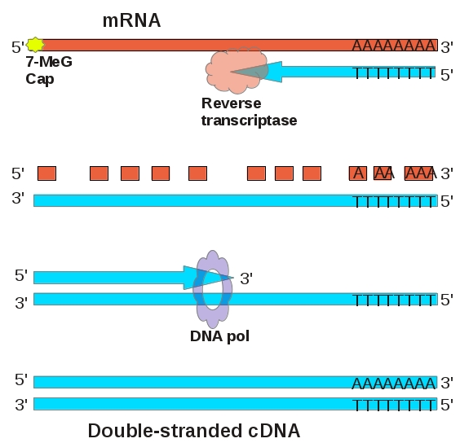
Method 1: Using Reverse Transcriptase to make cDNA
Cells that contain the protein made by the target gene will contain lots of mRNA which is complimentary to the target gene.
E.g. pancreas cells will contain lots of mRNA for insulin but there will only be 2 copies of the gene that codes for insulin in the cell, the introns will also have been removed so only coding DNA is copied.

Reverse transcriptase is an enzyme that can convert RNA back into DNA it has been isolated from a retrovirus such as HIV.

The reverse transcription enzyme is added and uses free DNA nucleotides to make DNA from the mRNA template – this DNA is called cDNA (complementary DNA as it matches the mRNA).

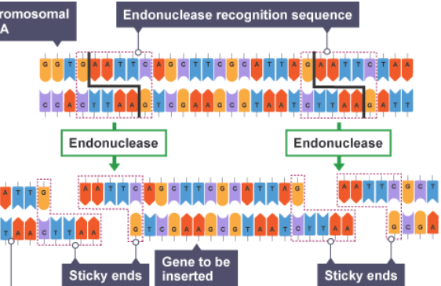
Method 2: Genes can be found and ‘cut out’ using restriction enzymes

Restriction endonucleases are a group of enzymes that can recognise and cut (hydrolyse) hydrogen bonds at specific sequences of DNA.

They cut at a specific recognition sequence in the DNA which is complimentary to their active site.

If there are recognition sites at each end of the gene you want you can cut out your gene from the rest of the DNA.
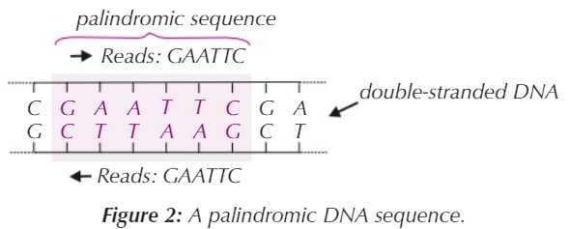
Restriction enzymes form sticky ends (pieces of DNA that have unpaired (exposed) nucleotides on a single strand at each end) and allow different fragments to be joined together or ‘annealed’ (when cut with the same restriction enzyme). The restriction sequence is palindromic, they are complimentary to each other.
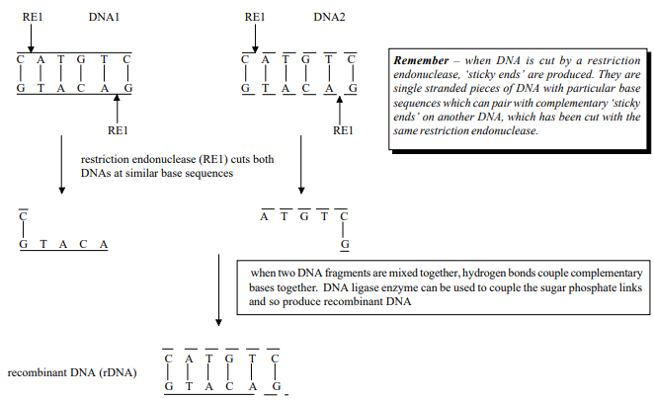 Method 3: Using a gene machine to build fragments
This method does not require a template and it means that a known DNA sequence could be copied or the DNA sequence can be created from scratch.
- The sequence is designed or fed into the computer
- The first nucleotide in the sequence is attached to a physical support e.g a bead
- Nucleotides are added step by step in the right order and joined in the correct place to prevent branching
- Short sections of DNA called oligonucleotides are produced (20 nucleotides long). Once these are complete they are broken off from the support. These can be joined together to make longer fragments.

Recall Questions:
- What is a restriction enzyme?
- What is meant when a restriction enzyme recognition site is said to be 'palindromic'?
- What are 'sticky ends'?
- Do restriction enzymes catalyse condensation or hydrolysis reactions?
- What does it mean when we say that two DNA fragments are 'annealed’?
- How are restriction enzymes used in genetic modification?
- Which isolation method will produce DNA with introns?

Exam Questions
Q1. Scientists wanted to measure how much mRNA was transcribed from allele A of a gene in a sample of cells. This gene exists in two forms, A and a.
The scientists isolated mRNA from the cells. They added an enzyme to mRNA to produce cDNA.
(a) Name the type of enzyme used to produce the cDNA.
__________________________________________________________________ _(1)
Q2. Describe how a gene can be isolated from human DNA.
___________________________________________________________________
___________________________________________________________________
___________________________________________________________________
_________________________________________________________________(2)

Q3. Plasmids can be used as vectors to insert lengths of foreign DNA into bacteria. The diagram shows how this is achieved.
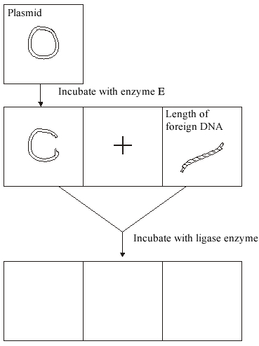
(a) Name enzyme E.
___________________________________________________________________(1)
(b) Cut plasmids and lengths of foreign DNA can join. What features of their ends allows them to join?
___________________________________________________________________
___________________________________________________________________
_________________________________________________________________(2)
Q4. DNA probes may be used to identify the presence of specific genes associated with human diseases. The flow chart summarises the way in which they are used.

Stage 1 DNA is cut into fragments
Stage 2 Electrophoresis separates the DNA fragments
Stage 3 Radioactive DNA probes are used to locate specific DNA fragments
(a) Name the enzyme used in Stage 1.
___________________________________________________________________ (1)
Q5. Some human DNA was cut into separate pieces using a restriction enzyme which produced a staggered cut. A scientist wanted to insert these pieces of DNA into plasmids and used the same restriction enzyme to cut the plasmids. Explain why the pieces of human DNA would be able to join to the cut DNA of the plasmids.
______________________________________________________________
______________________________________________________________
______________________________________________________________
______________________________________________________________
(2)

Q6. Scientists manufactured large quantities of human insulin using genetic engineering.
They started by isolating mRNA from pancreas cells. From this they produced DNA which coded for insulin.
(a) (i) Suggest two reasons why it was better to start with mRNA from pancreas cells rather than with the DNA from these cells.
1. ____________________________________________________________
______________________________________________________________
2. ____________________________________________________________
______________________________________________________________ (2)
(ii) The scientists used two enzymes, Enzyme 1 and Enzyme 2, to produce DNA from mRNA.
The reactions catalysed by these enzymes are shown below.
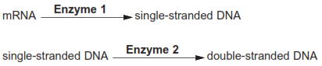
Name enzymes 1 and 2.
Enzyme 1 _____________________________________________________
Enzyme 2 _____________________________________________________
(2)
(iii) In a double-stranded DNA molecule, the two strands are held together by weak bonds.
Name this type of bond.
____________________________________________________________(1)

Q7. People suffering from pituitary dwarfism do not make enough human growth hormone (HGH). They can be treated using injections of HGH.
A geneticist wants to transform the bacterium, Escherichia coli, to make HGH by adding the gene coding for HGH.
The geneticist could obtain the HGH gene using any one of three methods.
1. Use restriction enzymes to cut out a fragment of DNA containing the HGH gene from a human genome.
2. Convert mRNA for HGH into cDNA using reverse transcriptase.
3. Create the HGH gene using a ‘gene machine’.
(a) The geneticist decided not to use restriction enzymes to cut out a fragment of DNA containing the HGH gene from a human genome. She made this decision because only methods 2 and 3 would produce DNA that E. coli could use to make HGH.
Explain why only methods 2 and 3 would produce DNA that E. coli could use to make HGH.
___________________________________________________________________
___________________________________________________________________
___________________________________________________________________
___________________________________________________________________
___________________________________________________________________
(2)
(b) The geneticist concluded it would be faster to create the HGH gene using a gene machine than by using reverse transcriptase to convert mRNA for HGH into cDNA.
Suggest why the geneticist reached this conclusion.
___________________________________________________________________
___________________________________________________________________
___________________________________________________________________
(1)

Lesson 3 - In Vivo Gene Cloning
Notes:
In Vivo | In Vitro
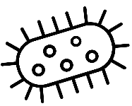 | 
Literally means “in the living” which means taking place inside whole, living organisms or cells | Literally means “in the glass” which means performed or taking place in a test tube, culture dish, or elsewhere outside a living organism
DNA fragment placed in a plasmid and relies on bacterial conjugation and replication to make copies of the plasmid | Uses the polymerase chain reaction (PCR) – in a test tube in a machine
Takes longer and requires screening as not all bacteria will take up gene | Makes millions of copies of a fragment of DNA in hours
Using marker genes and manipulating growth conditions can help to determine if genes have been taken up and amplified by the organism | Sequencing must be used to determine what genes have been amplified
Key word | Definition
DNA ligase | Enzyme that catalyses the joining of sugar and phosphate groups within DNA
Electroporation | Method of introducing a vector with a novel gene into a cell: a pulse of electricity makes the recipient cell membrane more porous
Plasmids | Small loops of DNA in prokaryotic cells
Recombinant DNA | A composite DNA molecule created in vitro by joining foreign DNA with a vector molecule such as a plasmid
Restriction enzymes | Endonuclease enzymes that cleave DNA molecules at specific recognition sites
Sticky ends | A length of DNA of a specific sequence that can join to its complementary base pair sequence on the end of another section of DNA.
Vector | In gene technology, anything that can carry DNA into a host organism, e.g. plasmids, viruses and certain bacteria
In vivo cloning relies on recombinant DNA technology or genetic modification. Genes are isolated from one organism and inserted into another organism using suitable vectors, this creates new combinations of genes.
1. Desired gene is isolated using restriction endonuclease enzymes
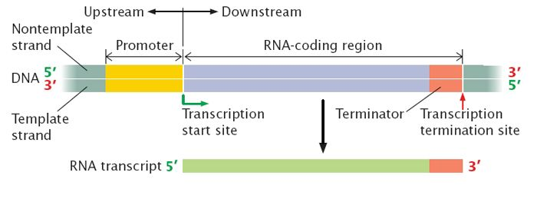
2. Promoter regions and terminator regions are added to the gene to make sure the gene can be correctly transcribed once in the host
- Promoter: Tells RNA polymerase where to start transcribing mRNA.
- Terminator: Tells RNA polymerase when to stop
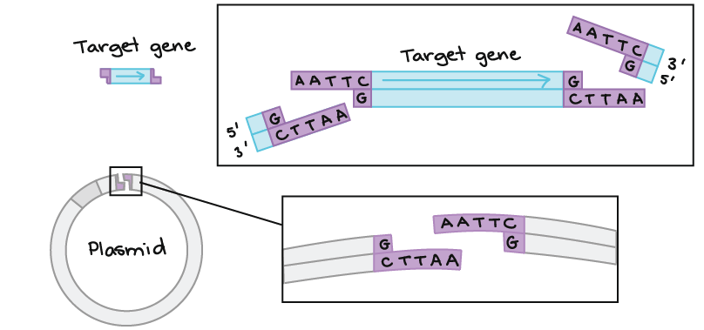
3. The gene is inserted into a vector – usually a plasmid
Cut the plasmid and the gene with the same restriction endonuclease enzyme to leave ‘sticky ends’. Sticky ends allow the target gene to lyse with the plasmid.
Ligase enzymes can join these two DNA fragments together they catalyse condensation reactions that join the sugar groups and the phosphate groups to the DNA backbone.
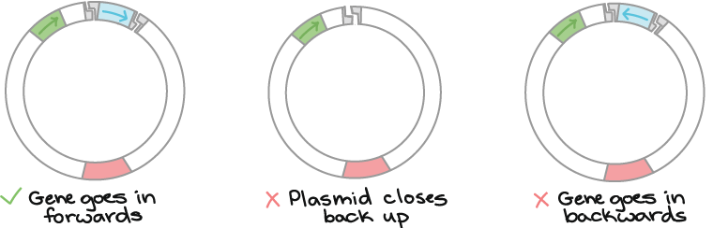
When DNA fragments and plasmids are mixed not ALL plasmids will take up the gene correctly.
DNA fragments that don’t get inserted can also join its own sticky ends to create a loop!

4. The recombinant plasmid is now transferred to host cells
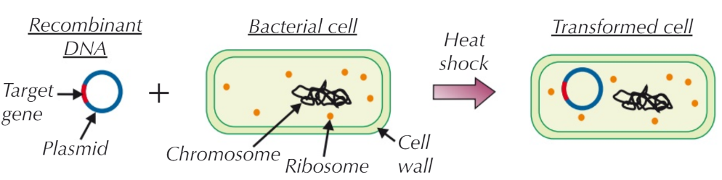
A solution e.g sodium chloride can be used to make cell walls more permeable. Heat shock can be used or electroporation (a small electric shock) to make holes in the membrane which DNA can pass through.

5. The host cells are allowed to multiply and those that have successfully taken up the gene are identified using a marker gene
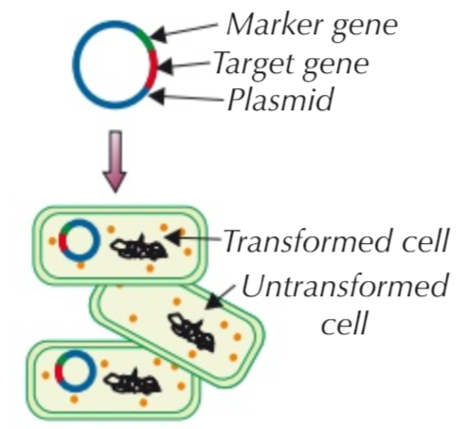
Marker genes are inserted into vectors at the same time the gene is. They can be used to quickly identify bacteria which have plasmids that contain the gene.
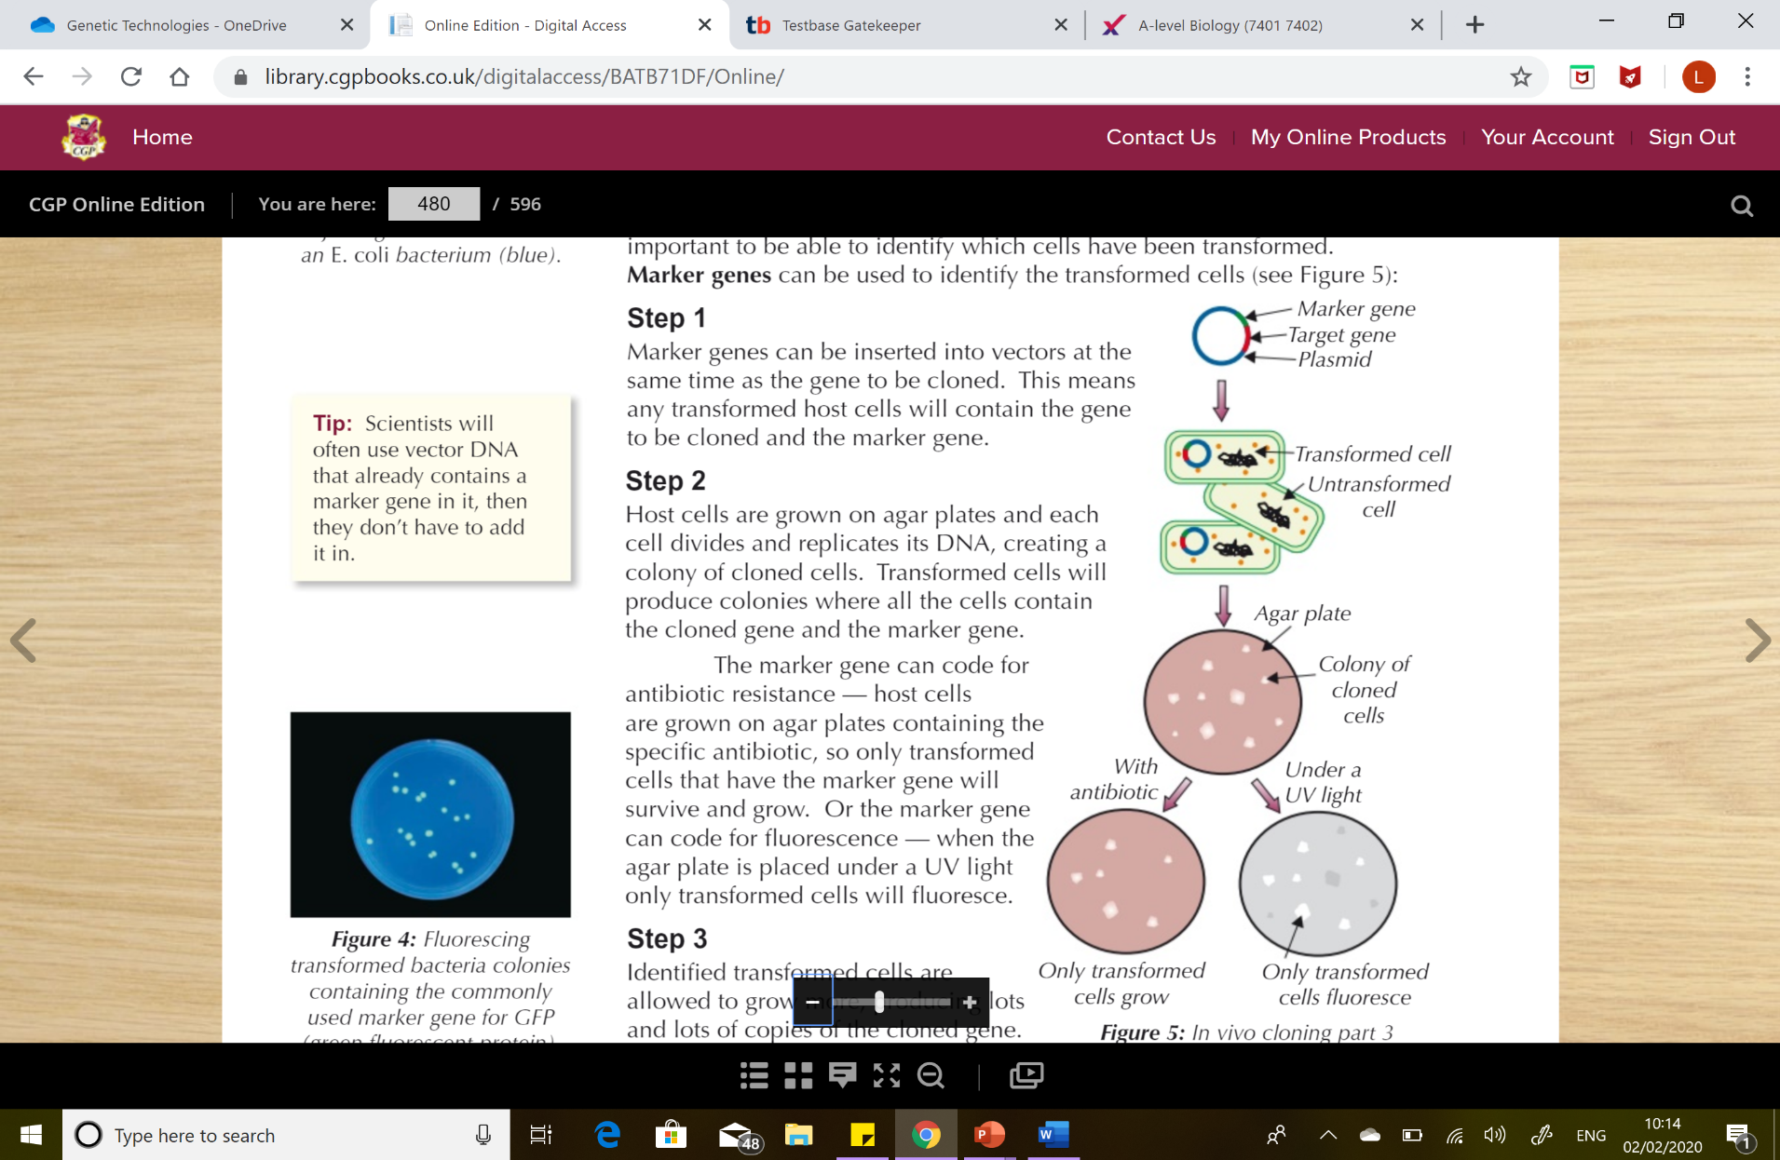
Marker genes can code for antibiotic resistance. Colonies of bacteria are grown on an agar plate that contains the antibiotic. Only transformed bacteria with the resistance gene will survive. They can then be selected.

Marker genes can also code for UV fluorescence. After they have been left to grow. A UV light can be used to identify colonies which will glow. These must contain the target gene so they can then be selected.
The genetic code is universal so bacteria can transcribe the DNA and translate the mRNA to produce the protein, the mechanism and machinery is the same in all organisms.
Recall Questions
- What is the role of a vector?
- Name a common vector used in genetic engineering.
- What is the role of DNA ligase when making a recombinant plasmid?
- Why are promoter regions important in plasmids?
- What is electroporation?
- Why are marker genes inserted into plasmids?
- Give an example of a marker gene.
Exam Questions:
Q1. Describe the roles of two named types of enzymes used to insert DNA fragments into plasmids.
Type of enzyme _____________________________________________________
Role _______________________________________________________________
___________________________________________________________________
___________________________________________________________________
___________________________________________________________________
Type of enzyme _____________________________________________________
Role _______________________________________________________________
___________________________________________________________________
___________________________________________________________________
___________________________________________________________________
(2)
Q2. Plasmids are often used as vectors in genetic engineering.
(i) What is the role of a vector?
______________________________________________________________
______________________________________________________________
(1)
(ii) Describe the role of restriction endonucleases in the formation of plasmids that contain donor DNA.
______________________________________________________________
______________________________________________________________
______________________________________________________________
______________________________________________________________
(2)
(iii) Describe the role of DNA ligase in the production of plasmids containing donor DNA.
______________________________________________________________
______________________________________________________________
(1)

Q3. Hindlll is an enzyme that cuts DNA into smaller fragments.
The enzyme cuts DNA at the specific base sequence shown in Figure 1.
Figure 1
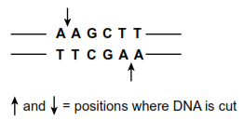
(a) What general name is given to enzymes such as Hindlll?
___________________________________________________________________
(1)
(b) Hindlll produces DNA fragments with sticky ends.
(i) Use information from Figure 1 to give the base sequence of one of these sticky ends.
______________________________________________________________
(1)
(ii) Sticky ends are useful in genetic engineering. Explain how.
______________________________________________________________
______________________________________________________________
______________________________________________________________
______________________________________________________________
(2)
Q4. (a) (i) Some human DNA was cut into separate pieces using a restriction enzyme which produced a staggered cut. A scientist wanted to insert these pieces of DNA into plasmids and used the same restriction enzyme to cut the plasmids. Explain why the pieces of human DNA would be able to join to the cut DNA of the plasmids.
______________________________________________________________
______________________________________________________________
______________________________________________________________
______________________________________________________________
(2)
(ii) Which other enzyme must the scientist have added to the mixture to form recombinant plasmids?
______________________________________________________________
______________________________________________________________ (1)
(b) A plasmid may be used as a vector. Explain what is meant by a vector.
___________________________________________________________________
___________________________________________________________________
___________________________________________________________________
___________________________________________________________________
(2)
(c) Molecular biologists often use plasmids which contain antibiotic resistance genes.
Explain the reason for this.
___________________________________________________________________
___________________________________________________________________
___________________________________________________________________
___________________________________________________________________
(2)
Q5.
Plasmids can be modified by genetic engineering and inserted into bacteria. These bacteria can then make useful substances normally made by another organism. Explain how modified plasmids are made by genetic engineering and how the use of markers enable bacteria containing these plasmids to be detected.
___________________________________________________________________
___________________________________________________________________
___________________________________________________________________
___________________________________________________________________
___________________________________________________________________
___________________________________________________________________
___________________________________________________________________
___________________________________________________________________
___________________________________________________________________
___________________________________________________________________
___________________________________________________________________
___________________________________________________________________
___________________________________________________________________
___________________________________________________________________(6)
Q6.
Agrobacterium tumefaciens is a bacterium that is often used in recombinant DNA technology to produce transformed plants that benefit humans.
A. tumefaciens contains a plasmid which can be used as a vector to transfer a desired gene into plant cells. These plant cells may then develop into plants which produce the protein coded for by the desired gene.
The diagram outlines this process.
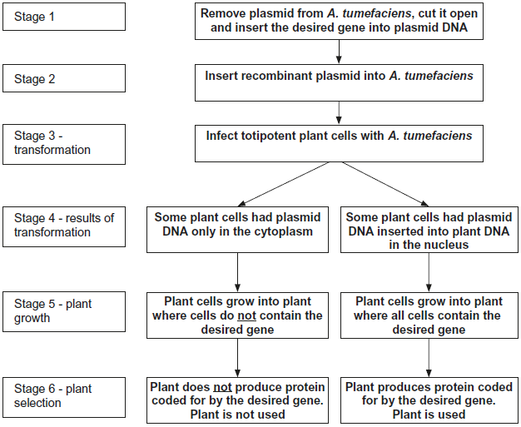
(a) (i) In stage 1, an enzyme is used to cut open the plasmid.
Name the type of enzyme used to cut open the plasmid.
______________________________________________________________
(1)
(ii) In stage 1, another enzyme is used to insert the desired gene into the plasmid DNA.
Name the type of enzyme used to insert the gene into the plasmid.
______________________________________________________________
(1)

(b) In stage 4, some plant cells had plasmid DNA only in their cytoplasm. In other plant cells, the plasmid DNA had become inserted into plant DNA in the nucleus.
In stage 5, only cells with plasmid DNA inserted into the plant DNA in the nucleus grew into plants where all the cells contained the desired gene.
Explain why some of the plants in stage 5 contained the desired gene in all of their cells and others did not.
___________________________________________________________________
___________________________________________________________________
___________________________________________________________________
___________________________________________________________________
___________________________________________________________________
___________________________________________________________________
(3)
(c) The desired gene in the diagram was from an insect. In stage 6, the plant containing this gene was able to use it to synthesise an insect protein.
The plant is able to synthesise the insect protein. Explain why this is possible.
___________________________________________________________________
___________________________________________________________________
___________________________________________________________________
___________________________________________________________________
___________________________________________________________________
___________________________________________________________________
(3)
Q7. People suffering from pituitary dwarfism do not make enough human growth hormone (HGH). They can be treated using injections of HGH.
A geneticist wants to transform the bacterium, Escherichia coli, to make HGH by adding the gene coding for HGH.
The geneticist could obtain the HGH gene using any one of three methods.
1. Use restriction enzymes to cut out a fragment of DNA containing the HGH gene from a human genome.
2. Convert mRNA for HGH into cDNA using reverse transcriptase.
3. Create the HGH gene using a ‘gene machine’.

(d) The geneticist plans to use the plasmids containing the HGH gene to try to transform cells of E. coli. She knows that some E. coli might not take up the plasmid.
To enable her to identify which bacteria have taken up the plasmid with the HGH gene, the plasmids she intends to use contain a gene that codes for a green fluorescent protein (GFP). Bacteria that contain this plasmid glow green under UV light.
Suggest one advantage of using this gene for GFP to identify bacteria that have taken up plasmids.
___________________________________________________________________
___________________________________________________________________
___________________________________________________________________
(1)
The diagram below shows part of the plasmid containing the gene that codes for GFP. It also shows the roles of two genes that control the GFP gene.
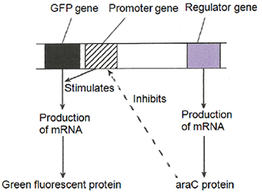
(e) Arabinose is a sugar that can bind to the araC protein.
Use information in the diagram to suggest why the geneticist must include arabinose in the agar on which she hopes to grow E. coli containing the transgenic plasmids.
___________________________________________________________________
___________________________________________________________________
___________________________________________________________________
___________________________________________________________________
___________________________________________________________________
(2)

Homework:
Transforming Bacteria with the pGLO plasmid.

Transforming the bacteria with the plasmid
- The pGLO plasmids (DNA) are mixed with an appropriate species of bacteria.
- The bacteria are first frozen, then heat-shocked. This causes the cell walls and plasma membrane to become permeable, allowing some of the bacteria to take up the plasmids.
- A nutrient media is added, and the bacteria are incubated for a short time to allow them to recover from the heat-shock. The transformed bacteria will begin to synthesize the protein that makes them resistant to ampicillin.
- The bacterial suspension is "plated" on medium containing the antibiotic ampicillin. Only the transformed bacteria (which contain the gene for ampicillin resistance) will grow on the ampicillin medium.
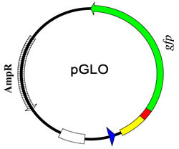
- A colony is removed from the ampicillin plate and resuspended in nutrient broth. After 2 days of growth, there will be so many transformed bacteria that measurable quantities of the desired protein (in this case GFP) can be obtained.
In addition to the GFP and ampicillin resistance genes, the plasmid contains several genes that control the expression of GFP.
This control is linked to the nutrient arabinose (a type of sugar). The plasmid naturally contains an operon for arabinose digestion. if arabinose is present in nutrient medium, the operon's structural genes for arabinose digestion will be turned on.
However, the arabinose operon in the pGLO plasmid has been altered by replacing the genes for arabinose digestion with the GFP gene.
So when arabinose is present to turn on the arabinose operon, GFP is produced and the bacteria can fluoresce. Without arabinose, the GFP gene is not expressed and there is no fluorescence.
How the petri dishes for the final incubation were set up:
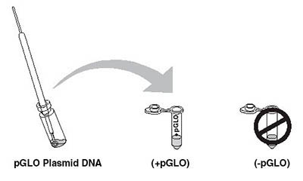 | Both bullet tubes contain bacteria, but only one tube receives the plasmid DNA.
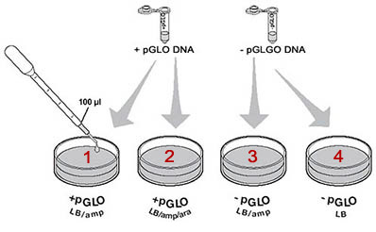 | After heat-shock and recovery, the bacteria are plated into 4 dishes of nutrient agar (LB). Ampicillin (amp) is present in 3 of the dishes, but only one dish contains arabinose (ara).
The petri dishes are incubated for two days to allow colonies to grow. Because the bacterial suspensions were spread evenly over the agar, individual colonies can usually be seen; each colony represents the multiplication of a single bacterium.
LB =Nutrient Agar

LB/AMP= Nutrient Agar plus Ampicillin (antibiotic)

LB/AMP/ARA= Nutrient Agar + Ampicillin + Arabinose

The dishes have been placed under ultraviolet light in a dark room.

Note that three of the dishes have bacterial colonies, but that only one dish contains fluorescent bacteria.

TASK: Explain the results of each petri dish.
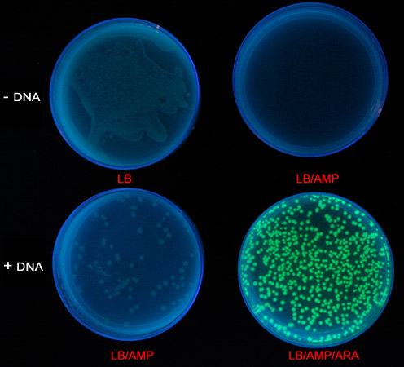

Recall Question Answers:
1. What is the role of a vector? | To carry genes from one organism to another / into bacteria cells
2. Name a common vector used in genetic engineering. | Plasmid
3. What is the role of DNA ligase when making a recombinant plasmid? | Joining DNA by forming phosphodiester bonds
4. Why are promoter regions important in plasmids? | So that the target gene can be transcribed
5. What is electroporation? | Using electricity to encourage bacteria to take up plasmids
6. Why are marker genes inserted into plasmids? | So transformed bacteria can be quickly identified
7. Give an example of a marker gene. | GFP/UV Fluorescence or antibiotic resistance

Lesson 4 In Vitro Cloning (PCR)
Key Word | Definition
Annealing | Joining of the primers to their complementary bases at the end of the DNA fragment
DNA ligase | An enzyme which can join the phosphate-sugar framework of two sections of DNA eg joining sticky ends
DNA polymerase | An enzyme which manufactures DNA by joining nucleotides (using a complementary strand as a blueprint).
Polymerase chain reaction | Automated method of in vitro cloning in which fragments of DNA are copied very quickly and many billions of times
Primer | A short sequence of nucleotides with a set of bases complementary to those at one end of each of the two DNA fragments
Taq Polymerase | Heat stable enzyme that replicates DNA .
Thermocycler | A computer-controlled machine that varies temperatures precisely over a period of time

In Vivo | In Vitro
Literally means “in the living” which means taking place inside whole, living organisms or cells | Literally means “in the glass” which means performed or taking place in a test tube, culture dish, or elsewhere outside a living organism
DNA fragment placed in a plasmid and relies on bacterial conjugation and replication to make copies of the plasmid | Uses the polymerase chain reaction (PCR) – in a test tube in a machine
Takes longer and requires screening as not all bacteria will take up gene | Makes millions of copies of a fragment of DNA in hours
Using marker genes and manipulating growth conditions can help to determine if genes have been taken up and amplified by the organism | Sequencing must be used to determine what genes have been amplified
Notes:
PCR is the artificial replication of short (up to 10’000 base pairs) sequences of DNA. It uses artificial DNA primers to amplify (make multiple copies of) a specific strand of DNA. Fragments of DNA undergo a series of heating and cooling steps in thermocycler to replicate them many times in a similar way to DNA replication in the nucleus.
The sample of DNA is mixed with the following reactants in a buffer:
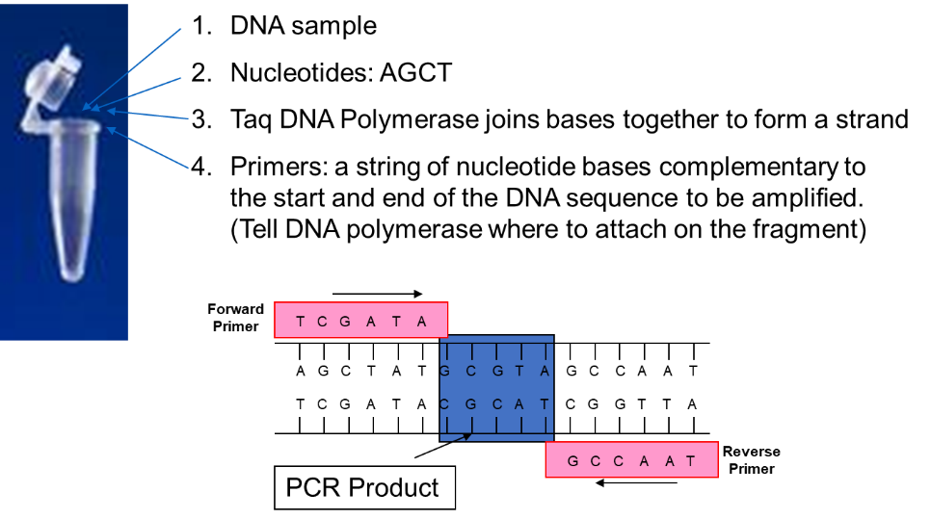
The DNA polymerase used is obtained from a thermophilic bacteria Thermus aquaticus. This enzyme is now called Taq polymerase and is stable at high temperatures, its optimum is 72°C.

A cycle of heating and cooling is needed to separate the DNA strands, bind primers to the strands and for DNA strands to be replicated. 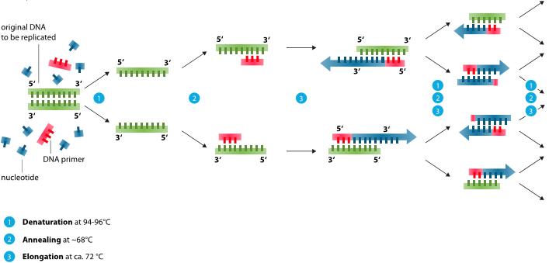
- The mixture is heated to around 94-96°C to break the hydrogen bonds between the complementary nucleotide base pairs and separate the double-stranded DNA into two single strands.
- The mixture is cooled to around 55-60°C, so that the primers can anneal (bind by hydrogen bonding) to one end of each single strand of DNA which identifies where Taq polymerase should bind.
- The temperature is raised to 72°C (optimum temperature for Taq DNA polymerase. Taq DNA polymerase catalyses the addition of DNA nucleotides by complimentary base pairing to create two complete double strands of DNA.
- The whole process begins again and is repeated for many cycles.
The amount of DNA increases exponentially 1→2 →4 →8 →16 →32 →64 →123 etc. Remember: when doubling calculate it using the formula: 1x2^{(number of times doubled)}
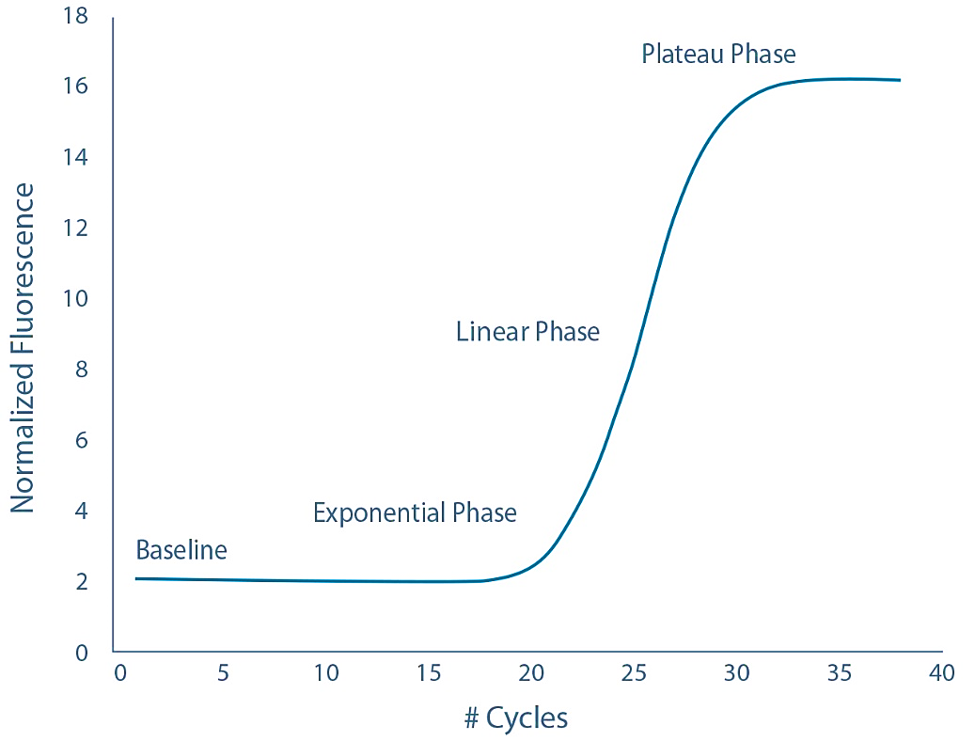
PCR graphs can show this exponential increase of fragments – this is usually detected in a similar way to the sequencing methods which detect fluorescence of nucleotides.
Describing the curve:
DNA is doubling at each cycle
but there are very low numbers to start with, so little fluorescence detected so it appears flat then
exponential growth occurs as numbers rapidly increase

Why does the number of fragments eventually reach a plateau/level off?
Primers are the only thing to be used up in the reaction so this limits the number of fragments that can be made. When they run out replication stops.

It could also be nucleotides running out but this is less likely.

Recall Questions:
- What does PCR stand for?
- What is the function of PCR?
- What is in the reaction mixture for PCR?
- Two primers are needed in PCR. What is a primer?
- The first step of a PCR cycle is to heat to 95°C. What happens in this step?
- What is special about Taq polymerase compared to other DNA polymerases?
- The second stage of PCR is to cool to around 55 °C. What is the purpose of this step?
- If the number of DNA fragments doubles in each PCR cycle, how many fragments will there be if one piece of DNA goes through 15 cycles of PCR?

Exam Questions:
Q1. The polymerase chain reaction is a process which can be carried out in a laboratory to replicate DNA. The diagram shows the main stages involved in the polymerase chain reaction.
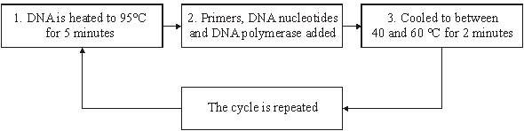
(a) Explain why DNA is heated to 95 °C.
___________________________________________________________________
___________________________________________________________________
(1)
(b) What is the role of
(i) a primer in this process;
______________________________________________________________
______________________________________________________________
(1)
(ii) DNA polymerase?
______________________________________________________________
______________________________________________________________
(1)
(c) (i) How many DNA molecules will have been produced from one molecule of DNA after 6 complete cycles?
______________________________________________________________ (1)
(ii) Suggest one use of the polymerase chain reaction.
______________________________________________________________
______________________________________________________________(1)
Q2. (a) Explain the reason for each of the following in the polymerase chain reaction (PCR).
(i) DNA is heated to 95 °C.
______________________________________________________________
______________________________________________________________
(1)
(ii) DNA polymerase used is heat-stable.
______________________________________________________________
______________________________________________________________
(1)
(iii) The reaction mixture is cooled to 40 °C.
______________________________________________________________
______________________________________________________________
(1)
(b) The graph shows the number of DNA molecules made using PCR, starting with one molecule.
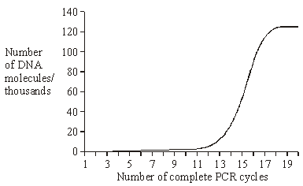
(i) Explain the shape of the curve from cycles 1 to 16.
______________________________________________________________
______________________________________________________________
______________________________________________________________
______________________________________________________________
(2)
(ii) Suggest one explanation for the levelling out of the curve from cycles 17 to 20.
______________________________________________________________
______________________________________________________________
______________________________________________________________(2)
Q3. Explain one way in which the polymerase chain reaction differs from DNA replication in a cell.
______________________________________________________________
______________________________________________________________
______________________________________________________________
______________________________________________________________
(2)
Q4.
(a) What is meant by a gene?
___________________________________________________________________
___________________________________________________________________
(2)
The polymerase chain reaction (PCR) can be used to obtain many copies of a particular gene.
(b) Explain how the strands of DNA are separated during the PCR.
___________________________________________________________________
___________________________________________________________________
___________________________________________________________________
___________________________________________________________________
(2)
(c) In a particular PCR, two different primers are added to the DNA. Suggest why two different primers are required.
______________________________________________________________
______________________________________________________________
(1)
(d) Starting with a single molecule of DNA, the polymerase chain reaction was allowed to go through three complete cycles. How many molecules of DNA would be produced?

Answer ____________________
(1)

Q5. The polymerase chain reaction (PCR) can be used to produce large quantities of DNA.
Describe how the PCR is carried out.
_______________________________________________________________________
_______________________________________________________________________
_______________________________________________________________________
_______________________________________________________________________
_______________________________________________________________________
_______________________________________________________________________
_______________________________________________________________________
_______________________________________________________________________
_______________________________________________________________________
_______________________________________________________________________
_______________________________________________________________________
(Total 6 marks)

Recall Question Answers:
What does PCR stand for? | Polymerase chain reaction
What is the function of PCR? | Used to make copies of DNA fragments, increasing the size of the sample
What is in the reaction mixture for PCR? | DNA, buffer, primers, free nucleotides, DNA polymerase
Two primers are needed in PCR. What is a primer? | Short sequence of bases complimentary to the start of sequence to be copied allows Taq polymerase to bind at the start of the sequence
The first step of a PCR cycle is to heat to 95°C. What happens in this step? | Hydrogen bonds between DNA bases are broken and strands separate
What is special about Taq polymerase compared to other DNA polymerases? | It has a higher optimum temperature so doesn’t get denatured at the usual high temperatures
The second stage of PCR is to cool to around 55 °C. What is the purpose of this step? | To allow primers to anneal/bind to DNA template strand
If the number of DNA fragments doubles in each PCR cycle, how many fragments will there be if one piece of DNA goes through 15 cycles of PCR? | 32,768

Lesson 5 – Genetic Fingerprinting
Notes:

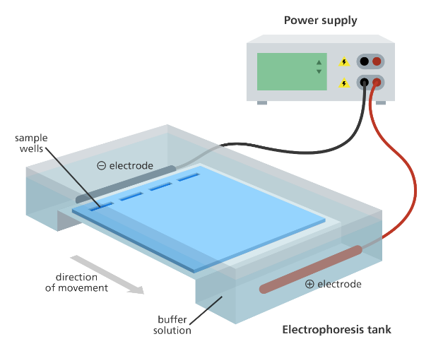
Separating Substances Using Gel Electrophoresis
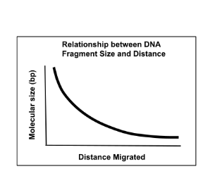
Gel electrophoresis is a technique used to separate different sizes of DNA, RNA or proteins as these molecules are polar. An electrical gradient is set up, much like in electrolysis in chemistry, however, the samples are loaded into an agar gel, which slows down the movement of the molecules. This means it takes time for the sample to be drawn to the anode or cathode and this time is directly proportional to the size and charge of the molecule. DNA has an overall negative charge so moves towards the positively charged end of the gel.

DNA and RNA fragments can be separated by length (number of base pairs), whilst proteins can be separated by size/mass.

A control sample is always run at the same time with strands of DNA or proteins of a known size or length so that comparisons can be made and the size of the fragments of DNA/identity of proteins determined.

Method:
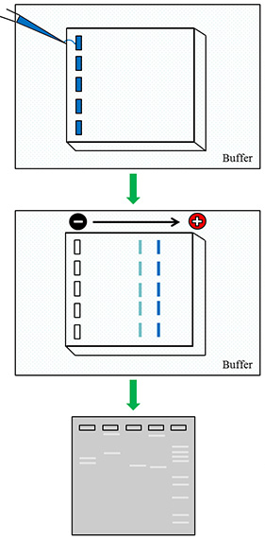
1. DNA fragments which have been amplified using PCR are mixed with a loading buffer and pipetted into the wells of an agar gel.
- Fluorescence is added to the primers that will bind to specific sequences during PCR, this stains the DNA so it can be tracked in the gel – usually this reacts to UV light so the fragments can be viewed and their position in the gel.
- The loading buffer is denser than the running buffer the gel is covered with so it ensures the mixture sinks into the wells

2. The gel is placed into a tank, covered with an alkaline buffer which has ions to carry the current and maintains constant pH, a current is applied (~18V)
- The DNA migrates through the gel (which is like a web and slows it down) towards the positively charged end – this is why it is important to place the gel in the correct way around!
- Smaller proteins/DNA fragments migrate the furthest as they are lighter/have fewer base pairs. If you leave the gel for too long they could run off the end of the gel into the buffer so timing is important!

3. Gels are removed from the tank and photographed under UV light
- The bands are compared to the ladder (known control) sample – far right in this diagram – to identify their size in base pairs or mass in nanograms.
- If a specific band is needed this can be cut out of the gel and stored in a buffer – perhaps amplified again using PCR.

N.B If specific sequences/genes are being identified then no dye/stain is used during PCR o the gel is transferred to a nylon membrane and incubated with a fluorescent or radioactive DNA probe (see next lesson) so that specific alleles or sequences can be identified and only those bands will show up.
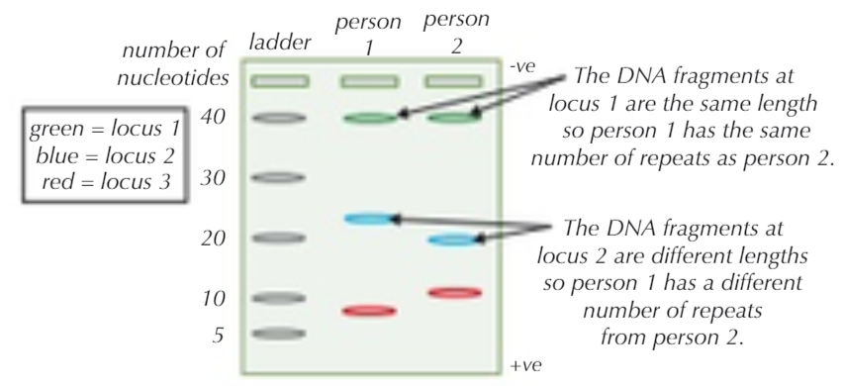
Preparing a sample for a genetic fingerprint
Variable Number Tandem Repeats (VNTRs) are repeating sequences that occur in different places in the genome of eukaryotes. The position and length of these non-coding sequences can be compared. The probability of two individuals having the same number of VNTRs in the same place is very low. This means that the length of VNTRs between coding genes are unique to every person (except identical twins).
Method:
            - Restriction enzymes are used to make DNA fragments that contain VNTRs – these are then amplified using PCR
            - DNA fragments are separated by size using gel electrophoresis
            - Compare DNA fragments/proteins next to known samples/ladder
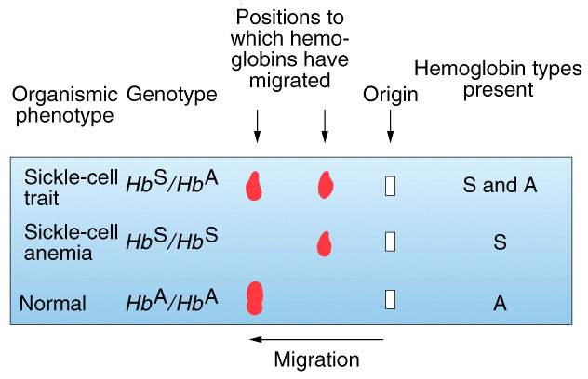
This is a protein example.

Normal heamoglobin has been run alongside two haemoglobin samples from someone with sickle cell anaemia and someone who is heterozygous for sickle-cell anaemia. The size/thickness of bands as well as the distance can help identifying what each band represents.

Uses of Genetic Fingerprinting
Medical Diagnosis | Testing to see if the cause of symptoms is a genetic diseases e.g Huntington’s or to identify cancer. Used to screening IVF embryos for genetic disease. | Most useful when specific mutation which causes the disease is known – e.g BRCA1 gene that is linked to breast cancer. This method prevents embryos with disease causing alleles from being implanted. Allows carriers of genetic disease to have healthy children.
Forensics Investigation (DNA Profiling) | 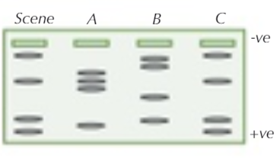  It can be used to establish a person was present at a crime scene if they left a biological sample containing DNA. | This does not determine if person carried out the crime! But can help to identify or narrow down suspects. As only trace amounts of DNA are collected PCR has to be used to amplify any DNA sample so that there is enough for multiple tests and it is not used up. The more bands a person has in common with the sample the more likely they are to be the person who left it.
Determining Genetic Relationships | 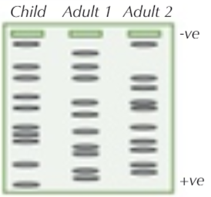  Paternity testing or identifying siblings | For paternity testing parents will have more bands in common with their parents as they will have inherited 50% of their VNTRs. Siblings also, more bands in common = more closely related.  It can be used to identify the relatedness of different populations (phylogenetics) often using mtDNA which is only inherited from mother or Y chromosome to trace paternal inheritance only.
Genetic Variability | Determining genetic variability within a population  Looking for variation within or between populations. | Populations where members have very similar genetic fingerprints have little genetic diversity – this can help with conservation plans to try and increase diversity in a population.
Animal and Plant Breeding | - Determining paternity and therefore pedigree of animals.  - Identifying plants or animals with a desired allele or gene | Identifying parents or genetic similarities between captive organisms prevents inbreeding which can increase the risk of genetic disorders. Also allows pedigree’s of award winning animals to be confirmed.  Knowing which genes organisms contain or which are more diverse can help with selective breeding.

Recall Questions
- Name the three molecules that can be separated using gel electrophoresis.
- Name the property of these compounds that allows them to be separated
- What is the purpose of the loading dye?
- In gel electrophoresis, is DNA attracted to the anode (+ve) or cathode (-ve)? Explain your answer.
- Describe the movement of small fragments compared to larger fragments in gel electrophoresis.
- What are large non-coding regions in DNA called?
- Explain how gel electrophoresis can be used to work out the genotype of a person with sickle cell or as a carrier of sickle cell.
- Explain how gel electrophoresis can be used to separate DNA fragments and how this Technique can be used to help with DNA profiling.
Exam Questions
Q1. DNA probes may be used to identify the presence of specific genes associated with human diseases. The flow chart summarises the way in which they are used.

Stage 1 DNA is cut into fragments
Stage 2 Electrophoresis separates the DNA fragments
Stage 3 Radioactive DNA probes are used to locate specific DNA fragments
(a) Name the enzyme used in Stage 1.
___________________________________________________________________
(1)
(b) Explain how electrophoresis separates the fragments of DNA in Stage 2.
___________________________________________________________________
___________________________________________________________________
___________________________________________________________________(2)
Q2. A gene was broken into fragments using enzyme Z. The mixture of fragments produced was then separated by electrophoresis.
(a) What type of enzyme is enzyme Z?
___________________________________________________________________
(1)
The table shows the number of base pairs present in the fragments.

Fragment | Number of base pairs (× 10³)
1 | 4.65
2 | 5.72
3 | 10.71
4 | 2.39
5 | 5.35
6 | 7.53
The diagram shows the electrophoresis gel used. The mixture of fragments was placed at the start point marked S and the process started. The boxes indicate the positions reached by the different fragments.
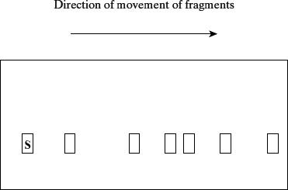
(b) Explain why base pairs are a suitable way of measuring the length of a piece of DNA.
___________________________________________________________________
___________________________________________________________________
___________________________________________________________________
___________________________________________________________________
(2)

(c) (i) Write 6 above the appropriate box on the diagram to show the position you would expect fragment 6 to have reached.
(1)
(ii) Explain how you arrived at your answer.
______________________________________________________________
______________________________________________________________
(1)
(d) Enzyme Z recognises a particular sequence of bases in the gene. How many times does this sequence appear in the DNA of this gene?
___________________________________________________________________
(1)
Q3. Soybeans are used in a number of processed foods. However, soybeans contain a protein known as P34 that causes an allergic response in some people. Scientists have created transgenic soybeans that produce single-stranded cDNA, which prevents transcription of the P34 gene. They used recombinant plasmids as vectors to transform soybean cells. After they had screened these cells for production of the P34 protein, they cultured the transformed cells to form soybean plants.
(f) The soybean cells were screened for the presence of the P34 protein. This process involved the use of gel electrophoresis to separate proteins extracted from soybean cells.
Suggest two features of the structure of different proteins that enable them to be separated by gel electrophoresis.
1. _________________________________________________________________
___________________________________________________________________
___________________________________________________________________
2. _________________________________________________________________
___________________________________________________________________
___________________________________________________________________
(2)
Q4. Read the following passage.
In 1991, nine skeletons were found in Russia. They were believed to be those of Tsar Nicholas II, his family and staff who were killed in 1917 during the Russian revolution. Very small amounts of DNA were isolated from these skeletons. This DNA was used in the polymerase chain reaction (PCR). Genetic fingerprinting was then carried out on this DNA to identify the skeletons.
The chart shows some of the results obtained from the genetic fingerprinting of seven of the skeletons, three children and four adults.
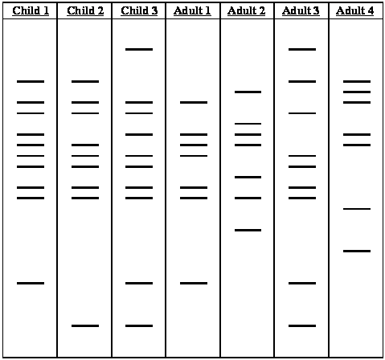
Use information from the passage and your own knowledge to answer the following questions.
(a) Explain why the polymerase chain reaction was used in this investigation.
___________________________________________________________________
___________________________________________________________________
___________________________________________________________________
___________________________________________________________________
(2)
(c) Describe how genetic fingerprinting is carried out.
___________________________________________________________________
___________________________________________________________________
___________________________________________________________________
___________________________________________________________________
___________________________________________________________________
___________________________________________________________________
___________________________________________________________________
___________________________________________________________________
___________________________________________________________________
___________________________________________________________________ (5)
(d) All three children on the chart had the same parents. One of the parents was Adult 1.
Which of the other three adults on the chart was the other parent? Give the reason for your answer.
___________________________________________________________________
___________________________________________________________________
___________________________________________________________________
___________________________________________________________________
(2)
Q5. Some populations of flies are becoming resistant to insecticides intended to kill them.
Scientists developed a method for finding out whether a fly was carrying a recessive allele, r, that gives resistance to an insecticide. The dominant allele, R, of this gene does not give resistance.
The scientists:
• crossed flies with genotype RR with flies with genotype rr
• obtained DNA samples from the parents and offspring
• used the same restriction endonuclease enzymes on each sample, to obtain DNA fragments.
(a) Explain why the scientists used the same restriction endonuclease enzymes on each DNA sample.
___________________________________________________________________
___________________________________________________________________
___________________________________________________________________
___________________________________________________________________
(2)
The scientists added two different primers to each sample of DNA fragments for the polymerase chain reaction (PCR).
• Primer A3 only binds to a 195 base-pair fragment from allele r.
• Primer A4 only binds to a 135 base-pair fragment from allele R.
The scientists separated the DNA fragments produced by the PCR on a gel where shorter fragments move further in a given time.
Their results are shown in Figure 1.
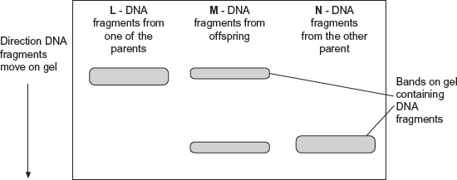
(b) Explain why primer A3 and primer A4 only bind to specific DNA fragments.
___________________________________________________________________
___________________________________________________________________
___________________________________________________________________
___________________________________________________________________
(2)
(c) Use all the information given to explain the results in Figure 1.
___________________________________________________________________
___________________________________________________________________
___________________________________________________________________
___________________________________________________________________
___________________________________________________________________
___________________________________________________________________
(3)
Q6. Huntington’s disease is a genetic condition that leads to a loss in brain function. The gene involved contains a section of DNA with many repeats of the base sequence CAG. The number of these repeats determines whether or not an allele of this gene will cause Huntington’s disease.
• An allele with 40 or more CAG repeats will cause Huntington’s disease.
• An allele with 36 – 39 CAG repeats may cause Huntington’s disease.
• An allele with fewer than 36 CAG repeats will not cause Huntington’s disease.
(b) Scientists took DNA samples from three people, J, K and L. They used the polymerase chain reaction (PCR) to produce many copies of the piece of DNA containing the CAG repeats obtained from each person. They separated the DNA fragments by gel electrophoresis. The diagram shows the appearance of part of the gel after an X-ray was taken. The bands show the DNA fragments that contain the CAG repeats.
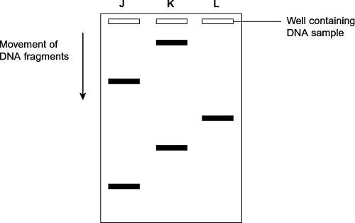
(i) Only one of these people tested positive for Huntington’s disease. Which person was this? Explain your answer.
Person _______________________________________________________
Explanation ____________________________________________________
______________________________________________________________
______________________________________________________________
______________________________________________________________ (2)
(ii) The diagram only shows part of the gel. Suggest how the scientists found the number of CAG repeats in the bands shown on the gel.
______________________________________________________________
______________________________________________________________
______________________________________________________________ (1)
(iii) Two bands are usually seen for each person tested. Suggest why only one band was seen for Person L.
______________________________________________________________
______________________________________________________________ (1)
Q7. There are wolves in many European countries. Scientists investigated the genetic diversity of these wolves. They collected samples of DNA from the mitochondria of wolves from different countries. For each sample they identified which haplotypes were present in the DNA. A haplotype is a particular sequence of bases on DNA. Mutations can produce new haplotypes.

Country | Number of wolves sampled | Number of different haplotypes in mitochondrial DNA
Spain | 84 | 3
Portugal | 19 | 2
Italy | 101 | 1
France | 7 | 1
Bulgaria | 29 | 6
Sweden | 93 | 1
The scientists wanted to find out whether one of the haplotypes in the Portuguese wolves was the same as one of those in the Spanish wolves. They used a restriction endonuclease, electrophoresis and a labelled DNA probe.
(a) For what purpose did they use
(i) the restriction endonuclease
______________________________________________________________
______________________________________________________________(1)
(ii) electrophoresis?
______________________________________________________________
______________________________________________________________ (1)
(c) The scientists analysed the DNA on the Y chromosome and the DNA in the mitochondria of the Swedish wolves. They concluded that the Swedish wolf population descended from one male wolf from Finland and one female wolf from Russia.
(i) Explain why DNA on the Y chromosome helped them to reach this conclusion.
______________________________________________________________
______________________________________________________________ (1)
(ii) Suggest why DNA in the mitochondria helped them to reach this conclusion.
______________________________________________________________
______________________________________________________________ (1)
Q8. Read the following passage.

The giant panda is one of the rarest animals in the world and is considered to be on the brink of extinction in the wild. Giant pandas have been kept and bred in zoos with the hope that they could be released into the wild. One worry is that small populations, like those in zoos, reduce the genetic variation needed to allow the species to adapt to changing conditions. Unfortunately, pandas find it difficult to reproduce in captivity. Fertilisation of the females is guaranteed only by insemination with semen from several males. With so many potential fathers, the true paternity of the cubs is not clear. It is important to identify the fathers to maintain genetic variation.  Panda faeces can be collected in the wild. The faeces contain DNA from the panda, from the bamboo on which they feed and from bacteria. The DNA is subjected to the polymerase chain reaction (PCR). The primers used attach only to the panda DNA. The resulting DNA is subjected to genetic fingerprinting. This can help us to count the number of individuals in the wild because it allows us to identify individual pandas. |  | 5  10
Use information in the passage and your own biological knowledge to answer the questions.
(b) (i) Explain how genetic fingerprinting allows scientists to identify the father of a particular panda cub.
______________________________________________________________
______________________________________________________________
______________________________________________________________
(2)
(ii) When pandas are bred in zoos, it is important to ensure only unrelated pandas breed. Suggest how genetic fingerprints might be used to do this.
______________________________________________________________
______________________________________________________________(1)
Homework:

Complete the sentences using the words in bold

alleles amplified biopsy buffer digested disease DNA forensic half heritable ladder length medicine mutant non-coding offspring offspring phosphate probes proto-oncogenes repeats repetitive restriction separated size slowed staining tumour-suppressor washed

Gel electrophoresis
Both gene probes and genetic fingerprinting require gel electrophoresis. Gel electrophoresis is a form of chromatography used to separate different pieces of DNA on the basis of their _________. The DNA samples are placed into wells at one end of a thin slab of gel made of agarose (agar) and covered in a __________ solution. At the same time a set of fragments of known length (known as a DNA _________) is run in one of the wells. An electric current is passed through the gel. Each nucleotide in a molecule of DNA contains a negatively-charged ___________ group, so DNA is attracted to the positive electrode. The molecules have to diffuse through the gel, and longer lengths of DNA are __________ by the gel than shorter lengths so move more a shorter distance over a given time. The DNA is then viewed by __________ with either a coloured chemical, fluorescent molecule or radioactive isotope, and the sizes compared to the ladder.
Genetic fingerprinting
DNA fingerprinting (AKA genetic fingerprinting) is used to distinguish between DNA samples from different people. Most differences in DNA between humans are found in ____-_________ DNA, since these regions can accumulate mutations without affecting function, and the differences are largely due to the presence of ___________ sequences (e.g. microsatellites). The method:
- Samples of DNA to be compared are __________ by PCR or cut by restriction enzymes. The PCR primers are designed to target and copy a region of the human DNA containing repetitive sequences.
- The amplified DNA is ___________ by a restriction enzyme. The same recognition sequences should be present in the different samples, so the same number of fragments should be produced, but the fragments will be different lengths depending on the number of _________ in each restriction fragments.
- The digested DNA is run on an electrophoresis gel to separate out the fragments by ______. The more similar the banding pattern, the more closely related the individuals are.
DNA fingerprinting is used:
- In __________ science, to match DNA samples collected from a crime (e.g. from sperm, blood, hair, skin) with that of suspects.
- In paternity testing. Since children inherit _______ their DNA from each parent 50% of the bands should match their mother’s bands and 50% match their father’s bands.
- For many other purposes.
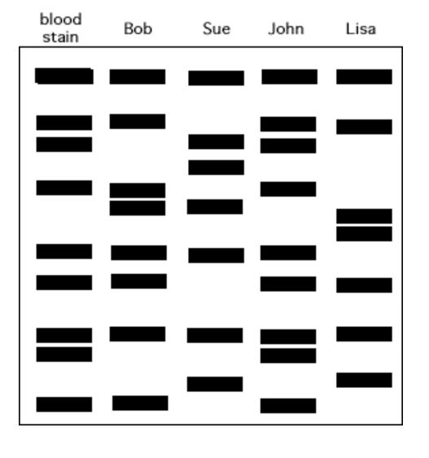
Answer the questions
- Mrs Brown had baked a birthday cake for her husband and then left it in a tin on the kitchen table. When she returned from shopping all that was left in the cake tin was a few crumbs and a smudge of blood where the thief had snagged their finger on the sharp edge of the tin. Below are the DNA fingerprints of her four children. Which one of the children’s DNA fingerprints most closely matches the blood stain and therefore is most likely to be the thief?
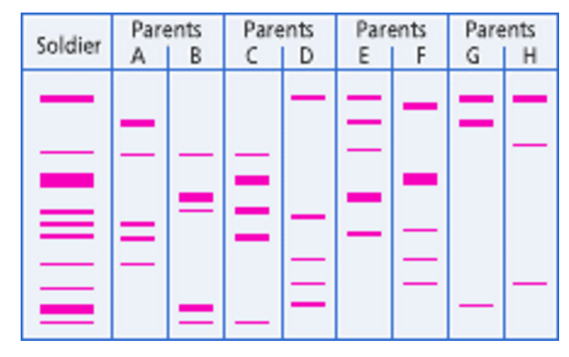

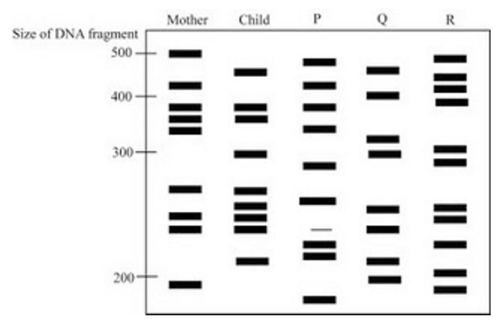
- A soldier has been killed in an explosion and has lost his dog tags that identify him. Three soldiers are missing from their unit so the Army ask the three sets of parents for a DNA sample so they might compare it to the soldier’s DNA and therefore make an identification. Which set of parents is the soldier the son of?

- Look carefully at the DNA fingerprints and decide which of the men (P, Q or R) are most likely to be the father.

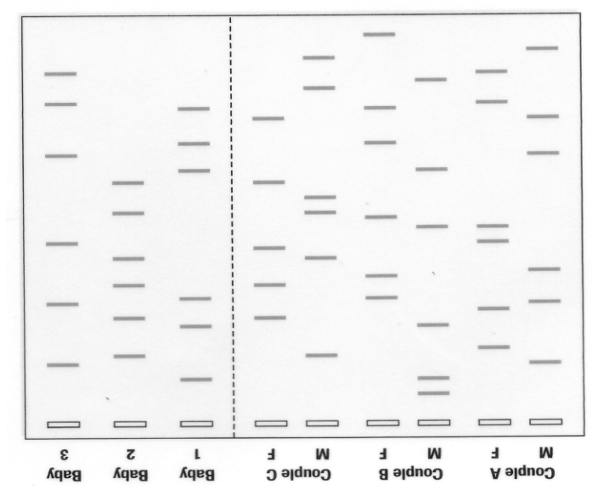

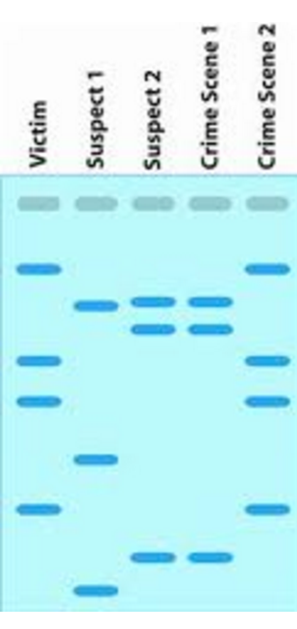
- Unfortunately three babies have got muddled up in the Maternity Ward at QA hospital. Can you analyse the results of a DNA fingerprint conducted on three babies and three sets of parents to determine which baby belongs to which parent?

- A body has been found surrounded in blood splatters and amid signs of a struggle. Analysis indicates that there is blood from two people at the crime scene. Two suspects, seen near the crime scene at the time of the murder, have been brought in for questioning and DNA samples. From which two people did the blood at the scene of the crime come from? Who should be arrested?

Lesson 6 – Gene Probes & Genetic Counselling

DNA probes are single stranded pieces of DNA which are complementary to and therefore bind to known base sequences. DNA probes can be used to stick to and highlight sequences on a gel. These probes are labelled with a radioactive marker, or more commonly with a fluorescent probe to detect it’s presence. The techniques of PCR is used so that the sequence can be amplified and run on a gel for this hybridisation to take place.
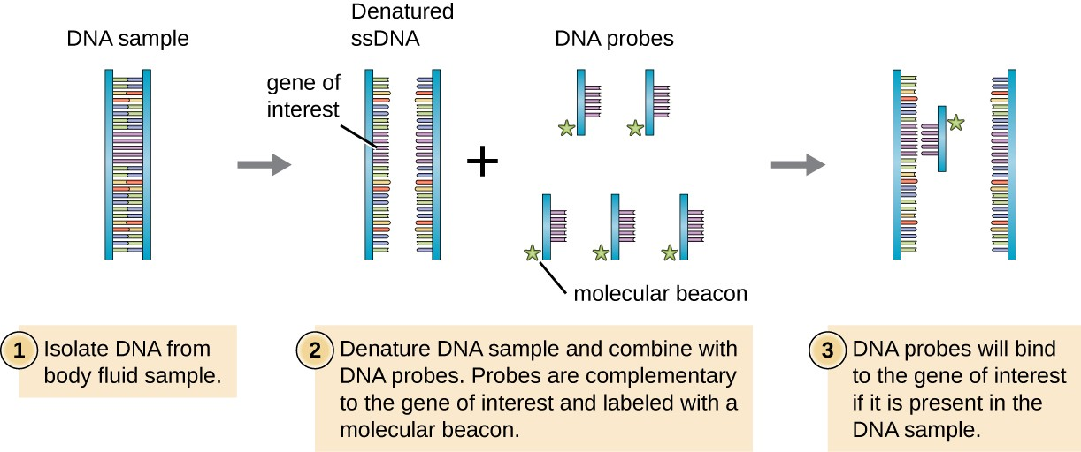
Uses:
- To locate specific alleles of genes
- To see if a person carries a mutated allele that causes a genetic disorder e.g. Cystic Fibrosis
- Help determine how patients will respond to drugs e.g. breast cancer treatment which only responds to a certain mutation.
- Identify health risks e.g. some peoples risk of cancer can be increased if they carry certain mutations. Knowing this can help them make choices about reducing their risk.
Method:
- DNA sample digested into fragments using restriction enzymes and separated using gel electrophoresis.
- Separated DNA fragments transferred to nylon membrane and incubated with the DNA probe. The probes will only bind to their complimentary sequence if it is present.
- The membrane is exposed to UV light or autoradiography (if using radioactive label) and if the gene is present it will fluoresce. DNA would be invisible without the probes so only bands which contain the gene will be visible.
A microarray can be used to screen a sample with multiple DNA probes all at once:
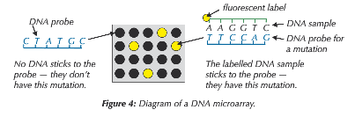
The sample of fluorescent DNA is washed over the array which has the DNA probes fixed to it.
DNA sequences that match the probe stick to the array.
The array is washed to remove any fluorescent DNA not stuck to a probe
The use of this technology needs to be managed and can result in personalised medicine, but may need support through genetic counselling. These probes can lead to much better information but guidance is needed by the doctor or counsellor to make the best decision with this new information.
Genetic counselling | Personalised medicine
Genetic counsellors guide people to make informed decisions about matters related to genetics that may come up in their or their families health. This could be about genetic disorders and heritability, or it could be about decisions based on the outcome of genetic testing. | Personalised medicine can be used to target different dosages or compounds as medicine depending on the genetic make-up of the person. The technology is in its infancy but it has the potential to revolutionise the effectiveness of a wide range of different medicines for different conditions.
Example: Screening is available for genetic mutations which can lead to breast cancer.  Genetic councillors can use the screen to explain the chance of developing cancer.  Genetic councillors can help patients decide if they want to take surgical steps to reduce their risk of breast cancer e.g. a mastectomy | Example: Some breast cancer treatments are targeted at specific mutations so screening can be used to make sure the right medication is used.
Recall Questions
- What is a DNA probe?
- What two ways can DNA probes be marked?
- Describe a use of DNA probes
- Which two useful techniques are used in the process of using DNA probes to screen DNA?
- Briefly describe the method of identifying a gene in a DNA sample using DNA probes.
- Why have DNA probes led to the need for genetic counselling?
- Why can DNA probes lead to personalised medicine?
Exam Questions
Q1. DNA probes may be used to identify the presence of specific genes associated with human diseases. The flow chart summarises the way in which they are used.

Stage 1 DNA is cut into fragments
Stage 2 Electrophoresis separates the DNA fragments
Stage 3 Radioactive DNA probes are used to locate specific DNA fragments
(c) (i) What is a DNA probe?
______________________________________________________________
______________________________________________________________
______________________________________________________________ (2)
(ii) Explain why radioactive DNA probes are used to locate specific DNA fragments.
______________________________________________________________
______________________________________________________________
______________________________________________________________
______________________________________________________________ (2)
Q2. Mycobacterium tuberculosis causes tuberculosis. The DNA of M. tuberculosis contains a direct repeat (DR) region. The DR region consists of 43 different, non-coding base sequences called spacers. Each spacer is found in a specific place in the DR region.
In different strains of M. tuberculosis, some of these spacers have been lost.
(a) (i) The DR region consists of non-coding base sequences.
What is meant by a non-coding base sequence?
______________________________________________________________
______________________________________________________________ (1)
(ii) Name the process by which the base sequence of a spacer is lost from a DR region.
______________________________________________________________
______________________________________________________________ (1)
Scientists investigated the DR regions of different strains of M. tuberculosis. They produced a DNA probe for each of the 43 spacer sequences. Each probe was:
• labelled with a fluorescent marker that gave off light if the probe attached to its complementary spacer
• attached to a particular square on a slide.
They obtained samples of the DR region from each strain. These were cut into small single-stranded DNA fragments. The fragments from each strain were added to a slide with the DNA probes attached. The diagram below shows their results for one strain of M. tuberculosis with 20 of the probes.
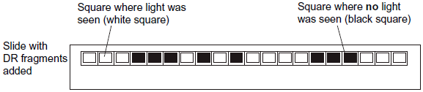
(b) The scientists cloned the DR region DNA in vitro before testing for the presence of spacers.
Give the name of the method they used to clone the DNA in vitro.
___________________________________________________________________ (1)
(c) Explain how the use of DNA probes produced the results in the diagram.
___________________________________________________________________
___________________________________________________________________
___________________________________________________________________
___________________________________________________________________
___________________________________________________________________
___________________________________________________________________
___________________________________________________________________ (3)
(d) Doctors can use the method with DNA probes to identify the specific strain of M. tuberculosis infecting a patient. This is very important when there is an outbreak of a number of cases of tuberculosis in a city.
Suggest and explain why it is important to be able to identify the specific strain of M. tuberculosis infecting a patient.
___________________________________________________________________
___________________________________________________________________
___________________________________________________________________
___________________________________________________________________
___________________________________________________________________
___________________________________________________________________ (2)
Q3. Scientists wanted to measure how much mRNA was transcribed from allele A of a gene in a sample of cells. This gene exists in two forms, A and a.
The scientists isolated mRNA from the cells. They added an enzyme to mRNA to produce cDNA.
(a) Name the type of enzyme used to produce the cDNA.
___________________________________________________________________
(1)
The scientists used the polymerase chain reaction (PCR) to produce copies of the cDNA. They added a DNA probe for allele A to the cDNA copies. This DNA probe had a dye attached to it. This dye glows with a green light only when the DNA probe is attached to its target cDNA.
(b) Explain why this DNA probe will only detect allele A.
___________________________________________________________________
___________________________________________________________________
___________________________________________________________________ (2)
(c) The scientists used this method with cells from two people, H and G.
One person was homozygous, AA, and the other was heterozygous, Aa.
The scientists used the PCR and the DNA probe specific for allele A on the cDNA from both people.
The figure shows the scientists’ results.
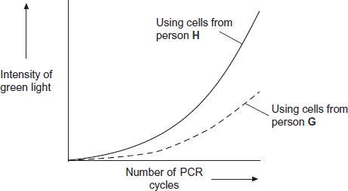
(i) Explain the curve for person H.
______________________________________________________________
______________________________________________________________
______________________________________________________________
______________________________________________________________
______________________________________________________________
______________________________________________________________
(3)
(ii) Which person, H or G, was heterozygous, Aa? Explain your answer.
______________________________________________________________
______________________________________________________________
______________________________________________________________
______________________________________________________________
(2)

Q4. A husband and wife wanted to know whether they were carriers of the mutated form of a gene. This mutation is a deletion that causes a serious inherited genetic disorder in people who are homozygous.
A geneticist took samples of DNA from the husband and the wife. He used a DNA probe to look for the deletion mutation. The DNA probe was specific to a particular base sequence in an exon in the gene. Exons are the coding sequences in a gene.
The geneticist compared the couple’s DNA with that of a person known not to carry this mutation.
The chart shows the geneticist’s results.
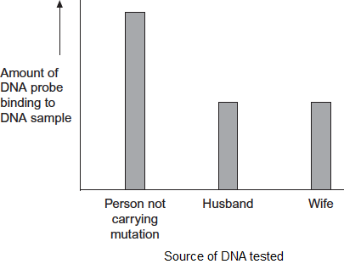
(a) The geneticist told the couple they were both carriers of the mutated gene.
Explain how he reached this conclusion.
___________________________________________________________________
___________________________________________________________________
___________________________________________________________________
___________________________________________________________________
___________________________________________________________________
(3)
(b) The DNA probe the geneticist used was for an exon in the DNA, not an intron. Explain why.
___________________________________________________________________
___________________________________________________________________
___________________________________________________________________
___________________________________________________________________
___________________________________________________________________
___________________________________________________________________ (3)
(c) To make the DNA probe, the geneticist had to find the base sequence of the normal gene. Once he had copies of the gene, what methods would he use to find the base sequence of the gene?
___________________________________________________________________
___________________________________________________________________
___________________________________________________________________
___________________________________________________________________
___________________________________________________________________
(2)
Q5.
β-thalassaemia is a genetic condition in which abnormal haemoglobin is produced. In one form, the recessive allele for β-thalassaemia, t, differs from the normal allele, T, by a single base-pair. A radioactive DNA probe was used to investigate the genotypes of four members of one family. The flowchart summarises the technique involved.

DNA samples extracted and cut into fragments using a restriction enzyme
↓
Fragments separated from each other by electrophoresis
↓
One region of the resulting gel was blotted with two pieces of filter paper. The first was soaked in a solution containing a radioactive DNA probe for the normal allele.
The second was soaked in a solution containing a radioactive DNA probe for the β-thalassaemia allele.
↓
Surplus probe washed off
The diagram below shows the appearance of the two pieces of filter paper which resulted from the investigation.
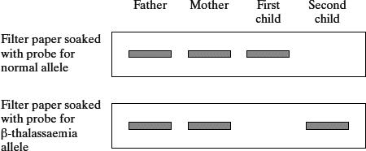

(a) What is the probability that the next child that this couple have is a girl who has β-thalassaemia? Explain your answer.
___________________________________________________________________
___________________________________________________________________
___________________________________________________________________
___________________________________________________________________
___________________________________________________________________
___________________________________________________________________
(3)
(b) (i) The fragment of DNA containing the normal allele and the fragment with the β-thalassaemia allele moved the same distance on the gel. Explain why.
______________________________________________________________
______________________________________________________________
______________________________________________________________
______________________________________________________________
(2)
(ii) The allele for β-thalassaemia differs from the normal allele by only one base-pair. Explain why the probe used to identify these alleles consists of a piece of DNA twenty bases in length and not just one base.
______________________________________________________________
______________________________________________________________
______________________________________________________________
______________________________________________________________
(2)
Q6. Duchenne muscular dystrophy (DMD) is a condition caused by the recessive allele of a sex-linked gene. A couple have a son with DMD. They want to know the probability that they could produce another child with DMD. They consulted a genetic counsellor who produced a diagram showing the inheritance of DMD in this family.
This is shown in Figure 2.
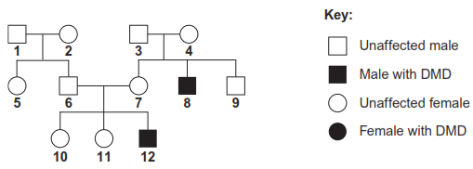
The couple who sought genetic counselling are persons 6 and 7.
(d) DMD is caused by a deletion mutation in the gene for a muscle protein called dystrophin. A deletion is where part of the DNA sequence of a gene is lost. People in different families may inherit mutations in different regions of this gene.
Scientists isolated the dystrophin gene from DNA samples taken from children 10, 11 and 12. They cut the gene into fragments using an enzyme. The scientists then used two DNA probes to identify the presence or absence of two of these fragments, called F and G. This allowed them to find the number of copies of each fragment in the DNA of a single cell from each child.
The table shows their results.

Child | Number of copies of gene fragment per cell
Child | F | G
10 (unaffected girl) | 2 | 1
11 (unaffected girl) | 2 | 2
12 (boy with DMD) | 1 | 0
(i) The number of copies of gene fragments F and G shows that person 12 has DMD.
Explain how.
______________________________________________________________
______________________________________________________________ (1)
(ii) The number of copies of gene fragments F and G shows that person 12 is male.
Explain how.
______________________________________________________________
______________________________________________________________
______________________________________________________________
______________________________________________________________ (2)
(iii) The genetic counsellor examined the scientists' results. He concluded that person 10 is a carrier of DMD but her sister, 11, is not.
Describe and explain the evidence for this in the table.
______________________________________________________________
______________________________________________________________
______________________________________________________________
______________________________________________________________
______________________________________________________________ (3)

Homework
Complete the sentences using the words in bold

alleles amplified biopsy buffer digested disease DNA forensic half heritable ladder length medicine mutant non-coding offspring offspring phosphate probes proto-oncogenes repeats repetitive restriction separated size slowed staining tumour-suppressor washed
Gene probes and genetic screening
Genetic screening using gene probes is based on DNA hybridisation and is used to identify _________ alleles. Short lengths of DNA, 100-1000 nucleotides long, are synthesised with base sequences found only in the mutant allele under study. These short lengths of DNA are called gene ________. These are amplified by PCR and then labelled either by radioactivity or by attaching a fluorescent tag. The genetic screen procedure is:
- A few cells are taken from a patient by _________.
- DNA is extracted and digested using ____________ enzymes.
- The DNA is _____________ using gel electrophoresis and the DNA is transferred to a nylon membrane.
- The membrane is incubated with the probe.
- The membrane is _________ clean of any unbound probe.
- The probe is detected by the radioactivity or by fluorescence.
This technique can be used to screen patients for _____________ conditions, drug responses or health risks. For example, genetic screening can help to identify defective ___________ (such as those that cause cystic fibrosis) in parents looking to have children; a counsellor can advise a couple on the emotional, economic, medical and social issues that may arise from having, or the potential of having, __________ that suffer from a certain genetic condition. Genetic screening can also help in the detection of mutated _______-___________ or _________-___________ genes; a counsellor can advise the best treatment plan that would give the patient the best chance of survival.
The results of screening can also be used in personalised ____________. Since different people have different combinations of alleles, even if they suffer from the same __________ they may not have the exact same genetic cause so people respond in different ways to different medicines. Personalised medicines are tailored to an individual’s ________ by using only those that are relevant to their particular combination of alleles.
Question: Explain how a DNA probe can be used to detect a diseased allele and not healthy alleles. [4]

………………………………………………………………………………………………………………………………………………
………………………………………………………………………………………………………………………………………………
………………………………………………………………………………………………………………………………………………
………………………………………………………………………………………………………………………………………………
………………………………………………………………………………………………………………………………………………
………………………………………………………………………………………………………………………………………………
………………………………………………………………………………………………………………………………………………
………………………………………………………………………………………………………………………………………………
………………………………………………………………………………………………………………………………………………
Recall Question Answers:
- What is a DNA probe? | DNA probes are single stranded pieces of DNA which are complementary to and therefore bind to known base sequences. DNA probes can be used to stick to and highlight sequences
- What two ways can DNA probes be marked? | Fluorescent marker or radioactive marker
- Describe a use of DNA probes | To locate specific alleles of genes /To see if a person carries a mutated allele that causes a genetic disorder Help determine how patients will respond to drugs/Identify health risks
- Which two useful techniques are used in the process of using DNA probes to screen DNA? | PCR and gel electrophoresis
- Briefly describe the method of identifying a gene in a DNA sample using DNA probes. | 1. Dna sample digested into fragments using restriction enzymes and separated using gel electrophoresis.  2. Separated dna fragments transferred to nylon membrane and incubated with the dna probe. probes bind to their complimentary sequence if it is present.  3. The membrane is exposed to uv light or autoradiography (if using radioactive label) and if the gene is present it will fluoresce.
- Why have DNA probes led to the need for genetic counselling? | Can identify genetic risks that can lead to choices about preventative treatments or reproducing
- Why can DNA probes lead to personalised medicine? | Some mutations mean that only certain medications will work – DNA probes can identify if people have these mutations to make sure the treatment they receive will work

Lesson 7 Gene Therapy
Gene therapy is the manipulation of the genetics of a human cell. Gene therapy happens by inserting functional alleles into gametes or zygotes or inserting functional alleles into body cells (somatic cells).
The potential for gene therapy is huge however the challenges that have presented themselves have been very difficult to overcome. There are some success stories, however as yet there are only a few examples where gene therapy has been completely successful.
Critical to the effectiveness of gene therapy has been the success and completion of the Human Genome Project. This was a project to sequence the entire human genome and as a result we have a much better understanding of the way in which genes interact and ways in which DNA can be targeted to cure diseases or to alter function within the cell.
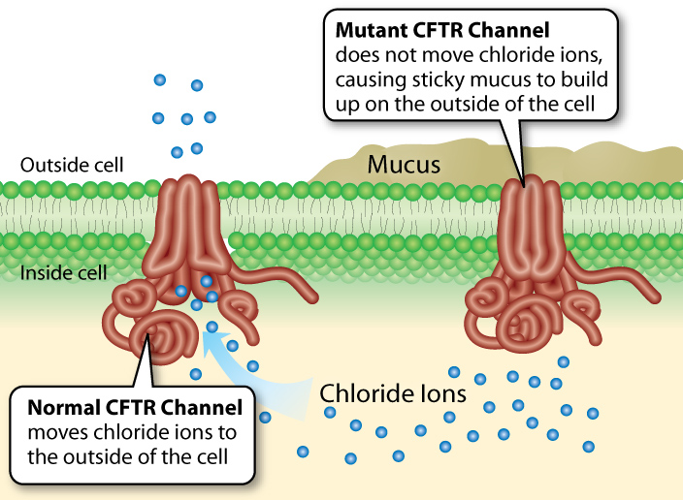
The basic principle of gene therapy is to insert a functional allele of a particular gene into the cells that contain only mutated and non-functioning alleles of that gene. If the inserted allele is expressed than the individual will produce a functioning protein and no longer have the symptoms associated with the genetic disorder.
Somatic Cell Gene Therapy
Somatic cell gene therapy affects only certain cell types. The alterations made to the patient’s genome in those cells are not passed on to the patients’ offspring. Our example of somatic cell gene therapy is cystic fibrosis, a genetic disease where there is a mutated version of a gene that is critical to the functioning of several important body functions.
Cystic Fibrosis
Individual inherits two faulty recessive alleles for the CFTR gene. Differentiated cells cannot express this gene normally due to it being faulty so they lack the CFTR protein. The CFTR protein is a transmembrane chloride ion channel.
Cells will function normally if functioning alleles for this gene can be delivered into the cell so it can make the protein.
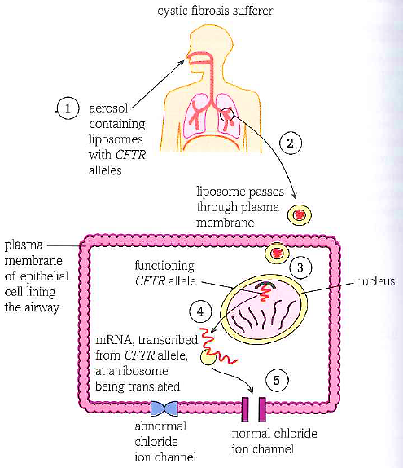
There are various methods available for delivering the functioning alleles to the patient's body cells. In this example the vector is a liposome. Normal alleles are packaged within small spheres of lipid bilayer to make liposomes.
Method:
- The liposomes are placed into an aerosol inhaler and sprayed into the noses of patients.
- Some liposomes will pass through the plasma membrane of the cells lining the respiratory tract.
- Some liposomes will then pass through the nuclear envelope and insert into the host genome.
- The host cell will express the CFTR protein.
This treatment has to be repeated every two weeks because the epithelial cells lining the respiratory tract are replaced every 10-14 days.

Viral Vectors
A genetically engineered virus can be used as a vector to deliver the functional gene copy. Scientists modify the viral genome removing the disease-causing genes, and the human DNA fragment inserted. Viruses are used because they are already engineered to encapsulate and deliver genes to human cells to be transcribed and translated into proteins. Lung cells will be infected with the viral vector which unloads its genetic material containing the functional human gene into the cells. The difficulty is guaranteeing that the gene will get into the lung cells before the vector is destroyed by the body’s immune system. The use of viruses as vectors also carries a risk as they could be toxic or cause immune and inflammatory responses. The viral vector also has the potential to reactivate its ability to cause disease
Germline Gene therapy
Germline gene therapy alters the gamete or zygote of the organism. This type of gene therapy has the potential to change the genetic make-up of the descendants of the original patient, none of whom would have given consent there are also concerns about how the genes may be inserted.
These genes may find their way to a location that could disrupt the expression or regulation of other genes or increase the risk of cancer. Strict guidelines are drawn up by the regulatory bodies and ethics committees consider it impermissible in humans.
ETHICAL ISSUES: POSITIVE AND NEGATIVE
 |  | 
Animal | Plant | Bacteria
- Genetic manipulation is no different from crossbreeding. domestic farm animals today are not closely related to their wild ancestors.  - Genetic manipulation reduces cost and increases production of crops for people | - Plant pathogens can reduce crop yield by 10-20% depending on the setting. However, this can be up to 100% if crops are not disease resistant. This risks famine and economic hardship.  - It also reduces cost and increases production of plant crops.  - There is no evidence of any genes escaping crop plants grown in the wild. | - Bacteria can be seen as little machines rather than parts of a larger ecosystem.  - Bacteria swap their DNA amongst themselves all the time via plasmids.  - Many life saving drugs can be produced from genetically modified bacteria.  - These bacteria can be completely contained in the laboratory.
Animal | Plant | Bacteria
- Animals are sentient.  - Genetic manipulation reduces the variation within the population this is because clones. are used.  - There could be health implications for the animals involved. | - Plants are harder to contain than animals and these can cross breed with wild varieties releasing new genes with unknown effects into the environment.  - Potential harm to human health from food.  - Negative impact on traditional farming practice  - Excessive corporate dominance (one crop could initiate a monopoly) | - There is a danger that they will escape from the lab.  - There could be contamination from the other products of the bacteria.  - Antibiotic resistance genes are used and these could create an untreatable pathogen as they are carried on a plasmid that can be shared between species of bacteria.
Recall Questions
- Describe what the Human Genome Project Was and why it was so important.
- What does the CFTR channel protein do?
- How many alleles are needed for this protein to function correctly?
- Explain what a somatic cell and a germline cell is.
- Gene therapy is delivered in a vector for cystic fibrosis sufferers. Explain the disadvantage of the current therapy.
- Explain what a vector is.
- Compare the positive and negative ethical issues of genetic manipulation of animals
- Summarise the advantages of genetic manipulation of plants. Projecting into the future, can you think of any other future advantages of genetic manipulation of plants?
- Compare the disadvantages of genetically manipulating bacteria and explain how and why these reasons are quite different to crop plants and farm animals.
- Explain why only some genes can be directly inserted into the bacterial chromosome and what the solutions to this problem are.

Exam Questions:
Q1. (a) Adrenaline binds to receptors in the plasma membranes of liver cells. Explain how this causes the blood glucose concentration to increase.
___________________________________________________________________
___________________________________________________________________
___________________________________________________________________
___________________________________________________________________ (2)
(b) Scientists made an artificial gene which codes for insulin. They put the gene into a virus which was then injected into rats with type I diabetes. The virus was harmless to the rats but carried the gene into the cells of the rats.
The treated rats produced insulin for up to 8 months and showed no side-effects. The scientists measured the blood glucose concentrations of the rats at regular intervals. While the rats were producing the insulin, their blood glucose concentrations were normal.
(i) The rats were not fed for at least 6 hours before their blood glucose concentration was measured. Explain why.
______________________________________________________________
______________________________________________________________
______________________________________________________________ (1)
(ii) The rats used in the investigation had type I diabetes. This form of gene therapy may be less effective in treating rats that have type II diabetes. Explain why.
______________________________________________________________
______________________________________________________________
______________________________________________________________ (1)

(iii) Research workers have suggested that treating diabetes in humans by this method of gene therapy would be better than injecting insulin. Evaluate this suggestion.
______________________________________________________________
______________________________________________________________
______________________________________________________________
______________________________________________________________
______________________________________________________________
______________________________________________________________
______________________________________________________________ (4)
Q2. (b) In gene therapy, genes are introduced into a person who has defective genes which do not produce an important substance. Three experiments were done to compare techniques for introducing an important substance into a person with defective genes.
1. The substance was injected directly.
2. Harmless viruses carrying genes coding for the substance were injected.
3. The genes were put into a protein capsule which was inserted into the tissues.
The graph shows results of the experiments.
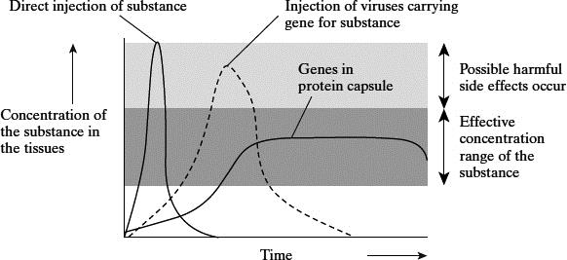
Takahiro Ochiya et al, Biomaterials for Gene Delivery: Studies on Metastasis,
(National Cancer Centre, Research Institute, Tokyo, Japan) 1999
(i) Describe the results of the three experiments.
______________________________________________________________
______________________________________________________________
______________________________________________________________
______________________________________________________________
______________________________________________________________(3)

(ii) Using the information in the graph, suggest one advantage and one disadvantage of the capsule method compared to the others.
Advantage ____________________________________________________
______________________________________________________________
Disadvantage __________________________________________________
______________________________________________________________
(2)
Q3.
(a) Cystic fibrosis can be caused by any one of several mutant alleles of the cystic fibrosis gene. The most common of these mutant alleles accounts for about 70% of cases of cystic fibrosis. The use of gene probes can identify individuals carrying this allele. Gene probes are single strands of DNA which are radioactively labelled. They have a base sequence that is complementary to a mutant allele. The main stages in using a gene probe are shown in the diagram.

Sample of DNA extracted from a person’s tissue and heated to separate the strands
↓
Radioactive gene probe added
to the DNA
↓
Excess probe washed away
↓
Sample tested for radioactivity
Using the information given, explain how the use of a gene probe could enable the presence of a mutant allele of the cystic fibrosis gene to be detected.
___________________________________________________________________
___________________________________________________________________
___________________________________________________________________
___________________________________________________________________
___________________________________________________________________
___________________________________________________________________
___________________________________________________________________ (4)

(b) Sheep have been genetically engineered to produce alpha-1-antitrypsin which is used to treat cystic fibrosis. Use your knowledge of this process to explain one argument for and one against using sheep in this way.
For
___________________________________________________________________
___________________________________________________________________
Against
___________________________________________________________________
___________________________________________________________________(2)
Q4. Read the following passage.
Complete achromatopsia is a form of complete colour blindness. It is caused
by having only rods and no functional cone cells. People with complete
achromatopsia have difficulty in seeing detail. Complete achromatopsia is
caused by an autosomal recessive allele and is usually very rare in
populations with only one in 40 000 being affected. However on the Pacific 5
island of Pingelap ten percent of the population are affected.
One form of red-green colour blindness is caused by a sex-linked recessive
allele which affects more men than women. People with this red-green
colour blindness are unable to distinguish between red and green, and also
between other colours. They have green-sensitive cones but the 10
photoreceptive pigment they contain does not function.
Scientists investigated the use of gene therapy to correct red-green colour
blindness in monkeys. They injected viruses containing the gene for the
green-sensitive pigment directly into the eyes of the monkeys. Although the
monkeys maintained two years of colour vision, there is debate on whether 15
this form of gene therapy is worthwhile. No clinical trials of this procedure
have been carried out on humans. Current research into the treatment of
red-green colour blindness involves the use of induced pluripotent stem cells
(iPS cells). The use of iPS cells could have advantages over the use of gene
therapy. 20
Use the information in the passage and your own knowledge to answer the following questions.
(c) Red-green colour blindness affects more men than women (lines 7–8).
Explain why.
___________________________________________________________________
___________________________________________________________________
___________________________________________________________________
___________________________________________________________________
___________________________________________________________________
(2)

(e) Current research into the treatment of red-green colour blindness involves the use of induced pluripotent stem cells (iPS cells) (lines 17–19).
Suggest how iPS cells could correct red-green colour blindness.
___________________________________________________________________
___________________________________________________________________
___________________________________________________________________
___________________________________________________________________
___________________________________________________________________
___________________________________________________________________
(2)
(f) The use of iPS cells could have advantages over the use of gene therapy to correct red-green colour blindness (lines 19–20).
Using the information from the passage, suggest and explain reasons why.
___________________________________________________________________
___________________________________________________________________
___________________________________________________________________
___________________________________________________________________
___________________________________________________________________
___________________________________________________________________
___________________________________________________________________
___________________________________________________________________
___________________________________________________________________
___________________________________________________________________
___________________________________________________________________
___________________________________________________________________
___________________________________________________________________
___________________________________________________________________
(3)

Homework:
Read the following article about the first instance of germline gene therapy:
https://www.nature.com/articles/d41586-019-00673-1

- What did the scientist in question do?

- What was his reasoning for doing it?

- What are the issues with what he did?

- How did the scientific community react?

Recall Question Answers:
Describe what the Human Genome Project was and why it was so important.
What does the CFTR channel protein do?
How many alleles are needed for this protein to function correctly?
Explain what a somatic cell and a germline cell is.
Gene therapy is delivered in a vector for cystic fibrosis sufferers. Explain the disadvantage of the current therapy.
Explain what a vector is.
Compare the positive and negative ethical issues of genetic manipulation of animals
Compare the positive and negative ethical issues of genetic manipulation of animals
Summarise the advantages of genetic manipulation of plants. Projecting into the future, can you think of any other future advantages of genetic manipulation of plants?
Compare the disadvantages of genetically manipulating bacteria and explain how and why these reasons are quite different to crop plants and farm animals.
Explain why only some genes can be directly inserted into the bacterial chromosome and what the solutions to this problem are.

