AQA Biology GCSE
Respiration
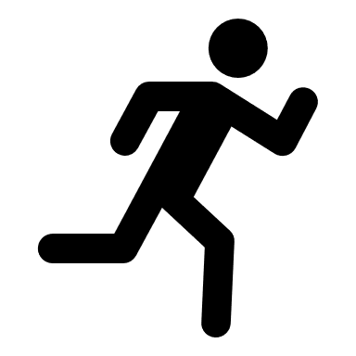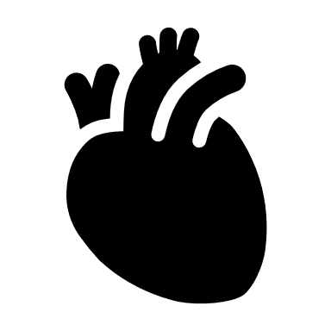

Name: ______________________

Week | Homework Task |  | SCAN CODE | Due
1 | Task 1: Watch ‘The Lungs: Structure and Breathing’ video, on Kay Science.com.  Task 2: Watch the video to revise then complete the fill in the blank activity and submit pictures of answers on MS Teams. |  | 
2 | Task 1: Watch the ‘Aerobic Respiration’ video on KayScience.com.  Task 2: Complete the Worksheet and submit pictures of answers on MS Teams. |  | 
3 | Task 1: Watch the ‘Anaerobic Respiration’ video on Kay Science.com.  Task 2: Complete the Worksheet and submit pictures of answers on MS Teams. |  | 
4 | Task 1: Watch the ‘The effect of Exercise on Respiration’ video on KayScience.com.  Task 2: Answer the questions towards the end of the video, self-assess and submit pictures of answers on MS Teams. |  | 
5 | Task 1: Watch the ‘Fermentation’ video on KayScience.com  Task 2: Complete the multiple-choice question task towards the end of the video. |  | 
6 | Task 1: Watch the ‘Metabolism’ video on KayScience.com  Task 2: Complete the Worksheet and submit pictures of answers on MS Teams. |  | 
Key Words
Aerobic respiration |  | Respiration that requires oxygen
Alveoli |  | Tiny air sacs in the lungs where gas is exchanged during breathing
Bronchi |  | The plural of ‘bronchus’. The bronchi are the two major air tubes in the lungs
Bronchioles |  | The many small, branching tubules into which the bronchi subdivide
Capillary |  | Tiny blood vessels with walls one-cell thick where exchange of material occurs.
Carbon dioxide |  | A gaseous compound of carbon and oxygen which is a by-product of respiration, and which is needed by plants for photosynthesis.
Cartilage |  | A strong, flexible type of connective tissue. It forms C-shape rings in the trachea that keeps the airway open.
Concentration gradient |  | The difference in the concentration of a chemical across a membrane
Counter current flow |  | Currents flowing in the opposite direction, for instance, blood and urine flow in the kidney tubule, water and blood in fish gills
Diaphragm |  | A large sheet of muscle that separates the lungs from the abdominal cavity
Diffuse |  | When particles spread out from a region of higher concentration to a region of lower concentration.
Diffusion |  | The movement of molecules from an area of higher concentration to an area of lower concentration
Epithelial cell |  | A cell that forms part of an epithelium
Exchange surface |  | A surface where substances, e.g. Gases, food substances and waste are moved across membranes.
Exhalation |  | The process of breathing out
Gills |  | The respiratory organ found in fish and other aquatic animal. Gills have a large surface area, and a good blood supply for efficient gas exchange to happen in water
Gill filament |  | Structures that make up the gills of a fish
Glucose |  | A simple sugar used by cells for respiration
Haemoglobin |  | The red protein found in red blood cells that transports oxygen round the body
Heart |  | Muscular organ that pumps blood around the body
Human thorax |  | The ribs and upper backbone and the organs found in the chest
Inhalation |  | The process of breathing in
Intercostal muscle |  | Sets of muscles between the ribs which raise and lower the ribcage.
Metabolism |  | All the chemical reactions in the cells of an organisms, including respirations.
Multicellular |  | Having more than one cell
Operculum |  | A flap on the side of the head of a fish through which water passes after it has flowed over the gills.
Organism |  | Living entity, eg animals, plants or microorganisms
Oxygen |  | Gaseous element making up approx. 20% of the air, which is needed by living organisms for respiration
Photosynthesis |  | A chemical process used by plants to make glucose and oxygen from carbon dioxide and water, using light energy. Oxygen is produced as a by-product of photosynthesis. Algae subsumed within plants and some bacteria are also photosynthetic
Pleural membranes |  | Thin, moist membranes surrounding the lungs that make an airtight seal
Respiratory system |  | The organ system where air is taken into and out of the body, and gas exchange happens
Ribcage |  | The arrangement of bones in the thorax, formed by the ribs, vertebral column sternum, that encloses the lungs and heart
Trachea |  | The windpipe, the tube that leads from the mouth towards the lungs
Ventilation |  | Breathing in and out of the lungs

Paper 1 – Respiration
To revise these facts, fold this sheet in half and try to write the answers down from memory. Repeat!
Fold page here
Outline the flow of air from the atmosphere into our lungs, starting from the nasal cavity. | Nasal cavity --> trachea --> bronchi --> bronchioles --> alveoli
What two structures change the pressure inside the chest cavity to ventilate lungs? | Intercostal muscles + Diaphragm
What is the diaphragm? | The diaphragm is a thin skeletal muscle that sits at the base of the chest and separates the abdomen from the chest. It contracts and flattens when you inhale. This creates a vacuum effect that pulls air into the lungs. When you exhale, the diaphragm relaxes and the air is pushed out of lungs.
Describe the state of the diaphragm as we breathe in. | Contracts and flattens
Describe the state of the diaphragm as we breathe out. | Relaxes and return to dome shape
State the function of the ribcage. | Protect the heart and lungs
Describe what happens to the ribcage as we breathe in. | Ribcage moves up and out
Describe what happens to the ribcage as we breath out. | Ribcage moves down and in
State one adaptation of the lungs for efficient gas exchange. | Lots of alveoli to increase surface area; Rich blood supply/Extensive capillary network; Thin walls (one cell thick)
Why is it important for the lungs to have a rich blood supply? | Maintain steep concentration gradient for efficient diffusion
Define 'aerobic respiration'. | An enzyme-controlled process in which glucose reacts with oxygen and energy is released. Takes place in the mitochondria of cells.
State the word equation of aerobic respiration. | Glucose + Oxygen --> Carbon dioxide + Water
Is respiration endothermic or exothermic? | Exothermic
Where does aerobic respiration occur in the cell? | Mitochondria
Give one importance of respiration. | Metabolic reactions (eg. Build)/Muscle contraction/Maintaining body temp/Active transport
State one response of the body to exercise. | Increase heart rate/breathing rate/Glycogen converted to glucose/Increase blood flow to muscles
What happens to the glycogen stored in muscles when you exercise? | Converted into glucose for respiration
What happens to the glycogen stored in muscles when you exercise? | Converted into glucose for respiration
What is anaerobic respiration? | Breakdown of glucose to release small amount of energy without the use of oxygen
Name the toxic substance produced by anaerobic respiration. | Lactic acid
Define 'oxygen debt'. | Amount of oxygen needed to break down lactic acid
What do plants make in anaerobic respiration? | Ethanol and carbon dioxide
Give one use of yeast doing anaerobic respiration. | Making bread and alcohol
Give one example of a metabolic reaction in cells. | Convert glucose to glycogen, starch or cellulose. Make/breakdown molecules Photosynthesis or respiration
Lesson 1 – The Respiratory System
CHECKLIST! – Have you…
- Watched the lesson video
- Read the notes and completed the recall questions
- Marked your recall questions
- Completed the exam questions
Notes: Instruction: Read the notes below.
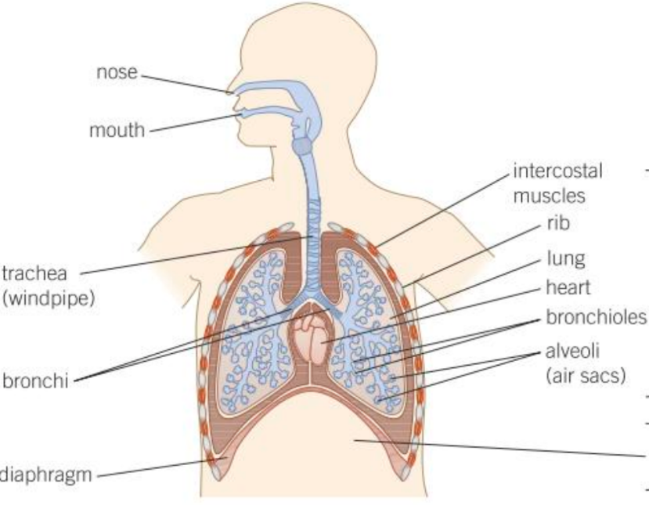
Part 1 – Label a diagram of the respiratory system
Your lungs and heart are found in your chest and are protected by your ribcage. They are separated from the digestive organs which are underneath by the diaphragm. The diaphragm is a strong sheet of muscle. The job of your respiratory system is to move air in and out of your lungs – this is known as ventilation.
The pathway of air into the lungs is:

- Breathing in: When your ribcage expands and your diapragm flattens (contracts) air rushes into the lungs through your nose and mouth.
- Breathing out: When your ribcage contracts and your diaphragm rises up (relaxes) air is forced out of your lungs through your mouth.
Atmospheric gas | % of air breathed in | % of gas breathed out
Nitrogen | 80 | 80
Oxygen | 20 | 16
Carbon dioxide | 0.04 | 4
Differences in the % of air breathed in and out
When you breathe in, oxygen-rich air moves into your lungs, you can see this in the table above that air breathed in has more oxygen. This makes sure there is more oxygen in your lungs than in your blood to help maintain a steep concentration gradient (difference). As a result, oxygen will always diffuses into your bloodstream through the alveoli.
When you breathe out you remove carbon dioxide that has come from the blood into the alveoli, you can see this in the table above that air breathed out has more carbon dioxide than air breathed in. This makes sure there is always a lower concentration of carbon dioxide in the lungs than the blood which maintains a concentration gradient (difference) so carbon dioxide will always diffuse out of the bloodstream into the air in the alveoli.
Part 2 – Explain the difference between respiration and breathing
Breathing is the mechanical action of getting air in and out of the lungs. We call this ventilation.
Respiration is the chemical reaction that uses the oxygen from the blood to provide energy for the organism to survive. It occurs in the mitochondria inside every cell of the organism. Respiration produces carbon dioxide that is removed from the blood by the lungs.
Instruction: Answer these questions in your exercise book. Use the notes above to help you (like a comprehension)

Recall Questions Part 1
- State the function of the ribcage.

- Outline the flow of air from the atmosphere into our lungs, starting from the nose.

- Describe how we breathe in
- Describe how we breathe out

- Describe the main differences in the air we breathe in compared to the air we breathe out

- Explain why ventilation is important for gas exchange

- Explain the difference between respiration and breathing
Part 3 – Explain how the alveoli is adapted for efficient gas exchange
Your lungs are specially adapted to make gas exchange more efficient. These are the main adaptions of the alveoli which help to speed up the diffusion (increase the rate of diffusion) of gases between the air into the blood:
Fun Fact!
If all the alveoli in your lungs were spread out flat, they would have a surface area equivalent to 10-15 table tennis tables!
- Lots of alveoli provide a very large surface area this increases the rate of diffusion
- Alveoli also have a good blood supply as they are covered in lots of capillaries this makes sure that the concentration gradient is maintained as red blood cells that have collected oxygen flow away from the lungs and red blood cells that need oxygen keep arriving.
- Alveoli have very thin walls that are only one cell thick this reduces the distance the gases have to diffuse so that the rate of diffusion increases.
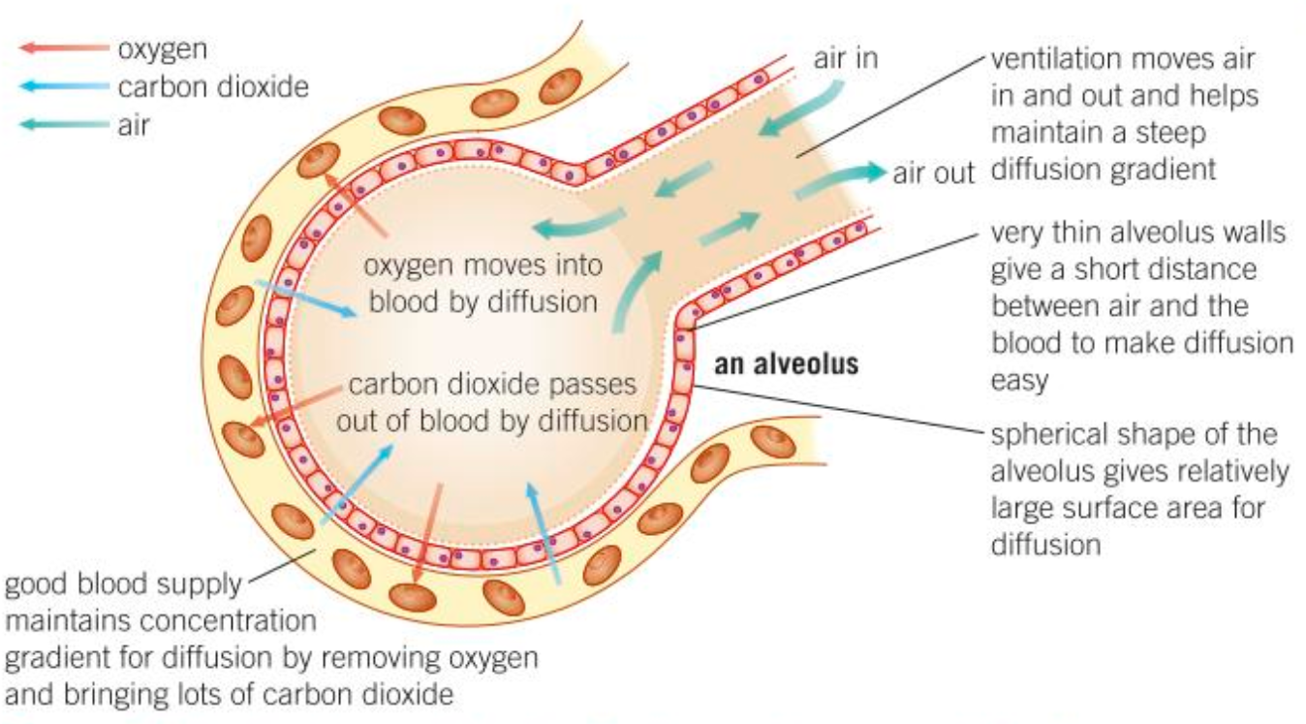
Instruction: Answer these questions in your exercise book. Use the notes above to help you (like a comprehension)
Recall Questions Part 2
1. State three adaptations of the lungs for efficient gas exchange.
2. Why is it important for the lungs to have a rich blood supply?

Exam Questions - Instruction: Answer these questions on this sheet – you can use the notes to help you
Q1. (a) The drawing shows some of the organs in the human thorax.
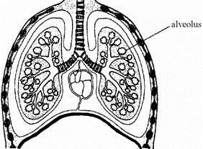
On the drawing, use guidelines to label:
(i) the heart;
(ii) a rib;
(iii) the diaphragm;
(iv) the trachea.
(4)
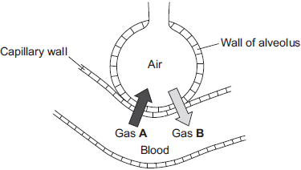
Q2. Gas exchange takes place in the lungs.
The diagram shows an alveolus next to a blood capillary in a lung.
The arrows show the movement of two gases, A and B.

(a) (i) Draw a ring around the correct answer to complete the sentence.

Gases A and B move by | diffusion.  osmosis.  respiration.
(1)
(ii) Gas A moves from the blood to the air in the lungs. Gas A is then breathed out.
Name Gas A.
______________________________________________________________
(1)
(iii) Which cells in the blood carry Gas B?
Draw a ring around the correct answer.
platelets red blood cells white blood cells
(1)
(c) An athlete trains to run a marathon. The surface area of each of the athlete’s lungs has increased to 80 m².
Give one way in which this increase will help the athlete.
___________________________________________________________________
___________________________________________________________________
(1)
Q3. The human lung has about 80 million alveoli. The diagram shows some alveoli in a human lung.
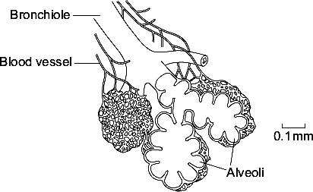
(a) Give three features of the alveoli that allow large amounts of oxygen to enter the blood.
1. _________________________________________________________________
___________________________________________________________________
2. _________________________________________________________________
___________________________________________________________________
3. _________________________________________________________________
___________________________________________________________________ (3)

(b) (i) Name the process by which oxygen passes from the air into the blood.
______________________________________________________________ (1)
(ii) Breathing allows large amounts of oxygen to enter the blood.
Explain how breathing does this.
______________________________________________________________
______________________________________________________________
______________________________________________________________
______________________________________________________________ (2)
Q4. The table shows the percentage of some gases in the air a boy breathed in and out.

Gases | Air  breathed in | Air  breathed out
carbon dioxide | 0.04% | 4.0%
oxygen | 20.0% | 16.0%
water vapour | 1.0% | 6.0%
(a) What happens in the lungs to change the levels of oxygen and carbon dioxide in this way?
Oxygen ____________________________________________________________
___________________________________________________________________
___________________________________________________________________
Carbon dioxide ______________________________________________________
___________________________________________________________________
___________________________________________________________________
(4)
(b) Compare the percentage of water vapour in the air breathed out with the percentage in air breathed in.
___________________________________________________________________ (2)
Challenge:
1. The drawing shows a section through an alveolus.
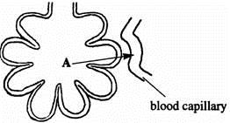
At A, oxygen moves from the air in the alveolus into the blood capillary.
Explain, as fully as you can, how oxygen moves into the blood.
___________________________________________________________________
___________________________________________________________________
___________________________________________________________________
___________________________________________________________________
___________________________________________________________________
___________________________________________________________________ (2)
2. Figure 2 shows a fish head and gill.
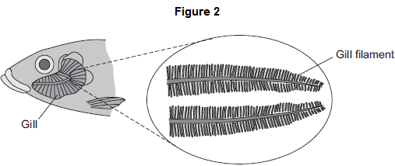

Fish absorb oxygen from the water. Oxygen is absorbed through the gills of the fish.
Explain one way in which the gills are adapted for rapid absorption of oxygen.
______________________________________________________________
______________________________________________________________
______________________________________________________________
______________________________________________________________
(2)


Lesson 2 – Aerobic Respiration
CHECKLIST! – Have you…
- Watched the lesson video
- Read the notes and completed the recall questions
Scan me for a another helpful video
- Marked your recall questions
- Completed the exam questions
Notes: Instruction: Read the notes below.

Notes: Instruction: Read the notes below.
Part 1 – Recall the site of cellular respiration and it’s two reactants
One of the most important enzyme-controlled processes in living things is aerobic respiration. It takes place all the time in plant and animal cells.
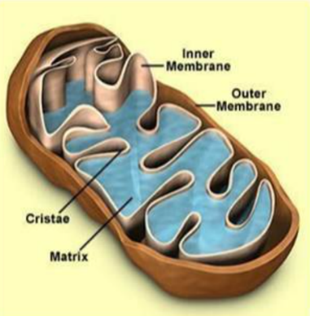
During aerobic respiration, glucose (a sugar) reacts with oxygen which releases energy that your cells can use. This energy is vital to keep you alive. Your digestive system, respiratory system and circulatory system all work together to provide your cells with the glucose and oxygen they need for respiration and to remove the waste products carbon dioxide and water from the body.
The site of aerobic respiration
Aerobic respiration takes place inside the mitochondria in cells.
Mitochondria are tiny rod-shaped parts (organelles) that are found in all eukaryotic cells. Cells that require a lot of energy will have lots of mitochondria e.g muscle cells for contraction or root hair cells for active transport of mineral ions
Use the notes above to help you answer these recall questions:
- Define ‘aerobic respiration.’
- Where does aerobic reaction occur in the cell?

Part 2 – Describe how cells and animals use energy produced by respiration
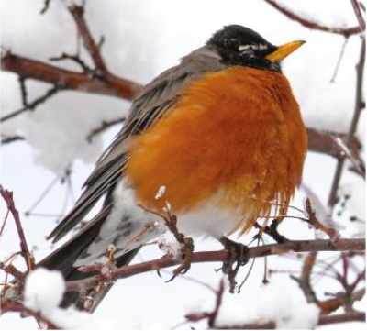
The energy transferred during respiration supplies all the energy needs for living processes in the cells. This energy is used:
- For cell division (mitosis)
- For movement e.g muscle contraction
- To move molecules against concentration gradients (active transport) e.g in root hair cells in plants
- To build new molecules e.g build carbohydrates, lipids and proteins from their monomers after digestion or photosynthesis
When the weather is cold birds like this robin use up a lot of food for respiration just to keep warm. Giving them extra food during the winter can help them survive the cold!
- To maintain constant conditions in cells and the body – homeostasis, especially too keep warm! As animals respire, heat is also released. In birds and mammals, this heat is distributed around the body by the blood. It keeps these animals warm and helps to keep a constant internal temperature.
Use the notes above to help you answer these recall questions:
3. Give two uses of the energy from respiration in organisms with an example

Part 3 -Explain how respiration is an exothermic reaction
Aerobic respiration is an exothermic reaction. Exothermic reactions transfer energy to the environment – more energy is transferred to the environment when new bonds are formed in the products than is taken to break the bonds in the reactants so this left over energy is transferred to the environment, making it slightly warmer.
Aerobic respiration equations:
Word Equation: Glucose + oxygen → carbon dioxide + water (+ energy transferred to the environment)
Symbol Equation: C₆H₁₂O₆ + 6O₂ → 6CO₂ + 6H₂O (+ energy transferred to the environment)
Use the notes above to help you answer these recall questions:
- Is respiration an endothermic or exothermic reaction?
- State the word equation for aerobic respiration.
- State the balanced symbol equation for aerobic respiration.

Exam Questions
Instruction: Answer these questions on paper or type in the word document
Q1. The diagram shows part of the breathing system in a human.
(a) Use words from the list to label the parts on the drawing.

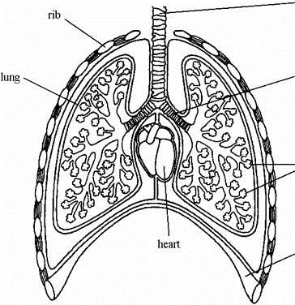

alveoli bronchiole bronchus diaphragm trachea (windpipe)
(4)
(b) Where in the lungs does oxygen enter the blood?
___________________________________________________________________
(1)
(c) Which process in cells produces carbon dioxide?
___________________________________________________________________
(1)
Q2. (a) (i) Complete the word equation for the process of aerobic respiration.
Glucose + ______________ → carbon dioxide + water
(1)
(ii) Which organ removes carbon dioxide from your body?
______________________________________________________________ (1)
Q3. Oxygen from our lungs is carried, by our blood, to cells in our body where aerobic respiration takes place.
(i) Complete the two spaces to balance the chemical reaction for aerobic respiration.
C₆H₁₂O₆ + 6O₂ → ____ CO₂ + ____ H₂O
(1)
(ii) Name the substance with the formula C₆H₁₂O₆.
___________________________________________________________________ (1)
(iii) Name the structures in the cytoplasm of our cells where aerobic respiration takes place.
___________________________________________________________________
(1)
Q4. Give three different ways in which animals use the energy released in respiration.
1. _________________________________________________________________
___________________________________________________________________
2. _________________________________________________________________
___________________________________________________________________
3. _________________________________________________________________
___________________________________________________________________ (3)
Q5. Complete the table by writing the correct process next to its description.
Choose your answers from the list in the box (3)

breathing diffusion digestion osmosis respiration

Description | Process
Moving air in and out of the lungs
The movement of particles of a substance from high to low concentration
The release of energy from glucose
Q6. Plants need chemical energy for respiration and for active transport.
(i) Write a balanced chemical equation which represents the process of respiration in plants.
___________________________________________________________________
(2)

Challenge: Describe the process of active transport in the root hair cells of plants.
___________________________________________________________________
___________________________________________________________________
___________________________________________________________________
___________________________________________________________________
___________________________________________________________________
___________________________________________________________________
___________________________________________________________________
___________________________________________________________________
___________________________________________________________________
___________________________________________________________________
(3)

Lesson 3 – Anaerobic Respiration in Animals
CHECKLIST! – Have you…
- Watched the lesson video
- Read the notes and completed the recall questions
- Marked your recall questions
- Completed the exam questions
Notes: Instruction: Read the notes below.
Part 1 - Recall the word equation for anaerobic respiration
Most organisms cannot respire without oxygen but some organisms and tissues can continue to respire if the oxygen runs out. These organisms and tissues use the process of anaerobic respiration. Anaerobic respiration is the breakdown of glucose to release small amount of energy without the use of oxygen.
Human muscle can respire anaerobically for short periods of time – even though the process is relatively inefficient, it's better to continue respiring and be able to run away from danger – or run a race.
The glucose in muscle is converted to lactic acid which is toxic. This is the word equation for anaerobic respiration.
glucose → lactic acid + energy released
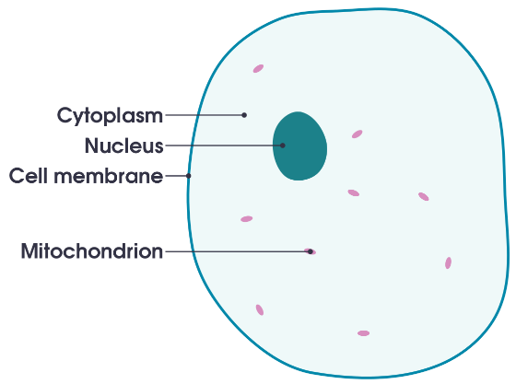
Anaerobic respiration occurs in the cytoplasm of cells (remember that aerobic respiration takes place in the mitochondria).
Recall Questions: Use the notes above to help you answer these recall questions:
- Define anaerobic respiration?
- What is the word equation for anaerobic respiration in animals?
- Name the toxic substance produced by anaerobic respiration.
- What is the function of the cytoplasm?

Part 2 - Compare and contrast aerobic and anaerobic respiration
There are several differences between aerobic and anaerobic respiration. The main differences are detailed below in the table.
 | Aerobic | Anaerobic
Prescence of oxygen | Present | Absent or in short supply
Oxidation of glucose | Complete | Incomplete. The products of respiration still contain energy
Products of respiration | Carbon dioxide and water. | Mammalian muscle: lactic acid.
Amount if energy released | Relatively large amount | Small amounts, but quickly.
Location in the cell | Mitochondria | Cytoplasm

Recall Questions: Use the table above to help you answer these recall questions:
- Which type of respiration can take place in the absence of oxygen?
- Which type of respiration produces carbon dioxide and water as products?
- Which type of respiration releases more energy?
- Where does anaerobic respiration take place?
- What is the function of the mitochondria?

Part 3 - Explain the oxygen debt after intense exercise
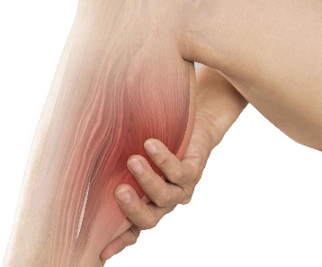
When we breathe, our lungs provide sufficient oxygen for our cells to respire aerobically. However, when we do intense exercise (e.g. sprinting or weightlifting) the heart and lungs are unable to supply enough oxygen as fast as muscles are using it, so muscles begin to respire anaerobically. The muscles continue to contract, but less efficiently as only small amounts of energy are produced.
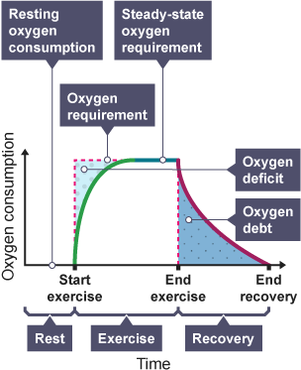
During anaerobic respiration Lactic acid is produced from glucose, instead of carbon dioxide and water, lactic acid levels build up the longer anaerobic respiration continues. Muscles become fatigued (tired) because they have used up their energy store of glycogen and contain lactic acid - this can result in cramp (a painful tight sensation).

This build-up of lactic acid produces an oxygen debt. The oxygen debt is the amount of oxygen needed to break down the lactic acid produced during anaerobic respiration:
lactic acid + oxygen -> carbon dioxide + water
This is why you have a fast breathing rate/breathe heavily (more than normal) for a short while after exercise. To take in enough oxygen to pay off the oxygen debt.

Recall Questions: Use the notes above to help you answer these recall questions:
- What is oxygen debt?
- State an effect on your body after anaerobic respiration.

Exam Questions: Instruction: Answer these questions by typing in this document or on paper
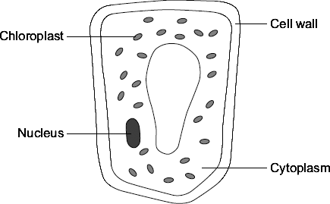
Q1.
The diagram shows a plant cell from a leaf.

(a) List A gives the names of three parts of the cell.
List B gives the functions of parts of the cell.
Draw a line from each part of the cell in List A to its function in List B.

List A  Parts of the cell |  | List B  Functions
Where most of the chemical
reactions take place
Nucleus
 |  | Absorbs light energy to make food
Cytoplasm
 |  | Strengthens the cell
Chloroplast
 |  | Controls the activities of the cell
(3)
(b) Respiration takes place in the cell.
Draw a ring around the correct answer to complete the sentence.

 | energy
All cells use respiration to release | oxygen.
 | sugar.
- (Total 4 marks)

Q2. (a) (i) Complete the word equation for the process of aerobic respiration.
Glucose + ______________ → carbon dioxide + water (1)
(ii) Which organ removes carbon dioxide from your body?
______________________________________________________________(1)
(b) Use names from the box to complete the two spaces in the passage.

carbon dioxide lactic acid nitrogen oxygen water
Anaerobic respiration can occur when an athlete does vigorous exercise.
This is because there is not enough ___________________________ in the body.
The product of anaerobic respiration is ________________________________.
(2)
Q3. (a) Aerobic respiration and anaerobic respiration are the two types of cell respiration.
Give three differences between aerobic and anaerobic respiration.
1. _________________________________________________________________
___________________________________________________________________
2. _________________________________________________________________
___________________________________________________________________
3. _________________________________________________________________
___________________________________________________________________
(3)
Q4. Eukaryotic cells respire continuously to transfer energy.
(a) Give two uses of energy transferred by respiration in eukaryotes.
1. _________________________________________________________________
2. _________________________________________________________________
(2)
(b) Name the cell structure in a eukaryotic cell where aerobic respiration occurs.
___________________________________________________________________
(1)
(c) Anaerobic respiration in muscle cells creates an oxygen debt.
What does oxygen debt mean?
___________________________________________________________________
___________________________________________________________________
(1)
(Total 4 marks)

Q5.
(a) Respiration is a process which takes place in living cells. What is the purpose of respiration?
___________________________________________________________________
___________________________________________________________________
(1)
(b) (i) Balance the equation for the process of respiration when oxygen is available.
C₆H₁₂O₆ + O₂ → CO₂ + H₂O
(1)
(ii) What is the name of the substance in the equation with the formula C₆H₁₂O₆?
______________________________________________________________
(1)
Q6.
Figure 1 shows an athlete running on a treadmill.
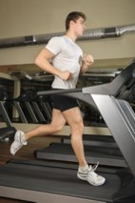
After running for several minutes, the athlete’s leg muscles began to ache.
This ache was caused by a high concentration of lactic acid in the muscles.
(a) The equation shows how lactic acid is made.
glucose lactic acid (+ energy)

Name the process that makes lactic acid in the athlete’s muscles. ___________________________________________________
(1)
(b) Scientists investigated the production of lactic acid by an athlete running at different speeds.
In the investigation:
• the athlete ran on the treadmill at 4 km per hour
• the scientists measured the concentration of lactic acid in the athlete’s blood after 2 minutes of running.
The investigation was repeated for different running speeds.

Figure 2 shows the scientists’ results.

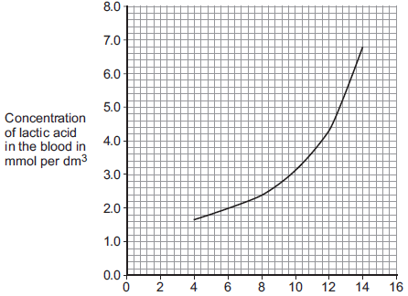

Treadmill speed in km per hour
(i) How much more lactic acid was there in the athlete’s blood when he ran at 14 km per hour than when he ran at 8 km per hour?
______________________________________________________________
______________________________________________________________
______________________________________________________________
Answer = _____________ mmol per dm³
(2)
(ii) Why is more lactic acid made in the muscles when running at 14 km per hour than when running at 8 km per hour?
______________________________________________________________
______________________________________________________________
______________________________________________________________
______________________________________________________________
______________________________________________________________
______________________________________________________________
(3)
(Total 6 marks)

Challenge:
An athlete ran as fast as he could until he was exhausted.
(a) Figure 1 shows the concentrations of glucose and of lactic acid in the athlete’s blood at the start and at the end of the run.
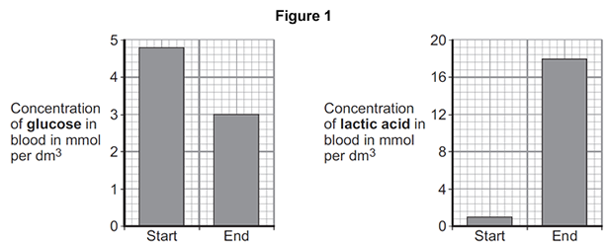
(i) Lactic acid is made during anaerobic respiration.
What does anaerobic mean?
______________________________________________________________
______________________________________________________________
(1)
(ii) Give evidence from Figure 1 that the athlete respired anaerobically during the run.
______________________________________________________________
______________________________________________________________
(1)
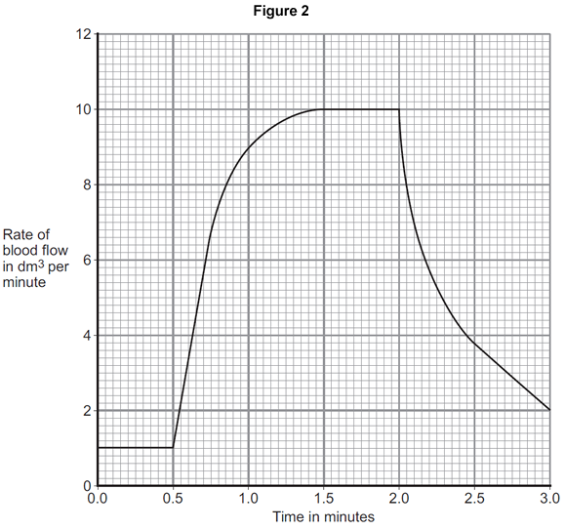
(b) Figure 2 shows the effect of running on the rate of blood flow through the athlete’s muscles.
(i) For how many minutes did the athlete run?
Time = ______________________ minutes
(1)
(ii) Describe what happens to the rate of blood flow through the athlete’s muscles during the run.
Use data from Figure 2 in your answer. ________________________________________________________
______________________________________________________________
____________________________________________________________(2)

(iii) Explain how the change in blood flow to the athlete’s muscles helps him to run.
______________________________________________________________
______________________________________________________________
______________________________________________________________
______________________________________________________________
______________________________________________________________
______________________________________________________________
______________________________________________________________
______________________________________________________________
(4)
(Total 9 mark)

Lesson 4 – Response to Exercise
CHECKLIST! – Have you…
- Watched the lesson video
- Read the notes and completed the recall questions
- Marked your recall questions
- Completed the exam questions
Notes: Instruction: Read the notes below.
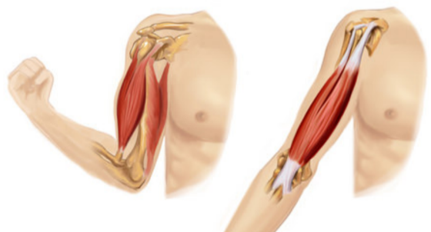
Part 1 – Recall the effects of exercise on the body.
Muscles need energy to contract.
While exercising, the muscles need additional energy which means they need to carry out more respiration. To create more energy, your body needs extra oxygen and glucose
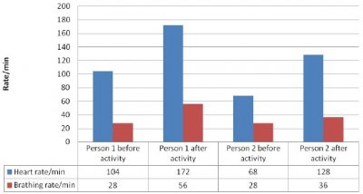

To help with this your body changes in two ways:
- The breathing rate and volume of each breath increases to bring more oxygen into the body and remove carbon dioxide produced
- The heart rate increases, to supply the muscles with extra oxygen and glucose and to remove the carbon dioxide produced
If the exercise is very intense or carries on for a long time, there isn’t enough oxygen available to the muscles because the heart and lungs are unable to supply sufficient oxygen. In this case muscles begin to respire anaerobically. Lactic acid is produced from glucose, instead of carbon dioxide and water. Muscles will continue to contract, but less efficiently. This is because:
- Lactic acid levels build up – this can cause cramp (pain) in the muslce
- Glycogen (stored glucose) in the muscles become low as more glucose is used for respiration, and additional glucose is transported from the liver – this causes the muscles to become tired (fatigued).
The build-up of lactic acid produces an oxygen debt – remember this is the amount of oxygen needed to break down the lactic acid into carbon dioxide and water. This is why we breathe heavily after exercise.
Use the notes above to help you answer these recall questions:
- State the body’s response to exercise.
- Why are changes to heart rate and breathing rate needed when doing exercise?
- What happens to the glycogen stored in the muscles when you exercise?
- State an effect on your body after anaerobic respiration.

Part 2 – Investigate anaerobic respiration and link the presence of lactic acid build up with the burning sensation in the muscles.
What do you think happens when lactic acid builds up in your muscles?
We can carry out a quick investigation to find out. (If you don’t have a peg or hair clip you can do any repetitive movement or exercise in a set time e.g lunges/star jumps/squats in 30 seconds. No need for dominant etc)
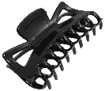


Materials:
This Photo by Unknown Author is licensed under CC BY-SA-NC
Clothes peg or Timer
Procedure:
- Hold a clothes peg (or you could use a hair clip!) between the thumb and index finger on your dominant hand (the one you use the most).
- Count the number of times you can open and close the peg or clip in a 20-second period while holding the other fingers of the same hand straight out. Make sure to squeeze quickly and completely to get the maximum number of squeezes for each trial.
- Repeat the process for nine more 20-second periods, recording the number of times for each repeat in the data table. DO NOT REST BETWEEN TRIALS.
- Repeat steps 1, 2 and 3 for your non dominant hand.
- Create a bar graph of your results for both hands. Use the graph in part one to help you
Data table – Number of Clothespin Squeezes
 | Repeat
Hand | 1 | 2 | 3 | 4 | 5 | 6 | 7 | 8 | 9 | 10
Dominant
Non-dominant

Use the notes above to help you answer these recall questions:
- What happened to your strength as you progressed through each trial?
- Describe how your hand and fingers felt at the end of your trials.
- Where the results different for your dominant and non-dominant hands? If yes, explain why.
- Your muscles will likely recover after about 10 mins of rest. Explain why.
Part 3 – To evaluate the results of the investigation and make valid conclusions.
Did you slow down significantly during your 8th trial compared to your first trial?
This quick experiment displays how your muscles get the energy they need to function. When you were opening and closing the clothespin quickly, your muscles were exercising anaerobically, drawing on their stores of glycogen to release the energy they needed to contract. As the glycogen ran out, your muscles ran low on energy and their ability to contract decreased. If you squeeze the clothespin slowly, you’re exercising aerobically. In aerobic exercise, your muscles also draw on oxygen and the glucose carried in by the blood to release energy. Your ability to keep exercising aerobically depends on the delivery of oxygen and glucose to your muscles. And that depends on your circulation and respiration.

Exam Questions
Instruction: Answer these questions on this sheet
Q1.
Exercise can improve health.
A student measured her breathing rate at rest, when walking and when jogging.
Figure 1 shows her results.
Figure 1
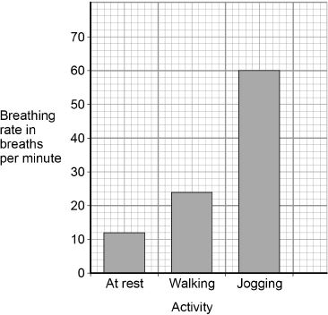
(a) Compare the breathing rates when doing the three different activities.
Use values from Figure 1 in your answer.
___________________________________________________________________
___________________________________________________________________
___________________________________________________________________
___________________________________________________________________
___________________________________________________________________
___________________________________________________________________
(3)

(b) Explain why the breathing rate changes when doing different activities.
___________________________________________________________________
___________________________________________________________________
___________________________________________________________________
___________________________________________________________________
___________________________________________________________________
___________________________________________________________________
(3)
Q2. Some students investigated how exercise affects heart rate.
The figure below shows their results.
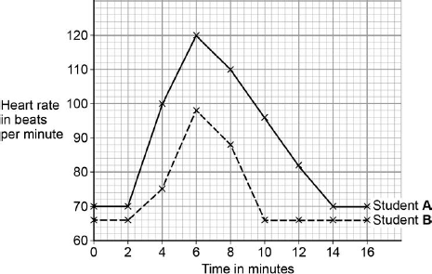
(a) What was Student B’s resting heart rate?
Resting heart rate = _______________ beats per minute
(1)
(b) The students started running at 2 minutes.
What evidence for this is in the figure above?
___________________________________________________________________
___________________________________________________________________
(1)

(c) For how many minutes did the students run?
Tick one box.

2 | 
4
6
14
(1)
Q3. The graph shows the rate of blood flow through different organs at rest and during exercise.
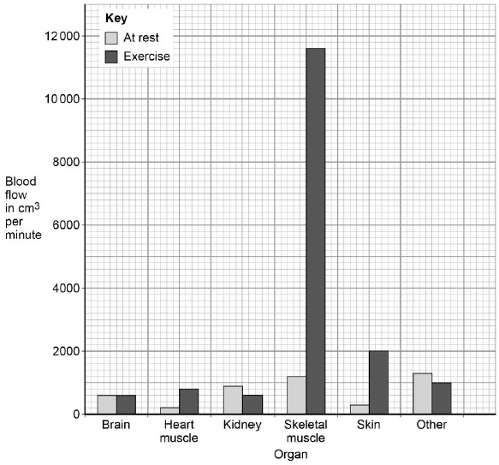
(a) Determine the total volume of blood that flows through the brain in 1 hour.
___________________________________________________________________
___________________________________________________________________
Volume = ____________________ cm³
(1)
(b) Look at the blood flow through the skeletal muscle.
Calculate how many times the blood flow increases by during exercise compared to at rest.
___________________________________________________________________
___________________________________________________________________
___________________________________________________________________
Answer = ____________________
(2)
(c) Explain why the blood flow to the skeletal muscles increases during exercise.
___________________________________________________________________
___________________________________________________________________
___________________________________________________________________
___________________________________________________________________
___________________________________________________________________
___________________________________________________________________
(3)
(Total 12 marks)

Challenge:
Q1. Marathon runners are recommended to have a high carbohydrate diet prior to a race. Three athletes tried out three dietary regimes prior to a marathon race.
These three dietary regimes were as follows.
Athlete A Up to 7 days before the race - Normal mixed diet
7 days before the race - Prolonged extreme physical activity
6-3 days before the race - Protein and fat diet; no carbohydrate
2 and 1 days before the race - Large carbohydrate intake
Athlete B Up to 5 days before race - Normal mixed diet
5 days before the race - Prolonged extreme physical activity
4-1 days before the race - Large carbohydrate intake
Athlete C Up to 4 days before the race - Normal mixed diet
4-1 days before the race - Large carbohydrate intake
The graph below shows the effect of each of these dietary regimes on glycogen levels in the athletes’ muscles
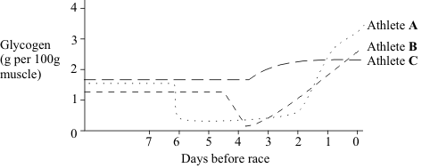

(a) (i) What is the immediate effect of extreme physical activity on the glycogen content of muscles?
______________________________________________________________
______________________________________________________________
(1)
(ii) Describe how this effect occurs.
______________________________________________________________
______________________________________________________________
______________________________________________________________
______________________________________________________________
______________________________________________________________
______________________________________________________________
______________________________________________________________ (3)
(b) (i) Evaluate the three regimes as preparation for a marathon race.
______________________________________________________________
______________________________________________________________
______________________________________________________________
______________________________________________________________
______________________________________________________________
______________________________________________________________
(3)
(ii) Suggest a possible explanation for the different effects of the three regimes.
______________________________________________________________
______________________________________________________________
______________________________________________________________
______________________________________________________________(2
Lesson 5 – Anaerobic respiration in plants
CHECKLIST! – Have you…
- Watched the lesson video
- Read the notes and completed the recall questions
- Marked your recall questions
- Completed the exam questions
Notes: Instruction: Read the notes below.
Key Words:
Anaerobic respiration | Breakdown of glucose to release small amount of energy without the use of oxygen.
Yeast | Yeast is a single celled, microscopic fungus used in the brewing and baking industries
Fermentation | A type of anaerobic respiration involving yeast.
Cellulose | Cellulose is the main substance found in plant cells walls and helps the plant to remain stiff and strong.
Notes: Instruction: Read the notes below.
Part 1 – State the products of anaerobic respiration in plants and fungi.
Humans and other animals are not the only living organisms that use anaerobic respiration. Plants and fungi can also respire without oxygen.
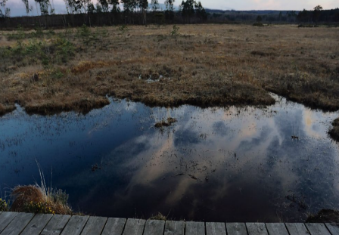
Plant cells and microorganisms can also respire anaerobically as it is better to sometimes release less energy but remain alive. It is useful for some plants that grow in marshes or bogs, where oxygen concentrations are low.
Plants growing in a marsh/bog where there is lots of water
Glucose is converted to carbon dioxide and ethanol, which we will refer to simply as alcohol. The word equation for anaerobic respiration in plants and microorganisms is as follows:
Glucose → ethanol + carbon dioxide + energy released
There are some similarities and differences between anaerobic respiration in plants/fungi and animals:
 | Anaerobic Respiration in Animals | Anaerobic Respiration in Plants/Fungi
Uses glucose | 
Releases energy
Happens in the cytoplasm
Produces Lactic Acid
Produces CO₂
Produces Alcohol

Use the notes above to help you answer these recall questions:
- Define anaerobic respiration.
- Why is it useful for organisms to be able to carry out anaerobic respiration?
- What is the word equation for anaerobic respiration in plants and microorganisms (fungi)?
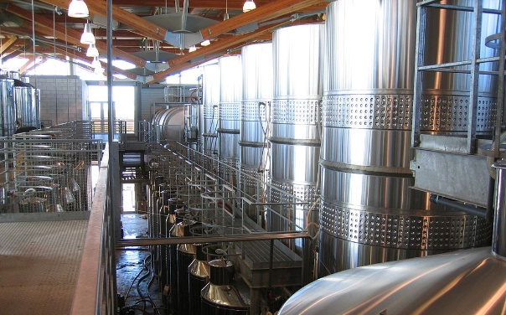
Part 2 – Describe the process of fermentation and its uses
Anaerobic respiration is economically important – many of our foods are produced by microorganisms respiring anaerobically.
The process of fermentation is where microorganisms are kept in large tanks without oxygen in order to make them respire anaerobically to produce alcohol and CO_{2.}
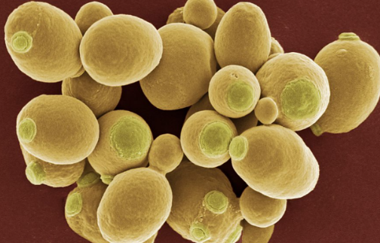
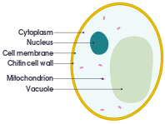
Making Beer and Wine
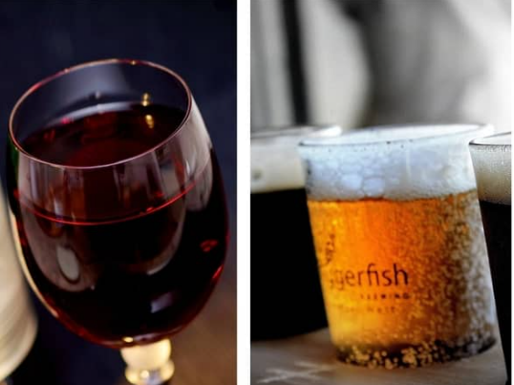
Yeast is a single celled, microscopic fungus. They are very similar to plant cells in that they have a cell wall but it is not made from cellulose and they behave more like bacterial cells. They can multiply rapidly.

Yeast is used to make alcoholic drinks. Yeast cells respire anaerobically in fermenters breaking down the sugars found in grapes (wine) or barley seeds (beer) to produce ethanol and carbon dioxide.
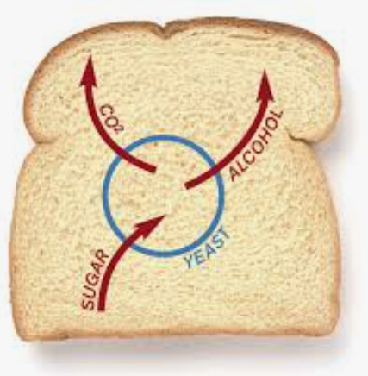
Yeast is also be used to produce bread. Yeast respires anaerobically using sugars in the flour. Bubbles of carbon dioxide make the bread rise by expanding the dough. This happens during the “proving stage” where dough is left to rise before the bread is baked. The alcohol that’s produced evaporates as the bread is baked and the microorganisms are eventually killed by the high temperature in the oven.
Yeast needs a warm environment to grow and warmer temperatures will increase the rate of growth and increase the rate of anaerobic respiration. At high temperatures yeast will stop respiring because the cells will be killed.
Use the notes above to help you answer these recall questions:
- Which microorganism is used in food production?
- What food can be produced by using this microorganism?
- What is beer made from?
- What is wine made from?
- What does the carbon dioxide do to the bread?
- What happens to the alcohol when the bread is being baked?

Part 3 – Explain the results of investigations using various methods to measure the products of anaerobic respiration.
One way to investigate fermentation is to study the production of carbon dioxide under different conditions. We can use different chemicals to see if carbon dioxide has been produced:
- Limewater turns cloudy white (milky)
- Hydrogen carbonate indicator changes from orange to yellow
Method
The following diagram shows the set-up of the apparatus required for this investigation:

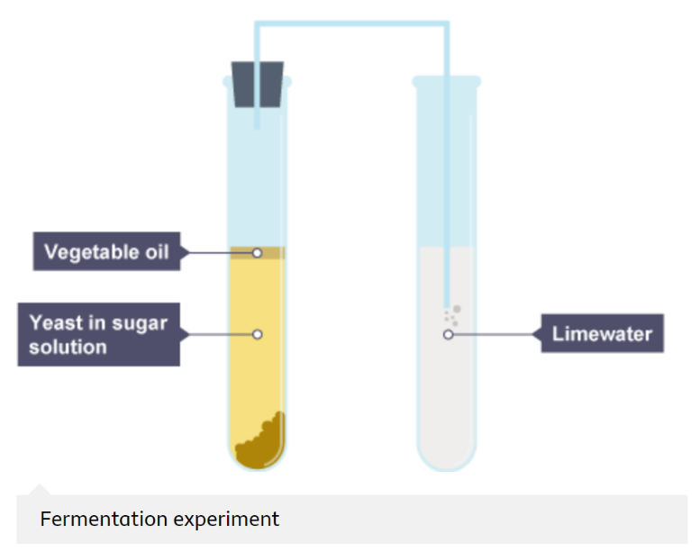
- Dissolve sugar/glucose in boiled (sterile) water. Cool before adding to the yeast – as high temperature will kill it.
- Add yeast and mix to form a suspension, and pour into a boiling tube.
- Add a layer of vegetable oil on top of the sugar/glucose solution to prevent oxygen entering.
- Connect a delivery tube to a second boiling tube, this time containing limewater or hydrogen carbonate indicator.
- Yeast will respire anaerobically producing alcohol, heat and carbon dioxide that can be collected in limewater.

The layer of vegetable oil prevents oxygen entering the mixture to make sure only anaerobic respiration is occurring. It usually takes an hour or so for fermentation to be visible. The number of bubbles over a set time can be counted, or the appearance of the indicator can be compared to a control using boiled (dead) yeast.
Use the notes above to help you answer these recall questions:
- What two solutions can we use to indicate the presence of carbon dioxide?
- What is the purpose of the vegetable oil?
- Why should you let the water cool before adding the yeast?

Exam Questions: Instruction: Answer these questions on this sheet
Q1. Respiration can happen aerobically or anaerobically. Respiration transfers energy from glucose.
(a) Draw one line from each type of respiration in human cells to the correct information.

Type of respiration  in human cells |  | Information
 |  | Produces ethanol
Aerobic respiration |  | Uses oxygen
Anaerobic respiration |  | Uses carbon dioxide
 |  | Produces lactic acid
(2)
(b) The table below shows the amount of energy released by aerobic and anaerobic respiration.

Energy in kJ transferred
from 1 g of glucose
Aerobic respiration | 16.1
Anaerobic respiration | 1.2
Suggest why human cells might respire anaerobically, even though only a small amount of energy is transferred.
___________________________________________________________________
___________________________________________________________________
(1)
(c) Yeast is used in the brewing and baking industries.
Why is yeast used in these industries?
___________________________________________________________________
___________________________________________________________________
___________________________________________________________________
___________________________________________________________________
___________________________________________________________________
___________________________________________________________________ (4)
Q2. Yeast cells can respire anaerobically.
The equation for anaerobic respiration in yeast is:
glucose alcohol + carbon dioxide (+ energy)
Give one way in which anaerobic respiration in yeast cells is different from anaerobic respiration in human muscle cells.
___________________________________________________________________
___________________________________________________________________
(1)
Q3. Anaerobic respiration happens in muscle cells and yeast cells.
(c) The diagram below shows an experiment to investigate anaerobic respiration in yeast cells.
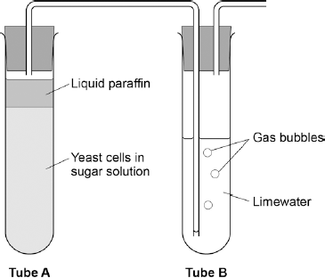

What is the purpose of the liquid paraffin in Tube A?
Remember rate of reaction means measuring how much product is produced in a certain time!
Tick one box.
To prevent evaporation
To stop air getting in
To stop the temperature going up
To stop water getting in

(1)
(d) Describe how you could use tube B to measure the rate of the reaction in tube A.
___________________________________________________________________
___________________________________________________________________
___________________________________________________________________
___________________________________________________________________ (2)
(e) Anaerobic respiration in yeast is also called fermentation.
Fermentation produces ethanol.
Give one use of fermentation in the food industry.
___________________________________________________________________
(1)

Q4. Sourdough bread is light in texture and tastes slightly sour. The bread is made using two types of microorganism, a yeast and a bacterium. The bacterium can make acids such as lactic acid. The acid makes the bread taste sour.
The graph shows how the growth rates of the yeast and the bacteria change with temperature.
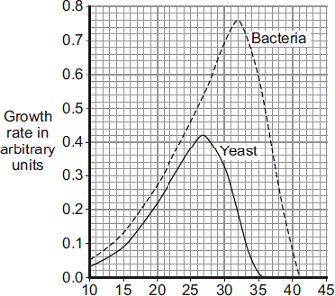
Temperature in °C
(i) Sourdough bread rises fastest at 27°C.
Use information from the graph to explain why.
______________________________________________________________
______________________________________________________________
______________________________________________________________
______________________________________________________________
(2)

Challenge:
Yeast can use other types of sugar instead of glucose.
Some scientists investigated the effect of three different types of sugar on the rate of anaerobic respiration in yeast.
The scientists:
• used the apparatus shown in Diagram 1 with glucose sugar
• kept the apparatus at 20 °C
• repeated the investigation with fructose sugar and then with mannose sugar
• repeated the investigation with water instead of the sugar solution.
Diagram 1
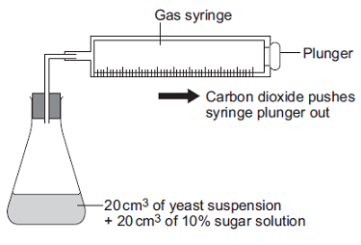
(i) Give two control variables the scientists used in this investigation.
______________________________________________________________
______________________________________________________________
(2)

(ii) The graph shows the scientists’ results.
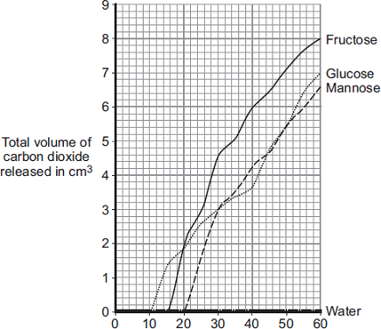
Time in minutes
From this information, a company decided to use fructose to produce alcohol and not mannose or glucose.
Explain the reason for the company’s choice.
______________________________________________________________
______________________________________________________________
______________________________________________________________
______________________________________________________________
(2)

