AQA Biology GCSE
Plant Structure and Photosynthesis
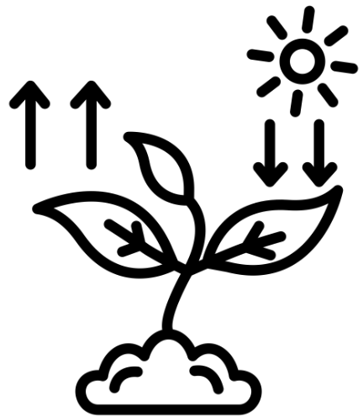
Name: ______________________

Week | Homework Task | SCAN CODE | Due
1 | Task 1: Watch the ‘Leaf Structure’ video and answer the worksheet questions (this can be in your book or on the sheet if you print it) – submit a picture of this on MS Teams.  Task 2: Complete any unanswered exam questions from L1 in your booklet | 
2 | Task1: Watch the ‘Xylem and Phloem’ video, complete the worksheet questions (this can be in your book or on the sheet if you print it) – submit a picture of this on MS Teams.  Task 2: Complete any unanswered exam questions from L2 and 3 in your booklet | 
3 | Task1: Watch the ‘Photosynthesis’ video, complete the worksheet questions (this can be in your book or on the sheet if you print it) – submit a picture of this on MS Teams.  Task 2: Complete any unanswered exam questions from L4 and 5 in your booklet | 
4 | Task1: Watch the ‘Photosynthesis Practical Part 1 & 2’ video, complete the worksheet questions (this can be in your book or on the sheet if you print it) – submit a picture of this on MS Teams.  Task 2: Complete any unanswered exam questions from L6 in your booklet | 


Paper 1 –Photosynthesis Fact Sheet
Fold page here
To revise these facts, fold this sheet in half and try to write the answers down from memory. Repeat!
- State the function of the cell wall. | Strengthens the cell, provide support
- State the function of the chloroplasts. | Contain chlorophyll, absorb light to do photosynthesis
- State the function of the permanent vacuole. | Contains cell sap to keep plant cells rigid, provide support
- State three differences between animal and plant cells. | Plant cells have chloroplasts, permanent vacuole and cellulose cell wall. Animal cells do not
- What substance makes up plants' cell walls? | Cellulose
- Name the tissue that covers and protects the surface of plants. | Epidermal tissue
- Name the part of the plant that waterproofs the leaf surface. | Waxy cuticle
- Name the cells that contains lots of chloroplasts for photosynthesis. | Palisade cells
- Name the tissue which is where gas exchange takes place in the leaf | Spongy mesophyll layer
- Which part of the plant allows gases to diffuse in and out of leaves? | Stomata
- What controls the opening and closing of stomata? | Guard cells
- Briefly describe the arrangement of xylem and phloem in the stem of a plant. | Organised in bundles, with xylem on the inside and phloem on the outside
- Which specialised cell in plants make up the tissue for transporting water? | Xylem cells
- State the function of xylem. | Transports water and mineral ions from roots to other parts of the plants
- State the function of phloem. | Transports dissolved sugars from leaves to the rest of the plant
- State a difference in structure between xylem and phloem. | X: dead, hollow tube, has lignin; P: living, has sieve plates, no lignin
- Name the process of the transport of dissolved sugars in plants. | Translocation
- Name one use of glucose in plants. | Respiration/Make and strengthen cellulose cell wall/Make starch for storage/Make lipids as energy store
- Describe a method to view stomata under a microscope. | A layer of clear nail varnish over the underside of a leaf, peeled off when dry and placed on a microscope slide.
- How can you calculate stomatal density in 1mm²? | Number of stomata x (1mm/area of field of view)
- What are the reactants for photosynthesis? | Carbon dioxide and water
- How do the reactants enter the plant? | Carbon dioxide diffuses into the leaf via the stomata, water is absorbed from the soil through the roots by osmosis
- What are the products of photosynthesis? | Glucose and oxygen
- How does oxygen leave the plant? | Diffuses through the stomata
- State the equation of photosynthesis. | 6CO₂ + 6H²O --> C₆H₁₂O₆ + 6O₂
- Where does photosynthesis occur in the cell? | Chloroplast
- Is photosynthesis endothermic or exothermic? | Endothermic
- What is an exothermic reaction? Give an example | Respiration
- Name the pigment in chloroplasts and its role in photosynthesis | Chlorophyll, absorbs light
- How are palisade cells adapted for photosynthesis? | Packed tightly together, near the surface of the leaf. Lots of chloroplasts with chlorophyll to absorb light
- Briefly explain an adaptation of spongy mesophyll tissue in plants. | Big air spaces and large surface area for efficient gas exchange/diffusion of gases
- State an adaptation of the leaf for efficient photosynthesis. | Broad leaves/Thin/Have chlorophyll/Air spaces/Guard cells to regulate stomata opening
- How do stomata help maintain efficient gas exchange in leaves? | Allow gases to move in and out of leaf, maintaining steep concentration gradient
- Root hair cells have lots of mitochondria to release energy. What is the energy used for? | Active transport of mineral ions into root hair cells
- How do the extensions in root hair cells help with their function? | Increase surface area for efficient water absorption
- Define 'active transport'. | Movement of particles against the concentration gradient (low to high) using energy in the form of ATP
- How are plant roots adapted for efficient water and mineral absorption? | Large SA (root hairs), transpiration stream
- Why do plants need nitrate ions? | For production of DNA and to combine with carbon and hydrogen to make proteins. they are required for plant growth
- Why do plants need magnesium? | To make chlorophyll
- Why don’t root hair cells contain any chloroplasts? | They are underground, no sunlight reaches them so they cannot carry out photosynthesis.
- Why do plants need water? | For photosynthesis, to transport minerals, maintain structural rigidity and to regulate temperature
- Define 'osmosis'. | Net movement of water molecules down the water concentration gradient through a partially permeable membrane
- What will happen to a plant if its cells are not turgid? | Wilted/droopy leaves or bent stems
- What does 'plasmolysed' mean? | The cell membrane becomes detached from cell wall
- Define 'transpiration'. | Loss of water vapour by evaporation from the leaf surface through stomata
- Briefly describe the transpiration stream. | Constant movement of water through xylem from roots to leaves
- Increasing the rate of photosynthesis will ……………(increase/decrease) the rate of transpiration. | Increase
- Give two adaptations of plants that live in hot/dry climates | Thick waxy skin to prevent evaporation, large stems to store water, deep roots to get groundwater, widespread shallow roots to create large S.A to absorb more water
- Why is having fewer stomata an adaptation to living in the desert? | Reduces spaces that water can evaporate from, reduces transpiration rate
- What are the factors that affect transpiration? | Wind/light intensity/humidity/temperature
- How does temperature affect rate of transpiration? | Higher temp increases rate
- Explain why a higher temperature results in faster transpiration. | More kinetic energy, particles move around more, evaporate easier
- How does humidity affect rate of transpiration? | Higher humidity decreases rate
- Explain why humidity affect rate of transpiration | Higher humidity decreases rate because there is a reduced concentration gradient between amount of water vapour in the air and inside the leaf
- How does wind or air flow affect rate of transpiration? | More wind increases rate (as maintains steep conc gradient)
- How does light intensity affect rate of transpiration? | More light increases rate
- Why does increased light intensity affect rate of transpiration? | Because it increases the rate of photosynthesis
- Name the equipment used to estimate transpiration rate. | Potometer
- How can the bubble in a potometer be reset? | By opening the tap and letting water in from the reservoir
- Why is a narrow capillary tube used? | Increases the resolution (bubble moves further in a small time) so it is easier to see small changes
- Why must the same plant be used in repeats? | As they can have different sized leaves and therefore different transpiration rates
- What can be used to measure the effect of wind on transpiration rate? | A fan
- How can humidity be increased around a shoot in a potometer? | A plastic bag can be tied around the leaf
- What is a limiting factor? | An environmental condition that when it is in short supply it slows down or prevents a reaction or process.
- What are the factors that can affect the rate of photosynthesis? | Light intensity/temperature/carbon dioxide concentration
- How does higher light intensity affect the rate of photosynthesis? | Increase
- Why would photosynthetic rate decrease at higher temperatures? | Enzymes become denatured
- State one factor to maintain in a greenhouse for optimal plant growth. | High CO2 levels/Constant light/Appropriate temperatures/Regulate watering
- What gas is present in the bubbles released from the pondweed? | oxygen
- What do you need to measure to calculate the rate of photosynthesis? | the number of bubbles in a set amount of time
- What is the inverse square law? | The light intensity is inversely proportional to the square of the distance

Lesson | Exam Question Marks |  |  | 
Lesson 1 – Plant Structure and Organisation
Lesson 2 – Photosynthesis and Plant Adaptations
Lesson 3 – Water Transport in Plants
Lesson 4 – Factors Affecting Rate of Transpiration
Lesson 5 – Effect of Limiting Factors on Photosynthesis
Lesson 6 – RP6 Effect of Limiting Factors on Photosynthesis
Lesson 1: Plant Structure and Organisation
CHECKLIST! – Have you…
- Read the notes and completed the recall questions
- Marked your recall questions using the answers
- Completed the exam questions
Do Now:
- Draw and label a plant cell.
- Which three components do plant cell have that animal cells do not?
- What are the functions of these three components?
- What substance makes up plant cell walls?
Key Words:
Chloroplast | Contains the green pigment chlorophyll; the site of photosynthesis.
Epidermis | means ‘skin’ or ‘outermost layer’. In plants the upper epidermis is transparent so that light can pass through it and the lower layer contains the stomata.
Leaf vein | Groups of xylem and phloem tissue in a plant.
Organ | A group of different tissues that work together to carry out a particular function, eg heart and lungs.
Organism | Living entity, eg animals, plants or microorganisms.
Palisade Mesophyll | Plant tissue containing closely packed cells which contain lots of chloroplasts in the upper layer of a leaf. Where most light is absorbed.
Phloem | The tissue in plants that transports the products of photosynthesis, including sugars and amino acids.
Photosynthesis | A chemical process used by plants to make glucose and oxygen from carbon dioxide and water, using light energy.
Spongy mesophyll | The plant tissue in a leaf which has loosely packed cells and air spaces between them to allow gas exchange.
Starch | A type of carbohydrate. Plants can turn the glucose produced in photosynthesis into starch for storage because it is insoluble.
Stomata | Tiny holes in the epidermis of a leaf. They control gas exchange by opening and closing and are involved in loss of water from leaves. Singular is stoma.
Transpiration | The evaporation of water from the leaves through stomata
Transpiration stream | The continuous flow of water from the roots to the leaves of a plant through the xylem
Xylem vessels | Narrow, hollow, dead tubes with lignin, responsible for the transport of water and minerals in plants.
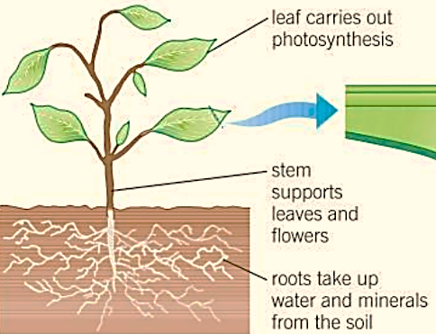
Information: Read the following notes

Part 1: Label the structures in a cross section of a leaf
Plants are organisms made of organs including the stem, roots and leaves. These can perform the various tasks that a plant needs to carry out to survive and grow – for example, transporting substances around the plant. Plant organs are made up of groups of tissues.

A cross section of a leaf
The leaf is an organ made of several types of tissue – there are collections of different tissues working together to perform specific functions for the organism.
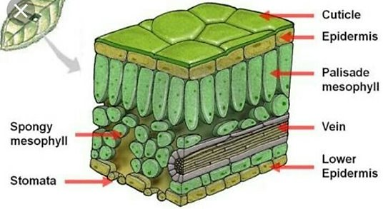
The table below describes how the structures of the tissue that make up the leaf are related to their function:
Tissue | Description/Function
Cuticle | A waxy layer to reduce water loss by evaporation
Upper epidermis | Epidermis (means skin or outer layer) it is transparent so that light can pass through it to the palisade layer
Palisade mesophyll | Cells are packed tightly. These cells have lots of chloroplasts. They are near the top of the leaf so they absorb the most sunlight.
Spongy mesophyll | Cells which have lots of gaps between them like a sponge. The air spaces in the spongy mesophyll tissue allow gas exchange to take place
Lower epidermis | Lower surface layer of the leaf. Has holes called stomata, which let gases diffuse in and out of the leaf. The opening and closing of these stomata are controlled by cells next to them called guard cells.
Xylem | Transports water and dissolved mineral ions from the roots up to the leaves
Phloem | Transports dissolved sugars and amino acids around the plant

Recall questions: Answer these in your book, use the information above to help you
- State the function of the cell wall.
- State the function of the chloroplasts.
- State the function of the permanent vacuole.
- State the three differences between animal and plant cells.
- What substance makes up plants’ cell wall?
- Name the tissue that covers and protects the surface of plants.
- Name the part of the plant that waterproofs the leaf surface.
- Name the cells that contain lots of chloroplasts for photosynthesis.
- Name the tissue which is where gas exchange takes place in leave.
- Which part of the plant allows gases to diffuse into and out of leaves?
- What controls the opening and closing of stomata?
Part 2: Describe the tissues which make up the leaf vein
Information: Read the following notes
Plants make glucose by photosynthesis in the leaves and other green parts. This glucose is needed all over the plant to be used in respiration; to build cell walls, or to build other molecules for growth. It can also be stored as starch. Similarly, water and mineral ions move into the plant from the soil through the roots, but they are needed by every cell of the plant. Plants have two separate transport systems to move substances around the whole plant – they are made up of two different types of tissue: xylem and phloem.
Xylem and phloem are organised in bundles called veins – xylem is always on the inside and phloem on the outside.
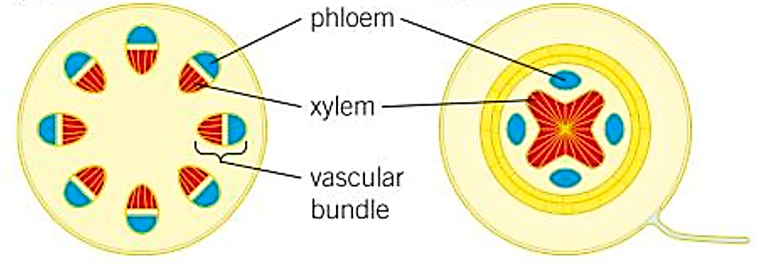
Stem
Root

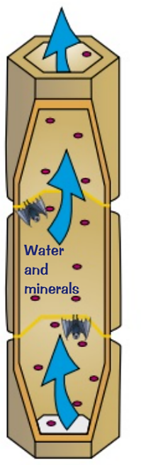
Xylem
The xylem moves water and solutes from the roots to the leaves. Water is absorbed from the soil through the root hair cells. It is then transported through the xylem vessels up the stem to the leaves.
Xylem adaptations:
- Made of dead cells joined end to end with no end walls between them and a hole down the middle. They are strengthened with lignin.
- They carry water and mineral ions from the roots to the stem and leaves.
- The movement of water from the roots, through the xylem and out of the leaves is called the transpiration stream.
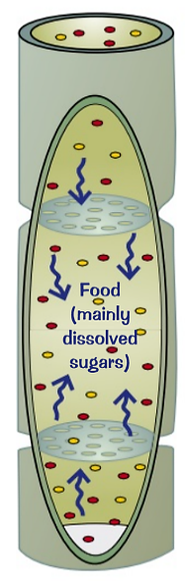
Phloem
Phloem tubes transports dissolved sugars including glucose and amino acids.
Phloem adaptations:
- They are made of columns of elongated living cells with small pores in the end walls to allow cell sap to flow through.
- They transport nutrients (mainly dissolved sugars made in the leaves) to the rest of the plant
- The movement is in both directions. This process is called translocation.
Greenfly and other aphids are plant pests. They push their sharp mouthparts right into the phloem and feed on the sugary fluid. If too many of them attack a plant, they can kill it by taking all of its sugars.

Recall questions: Answer these in your book, use the information above to help you
- Briefly describe the arrangement of xylem and phloem in the stem of a plant.
- State the function of xylem.
- State the function of phloem.
- State a difference in structure between xylem and phloem.
- Name the process of the transport of dissolved sugars in plants.
- Name one use of glucose in plants.
Part 3: Describe a method to observe and count the stomata of a leaf under the microscope
Information: Read the following notes
Scientists use sampling and counting techniques to investigate the distribution of stomata on leaves. There are several ways to do this, but we will look at one where nail varnish is used:
Method:
- Paint the surface of the leaf with clear nail varnish.
- Allow to dry.
- Peel off the nail varnish with forceps.
- Place on a dry microscope slide and examine.
Recording the distribution
The density of stomata on a leaf is recorded per unit area, usually the number per sq mm. A microscope is calibrated so that its field of view is known.
Calculating the area
In the illustration, the diameter of the field of view of the microscope is 0.40 mm.
Its area can be calculated using formula ꙥr². Where ꙥ = 3.14 and r = radius of the field of view
If the diameter of the field of view is 0.04 mm, the radius is 0.20 mm.
Area = ꙥr² = 3.14 x 0.2 x 0.2 = 0.13mm².
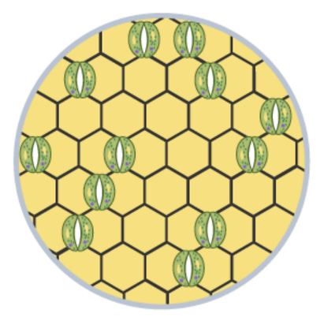
The number of stomata in the field of view is 12.
The area of the field of view is 0.13mm².
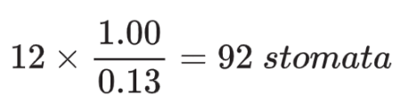
Therefore, based on this single count, the density of stomata over 1mm² is:

The density of stomata is therefore 92 stomata per mm².

Recall questions: Answer these in your book, use the information above to help you
- Describe a method to view stomata under a microscope.
- What is the density of stomata in 1mm² if the diameter of the field of view is 0.6mm and the number of stomata is 30?

Exam question practice: Answer these on this sheet, use the answers to your recall questions to help you
Q1. This question is about organisation in living organisms.
(c) Which is a plant tissue?
Tick (✓) one box.

Flower | 
Leaf
Phloem
Root
(1)
Q2. The diagram shows a section through a plant leaf.
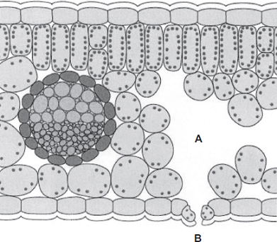
(a) Use words from the box to name two tissues in the leaf that transport substances around the plant.

epidermis | mesophyll | phloem | xylem

______________________________ and ______________________________ (1)
(b) Gases diffuse between the leaf and the surrounding air.
(i) What is diffusion?
______________________________________________________________
______________________________________________________________
______________________________________________________________ (2)
Q3. Leaves are made from layers of cells.
The diagram shows a section through part of a leaf.
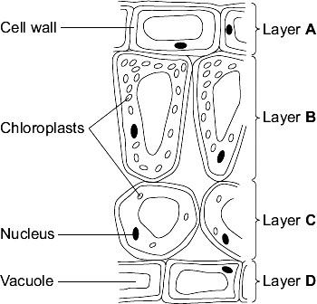
(a) (i) Which word in the table describes layer A?
Tick () one box.
Layer A | Tick  ()
Tissue
Organ
Cell

(ii) Which word describes a whole leaf?
Draw a ring around one answer.

organ | tissue | organism
(1)
Q4. The diagram below shows a cross-section of a plant root. The transport tissues are labelled.
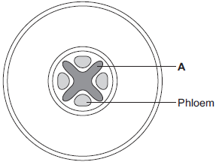
(a) (i) What is tissue A?
Draw a ring around the correct answer.
cuticle epidermis xylem
(1)
(ii) Name two substances transported by tissue A.
1. ____________________________________________________________
2. ____________________________________________________________ (2)
Q5. (a) Plants have leaves which contain guard cells and palisade cells. Explain how each of these kinds of cell assists photosynthesis.
Guard cells _________________________________________________________
___________________________________________________________________
___________________________________________________________________
___________________________________________________________________
(2)
Palisade cells _______________________________________________________
___________________________________________________________________
___________________________________________________________________
___________________________________________________________________
(2)
Q6. Plants lose water vapour from their leaves. Most of this water vapour is lost through the stomata.
A class of students investigated the number of stomata per mm² on the upper surface and on the lower surface of the leaves of three species of plant, P, Q and R.
The students placed samples of the surface cells onto a grid on a microscope.
Student X counted the stomata on the lower surface of a leaf from one of the plant species.
The diagram shows part of the grid that student X saw under the microscope.
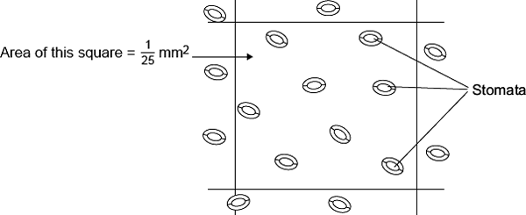
(i) Complete the calculation to estimate the number of stomata per mm² on the lower surface of this leaf.
Number of stomata in mm² = ____________________________
Number of stomata in 1 mm² = ______________________________
(2)

Lesson 2: Photosynthesis and Plant Adaptations
CHECKLIST! – Have you…
- Read the notes and completed the recall questions
- Marked your recall questions using the answers
- Completed the exam questions
Do Now: Complete the DO NOW:
Key Words:
Photosynthesis | A chemical process used by plants to make glucose and oxygen from carbon dioxide and water, using light energy. Oxygen is produced as a by product of photosynthesis. Algae subsumed within plants and some bacteria are also photosynthetic.
Stomata | Tiny holes in the epidermis (skin) of a leaf. They control gas exchange by opening and closing and are involved in loss of water from leaves. Singular is stoma.
Chloroplasts | Contains the green pigment chlorophyll; the site of photosynthesis.
Chlorophyll | A green pigment which absorbs light energy for photosynthesis
Endothermic reaction | Reactions which absorb heat energy from their surroundings
Exothermic reaction | Reactions which release heat into their surroundings
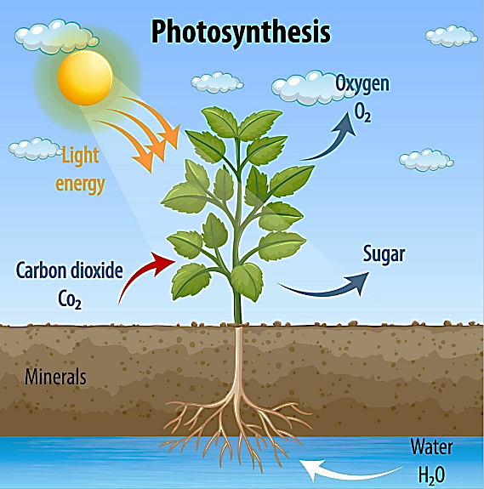
Part 1 – State the word and symbol equation for photosynthesis
Information: Read the following notes
Plants and algae are producers – they need to make their own food, glucose. They carry out a process called photosynthesis. Photosynthesis is a chemical reaction which uses energy to convert carbon dioxide and water into glucose and oxygen. Water is absorbed through the roots and carbon dioxide diffuses into the leaves through the tiny pores called stomata. This chemical reaction produces oxygen gas as a by-product. The oxygen diffuses out of the leaf and into the atmosphere through the stomata. Plants use this glucose for many processes.
The word equation for photosynthesis is:
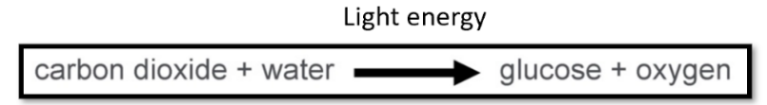

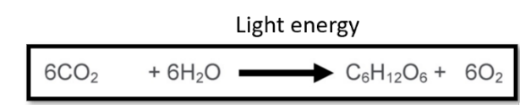
The symbol equation for photosynthesis is:

Part 2 – State where photosynthesis occurs in cells
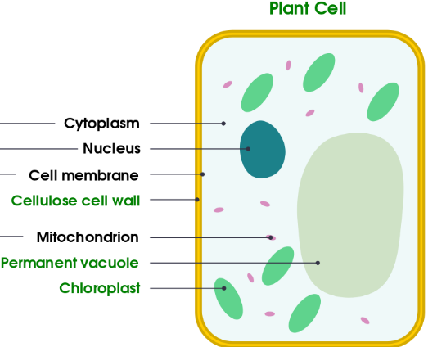
Photosynthesis takes place in the chloroplasts in green plant cells – they contain a green pigment called chlorophyll.
Chlorophyll absorbs light energy needed for photosynthesis.

Explain why photosynthesis is an endothermic reaction

Photosynthesis is considered an endothermic reaction, because during the process of photosynthesis, energy from the sun or sunlight is being absorbed. Any chemical reactions that absorb heat energy from the surroundings to form products are known as endothermic reactions.
Exothermic reactions on the other hand, release heat and light into their surroundings. For example, combustion reactions are usually exothermic. An example of an exothermic reaction in biology is respiration – as energy is released.

Recall questions: Answer these in your book, use the information above to help you
- What are the reactants for photosynthesis?
- How do the reactants enter the plant?
- What are the products of photosynthesis?
- How does oxygen leave the plant?
- What is the chemical formula for glucose?
- Where does photosynthesis take place in a plant cell?
- What is the green pigment found in the chloroplast?
- What is the function of this green pigment?
- Why is photosynthesis referred to as an endothermic reaction?
- What is an exothermic reaction? Give an example.
Part 2 Describe and explain how tissues in leaves are adapted for photosynthesis
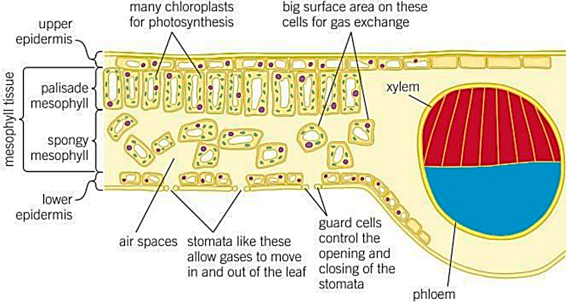
Information: Read the following notes

Leaves are broad/flat so they have a large surface area to absorb sunlight and they are thin so gases do not have far to diffuse from the atmosphere to the inside.
The leaf is adapted for gas exchange and photosynthesis because the tissues are specialised and work together to provide all the reactants:

Recall questions: Answer these in your book, use the information above to help you
- State an adaptation of leaves for efficient photosynthesis.
- Why are leaves covered with a waxy cuticle?
- Why is the epidermis transparent?
- How are the palisade cells adapted for photosynthesis?
- What happens in the spongy mesophyll, how is adapted for its function?
- Why are stomata an adaptation to photosynthesis?
- Where does the water come from for photosynthesis in the leaf cells?
Part 3 Explain how the roots are adapted for absorbing water and mineral ions from the soil
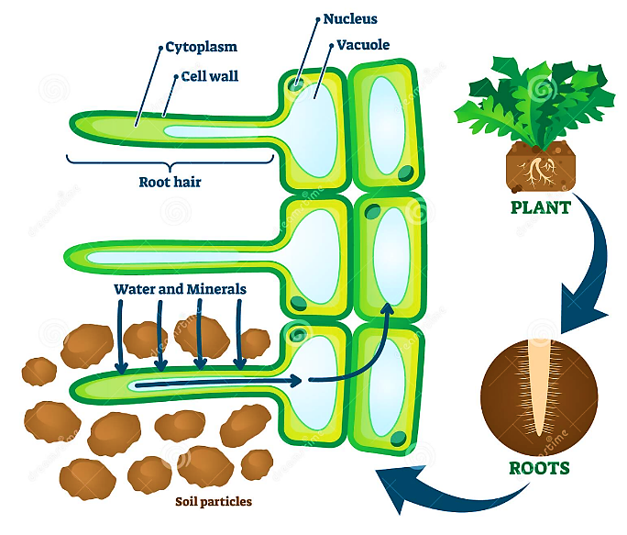
Information: Read the following notes
Roots absorb water which is a reactant in photosynthesis. Root hair cells are found close to the tips of growing roots. Plants need to take in lots of water (and dissolved mineral ions). The root hair cells are adapted to take up water and mineral ions more efficiently.
Plant roots absorb mineral ions from the soil often using active transport. For healthy growth plants need mineral ions including:
- Nitrates needed for producing DNA and amino acids which are then combined with glucose to form proteins.
- Magnesium which is needed to make chlorophyll.
Root hair cells have three main adaptations:
- They greatly increase the surface area available for water and ions to move into the cell.
- They have a large permanent vacuole that speeds up the movement of water by osmosis from the soil across the root hair cell.
- They have many mitochondria that provide the energy needed for the active transport of mineral ions into the root hair cells.
Root hair cells do not contain any chloroplasts as they are underground so cannot absorb any light for photosynthesis.
Recall questions: Answer these in your book, use the information above to help you
- How are the root hair cells adapted for their function?
- Why do plants need to absorb mineral salts and ions?
- Why do plants absorb nitrates?
- Why do plants absorb magnesium?
- Why don’t root hair cells contain any chloroplasts?

Exam question practice: Answer these on this sheet, use the answers to your recall questions to help you
Q1. Plants can photosynthesise.
- Complete the word equation for photosynthesis.
__________________ + __________________ → glucose + __________________
(1)
- Light is needed for photosynthesis.
Name the green pigment that absorbs light for photosynthesis.
___________________________________________________________________(1)

(c) Plants need carbon dioxide, water and energy for photosynthesis.
Complete the sentences.
Carbon dioxide is obtained from the _____________________________________.
Plant roots obtain water from the _______________________________________.
The energy for photosynthesis is from the._________________________________.
(3)
(d) Root hair cells do not contain chloroplasts.
Suggest one reason why.
___________________________________________________________________
___________________________________________________________________
(1)
Q2. Diagram 2 shows a section through a plant leaf.
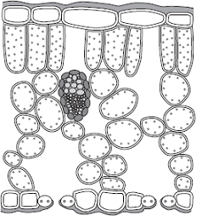
Describe the structure of the leaf and the functions of the tissues in the leaf.
You should use the names of the tissues in your answer.
___________________________________________________________________
___________________________________________________________________
___________________________________________________________________
___________________________________________________________________
___________________________________________________________________
___________________________________________________________________
___________________________________________________________________
___________________________________________________________________
___________________________________________________________________ (6)
Q3. This question is about photosynthesis.
(a) What are the two products of photosynthesis?
Tick two boxes.

Carbon dioxide
Chlorophyll
Glucose
Oxygen
Water
(2)
(b) What is the correct balanced equation for photosynthesis?
Tick one box.

C₆H₁₂O₆ + 6O₂ ⟶ 6CO₂ + 6H₂O
O₂ + H₂O ⟶ C₆H₁₂O₆ + CO₂
6CO₂ + 6H₂O ⟶ C₆H₁₂O₆ + 6O₂
6O₂ + 6CO₂ ⟶ 6H₂O + C₆H₁₂O₆
(1)
(c) What type of reaction is photosynthesis?
Tick one box.

Aerobic
Endothermic
Exothermic
Oxidation
Q4. The table shows the concentrations of three mineral ions in the roots of a plant and in the water in the surrounding soil.

Mineral ion | Concentration in millimoles per kilogram
Mineral ion | Plant root | Soil
Calcium | 120 | 2.0
Magnesium | 80 | 3.1
Potassium | 250 | 1.2
(a) (i) The plant roots could not have absorbed these mineral ions by diffusion.
Explain why.
______________________________________________________________
______________________________________________________________
______________________________________________________________
______________________________________________________________
(2)
(ii) Name the process by which the plant roots absorb mineral ions.
______________________________________________________________
(1)
(b) How do the following features of plant roots help the plant to absorb mineral ions from the soil?
(i) A plant root has thousands of root hairs.
______________________________________________________________
______________________________________________________________
(1)
(ii) A root hair cell contains many mitochondria.
______________________________________________________________
______________________________________________________________
______________________________________________________________
______________________________________________________________
(2)
(iii) Many of the cells in the root store starch.
______________________________________________________________
______________________________________________________________ (1)
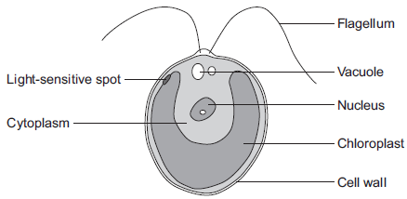
Challenge:
Q5.
The diagram below shows a single-celled alga which lives in fresh water.

(a) Which part of the cell labelled above:
(i) traps light for photosynthesis
______________________________________________________________
(1)
(ii) is made of cellulose?
______________________________________________________________
(1)
(b) In the freshwater environment water enters the algal cell.
(i) What is the name of the process by which water moves into cells?
______________________________________________________________
(1)
(ii) Give the reason why the algal cell does not burst.
______________________________________________________________
______________________________________________________________
(1)
(c) (i) The alga can photosynthesise.
Complete the word equation for photosynthesis.
water + _______________ 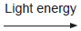 _______________ + oxygen
(2)
(ii) The flagellum helps the cell to move through water. Scientists think that the flagellum and the light-sensitive spot work together to increase photosynthesis.
Suggest how this might happen.
______________________________________________________________
______________________________________________________________
______________________________________________________________
______________________________________________________________
(2)

Lesson 3: Water Transport in Plants
CHECKLIST! – Have you…
- Read the notes and completed the recall questions
- Marked your recall questions using the answers
- Completed the exam questions
Do Now: Complete the DO NOW:
Key Words:
Plasmolysed | When cells loose water from their vacuole and the cytoplasm shrinks from the cell wall
Stomata | Tiny holes in the epidermis of a leaf. They control gas exchange by opening and closing and are involved in loss of water from leaves. Singular is stoma.
Transpiration | The evaporation of water from the leaves through stomata
Transpiration stream | The continuous flow of water from the roots to the leaves of a plant through the xylem
Turgid | When plant cell vacuoles are full of water they are swollen.

Part 1 – Explain the importance of water in plants
Information: Read the following notes
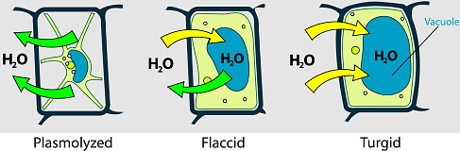
Plants need water for photosynthesis, the process in which carbon dioxide and water combine to make glucose (plus oxygen). Water is also required to transport minerals and regulate temperature.
The plant also needs to hold itself upright. When a cell has plenty of water inside it, the vacuole presses the cytoplasm against the cell walls. This pressure of the cytoplasm against the cell wall gives support for the stem and leaves.
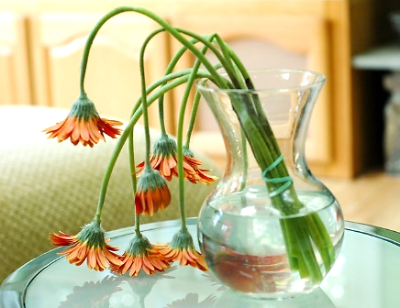
Turgid cells help to maintain structural rigidity without it, plants wilt (go droopy/floppy).
Recall questions: Answer these in your book, use the information above to help you
- Why do plants need water?
- What physical effect will you see in a plant that doesn’t contain enough water?
A wilted plant
- Define 'osmosis'.
- What does 'plasmolysed' mean?
Part 2 – Define transpiration
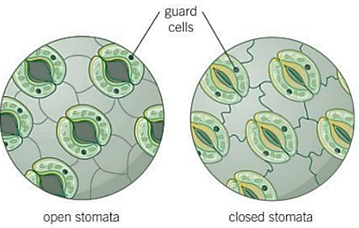
When the stomata are open, plants lose water vapour through them. The water vapor evaporates from the cells lining the air spaces and then passes out of the leaf through the stomata by diffusion. This loss of water vapour through the stomata is known as transpiration.

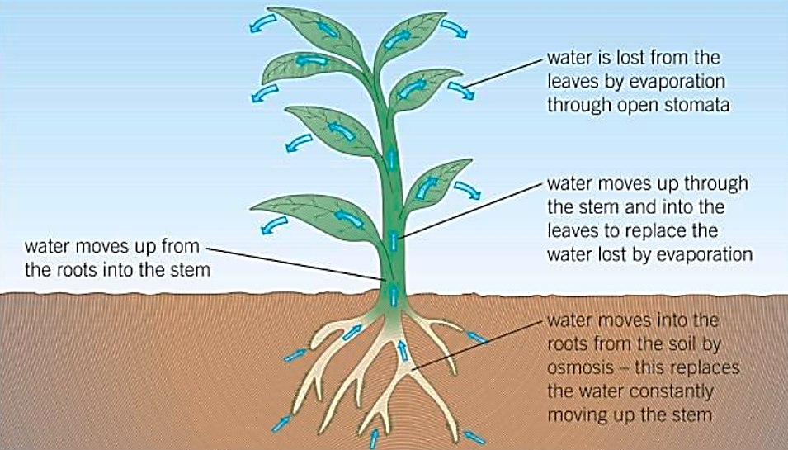
The transpiration stream is used to describe the constant movement of water through the xylem from the roots up the stem to the leaves where evaporation then occurs through the stomata.

Recall questions: Answer these in your book, use the information above to help you
- Define 'transpiration'.
- Briefly describe the transpiration stream.
- Increasing the rate of photosynthesis will ……………(increase/decrease) the rate of transpiration.

Part 3 – Describe adaptations of desert plants to reduce water loss
Information: Read the following notes
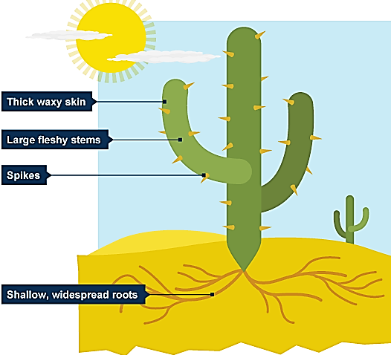
Plants like cactuses that live in the desert or hot dry countries have to have special adaptations to prevent too much water being lost through transpiration.
- thick, waxy skin to reduce evaporation of water and to reflect heat
- large, fleshy stems to store water
- thorns or thin, spiky leaves to reduce surface area for water loss
- fewer stomata to reduce evaporation of water
- stomata that open at night when it is cooler to reduce evaporation of water
- deep roots to find water far underground OR long shallow roots cover a large surface area to absorb more water
Recall questions: Answer these in your book, use the information above to help you
- Explain two adaptations of plants that live in hot/dry climates
- Why is having fewer stomata an adaptation to living in the desert?
Exam question practice: Answer these on this sheet, use the answers to your recall questions to help you
Q1. Draw a ring around the correct answer to complete the sentence.

 | distillation.
A plant loses water from its leaves by a process called | respiration.
 | transpiration.
Q2.Transpiration occurs mainly in the leaves of a plant.
(a) (i) What is transpiration?
______________________________________________________________
______________________________________________________________
______________________________________________________________
(2)
(ii) Through which part of a leaf does most transpiration occur?
______________________________________________________________
(1)
Q3. What is meant by the transpiration stream?
___________________________________________________________________
___________________________________________________________________
___________________________________________________________________
___________________________________________________________________
(3)
Q4. Some students set up the following apparatus.
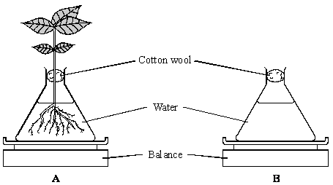
The balances show the same mass at the start of the investigation.
After 24 hours the mass of flask B was the same but the mass of flask A had changed.
(i) Describe and explain the change to the mass of flask A.
___________________________________________________________________
___________________________________________________________________
___________________________________________________________________
___________________________________________________________________ (3)
(ii) Why did the students need to set up flask B?
___________________________________________________________________
___________________________________________________________________(1)
Q5. The diagram shows the desert plant, Fredolia.
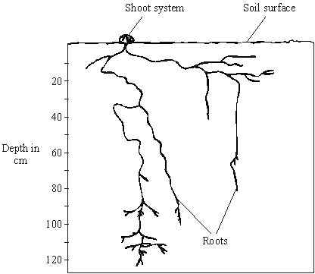
Describe and explain three adaptations of Fredolia, which you can see in the diagram, that help it to survive in dry conditions.
1. _____________________________________________________________________
_______________________________________________________________________
2. _____________________________________________________________________
_______________________________________________________________________
3. _____________________________________________________________________
_______________________________________________________________________
(Total 3 marks)
Challenge. The table gives information about a geranium plant and a cactus plant. The geranium grows in gardens in the UK. The cactus grows in hot deserts.
Using only information in the table, explain how the cactus is better adapted for living in hot, dry conditions.

Feature | Geranium | Cactus
Thickness of waxy cuticle in micrometres | 5 | 15
Total leaf surface area in cm² | 1800 | 150
Percentage of water storage tissue in stem | 50 | 85
Number of stomata per mm² | 59 | 13
Time of day when stomata open | daylight | at night
Horizontal spread of roots in metres | 0.2 | 5

Lesson 4: Factors Affecting Transpiration
CHECKLIST! – Have you…
- Read the notes and completed the recall questions
- Marked your recall questions using the answers
- Completed the exam questions
Do Now: Complete the DO NOW:
Key Words:
Transpiration | Transpiration is the loss of water vapour through the stomata
Stomata | Tiny holes in the epidermis of a leaf. They control gas exchange by opening and closing and are involved in loss of water from leaves. Singular is stoma.
Resolution | The resolution of a measuring instrument is the smallest change in a quantity that gives a change in the reading that can be seen.
Humidity | Humidity is the amount of wate vapour in the air. If there is a lot of water vapour in the air, the humidity will be high. The higher the humidity, the wetter it feels outside.
Part 1 – State and explain the factors that can affect transpiration rate
Information: Read the following notes
Transpiration is the loss of water vapour through the stomata. If the rate of transpiration increases, the rate of absorption of water by the root increases too to replace the water being lost at the leaves.
If water lost from transpiration is not replaced because water is there is not enough water in the soil (a drought), or the roots are damaged, a plant may wilt. The rate of transpiration is affected by several factors the table shows the effects on the rate of transpiration of each factor:
Environmental Factor | Effect | Explanation
  High Temperature |   Increases Transpiration Rate | High temperatures cause the increase of kinetic energy of water particles meaning they are able to evaporate faster and more easily from the leaf surface
  High Light Intensity | Increases Transpiration Rate | In high light intensities more photosynthesis will be happening so stomata are open to allow more carbon dioxide to enter the leaf. This makes more space for water to evaporate. High light intensities also usually mean high temperatures as well.
  High/Strong Wind Speed | Increases Transpiration Rate | Moving air removes water vapour so it reduces humidity around the leaf increasing the water concentration gradient allowing evaporation to happen faster.
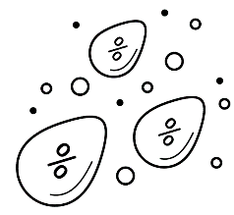  High Humidity | Decreases Transpiration Rate | High humidity means there is a lot of water vapour in the air around the leaf so it reduces the water concentration gradient meaning evaporation is reduced.
Recall questions: Answer these in your book, use the information above to help you
- State the 4 factors that affect the rate of transpiration.
- Explain how wind speed affects the rate of transpiration.
- Explain how light intensity affects the rate of transpiration.
- Why does transpiration increase when the temperature increases?
- Why does transpiration decrease when humidity increases?

Part 2 – Describe how a potometer can be used to measure transpiration rate
Information: Read the following notes
There are many ways to investigate the effect of different factors on the rate of transpiration in plants. Some involve estimating the mass of water lost from leaves or shoots by weighing the mass before and mass after in different conditions. Others involve a piece of equipment known as a potometer.
A potometer can be used to show how the uptake of water by a plant changes in different conditions. This gives you a good idea of the amount of water lost by the plant in transpiration. Most of the water taken up by plants is lost in transpiration, but a small amount is used in photosynthesis. When this experimented is repeated, the same species of plant should be used as different plants have different sized leaves so they will have different transpiration rates.
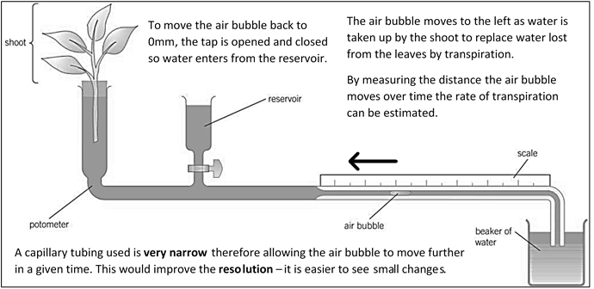
The potometer should also be sealed (the stopper in the top of the shoot) so that the only water that can evaporate is from the leaves not anywhere else.
Recall questions: Answer these in your book, use the information above to help you
- Which apparats can be used to measure the uptake of water in a plant?
- How can the bubble be brought back to 0mm?
- Why is a narrow capillary tubing used?
- Why is the same plant species/type be used when this experiment is repeated?

Part 3 – Interpret data from transpiration experiments
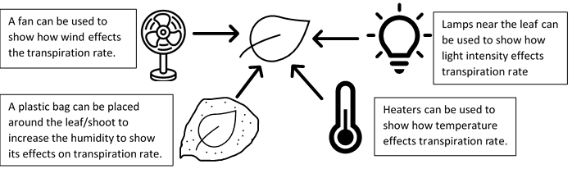
To measure the effect of the different factors on transpiration rate you can create different conditions around the leaves of the shoot:
When completing these experiments, you can only change one factor at a time all the others must be controlled (kept the same) so that you know only the factor you changed had an effect. You should also do a control trial where no factors are changed so that you can compare your results and see the effect of the factor on the transpiration rate.
Recall questions: Answer these in your book, use the information above to help you
- How could you set up a potometer to show the effect of wind on transpiration rate?
- How could you set up a potometer to show the effect of humidity on transpiration rate?
- How could you set up a potometer to show the effect of temperature on transpiration rate?
- What should you make sure when running an experiment to show the effect of light intensity on transpiration rate?
Exam question practice: Answer these on this sheet, use the answers to your recall questions to help you
Q1. A potometer is a piece of apparatus that can be used to measure water uptake by a leafy shoot.
Figure 1 shows a potometer.
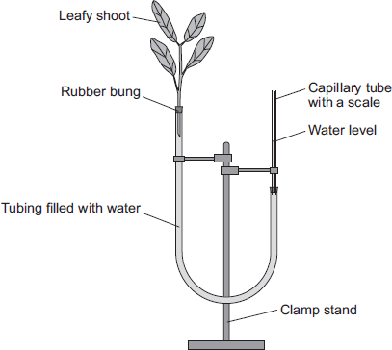
Some students used a potometer like the one shown in Figure 1.
• They measured the water taken up by a shoot in normal conditions in a classroom.
• As the water was taken up by the shoot, the level of water in the capillary tube went down.
• The students recorded the level of the water in the capillary tube at 2-minute intervals for 10 minutes.

Table 1 shows the students’ results.

Time in minutes | 0 | 2 | 4 | 6 | 8 | 10
Level of water (on scale) in  capillary tube in mm | 2.5 | 3.6 | 4.4 | 5.4 | 6.5 | 7.5
The area of the cross section of the capillary tube was 0.8 mm².
(a) (i) Complete the following calculation to find the volume of water taken up by the shoot in mm³ per minute.
Distance water moved along the scale in 10 minutes = ______ mm
Volume of water taken up by the shoot in 10 minutes = ______ mm³
Therefore, volume of water taken up by the shoot in 1 minute = ______ mm³
(3)
(ii) The students repeated the investigation but this time placed the potometer next to a fan blowing air over the leafy shoot.
Suggest how the results would be different. Give a reason for your answer.
______________________________________________________________
______________________________________________________________
______________________________________________________________
______________________________________________________________
(2)
(b) The students repeated the investigation at different temperatures.
The results are shown in Table 2.
Table 2

Temperature  in °C | Rate of water uptake  in mm³ per minute
10 | 0
15 | 0.4
20 | 1.0
25 | 2.1
30 | 3.2
35 | 4.0
40 | 4.4
Plot the data from Table 2 on the graph paper in Figure 2.
Choose suitable scales, label both axes and draw a line of best fit.
Figure 2

(5)
(c) What would happen to the leaves if the potometer was left for a longer time at 40 °C?
Explain your answer.
___________________________________________________________________
___________________________________________________________________
___________________________________________________________________
___________________________________________________________________
___________________________________________________________________
___________________________________________________________________
(3)

Q2. Some students used the apparatus shown in the diagram to measure the rate of water uptake by a plant cutting.
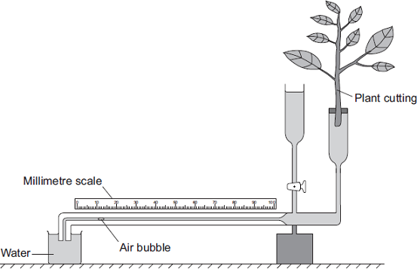
The students set up the apparatus in three different conditions:
• no wind at 15°C
• no wind at 25°C
• wind at 25°C
For each experiment, the students recorded the movement of the air bubble along the scale.
(a) (i) Name the two variables the students chose to change in these experiments.
1. ____________________________________________________________
2. ____________________________________________________________
(2)
(ii) It was important to use the same plant cutting each time to make these experiments fair.
Explain why.
______________________________________________________________
______________________________________________________________
(1)

b) The graph shows the students’ results.
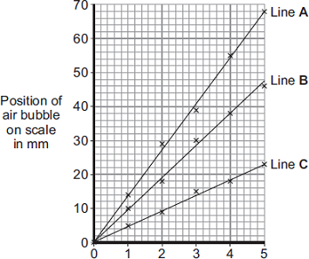
Time in minutes
Which line on the graph, A, B or C, shows the results for each of the three different experiments?
Write each of the letters, A, B and C, in the correct boxes in the table.

Conditions | Letter
No wind at 15°C
No wind at 25°C
Wind at 25°C
(2)
(c) Water is lost from the leaves of the plant cutting.
Name this process.
Draw a ring around one answer.

distillation | respiration | transpiration
(1)

Q3. Students investigated the effect of different conditions on water loss from leaves.
The apparatus is shown in Figure 1.
Figure 1
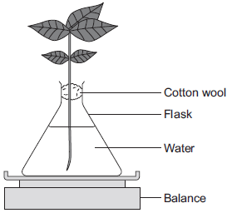
The students set up four flasks, A, B, C and D.
The students:
• used the same size plant shoot in each flask
• recorded the mass of the flask and plant shoot at the start of each experiment
• left each flask and plant shoot in different conditions
• recorded the mass of each flask and plant shoot after 2 hours.
Table 1 shows the conditions that flasks A, B, C and D were left in for 2 hours.
Table 1

Flask | Temperature in °C | Fan or no fan
A | 20 | No Fan
B | 20 | Fan
C | 35 | No Fan
D | 35 | Fan
(i) Suggest why the students used cotton wool in each flask.
______________________________________________________________
______________________________________________________________
(1)

(ii) The use of the same size of plant shoot made the investigation a fair test.
Explain why.
______________________________________________________________
______________________________________________________________
______________________________________________________________
______________________________________________________________
(2)
(iii) Table 2 shows the students’ results.
Table 2

 | Conditions |  | Mass at the start in grams | Mass after 2 hours in grams | Mass of water lost in 2 hours in grams
Flask | Temperature in °C | Fan or no fan | Mass at the start in grams | Mass after 2 hours in grams | Mass of water lost in 2 hours in grams
A | 20 | No Fan | 150.0 | 148.1 | 1.9
B | 20 | Fan | 152.0 | 148.5 | 3.5
C | 35 | No Fan | 149.0 | 145.9 | 3.1
D | 35 | Fan | 150.0 | 145.5
What mass of water was lost by the plant shoot in flask D?
______________________________________________________________
______________________________________________________________
___________ grams
(1)
(iv) Suggest what conclusion can be made about the effect of temperature on water loss from the plant shoot.
______________________________________________________________
______________________________________________________________
______________________________________________________________
(1)
(v) Suggest what conclusion can be made about the effect of the fan on water loss from the plant shoot.
______________________________________________________________
______________________________________________________________
______________________________________________________________ (1)
(c) The students carried out another experiment at 20 °C, with no fan.
The students used the apparatus in Figure 2.
Figure 2
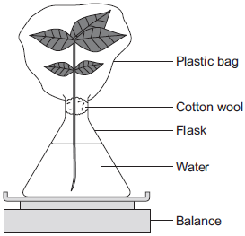
In this experiment, the students:
• recorded the mass of the flask and plant shoot before tying the plastic bag around the plant shoot
• removed the bag after 2 hours and recorded the mass again.
(i) What mass of water would be lost from the plant shoot in 2 hours?
Draw a ring around the correct answer.

0.3 g | 1.9 g | 3.9 g
(1)
(ii) Give a reason for your answer to part (c)(i).
______________________________________________________________
______________________________________________________________
______________________________________________________________
(1)

Lesson 5: Effect of limiting factors on photosynthesis
CHECKLIST! – Have you…
- Read the notes and completed the recall questions
- Marked your recall questions using the answers
- Completed the exam questions
Do Now: Complete the DO NOW:
Key Words:
Greenhouse | A glass building in which plants can be grown to protect them from cold weather.
Limiting factors | An environmental condition that when it is in short supply it slows down or prevents a reaction or process.
Optimum | the most favourable/best condition or level for growth, reproduction, or success.
Yield | Yield is an amount produced of an agricultural or industrial product.

Part 1 – State the factors that affect the rate of photosynthesis
Plants grow quickly in the summer, yet they hardly grow at all in the winter. Plants need light, warm temperatures, and carbon dioxide if they are going to photosynthesise and grow as fast as they can. Three factors can limit the rate of photosynthesis: light intensity, carbon dioxide concentration and temperature. If they are not at their optimum levels they will slow down the rate of photosynthesis, this is why they are known as limiting factors.
Recall questions: Answer these in your book, use the information above to help you
- What is a limiting factor?
- State the 3 factors that can affect the rate of photosynthesis.
Part 2 – Explain how each factor affects the rate of photosynthesis
Light intensity  The most obvious factor affecting the rate of photosynthesis is light intensity. If there is plenty of light, lots of photosynthesis can take place. If there is very little or no light, photosynthesis will stop, whatever the other conditions are around the plant. As light intensity increases the rate of photosynthesis increases. There will be a maximum point (flatline) where no more light will increase the rate. The other factors (CO₂ concentration or temperature) become limiting at this point | 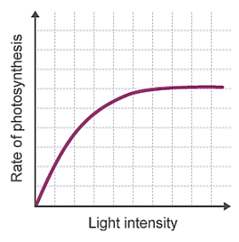  Light is the limiting factor here  Other factors are limiting the rate here
Carbon dioxide concentration  Plants need carbon dioxide to photosynthesis and make glucose. Increasing the carbon dioxide concentration will increase the rate of photosynthesis. On a sunny day, carbon dioxide concentration is the most common limiting factor for plants. The carbon dioxide concentrations around a plant tend to rise at night, because in the dark a plant respires but doesn’t photosynthesise. As light intensity and temperature increase in the morning, most of the carbon dioxide around the plant gets used up. | 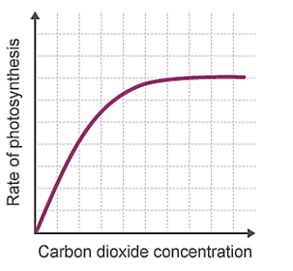  CO₂ concentration is the limiting factor here  Other factors are limiting the rate here
Temperature  Temperature affects all chemical reactions, including photosynthesis because they are controlled by enzymes. As the temperature rises, the rate of photosynthesis increases as the reaction speeds up. However, most enzymes are denatured once the temperature rises to around 40-50°C. If the temperature gets too high, the enzymes controlling photosynthesis are denatured and the rate of photosynthesis will fall. However, if it gets too cold, the rate of photosynthesis will decrease. | 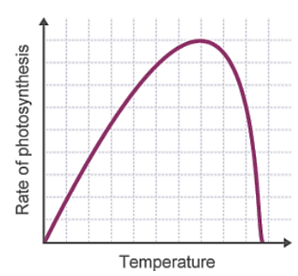  Temperature is the limiting factor here  The optimum temperature
Recall questions: Answer these in your book, use the information above to help you
- What happens to the rate of photosynthesis when light intensity increases?
- What happens to the rate of photosynthesis when the concentration of carbon dioxide increases?
- What happens to the rate of photosynthesis between 0°C and 40°C?
- Why does the rate of photosynthesis decrease after 40°C?

Part 3 – Explain how greenhouses can maintain conditions for optimal plant growth
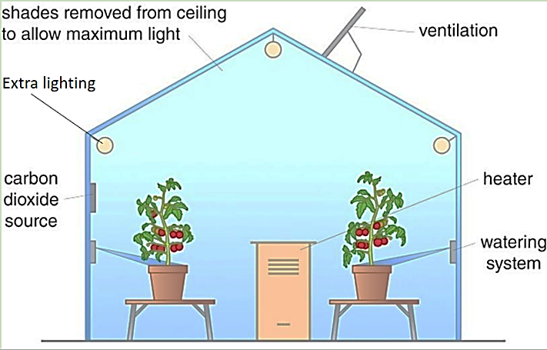
Big commercial greenhouses now take advantage of what is known about limiting factors of photosynthesis. They control not only the temperature but also the levels of light and carbon dioxide to make sure they are at their optimum to get the fastest possible rates of photosynthesis. This will increase the yield of the crop as it maximises growth. If the crop yield increase, the profits also increase.
However, electricity and gas are used to maintain the lighting and temperatures and to control the carbon dioxide levels. Expensive monitoring equipment and computers are needed to maintain conditions inside the greenhouse. The increased income from larger crop and the ability to grow more crops each year has to be balanced against the cost of setting up and maintaining the system.
Recall questions: Answer these in your book, use the information above to help you
- What conditions can be controlled in a greenhouse?
- Why are greenhouses used? What are the advantages?
- What are the disadvantages of commercial greenhouses?
Exam question practice: Answer these on this sheet, use the answers to your recall questions to help you
Q1. The graph shows how the rate of photosynthesis is affected by different conditions.
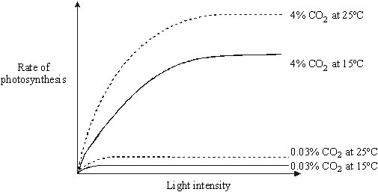

(a) What patterns can you find from this graph?
___________________________________________________________________
___________________________________________________________________
___________________________________________________________________
___________________________________________________________________
___________________________________________________________________
(5)
(b) How useful could this information be to a grower using glasshouses? Give reasons for your answer.
___________________________________________________________________
___________________________________________________________________
___________________________________________________________________
(2)
Q2. (a) The equation describes the process of photosynthesis.
carbon dioxide + _____________ + light energy glucose + _____________
(i) Write in the names of the two missing substances.
(2)
(ii) Name the green substance which absorbs the light energy.
______________________________________________________________
(1)
(b) (i) In bright sunlight, the concentration of carbon dioxide in the air can limit the rate of photosynthesis. Explain what this means.
______________________________________________________________
______________________________________________________________
______________________________________________________________
(2)
(ii) Give one environmental factor, other than light intensity and carbon dioxide concentration, which can limit the rate of photosynthesis.
______________________________________________________________
(1)
Q3. (a) Complete the equation for photosynthesis. (2)
Carbon dioxide + ______________ | light  energy | ______________ + oxygen

(b) A farmer grew tomato plants in a greenhouse.
The graph shows the effect of light intensity on the rate of photosynthesis in the tomato plants growing in the greenhouse.
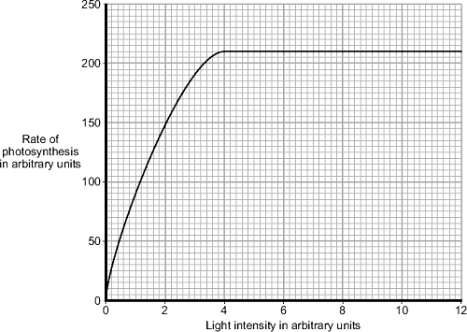
(i) At which light intensity was light a limiting factor for photosynthesis?
Tick () one box.

1 arbitrary unit | 
4 arbitrary units
10 arbitrary units
(1)
(ii) What was the highest rate of photosynthesis?
_________________________________ arbitrary units
(1)
(iii) The farmer wants to increase the rate of photosynthesis in his tomato plants.
Apart from light intensity, name one factor that the farmer could change to increase the rate of photosynthesis in his tomato plants.
______________________________________________________________
(1)
Q4. Plants are grown in glasshouses to protect them from the weather or extend the growing season.
Plants make food by photosynthesis.
6CO₂ + 6H₂O energy from C₆H₁₂O₆ + 6O₂
light glucose
In winter, when days are shorter, glasshouses are heated to keep the enzyme reactions in plants at optimum rates.
What else should a grower do to make sure that the plants are photosynthesising at the optimum rate? Give a reason for your answer.
_______________________________________________________________________
_______________________________________________________________________
_______________________________________________________________________
_______________________________________________________________________
_______________________________________________________________________
_______________________________________________________________________
(Total 3 marks)
Q5. The graph shows the concentration of carbon dioxide in the air in a greenhouse full of tomato plants, measured over a period of 24 hours.
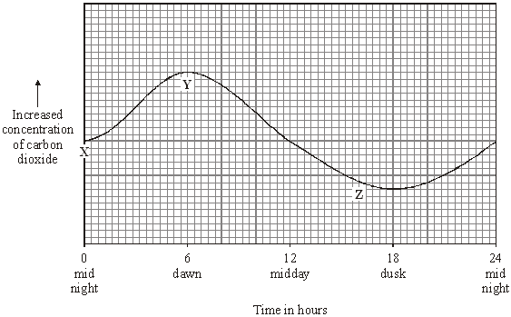
(a) Explain why the concentration of carbon dioxide in the air in the greenhouse increased between X and Y.
___________________________________________________________________
___________________________________________________________________
___________________________________________________________________ (2)
(b) Explain why the concentration of carbon dioxide in the air in the greenhouse decreased between Y and Z.
___________________________________________________________________
___________________________________________________________________
___________________________________________________________________
___________________________________________________________________
(2)
Q6. The diagram shows some plants growing in a greenhouse on a hot summer’s day.
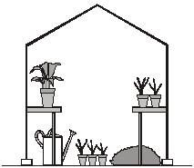
Which one of the following factors is most likely to limit the rate of photosynthesis at this time?
• carbon dioxide concentration
• light intensity
• temperature
Factor ______________________________________________
Explain the reason for your answer.
_______________________________________________________________________
_______________________________________________________________________
_______________________________________________________________________
_______________________________________________________________________
_______________________________________________________________________
_______________________________________________________________________
(Total 4 marks)

Q5. Photosynthesis uses carbon dioxide to make glucose.
(b) The graph shows the effect of the concentration of carbon dioxide on the rate of photosynthesis in tomato plants at 20 °C.
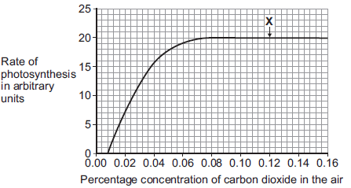
(i) What is the maximum rate of photosynthesis of the tomato plants shown in the graph?
_____________ arbitrary units
(1)
(ii) At point X, carbon dioxide is not a limiting factor of photosynthesis.
Suggest one factor that is limiting the rate of photosynthesis at point X.
______________________________________________________________
(1)
(c) A farmer plans to grow tomatoes in a large greenhouse.
The concentration of carbon dioxide in the atmosphere is 0.04%.
The farmer adds carbon dioxide to the greenhouse so that its concentration is 0.08%.
(i) Why does the farmer use 0.08% carbon dioxide?
Tick () one box.

To increase the rate of growth of the tomato plants | 
To increase the rate of respiration of the tomato plants
To increase water uptake by the tomato plants
(1)

(ii) Why does the farmer not use a concentration of carbon dioxide higher than 0.08%?
Tick () two boxes.
Because it would cost more money than using 0.08%
Because it would decrease the temperature of the greenhouse
Because it would not increase the rate of photosynthesis of the
tomato plants any further
Because it would increase water loss from the tomato plants
(2)
Q6. The rate of photosynthesis in a plant depends on several factors in the environment.
These factors include light intensity and the availability of water.
Describe and explain the effects of two other factors that affect the rate of photosynthesis.
You may include one or more sketch graphs in your answer.

___________________________________________________________________
___________________________________________________________________
___________________________________________________________________
___________________________________________________________________
___________________________________________________________________
___________________________________________________________________
___________________________________________________________________
___________________________________________________________________
___________________________________________________________________
___________________________________________________________________
(5)
Lesson 6: Required Practical 5 - Investigate the effect of light intensity on the rate of
photosynthesis using an aquatic organism such as pondweed
CHECKLIST! – Have you…
- Read the notes and completed the recall questions
- Marked your recall questions using the answers
- Completed the exam questions
Do Now: Complete the DO NOW:
Key Words:
LED | A light-emitting diode is a light source that emits light when current flows through it.
Sodium hydrogen carbonate | Sometimes called bicarbonate of soda. Releases CO2 when dissolved in water
Wavelength | The distance between the two successive crests or troughs of the light wave. Different colours of light have different wavelengths
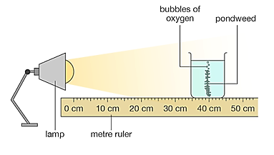

Part 1 – Describe a method do measure the effects of one limiting factor on the rate of photosynthesis
stopwatch
Risks to consider
- Care should be taken when handling glassware.
- Care should be taken with the use of lamps that may get hot.
- Care should be taken with the presence of water and the electrical power supply for the lamp

Method and notes​
- ​Set up a test tube/beaker at a distance of 40cm away from the light ​source​

It is best to use an LED light source as they give off less heat. If a normal lightbulb is used it place a beaker of water in between the boiling tube and the lamp to absorb the heat and reduce the temperature to prevent it from affecting the results.​
- Fill the boiling tube with sodium hydrogen carbonate​
This increases the concentration of CO2 in the water, stopping CO2 being a limiting factor​
Scan to watch a video of the practical
- Put a piece of pondweed into the boiling tube​
- Leave for a couple of minutes​
This allows the pondweed to adjust to the new light intensity
- Start the stopwatch and count the number of bubbles produced ​in 1 minute​
- Repeat step 5 twice more (use data to calculate a mean)​
This increases the reliability of your results if there are any anomalous readings do not include them when calculating the mean
- Move the light closer to the pondweed at distances of 30cm, 20 cm and 10cm from the light source​ and repeat your measurement.
- Record your results in a table and use your means for each temperature to plot a line graph
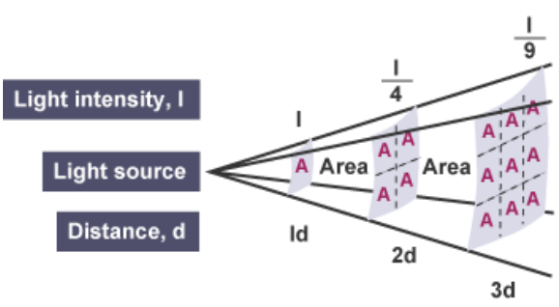
The Inverse Square Law - HT ONLY
You can use the inverse square law to convert your distance measurements to create a linear graph.
There is an inverse relationship between distance and light intensity - as the distance increases, light intensity decreases. This is because as the distance away from a light source increases, photons of light become spread over a wider area.
The light energy at twice the distance away is spread over four times the area. The light energy at three times the distance away is spread over nine times the area, and so on.
The light intensity is inversely proportional to the square of the distance - this is the inverse square law.
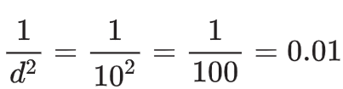
For each distance of the plant from the lamp, light intensity will be proportional to the inverse of the distance squared (d²). For instance, for the lamp 10 cm away from the plant:
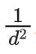
Be careful - the x-axis is values of not light intensity. is proportional to light intensity.
Recall questions: Answer these in your book, use the information above to help you
- Why do you need to add sodium hydrogen carbonate to the water?
- What is the dependent variable in this experiment?
- What variables should be controlled in the experiment?
- What gas is present in the bubbles released from the pondweed?
- What do you need to measure to calculate the rate of photosynthesis?
- Why should LED bulbs be used?
- What is the inverse square law?
- How can you calculate the inverse square law.
Part 2 – Interpret data from photosynthesis experiments
Information: Read the following notes
This practical can be adapted in the following ways to test different factors:
Factor | Adaptations | Control Variables
Carbon dioxide concentration | Change the concentration of sodium hydrogen carbonate by adding different mass to the beaker. | Keep light intensity (distance from the lamp) the same.  Keep temperature constant.
Colour/wavelength of light | Use coloured filters in front of the lamp to change the colour of the light. | Keep light intensity (distance from the lamp) the same.  Keep temperature constant.
Temperature | Place the beaker in a water bath at different temperatures | Keep light intensity (distance from the lamp) the same.  Keep carbon dioxide concentration constant (use the same mass of sodium hydrogen carbonate)

Recall questions: Answer these in your book, use the information above to help you
- How could you measure the effect of light wavelength on the rate of photosynthesis?
- How could you measure the effect of carbon dioxide concentration on the rate of photosynthesis?
Exam question practice: Answer these on this sheet, use the answers to your recall questions to help you
Q1. Students investigated the effect of light intensity on the rate of photosynthesis in pondweed.
The diagram shows the equipment the students used.
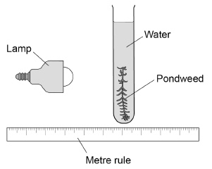
This is the method used.
1. Place the lamp 50 cm from the pondweed.
2. Count the number of bubbles of gas released in two minutes.
3. Repeat steps 1–2 with the lamp at different distances from the pondweed.
(a) The students could not make a firm conclusion because their method did not control enough variables.
Give two variables the students have not controlled that would affect the rate of photosynthesis.
1. _________________________________________________________________
2. _________________________________________________________________ (2)
The table shows the students’ results.

Distance of lamp from the pondweed in cm | Number of bubbles released in two minutes
Distance of lamp from the pondweed in cm | 1 | 2 | 3 | 4 | Mean
50 | 5 | 8 | 6 | 5 | 6
40 | 10 | 8 | 9 | 4 | 9
30 | 12 | 12 | 15 | 17 | 14
20 | 25 | 17 | 23 | 24 | 24
10 | 22 | 34 | 31 | 31 | X
(b) Calculate the mean rate of bubbles produced per minute when the lamp was 10 cm from the pondweed.
___________________________________________________________________
Mean rate = ____________________ bubbles per minute (3)
(c) The mean number of bubbles released when the lamp was 30 cm away from the plant was greater than when the lamp was 50 cm away.
How many times greater?
___________________________________________________________________
Number of times greater = ____________________ (1)
(d) The students wanted to find out if different wavelengths of light affect the number of bubbles released.
Describe how the method could be adapted to find the effect of different wavelengths of light.
___________________________________________________________________
___________________________________________________________________
___________________________________________________________________
___________________________________________________________________ (2)
Q2. This question is about photosynthesis.
(a) Plants make glucose during photosynthesis. Some of the glucose is changed into
insoluble starch.
What happens to this starch? Tick () one box.

The starch is converted into oxygen.
The starch is stored for later use.
The starch is used to make the leaf green.
(1)
(b) A student investigated the effect of temperature on the rate of photosynthesis in pondweed.
The diagram shows the way the experiment was set up.
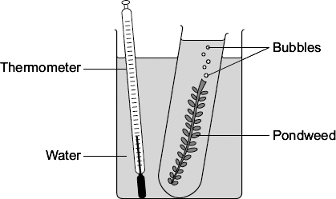
(i) The student needed to control some variables to make the investigation fair.
State two of these variables.
1. ____________________________________________________________
2. ____________________________________________________________
(2)
(ii) The bubbles of gas are produced only while photosynthesis is taking place.
What two measurements would the student make to calculate the rate of photosynthesis?
1. ____________________________________________________________
2. ____________________________________________________________
(2)
(c) The graph shows the effect of temperature on the rate of photosynthesis.
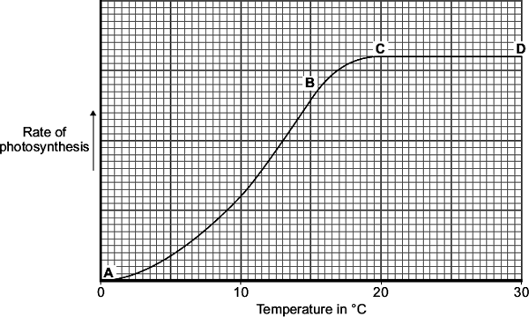
(i) Name the factor that limits the rate of photosynthesis between the points labelled A and B on the graph.
______________________________________________________________
(1)
(ii) Suggest which factor, carbon dioxide, oxygen or water, might limit the rate of photosynthesis between the points labelled C and D on the graph.
______________________________________________________________
(1)

Q3. Some students investigated the effect of light intensity on the rate of photosynthesis.
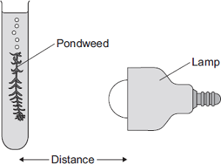
They used the apparatus shown in Diagram 1.
The students:
• placed the lamp 10 cm from the pondweed
• counted the number of bubbles of gas released from the pondweed in 1 minute
• repeated this for different distances between the lamp and the pondweed.
(a) The lamp gives out heat as well as light.
What could the students do to make sure that heat from the lamp did not affect the rate of photosynthesis?
___________________________________________________________________
___________________________________________________________________
(1)
(b) The table shows the students’ results.

 | Distance in cm | Number of bubbles per minute
 | 10 | 84
 | 15 | 84
 | 20 | 76
 | 40 | 52
 | 50 | 26
(i) At distances between 15 cm and 50 cm, light was a limiting factor for photosynthesis.
What evidence is there for this in the table?
______________________________________________________________
______________________________________________________________ (1)
(ii) Give one factor that could have limited the rate of photosynthesis when the distance was between 10 cm and 15 cm.
______________________________________________________________
(1)

Q4. (a) Complete the equation for photosynthesis. Draw a ring around each correct answer.

 |  | hydrogen |  | alcohol
Carbon dioxide | + | nitrogen | light energy | glucose | + | oxygen
 |  | water |  | methane
(2)
Some students investigated the effect of light intensity on the rate of photosynthesis in pondweed.
The diagram shows the apparatus the students used.
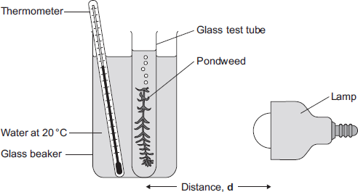
The closer the lamp is to the pondweed, the more light the pondweed receives.
The students placed the lamp at different distances, d, from the pondweed.
They counted the number of bubbles of gas released from the pondweed in 1 minute for each distance.
(b) A thermometer was placed in the glass beaker.
Why was it important to use a thermometer in this investigation?
___________________________________________________________________
___________________________________________________________________
___________________________________________________________________
___________________________________________________________________
___________________________________________________________________
___________________________________________________________________
(3)

(c) The students counted the bubbles four times at each distance and calculated the correct mean value of their results.
The table shows the students’ results.

Distance  d in cm | Number of bubbles per minute
Distance  d in cm | 1 | 2 | 3 | 4 | Mean
10 | 52 | 52 | 54 | 54 | 53
20 | 49 | 51 | 48 | 52 | 50
30 | 32 | 30 | 27 | 31 | 30
40 | 30 | 10 | 9 | 11
(i) Calculate the mean number of bubbles released per minute when the lamp was 40 cm from the pondweed.
______________________________________________________________
Mean number of bubbles at 40 cm = ______________________
(2)
(ii) On the graph paper below, draw a graph to show the students’ results:
• add a label to the vertical axis
• plot the mean values of the number of bubbles
• draw a line of best fit.
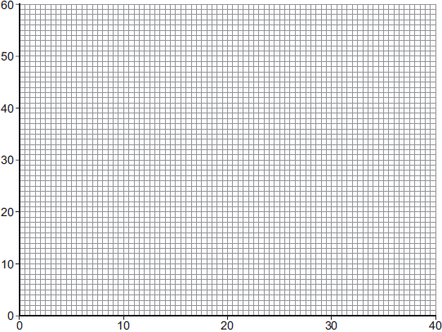
Distance d in cm (4)
(iii) One student concluded that the rate of photosynthesis was inversely proportional to the distance of the lamp from the plant.
Does the data support this conclusion?
Explain your answer.
______________________________________________________________
______________________________________________________________
______________________________________________________________
______________________________________________________________
______________________________________________________________
______________________________________________________________
(2)
Challenge.
Figure 1 shows some of the apparatus that can be used to measure the rate of photosynthesis.
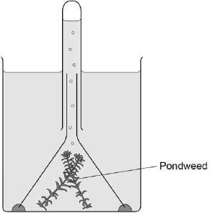
The rate of photosynthesis in the pondweed is affected by different colours of light.
Describe a method you could use to investigate this.
You should include:
• what you would measure
• variables you would control.
___________________________________________________________________
___________________________________________________________________
___________________________________________________________________
___________________________________________________________________
___________________________________________________________________
___________________________________________________________________
___________________________________________________________________
___________________________________________________________________
___________________________________________________________________
___________________________________________________________________ (6)

