AQA Biology GCSE
Ecology

Name: ______________________
Week | Homework Task | SCAN CODE | Due
1 | Task 1: Watch the ‘ Abiotic Factors’ video and answer the worksheet questions (this can be in your book or on the sheet if you print it) – submit a picture of this on MS Teams.  Task 2: Complete any unanswered exam questions from L1 in your booklet | 
2 | Task1: Watch the ‘Predator-Prey Cycles ’ video, complete the worksheet questions (this can be in your book or on the sheet if you print it) – submit a picture of this on MS Teams.  Task 2: Complete any unanswered exam questions from L2 and 3 in your booklet | 
3 | Task1: Watch the ‘Carbon Cycle’ video, complete the worksheet questions (this can be in your book or on the sheet if you print it) – submit a picture of this on MS Teams.  Task 2: Complete any unanswered exam questions from L4 and 5 in your booklet | 
4 | Task1: Watch the ‘Deforestation & Conservation’ video, complete the worksheet questions (this can be in your book or on the sheet if you print it) – submit a picture of this on MS Teams.  Task 2: Complete any unanswered exam questions from L6 in your booklet | 

Paper 2 - Ecology Fact Sheet
To revise these facts, fold this sheet in half and try to write the answers down from memory. Repeat!
Fold page here
- Define 'community'. | A group of interdependent organisms that are made of different species
- Define 'ecosystem'. | The interaction of a community with the abiotic parts of the environment
- What are abiotic factors? State two examples. | Non-living factors in an environment (eg. light intensity, soil pH, wind, humidity, temperature)
- What are biotic factors? State two examples. | Living factors in an environment (eg. predators, competitors, pathogens/microorganisms)
- Define 'population'. | A group of organisms of one species that interbreed and live in the same place at the same time
- What is interdependence? | A relationship that describes how all species within a community depend on each other to survive
- A disease causes large areas of trees to die. Is their death cause by an abiotic or biotic factor? | Biotic (as diseases are caused by pathogens, which are living beings)
- Briefly explain why low light intensity may decrease animal populations. | Less light, less photosynthesis by plants --> poor plant growth --> less plant availble for animals to eat --> less herbivores grow and survive --> further affects higher levels in the food chain
- Sort the following into abiotic and biotic factors: soil pH, availability of food, oxygen availability, wind intensity, new competitors, carbon dioxide levels | Ab: soil pH, CO2 levels, O2 availability, wind intensity; Bio: food availability, new competitors
- State three biotic factors. | New pathogens, new predators, new competitors, food availability
- What are the three things that animals compete for? | Food, mates, territory
- Give one characteristic of a peacock that makes it a good competitor, and state what it is competing for using this trait. | Behaviour (eg. mating dance)/Attractive, colourful feathers to attract mate
- Tigers urinating on trees is a behaviour adaptation to compete for...? | Territory
- Wasps building nests is a behaviour adaptation to compete for...? | Shelter/Habitat
- Owls' sharp hearing is an adaptation to compete for...? | Food
- What are the four things that plants compete for? | Light, space, water, mineral ions
- Some small plants in woodlands grow only in winter and dies before spring comes. Suggest why this occurs. | To avoid competiton for sunlight when large trees grow leaves and block out sunlight in spring/summer
- Suggest why plants may have different root depths. | To avoid competition for water and/or minerial ions at the same soil depth
- Suggest why seed dispersal is considered an adaptation to avoid competition. | Seed is carried far away instead of landing right next to parent plant, so offspring plant doesn't compete with parent plant
- Catcus' long roots is a feature to help compete for...? | Water
- Large flowers are a feature to help compete for...? | (attract) Pollinators
- Weeds' rapid growth in height is a feature to help compete for...? | Light
- Define 'biomass'. | Amount of biological material in an organism (without water)
- What are producers? | Organisms that can make food/biomass from raw materials such as CO2 and water (eg. plants, algae)
- How do producers make biomass? | By doing photosynthesis
- What are primary consumers? Give an example. | Animals that eat producers + Any herbivores (eg. cows, sheep, rabbits)
- What are secondary consumers? Give an example. | Animals that eat primary consumers + Any carnivores (eg. lions, foxes, eagles)
- Secondary consumers may be eaten by...? | Tertiary consumers
- Describe and explain how prey population changes as predator population increases. | Prey population decreases as more predator eats more prey
- Describe and explain how predator population changes as prey population decreases. | Predator population decreases, as less prey/food available, more predators die
- Describe and explain how prey population changes as predator population decreases. | Prey population increases, as less predators hunting them, more prey can survive and reproduce
- Describe and explain how predator population changes as prey population increases. | Predator population increases, as more food/prey available, more predator and eat to survive and reproduce
- What are decomposers? | Microorganisms that break down waste products and dead bodies
- Name the type of organism that decomposes dead material. | Microorganisms
- As decomposers break down organic material, what is released into the air? How does it return to organisms? | Carbon dioxide --> taken into producers for photosynthesis
- As decomposers break down organic material, what is released into the soil? How does it return to organisms? | Mineral ions (eg. nitrates) --> taken into producers through roots to build biomass (eg. proteins)
- Name two ways in which organic material is returned to the soil for decomposers to break down. | Death + Excretion
- Name two ways in which water gets released from plants to the environment. | Transpiration + Respiration
- How does carbon get from the air into plants? | Photosynthesis
- How does carbon from plants get into animals? | Feeding/Eating
- How does carbon from animals get into the atmosphere? | Respiration/Decay (or decomposition)
- How does carbon from plants and animals get formed into rocks? | Fossilisation
- How does carbon from fossil fuels get into the air? | Combustion
- In what form is carbon in the air? | Carbon dioxide
- Name the process where water escapes into the ocean through gaps between soil and rocks. | Percolation
- Name the process where water is rained down from the clouds. | Precipitation
- Name the process(es) where water escapes from the oceans and into the clouds. | Evaporation and condensation
- How does carbon get from the air into plants? | Photosynthesis
- How does carbon from plants get into animals? | Feeding/Eating
- How does carbon from animals get into the atmosphere? | Respiration/Decay (or decomposition)
- How does carbon from plants and animals get formed into rocks? | Fossilisation
- How does carbon from fossil fuels get into the air? | Combustion
- In what form is carbon in the air? | Carbon dioxide
- Define 'biodiversity'. | A measure of the variety of all the different species of organisms within an ecosystem
- What are two major problems from the exponential increase in human population? | More natural resources are used up + Produce more wastes --> decrease biodiversity
- State four sources of land pollution. | Human sewage + Household wastes + Industrial wastes + Pesticides and herbicides in farming
- How does land pollution affect our biodiversity? | Less (clean) food available / Loss of habitat / Global warming leading to migration
- How does human sewage contribute towards land pollution? | Harmful microbes and bad chemicals lead to spread of diseases on land
- Explain how household and industrial wastes pollute land. | Take up space in landfills + Toxic/radioactive chemicals --> poison soils + destorys habtitats
- State four sources of water pollution. | Untreated sewage + Fertilisers + Industrial wastes + Pesticides and herbicides
- Name the situation where a body of water has low oxygen levels, leading to marine organisms' death. | Eutrophication
- What causes eutrophication? | Fertilisers leaked into lakes, excess nutrients causes excessive plant growth, leading to an increase in competition/algae covering water surface (less light allowed into lake for water plants)
- What is bioaccumulation? | Accumulation of chemicals in an organism
- Name a chemical that gets built up in organisms in bioaccumulation. | Heavy metals/Fertiliers/Pesticides/Herbicides
- Why is bioaccumulation bad? | Chemical conc increases each trophic levels --> may reach fatal levels when get to the top consumer
- Name a source of air pollution. | Combustion of fossil fuels
- How is acid rain formed? | Acidic gases released from burning fossil fuels are dissolved in rain water
- Name three acidic gases released from burning fossil fuels. | Carbon dioxide + sulphur dioxide + Nitric oxides
- Give 3 effects of acid rain. | Kills plants; Destroys roots in soil; Acidifies bodies of water, killing marine organisms; Affects neighbouring countries; Acid snow kills young plants
- What is global dimming? | Particulates made from combustion covers the atmosphere, reflecting sunlight so less light reaches the surface
- What causes global dimming? | Particulates
- Name two conditions that particulates can cause. | Global dimming + Smog
- Explain how global dimming can affect plant growth. | Cooling temperatures + Less sunlight --> Plants die due to insufficient photosynthesis
- What is smog? | Particulates + Acidic gases
- How does smog affect our health? | Inhaling particulates damages our lungs and cardiovascular systems
- Name a toxic gas that is released from incomplete combustion. | Carbon monoxide
- How does carbon monoxide cause an effect in our body? | Binds to haemoglobin irreversibly --> less Hb available to bind to oxygen --> suffocation
- Suggest two ways to reduce air pollution. | Use low-sulphur fuels / Set strict emission levels / Use biofuels / Use exhaust gas filters in power stations / Catalytic converters in cars
- Suggest two alternative power source that reduces air pollution. | Low-sulphur fuels / Biofuels / Renewable energy
- What is meant by a 'carbon sink'? | A place that stores carbon
- Give two examples of good carbon sinks. | Forests + Peat bogs
- Give a reason for deforestation. | Provide resources / Provide land for agriculture / Provide land to make biofuel
- Give a reason for peat destruction. | Provide fuel/garden compost
- Name two major impacts deforestation and peat destruction have on the environment and our biodiversity. | More CO2 release (more global warming and acid rain) + Decrease biodiversity
- How does a decrease in biodiversity have a negative impact on humans? | Loss of potential new sources of food and medicine / Loss of resources
- Name three major greenhouse gases. | Carbon dioxide + Methane + Water vapour
- Suggest a source of carbon dioxide release. | Burning fossil fuels/Deforestation/Peat destruction etc.
- Suggest a natural source of methane. | Growing rice and cattle
- What is the greenhouse effect? | Thermal energy from the sun reaches the earth and some are reflected. Greenhouse gases absorb these reflected thermal energy and keep Earth warm
- Any greenhouse effect is bad for the Earth. True or false? Explain. | FALSE (essential to keep earth warm, vital for life)
- What causes global warming? | Too much greenhouse gases --> trap too much heat within atmosphere (enhance greenhouse effect)
- State three effects of global warming. | Climate change / Ice caps melt / Warming seas dissolve less carbon dioxide
- What biological consequences does climate change bring about? | Changes in migration pattenrs and species distribution
- What biological consequences does melting of ice caps bring about? | Loss of habitat --> some animals die --> reduce biodiversity
- State the three environmental factors that can cause a change in the distribution of organisms. | Water availability, temperature, (dissolved) atompsheric gases concentration
- Give three possible reasons to changes in environmental factors. | Seasonal changes, geographical changes, result of human interaction
- Suggest one positive change on the environment due to human interaction. | Maintain rainforests / Reduce water pollution and monitor pH / Restrict entry to protected areas / Conservation measures
- Suggest one negative impact on the environment due to human interaction. | Global warming and climate change / Acid rain / Pollution
- Suggest how organisms may adapt to seasonal changes. | Migrate to areas with more ideal conditions
- State three methods to maintain biodiversity. | Breeding programmes / Protect and regenerate rare habitats / Grow hedgrows / Reduce deforestation and CO2 emission / Recycling
- Why is important to protect and regenerate rare habitats? | To allow specifically adapted species to live in nature again (as they cannot live in "normal" conditions)
- Give one impact on the environment by removing hedgerows. | Soil erosion / Reduce soil fertility
- What problem is solved by recycling? | Avoiding landfills becoming full, which leads to pollution
- Suggest a possible challenge in breeding programmes. | Animals do not reproduce easily or fast / Must avoid inbreeding / No natural habitats for them to return to
- Suggest a possible challenge in reintroducing hedgerows. | Loss of land available for growing crops (less profit)
- Suggest a possible challenge in buying lands to restrict deforestation. | Resistance from businesses to maintain profit or demand / Money needed
- Suggest a possible challenge in reducing carbon dioxide emission. | Lack of scientific research on better engines or methods to reduce emission

Lesson Title | My Marks | Total Exam Question Marks |  |  | 
Lesson 1 - Communities, Interdependence and Competition
Page. 8
Lesson 2 - Measuring Biodiversity RP9
Page. 13
Lesson 3 - Feeding Relationships
Page. 21
Lesson 4 – Cycling of Materials
Page. 28
Lesson 5 – Human Impact on Biodiversity: Land Use
Page. 34
Lesson 6 - Waste Management and Pollution
Page. 38
Lesson 7 - Climate Change & Maintaining Biodiversity
Page. 43

Lesson 1 – Communities and Interdependence
Key Words:
Abiotic | Non-living
Biotic | Living organisms
Community | All the organisms living in a particular habitat
Competition | interaction between animal or plant species, or individual organisms, that are attempting to gain a share of a limited environmental resource e.g food, territory or mates
Ecosystem | The habitat and all of the communities of living organisms that interact with it e.g a seashore
Environment | All the ecosystems in an area/continent
Habitat | The non-living physical part of an ecosystem
Interdependence | Where one species survival depends on another species​ for survival
Population | All the members of one species living in the habitat
Species | A group of similar organisms which can breed to produce fertile offspring

Part 1 – Describe what makes up an ecosystem
Notes: Instruction: Read the notes below.
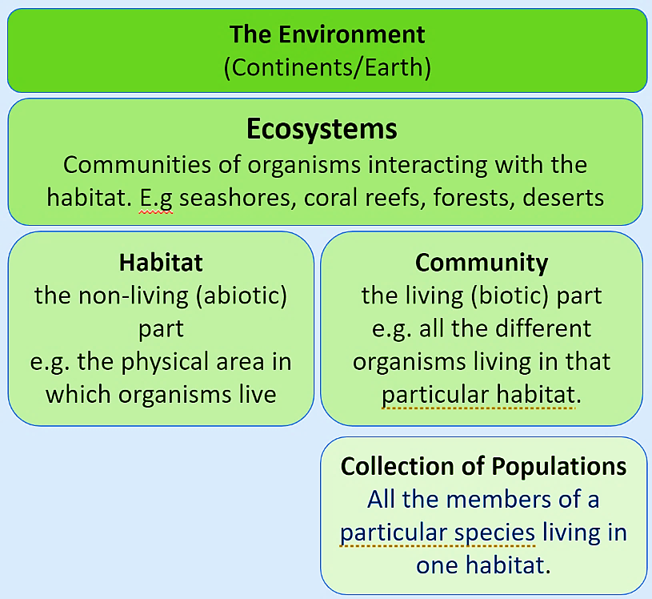
All organisms live in complex communities. These communities are made up of the populations of all the different species of animals, plants, fungi and microorganisms in a habitat (the physical environment an organism lives in).
An ecosystem is created when the community of organisms interacting with the non-living (abiotic) factors. In an ecosystem energy from the sun is transferred through the ecosystem in the chemical stores of chemical bonds. Material like carbon, nitrogen and water are recycled constantly.
The diagram shows how each of the groups fit together to make up the environment. E.g lots of populations make up a community. An ecosystem is made up of communities and the habitat they live in etc.
Recall Questions: Answer these questions in your exercise book. Use the notes above to help you
- What is an organism?
- What is a habitat?
- What is an ecosystem?
- Complete the sentence: Some people think an ecosystem is the same as a community. They are wrong. In fact it is different because……​

Part 2 – Define Interdependence
Communities of organisms often overlap both geographically and, in their need to compete for natural resources. Within a community all species depend on each other. This creates complex interdependence between species where the success or failure of one has consequences on all the others. Within a community each species depends on other species for food, shelter, pollination and seed dispersal.
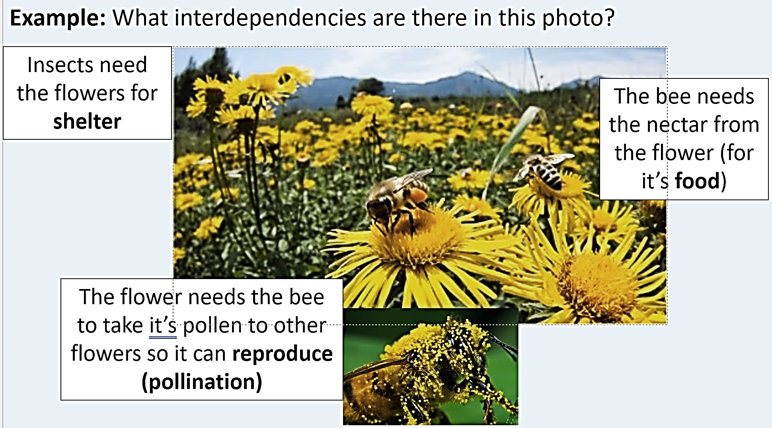
If the flowers were to die suddenly the population of bees would be affected because they would have no food or shelter so they would start to decrease in numbers as bees died out. This would have knock on effects on populations of other animals that also relied on the bees.
If the bees were to suddenly die or leave, the flowers would not be able to reproduce as there would be no pollination, this means the population of this plant will decrease.
This would have knock on effects to other populations of insects or animals that also relied on the plants for food or shelter.
Recall Questions: Answer these questions in your exercise book. Use the notes above to help you
- What happens to resources when two communities are overlapping geographically?
- List the 4 things species in a community rely on each other to provide
- What does interdependence mean?
Part 3 – Explain how biotic and abiotic factors can affect populations in an ecosystem
Abiotic factors are non-living factors like light intensity, temperature, moisture levels, soil pH, wind intensity and availability of oxygen and carbon dioxide. Biotic factors are the living components of an ecosystem. This includes: availability of food, new pathogens or parasites, new predators and competition between species. Each habitat will have a unique mix of biotic and abiotic factors which can cause populations of organisms to increase or decrease.
Abiotic factors |  | Biotic factors
Factor | How does it affect organisms (plants or animals) | Factor | How does it affect organisms
Light intensity |  | Availability of food
Temperature |  | New pathogens
Availability of Water |  | New predators
Availability of oxygen and carbon dioxide |  | Competition with other organisms

As each species forms part of a community in an ecosystem they often find themselves in competition for limited resources. Animals compete for food, territory and mates. Plants compete for light, water, nutrients (minerals) and space. The organism that outcompetes its neighbours will increase the chance that it will survive and reproduce. Organisms have evolved many complex ways of outcompeting other species, but it is also important to remember that within a species, individuals will also compete especially male competition for mates.
Recall Questions
Instruction: Answer these questions in your exercise book. Use the notes above to help you (like a comprehension)

- What are abiotic factors? State two examples.
- What are biotic factors? State two examples.
- A disease causes large areas of trees to die. Is their death cause by an abiotic or biotic factor?
- Briefly explain why low light intensity may decrease animal populations.
- List the things animals compete for
- List the things plants compete for
- What things do both animals and plants compete for?
- Why do organisms compete?
- What is the reward for successful competition?

Exam Questions
Q1. The diagram below shows a food web.
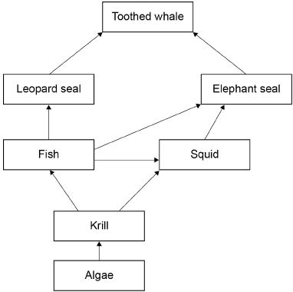
(a) What name is given to all the organisms together in an ecosystem?
Tick one box.

Community | 
Environment
Habitat
Population
(b) Look at the diagram above.
The population of leopard seals decreases if there are fewer elephant seals.
Explain why.
___________________________________________________________________
___________________________________________________________________
___________________________________________________________________
___________________________________________________________________(2)
Q2. Many biotic and abiotic factors can affect the growth of plants.
Are the factors in Table 1 biotic or abiotic?
Tick one box for each factor.
Table 1

Factor | Biotic | Abiotic
Diseases
Herbivores
Temperature
Water
(2)
Q3. Moose are animals that eat grass. Figure 1 shows a moose.
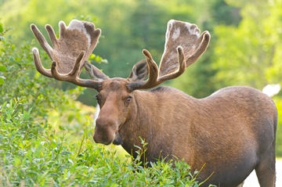
The number of predators is one biotic factor that could affect the size of the moose population.
Give two other biotic factors that could affect the size of the moose population.
1. _________________________________________________________________
___________________________________________________________________
2. _________________________________________________________________
___________________________________________________________________ (2)
Q4. This question is about ecology.
(a) Give two abiotic (non-living) factors which will affect the growth of plants on a school playing field.
Give a reason why each factor will affect the growth of the plants.
Abiotic factor 1 ______________________________________________________
Reason ____________________________________________________________
___________________________________________________________________
Abiotic factor 2 ______________________________________________________
Reason ____________________________________________________________
___________________________________________________________________
(4)

Challenge:
Every year scientists have recorded the date when migrating birds arrived at summer breeding grounds in the UK.
The records show that for every 1 °C increase in mean global temperature, the birds arrived one day earlier.
(a) What will the birds be competing for when they arrive at their UK breeding grounds?
Tick two boxes.

Eggs | 
Food
Light
Mates
Oxygen
(2)
(b) Birds that arrive early might survive better than birds that arrive later.
Suggest one reason why.
___________________________________________________________________
___________________________________________________________________
(1)

Lesson 2 – Measuring Species Distribution in an Ecosystem
Key Words:
Abundance | the quantity or amount of something present in a particular area, volume, or sample
Bias | showing inclination or prejudice for or against something.
Co-ordinates | any of a set of numbers used in specifying the location of a point on a line, on a surface, or in space
Distribution | the way in which something is spread over an area
Estimate | roughly calculate or judge the value, number, quantity, or extent of
Quadrat | a portable frame, typically with an internal grid, used to mark out a small area of habitat, typically of one square meter, selected at random to act as samples for assessing the local distribution of plants or animals.

Notes
To study an ecosystem ecologists, need to know the abundance (the number of individuals) or the distribution (where the individuals occur) of organisms in a specific area of habitat. Measuring these allows scientists to investigate how biotic and abiotic factors effect populations in an ecosystem. It is impossible to count the exact number of organisms in a large area so ecologists use sampling techniques to estimate the actual number. There are two main sampling techniques: quadrats and transects.
Quadrats are an example of random sampling. A quadrat is a simple square frame containing a grid that is placed randomly on the ground to count the number of plant species in a small area, usually 1m². It is then moved to a different random location and the process is repeated.
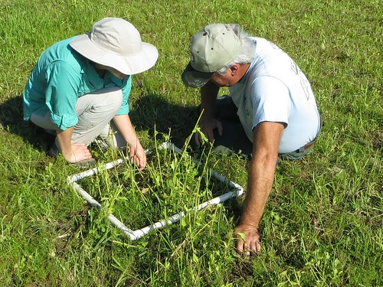
Random sampling is a way of eliminating personal choice (bias) in the selection of a sample. For a sample to be random, every part of your sample area should have an equal chance of being chosen every time you measure a section. Throwing a quadrat is not truly random as the whole area will not be equally as likely to be sampled it is restricted to your throw distance and the direction which you choose. Using coordinates to create a grid of the sample area and a random number generator (or picking numbers out of a hat) can be used to select coordinates which then tell you where to place the quadrat.
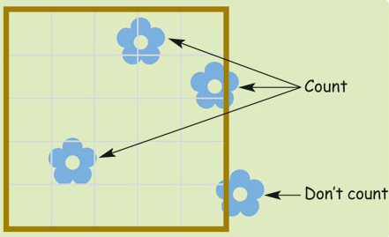
Only individuals completely within the frame are counted each time. It is important that as many quadrats as possible are taken during the sampling to ensure the result are reliable. More quadrats would make a larger sample so the data would be more representative. Once a large number of results have been recorded a mean can be calculated.
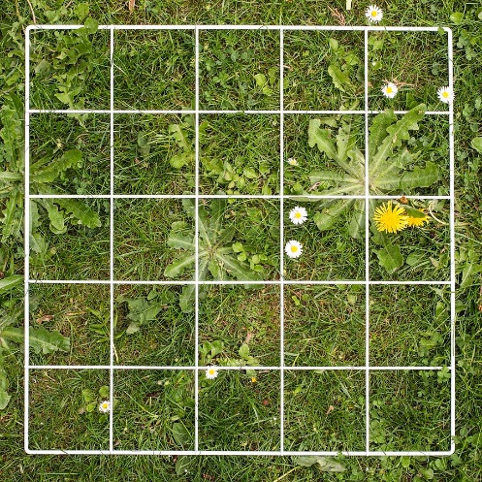
To estimate population size = sampled area x number of organisms total area

Recall Questions
- What does abundance mean?
- What does distribution mean?
- What is a quadrat?
- What method would you use to randomly positioning quadrats
- Count how many daisies are in this quadrat
- If each square of the quadrat in the picture is 10cmx10cm what area does the quadrat cover?
- Some students used quadrats to sample dandelions on a field that is 150 square meters they place the quadrat 8 times. How could they make their estimate of the number of plants more accurate?
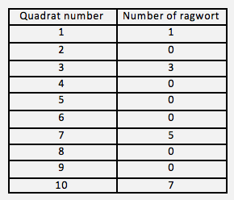
- Ragwort is a plant that often grows in weed in grassland. Students estimated the number of ragwort growing in a field. The table shows the students’ results. The area of the field was 80 000 m². The quadrat used was 1 metre x 1 metre

Complete the following calculation to estimate the number of ragwort plants in the field.
Use the information from the table above
Total number of ragwort plants in 10 quadrats =
Mean number of ragwort plants in 1 m² =
Therefore estimated number of ragwort plants in a field =

Transects are an example of systematic (non random) sampling
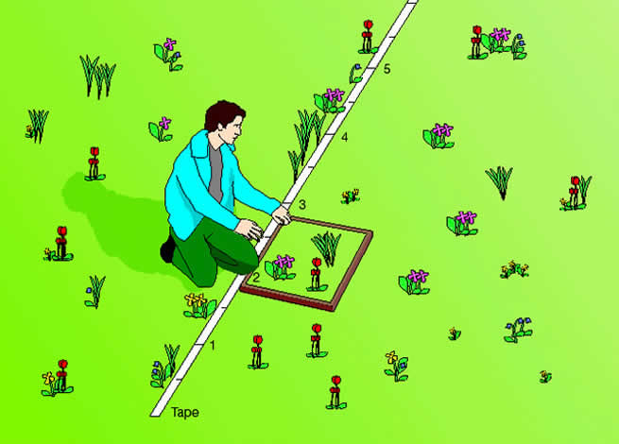
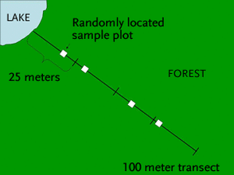
Transects involve a tape measure being placed along a varied stretch of habitat (eg a coastline from sea to beach or from a shaded spot to a sunny spot) and using a quadrat to record species at regular intervals along the line. Because these regular intervals this is not random sampling
Transects allow scientists to see how the distribution of a species changes as the habitat changes and is a useful way of investigating how biotic and abiotic factors affect a species. For example: light, temperature, nutrients, water, pH of soil. competition, trampling by animals (including humans!). You can increase the reliability of transects by repeating them in similar areas.
Recall Questions
- What does distribution mean?
- What is a transect designed to investigate?
- Compare the information you can get from a quadrat and transect.
Exam Questions:
Q1. Some students wanted to find the number of thistle plants growing on a lawn.
The students placed 10 quadrats at different positions on the lawn. Each quadrat measured 1 metre × 1 metre. The students counted the number of thistle plants in each quadrat.
(a) Which method should the students use to decide where to place the 10 quadrats?
Tick () one box.

Place the quadrats as evenly as possible around the lawn. | 
Place 5 quadrats in areas with many thistle plants and 5 quadrats in areas with only a few thistle plants.
Place all the quadrats randomly on the lawn.
(b) The diagram shows the lawn with the positions of the thistle plants and the students’ 10 quadrats.
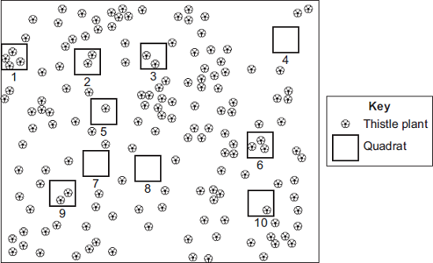
(i) Complete the table to show:
• how many thistle plants the students found in each of the first four quadrats
• the total number of thistle plants found in all 10 quadrats.

 | Quadrat  number | Number of thistle  plants in each  quadrat
 | 1
 | 2
 | 3
 | 4
 | 5 | 1
 | 6 | 3
 | 7 | 0
 | 8 | 0
 | 9 | 2
 | 10 | 1
 | Total
(2)
(ii) Calculate the mean number of thistle plants in one quadrat.
Mean = ______________________________________________ (1)
(iii) The lawn measured 12 metres long and 10 metres wide.
Use your answer from part (b)(ii) to estimate the number of thistle plants on the lawn.
______________________________________________________________
______________________________________________________________
Estimated number of thistle plants = _______________________ (2)
(c) How could the students make their estimate more accurate?
___________________________________________________________________
___________________________________________________________________ (1)
Q2. A student investigated the number of ribwort plants in a field.
The student used the apparatus shown in Figure 1.
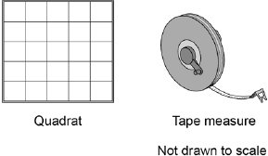
This is the method used.
1. Place the quadrat in an area where there are lots of ribwort plants in the field.
2. Count the number of ribwort plants inside a quadrat.
3. Repeat steps 1 and 2 four more times.

(a) How could the student improve his method so that he can collect valid results?
Tick two boxes.

Count the leaves of each ribwort plant | 
Place more quadrats in the field
Place the quadrats randomly
Use a smaller quadrat
Weigh the ribwort plants
(2)
(b) The student calculated that the mean number of ribwort plants per m² was 3.2
The area of the field was 8250 m².
Calculate the total number of ribwort plants in the field.
___________________________________________________________________
Total number of ribwort plants = ________________
(1)
(c) Another group of students did an investigation in the field.
Figure 2 shows how the students placed their quadrats in this investigation.
Figure 2
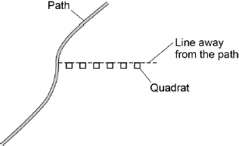
What is the name given to the line in Figure 2?
___________________________________________________________________
(1)
(d) Figure 3 shows the students’ results.
Figure 3
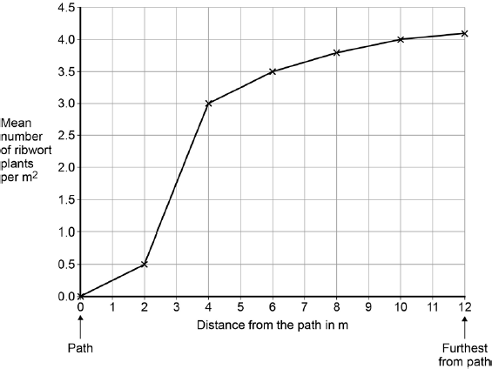
Describe the relationship shown in Figure 3.
___________________________________________________________________
___________________________________________________________________
___________________________________________________________________
___________________________________________________________________
(2)
(e) What is one reason why there are no ribwort plants next to the path?
Tick one box.

There is less light near the path
The ribwort plants get walked on
There are more nutrients in the soil near the path
There are fewer animals near the path
(1)
Q1. A grassy field on a farm measured 120 metres by 80 metres.
A student wanted to estimate the number of buttercup plants growing in the field.
The student found an area where buttercup plants were growing and placed a 1 m × 1 m quadrat in one position in that area.
Figure 1 shows the buttercup plants in the quadrat.
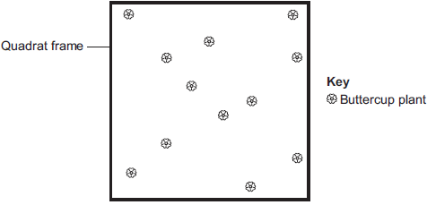
The student said, 'This result shows that there are 115 200 buttercup plants in the field.'
(a) (i) How did the student calculate that there were 115 200 buttercup plants in the field?
______________________________________________________________
______________________________________________________________
______________________________________________________________
______________________________________________________________ (2)
(ii) The student’s estimate of the number of buttercup plants in the field is probably not accurate. This is because the buttercup plants are not distributed evenly.
How would you improve the student’s method to give a more accurate estimate?
______________________________________________________________
______________________________________________________________
______________________________________________________________
______________________________________________________________
(2)
(b) Sunlight is one environmental factor that might affect the distribution of the buttercup plants.
(i) Give three other environmental factors that might affect the distribution of the buttercup plants.
1. ____________________________________________________________
2. ____________________________________________________________
3. ____________________________________________________________
(3)
(ii) Explain how the amount of sunlight could affect the distribution of the buttercup plants.
______________________________________________________________
______________________________________________________________
______________________________________________________________
______________________________________________________________
______________________________________________________________
______________________________________________________________
______________________________________________________________
(3)

Challenge:
Students used quadrats to estimate the population of dandelion plants on a field.
(a) Describe how quadrats should be used to estimate the number of dandelion plants in a field.
___________________________________________________________________
___________________________________________________________________
___________________________________________________________________
___________________________________________________________________
___________________________________________________________________
___________________________________________________________________
___________________________________________________________________
(4)
(b) The field measured 40 m by 145 m.
The students used 0.25 m² quadrats.
The students found a mean of 0.42 dandelions per quadrat.
Estimate the population of dandelions on the field.
___________________________________________________________________
___________________________________________________________________
___________________________________________________________________
___________________________________________________________________
Estimated population of dandelions = ______________
(2)
(c) In one area of the field there is a lot of grass growing in the same area as dandelions.
Suggest why the dandelions may not grow well in this area.
___________________________________________________________________
___________________________________________________________________
___________________________________________________________________
___________________________________________________________________
___________________________________________________________________
___________________________________________________________________
___________________________________________________________________
(4)

Lesson 3: Feeding relationships
Key Words
Biomass | the mass of tissue in living organisms
Competition | interaction between animal or plant species, or individual organisms, that are attempting to gain a share of a limited environmental resource e.g food, territory or mates
Consumers | Animals that need to eat and digest producers or other consumers, or both, to survive
Ecosystem | The habitat and all of the communities of living organisms that interact with it e.g a seashore
Excretion | The elimination of wastes from the body e.g faeces, urine, carbon dioxide.
Herbivores | An animal that consumes herbaceous vegetation
Population | All the individuals of a species living in a habitat
Predator | an organism that obtains food by the killing and consuming other organisms
Producers | organisms capable of creating simple carbohydrates, like glucose from carbon dioxide.
Notes
Part 1 – Explain why plants are known as producers
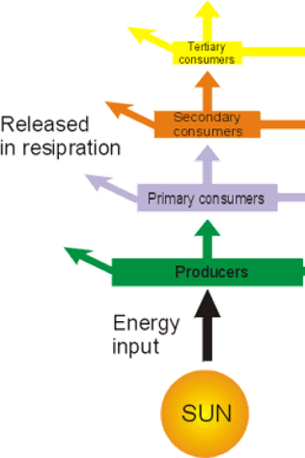
All species in an ecosystem live in a finely tuned balance. This interdependence requires biomass to be added by plants, algae and phytoplankton through photosynthesis. Biomass is the scientific name for the mass of tissue in living organisms. Using sunlight absorbed by chlorophyll in the chloroplasts they turn carbon dioxide and water into glucose. They also produce oxygen, which all aerobically respiring organisms require to survive.
For these reasons’ photosynthetic organisms like plants, algae and phytoplankton are called producers. Their biomass forms the foundation of all feeding relationships.
Energy moves from one organism to the next when they are consumed, however energy is lost at each stage due to it being released in respiration (for movement, active transport and as heat to maintain body temperature) and during excretion.

Recall Questions
- What is biomass?
- Write the word equation for photosynthesis
- What does ‘aerobic respiration’ mean?
- Write the word equation for aerobic respiration.
- Why do all organisms need to respire?
- Where does all the energy in an ecosystem come from?
- Why is energy lost each time an organism is consumed?
Part 2 – Identify trophic levels in a food chain
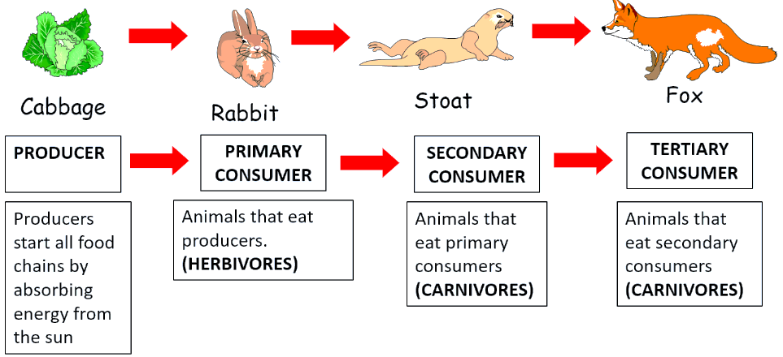
The herbivores that feed off the producers are known as primary consumers.
The carnivores that eat the primary consumers are known as secondary consumers. The tertiary consumers subsequently eat the secondary consumers.
Producers and consumers make up the different trophic levels of a food chain.

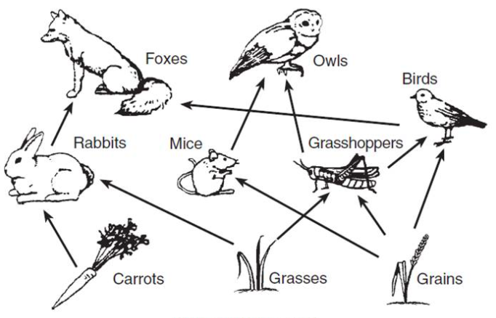
Simple feeding relationships are shown in a food chain. These are often over simplistic as a consumer might eat more than one organism from the level below. Instead, we represent these as food webs.
Biotic factors (predators, pathogens, availability of food) can change the numbers of individuals in each population. For example: competition between different types of rabbits can also reduce their numbers – when they have to share food and space the populations will be smaller than when they don’t have to compete with other rabbit species in the same area. Abiotic factors like temperature, chemicals (weed killer/pesticide), pH and light intensity can also affect organisms like insects and the plants they live on.

Food web interactions - If a factor causes an increase in the number of rabbits (like fewer predators) this would decrease the number of carrots and grasses. If the number of rabbits decreased this would reduce the amount of food for the foxes so their numbers are likely to decrease. The foxes will then also eat fewer birds so their number would increase. Remember to look at the impact on organisms on trophic levels above and below the organism that is directly affected by the factor.

Recall Questions
- What is a consumer?
- What is a herbivore?
- What is a carnivore?
- Why are food webs more accurate than food
- Define predator and give an example from the diagram
- Define prey and give an example from the diagram
- Using the food web above write 3 food chains.
- What will happen to the number of owls and mice if the birds eat more grasshoppers

Part 3 – Explain the changes in predator-prey relationships over time
Predators are consumers which hunt and kill their food (known as prey). As such over time a complex predator-prey relationship builds up. These change the population numbers which rise and fall in repeating cycles, for example:
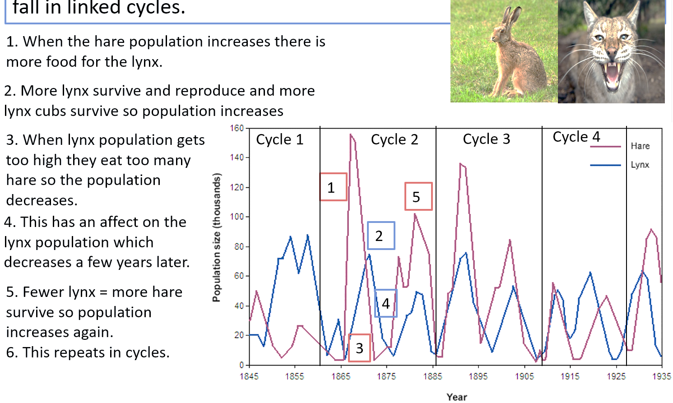

Recall Questions
- Why will the number of prey increase if the number of predators drops?
- Why will the number of predators increase if more prey are born?
- Explain why the population of a prey is linked to the population of a predator.
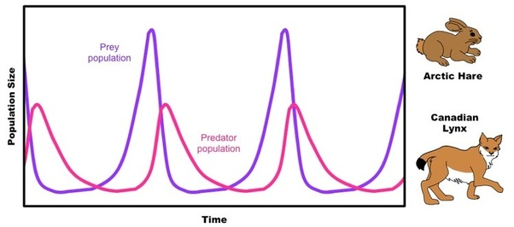
- Look at the graph below

Describe the changes in the population of the arctic hare. Explain the role of the Canadian lynx in those changes.

Exam Questions
Q1. Moose are animals that eat grass. Figure 1 shows a moose.
Figure 2 shows a food chain.
Grass Moose Wolves
(a) What word describes the grass in Figure 2?
Tick one box.

Consumer
Predator
Prey
Producer
(b) What word describes the wolves in Figure 2?
Tick one box.

Communities
Predators
Prey
Producers
(c) Figure 3 and Figure 4 show how the moose population and the wolf population changed in one area.
Figure 3
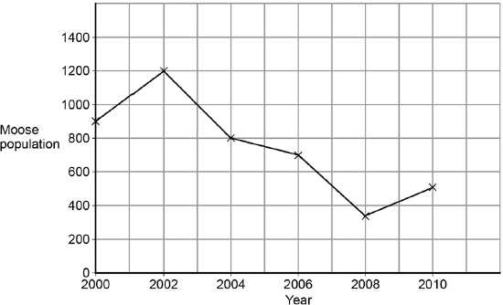
Figure 4
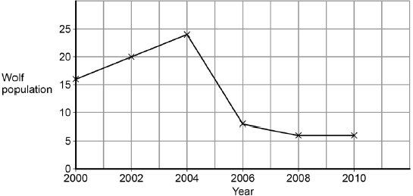
Look at Figure 3.
In this area the moose population reached its peak in 2002.
What was the size of the moose population in 2002?
___________________________________________________________________
(1)
(d) Look at Figure 4.
How long after the moose population peak did the wolf population peak occur?
___________________ years
(1)
(e) When the moose population increases, the wolf population increases soon after.
Why does the wolf population increase?
Tick one box.

There is more competition for moose
There is more food for wolves
Other animals prey on moose
There are more predators of wolves
(1)

Q2.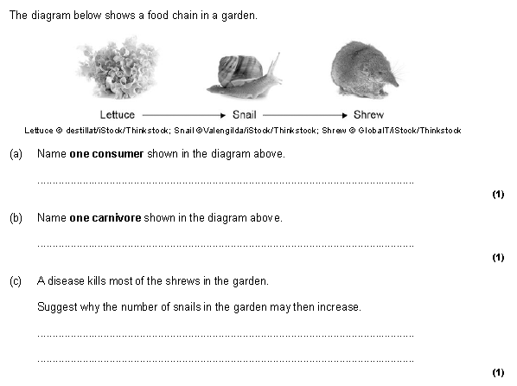

Q3. Owls are predators of mice and voles.The graph below shows how the total number of mice and voles changed over two years.
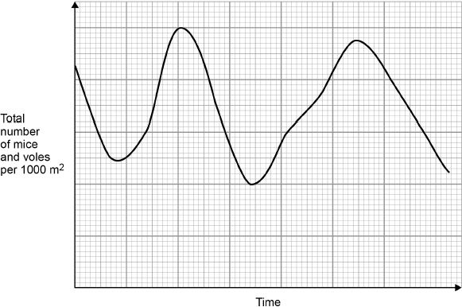
(c) The number of owls also changed over the same time period.
The changes in the numbers followed a typical predator−prey relationship.
Sketch a line on the graph above to show how you would expect the number of owls to change.
(3)
(d) What would happen to the number of voles if the population of mice decreased?
Give reasons for your answer.
___________________________________________________________________
___________________________________________________________________
___________________________________________________________________
___________________________________________________________________
(2)
Q1. The greenfly is an insect which is eaten by ladybirds.
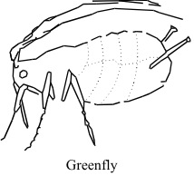
(a) (i) What do we call animals, like the ladybird, which hunt and kill other animals for food?
__________________________________________________________
(1)
(ii) What do we call animals, like the greenfly, which are eaten by other animals?
__________________________________________________________
(1)

(b) What would happen to the number of ladybirds if the numbers of greenfly suddenly dropped?
___________________________________________________________________
(1)
Give a reason for your answer.
___________________________________________________________________
___________________________________________________________________
(1)
(c) Suggest two factors, other than the number of ladybirds, which could affect the number of greenfly.
1. _________________________________________________________________
2. _________________________________________________________________
(2)
Q2. Greenfly feed on rose bushes. Ladybirds (predators) feed on these greenfly. The graph shows how the population of greenfly and ladybirds in a garden change over a period of three years.
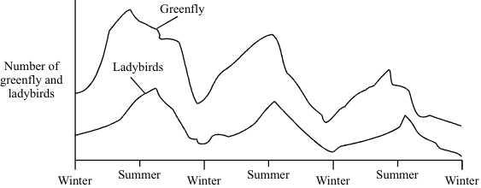
(a) Describe what happened to the population of greenfly over the three years.
_______________________________________________________________
_______________________________________________________________
_______________________________________________________________
_______________________________________________________________
_______________________________________________________________
_______________________________________________________________
_______________________________________________________________
(3)
(b) Give one factor that limits the number of ladybirds.
_______________________________________________________________
_______________________________________________________________(1)
Lesson 4 – Cycling of Materials
Key Words:
Decay | rot or decompose through the action of bacteria and fungi.
Decomposer | an organism that decomposes organic material.
Deforestation | the action of clearing a wide area of trees.
Fossil Fuel | a natural fuel formed in the geological past from the remains of living organisms
Microorganism | a microscopic organism, especially a bacterium, virus, or fungus.
Recycle | return (material) to a previous stage in a cyclic process.
Notes:
Part 1 – Describe how nutrients are cycled in ecosystems
The earth is a closed system, there is a fixed amount of each element. Life has evolved to constantly recycle important nutrients. Nutrients that are recycled include: carbon, oxygen, hydrogen, nitrogen. These are needed to make the molecules essential to life including: water, DNA, proteins, carbohydrates (including glucose) and carbon dioxide.
Plants get these nutrients from the air, water and soil and make them into complex compounds such as carbohydrates and proteins – these then move into animals through food chains when they eat the plant material.
Nutrients go back to the soil in excreted waste products or when organisms die and tissues decay. Organisms decay because they are broken down by microorganisms usually in warm, moist, aerobic (oxygen) conditions.
The organisms that decompose (breakdown) dead organisms are called decomposers. They are mostly microorganisms (bacteria and fungi) but they are helped by larger organisms such as maggots, worms and beetles which start the process off by breaking up large material. Decomposers are a group of organisms which have adapted to feed on waste, dead animals and plants. They use them as food and in the process release the nutrients back into the soil and the carbon dioxide into the air. These are then taken up again by producers and the process restarts!
Part 2 - Describe how carbon cycles in an ecosystem
The cycling of carbon is in balance as long as there are enough trees and there are no extra processes putting CO₂ into the atmosphere. Humans cut down trees and burn fossil fuels which have disrupted the carbon cycle.
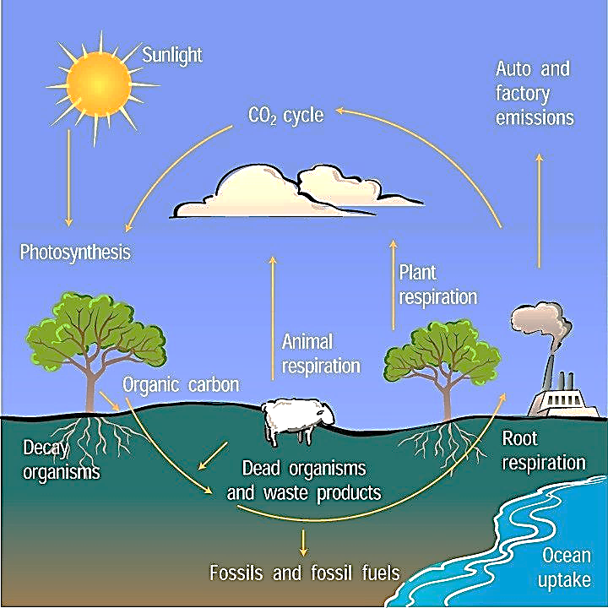
- The only process that removes carbon dioxide from the atmosphere is photosynthesis. Some can also be dissolved in oceans but this makes them acidic.
- Processes that put carbon dioxide back into the atmosphere include: respiration and burning fossil fuels.
- When organisms decay the carbon in molecules in their bodies (e.g cellulose in plants) is returned to the ecosystem as carbon dioxide.
- Fossil fuels are the remains of organisms from millions of years ago that didn’t decay properly so they contain a lot of carbon. This is released as carbon dioxide when the fossil fuels (coal and oil) are burned.

Recall Questions
- Name 3 substances that can be recycled in our atmosphere
- How do plants absorb nitrates?
- What is a decomposer?
- Name two ways in which organic material is returned to the soil for decomposers to break down.
- How does carbon from plants get into animals?
- How does carbon from fossil fuels get into the air?
- Name the only process that removes carbon dioxide from the atmosphere
- List the processes that add carbon dioxide to the atmosphere
- How is carbon released from dead matter in the soil?
- How does carbon in the atmosphere return to organisms?
- How can deforestation affect the carbon cycle?
- What aspect of the carbon cycle has been changed by human activity?

Part 3 – Describe how water cycles on Earth
Water is endlessly cycled on Earth through a series of processes:
- Precipitation – as water droplets in clouds get heavier they fall as rain, hail, sleet & snow. This provides fresh water for animals and plants who cannot use salt water.
- Condensation – as warm air rises water vapour rises and as it gets higher up it cools and condenses, forming clouds.
- Evaporation – the Sun heats the Earth’s surface, water evaporates to form water vapour.
- Percolation – water trickles through gaps in the soils and rocks and eventually drains to rivers and the sea.
- Transpiration – water evaporates from the leaves of plants through stomata
Task
Write the processes of the water cycle correctly on the diagram
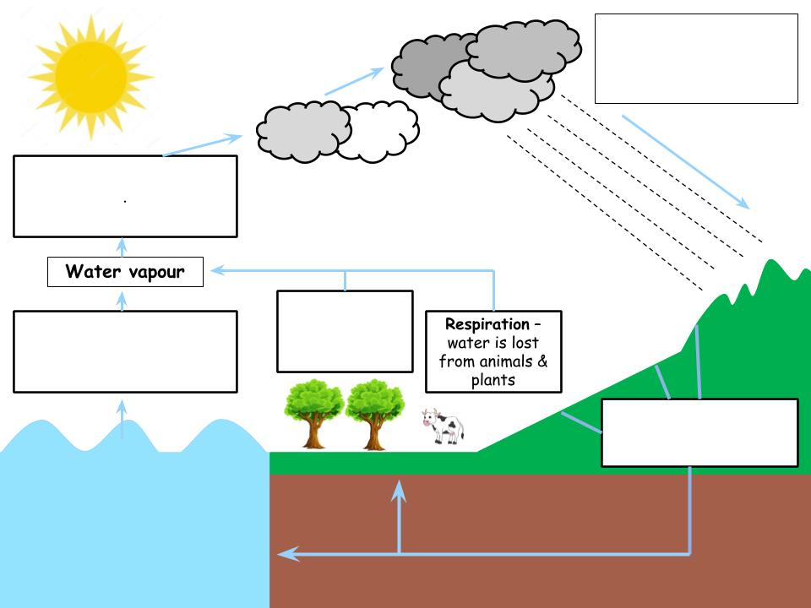
Exam Questions
Q1. The figure below shows the carbon cycle.
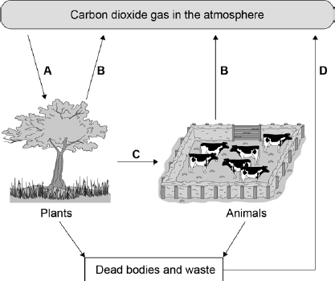
Use the information from the figure above to answer the questions.
(a) In process A, carbon dioxide in the atmosphere is taken into plants.
What is process A?
Tick one box.

Evaporation
Fossilisation
Photosynthesis
Respiration
(1)
(b) In process B, carbon dioxide is released from plants and animals into the atmosphere.
What is process B?
Tick one box.

Burning
Feeding
Photosynthesis
Respiration
(c) In which process is carbon passed from one organism to another?
Tick one box.

A
B
C
D
(1)
(d) What will happen to the concentration of carbon dioxide in the atmosphere if lots of trees are cut down?
___________________________________________________________________
___________________________________________________________________
(1)
(e) Greenhouse gases cause global warming.
Carbon dioxide is a greenhouse gas.
Name two other greenhouse gases.
1. _________________________________________________________________
2. _________________________________________________________________
(2)
(f) When living organisms die the dead material decays and is broken down.
The process of decay returns carbon dioxide to the atmosphere.
What type of organism causes decay?
___________________________________________________________________ (1)
(g) Gardeners use compost heaps to decay dead plants. Decayed compost is then spread onto the soil in a garden.
Explain why gardeners spread decayed compost onto the soil.
___________________________________________________________________
___________________________________________________________________
___________________________________________________________________
___________________________________________________________________
(2)

Q2. Complete the sentences about the water cycle.

Water _______________ from the surface of the ______________ . Heat from

the ________________ speeds up this process and so does the ____________.

Water vapour in the atmosphere cools down and ____________ to form billions

of tiny water droplets. Some of the droplets join together and fall as ____________ .
Q3. (a) Complete the following sentences.
(i) Plants remove carbon dioxide from the air by a process
called ___________________________________
(1)
(ii) All organisms produce carbon dioxide during a process
called ___________________________________
(1)
(b) Too much carbon dioxide in the atmosphere can harm the environment.
Suggest two different ways of reducing the amount of carbon dioxide in the atmosphere.
___________________________________________________________________
___________________________________________________________________
___________________________________________________________________
(2)

Q1. The diagram shows some processes in the carbon cycle.
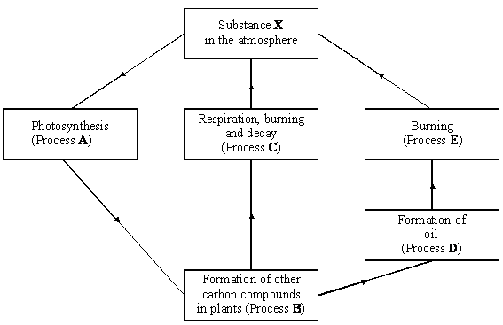

- What is the name of substance X?
___________________________________________________________________ (1)

(ii) Which process, A, B, C, D or E, takes the longest and approximately how long does it take?

___________________________________________________________________
___________________________________________________________________ (1)

Q4. (i) Why are fungi called decomposers?
___________________________________________________________________
___________________________________________________________________
- Give one other type of decomposer.
___________________________________________________________________

Q5 Complete the following sentences about decay processes.

Materials are constantly cycled.

Dead organisms decay because they are broken down and digested by

___________________________________________________________________

The decay process releases substances. These substances help the growth of

___________________________________________________________________

Carbon dioxide is also released when dead organisms decay. Carbon dioxide

is a waste product of _________________________________________________ .

(3)

Challenge. The diagram shows part of the carbon cycle.
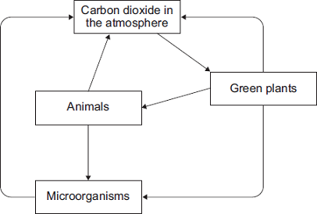
Describe how living things are involved in the constant cycling of carbon.
(Total 6 marks)

Lesson 5 – Human Impact on Biodiversity: Land Use
Key Words:
Biodiversity | The range and variety of species and habitats within a particular area
Biofuels | A fuel derived immediately from living matter.
Carbon sink | A natural environment that is able to absorb carbon dioxide from the atmosphere.
Decomposition | The state or process of rotting; decay.
Exponential | An increase that is becoming more and more rapid.
Extinct | When a species has no living members; it no longer exists
Greenhouse gas | A gas that contributes to the greenhouse effect by absorbing infrared radiation.
Habitat | The non-living physical part of an ecosystem
Peat | A brown substance resembling soil, formed by the partial decomposition of plant matter in the wet, acidic conditions of bogs, often cut out and dried for use as fuel and in gardening
Population | A group of individuals of the same species that occupy the same habitat
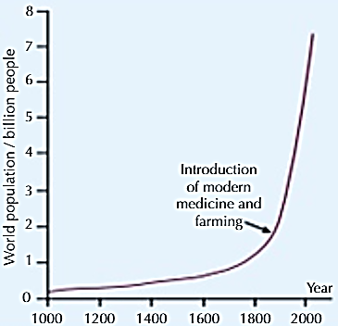
Notes
Part 1 – Describe the recent changes in the human population
Modern humans have existed on earth for less than one million years. This is less than 0.02% of the entire time life has been on earth. Yet in that tiny fraction of time our actions have made huge changes to the earth. In 2019 there were 7.7 billion people on the earth, with an increase of 82 million people each year. Only 200 years ago the global population was under 1 billion people. The population is continuing to rise exponentially, and it is due to a few factors:
- Modern medicine keeping more people alive and alive for longer.
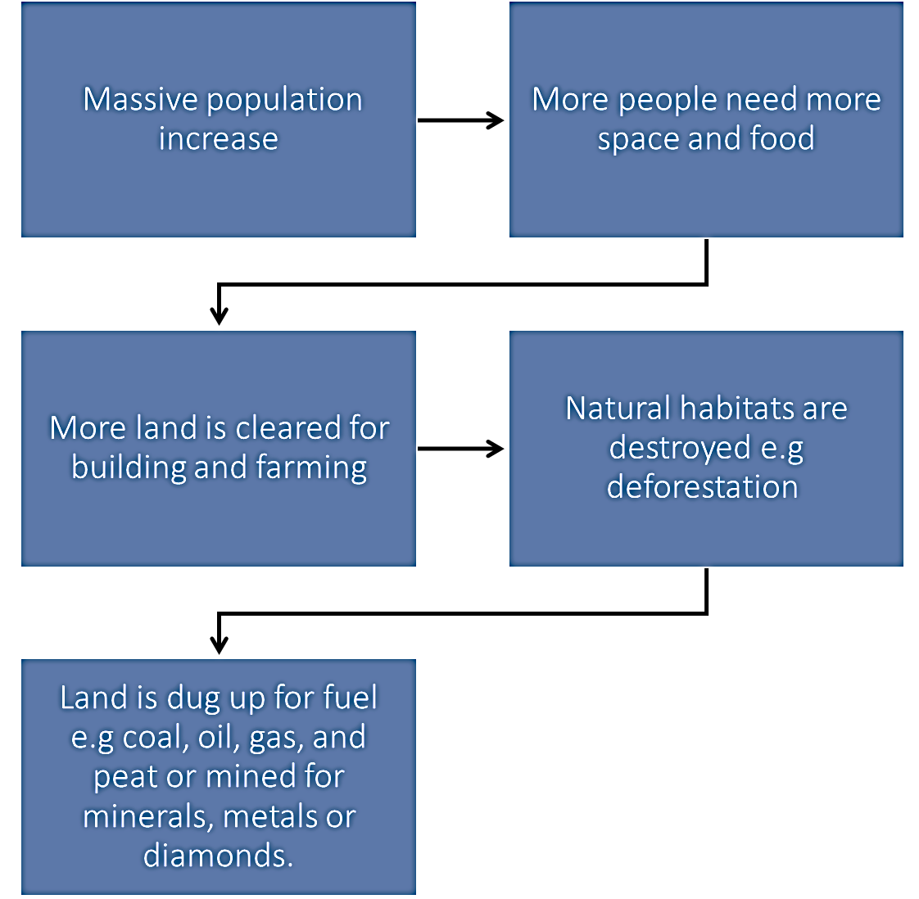
- Improved farming methods and ability to transport and store food so fewer people die from hunger or deficiency diseases.
Part 2 – Describe ways humans are impacting biodiversity
Biodiversity is the measure of the variety of all species on earth, or in a particular ecosystem. In general, high biodiversity is good for the stability of ecosystems. The success of the earth to maintain life is dependent on maintaining a high level of biodiversity.
Biodiversity is reduced (the number of different species decreased) by human activity when:
- Habitat is lost or changed e.g deforestation
- Ecosystems are disrupted by flooding or drought (caused by climate change or humans)
- Climate change causes extreme weather or changes in migration patterns
Humans need biodiversity because it increases our natural resources for materials, medicines and food. This massive increase in the population has caused us to take up more space on the planet. Look at the flow diagram to see the effect of population increase on land use and its impact on biodiversity.
Recall Questions
- Define 'biodiversity'.
- Why is having a high biodiversity important?
- What are two major problems from the exponential increase in human population?
- What is an ecosystem?
- Why has human population expanded so much? Give 2 reasons.
- Give three examples of ways humans reduce biodiversity
- How does a decrease in biodiversity have a negative impact on humans?
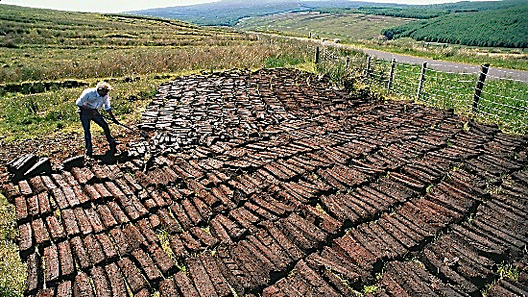
Part 3 – Explain how two types of land use affect the environment
Peat Extraction
Peat is formed in waterlogged, bogs over thousands of years by the growth of mosses and other plants, which absorb and ‘lock away’ carbon dioxide during photosynthesis - they are known as carbon sinks. When the moss dies, the waterlogged bog provides anaerobic conditions which prevent decomposition of the moss. It accumulates in the bogs in a partially decayed state, forming peat (a soil like substance).
Reasons for Peat Extraction: | Problems with Peat Extraction:
- Peat can be dug up, dried and burnt as a fuel, which makes it an important energy source in some countries.  - Peat has valuable properties when mixed in with soil making it valuable in agriculture and gardening. Many peat bogs have been drained (water removed) to allow the peat to be extracted to make compost. | - Draining peat bogs reduces biodiversity because they are a unique environment and some species can only live there  - Uses peat for energy releases carbon dioxide in the atmosphere.  - When peat is exposed to the air it starts to decay – microorganisms respire while they do this using the peat and oxygen from the air which releases more CO₂  - Destroying peat bogs increases the risk of flooding as they help absorb water.
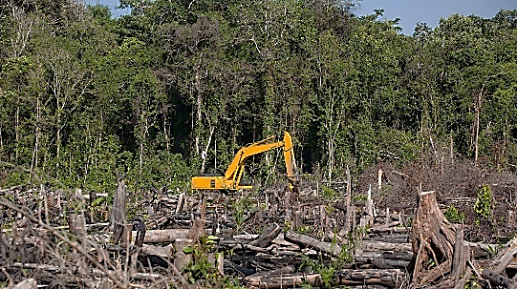
Deforestation
Deforestation is the cutting down of large areas of trees or forests and is another major example of humans reducing biodiversity by changing the land. Forests are also a carbon sink because they remove CO₂ from the atmosphere and trap it through photosynthesis.
Reasons for Deforestation: | Problems caused by Deforestation
- Provides land for farming animals such as cattle (cattle also produce methane. A greenhouse gas)  - Clears land to grow crops for food and biofuels  - Jungles are cut down to clear space to plant palm trees to sell the oil. The palm oil is used in foods, beauty products and to make biofuels | - Less carbon dioxide is removed from the atmosphere by trees through photosynthesis  - More carbon dioxide is released into the atmosphere when trees are burned or left to decay once they are chopped down  - Reduces biodiversity as forest habitats support a huge number of different species of plants and animals. Rainforests especially are a unique habitat so removing large areas of them can cause species to become extinct.

Recall Questions
- What is a habitat?
- Give two examples of good carbon sinks.
- Give a reason for deforestation.
- Give a reason for peat destruction.
- Name two major impacts deforestation has on the environment and biodiversity.
- Name two major impacts peat extraction has on the environment and biodiversity.
- Suggest a source of carbon dioxide release.

Exam Questions

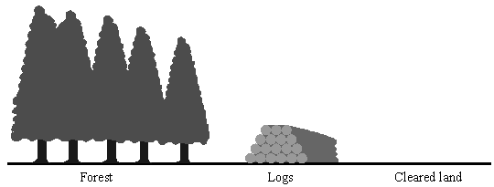
Q1.
Some large forest areas are being destroyed. This changes the amount of carbon dioxide in the atmosphere.

(a) (i) State one use for the trees that are cut down.
______________________________________________________________ (1)
(ii) State one use for the cleared land.
______________________________________________________________ (1)
(iii) How has the destruction of forests affected the amount of carbon dioxide in the atmosphere?
______________________________________________________________ (1)
Q2. Deforestation affects the environment in many ways.
(a) Deforestation increases the amount of carbon dioxide in the atmosphere.
Give two reasons why.
1. _________________________________________________________________
___________________________________________________________________
2. _________________________________________________________________
___________________________________________________________________ (2)
(b) Deforestation also results in a loss of biodiversity.
(i) What is meant by biodiversity?
______________________________________________________________
______________________________________________________________ (1)
Q3. Peat is removed from peat bogs. The peat can be mixed with air and added to garden compost.
The release of carbon dioxide from peat is a problem. Give two other reasons why gardeners should use less peat-based compost in the future.
1. _________________________________________________________________
___________________________________________________________________
2. _________________________________________________________________
___________________________________________________________________(2)
Q4. The UK contains large areas of peat bogs that have been present for thousands of years.
(a) Peat is removed from peat bogs.
The peat can be mixed with air and added to garden compost.
The release of carbon dioxide from peat is a problem.
Give two other reasons why gardeners should use less peat-based compost in the future.
1. _________________________________________________________________
___________________________________________________________________
2. _________________________________________________________________
___________________________________________________________________
(2)

Q5. Human activities have many effects on our ecosystem. The graph shows the volume of peat compost and peat-free compost used in gardening from 1999 to 2009.
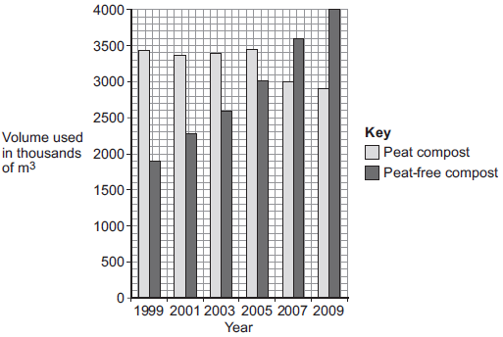
- Describe the trends shown in the graph.
______________________________________
______________________________________
______________________________________
- What effect does the destruction of peat bogs have on the gases in the atmosphere?
______________________________________
______________________________________
______________________________________
- Describe one effect of deforestation on ecosystems.
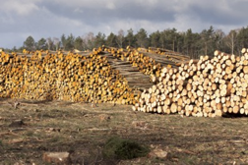
____________________________________________________________________________
Challenge:
Deforestation affects the environment. Deforestation is causing a change in the amounts of different gases in the atmosphere. This change causes global warming and climate change.
Give the reasons why deforestation is taking place.
Describe how deforestation is causing the change in the amounts of different gases in the atmosphere.
(Total 6 marks)
Lesson 6 – Human Impact on Biodiversity: Pollution

Key Words:
Acid rain | rainfall made so acidic by atmospheric pollution that it causes environmental harm
Algae | a simple aquatic plant includes seaweeds and many single-celled forms.
Bioaccumulation | When a substance becomes concentrated inside the bodies of living things.
Biodiversity | The range and variety of species and habitats within a particular area
Decomposer | an organism (usually bacteria or fungi) that decomposes organic material.
Fertilisers | a chemical or natural substance added to soil or land to increase its concentration of nutrients
Herbicide | A toxic chemical that kills plants. Sometimes called ‘weed killer’.
Pesticide | A toxic chemical that kills animals.
Pollution | The introduction into the environment of a substance which has harmful or poisonous effects.
Sewage | waste water and excrement normally transported in sewers.
Smog | fog or haze intensified by smoke or other atmospheric pollutants

Notes:
Part 1 – Describe the impact of land pollution by humans
Humans don’t just affect the environment by what we remove. Humans also release a huge amount of waste as sewage, litter and as waste from industrial processes. These can have a massive effect on ecosystems and biodiversity. We risk damaging the water and air supply, affecting both the lives of the humans and the native species that reside in a particular habitat.
Most land pollution is either the result of deliberate pollution from toxic industrial waste, human sewage or from farming. Sewage, radioactive waste, fertilisers, pesticides (chemicals that kill insects) and herbicides (chemicals that kill plants) can poison soils and make habitats not safe to live in.
Recall Questions
- State four sources of land pollution.
- Explain how household and industrial wastes pollute the land.

Part 2 – Describe the impact of water pollution by humans
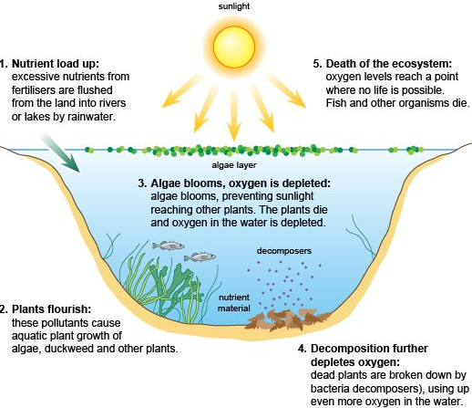
Everything that humans do to the land in time will end up in the water. This is due to rainfall causing water to run off the land into the rivers and streams.
If fertilisers build up in a lake, they can cause algae to grow incredibly quickly. They cover the surface of the pond blocking out the light to the plants at the bottom. These underwater plants die and are fed on by decomposers which use up all the oxygen in the water. The lack of oxygen kills the fish and other aquatic animal life. This process is called eutrophication.

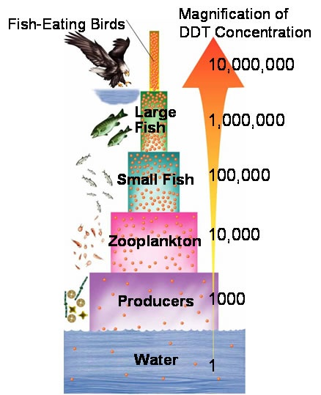
Pesticides, herbicides, and poisonous metals can cause a problem due to bioaccumulation. This is when the chemicals that are in low levels in the water begin to build up in producers and primary consumers. These levels are still too low to kill the organisms, but the consumers above them eat many and the toxins begin to build up as they move up the food chain. By the time the top carnivore has fed the amount of chemical is in much higher concentration and kills them.
Recall Questions
- State four sources of water pollution.
- Name the situation where a body of water has low oxygen levels, leading to marine organisms' death.
- What causes eutrophication?
- What is bioaccumulation?
- Name a chemical that gets built up in organisms in bioaccumulation.
- Why is bioaccumulation bad?

Part 3 – Describe the impact of air pollution caused by humans
Most air pollution is the result of humans burning fossil fuels. The gases from engines cause problems like acid rain, smog and global warming and global dimming.
Source | Pollution | Problem Caused
Burning fossil fuels (power stations, vehicles and factories) | Sulphur dioxide |   Acid Rain is caused by sulphur dioxide and nitrous oxides dissolving into the water in clouds forming acidic compounds. When the rain falls it kills the trees, increases the pH of ponds and lakes damaging aquatic life and destroys marble and limestone buildings.
 | Nitrogen dioxide
 | Smoke/particulates |   The tiny particulates of smoke pollution travel in the air they reflect the sunlight causing the global temperature to drop, known as global dimming. It also has a short-term effect in that it irritates human lungs leading to breathing problems.
 | Carbon dioxide |   Global warming is caused by these gases trapping more heat energy from the sun in the atmosphere and causing it to reflect back to the earth increasing the overall earth temperature.
Farming (Cows and rice fields) | Methane
 | All of the above |   Smog forms a cloudy haze that is seen over major cities and has been suggested that it contributes to lower life expectancy for people that live in cities compared to those that live in the countryside

Recall Questions
- Name a source of air pollution.
- How is acid rain formed?
- Name three gases released from burning fossil fuels.
- Give 3 effects of acid rain.
- What is global dimming?
- What causes global dimming?
- Explain how global dimming affect plant growth.
- What is smog?
- How does smog affect our health?
- Suggest two ways to reduce air pollution.
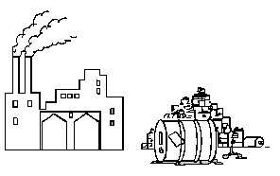
Exam Questions
Q1. The drawings below show some of the effects that human activities have on the environment.
Use information from the drawings to give two ways in which these human activities affect other living organisms.
1. _____________________________________________________________________
_______________________________________________________________________
_______________________________________________________________________
2. _____________________________________________________________________
_______________________________________________________________________
_______________________________________________________________________
( 2)
Q2. The diagram shows a village and its surroundings.
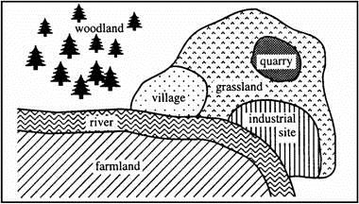
(a) Use words from the list to complete the sentences about pollution.
oxygen pesticides sewage sulphur dioxide
The air might be polluted by ____________________ from the industrial site.
The river might be polluted by ____________________ from the village and
by ____________________ from the farmland.
(3)
(b) The owners of the quarry want to make it larger.
Give one effect that this might have on wild plants and animals that live near the quarry.
___________________________________________________________________
___________________________________________________________________ (1)
Q3. Human activities affect the environment.
Water pollution and global warming are two problems that have been caused by the rapid increase of the human population.
Suggest two other problems caused by the rapid increase of the human population.
1. _________________________________________________________________
___________________________________________________________________
2. _________________________________________________________________
___________________________________________________________________
(2)
Q4. In December 1952, there was a thick fog in London. The graph shows changes in the amounts of sulphur dioxide and smoke in the air and the number of people dying during this period.
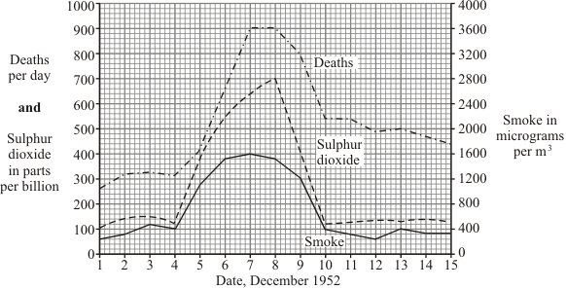
(a) Describe one human activity which releases sulphur dioxide into the air.
_________________________________________________________________ (1)
(b) Human deaths during this period were caused mainly by lung diseases.
(i) Why were the lungs particularly affected?
_____________________________________________________________
_____________________________________________________________ (1)
(ii) Give evidence from the graph which suggests that sulphur dioxide might have caused these deaths.
_____________________________________________________________
_____________________________________________________________ (1)
Challenge:
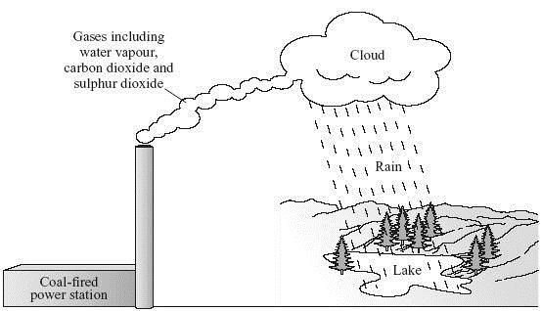
Coal is used in many power stations.
Use information from the diagram to describe, in as much detail as you can, how using coal in power stations can damage the environment.
(Total 4 marks)

___________________________________________________________________
___________________________________________________________________
___________________________________________________________________
___________________________________________________________________
___________________________________________________________________
___________________________________________________________________
___________________________________________________________________

Lesson 7 – Climate Change and Its Impact on Biodiversity
Key Words
Agriculture | the practice of farming, including the growing of crops and the rearing of animals to provide food, wool, and other products.
Biodiversity | The range of species and habitats within a particular region
Conservation | protect something of environmental importance from harm or destruction.
Distribution | the way in which something is spread over an area
Endangered | a species seriously at risk of extinction.
Extinct | When a species has no living members; it no longer exists
Fossil Fuel | a natural fuel formed in the geological past from the remains of living organisms
Greenhouse gas | A gas that contributes to the greenhouse effect by absorbing infrared radiation.
Habitat | The non-living part of an ecosystem – the area in which an organism normally lives.
Land-fill | the disposal of waste material by burying it, especially as a method of filling in and reclaiming excavated pits.
Peer-review | evaluation of scientific or academic work by others working in the same field.

Notes:
Part 1 – Explain how human impact has caused the global temperature to rise
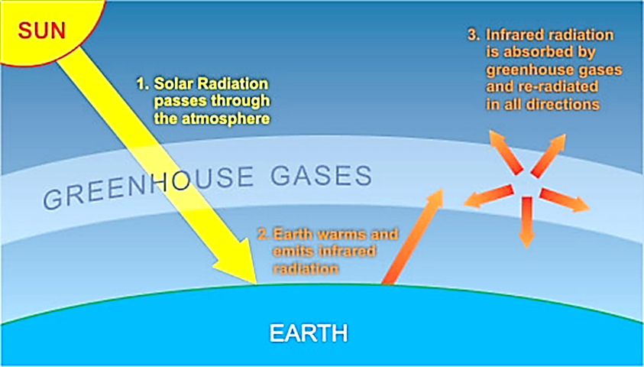
More carbon dioxide pollution from burning fossil fuels and more deforestation has caused a build-up of carbon dioxide in the atmosphere, more farming of cows and growing of crops like rice has released more methane into the atmosphere. Carbon dioxide and methane are known as greenhouse gases along with water vapour, because they trap heat energy from the sun.
High concentrations of greenhouse gases in the atmosphere allows more UV radiation from the sun to pass into the Earth’s atmosphere and more infra-red radiation from earth is absorbed by the gases increasing global temperatures
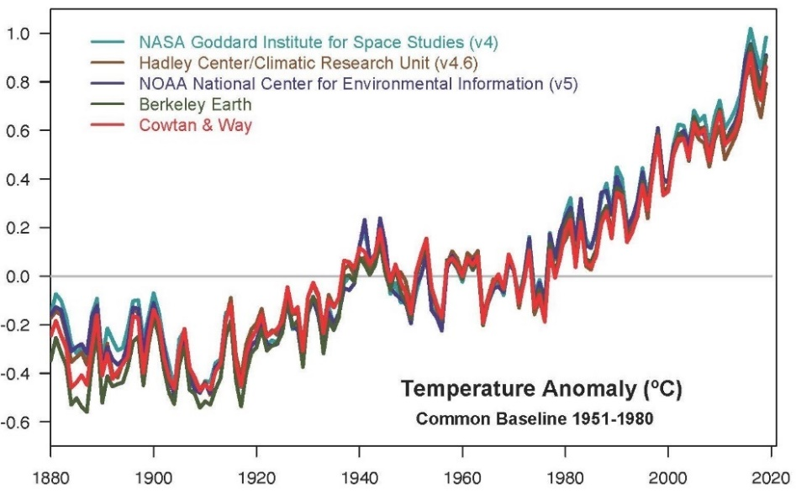
Supporting Evidence for Global Warming
According to NASA data, 2016 was the warmest year since 1880, continuing a long-term trend of rising global temperatures.
The 10 warmest years in the 140-year record all have occurred since 2005, with the six warmest years being the six most recent years.

Multiple studies published in peer-reviewed scientific journals show that 97% or more of actively publishing climate scientists agree that climate-warming trends over the past century are extremely likely due to human activities. In addition, most of the leading scientific organizations worldwide have issued public statements supporting this position.
Recall Questions
- Name three major greenhouse gases.
- Suggest a source of carbon dioxide release.
- Suggest a natural source of methane.
- What is the greenhouse effect?
- What causes global warming?

Part 2 – Explain the impact of climate change on biodiversity
Climate change is responsible for a reduction in biodiversity as it is linked to changes in:
 | Habitat. Higher temperatures cause seawater to expand and ice to melt causing sea levels to rise. This will reduce the amount of cold habitats at the poles of the earth and rising sea levels will cause flooding and destroy coastal ecosystems.
 | Weather changes. Wind patterns, rainfall and seasonal changes will lead to some species finding it hard to survive in their existing ecosystem. This may change where they can live or their distribution.
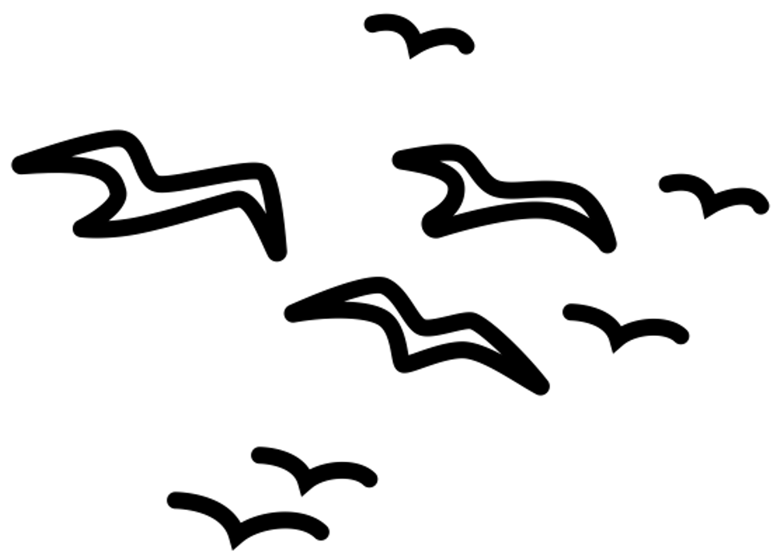 | Migration patterns. As climates become hotter and colder migrating patterns of birds, insects and mammals could change as they can no longer live in their previous locations.
These changes reduce biodiversity as organisms are not able to adapt and they may go extinct. This is more likely for species that live in areas which will suffer the greatest change. For example, polar bears are at high risk of extinction because they live on ice in the coldest regions.
Recall Questions
- State three effects of climate change.
- What biological consequences does the melting of ice caps bring about?
- State the three environmental factors that can cause a change in the distribution of organisms.

Part 3 – Explain why maintaining biodiversity is important
It is important to ensure that human developments and activities are sustainable in order to ensure that sufficient resources are available for future generations. It is important to maintain biodiversity because: ​
- We have a moral responsibility​ not to destroy the planet
- Animals and plants can be useful for the development of medicines​
- Aesthetic reasons​ (nature is beautiful)
- We need to conserve ecosystems so that the planet functions (e.g. we rely on microorganisms for the breakdown of waste/recycling of nutrients).​

What can we do to help maintain biodiversity?
- Have breeding programmes for endangered species
- Protect and regenerate rare habitats
- Reintroduce hedgerows in agricultural areas where farmers grow only one type of crop to increase biodiversity
- Reduce deforestation and carbon dioxide emissions by governments
- Reduce, reuse and recycle resources rather than dumping waste in landfill

Recall Questions
- Suggest one positive change humans have started to make to reduce their impact.
- Suggest one negative impact on the environment due to humans.
- State three methods to maintain biodiversity.
- Why is important to protect and regenerate rare habitats?
- Give one impact on the environment by removing hedgerows.
- What problem is solved by recycling?
Exam Questions
Q1. The following passage is from a newspaper report on a recent conference about global warming.
If we keep pumping out greenhouse gases, islands in the Pacific will disappear; droughts in Africa will bring famine to 50 million people; floods in low lying places like Bangladesh will make 200 million people homeless; Venice will be submerged:

(a) Name one major greenhouse gas.
___________________________________________________________________
(1)
(b) Explain how greenhouse gases may cause effects like those described in the passage.
___________________________________________________________________
___________________________________________________________________
___________________________________________________________________
___________________________________________________________________
(4)
Q2. Global warming may reduce biodiversity in some areas.
(a) What gases cause global warming?
Tick two boxes.

Carbon dioxide
Methane
Nitrogen
Oxygen
Water vapour
(2)
(b) Give two effects of global warming that could reduce biodiversity in an area.
1. _________________________________________________________________
___________________________________________________________________
2. _________________________________________________________________
___________________________________________________________________ (2)

Q3. The graph shows changes in temperature and in carbon dioxide concentration in the earth’s atmosphere between 1860 and 1990.
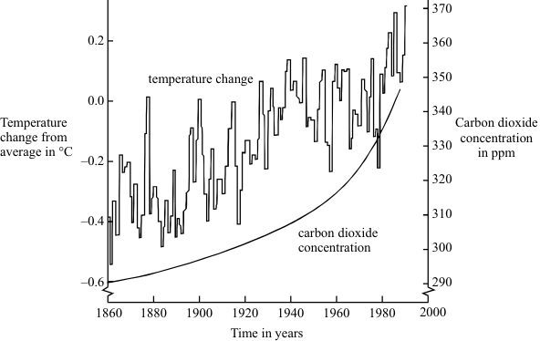
(a) Give two human activities which may have helped to increase the concentration of carbon dioxide in the atmosphere.
1 ________________________________________________________
2 ________________________________________________________
(2)
(b) (i) Describe the changes in temperature shown by the graph between 1860 and 1990.
______________________________________________________________
______________________________________________________________
______________________________________________________________
(2)
(ii) Do the data in the graph prove that increased carbon dioxide concentrations in the atmosphere caused the changes in temperature you described in part (b)(i)?
Give a reason for your answer.
______________________________________________________________
______________________________________________________________
(1)

Q4. Scientists have discovered that curry spices affect sheep and cattle. Curry spices can reduce the amount of methane that grazing animals give off.
‘Bad’ bacteria in the animal’s stomach produce methane. About 12% of the animal’s food is changed into methane.
The curry spice coriander works like an antibiotic. Adding coriander to animal food reduces methane production by about 40%.
(a) (i) Why does adding coriander to an animal’s food reduce methane production?
______________________________________________________________
______________________________________________________________ (1)
(ii) Explain one advantage to a farmer of adding coriander to the animal’s food.
______________________________________________________________
______________________________________________________________
______________________________________________________________ (2)
(b) Farm animals give off large amounts of methane.
Explain the effects of adding large amounts of methane to the atmosphere.
___________________________________________________________________
___________________________________________________________________
___________________________________________________________________
___________________________________________________________________
___________________________________________________________________ (3)
Q5. As we are using more resources, waste management is becoming more important. In the UK much of the solid waste is still being dumped in landfill sites.
In 1996, the UK government introduced a landfill tax because landfill sites were being used up. However, the year after the landfill tax was introduced it was estimated that 18 million tonnes of landfill waste was not reported. The government was trying to encourage other forms of waste management, such as:
• reduce waste
• reuse waste
• recycle waste
(i) Explain the main problem caused by the landfill tax.
______________________________________________________________
______________________________________________________________
______________________________________________________________
(2)
(ii) Describe one example of how each of the different forms of waste management can be put into practice.
Reduce waste __________________________________________________
______________________________________________________________
Reduce waste __________________________________________________
______________________________________________________________
Reduce waste __________________________________________________
______________________________________________________________
(3)
Q6. Approximately a third of UK household rubbish is organic matter such as food waste and gardening rubbish.
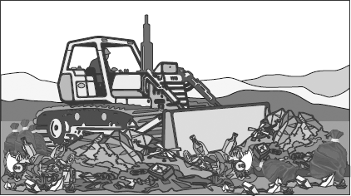
Many councils have large-scale composting schemes to decompose this rubbish. The products from this process can be sold. This pays for some of the cost of collecting and processing the rubbish.
(a) Which two of the following are reasons to encourage more councils to have large-scale composting schemes?
Tick () two boxes.

There will be less household rubbish
They produce substances that help plants grow
They do not cost anything
They reduce landfill
(2)

Q7. Approximately a third of UK domestic rubbish is organic matter such as food waste and gardening rubbish.
Many councils have started industrial composting schemes to decompose these wastes. One product of the decomposition is compost (decaying organic matter).
Use this information and your own knowledge to suggest reasons why more councils should be encouraged to start industrial composting schemes.
_______________________________________________________________________
_______________________________________________________________________
_______________________________________________________________________
_______________________________________________________________________
_______________________________________________________________________
_______________________________________________________________________
(3)
Challenge:
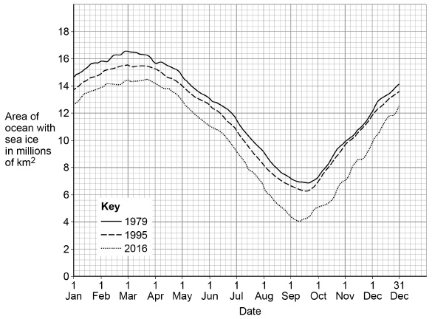
Human activities can affect our ecosystem. The graph shows information about how the area of ocean with sea ice in the arctic has changed between 1979 and 2016.
The area of ocean with sea ice in the arctic has changed.
Most scientists believe this is due to the activities of humans.
Explain the activities of humans that have led to the changes in sea ice from 1979 to 2016.
(6)

