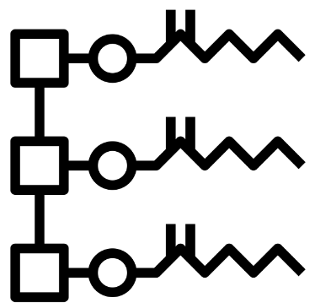
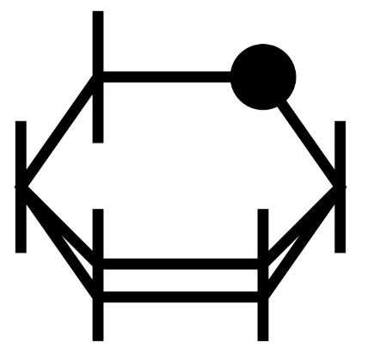
AQA A Level Biology

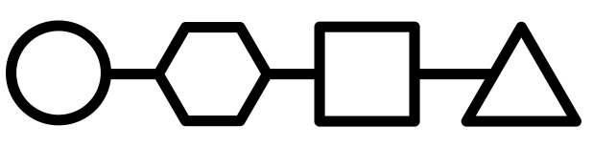

Biological Molecules
(3.1.1 - 3.1.4.1)

Name: ______________________

Lesson | My Marks | Total Exam Question Marks | Homework Checked | Date
Lesson 1 – Monomers and Polymers
Lesson 2 – Carbohydrates I
Lesson 3 – Lipids
Lesson 4 – Proteins
Lesson 5 – Enzymes
Lesson 6 – Biochemical Tests
End of Topic Test

Specification Section

3.1.1 Monomers and polymers
Content
The variety of life, both past and present, is extensive, but the biochemical basis of life is similar for all living things.
Monomers are the smaller units from which larger molecules are made.
Polymers are molecules made from a large number of monomers joined together.
Monosaccharides, amino acids and nucleotides are examples of monomers.
A condensation reaction joins two molecules together with the formation of a chemical bond and involves the elimination of a molecule of water.
A hydrolysis reaction breaks a chemical bond between two molecules and involves the use of a water molecule.

3.1.2 Carbohydrates
Content
Monosaccharides are the monomers from which larger carbohydrates are made. Glucose, galactose and fructose are common monosaccharides.  A condensation reaction between two monosaccharides forms a glycosidic bond.  Disaccharides are formed by the condensation of two monosaccharides:  - maltose is a disaccharide formed by condensation of two glucose molecules  - sucrose is a disaccharide formed by condensation of a glucose molecule and a fructose molecule  - lactose is a disaccharide formed by condensation of a glucose molecule and a galactose molecule.  Glucose has two isomers, α-glucose and β-glucose, with structures:  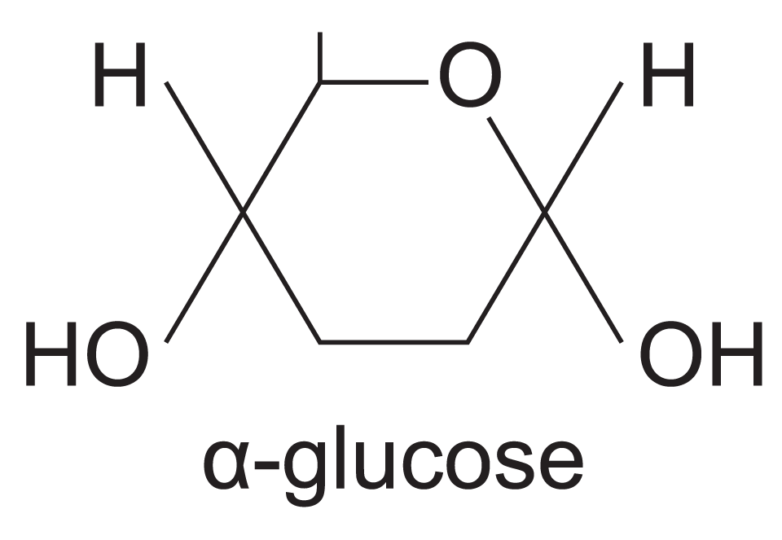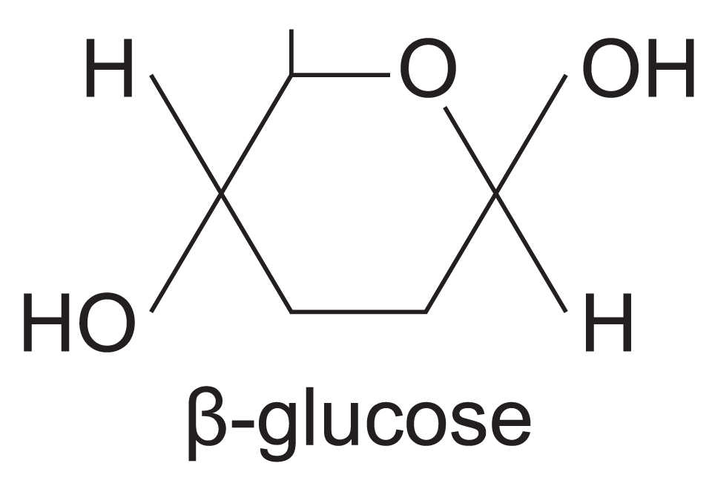  Polysaccharides are formed by the condensation of many glucose units.  - Glycogen and starch are formed by the condensation of α-glucose.  - Cellulose is formed by the condensation of β-glucose.  The basic structure and functions of glycogen, starch and cellulose. The relationship of structure to function of these substances in animal cells and plant cells.  Biochemical tests using Benedict's solution for reducing sugars and non-reducing sugars and iodine/potassium iodide for starch. | AT f  Students could use, and interpret the results of, qualitative tests for reducing sugars, non-reducing sugars and starch.  AT g  Students could use chromatography, with known standard solutions, to separate a mixture of monosaccharides and identify their components.  AT c  Students could produce a dilution series of glucose solution and use colorimetric techniques to produce a calibration curve with which to identify the concentration of glucose in an unknown solution.

3.1.3 Lipids
Content | Opportunities for skills development
Triglycerides and phospholipids are two groups of lipid.  Triglycerides are formed by the condensation of one molecule of glycerol and three molecules of fatty acid.  A condensation reaction between glycerol and a fatty acid (RCOOH) forms an ester bond.  The R-group of a fatty acid may be saturated or unsaturated.  In phospholipids, one of the fatty acids of a triglyceride is substituted by a phosphate-containing group.  The different properties of triglycerides and phospholipids related to their different structures.  The emulsion test for lipids.  Students should be able to:  - recognise, from diagrams, saturated and unsaturated fatty acids  - explain the different properties of triglycerides and phospholipids. | AT f  Students could use, and interpret the results of, the emulsion test for lipids.

3.1.4 Proteins

3.1.4.1 General properties of proteins
Content | Opportunities for skills development
Amino acids are the monomers from which proteins are made. The general structure of an amino acid as:  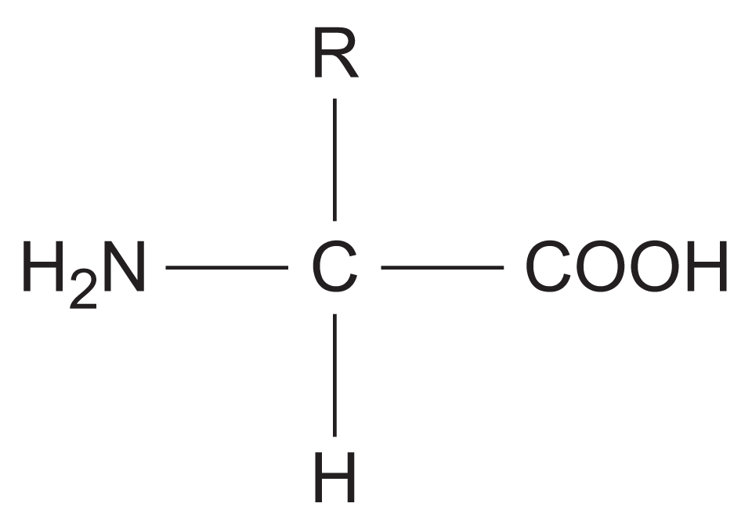  where NH₂ represents an amine group, COOH represents a carboxyl group and R represents a side chain. The twenty amino acids that are common in all organisms differ only in their side group.  A condensation reaction between two amino acids forms a peptide bond.  - Dipeptides are formed by the condensation of two amino acids.  - Polypeptides are formed by the condensation of many amino acids.  A functional protein may contain one or more polypeptides.  The role of hydrogen bonds, ionic bonds and disulfide bridges in the structure of proteins.  Proteins have a variety of functions within all living organisms. The relationship between primary, secondary, tertiary and quaternary structure, and protein function.  The biuret test for proteins.  Students should be able to relate the structure of proteins to properties of proteins named throughout the specification. | AT f  Students could use, and interpret the results of, a biuret test for proteins.  AT g  Students could use chromatography with known standard solutions, to separate a mixture of amino acids and identify their components.

GCSE Recap
Biological molecules
What do we know already?

- What is the chemical formula for glucose?
- Name 5 things plants and animals need glucose for.
- How do animals get glucose?
- How do plants get glucose?
- Name 5 uses of proteins in the human body.
- Which carbohydrate is found in plant cell walls?
- Where in the human body is starch broken down?
- What do proteases do?
- What is the function of an emulsifier?
- Where are the instructions for making proteins?
- Name 2 types of chemical bonds.

Lesson 1 – Monomers and Polymers
Key Words
Amino acid | A monomer which makes up proteins. Has a central carbon atom which is bonded to: a carboxylic acid group, an amino group, a hydrogen atom and a R group.
Condensation Reaction | Chemical process in which two molecules combine to form a more complex one with the elimination of a simple substance, usually water. Many biological polymers (e.g. polysaccharides, polypeptides) are formed by condensation.
Covalent Bond | Type of chemical bond in which two atoms share a pair of electrons.
Hydrolysis | The breaking down of large molecules into smaller ones by the addition of water molecules.
Monomer | One of many small molecules that combine together to form a polymer
Monosaccharide | A single sugar e.g. glucose. The monomers of long chain carbohydrate polymers
Nucleotide | A compound consisting of an organic base and ribose sugar linked to a phosphate group. Nucleotides form monomers of nucleic acids such as DNA.
Organic Molecule | Molecules containing carbon that can be found in living things; four classes are carbohydrates, proteins (chain of amino acids), lipids, and nucleic acids

Notes
The biochemistry of life is shared across all organisms, this is indirect evidence of evolution. The molecules of life all contain carbon, hydrogen and oxygen – they are organic, and they can be grouped into four types:
- Carbohydrates – respiratory substrates which provide energy for cells, also used for structure in cell membranes and cell walls in plants
- Lipids – can be used as respiratory substrates which provide energy for cells, form a bilayer in cell membranes and make up some hormones.
- Proteins – main component of many cellular structures, form enzymes and chemical messengers.
- Nucleic Acids – form polymers (DNA and RNA) which make up the genetic material of organisms. Code for the sequence of amino acids which make up all proteins.
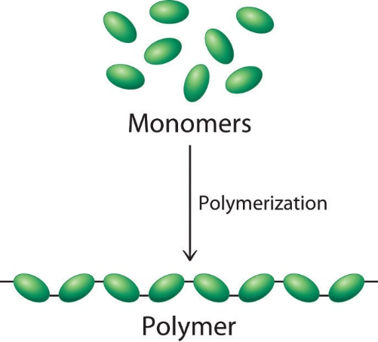
All organisms use the same nucleic acids as genetic material, use the same 20 amino acids to build proteins and use lipids and carbohydrates as energy stores and to make up their cell membranes and walls. These similarities give support for the theory that all animals and plants share a common ancestor.
Monomers and Polymers
Monomers are the smaller units from which larger molecules are made.
Polymers are molecules made from lots of repeating units (monomers) joined together.
Monosaccharides, amino acids and nucleotides are examples of monomers.

A condensation reaction joins two monomers together with the formation of a covalent bond and involves the elimination of a molecule of water. (hence the term condensation as a molecule of water is produced!)
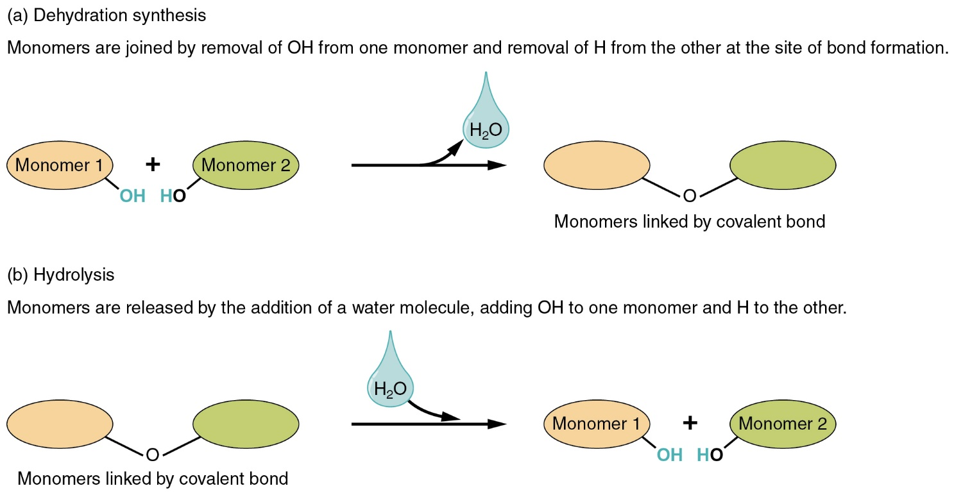
A hydrolysis reaction breaks the covalent bond between two monomers and involves the use of a water molecule. (literally the water molecule is split to form an OH and a H group – “hydro” = water, “lysis” = to split)
Examples
 | Carbohydrates | Proteins | Nucleic Acids
Monomers | Monosaccharides e.g glucose, fructose, galactose | Amino acids | Nucleotides
Covalent Bond Type | Glycosidic bond | Peptide bond | Phosphodiester bond
Polymer Made | Polysaccharides | Polypeptide | Polynucleotide
Polymer Examples | Glycogen (animals only)  Cellulose (plants only)  Starch (plants only) | Enzymes  Antibodies  Channel Proteins  Haemoglobin | DNA  RNA

Recall Questions
- What elements are common to all the molecules of life?
- What are the four main groups of carbon-based molecules common to all life forms?
- Which molecule forms part of the plasma membrane?
- Which biological molecules are required to make proteins?
- Which two biological molecules are the main respiratory substrates?
- What is a polymer?
- What reaction joins two monomers together?
- Which reaction breaks down polymers?
- What type of chemical bond is formed between monomers?
- Why is it known as a condensation reaction?
- Describe the process of hydrolysis
- What type of polymer is made from monosaccharides and what bond joins them together?
- What type of polymer is made from amino acids and what bond joins them together?
- What type of polymer is made from nucleotides and what bond joins them together?

Exam Questions
Q1. Starch and protein are biologically important polymers.
(i) Explain what is meant by a polymer.
______________________________________________________________
______________________________________________________________
(1)
(ii) Give one example of a biologically important polymer other than starch or protein.
______________________________________________________________
(1)
Q2. The diagrams show four types of linkage, A to D, which occur in biological molecules.
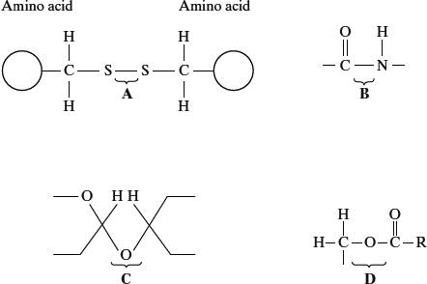
Name the chemical process involved in the formation of linkage A.
___________________________________________________________________ (1)
Q3. What is a monomer?
___________________________________________________________________
___________________________________________________________________
___________________________________________________________________
___________________________________________________________________
___________________________________________________________________
(1)
Q4. Name the type of reaction that joins monosaccharides together.
______________________________________________________________ (1)
Q5. (a) The table shows some statements about three carbohydrates. Complete the table with a tick in each box if the statement is true.

Statement | Starch | Cellulose | Glycogen
Found in plant cells
Contains glycosidic bonds
(2)
(b) Name the type of reaction that would break down these carbohydrates into their monomers.
___________________________________________________________________ (1)
Q6. The diagram shows part of a DNA molecule.
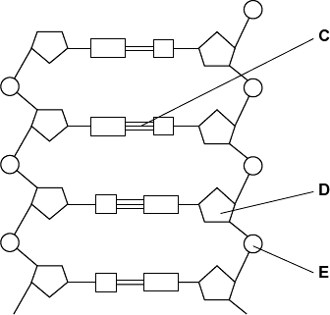
(a) (i) DNA is a polymer. What is the evidence from the diagram that DNA is a polymer?
______________________________________________________________
______________________________________________________________
______________________________________________________________
(1)
Q7. The equation shows the breakdown of lactose by the enzyme lactase.
Lactose + water galactose + monosaccharide X

(a) (i) Name the type of reaction catalysed by the enzyme lactase.
______________________________________________________________ (1)


Homework
1. Complete all exam questions from Lesson 1
2. Read notes and complete recall questions for lesson 2 as pre-learning
3. Stretch – Read: New Evidence from Molecular Biology section from “Science and Creationism: A View from the National Academy of Sciences”. Use the following Link: bit.ly/3A6n9pW or scan the code

Lesson 2 – Carbohydrates
Key Words
Alpha glucose | An isomer of glucose that can bond together to form starch or glycogen.
Beta glucose | An isomer of glucose that can bond together to form cellulose.
Cellulose | A polysaccharide made up of beta-glucose found in plant cells (beta-1,4-glycosidic bonds).
Disaccharide | Made up of two sugar units that are formed by a condensation reaction. Monosaccharides are joined by a glycosidic bond.
Glucose | C₆H₁₂O₆ – a single sugar which is used in respiration.
Glycogen | A highly branched polysaccharide made up of alpha-glucose found in animal cells (alpha-1,4- and alpha-1,6-glyosidic bonds).
Glycosidic bond | Bond between sugar molecules in disaccharides and polysaccharides.
Hexose sugar | A sugar made up of 6 carbons.
Hydrogen Bond | Chemical bond formed between the positive charge on a hydrogen atom and the negative charge on another atom of an adjacent molecule. Often between negative oxygen and positive hydrogen atoms
Isomer | Two or more compounds with the same formula but a different arrangement of atoms in the molecule and therefore different properties.
Monosaccharide | A single sugar e.g. glucose
Non-reducing sugar | A sugar which cannot serve as a reducing agent. An example is sucrose.
Polysaccharide | Made of many sugar units that are formed by a condensation reaction. Monosaccharides are joined by a glycosidic bond.
Reducing Sugar | A sugar that serves as a reducing agent. All monosaccharides are reducing sugars along with some disaccharides.
Starch | A polysaccharide found in plant cells made up of alpha-glucose – comprised of amylose (alpha-1,4 glycosidic bonds) and amylopectin (alpha-1,4- and alpha-1,6-glyosidic bonds).
Notes
Monosaccharides:
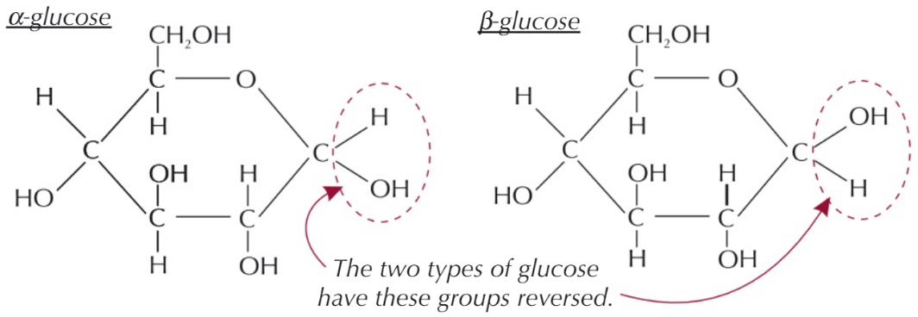
These are the individual sugar molecules (monomers) that make up disaccharides and polysaccharides. Examples include: glucose, fructose and galactose. There are two types of sugar molecules we encounter in the course: hexose sugars (contains six carbon atoms – “hex” as in hexagon) and pentose sugars (contains five carbon atoms “pent” as in pentagon) you will see pentose sugars when we look at nucleotides in more detail.
Glucose is a hexose sugar that can form to isomers: α-glucose (alpha) and β-glucose (beta). You need to learn the structure and the difference between them so that you can recognise each one in diagrams.

Disaccharides:
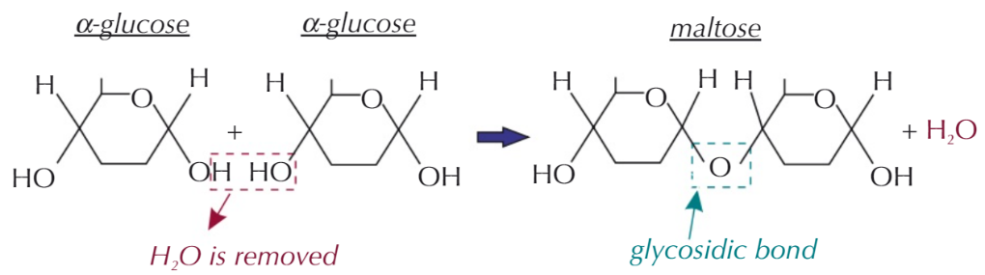
Disaccharides are formed when two monosaccharides join through a condensation reaction forming a glycosidic bond between the two OH groups. Maltose, sucrose and lactose are examples of disaccharides. All monosaccharides and some disaccharides are reducing sugars (they can lose or donate electrons to other compounds).
Maltose = glucose + glucose (reducing)
Lactose = glucose + galactose (reducing)
Sucrose = glucose + fructose (non-reducing)
Polysaccharides:
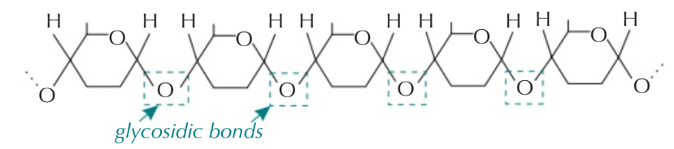
A polysaccharide is formed when more than two monosaccharides are joined together by condensation reactions. Polysaccharides can be broken down by hydrolysis back into their monomers.
 | Starch | Glycogen | Cellulose
Monosaccharide | α-glucose | α-glucose | β-glucose
Structure | Mixture of two polysaccharides: amylose and amylopectin  Amylose = long unbranched forms coiled/spring shape.  Amylopectin = long branched chain due to 1-6 glycosidic bonds | A long, branched chain with lots of side branches (more than amylopectin). The glycosidic bonds are also 1-6. | Long unbranched straight chains. The glycosidic bonds are 1-4. The cellulose chains are then linked together by hydrogen bonds between the glucose molecules in each chain to form thicker fibres called microfibrils.
Diagram | 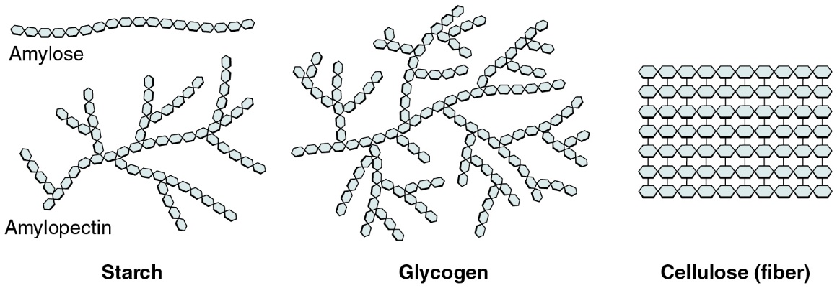
Properties | Amylose = coiling makes it compact and stores more in a smaller space  Amylopectin = branches increase surface area for enzymes to hydrolyse glycosidic bonds allowing glucose to be released quickly | Lots of branches increase surface area for enzymes to hydrolyse glycosidic bonds allowing glucose to be released quickly. It is also a compact molecule so it is good for storage. | The hydrogen bonds between the cellulose chains make the microfibrils very strong but still flexible allowing them to provide support.
Uses | Plants use starch as a way of storing excess glucose as it is too large to leave cells and insoluble (doesn’t dissolve in water – this also means it does not affect water potential). Starch can be hydrolysed to release glucose for respiration. | Animals store excess glucose as glycogen in muscles and in the liver. Glycogen is therefore an energy store as it can be hydrolysed to release glucose quickly when needed for respiration e.g during exercise. | Cellulose is a major structural component in the cell walls of plants, it provides support and allows cells to become turgid.
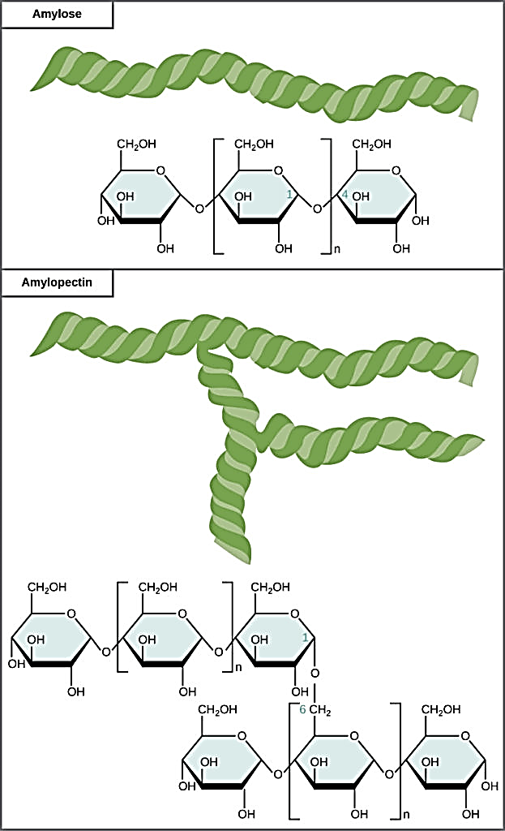
Polysaccharides can be formed from glucose monomers that are joined by 1-4 or 1-6 glycosidic bonds. The numbers 1-4 and 1-6 refer to the carbon number of the two molecules that have joined to form the bond.

Amylose and cellulose are formed by straight unbranched chains of glucose monomers with 1-4 glycosidic bonds, whereas amylopectin and glycogen are branched polysaccharides with 1-6 linkages at the branch points. This gives different shapes to the molecules that gives them their properties.
Recall Questions
- What type of reaction joins monosaccharides together?
- What is a disaccharide? What type of bond is involved?
- State the reaction that breaks down maltose.
- What disaccharide is made by joining glucose and glucose?
- What are the two monosaccharides that join up to make sucrose?
- What disaccharide is made by joining glucose and galactose?
- What are the 3 types of polysaccharides that α-glucose can form?
- What type of reaction breaks polysaccharides apart?
- Describe the structure of glycogen
- State the two structures that make up starch.
- Describe the structure and properties of starch
- What’s the differences and similarities between starch and glycogen?
- How are the monosaccharides in cellulose arranged?
- Why are different enzymes needed to digest starch and cellulose?
- Based on the arrangement of cellulose molecules, explain why cell walls provide strength and support to plant cells.
- 1,6 glycosidic bonds are found on ........
- β-glucose can only be found in ........
- Describe the structure of amylopectin, including the bonds involved and the shape.
Practice Questions
1. Complete the table. [9]

 | Starch |  | Glycogen | Cellulose
 | Amylose | Amylopectin | Glycogen | Cellulose
Zoomed out image showing general structure
Zoomed in image showing monosaccharide bonding
Found in plants or animals?
Alpha or beta glucose?
Structural or energy storage?
Found in plants or animals?
Branched or straight chain?
Soluble or insoluble?
2. Draw two molecules of alpha glucose and show how they react together to form a disaccharide. Name the reaction and the bond. [4]

Exam Questions
Q1. (a) The table shows some statements about three carbohydrates. Complete the table with a tick in each box if the statement is true.

 | Statement | Starch | Cellulose | Glycogen
 | Found in plant cells
 | Contains glycosidic bonds
 | Contains β-glucose
(3)
(b) Name the type of reaction that would break down these carbohydrates into their monomers.
........................................................................................................................
(1)
(c) Give one feature of starch and explain how this feature enables it to act as a storage substance.
Feature...........................................................................................................
Explanation.....................................................................................................
........................................................................................................................
........................................................................................................................
(2)
Q2.Starch and cellulose are two important plant polysaccharides.
The following diagram shows part of a starch molecule and part of a cellulose molecule.
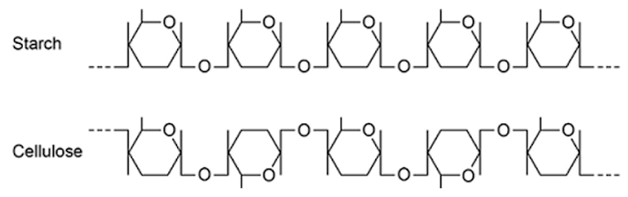

(a) Explain the difference in the structure of the starch molecule and the cellulose molecule shown in the diagram above.
........................................................................................................................
........................................................................................................................
........................................................................................................................
........................................................................................................................(2)
(b) Starch molecules and cellulose molecules have different functions in plant cells. Each molecule is adapted for its function.
Explain one way in which starch molecules are adapted for their function in plant cells.
........................................................................................................................
........................................................................................................................
........................................................................................................................
........................................................................................................................
(2)
(c) Explain how cellulose molecules are adapted for their function in plant cells.
........................................................................................................................
........................................................................................................................
........................................................................................................................
........................................................................................................................
........................................................................................................................
........................................................................................................................
(3)
Q3. The diagram shows one end of a cellulose molecule.
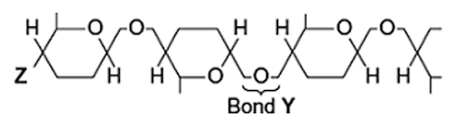
(a) (i) Name the monomers that form a cellulose molecule.
...............................................................................................................
(1)
(ii) Name bond Y.
...............................................................................................................
(1)
(iii) What chemical group is at position Z?
...............................................................................................................(1)
(b) (i) Complete the table to show two ways in which the structure of cellulose is different from the structure of starch.

 | Starch | Cellulose

(2)

(ii) Explain one way in which the structure of cellulose is linked to its function.
...............................................................................................................
...............................................................................................................
...............................................................................................................
...............................................................................................................
...............................................................................................................
(2)

Q4. Cellulose is made from one type of monomer. The monomers are held together by bonds. The diagram shows parts of three cellulose molecules in a cell wall.
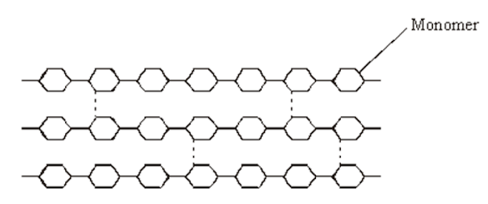

(a) Name the monomer present in cellulose.
......................................................................................................................
(1)
(b) Name the type of reaction that converts cellulose to its monomers.
......................................................................................................................
(1)

(c) Cotton is a plant fibre used to make cloth. Explain how cellulose gives cotton its strength.
......................................................................................................................
......................................................................................................................
......................................................................................................................
......................................................................................................................
......................................................................................................................
......................................................................................................................
(3)
Q5. The diagram shows a cell from a potato.
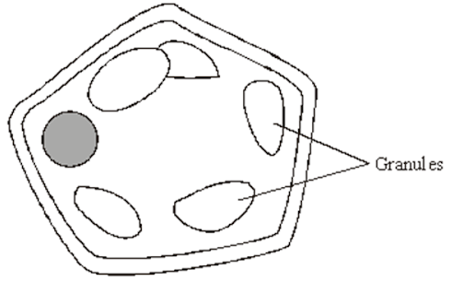
(a) Give two features which may be found in a prokaryotic cell which would not be found in this cell.
1 ...................................................................................................................
2 ...................................................................................................................
(2)
(b) Name one polysaccharide other than starch that would be found in this cell.
.............................................................................................................
(1)

(c) Explain one advantage of storing starch rather than glucose in potato cells.
......................................................................................................................
......................................................................................................................
......................................................................................................................
......................................................................................................................
(2)

Homework
1. Complete all exam questions from lesson 2 ready to be marked next lesson
2. Read notes and complete recall questions for lesson 3 as pre-learning
3. Complete the sentences using the words in bold
alpha amylopectin amylose beta biomass blue branched branches compact condensation glycosidic glycosidic helical hexose hydrolysis insoluble inverted lactose large liver maltose microfibrils monomers monosaccharides one pentose polymers polysaccharides red straight strong structure sucrose transport permeable

The majority of the ___________ that makes up organisms is composed of lipids, proteins, nucleic acids and carbohydrates. Of these, the latter three are all ___________. Polymers are long chains of repeating units known as ___________. Monomers are joined by ______________ reaction (water is formed as a byproduct) to form polymers and polymers broken down into constituent monomers by ___________ reaction (water is required to break the bonds).

The monomers in carbohydrates are called ________________. Alpha-glucose, beta-glucose, fructose and galactose are all ___________ (6 carbon) sugars, while ribose and deoxyribose are all ___________ (5 carbon) sugars. Monosaccharides can be joined together to form disaccharides or ______________. The bond between the two monosaccharides is called a _____________ bond.
The most common disaccharides are:
Glucose + Glucose = _______________ (used by germinating seeds)
Glucose + Galactose = ______________ (found in mammalian milk)
Glucose + Fructose = _______________ (used to ____________ sugar around plants)

Starch is produced in plants and made of two types of polysaccharide: amylose and _________________. Amylose is made of a long, _________ chain of ________-glucose molecules joined together through a 1-4 bonds (i.e. carbon 1 on one glucose molecule is bonded to carbon 4 on the next). __________ is also made of a chain of glucose molecules but there are also side ___________ as a result of 1-6 bonds. Starch is an important storage molecule in plants as a result of the following properties:
- ___________: Soluble molecules change the water potential of the solution they are dissolved in. It is important that starch is insoluble so the water potential remains constant and no water is drawn into the cell by osmosis.
- ___________: A lot of glucose can be stored in a small space.
- ___________: It cannot diffuse out of the cell.
- ___________ (amylopectin): Many enzymes can work simultaneously on the starch to rapidly hydrolyse it back into usable glucose molecules.

Glycogen is produced in animals. It has a similar function to starch but is composed of only _______ polysaccharide that appears like a more highly branched form of amylopectin. Glycogen is often stored in the _______ and muscles.
Cellulose is composed of long chains of _______-glucose molecules. Within the chain each glucose molecule is _________ (upside-down) compared to the glucose molecules either side. This arrangement means the chains are _________ rather than helical. When different chains run parallel to one-another they form hydrogen bonds between them resulting in clusters of chains, known as ___________. These microfibrils make up the plant cell wall, so cellulose is required for ___________ rather than storage of glucose. The properties of cellulose make it suitable for this function:
- _________ and rigid: Many hydrogen bonds form between many cellulose strands to form microfibrils. Collectively this confers great strength and rigidity, thus preventing plant cells from bursting when water enters by mitosis.
- Fully ___________: Large gaps remain between different microfibrils which ensures substances are able to move close to the cell membrane where selective absorption can take place.

Lesson 3 – Lipids
Key Words
Glycerol | A molecule which combines with three fatty acids to form triglycerides. It is 3 carbon chain with 3 hydroxyl groups.
Hydrophilic | Section of a molecule which is attracted to water.
Hydrophobic | Section of a molecule which is repulsed by water.
Lipid | A class of organic compounds that are fatty acids are their derivatives and are insoluble in water but soluble in organic solvents. They include triglycerides, phospholipids, waxes and steroids.
Mono-unsaturated fatty acid | Fatty acid which possesses a carbon chain with a single double bond between carbon atoms.
Phospholipid | Triglyceride in which one of the three fatty acid molecules is replaced by a phosphate molecule. Phospholipids are important in the structure an functioning of plasma membranes.
Poly-unsaturated fatty acid | Fatty acid which possesses a carbon chain with many double bonds between carbon atoms.
Saturated fatty acid | A fatty acid in which there are no double bonds between the carbon atoms
Triglyceride | An individual lipid molecule made up of a glycerol molecule and three fatty acids. Contains ester bonds.
Notes
Lipids are different from proteins and carbohydrates as they are not polymers. They are still organic molecules as they contain hydrogen and carbon. Lipids can provide a source of energy, help to insulate organisms, act as waterproofing, form membranes and hormones There are two types of lipids you need to know and how their structure relates to their function:
 | Triglycerides | Phospholipids
Components | A glycerol molecule and three fatty acid chains | A glycerol molecule, a phosphate group and two fatty acid chains.
Bonds | Ester bond formed by condensation reaction between each of the three OH groups on the glycerol and the OH group of each fatty acid chain. They are non-polar | Ester bond formed by condensation reaction between two OH groups on the glycerol and the OH group of each fatty acid chain.
Diagram | 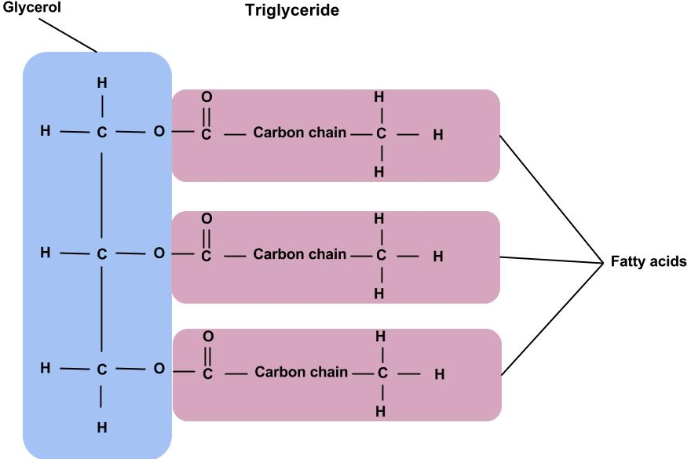 | 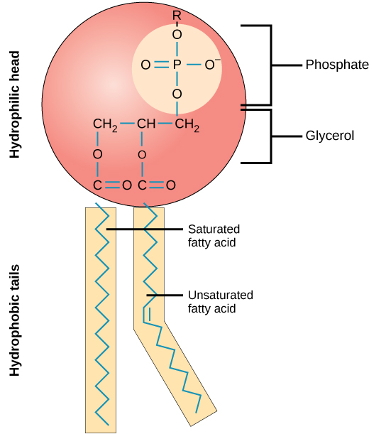
Properties | The fatty acid chains are hydrophobic (repel water) which makes lipids insoluble in water. They bundle together as insoluble droplets because the tails face inwards, and the glycerol heads shield them from the water. The hydrocarbon fatty acid chains can be saturated or unsaturated. | The phosphate group is hydrophilic (attracts water) and the fatty acid chains are hydrophobic (repel water). This allows phospholipid to form bilayers which make up membranes in and around cells.
Examples | Used as an energy store as there is a lot of energy released when the fatty acid chains are broken down. | Membranes, hormones e.g testosterone
Saturated and Unsaturated fatty acids:
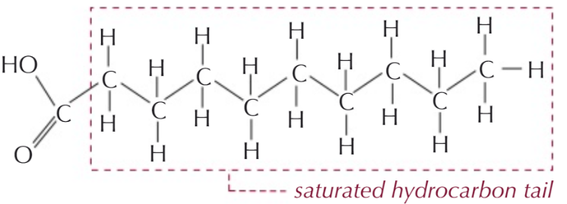
Saturated fatty acids don’t have any double bonds between their carbon atoms. The fatty acid has all the hydrogens it can hold or is “saturated” with hydrogen.

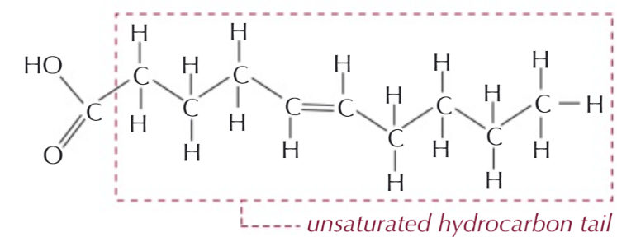
Unsaturated fatty acids have double bonds between carbon atoms which means they contain fewer hydrogen atoms. The double bond also causes the chain to bend or kink.
Unsaturated fatty acid chains can contain one (mono) or many (poly) carbon double bonds.
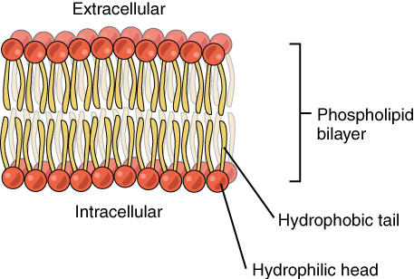
Phospholipid bilayer
Phospholipid heads are hydrophilic and their tails are hydrophobic so when placed in water they form a double layer with the heads facing outwards towards the water and their tails facing inwards away from the water.
The centre of the bilayer is therefore hydrophobic so water soluble substances cannot easily pass through. This creates a barrier and allows separation of solutions and can create different conditions either side of the membrane.
Recall Questions
- State four roles of lipids
- What does a triglyceride consist of? Which type of bonds hold it together?
- How is a phospholipid different to a triglyceride? And how are they similar?
- How many water molecule(s) is/are needed when breaking down a triglyceride?
- What is the term for the reaction that makes lipids?
- What is the difference in structure between saturated and unsaturated lipids?
- Describe how phospholipids can form a bilayer arrangement.

Practice Questions
1. Draw a glycerol molecule and three fatty acids. Two of the fatty acids should be saturated and one unsaturated. All fatty acids should contain ten carbon atoms. Draw a box around the atoms on the glycerol molecule and the unsaturated fatty acid that react together to form an ester bond.

Exam Questions
Q1.(a) Some seeds contain lipids. Describe how you could use the emulsion test to show that a seed contains lipids.
........................................................................................................................................................................................................................................................................................................................................................................................................................................................................................................................................................................................................................................................................................................................................................................................................................................................................................................................................................................(3)
(b) A triglyceride is one type of lipid. The diagram shows the structure of a triglyceride molecule.
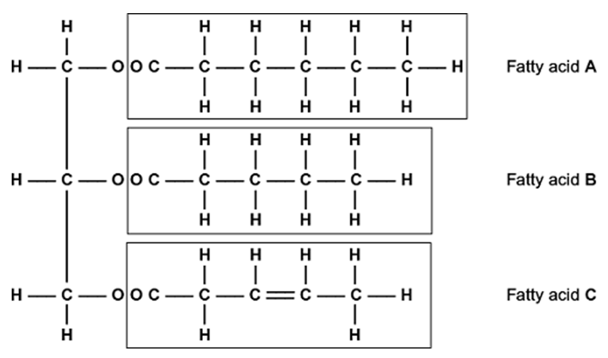
(i) A triglyceride molecule is formed by condensation. From how many molecules is this triglyceride formed?
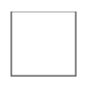
(1)
(ii) The structure of a phospholipid molecule is different from that of a triglyceride.
Describe how a phospholipid is different.

................................................................................................................................................................................................................................................................................................................................................................................................................................................................................................................................................................................................................................................................................................................................................................................ (2)

(iii) Use the diagram to explain what is meant by an unsaturated fatty acid.
...............................................................................................................
...............................................................................................................
...............................................................................................................
...............................................................................................................
...............................................................................................................
(2)
Q2. (a) Omega-3 fatty acids are unsaturated. What is an unsaturated fatty acid?
......................................................................................................................
......................................................................................................................
......................................................................................................................
......................................................................................................................
(2)
(c) Olestra is an artificial lipid. It is made by attaching fatty acids, by condensation, to a sucrose molecule. The diagram shows the structure of olestra. The letter R shows where a fatty acid molecule has attached.
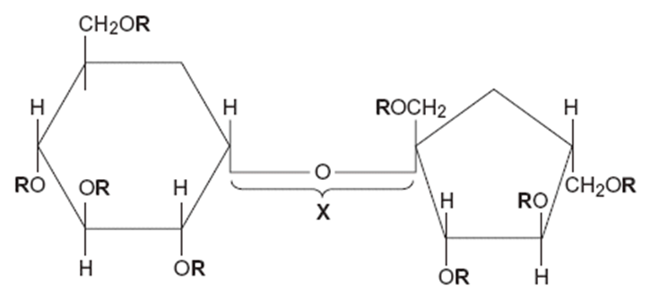

(i) Name bond X. .............................................................................................................
(1)
(ii) A triglyceride does not contain sucrose or bond X. Give one other way in which the structure of a triglyceride is different to olestra.
............................................................................................................................................................................................(1)
(iii) Starting with separate molecules of glucose, fructose and fatty acids, how many molecules of water would be produced when one molecule of olestra is formed?
Q3.Omega-3 fatty acids are found in cows’ milk. Scientists investigated changes in the concentration of omega-3 fatty acids in milk when cows were moved from eating grass in fields to eating corn in cattle sheds. The following figure shows the results of one investigation.
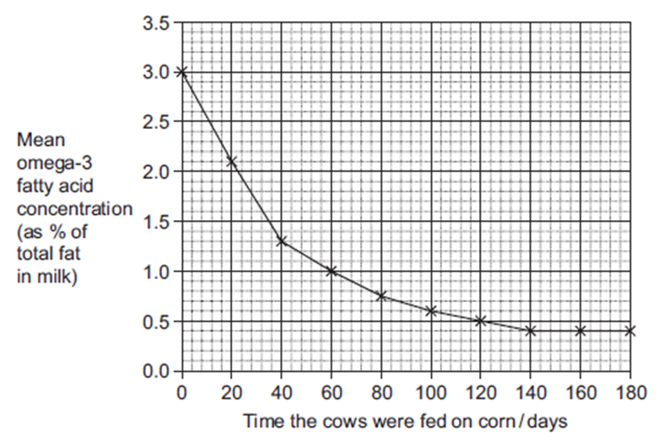
(a) The concentration of omega-3 fatty acids in milk changed when cows were fed on corn instead of grass. Describe how.
........................................................................................................................
........................................................................................................................
........................................................................................................................
........................................................................................................................
(2)
(b) (i) Calculate the rate of decrease in the mean omega-3 fatty acid concentration between 0 and 40 days.
Show your working.

Answer.......................................................% per day
(2)
(ii) The omega-3 fatty acid concentration is expressed as a percentage of total fat.
Explain the advantage of this.
...............................................................................................................
...............................................................................................................
...............................................................................................................
...............................................................................................................
(2)
(iii) One farmer concluded from the graph that feeding cows on corn reduces the omega-3 fatty acid content in milk. Evaluate this conclusion.
............................................................................................................................................................................................................................................................................................................................................................................................................................................................................................................................................................................................................................................................................................................................................................................................................................................................................................................................................................................ (4)

Homework
1. Complete all exam questions from Lesson 3
2. Read notes and complete recall questions for lesson 4 as pre-learning
3. Stretch – Read and summarise any new knowledge:” The truth about fats: the good, the bad, and the in-between”
Use the following Link: https://bit.ly/2TSNVCH or scan the code

Summary/Notes:
............................................................................................................................................................................................................................................................................................................................................................................................................................................................................................................................................................................................................................................................................................................................................................................................................................................................................................................................................................................
............................................................................................................................................................................................................................................................................................................................................................................................................................................................................................................................................................................................................................................................................................................................................................................................................................................................................................................................................................................
............................................................................................................................................................................................................................................................................................................................................................................................................................................................................................................................................................................................................................................................................................................................................................................................................................................................................................................................................................................
Lesson 4 – Proteins
Key Words
Amino acid | A monomer which makes up proteins. Has a central carbon atom which is bonded to: a carboxylic acid group, an amino group, a hydrogen atom and a R group.
Amine group | The -NH2 group of an amino acid.
Carboxyl group | The -COOH group of an amino acid.
Disulfide bridge | Bond formed between Sulphur atoms in R groups of amino acids.
Hydrogen Bond | Chemical bond formed between the positive charge on a hydrogen atom and the negative charge on another atom of an adjacent molecule. Often between negative oxygen and positive hydrogen atoms
Ionic Bond | A bond between a positive ion which has lost an electron(s) and a negative ion which has gained an electron(s).
Peptide bond | The type of bond that is formed between two amino acids.
Polypeptide | Many amino acids joined together by peptide bonds.
Primary protein structure | The sequence of amino acids that makes up the polypeptides of a protein.
Protein | A polymer which is made up of amino acids linked by peptide bonds. May also contain prosthetic groups as part of its quaternary structure.
Quaternary protein structure | A number of polypeptide chains linked together, and sometimes associated with non-protein groups to form a protein.
R-group | Each of the 20 amino acids has a different R group – determines the bonding that the amino acid can carry out.
Secondary protein structure | The way in which the chain of amino acids of the polypeptides of a protein is folded.
Tertiary protein structure | The folding of a whole polypeptide chain in a precise way, as determined by the amino acids of which it is composed.
Notes
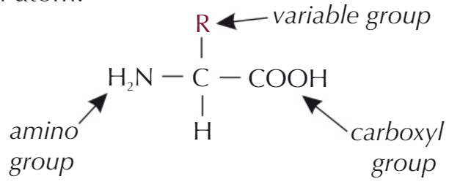
Proteins are polymers made up of monomers known as amino acids. There are only twenty amino acids present in all life forms and the different combinations of these determines the shape and structure of each protein as well as its properties. Each amino acid has the same general structure with a variable R group which is the only difference between them.
Like the other molecules of life proteins contain carbon, hydrogen and oxygen but unlike carbohydrates and lipids proteins also contain nitrogen in their amine group.
The R group generally contains carbon with the exception of glycine which is just one hydrogen atom. The R group can contain other elements including sulphur (cysteine).
When two amino acids join via a condensation reaction a peptide bond is formed and a water molecule is released. The peptide bond forms between the amine group of one amino acid and the hydroxyl group of the other. Two amino acids joined together is known as a dipeptide.
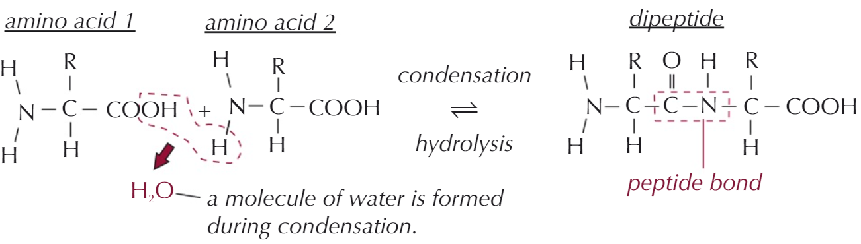
More than two amino acids joined together is known as a polypeptide. Proteins can be made of either a single or multiple polypeptide chains joined together. Dipeptides and polypeptides can be broken down through hydrolysis.
There are four levels of protein structure, single chain polypeptides can have three levels (primary, secondary and tertiary) of structure and proteins made of multiple polypeptide chains have quaternary structure. You need to be able to describe the four structure levels and
Structure Level | Description | Diagram
Primary (1°) | The number and sequence of amino acids in the polypeptide chain. This can determine the 3D shape or tertiary structure and can therefore effect the shape of the active site in enzymes. | 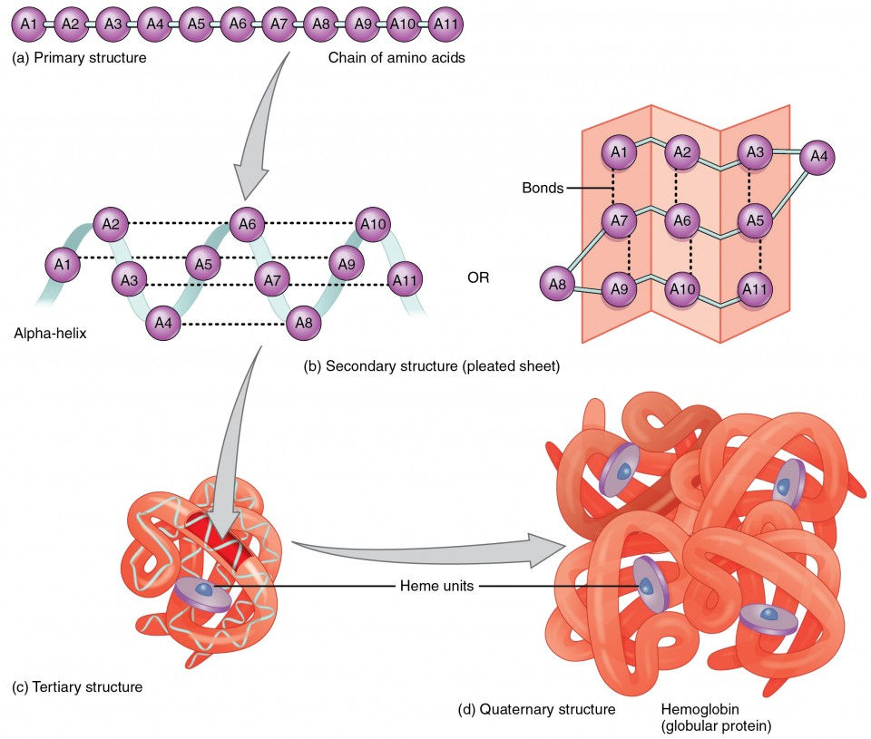
Secondary (2°) | Hydrogen bonds form between amino acids in the chain, this causes it to coil into an α-helix or fold into a β-pleated sheet. The many hydrogen bonds make these structures stable. Most channel proteins are made of alpha helices.
Tertiary (3°) | This is the 3D shape of the polypeptide chain. It creates a specific shape due to the sequence of amino acids in the chain as hydrogen bonds, ionic bonds and disulphide bridges (covalent bonds) form between R groups. A change to the sequence of amino acids would affect the secondary and tertiary structure as these bonds would form in different places. All enzymes, antibodies and some hormones have tertiary structure. | 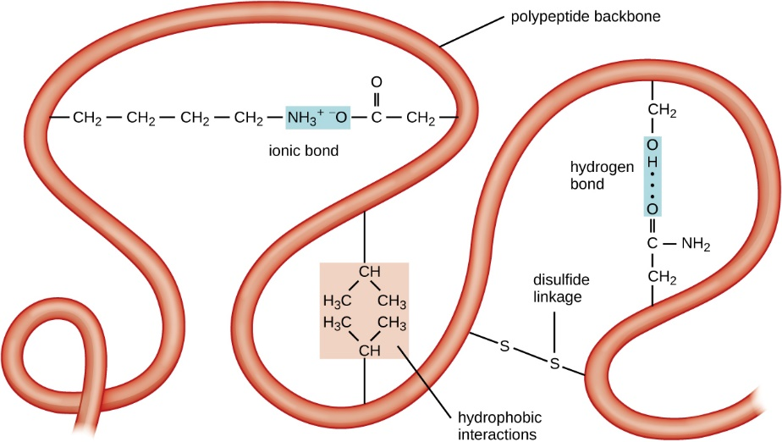
Quaternary (4°) | If proteins are made of more than one polypeptide chain, then they are joined together to create quaternary structure. Antibodies and haemoglobin are examples of these. Other non-protein groups may also be associated e.g the haem group in haemoglobin. | 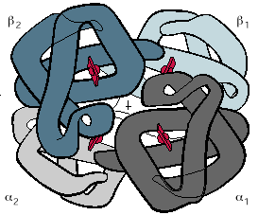

Recall Questions
- State the monomer of a protein.
- What are the components that make up an amino acid?
- Which part of the amino acid is variable? And how many different types are there?
- Name the bond formed between two amino acids.
- Draw the structure of an amino acid
- What is the primary structure of a protein?
- What is the secondary structure of a protein?
- What is the tertiary structure of a protein?
- What is the quaternary structure of a protein?
- What's the difference between primary and secondary structure of polypeptides?
- State the bonds involved in the tertiary structure of a protein.
- Name the reaction that breaks down proteins.
Exam Questions
Q1. Haemoglobin is a protein. It is made of two alpha polypeptides and two beta polypeptides. Each alpha polypeptide has 141 amino acids and each beta polypeptide has 146 amino acids.
(a) What term is used to describe the structure of a protein made of two or more polypeptides?
___________________________________________________________________
(1)
Q2. A dipeptide consists of two amino acids joined by a peptide bond. Dipeptides may differ in the type of amino acids they contain.
Describe two other ways in which all dipeptides are similar and one way in which they might differ.
Similarities
1 _________________________________________________________________
___________________________________________________________________
___________________________________________________________________
2 _________________________________________________________________
___________________________________________________________________
___________________________________________________________________
Difference _________________________________________________________
___________________________________________________________________
(3)
Q3. (a) Describe how a peptide bond is formed between two amino acids to form a dipeptide.
___________________________________________________________________
___________________________________________________________________
___________________________________________________________________
___________________________________________________________________
___________________________________________________________________
___________________________________________________________________
___________________________________________________________________
___________________________________________________________________
___________________________________________________________________
___________________________________________________________________
(2)
(b) The secondary structure of a polypeptide is produced by bonds between amino acids.
Describe how.
___________________________________________________________________
___________________________________________________________________
___________________________________________________________________
___________________________________________________________________
___________________________________________________________________
___________________________________________________________________
___________________________________________________________________
___________________________________________________________________
___________________________________________________________________
___________________________________________________________________
(2)
(c) Two proteins have the same number and type of amino acids but different tertiary structures.
Explain why.
___________________________________________________________________
___________________________________________________________________
___________________________________________________________________
___________________________________________________________________
___________________________________________________________________
___________________________________________________________________
___________________________________________________________________
___________________________________________________________________
___________________________________________________________________
___________________________________________________________________
(2)

Q4. Scientists measured the mean amino acid concentration in white wines made from grapes grown organically and white wines made from grapes that were not grown organically.
All amino acids have the same general structure. The image below shows the structure of the amino acid isoleucine.
Draw a box around the part of the molecule that would be the same in all amino acids.
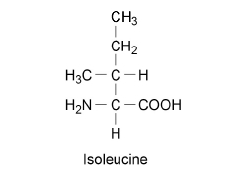
(1)
(c) Name the chemical element found in all amino acids that is not found in triglycerides.
___________________________________________________________________
(1)
Q5. The diagrams show four types of linkage, A to D, which occur in biological molecules.
(a) Name the chemical process involved in the formation of linkage B.
___________________________________________________________________
(1)
(b) Give the letter of the linkage which
(i) occurs in a triglyceride molecule;
______________________________________________________________
(1)
(ii) might be broken down by the enzyme amylase;
______________________________________________________________
(1)
(iii) may occur in the tertiary, but not the primary structure of protein.
______________________________________________________________
(1)
Q6. The diagram shows the structure of the amino acid serine.
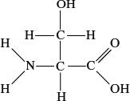
(a) (i) Draw a box on the diagram around the R group of serine and label the box with the letter R.
(1)
(ii) Draw a circle around each of the parts of the serine molecule which would be removed when two other amino acid molecules join directly to it.
(1)
(b) (i) Which two substances are formed when two amino acid molecules join together?
1. ____________________________________________________________
2. ____________________________________________________________
(1)
(ii) Name the type of bond formed between the joined pair of amino acid molecules.
______________________________________________________________
(1)
(c) Explain how a change in the primary structure of a globular protein may result in a different three-dimensional structure.
___________________________________________________________________
___________________________________________________________________
___________________________________________________________________
___________________________________________________________________
___________________________________________________________________
___________________________________________________________________
(3)

Q7. Read the following passage.
During the course of a day, we come into contact with many poisonous substances. These include industrial and household chemicals. The skin acts as a barrier and prevents many of these substances entering and harming the body.
The skin is one of the largest organs in the body. It is composed of several layers of
5 tissue. The outer layer consists of dead cells packed with keratins. Keratins are a group of proteins that differ from each other in their primary structure. Each keratin molecule consists of several polypeptide chains, each individual chain wound into a spiral or helix. The polypeptide chains include many sulphur-containing amino acids and these help to give the keratin molecules their characteristic strength.
Use information from the passage and your own knowledge to answer the questions.
(a) What is the evidence from the passage that keratin molecules have a quaternary structure?
___________________________________________________________________
___________________________________________________________________
(1)
(b) Explain how sulphur-containing amino acids help to give keratin molecules their characteristic strength (lines 8–9).
___________________________________________________________________
___________________________________________________________________
___________________________________________________________________
___________________________________________________________________
(2)
(c) Explain why differences in primary structure result in keratins with different properties
(line 6).
___________________________________________________________________
___________________________________________________________________
___________________________________________________________________
___________________________________________________________________
(2)

Homework
1. Complete all exam questions from Lesson 4
2. Read notes and complete recall questions for lesson 5 as pre-learning

3. Complete the sentences using the words in bold:
20 3D 3D alpha helix amine amino acid away bilayer biuret bonds carboxylic acid chains condensation condensation dipeptide disulphide emulsion enzymes ethanol fattyacids fibrous functions gene globular glycerol ground head hydrocarbons hydrogen hydrolysis hydrophilic hydrophobic insoluble peptide peptide phosphate polypeptide properties properties purple R saturated sequence structural structure tail unsaturated water water

Lipids are a diverse group of molecules that have many functions, two of which you need to be familiar with: triglycerides and phospholipids.
Triglycerides are formed from one molecule of _________ (a 3-carbon carbohydrate) bonded with three ________ _______ on one side of the glycerol. Fatty acids are long _____________ with a methyl group at one end and a carboxylic acid group at the other. If the fatty acid chain has no double bonds then it is said to be ____________ because it is saturated with hydrogen; these form solids and are most common in animals. If carbon-carbon double bonds are found in the chain then the fatty acid is said to be _____________; these form liquids and are mostly found in plants. The triglyceride is produced when the carboxylic acid group on the fatty acids react with the hydroxyl groups attached to carbon atoms of glycerol by ______________ reaction (i.e. water is formed), forming an ester bond. The bond can be broken by _____________ reaction, which uses a molecule of ___________.
Phospholipids have a similar structure to triglycerides but one fatty acid is replaced by a _____________ group (PO₄) on the other side of the glycerol molecule. This seemingly simple change produces some quite significant differences in the _____________ of the molecule, which manifest in two distinct regions in the molecule. The fatty acid ‘________’ region is uncharged so does not interact with water and so is said to be ____________ (water-hating). The phosphate ‘________’ region has a negative charge so can form hydrogen bonds with water and so is said to be _____________ (water-loving). As a result of this, phospholipids form a ___________ in the membrane of cells with phosphate heads pointing both into the cell towards the aqueous cytoplasm and out of the cell towards the aqueous tissue fluid, and the tails point towards each other and _________ from water.
Different proteins can appear very different and perform diverse _____________. Despite this, each one is made up of ______ ______ subunits. There about _____ different amino acids, where each amino acid has the same _______ group (NH₂) and ___________ _____ group (COOH) but a different variable (__) group that can make them neutral, acidic, alkaline, aromatic or sulphur-containing. This means that, although they all have a similar chemical ____________, they behave in very different ways and stringing them together in different combinations produces very different ____________. Two amino acids react together by _____________ reaction, where the amine group from one and the carboxylic acid group from another form a ___________ bond. Two amino acids joined in this way are call a _____________ and multiple amino acids joined together are called a ______________. Proteins are formed from polypeptides that may have more polypeptides or prosthetic groups joined to them.
The structure of a proteins can be described in four ways: The primary structure describes the _____________ of amino acids in the protein. The primary structure is determined by the ________ that codes for the polypeptide(s) and influences all of the following structural properties. The secondary structure is the basic shape that the chain of amino acids takes on as a result of common and predictable hydrogen bonding. The two most common structures are the ______ _______ and the beta-pleated sheet. The tertiary structure is the overall _____ structure of the protein. The shape of the protein is held together by hydrogen and ionic ___________ between R groups. The protein may be reinforced by strong covalent bonds called ___________ bridges which form between two amino acids with sulphur groups on their side chains. The quaternary structure is present if a protein is made up of several polypeptide __________.
There are two main types of protein. ___________ proteins are generally long, straight chains of amino acids that do not show a tertiary structure and as a result are ___________. They have _____________ roles in cells, such as spindle fibres used in cell division and myosin fibres in muscle fibres. _____________ proteins are are generally rounded, soluble and show a _____ structure as a result of their tertiary and quaternary structures. They have numerous roles including as antibodies, ___________, hormones and receptors.

Lesson 5 – Enzymes
Key Words
Activation energy | Energy required to bring about a reaction.
Active Site | A group of amino acids that makes up the region of an enzyme into which the substrate fits to catalyse a reaction.
Competitive inhibitor | A form of inhibitor which binds to the active site of the enzyme preventing the binding of substrate.
Complimentary | Describes the relationship between the active site of an enzyme and the substrate molecule – the way in which they fit together.
Enzyme | A protein that acts as a catalyst and so lowers the activation energy needed for a reaction.
Enzyme-substrate (ES) complex | The intermediate formed when a substrate molecule interacts with the active site of an enzyme.
Induced fit model | A mechanism of interaction between an enzyme and a substrate. As the substrate fits into the active site the active site of the enzyme changes shape to allow an enzyme-substrate complex to be formed.
Inhibitor | A substance which reduces the activity of an enzyme.
Kinetic Energy | The energy of motion, observable as the movement of an object, particle or set of particles.
Lock and key model | An analogy for how enzymes work – only the correctly sized key (substrate) fits into the keyhole (active site) of the lock (enzyme)
Metabolism | All the chemical processes that take place in living organisms.
Non-competitive inhibitor | A form of inhibitor which does not bind at the active site of the enzyme which prevents the binding of substrate.
pH | A figure expressing the acidity or alkalinity of a solution on a logarithmic scale on which 7 is neutral, lower values are more acidic and higher values are more alkaline. Equivalent to -log10[H+].
Rate of reaction | The speed of a chemical reaction - can be worked out by looking at the decrease in concentration of a reactant over time or increase in concentration of a product over time.
Specific | Describes how each enzyme only catalyses a certain chemical reaction.
Substrate | A substance that is acted on or used by another substance or process. Fits into the active site of an enzyme.

Notes
Enzymes speed up the rate of chemical reactions in organisms by acting as catalysts (they do not get used up in the reaction). Enzymes catalyse specific metabolic reactions at a cellular level e.g respiration and extracellularly (outside cells) e.g during digestion in mammals.
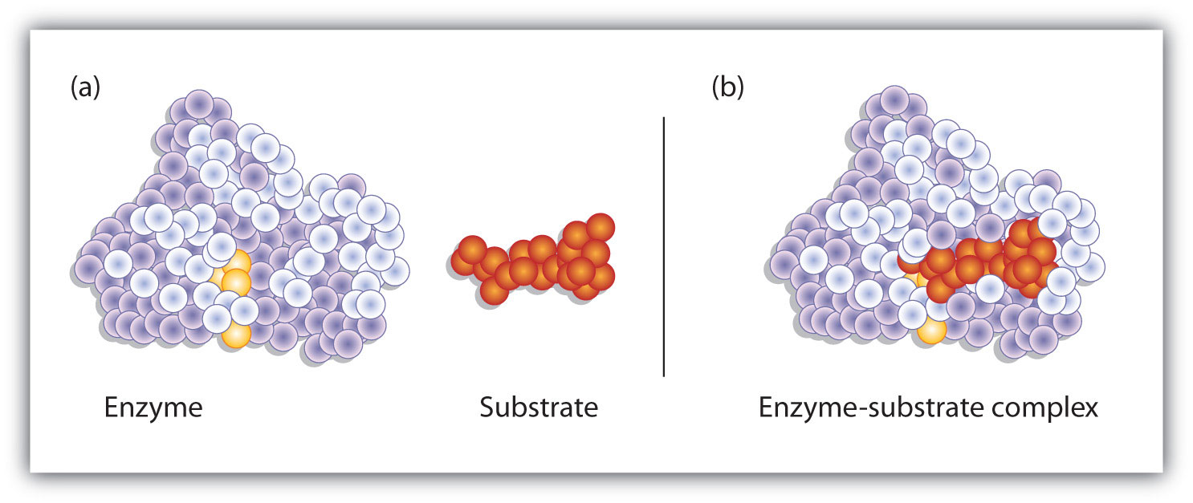
Enzymes are proteins with a 3D structure, they have an active site which has a specific shape, that can only bind to a certain substrate. When the enzyme binds to a substrate an enzyme-substrate complex is formed because the shape of the active site is complimentary to that substrate. After the reaction has occurred the products leave the active site, and the enzyme goes onto make more ES-complexes.

Enzymes speed up the rate of metabolic reactions by lowering the activation energy of a reaction. Usually, they allow reactions to happen at a lower temperature than they would without the enzyme being present. This is because they either hold substrates close together, reducing repulsion and allowing them to bond more easily or put more strain on the bonds of a substrate allowing them to break apart more easily.
Enzyme Models
Lock and Key-Model (original) | Induced-fit Model (updated)
The original model which explained how enzymes worked. It states that the shape of an active site is exactly complimentary (like a lock) to the specific substrate molecule (the key) and the substrate fits in exactly when they collide forming an ES-complex. | New molecular evidence suggests that the shape of the active site of an enzyme is not exactly complimentary to the substrate molecule. When the substrate collides with the enzyme, the active site can change shape slightly to fit around the substrate and form an ES complex.
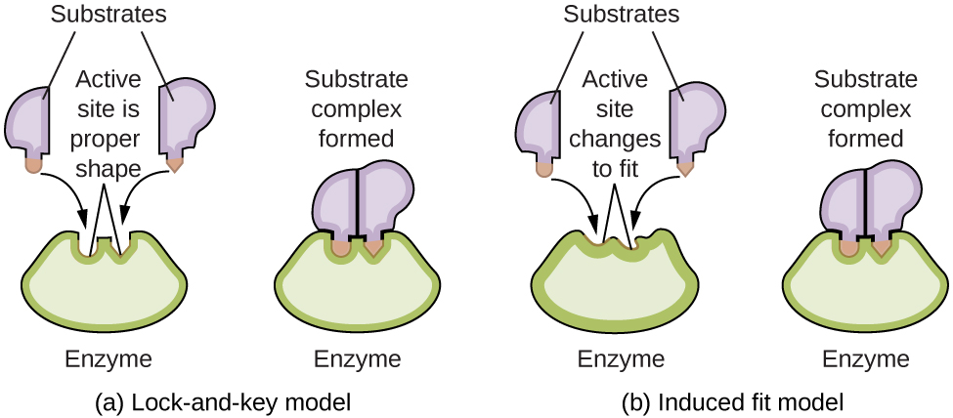

Factors Affecting Enzyme Action
Factor | Effect
Enzyme Concentration  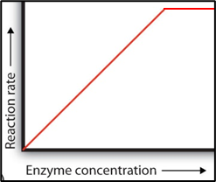 | - Increasing enzyme concentration increases the number of active sites available for the substrate to collide with  - More ES-complexes can form as enzyme concentration increases  - The rate of reaction will increase until the amount of substrate becomes the limiting factor as there are more enzymes than substrate so increasing the enzyme concentration will have no more effect on the rate.  - The gradient can be used to calculate how fast the rate is changing
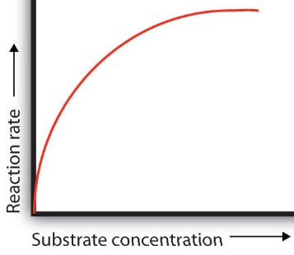  Substrate Concentration | - Increasing the substrate concentration will increase the rate of reaction as there are more substrate molecules.  - More collisions so more ES-complexes will form.  - The rate of reaction will slow as the enzyme concentration becomes a limiting factor. When all the enzyme active sites are occupied (saturation point) increasing the substrate concentration will have no further effect on the rate.
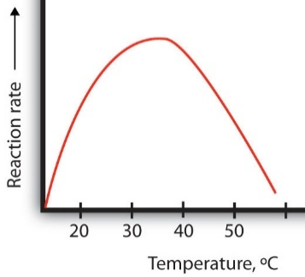  Temperature | - As temperature increases so does the rate of reaction as there is more kinetic energy so the molecules move faster increasing the number of collisions and therefore the number of ES-complexes formed.  - Each enzyme has an optimum temperature. Once this has been reached increasing the temperature further decreases the rate of reaction.  - At high temperatures the enzyme molecules vibrate too much, and bonds are broken which maintain the tertiary structure. The active site changes shape and no more ES-complexes can be formed as the substrate no longer fits. The enzyme is permanently denatured, the reaction stops.
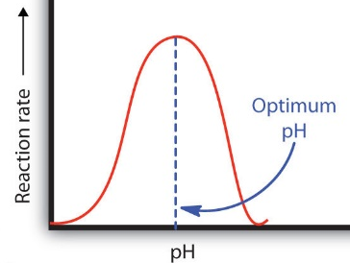  pH | - All enzymes also have an optimum pH as well as temperature. Most work best at pH 7 but some work best at pH 2 (e.g pepsin in the stomach).  - Above and below the optimum pH for each enzyme the H⁺ ions and OH⁻ ions disrupt the ionic and hydrogen bonds holding the enzyme’s tertiary structure in place.  - At extremes of pH the active site changes shape and no more ES-complexes can be formed as the substrate no longer fits. The enzyme is permanently denatured, the reaction stops.
Enzyme Inhibitors
Enzyme activity can be slowed or prevented by molecules other than the substrate which bind to them called enzyme inhibitors. There are two different kinds: competitive and non-competitive.
Competitive Inhibition |  | Non-Competitive Inhibition
- Have a similar shape to that of substrate molecules  - Compete with the substrate to bind to the active site of the enzyme  - They block the active site so the substrate cannot bind, and no ES complexes are formed |  | - Do not bind to the active site as have different shape to the substrate so do not compete  - Bind to a site away from the active site known as the allosteric site.  - Causes the active site of the enzyme to change shape so it is no longer complimentary to the substrate so no ES complexes can be formed.
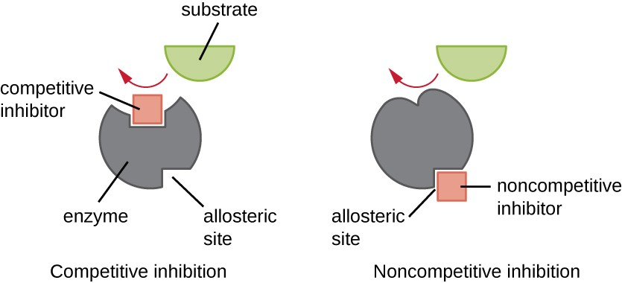

Increasing the substrate concentration still increases the rate of reaction.  Increasing the concentration of substrate will reverse the effects of a competitive inhibitor as the substrate will out-compete the inhibitor for the active sites. | 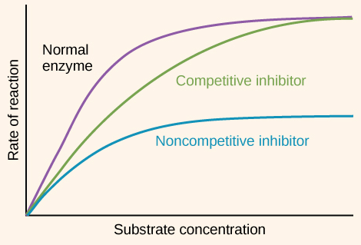 |  | Increasing the concentration of the substrate will not affect the rate of reaction.  Increasing the concentration of the substrate will not have any effect on the rate of reaction as they cannot bind to the active site.

Recall Questions
- Name the three bonds that maintain the tertiary structure in a protein.
- Why are enzymes described as catalysts?
- What do we mean by the term “enzymes are specific”?
- How do enzymes speed up reactions?
- How do we describe the shape of an enzymes active site>
- Describe the lock and key model
- What is the most up to date model used to describe enzyme action? Explain how it has changed.
- If a substrate successfully collides with an enzyme, what is said to have formed?
- Why does increasing the temperature of a reaction increase the rate of reaction?
- Describe how an enzyme can become denatured at high temperatures.
- If you were to increase the concentration of substrate in a reaction but the rate of reaction did not increase, what would you suggest is the limiting factor?
- How can the pH affect the rate of an enzyme-controlled reaction?
- Describe competitive inhibition
- Where does a non-competitive inhibitor bind?
- What’s the difference between competitive and non-competitive inhibition?
- How can you tell if an inhibitor is competitive or non-competitive?

Exam Questions
Q1. (a) What is an enzyme?
______________________________________________________________
______________________________________________________________
______________________________________________________________
(2)

The diagram shows stages during an enzyme-catalysed reaction.
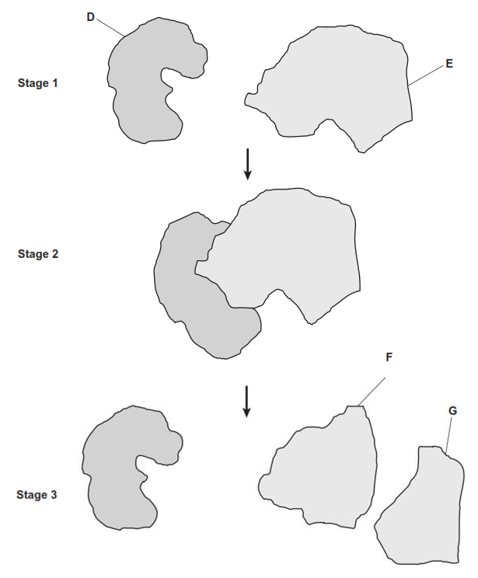
(b) Using the letters in the diagram, describe what is happening in this reaction.
___________________________________________________________________
___________________________________________________________________
___________________________________________________________________
___________________________________________________________________
___________________________________________________________________
___________________________________________________________________
___________________________________________________________________
___________________________________________________________________
(3)

Q2. A technician investigated the effect of temperature on the rate of an enzyme-controlled reaction. At each temperature, he started the reaction using the same volume of substrate solution and the same volume of enzyme solution. The figure below shows his results.
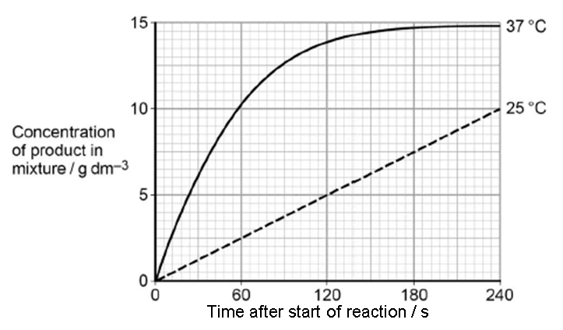
(a) Give one other factor the technician would have controlled.
______________________________________________________________
(1)
(b) Calculate the rate of reaction at 25 °C.

Answer ................................................
(2)
(c) Describe and explain the differences between the two curves.
___________________________________________________________________
___________________________________________________________________
___________________________________________________________________
___________________________________________________________________
___________________________________________________________________
___________________________________________________________________
___________________________________________________________________
___________________________________________________________________
(5)
Q3. (a) An enzyme catalyses only one reaction. Explain why.
______________________________________________________________
______________________________________________________________
______________________________________________________________
(2)
(b) Gout is a disease caused by the build-up of uric acid crystals in joints. Uric acid is produced from xanthine in a reaction catalysed by the enzyme xanthine oxidase.
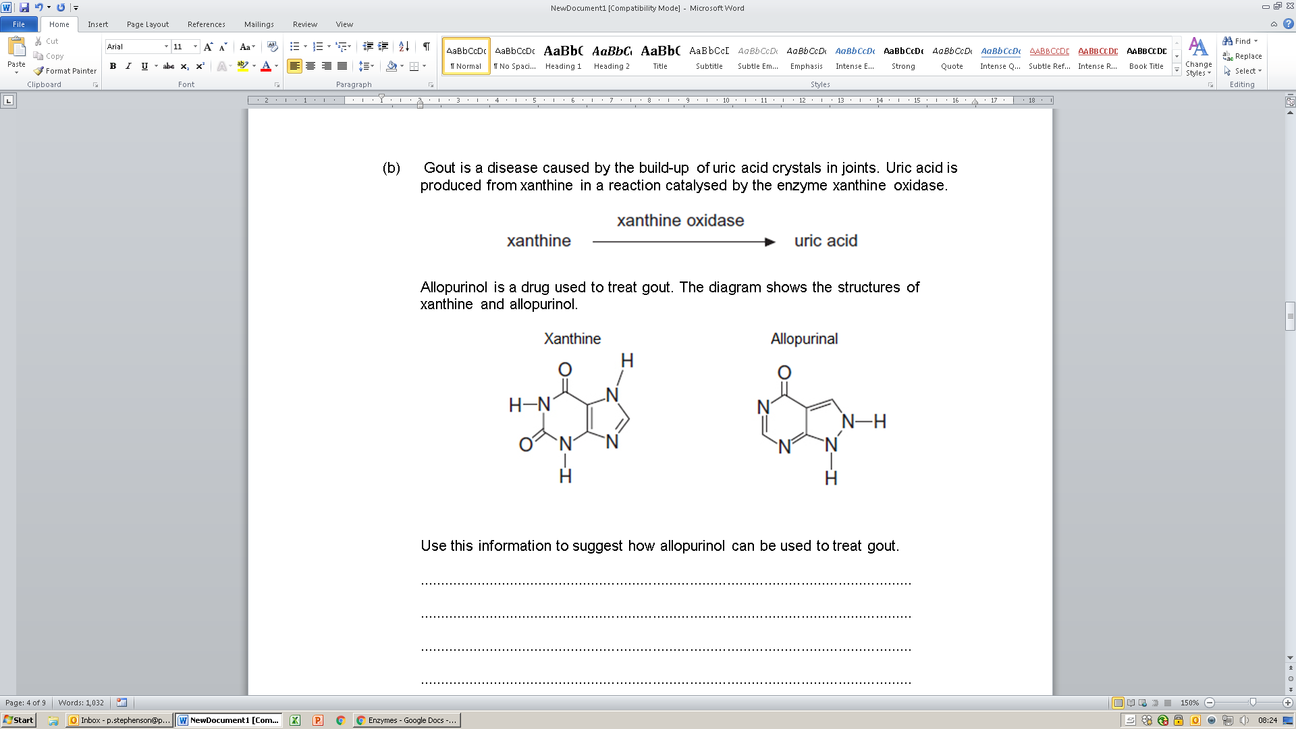
Allopurinol is a drug used to treat gout. The diagram shows the structures of xanthine and allopurinol.
Use this information to suggest how allopurinol can be used to treat gout.
___________________________________________________________________
___________________________________________________________________
___________________________________________________________________
___________________________________________________________________
___________________________________________________________________
___________________________________________________________________
___________________________________________________________________
___________________________________________________________________
(3)
Q4. Describe competitive and non-competitive inhibition of an enzyme.
___________________________________________________________________
___________________________________________________________________
___________________________________________________________________
___________________________________________________________________
___________________________________________________________________
___________________________________________________________________
___________________________________________________________________
___________________________________________________________________
___________________________________________________________________
___________________________________________________________________
(5)
Q5. A protease is an enzyme that digests protein. The graph shows how the activity of a protease varies with temperature.
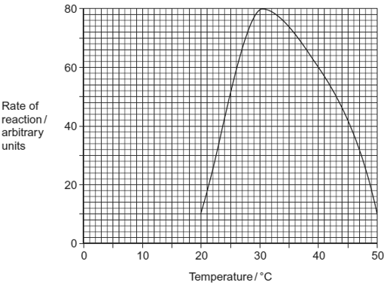
(a) (i) Describe what the graph shows about the effect of temperature on the rate of reaction.
______________________________________________________________
______________________________________________________________
(1)
(ii) Explain the shape of the curve between 30 °C and 50 °C.
______________________________________________________________
______________________________________________________________
______________________________________________________________
______________________________________________________________
______________________________________________________________
______________________________________________________________
(3)
Q6. (a) Explain how the shape of an enzyme molecule is related to its function.
___________________________________________________________________
___________________________________________________________________
___________________________________________________________________
___________________________________________________________________
___________________________________________________________________
___________________________________________________________________ (3)
(b) Bacteria produce enzymes which cause food to decay. Explain how vinegar, which is acidic, can prevent the action of bacterial enzymes in some preserved foods.
___________________________________________________________________
___________________________________________________________________
___________________________________________________________________
___________________________________________________________________
___________________________________________________________________
___________________________________________________________________
(3)
Q7.
(a) The diagrams represent an enzyme, its substrate and two other molecules, A and B.
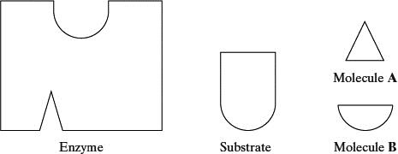
The addition of a non-competitive inhibitor will prevent the formation of an enzyme-substrate complex. Draw a labelled diagram based on relevant molecules selected from the diagram above to explain how this occurs.

(2)
(b) A decrease in temperature decreases the kinetic energy of molecules in a solution. Explain how a decrease in temperature decreases the rate of an enzyme-controlled reaction.
___________________________________________________________________
___________________________________________________________________
___________________________________________________________________
___________________________________________________________________
(2)

(c) Urea breaks hydrogen bonds. Explain how the addition of urea would affect the rate of an enzyme-controlled reaction.
___________________________________________________________________
___________________________________________________________________
___________________________________________________________________
___________________________________________________________________
___________________________________________________________________
___________________________________________________________________
(3)
Q8.
Two samples of the roots of pea plants were placed in solutions containing potassium ions. An inhibitor to prevent respiration was added to one solution. The concentrations of potassium ions in the two solutions were measured at regular intervals. The graph shows the results.
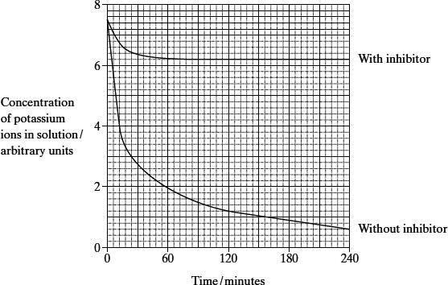
(a) Explain the decrease in the concentrations of potassium ions in the two solutions between 0 and 30 minutes.
(i) With inhibitor
______________________________________________________________
______________________________________________________________
______________________________________________________________
______________________________________________________________
(2)

(ii) Without inhibitor
______________________________________________________________
______________________________________________________________
(1)
(b) Explain why there is no further decrease in the concentration of potassium ions in the solution with the inhibitor after 60 minutes.
___________________________________________________________________
___________________________________________________________________
___________________________________________________________________
___________________________________________________________________
(2)
(c) The substance malonate is an inhibitor of respiration. It has a structure very similar to the substrate of an enzyme that catalyses one of the reactions of respiration. Explain how malonate inhibits respiration.
___________________________________________________________________
___________________________________________________________________
___________________________________________________________________
___________________________________________________________________
(2)
Homework
1. Complete all exam questions from Lesson 5
2. Read notes and complete recall questions for lesson 6 as pre-learning

3. Complete the sentences using the words in bold:
accurate active active allosteric biological bonds closer collision control denatures diffusion energy enzyme-substrate hydrogen hydrogen hydrogen increase induced ionic limiting lock low maximum no optimum organisms overcome proteins random rate reaction repeat slower specific speed substrate tangent tertiary x y
Enzymes are ______________ catalysts. This means that they are produced by living __________ and that they _________ up reactions without being used up themselves. They do this by lowering the activation _______ needed for a reaction to occur.
Enzymes are globular __________ and therefore have a very specific and important __________ structure, held together by hydrogen, ionic and covalent (disulphide) bonds. Enzymes have an area called an active site where the ____________ molecule binds. The shape of this site is __________ for the substrate. There are two theories that explain how a substrate fits into the active site:
- The _______ and key theory suggests that the shape of the substrate is complementary to the shape of the active site. The substrate fits perfectly in the active site (like a key in a lock) allowing the _________ to take place.
- The __________ fit model suggests that, although the substrate is complementary to the shape of the active site, once the substrate has bound the enzyme changes shape. As a result the activation energy is lowered by either putting strain on _____ so that they break more easily or bringing substrate molecules _________ together so a reaction is more likely to occur.
Enzymes bonding with substrates is an entirely __________ process governed only by the random ___________ of the molecules as a result of the kinetic energy they gain from heat. In order for a reaction to take place the substrate and enzyme must first have a successful __________. This means the substrate must collide with the active site, in the right orientation and at a suitable speed. If this does occur then an __________-_____________complex is formed and the reaction can occur. The product is then released from the active site and the enzyme is free to catalyse the next reaction.
Enzyme action is affected by a number of factors:
- Temperature: If the temperature is ________ then the number of collisions between a substrate molecule and the enzyme will be low. This is because at low temperatures molecules move _______ and have little kinetic energy. If the temperature is too high then the enzyme _______. This is a permanent change as the heat energy breaks the __________ bonds that give the enzyme its 3D structure. Each enzyme with have an optimum pH where the maximum kinetic energy can be sustained without breaking any intramolecular bonds.
- pH: At different pH values there are different concentrations of ___________ and hydroxide ions. These can cause the __________ site to change shape as the ions interact with it the __________ and _________ bonds holding its shape. Different enzymes will have different _____________ pH values.
- Substrate concentration: As the concentration of substrate increases the ________ of reaction will increase proportionally until the enzymes are working at their ____________ rate. After this changing the concentration of substrate has no effect.
- Enzyme concentration: Increasing the enzyme concentration will ___________ the rate of the reaction until the enzyme reaches a maximum rate of activity. The substrate concentration will then become the _____________ factor.
- Competitive inhibitors: These compete with the substrate for the _________ site. Increasing the substrate concentration can ___________ the presence of the competitive inhibitor since it has a greater __________ of a successful collision with the active site than the inhibitor.
- Competitive inhibitors: The bond to a different (___________) site on the enzyme other than the active site. Increasing the substrate concentration has ____ effect on rate of reaction since successful collisions are no longer possible if the inhibitor is bound to the enzyme.
When performing enzyme controlled reactions it is important to __________ all variables other than those under study. For example, if you were investigating the effect of temperature on the activity of trypsin, it is important to control pH, substrate concentration, enzyme concentration, the presence of inhibitors, and the time each reaction is running for. It is also important to ensure that __________ results are collected, using suitable equipment, and preferably to give quantitative data. Finally, a suitable number of __________ measurements should be made so that a mean can be calculated (and/or a statistical test carried out), thus making the result more reliable.
It is often necessary to calculate the initial rate of reaction, if the experiment were looking at the amount of product released against time. This can be done by plotting a ____________ against a line graph. Then pick any point on that line and divide the value on the __ axis by the value on the __ axis.

Stretch
Watch: The Secrets of Quantum Physics with Professor Jim Al-Khalili

More about how enzymes work – links to physics + wormholes!! Cannot recommend enough.
Part 1 - type in the link or scan the code https://bit.ly/3ytDpkz


Part 2 (more biology based but 1st episode helps to understand quantum physics first!)
Type in the link or scan the code https://bit.ly/37nsv3Q

Lesson 6 – Biochemical Tests
Key Words
Benedict’s reagent | Blue solution which is used to test for reducing and non-reducing sugars.
Biuret test | A simple biochemical reaction to detect the presence of protein, if the Biuret’s solution turns purple then protein is present.
Emulsion test | Test for lipids. Mix your sample with ethanol and then add water. If a white cloudy emulsion forms, then a lipid is present.
Non-reducing sugar | A sugar which cannot serve as a reducing agent. An example is sucrose.
Non-reducing sugar test | Following a negative reducing sugars test. Heat the solution with HCl to hydrolyse the non-reducing sugar into it’s monosaccharides. Then perform the Benedict’s test again. If you get a positive result after hydrolysis, then a non-reducing sugar is present.
Reducing sugar test | Heat solution with Benedict’s reagent to test for reducing sugars. If it goes brick red, then a reducing sugar is present.
Reducing Sugar | A sugar that serves as a reducing agent. All monosaccharides are reducing sugars along with some disaccharides.

Notes
Testing for sugars
 | Reducing | Non-Reducing
Tests for | Reducing sugars e.g all monosaccharides and some disaccharides including maltose and lactose | Non-reducing sugars e.g disaccharides or polysaccharides like sucrose – used if the reducing test is negative (stays blue).
Reagent | Benedict’s reagent – pale blue colour
Hazards and Precautions | - Benedict’s reagent is an irritant – wear goggles, wash hands on contact with skin.  - Hot water can cause burns – use caution when pouring/carrying | - Benedict’s reagent is an irritant – wear goggles, wash hands on contact with skin.  - Hot water can cause burns – use caution when pouring/carrying  - Dilute HCl and NaOH can be corrosive – wear goggles, wash hands on contact with skin.
Method | - Add excess Benedict’s reagent to the sample.  - Heat in a water bath above 80°C (boiling) | - Add dilute hydrochloric acid and heat in a water bath (to break the bonds and produce monosaccharides).  - Add an alkali (e.g NaOH) to neutralise  - Add excess Benedict’s reagent to the sample.  - Heat in a water bath above 80°C (boiling)
Positive Result | 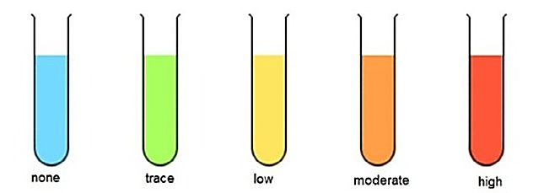  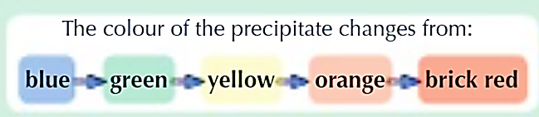  If reducing sugar is present a precipitate forms, if not the solution will remain blue.  The colour of the precipitate formed indicates the amount of sugar present:
Quantitative Measurements | The amount of reducing sugar in samples can be compared qualitatively by visually comparing the precipitate colour but there are also methods to get quantitative data:  1) Filter the solution and weigh the precipitate  2) Remove the precipitate and use a colorimeter to measure the absorbance of the remaining Benedict’s solution.
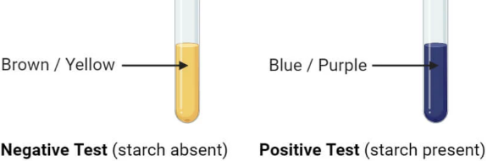
Testing for Starch
Add iodine. If starch is present the iodine will turn from brown/yellow to blue/black. This is a yes/no result so is only qualitative.
Testing for proteins
Tests for | Presence of amino acids
Reagent | Biuret’s reagent – pale blue colour (Dilute copper sulphate + sodium hydroxide)
Hazards and Precautions | Biuret’s reagent is an irritant – wear goggles, wash hands on contact with skin.
Method | - Add excess Biuret’s reagent to sample  - Shake and leave at room temperature
Positive Result | 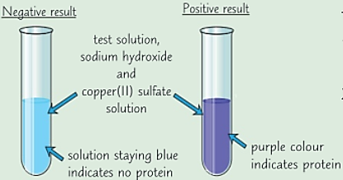  If amino acids are present a purple precipitate forms, if not the solution will remain blue.
Quantitative Measurements | The more amino acids are present the stronger the purple colour, but this is a qualitative test. Chromatography can be used to identify amino acids in a mixture, separating them by mass.

Testing for Lipids
Tests for | Presence of lipids
Reagent | Emulsion test – uses ethanol and water
Hazards and Precautions | Ethanol is flammable – do not conduct this test near a naked flame.
Method | - Add ethanol to the sample  - Add water to the sample and shake for a minute
Positive Result | 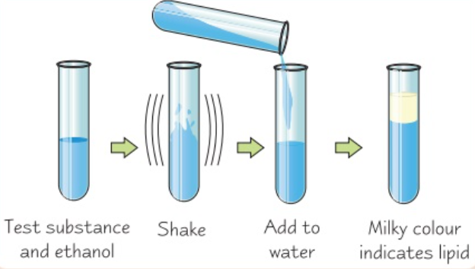  If lipids are present, they will form a milky white emulsion (layer on the top of the ethanol/water)
Quantitative Measurements | The more lipids are present the more milky/opaque the precipitate will be, but this is a qualitative test only.

Recall Questions
- Describe the test for a reducing sugar and state the positive result
- What can be done if the test for a reducing sugar produces a negative result but sugars should be present?
- Why is the Benedict’s test known as a semi-quantitative test
- How can we use a colorimeter to do a quantitative Benedict's test?
- Describe the test (and result) for starch
- What is the solution used to test for the presence of proteins?
- Describe a positive result for proteins.
- Describe the steps in identifying lipids and state the positive result.
Exam Questions
Q1. (a) Describe a biochemical test to confirm the presence of protein in a solution.
___________________________________________________________________
___________________________________________________________________
___________________________________________________________________
___________________________________________________________________
(2)
(b) A dipeptide consists of two amino acids joined by a peptide bond. Dipeptides may differ in the type of amino acids they contain.
Describe two other ways in which all dipeptides are similar and one way in which they might differ.
Similarities
1 _________________________________________________________________
___________________________________________________________________
___________________________________________________________________
2 _________________________________________________________________
___________________________________________________________________
___________________________________________________________________
Difference _________________________________________________________
___________________________________________________________________
(3)
Q2. The diagram represents a triglyceride.
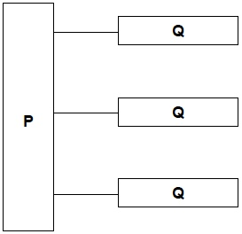
(a) Name the molecules represented in the diagram by:
Box P _____________________________________________________________
Box Q _____________________________________________________________
(2)
(b) Name the type of bond between P and Q in the diagram.
___________________________________________________________________
(1)
(c) Describe how you would test a liquid sample for the presence of lipid and how you would recognise a positive result.
___________________________________________________________________
___________________________________________________________________
___________________________________________________________________
___________________________________________________________________
___________________________________________________________________
___________________________________________________________________
___________________________________________________________________
___________________________________________________________________
(2)
Q3. (a) Most blood glucose comes from starch and disaccharides in the diet.
Describe a test you could use to check if food in the diet contained starch.
___________________________________________________________________
___________________________________________________________________
___________________________________________________________________
___________________________________________________________________
___________________________________________________________________
(2)
(c) Suggest a method you could use to estimate the concentration of glucose in several different solutions that all turned brick red with Benedict’s reagent in 3 minutes.
___________________________________________________________________
___________________________________________________________________
___________________________________________________________________
(1)
Q4. (a) Describe the difference between the structure of a triglyceride molecule and the structure of a phospholipid molecule.
___________________________________________________________________
___________________________________________________________________
___________________________________________________________________
(1)
(b) Describe how you would test for the presence of a lipid in a sample of food.
___________________________________________________________________
___________________________________________________________________
___________________________________________________________________
___________________________________________________________________
(2)
(c) Animal fats contain triglycerides with a high proportion of saturated fatty acids. If people have too much fat in their diet, absorption of the products of fat digestion can increase the risk of obesity. To help people lose weight, fat substitutes can be used to replace triglycerides in food.
Describe how a saturated fatty acid is different from an unsaturated fatty acid.
___________________________________________________________________
___________________________________________________________________
___________________________________________________________________
(1)
The diagram shows the structure of a fat substitute.
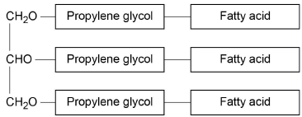
(d) This fat substitute cannot be digested in the gut by lipase.
Suggest why.
___________________________________________________________________
___________________________________________________________________
___________________________________________________________________
___________________________________________________________________
___________________________________________________________________
(2)
(e) This fat substitute is a lipid. Despite being a lipid, it cannot cross the cell-surface membranes of cells lining the gut.
Suggest why it cannot cross cell-surface membranes.
___________________________________________________________________
___________________________________________________________________
___________________________________________________________________ (1)
Q5. Lactose is a disaccharide sugar which can be broken down by the enzyme lactase into two monosaccharides, glucose and galactose.
lactase
lactose+ water glucose + galactose
(a) The formula for galactose is C₆H₁₂O₆. What is the formula for lactose?
___________________________________________________________________
(2)
(b) A solution containing the enzyme lactase was added to a lactose solution. The solution was incubated at 40 °C for one hour. Sample A was removed from the tube before incubation. Sample B was removed after one hour.
(i) Describe a chemical test you could carry out on sample A to show that lactose is a reducing sugar.
______________________________________________________________
______________________________________________________________
______________________________________________________________
______________________________________________________________
(2)
(ii) This chemical test was carried out on samples A and B. All experimental variables were the same in the testing of the two samples. Both tubes were left for ten minutes to allow the precipitate to settle. The diagram shows the result.
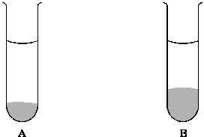
Is galactose a reducing sugar? ____________________
Explain how the results in the diagram support your answer.
______________________________________________________________
______________________________________________________________
______________________________________________________________
______________________________________________________________
(2)
(Total 6 marks)

Q6. (b) Describe the biochemical tests you would use to confirm the presence of lipid, non-reducing sugar and amylase in a sample.
___________________________________________________________________
___________________________________________________________________
___________________________________________________________________
___________________________________________________________________
___________________________________________________________________
___________________________________________________________________
___________________________________________________________________
___________________________________________________________________
___________________________________________________________________
___________________________________________________________________
___________________________________________________________________
___________________________________________________________________
(5)
(c) Describe the chemical reactions involved in the conversion of polymers to monomers and monomers to polymers.
Give two named examples of polymers and their associated monomers to illustrate your answer.
___________________________________________________________________
___________________________________________________________________
___________________________________________________________________
___________________________________________________________________
___________________________________________________________________
___________________________________________________________________
___________________________________________________________________
___________________________________________________________________
___________________________________________________________________
___________________________________________________________________
___________________________________________________________________
___________________________________________________________________
(5)

Recall Question Answers

- What elements are common to all the molecules of life? | C, O, H
- What are the four main groups of carbon-based molecules common to all life forms? | Carbohydrates, Lipids, Proteins, Nucleic Acids
- Which molecule forms part of the plasma membrane? | Phospholipids
- Which biological molecules are required to make proteins? | Amino acids (and nucleic acids)
- Which two biological molecules are the main respiratory substrates? | Lipids and Carbohydrates
- What is a polymer? | A series of repeating units (monomers) joined together
- What reaction joins two monomers together? | Condensation reaction
- Which reaction breaks down polymers? | Hydrolysis
- What type of chemical bond is formed between monomers? | Covalent bond
- Why is it known as a condensation reaction? | A molecule of water is produced/released
- Describe the process of hydrolysis | A water molecule is used to break a covalent bond. An H and an OH group are joined to the monomers
- What type of polymer is made from monosaccharides and what bond joins them together? | A polysaccharide – glycosidic bonds
- What type of polymer is made from amino acids and what bond joins them together? | A polypeptide – peptide bonds
- What type of polymer is made from nucleotides and what bond joins them together? | A polynucleotide – phosphodiester bonds
- What type of reaction joins monosaccharides together? | Condensation
- What is a disaccharide? What type of bond is involved? | Two monosaccharides joined together by a glycosidic bond
- What type of reaction breaks down maltose | Hydrolysis
- What disaccharide is made by joining glucose and glucose? | Maltose
- What are the two monosaccharides that join up to make sucrose? | Fructose and glucose
- What disaccharide is made by joining glucose and galactose? | Lactose
- What are the 3 types of polysaccharides that α-glucose can form? | - Amylose  - Amylopectin  - Glycogen
- What type of reaction breaks polysaccharides apart | Hydrolysis
- Describe the structure of glycogen | Polymer of alpha glucose - highly branched
- State the two structures that make up starch. | Amylose + Amylopectin
- Describe the structure and properties of starch | A mixture of two polysaccharides of alpha glucose. amylose is a long branched chain of a glucose. The angles of the glycosidic bonds give it a coiled structure which makes it compact so good for storage. Amylopectin is a long branched chain of a glucose. its side branches allow enzymes to get at the glycosidic bonds easily so glucose can be released quickly. it is insoluble in water
- What’s the differences and similarities between starch and glycogen? | Glycogen is always branched, starch isn't. Starch found in plants, glycogen in animals. Both are energy stores, both made of alpha glucose
- How are the monosaccharides in cellulose arranged? | Alternative β-glucose molecules are turned upside down
- Why are different enzymes needed to digest starch and cellulose? | different shape molecule requires a different enzyme as they have different active site shapes. cellulose is made of B glucose and starch of a glucose. 1,6 glycosidic bonds are only in starch. starch is made of amylose and amylopectin, cellulose is linear and starch is branched
- Based on the arrangement of cellulose molecules, explain why cell walls provide strength and support to plant cells. | - cellulose molecules form hydrogen bonds with each other to make microfibrils  - fibres are tough and flexible
- 1,6 glycosidic bonds are found on ........ | Amylopectin  / Glycogen
- β-glucose can only be found in ........ | Cellulose
- Describe the structure of amylopectin, including the bonds involved and the shape. | Amylopectin is a long branched chain of a glucose. its side branches,1,4 and 1,6 glycosidic bonds, branched
- State 4 roles of lipids | source of energy, waterproofing, insulation, protection
- What does a triglyceride consist of? Which type of bonds hold it together? | Glycerol and 3 fatty acids - ester bonds
- How is a phospholipid different to a triglyceride? And how are they similar? | Only 2 fatty acids (Tryglyceride has three). Phosphate head (tryglyceride has no phosphate). Both have fatty acids.
- How many water molecule(s) is/are needed when breaking down a triglyceride? | 3
- What is the term for the reaction that makes lipids? | Condensation
- What does a triglyceride consist of? Which type of bonds hold it together? | Glycerol and 3 fatty acids - ester bonds
- How is a phospholipid different to a triglyceride? And how are they similar? | Only 2 fatty acids (Tryglyceride has three). Phosphate head (tryglyceride has no phosphate). Both have fatty acids.
- Describe how phospholipids can form a bilayer arrangement. | - Hydrophilic heads point outwards  - Hydrophobic tails point inwards (shielded from aqueous environment)
- State the monomer of a protein. | amino acids
- What are the components that make up an amino acid? | Central carbon + H atom + Amine group + Carboxyl group
- Which part of the amino acid is variable? And how many different types are there? | R group - 20
- Name the bond formed between two amino acids. | Peptide bond
- What is the primary structure of a protein? | Amino acid sequence
- What is the secondary structure of a protein? | alpha-helix + beta-pleated sheets
- What is the tertiary structure of a protein? | Folding into a 3D shape
- What is the quaternary structure of a protein? | Binding with other subunits
- What's the difference between primary and secondary structure of polypeptides? | Primary = sequence of amino acids. Secondary - the shape in which the chain forms due to hydrogen bonds
- State the bond involved in the tertiary structure of a protein. | ionic, covalent, hydrogen, hydrophobic interactions, disulphide bridges
- Name the reaction that breaks down proteins. | hydrolysis
- Name the three bonds that maintain the tertiary structure in a protein. | Hydrogen bonds, ionic bonds and disulphide bridges
- Why are enzymes described as catalysts? | They are not used up in the reaction
- What do we mean by the term “enzymes are specific”? | They only catalyse certain reactions due to the shape of their active site
- How do enzymes speed up reactions? | They lower the activation energy
- How do we describe the shape of an enzymes active site? | It is 3D and complimentary to the substrate
- Describe the lock and key model | An analogy for how enzymes work – only the correctly sized key (substrate) fits into the keyhole (active site) of the lock (enzyme) to form an ES complex
- What is the most up to date model used to describe enzyme action? Explain how it has changed. | The shape of the active site of an enzyme is not exactly complimentary to the substrate molecule like a key in a lock. When the substrate collides with the enzyme, the active site can change shape slightly to fit around the substrate and form an ES complex.
- If a substrate successfully collides with an enzyme, what is said to have formed? | An enzyme-substrate complex
- Why does increasing the temperature of a reaction increase the rate of reaction? | As temperature increases so does the rate of reaction because there is more kinetic energy so the molecules move faster increasing the number of collisions and therefore the number of ES-complexes formed.
- If you were to increase the concentration of substrate in a reaction but the rate of reaction did not increase, what would you suggest is the limiting factor? | The concentration of enzyme
- How can the pH affect the rate of an enzyme-controlled reaction? | Above and below the optimum pH for each enzyme the H⁺ ions and OH⁻ ions disrupt the ionic and hydrogen bonds holding the enzyme’s tertiary structure in place.  At extremes of pH the active site changes shape and no more ES-complexes can be formed as the substrate no longer fits. The enzyme is permanently denatured, the reaction stops.
- Describe competitive inhibition | Competitive inhibitor molecules have a similar shape to the substrate of the enzyme they inhibit. They compete with the substrate to bind to the active site of the enzyme. They block the active site so the substrate cannot bind, and no ES complexes are formed
- Where does a non-competitive inhibitor bind? | a site away from the active site known as the allosteric site.
- What’s the difference between competitive and non-competitive inhibition? | Do not bind to the active site as have different shape to the substrate so do not compete.  Binds to a site away from the active site so doesn’t block the enzyme. Causes the active site of the enzyme to change shape so it is no longer complimentary to the substrate. Not affected by increasing the substrate concentration.
- How can you tell if an inhibitor is competitive or non-competitive? | Change the concentration of the substrate – if the rate of reaction increases as substrate increases then the inhibitor is competitive. If increasing the substrate concentration has little effect on the rate of reaction it is non-competitive
- Describe the test for a reducing sugar and state the positive result | Add benedicts reagent, heat, positive result = turns from blue to orange-brown
- What can be done if the test for a reducing sugar produces a negative result but sugars should be present? | Take another sample, add HCl and heat in a water bath, then add NaOH to neutralise. Add Benedict’s and boil.
- Why is the benedicts test known as a semi-quantitive test | Because it tells you how much sugar there is, but not exactly how much (i.e. it's not quantitative)
- How can we use a colorimeter to do a quantitative Benedict's test? | - Colorimeter measure the absorbance or transmission of light by a coloured solution  - More concentrated solution à more light absorbed / less light transmitted  - Compare to data table (known concentrations vs. abs/trans value)
- Describe the test (and result) for starch | add iodine solution. If starch is present it will change from orange/brown to blue/black
- What is the solution used to test for the presence of proteins? | Biuret solution
- Describe the test (and result) for proteins | If the blue solution turns purple then it's a postive result
- Describe the steps in identifying lipids and state the positive result. | - mix sample with ethanol  - mix solution with water and shake  - white emulsion layer formed à lipid present

