AQA Biology GCSE
Genetics I: Inheritance
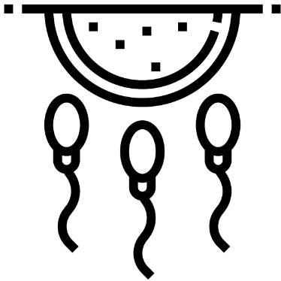

Name: ______________________

Lesson | Homework Task | SCAN CODE | Due
1 | Task 1 – Watch the video, complete the quick quiz and worksheet for the ‘Meiosis’ lesson on Kay Science.com. Submit worksheet answers on MS teams | 
2 | Task 1 – Watch the video, complete the quick quiz and worksheet for the ‘Mitosis vs Meiosis’ lesson on Kay Science.com. Submit worksheet answers on MS teams  Task 2 - Complete the weekly quiz set on MS Teams  Remember! you can revise for the quiz using Seneca! (appropriate sections will be set as an assignment) | 
3 | Revision Task 1 – Watch the video, complete the quick quiz and worksheet for the ‘Sperm cells’ lesson on Kay Science.com. Submit worksheet answers (pg5/6 only) on MS teams | 
4 | Task 1 – Watch the video, complete the quick quiz for the ‘Alleles’ lesson on Kay Science.com  Task 2 - Complete the weekly quiz set on MS Teams  Remember! you can revise for the quiz using Seneca! (appropriate sections will be set as an assignment) | 
5 | Task 1 – Watch the video, complete the quick quiz and worksheet for the ‘Sex Inheritance lesson on Kay Science.com. Submit worksheet answers on MS teams | 
6 | Task 1 – Watch the video, complete the quick quiz and worksheet for the ‘Recessive Disorders’ lesson on Kay Science.com. Submit worksheet answers on MS teams  Task 2 - Complete the weekly quiz set on MS Teams  Remember! you can revise for the quiz using Seneca! (appropriate sections will be set as an assignment) | 

Paper 2 - Genetics I Fact Sheet
Fold page here
To revise these facts, fold this sheet in half and try to write the answers down from memory. Repeat!
- Define 'gametes'. | Sex cells
- How are gametes formed? | Meiosis
- How is a gamete different from a normal body cell? | Half genetic information
- Name the gametes in plants. | Egg + Pollen
- Name the gametes in animals. | Sperm + Egg
- Name the organ that produces female gametes in animals and plants. | Ovaries
- Name the organ that produces male gametes in plants. | Anther
- Name the organ that produces male gametes in animals. | Testes
- How many divisions do a cell undergo in meiosis? | Twice
- State the three key steps in meiosis. | 1. Copies of the DNA are made.
- State the three key steps in meiosis. | 2. The cell divides twice to form 4 gametes, each with a single set of chromosomes.
- State the three key steps in meiosis. | 3. All 4 cells are genetically different from each other.
- Describe the cells produced by meiosis. | 4 cells, genetically different.
- How many chromosomes are there in a human gamete? | 23
- Name the process where a sperm and an egg cell fuse together. | Fertilisation
- Explain why meiosis is necessary for fertilisation to occur? | Cells have to be haploid so that when they fuse they create a diploid cell with the right number of chromosomes
- Name the structure formed by fertilisation (fusion of male and female gametes). | Zygote
- When a new cell is formed through fertilisation, how does it divide? | By mitosis – zygote becomes an embryo once it starts dividing to form a ball of cells
- Define 'mitosis'. | Cell division that produces two genetically identical daughter cells
- Which type of reproduction is based only on mitosis? | Asexual
- Define 'cloning'. | Production of identical offspring by asexual reproduction/mitosis
- By which cell division type does cloning occur? | Mitosis
- What are the advantages of asexual reproduction? | Fast, only one parent needed (no need to find a mate
- Describe the cells produced by meiosis. | 4 cells, genetically different.
- Describe the cells produced by mitosis. | 2 cells, genetically identical (clones).
- By which cell division type does asexual reproduction rely on? | Mitosis
- State one difference between asexual and sexual reproduction. | A: no fertilisation/genetically identical offspring; S: fertilisation/genetic variation
- The genetic material in the nucleus of a cell is…. | DNA
- Describe the structure of DNA. | A polymer made up of two strands forming a double helix.
- Name the structure within which DNA is contained. | Chromosomes.
- What is a gene? | A small section of DNA on a chromosome.
- What is the function of a gene? | To code for a particular sequence of amino acids in order to make a specific protein.
- What is a genome? | The entire genetic material of an organism.
- What is a change in the DNA sequence called? | A mutation.
- What are chromosomes? | Structures in the nucleus that carry genes
- How many chromosomes are in one human body cell? | 46
- State 3 ways in which understanding of the human genome will be important? | 1. To search for genes linked to different types of disease
 | 2. To understand and treat inherited disorders
 | 3. To trace early human migration patterns
- How many percent of your chromosomes have you inherited from your father? | 50%
- What is an allele? | A different version of a gene.
- What is a genotype? | The alleles of an organism for a particular gene (e.g. RR).
- What is a phenotype? | The displayed characteristic or physical appearance caused by alleles (e.g. red flowers).
- What does the term “dominant” mean? | The individual only needs one copy of this allele for its phenotype to be seen.
- What does the term “recessive” mean? | The individual needs two copies of this allele for its phenotype to be seen.
- What does the term “heterozygous” mean? | The individual has two different alleles for this gene.
- What does the term “homozygous” mean? | The individual has two identical alleles for this gene.
- What is the genotype of a female? | XX
- What is the genotype of a male? | XY
- What is polydactyly? | A condition that causes the individual to have extra fingers or toes.
- Is polydactyly a dominant or recessive condition? | Dominant.
- State the genotype(s) that would result in polydactyly. | PP or Pp (homozygous dominant or heterozygous for this gene).
- What is cystic fibrosis? | A condition which causes sticky mucus to build up in the lungs.
- Is cystic fibrosis a dominant or recessive condition? | Recessive.
- State the genotype(s) that would result in cystic fibrosis. | cc (homozygous recessive).
- State one concern of screening embryos. | Causing miscarriage/Ethical concerns/Inaccurate results/Expensive
- State one benefit of embryo screening. | Know if child will have disorder/Able to decide if proceed with pregnancy or abortion

Once we have finished this topic, use this table to record your exam question marks and decide which topics you need to revise!

Lesson | Exam Question Marks |  |  | 
Lesson 1 – Meiosis | /14
Lesson 2 – Sexual & Asexual Reproduction | /25
Lesson 3 – DNA and the Genome | /18
Lesson 4 – Genotype and Phenotype | /20
Mid Topic Test

Lesson 5 - Genetic Inheritance and Sex Determination | /6 or 9
Lesson 6 - Inherited Disorders | /17
Lesson 7 - Genetic Diagrams | /12 or 16
End of Topic Test

Lesson 1 – Meiosis
CHECKLIST! – Have you…
- Read the notes and completed the recall questions
- Marked your recall questions using the answers
- Completed the exam questions
Key Words:
Meiosis | A type of cell division which forms four non-identical gametes - the chromosome number is halved from diploid to haploid.
Gametes | A sex cell (sperm/pollen in males and ova/eggs in females).
Ovaries | A female reproductive organ in which ova or eggs are produced, present in humans and other vertebrates as a pair.
Testes | One of two egg-shaped glands inside the scrotum that produce sperm and male hormones. Also called testicle.
Anther | The part of the stamen where pollen is produced.
Pollen | Male sex (gamete) from flowering plants.
Daughter cells | - A cell formed by the division of another.
Fertilisation | The process where the nuclei of two haploid gametes fuses together to form a new diploid cell (zygote)
Haploid | A word used to describe a cell that has half the number of chromosomes e.g. human gametes have 23
Diploid | A word used to describe a cell that has the full set of chromosomes e.g. in humans 46
Zygote | A fertilised egg cell – the first cell formed after fertilisation

Part 1 - State the purpose of meiosis and where it occurs
Information: Read the following notes
Meiosis is a form of cell division which produces four gametes. Gametes are sex cells which contain half the number of chromosomes that a normal body cell has. It is important as it allows sexual reproduction to occur where chromosomes from each parent are mixed to produce offspring. Meiosis takes place in reproductive organs.
In animals and plants meiosis happens in ovaries to produce egg cells (the female gamete). In animals, sperm are the male gametes and they are produced by meiosis in the testes, in plants pollen is produced in the anther.
Recall questions: Answer these in your book, use the information above to help you
- Define 'gametes'.
- What type of cell division forms gametes?
- How is a gamete different from a normal body cell?
- Name the gametes in plants.
- Name the gametes in animals.
- Name the organ that produces female gametes in plants and animals.
- Name the organ that produces male gametes in plants
- Name the organ that produces male gametes in animals.
Part 2 - Describe how cells in reproductive organs divide by meiosis to form gametes
Information: Read the following notes
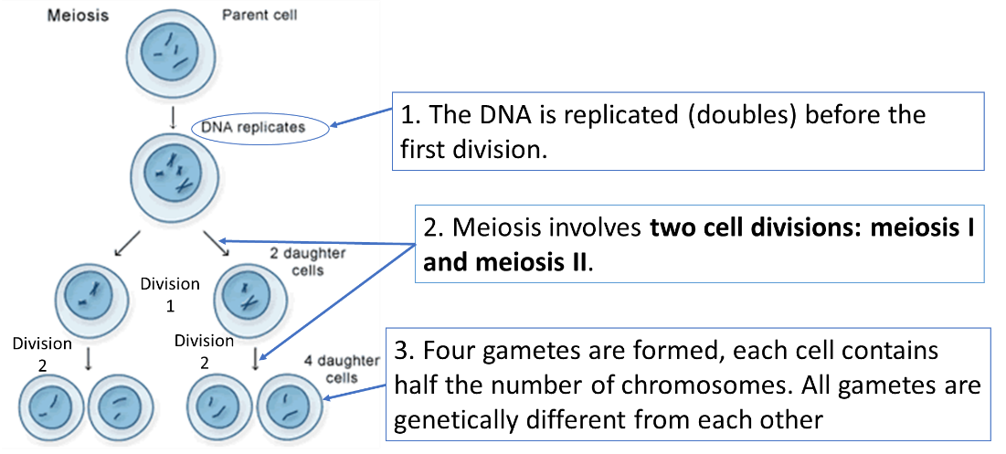
Meiosis follows the same steps as mitosis to start, but once the daughter cells have formed, they undergo a second division. This results in 1 parent cell forming 4 gametes, each with half the number of chromosomes as an adult cell. We say these cells have a haploid nucleus because they have half the number of chromosomes. In humans the haploid number is 23.
Meiosis also means the offspring will all be different from each other and their parents as they have a unique combination of genes from both parents, so they are not identical. This leads to variation within the population.
Recall questions: Answer these in your book, use the information above to help you
- How many divisions does a cell undergo in meiosis?
- State the three key steps in meiosis.
- Describe the product of meiosis.
- How many chromosomes are there in a human gamete?
Part 3 - Explain the importance of meiosis for fertilisation to occur
Information: Read the following notes
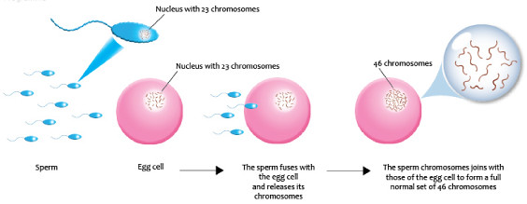
Fertilisation occurs when two gametes fuse (join). At this stage the first cell of a new organisms has been formed, called a zygote, with the correct number of chromosomes (a diploid nucleus, 46 chromosomes). This one cell then divides (by mitosis) before differentiating into all the specialised cells that make up an organism.
Meiosis is important because if gametes didn’t have half the number of chromosomes, they wouldn’t be able to fuse during fertilisation to make an embryo with body cells that had the full number of chromosomes needed in each cell.

Recall questions: Answer these in your book, use the information above to help you
- Name the process where a sperm and an egg cell fuse together.
- Explain why meiosis is necessary for fertilisation to occur?
- Name the cell type formed by fertilisation (fusion of male and female gametes).
- When a new cell is formed through fertilisation, how does it divide?

Exam question practice: Answer these on this sheet, use the answers to your recall questions to help you
Q1. Diagram 1 shows the nucleus of a cell at the start of meiosis.

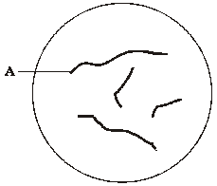
Diagram 1
(a) Name structure A. ___________________________________________________ (1)
(b) During meiosis, the nucleus shown in diagram 1 will divide twice to form four nuclei.
Complete diagram 2 to show the appearance of one of these nuclei.

Diagram 2 (2)
Q2. (a) Gametes (sex cells) contain half the amount of DNA compared to body cells.
Give the names of the two types of gametes in humans.
_______________________________ and _______________________________
(1)
(b) What is the process called when the gametes join?
___________________________________________________________________
(1)

(c) The diagram below shows cell division by meiosis to form gametes.
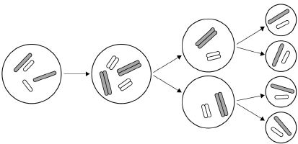
Which two features in the diagram above show that this cell division is meiosis and not mitosis?
Tick two boxes.

The cell divides twice | 
The chromosomes pull apart into the new cells
The cytoplasm divides into new cells
The DNA is copied
The new cells have half the number of chromosomes

(2)

Q3. Sex cells are produced by meiosis.
Describe what happens to the chromosomes when a cell divides by meiosis.
___________________________________________________________________
___________________________________________________________________
___________________________________________________________________
___________________________________________________________________ (2)

Q4. The diagram shows some of the cell divisions that occur during human reproduction.
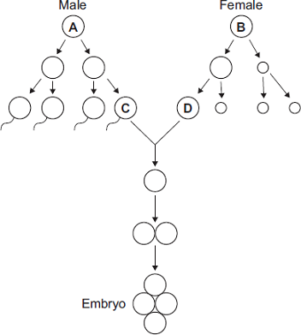
(a) (i) Name the type of cell division that produces cell D from cell B.
______________________________________________________________
(1)
(ii) Which organ in the male body produces cell C from cell A?
______________________________________________________________
(1)
(b) (i) Cells A and B each contain 46 chromosomes.
How many chromosomes would there be in the nucleus of cell C?  (1)
(ii) Why is it important that cell C has this number of chromosomes?
______________________________________________________________
______________________________________________________________
______________________________________________________________ (2)

Lesson 2: Sexual and Asexual Reproduction
CHECKLIST! – Have you…
- Read the notes and completed the recall questions
- Marked your recall questions using the answers
- Completed the exam questions
Key Words:
Clones | An organism that is genetically
Cloning | A scientific method by which genetically identical copies are made of animals or plants.
Variation | Difference between individuals, distance from the norm.
Mitosis | A type of cell division which produces daughter cells identical to the parent.
Asexual reproduction | A type of reproduction requiring only one parent and produces offspring that are genetically identical to each other.
Sexual Reproduction | Type of reproduction involving two parents and the fusion of gametes to produce genetically unique offspring.
Gamete | A sex cell (sperm/pollen in males and ova/eggs in females).
Haploid | A word used to describe a cell that has half the number of chromosomes e.g. human gametes have 23
Diploid | A word used to describe a cell that has the full set of chromosomes e.g. in humans 46
Somatic cells | A somatic cell is any cell in the body other than cells involved in reproduction.
Tubers | A swollen, fleshy underground stem of a plant, such as a potato, which can grow new shoots to form a clone of the parent plant

Part 1 - Describe how sexual reproduction leads to variation in offspring.
Information: Read the following notes
Asexual reproduction only needs one parent. Asexual reproduction produces offspring that are genetically identical to each other, and their parents – they are clones of each other. This is because in asexual reproduction, there is no mixing of genetic information. Examples include: Mitosis, binary fission in bacteria, and some plants can create clones of themselves by producing side shoots which can then grow into new plants e.g. strawberries or by producing tubers or bulbs (underground storage organs) that can regrow into a new plant after winter e.g. potatoes and onions.

A disadvantage of asexual reproduction is that there is no genetic variation as all offspring are clones – this can make them more susceptible to environmental change or disease

In sexual reproduction genes are mixed to produce variation in the offspring. This is because offspring inherit half their chromosomes from each parent. The best solution is to be able to do both forms of reproduction.
Recall questions: Answer these in your book, use the information above to help you
- Define 'mitosis'.
- Which type of reproduction is based only on mitosis?
- Define 'cloning'.
- By which cell division type does cloning occur?
- What are the advantages of asexual reproduction?
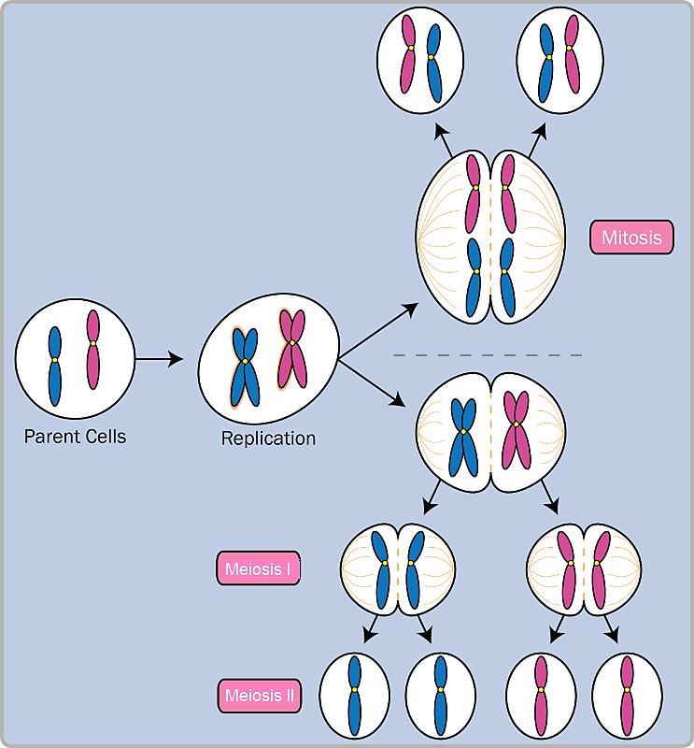
Part 2 - Compare sexual and asexual reproduction
Information: Read the following notes
Asexual reproduction produces clones - two genetically identical daughter cells.
Mitosis is a form of asexual reproduction. Both cells have 23 pairs of chromosomes. They are known as diploid.
Sexual reproduction (meiosis) produces four non-identical daughter cells.
These are sex cells called gametes.
Each gamete has half the number of chromosomes of a body cell so they are known as haploid.
Comparing sexual and Asexual reproduction
 | Asexual Reproduction | Sexual Reproduction
Number of parent cells | One | Two
Cell division type used | Mitosis | Meiosis
Number of cells produced | 2 | 4
Genetic information inherited by offspring | All of genes passed on – genetically identical clones | Half of genes from each parent passed on
Genetic variation in offspring | No – all offspring are clones of parent and each other because there is no mixing of genes | Yes – offspring are genetically different to parent and each other because genes from two parents are mixed.

Recall questions: Answer these in your book, use the information above to help you
- Describe the cells produced by meiosis.
- Describe the cells produced by mitosis.
- By which cell division type does asexual reproduction rely on?
- State one difference between asexual and sexual reproduction.
Worksheet questions: Answer these in your book, use the information above to help you
Mitosis
- What are the main purposes of mitosis?
- Mitosis is part of what cycle?
- What type of cell undergoes mitosis?
Circle one: Reproductive sex cells or somatic cells
- How does a daughter cell compare to the parent cell after undergoing mitosis?
Circle one: identical to the parent or different than the parent
- Does mitosis make haploid or diploid cells?
Circle one: haploid or diploid
Meiosis
- What type of cell undergoes meiosis?
Circle one: reproductive sex cells or somatic cells
- What are the two main types of gametes?
- What are gametes used for?
- Does meiosis make haploid or diploid cells?
Circle one: haploid or diploid
- How does a daughter cell compare to the parent cell after undergoing meiosis?
Circle one: identical to the parent or different than the parent
- What process in prophase 1 of meiosis makes every gamete different?
- Compare and contrast mitosis and meiosis by filling in the Venn diagram below:

Mitosis Meiosis

Exam question practice: Answer these on this sheet, use the answers to your recall questions to help you
Q1. (i) Mitosis and meiosis are types of cell division.
For each feature in the table, tick () one box to show if the feature occurs:
• only in mitosis
• only in meiosis.

Feature | Only in mitosis  () | Only in mitosis  ()
Produces new cells during growth and repair
Produces gametes (sex cells)
Produces genetically identical cells
(2)
(ii) Name the organ that produces gametes (sex cells) in:
a man ______________________
a woman ____________________
(2)
Q2. Meiosis and mitosis are different types of division in human cells. Compare the two processes by referring to where each takes place and the kind of products that are made.
_______________________________________________________________________
_______________________________________________________________________
_______________________________________________________________________
_______________________________________________________________________
_______________________________________________________________________
_______________________________________________________________________
_______________________________________________________________________
_______________________________________________________________________
_______________________________________________________________________
_______________________________________________________________________
(Total 6 marks)
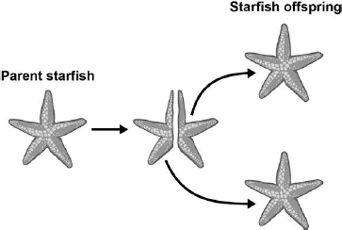
Q3. Starfish can split in half. Each half can then grow new arms to form offspring.
This process is shown in the figure

(a) What process produces the starfish offspring?
Tick one box.

Asexual reproduction | 
Fertilisation
Selective breeding
Sexual reproduction
(1)
(b) More cells are produced as the starfish grows more arms.
What process will produce more cells in the starfish as they grow?
___________________________________________________________________
(1)
(c) All the offspring produced are genetically identical.
What name is given to genetically identical organisms?
___________________________________________________________________
(1)
(d) Each body cell of the parent starfish contains 44 chromosomes.
How many chromosomes are in each body cell of the offspring?
___________________________________________________________________ (1)
Q4. A gardener wanted to produce a new variety of onion.
Explain why sexual reproduction could produce a new variety of onion.
___________________________________________________________________
___________________________________________________________________
___________________________________________________________________
___________________________________________________________________ (3)
Q5. The bean aphid is a type of black-fly which lives on broad bean plants in summer.
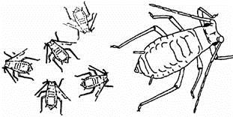
In the autumn, males and females mate and produce eggs.

(a) Name the type of reproduction which produces the eggs.
___________________________________________________________________
(1)
(b) In spring these eggs hatch. The young aphids are all female.
Explain why they are all similar but not identical to each other.
___________________________________________________________________
(1)
(c) These females are then able to produce offspring without needing any males.
(i) Name the type of reproduction where females do not need males to produce offspring.
______________________________________________________________
(1)
(ii) How will the offspring from one of these females:
A compare with each other
______________________________________________________________
B compare with the offspring from other females?
______________________________________________________________ (2)
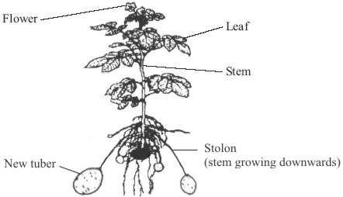
Q6. The drawing shows a potato plant producing new tubers (potatoes). Buds on the stem of the parent plant produce stolons. The new tubers are formed at the ends of the stolons (stems that grow downwards).
Explain why the new tubers are genetically identical to each other.
___________________________________________________________________
___________________________________________________________________
___________________________________________________________________(3)
Lesson 3 – DNA and the Genome
CHECKLIST! – Have you…
- Read the notes and completed the recall questions
- Marked your recall questions using the answers
- Completed the exam questions
Key Words:
Polymer | A large molecule formed from many identical smaller molecules known as monomers.
DNA | DNA stands for deoxyribonucleic acid. DNA carries genetic information. It has all the instructions that a living organism needs to grow, reproduce and function.
Gene | A short section of DNA that codes for a protein
Genome | An organisms complete set of genetic information (in every cell)
Chromosomes | The structure that DNA is organised into – humans have 23 pairs of chromosomes in the nucleus
Nucleus | The nucleus controls what happens inside the cell. Chromosomes are structures found in the nucleus of most cells. The plural of nucleus is nuclei.
Double helix | The shape of the DNA molecule which has two strands twisted together in a spiral
Genetic Code | The code formed by the order of the bases in DNA that determines an organism's characteristics.

Part 1: State the structure and role of DNA
Information: Read the following notes

DNA is a polymer made up of two strands forming a double helix (‘Double’ = two strands ‘Helix’ = twisted around each other).
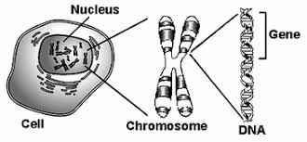
The two strands are held together by chemicals called ‘bases’. DNA is a chemical which contains genetic information or the “code for life”, small sections of the DNA called genes code for a particular sequence of amino acids in order to make a specific protein.
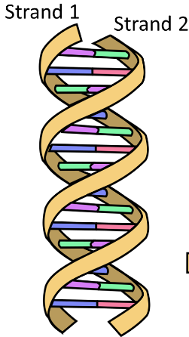
An organisms complete set of genetic information (in every cell) is called its genome.

Part 2: Describe how genetic material is organised.
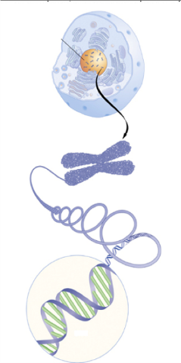
Information: Read the following notes
DNA is coiled into structures called chromosomes. The chromosomes are found in the nucleus of each cell. Human body cells contain 23 pairs (46) chromosomes
A gene is a short section of DNA that codes for a specific protein. The code of each gene tells the ribosomes the order to place certain amino acids.
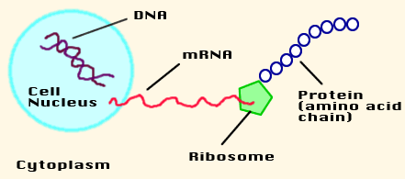
We say each gene ‘codes for’ a specific protein because if you change the order of the amino acids a different protein would be made.

Recall questions: Answer these in your book, use the information above to help you

- The genetic material in the nucleus of a cell is….
- Describe the structure of DNA.
- Name the structure within which DNA is contained.
- What is a gene?
- What is the function of a gene?
- What is a genome?
- What is a change in the DNA sequence called?
- What are chromosomes?
- How many chromosomes are in one human body cell?

Part 3: Discuss the importance of understanding the human genome.
The Human Genome Project (HGP) was an international scientific research project with the goal of determining the sequence of chemical bases which make up all of human DNA which is over 3 billion bases long!
The importance of identifying and knowing the order of genes in the human genome is so that we can:
- To search for genes linked to different types of disease
- To understand and treat inherited disorders
- To trace early human migration patterns

Recall questions: Answer these in your book, use the information above to help you
- State 3 ways in which understanding of the human genome will be important.

Exam question practice: Answer these on this sheet, use the answers to your recall questions to help you
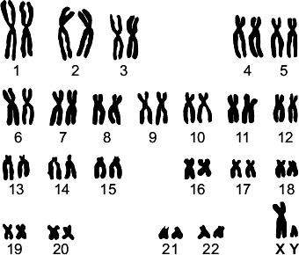
Q1. When scientists look at dividing cells under a microscope, they can see strands that contain a chemical called DNA.

The diagram shows an arrangement of the strands from a human cell.
(a) What name is given to the strands containing DNA shown in the diagram?
Draw a ring around one answer.

alleles | chromosomes | genes
(1)
Q2. The diagram shows a human cell and some of its contents.
(a) Choose words from this list to label the diagrams.
chromosome cytoplasm gene nucleus
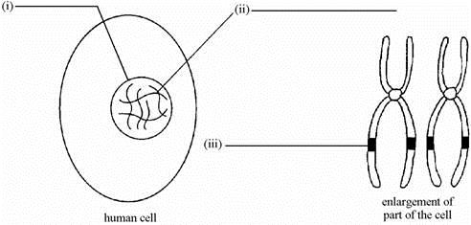
(3)
(b) Choose words from this list to complete the sentence.
a body cell an egg cell a gamete a sperm cell
In the cell above, the chromosomes are found in pairs so this cell must be
__________________________________________________________________
Q3. DNA is the genetic material of human cells.
Figure 1 shows the structure of part of a DNA molecule.
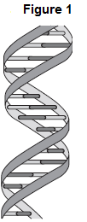
(a) (i) Describe where DNA is found in a human cell.
______________________________________________________________
______________________________________________________________
______________________________________________________________(2)
(ii) When a cell divides by mitosis the new cells are genetically identical.
What causes the cells to be genetically identical?
______________________________________________________________
______________________________________________________________ (1)

Q4. Marfan syndrome is a rare genetic disorder that causes problems with many body systems.
(a) Which sentence best describes a gene? Tick one box.

A long chain of carbohydrate | 
A short section of DNA
All of the chromosomes in an organism
Several amino acids joined together
(1)

(b) What does a gene code for? Tick one box.

A carbohydrate polymer
A DNA double helix
One glycerol and three fatty acids
A sequence of amino acids
(1)
(c) What scientific term is used to describe all the genes of one organism?
___________________________________________________________________
(1)
Q5. Diagram 1 shows an animal cell and some of the structures inside the cell.
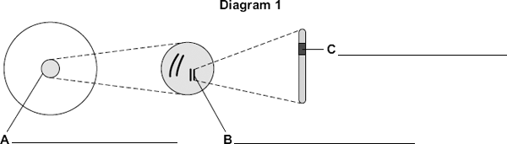
(a) Label structures A, B and C, on Diagram 1 (3)
Q6. Proteins are made according to information stored in the DNA structure of genes.
(c) Describe the structure of DNA.
___________________________________________________________________
___________________________________________________________________
___________________________________________________________________
___________________________________________________________________
(2)
(d) Describe how DNA controls the structure of a protein.
___________________________________________________________________
___________________________________________________________________
___________________________________________________________________
___________________________________________________________________ (2)

Lesson 4 – Genotype and Phenotype
CHECKLIST! – Have you…
- Read the notes and completed the recall questions
- Marked your recall questions using the answers
- Completed the exam questions
Key Words:
Alleles | Different form of the same gene
Characteristics | A characteristic is an observable (can see it or measure it) quality, trait or feature of an individual e.g. hair colour, eye colour, flower colour, leaf shape.
Dominant | An allele that always expresses itself whether it is it is partnered by a recessive allele or by another like itself.
Recessive | Describes the variant of a gene for a characteristic which is masked or suppressed in the presence of the dominant variant. A recessive gene will remain dormant unless it is paired with another recessive gene.
Genotype | The alleles that an organism has for a particular characteristic, usually written as letters.
Phenotype | The visible characteristics of an organism which occur as a result of its genes.

Part 1: Define the terms genotype and phenotype.
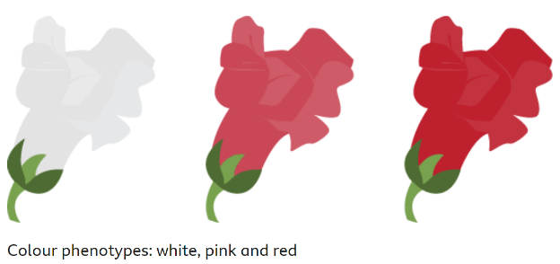
Information: Read the following notes
When we describe how different organisms appear or look, we are describing their phenotype – their observable characteristics. A characteristic is an observable (can see it or measure it) quality, trait or feature of an individual e.g hair colour, eye colour, flower colour, leaf shape.
Different forms of the same gene are known as alleles. An organism’s genotype is the alleles an individual has for a certain characteristic.
Recall questions: Answer these in your book, use the information above to help you
- What is an allele?
- What is a genotype?
- What is a phenotype?

Part 2: Describe how some characteristics are controlled by a certain allele.
Information: Read the following notes
There are two copies of every chromosome in a body cell nucleus (one copy inherited from the mother the other copy inherited from the father).
Therefore, there are two copies of every gene. These may have different alleles and the combination of the two alleles (the genotype) determines the characteristic (the phenotype).
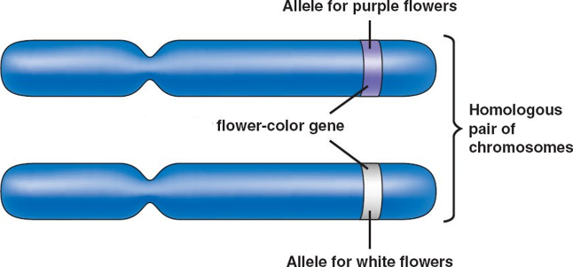
In this example there is a gene for flower colour, this plant has two copies of the flower colour gene one on each chromosome. This plant has two different alleles (versions of the flower colour gene) one allele codes for purple petals the other codes for white petals.
Recall questions: Answer these in your book, use the information above to help you
- What percent of your chromosomes have you inherited from your father?
- What is the word used to describe the alleles an organism has for a gene?
- What word describes the physical characteristics an organism has?

Part 3: Explain how a dominant allele is always expressed
Information: Read the following notes
For most genes, one allele is said to be dominant and the other recessive. Only one dominant allele needs to be present for the dominant phenotype to be expressed. This means individuals that have two dominant alleles OR one dominant and one recessive allele will express the dominant phenotype. Two copies of recessive alleles need to be present for the recessive phenotype to be expressed. Due to this relationship, we often refer to the alleles using the same letter, the dominant in UPPER case and the recessive in lower case e.g. “B” is dominant, “b” is recessive.
For example: In the gene for flower colour purple is the dominant allele, so our code is P= purple and p=white
Chromosomes/Gene | Genotype | Phenotype
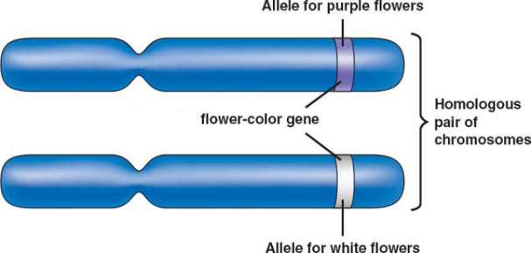  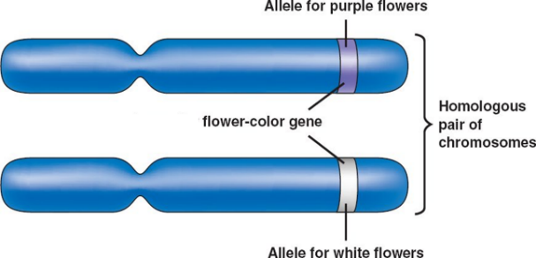  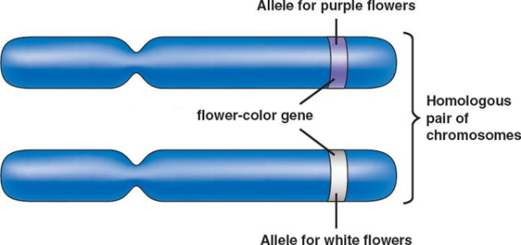 | PP  Dominant Alleles Only | Purple Flowers
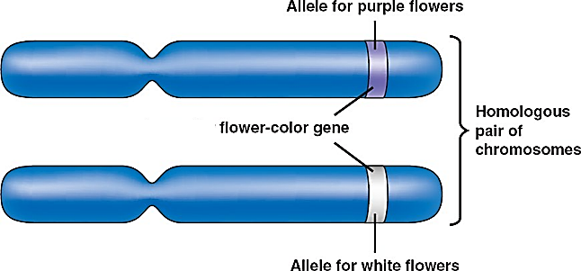 | Pp  Dominant and Recessive Alleles | Purple Flowers
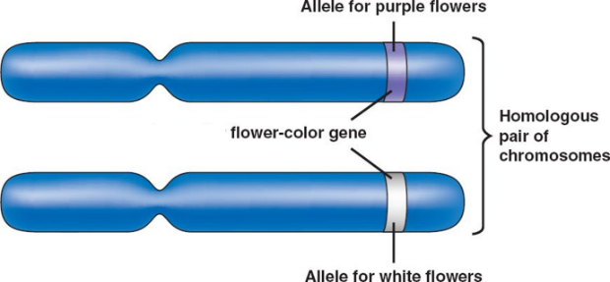  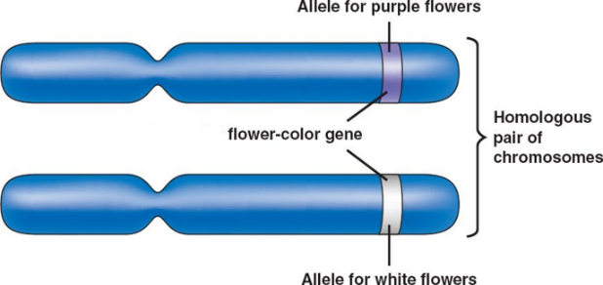 | pp  Recessive Alleles only | White Flowers
Organisms which have two copies of a recessive allele and show the recessive phenotype cannot pass on any dominant alleles to their offspring unless they sexually reproduce with a mate that has dominant alleles. E.g. two plants with white flowers cannot produce plants with purple flowers but one white plant could reproduce with a purple plant and their offspring would have purple flowers. You can use this as evidence to tell if a characteristic is dominant or recessive!
Recall questions: Answer these in your book, use the information above to help you
- What does the term “dominant” mean when used to describe an allele?
- Give an example of a dominant genotype using the letter G.
- What does the term “recessive” mean when used to describe an allele?
- Give an example of a recessive genotype using the letter G.
- How can you identify if a characteristic or phenotype is recessive?

Exam question practice: Answer these on this sheet, use the answers to your recall questions to help you
Q1. A mouse will always have black fur if one or two black fur alleles are inherited.
What word describes the black fur allele? Tick one box.

Dominant
Recessive
Heterozygous
Homozygous
(1)
Q2. (i) describe the difference between dominant and recessive alleles;
______________________________________________________________
______________________________________________________________
______________________________________________________________ (2)
(ii) describe the difference between alleles and genes;
______________________________________________________________
______________________________________________________________
______________________________________________________________ (2)

Q3. In humans, hair colour is an inherited characteristic. Red hair is caused by a recessive allele.

(a) When does a recessive allele control the development of a characteristic? (1)

Tick (✔) one box.
When the allele is present on only one of the chromosomes.
When the dominant allele is not present.
When the allele is inherited from the female parent.

Q4. Variation in individual organisms can be caused by:
• genes
• the environment
• a combination of both genes and the environment.
The table shows variations in a woman.
(a) What is the cause of each variation in the table below?
Tick only one box in each row.

Variation | Cause of variation
Variation | Genes only | Environment only | Both genes and the environment
Brown eyes
Light brown skin colour
Short hair
(3)
(b) The allele for blue eyes is recessive (b).
The allele for brown eyes is dominant (B).
A woman has blue eyes.
What are the woman’s alleles?
Tick one box.

BB |  | Bb |  | bb
(1)
(c) The woman marries a man with the alleles Bb for eye colour.
What colour eyes does the man have?
___________________________________________________________________
(1)
(d) What is the scientific term used for the child’s eye colour?
Tick one box.

Chromosome
Condition
Genotype
Phenotype

(e) What effect will a mutation have?
Tick one box.

Almost certainly have no effect
Definitely change appearance
Definitely be passed on to all children
Probably cause a disease
(1)
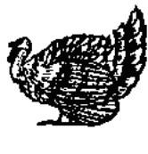
Q5. Wild turkeys have black feathers. Until about 30 years ago turkeys reared for meat also had black feathers.
However, a recessive gene which produced entirely white feathers appeared, and turkey farmers changed to breeding white-feathered birds.
Now, however, there is a demand again for birds with black feathers which can be marketed as ‘traditional’ farm-produced turkeys.
(a) Feather colour is controlled by one pair of genes.
(i) Suggest suitable symbols for each of the two alleles of this pair of genes.
Black feathers ____________ White feathers _________________
(1)
(ii) What alleles for feather colour would a white turkey have? ______________ (1)
(b) Explain carefully why ‘traditional’ black-feathered turkeys could not be bred from a flock of white-feathered birds.
___________________________________________________________________
___________________________________________________________________ (2)
Q6. Pompe disorder is an inherited condition that affects thousands of people, it is caused by the GAA gene.
(a) What is a gene made of?
___________________________________________________________________
(1)
Pompe disorder is caused by a recessive allele. r is the recessive allele and R is the dominant allele
(b) What is the genotype of person that has Pompe disorder?
_________________________________________ (1)

Lesson 5 - Genetic Inheritance and Sex Determination
CHECKLIST! – Have you…
- Read the notes and completed the recall questions
- Marked your recall questions using the answers
- Completed the exam questions
Key Words:
Heterozygous | This describes a genotype in which the two alleles for a characteristic are different.
Homozygous | This describes a genotype in which the two alleles for the characteristics are identical.
Punnet Square | A grid that shows the possible combinations of alleles that can result at fertilisation.

Part 1: Define the terms homozygous and heterozygous
Information: Read the following notes
If the two alleles of a gene are the same, the individual is described as homozygous. Example: BB or bb
If two alleles of a gene are different, the individual is described as heterozygous. Example: Bb​

Example: The gene for flower colour in pea plants has two alleles, purple and white.
The purple allele is represented by “P” and the white allele by “p”.
Chromosomes/Gene | Genotype | Phenotype
 | PP  Dominant Alleles Only  Homozygous dominant | The homozygous dominant phenotype is purple flowers
 | Pp  Dominant and Recessive Alleles  Heterozygous | The heterozygous phenotype purple flowers
 | pp  Recessive Alleles Only  Homozygous recessive | The homozygous recessive phenotype is white flowers
Recall questions: Answer these in your book, use the information above to help you
- What does the term “heterozygous” mean?
- What does the term “homozygous” mean?

Part 2: Use Punnett squares to predict and interpret the results of a genetic cross.
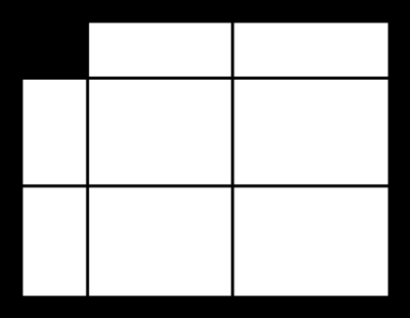
Information: Read the following notes
Parent 1
allele 1
Parent 1
allele 2
Parent
2
allele
1
Parent
2
allele
2
Offspring
alleles chance 1
Offspring
alleles chance 2
Offspring
alleles chance 3
Offspring
alleles chance 4
A Punnett square can be used to perform a genetic cross to work out the probability of a certain allele being present in the offspring of two parents each time they reproduce. The information in a punnet square is labelled here.

Remember - Probability means 'how likely' or 'what chance' - normally a fraction or a % example: ¼, 0.25 or 25%
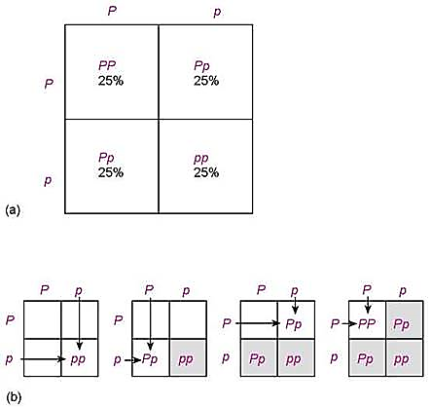
In this example using our Pp alleles for purple and white flowers again:
Genotypes
- ¼ or 25% chance of the homozygous dominant PP
- ½ or 50% chance (2x 25%) of the heterozygous Pp
- ¼ or 25% chance of the homozygous recessive
Phenotypes
- ¾ or 75% chance of having purple flowers (as it is dominant)
- ¼ or 25% chance of having white flowers (as it is recessive)
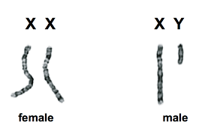
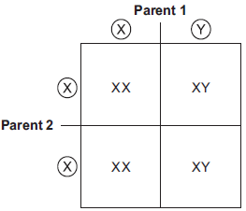
A sex chromosome is a type of chromosome that determines the sex of an organism. Humans and most mammals have two sex chromosomes, the X and the Y. Females have two X chromosomes in their cells, while males have one X and one Y chromosomes in their cells.
Father
Mother

We can use a punnet square to show that the probability of getting a girl or a boy each time an embryo is fertilised is always 50%.
Recall questions: Answer these in your book, use the information above to help you

- What is the genotype of a female?
- What is the genotype of a male?
Worksheet questions: Answer these in your book, use the information above to help you
Bronze:
- What is an allele?
- How many alleles of each gene does a person have?
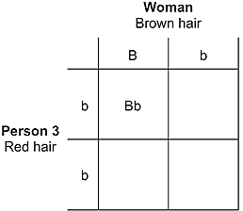
- Circle the alleles which represent a person who is heterozygous: Aa aa aA AA
- What does homozygous mean?
- Look at the genetic cross diagram:
  - Complete the diagram to show the alleles for each box
  - Is person 3 heterozygous or homozygous?
  - Why does Person 3 have red hair?
  - Draw a ring around the boxes which show the alleles for children with red hair.
  - What is the probability that one of the children will have red hair?
Silver:
- Why does a person usually inherit two alleles of each gene?
- A mouse will always have black fur if one or two black fur alleles are inherited. What word best describes the black fur allele?
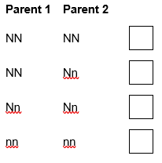
- Some humans are albino (they have white hair and pale skin). This condition is caused by a recessive allele, n. The other allele, N, causes pigment to be made. There are three possible combinations of these alleles: NN, Nn or nn.
  - Which one of these combinations will an albino person have?
  - Two non-albino parents can sometimes have an albino child. Which combination of alleles must the two parents have for this to happen? Tick one box:

Gold:
- The allele for blue eyes is recessive (b) and the allele for brown eyes is dominant (B).
  - A woman has blue eyes what are her alleles?
  - The woman would like to have a baby with a homozygous brown eyed man. Draw a Punnett square diagram to show the alleles for eye colour for their offspring.
  - What is the probability that one of their children will have brown eyes? Can you explain your answer?

Exam question practice: Answer these on this sheet, use the answers to your recall questions to help you
Q1. The allele for blue eyes is recessive (b). The allele for brown eyes is dominant (B).
A woman has blue eyes. What are the woman’s alleles?
Tick one box.

BB |  | Bb |  | bb
(1)
(d) Complete the Punnett square diagram in Figure 2 for this man and the woman. (1)
Figure 2 |  | Woman
Man | B
Man | b

(e) What is the probability that a child of this man and woman will have brown eyes?
___________________________________________________________________
(1)
Q2. Two black mice both have one black fur allele (B) and one brown fur allele (b).
(f) Complete the genetic diagram below to show the possible offspring of these mice.

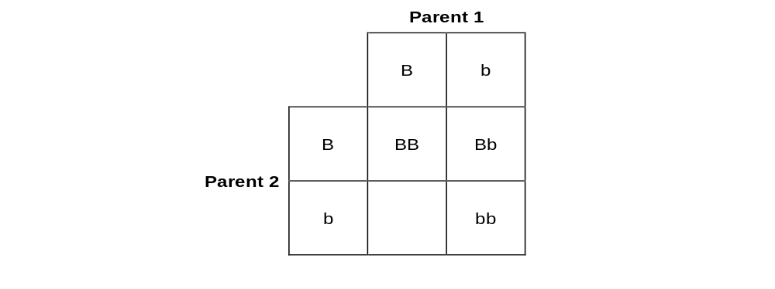 (1)
(g) On the diagram above draw a ring around one offspring with brown fur. (1)
(h) What is the chance of the offspring from the two black mice being brown?
___________________________________________________________________ (1)

Challenge:

Q1. Two heterozygous parents, with alleles Rr, produce offspring.
(i) Draw a genetic diagram to show all the possible arrangements of alleles in their offspring.

(2)
(ii) One of the offspring is dominant homozygous. What is the chance of this occurring?
___________________________________________________________________ (1)
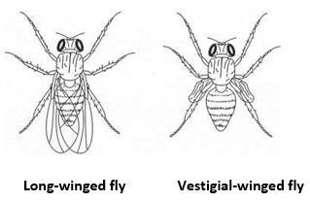

Q2. The fruit fly, Drosophila, has either long wings or vestigial wings, as shown in the diagram.

The size of the wings is determined by a pair of alleles: A and a.
Long-winged flies have one of two possible genotypes: AA or Aa.
Vestigial-winged flies have only one genotype: aa.
(a) (i) What is the genotype of a heterozygous fly?
______________________________________________________________(1)
(ii) Why can vestigial-winged flies only have the genotype aa?
______________________________________________________________
(1)
(b) A male and a female long-winged fly were crossed. They produced 96 offspring.
72 of the offspring had long wings and 24 had vestigial wings.
Use a genetic diagram to explain this.

(4)

Lesson 6 – Inherited Disorders
CHECKLIST! – Have you…
- Read the notes and completed the recall questions
- Marked your recall questions using the answers
- Completed the exam questions
Key Words:
Polydactyly | Polydactyly is a genetic disorder caused by a dominant allele. People born with polydactyly have extra fingers or toes.
Cystic fibrosis | Cystic fibrosis is a genetic disorder caused by 2 recessive alleles.
Embryo | A ball of cells formed after fertilisation that undergoes mitosis to grow and form a foetus.
Mutation | A change to the DNA base sequence.

Part 1 - State (at least) two inherited disorders (cystic fibrosis and polydactyly)
Information: Read the following notes
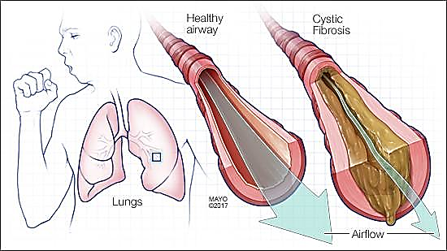
Cystic Fibrosis is a genetic disorder caused by a mutation. It affects many organs including the: lungs, digestive system and reproductive system. It affects mucus made by cells in different areas of the body causing it to become very thick and sticky.

Organs such as the lungs can become clogged up, this makes breathing harder and increases their chance of getting chest infections due to build-up of dust and dirt. Their pancreatic duct can also be blocked, resulting in less digestive enzymes making their way into the small intestine. This can reduce the amount of nutrients they can get from their food – this often leads to them being underweight.
It cannot be cured as it is a genetic disorder, but it can be treated to help reduce symptoms. Physiotherapy can help keep area’s clear of mucus and antibiotics are used to prevent infection. Later in life a lung transplant may be needed.
Cystic fibrosis is a recessive genetic disorder (only people who are homozygous recessive (have two copies of the recessive allele) for the cystic fibrosis gene have the disorder).
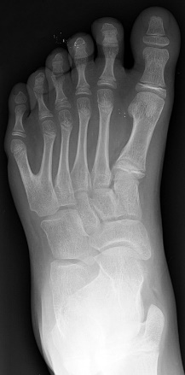
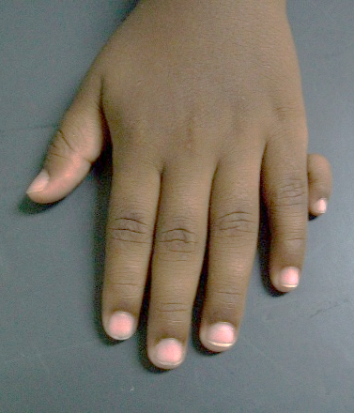
Not all genetic diseases are recessive.
Polydactyly is caused by a dominant allele. People born with polydactyly have extra fingers or toes.
This genetic disorder is not harmful. People can choose to have extra digits removed with surgery but some keep them.
Some dominant genetic disorders have a much more widespread effects on the way the body works and cause serious symptoms, they are often life limiting e.g. Huntington’s disease.
Recall questions: Answer these in your book, use the information above to help you
- What are the symptoms associated with cystic fibrosis?
- What type of genetic disorder is cystic fibrosis?
- How can cystic fibrosis be treated?
- What is polydactyly?
- Is polydactyly a dominant or recessive condition?
- State the genotype(s) that would result in polydactyly.

Part 2: Describe the difference in inheritance patterns for dominant/recessive allele disorders.
Information: Read the following notes
Cystic fibrosis is caused by a recessive allele. This means that only homozygous recessive people are suffering from the disorder and heterozygous people are completely normal, but they have a chance of having a child which suffers from it. They are known as carriers.
To the right is the Punnett square for a cross between two heterozygous carriers. C= healthy, c= cystic fibrosis
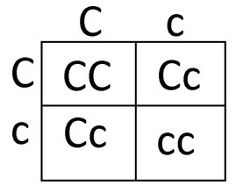
In this example:
Genotypes
- 25% chance of the homozygous dominant CC
- 50% chance of the heterozygous Cc
- 25% chance of the homozygous recessive cc
Phenotypes
- 25% of being unaffected CC
- 50% of having no symptoms but being a carrier Cc
- 25% chance of suffering from cystic fibrosis cc (circled)

Polydactyly is caused by a dominant allele. This means that only one parent needs to pass on the faulty allele for the child to suffer from polydactyly, So a homozygous dominant parent is guaranteed to have a polydactyly child and a heterozygous parents will have a chance of having one.
To the right is a Punnett square showing the chances of having child with polydactyly when one parent with the disorder mates with a homozygous recessive partner.
In this example:
Genotypes
- 25% chance of the homozygous dominant PP
- 50% chance of the heterozygous Pp
- 25% chance of the homozygous recessive pp
Phenotypes
- 75% chance of having polydactyly (circled)
- 25% chance of being unaffected

Recall questions: Answer these in your book, use the information above to help you
- What is cystic fibrosis?
- Is cystic fibrosis a dominant or recessive condition?
- State the genotype(s) that would result in cystic fibrosis.

Part 3: Discuss the issues surrounding embryo screening.
Information: Read the following notes
Genetic testing involves analysis of a person's DNA to see if they carry alleles that cause genetic disorders. It can be done at any stage in a person's life. If people know they are carriers of a genetic disorder and they would like to have children but not pass on the alleles that cause their genetic disorder they can have their embryos screened before pregnancy occurs.
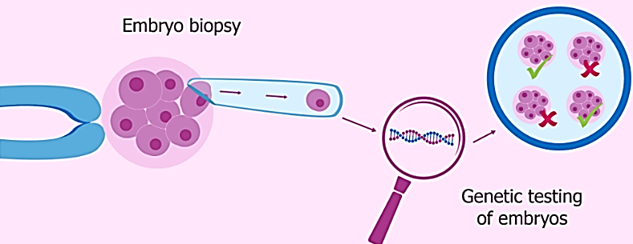
Pre-implantation genetic diagnosis (PGD) or embryo screening can be used on embryos before placing them into the uterus of the mother. Fertility drugs stimulate the release of several eggs. The eggs are collected and fertilised with sperm in a Petri dish. This is known as in vitro fertilisation (IVF).
Once the embryos have reached the eight-cell stage, one cell is removed from each. These cells are tested for the disorder causing alleles. Only embryos that do not contain the alleles are then implanted into the uterus, embryos with the alleles for the disorder are destroyed.
Testing can also be done during the pregnancy. This testing uses a needle to take a sample of the growing foetus’s blood in the womb. It is offered to couples who may have an increased risk of producing a baby with an inherited disorder, but it cannot detect all the inherited disorders unlike embryo screening.
The main advantage of screening is it allows parents the ability to have healthy children without the disorder or they can make an informed choice to continue or terminate a pregnancy.
But there are also some disadvantages:
- Testing can cause miscarriage by damaging the embryo or cause harm to the mother or unborn foetus (if done during pregnancy)
- People can be against these tests for moral and religious reasons. Some people have a strong belief that it is immoral or unethical to destroy embryos or terminate foetuses which could have lived.
- The tests are often expensive, and the results are not always reliable
Recall questions: Answer these in your book, use the information above to help you
- State the benefit of embryo screening.
- State one concern of screening embryos.

Exam question practice: Answer these on this sheet, use the answers to your recall questions to help you

Q1. (i) What is meant by ‘embryo screening’?
______________________________________________________________
______________________________________________________________
(1)
(ii) Why do some people believe that embryos should not be screened?
______________________________________________________________
______________________________________________________________ (1)

Q2. Cystic fibrosis is an inherited disorder.
Mr and Mrs Brown do not have cystic fibrosis but they have a child with cystic fibrosis.

(a) Draw a ring around the correct answer to complete each sentence.
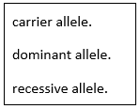
(i) The allele for cystic fibrosis is a

(1)
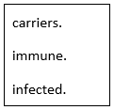

    - Mr and Mrs Brown are both

(1)

(b) The diagram shows how the allele for cystic fibrosis can be inherited by Mr and Mrs Brown’s children.
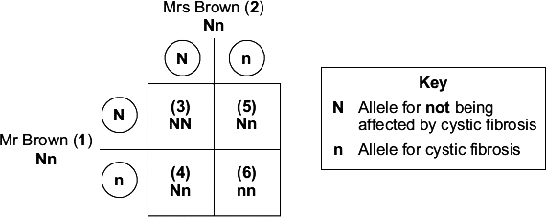
(i) Give the number of one person in the diagram who has
cystic fibrosis. (1)
(ii) The chance that Mr and Mrs Brown's next child will have cystic fibrosis is
_____________________________________________________________ (1)
(c) A genetic counsellor describes to Mr and Mrs Brown one way of screening embryos for cystic fibrosis.
• Some eggs are collected from Mrs Brown.
• The eggs are then fertilised in a dish.
• Several embryos may start to develop.

The photograph shows how doctors take one cell from each embryo when it is only 3 days old.
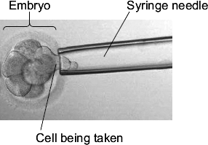
©Pascal Goetgheluck/Science Photo Library
• The DNA in the cell from each embryo is tested for cystic fibrosis.
• Doctors select one embryo that is unaffected and place it in Mrs Brown’s uterus.
• The embryo then develops into a baby.
Use the information to suggest one advantage and one disadvantage of screening embryos in this way.
Advantage __________________________________________________________
___________________________________________________________________
Disadvantage _______________________________________________________
___________________________________________________________________
(2)
Q3. Polydactyly is an inherited condition caused by a dominant allele.
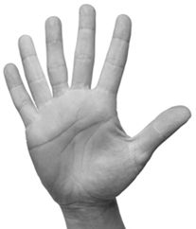
(a) The figure below shows the hand of a man with polydactyly. The man has an extra finger on each hand.
The man’s mother also has polydactyly, but his father does not.
(i) The man is heterozygous for polydactyly.
Explain how the information given above shows that the man is heterozygous for polydactyly.
______________________________________________________________
______________________________________________________________
______________________________________________________________
______________________________________________________________ (3)
(ii) The man marries a woman who does not have polydactyly.
What is the probability that their first child will have polydactyly?
______________________________________________________________
(1)
Q4. To avoid having another child with CRAM, persons 7 and 8 may decide to use embryo screening.
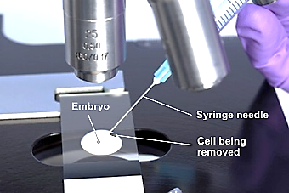
Two ways of doing this are:
• PGD (pre-implantation genetic diagnosis)
• CVS (chorionic villus sampling).
PGD involves IVF (in vitro fertilisation) of a few eggs, then taking a cell from each embryo when it is 3 days old. The image shows how the cell is removed.
The DNA in the cell can then be tested. An unaffected embryo can be implanted in the woman’s uterus. The possibility of a false positive result is around 1 in 6. The procedure costs about £6000. Affected embryos would be discarded. Extra unaffected embryos might be frozen and kept for later implantation. Alternatively, the extra embryos might be used in scientific research.
CVS involves taking a sample of blood from the placenta a few weeks into pregnancy. DNA from white blood cells can then be tested.
If an affected embryo is detected, the parents then have to decide whether to terminate the pregnancy or allow it to continue.
CVS has a 1 percent chance of giving an incorrect result and a 0.9 percent chance of causing a miscarriage. CVS costs about £600.
Evaluate the benefits of these two methods of embryo screening.
You should include a conclusion to your evaluation.
______________________________________________________________
______________________________________________________________
______________________________________________________________
______________________________________________________________
______________________________________________________________
______________________________________________________________
______________________________________________________________
______________________________________________________________ (5)

Lesson 7 – Genetic Diagrams
CHECKLIST! – Have you…
- Read the notes and completed the recall questions
- Marked your recall questions using the answers
- Completed the exam questions
Key Words:
Genetic diagram/family tree/Pedigree Chart | A diagram which shows the inheritance of a genetic condition in a family across generations.

Part 1 - Identify alleles on a genetic diagram or ‘family tree’
Information: Read the following notes
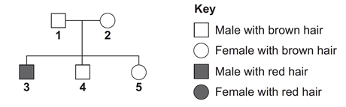
Genetic diagrams or family trees show how characteristics are inherited across multiple generations. They can be abstract with shapes and a key (humans usually) or with pictures and descriptions (plants usually)
Example: Seed colour in peas is controlled by a single gene which has two alleles. A represents the dominant allele, and a represents the recessive allele.
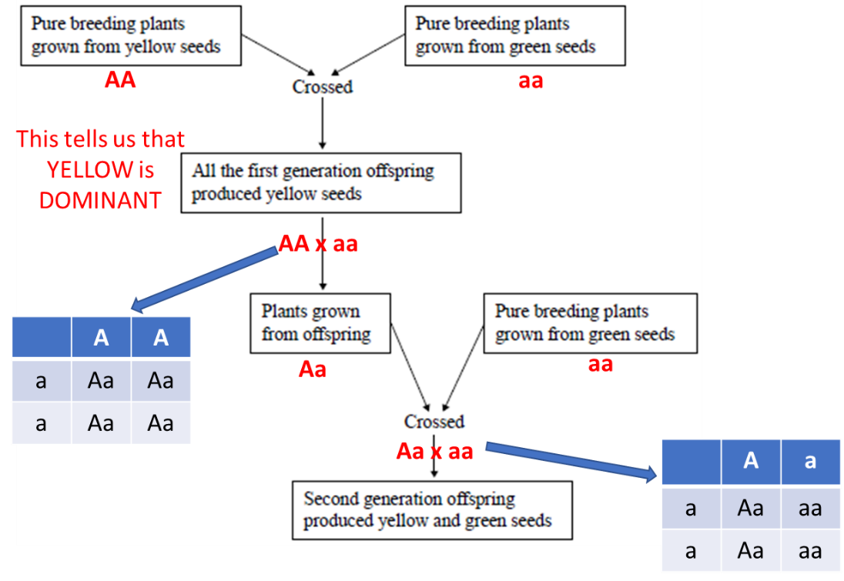
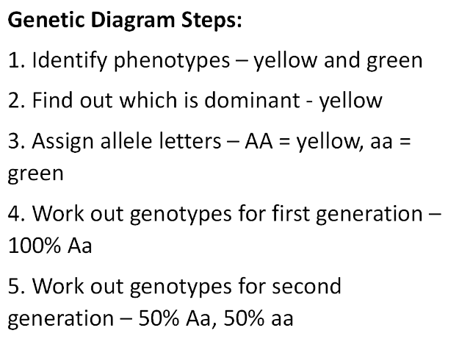

Part 2: Explain the phenotypes or ratios of offspring using evidence from a genetic diagram or ‘family tree’
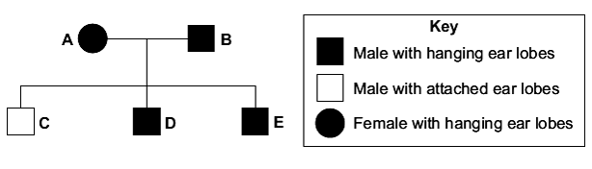
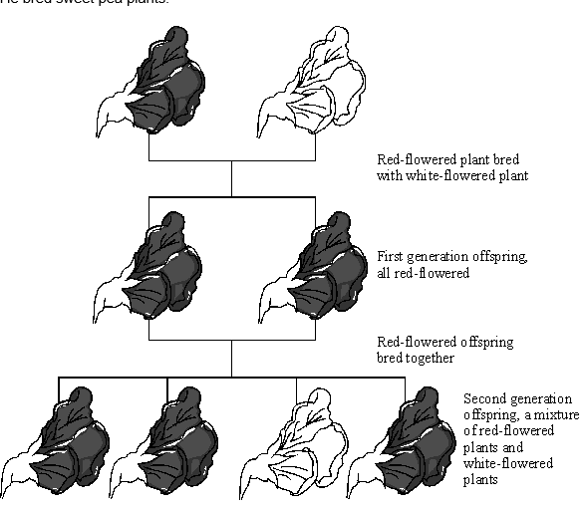
You can determine if the allele for a characteristic or disorder is dominant or recessive using a family tree diagram. If all children/offspring have the characteristic/disorder, then there is a strong chance the allele for it is dominant.
You can tell if the allele for a characteristic or disorder is recessive if only offspring of heterozygous parents have it e.g. if parents do not have the characteristic/trait but some of their children do. The parents are carriers – you can show this with a punnet square. In both the diagrams above white flowers and attached ear lobes must be caused by recessive alleles whereas red flowers and hanging ear lobes are dominant.
With the ear lobe diagram, there is no evidence from that family tree that females can have attached earlobes so that allele may only be present on the Y chromosome.
With the flower colour diagram you can see that recessive inherited characteristics or traits have the ability to skip generations as there are no white flowers in the second generation of plants.
Worksheet questions: Answer these in your book, use the information above to help you
Bronze:
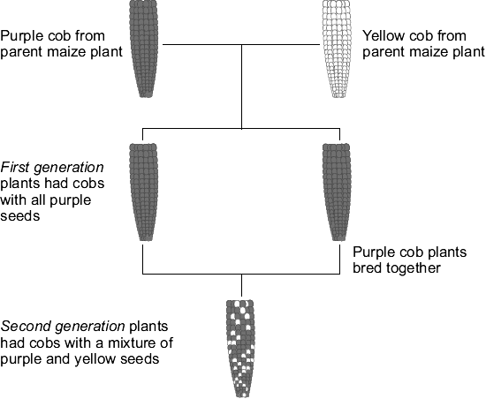
The colour of the seeds is controlled by a gene. The gene has two alleles, purple and yellow. The allele for purple can be represented by the letter A. The allele for yellow can be represented by the letter a.
- All of the first-generation offspring are purple what does this tell you about the purple allele?
- What alleles does a yellow seed plant have? AA Aa aa
- What will the alleles of the first-generation plants be? Use a Punnett square to help you.
- The second generation of plants had a mixture of yellow and purple seeds. Can you explain why?
Silver:
People have different shaped ear lobes, either ‘hanging’ or ‘attached’. A gene controls the shape of a person’s ear lobes. Parents A and B both have hanging ear lobes.
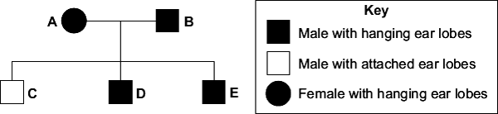
- Draw the symbol for a female with attached ear lobes to complete the key.
- What does the diagram tell you about the allele for hanging ear lobes? Explain your answer.

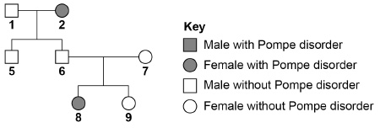
Pompe disorder is an inherited condition that affects thousands of people. R is the allele for no Pompe disorder and r is the allele for Pompe disorder.
- What is the genotype of person 2?
- Explain how we can tell Pompe disorder is caused by a recessive allele
- Person 6 and 7 decide to have another child. What is the probability of 6 and 7 having another child with Pompe disorder?
Gold:
A scientist investigated inheritance in pea plants. The scientist crossed tall pea plants with short pea plants.
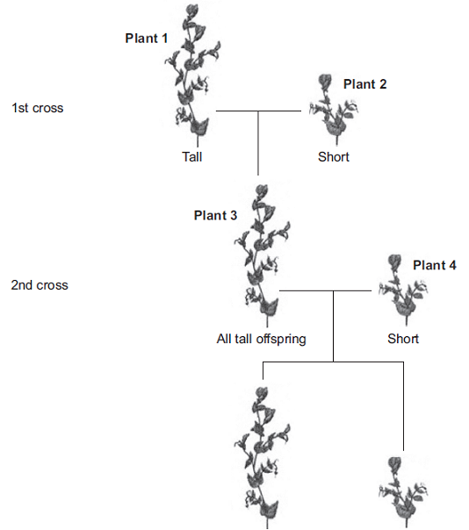
T = allele for tall and t = allele for short
- What alleles does plant 1 contain?
- What will the ratio of tall : short offspring be in the second generation?
- Two short plants were crossed. This cross produced 100 offspring. How many tall and short plants will there be?

Exam question practice: Answer these on this sheet, use the answers to your recall questions to help you
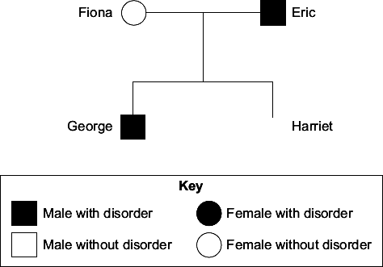
Q1. The family tree shows the inheritance of a disorder caused by a dominant allele.
Fiona and Eric have two children George and Harriet.
(a) The son, George, has the disorder.
The daughter, Harriet, does not have the disorder.
    - Use the key to draw the symbol for Harriet next to her name on the family tree. (2)

(ii) The symbol D represents the dominant allele for the disorder.
The symbol d represents the recessive allele. Fiona has the pair of alleles dd.
Write the correct pairs of alleles in the boxes.

Harriet has the pair of alleles

A person with the disorder could have

the pair of alleles |  | or the pair of alleles
(3)
Q2. The diagram shows a family tree in which some individuals have an inherited disorder, which may cause serious long-term health problems.
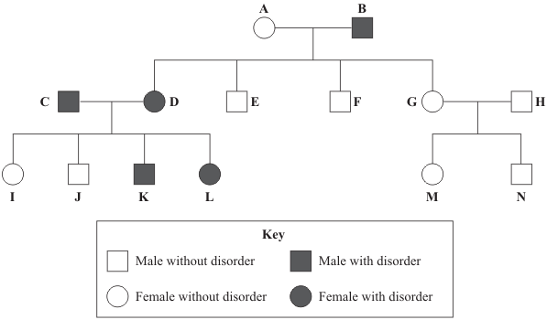
(a) What proportion of the children of A and B have the disorder?
___________________________________________________________________ (1)
Q3. CRAM is an inherited condition which causes muscle breakdown.
The breakdown products enter the urine, making it dark-coloured.
The diagram below shows the inheritance of CRAM in one family.
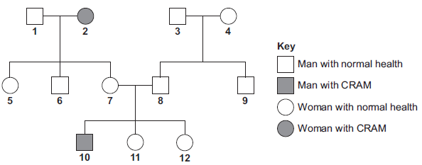
CRAM is caused by a recessive allele, n. The allele for normal health is N.
(a) (i) What is an allele?
______________________________________________________________(1)
(ii) What does recessive mean?
______________________________________________________________ (1)
(iii) Give evidence from the diagram that CRAM is caused by a recessive allele.
______________________________________________________________
______________________________________________________________ (1)
(b) (i) Person 2 is homozygous for CRAM. What does homozygous mean?
______________________________________________________________
______________________________________________________________
(1)
(ii) None of person 2’s children have CRAM.
Explain why.
______________________________________________________________
______________________________________________________________
______________________________________________________________ (2)
Hard:
Q1. The diagram shows a family tree in which some individuals have an inherited disorder, which may cause serious long-term health problems.
(a) What proportion of the children of A and B have the disorder?
___________________________________________________________________ (1)

(b) Explain the evidence from the diagram which shows that the allele for the disorder is dominant.
Use the appropriate letters to identify individuals in your answer.
You may use genetic diagrams in your explanation.

___________________________________________________________________
___________________________________________________________________
___________________________________________________________________
___________________________________________________________________
(3)

