AQA Biology GCSE
Cell Transport
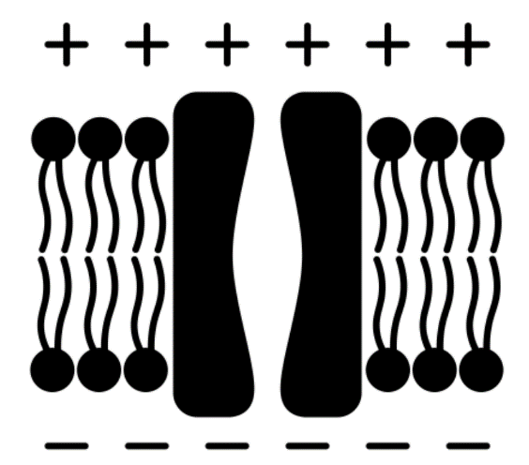
Name: ______________________

Lesson | Homework Task | SCAN CODE | Due
1 | Task 1 – Watch the videos ‘Diffusion’ and ‘Factors Affecting Diffusion’ complete the questions in the Kay Science videos and then complete the quiz set on teams. | 
2 | Task 1 – Watch the video ‘surface area to volume ratio’ complete the questions in the Kay Science videos and then complete the quiz set on teams.  Task 2 – Revise for the weekly quiz! | 
3 | Task 1 – Watch the video ‘Osmosis’ complete the questions in the Kay Science videos and then complete the quiz set on teams. | 
4 | Task 1 – Watch the videos ‘Osmosis Required Practical’ complete the questions in the Kay Science videos and then complete the quiz set on teams.  Task 2 – Revise for the weekly quiz! | 
5 | Task 1 – Watch the videos ‘Active Transport’ complete the questions in the Kay Science videos and then complete the quiz set on teams.  Task 2 – Revise for the End of Topic Test | 


Paper 1 – Cell Transport Fact Sheet
To revise these facts, fold this sheet in half and try to write the answers down from memory. Repeat!
Fold page here
- How do particles suspended in a liquid or gas move? | Particles will spread/move in a random and passive way – no energy is needed to move them
- Define 'diffusion'. | Net movement of particles from an area of high to low concentration (down concentration gradient)
- What does it mean by 'net movement'? | Overall movement: particles can move in any direction, but generally speaking, most of the particles are moving in one particular direction, hence 'net' movement
- State three factors that affect the rate of diffusion. | Concentration gradient, temperature, surface area
- How does concentration difference affect the rate of diffusion? | Higher conc difference/Steeper conc gradient --> faster diffusion
- Explain why a higher temperature results in faster diffusion. | More kinetic energy, particles move around more
- Name a useful substance that diffuses into our cells | Oxygen, glucose
- Name a waste substance that diffuses out of our cells | Carbon dioxide, urea
- Describe three adaptations of exchange surfaces. | Large SA, thin membrane/surface, ability to maintain high conc difference
- Define 'osmosis'. | Net movement of water molecules down the water concentration gradient through a partially permeable membrane
- Define 'osmosis'. | Net movement of water molecules down the water concentration gradient through a partially permeable membrane
- Define 'dilute'. | A solution with a high water conc, but low solute conc
- Define 'concentrated'. | A solution with a low water conc, but high solute conc
- What are partially permeable membranes? | Membranes that only allow some types of substances to pass through
- What is an isotonic solution? | A solution with the same water concentration as the cell
- If a cell is in a concentrated solution, water will ___ (enter/leave) the cell. | Leave
- If a cell is in a dilute solution, water will ___ (enter/leave) the cell. | Enter
- What will happen to an animal cell if it is in a concentrated solution? | Water leaves cell --> shrivelled/crenated
- What will happen to an animal cell if it is in a dilute solution? | Water enters cell --> burst/lysed
- Why do animal cells burst in pure water? | No cell wall
- How do cell walls protect plant cells from the effects of osmosis? | They are elastic and strong
- What will happen to a plant cell if it is in a concentrated solution? | Water leaves cell --> plasmolysed/flaccid
- What will happen to a plant cell if it is in an isotonic solution? | No net water movement
- What will happen to a plant cell if it is in a dilute solution? | Water enters cell --> turgid
- What does 'plasmolysed' mean? | The cell membrane becomes detached from the cell wall
- Why does the potato skin need to be removed before putting the potato cylinders into the solutions? | Skin is impermeable
- How do we calculate % change in mass? | (final mass - intial mass)/initial mass x 100
- Define 'active transport'. | Movement of particles against the concentration gradient (low to high) using energy in the form of ATP
- Why is active transport not a passive process? | Requires energy from respiration
- State one adaptations cells may have if they need to carry out active transport. | Lots of mitochondria for respiration for energy
- Give an example of active transport in plants. | Root hair cells carry out AT to absorb mineral ions effectively in soil
- Give an example of active transport in animals. | Cells in gut lining does AT to absorb glucose effectively
- How does active transport differ from diffusion and osmosis? | AT uses energy, D and O do not
- State two differences between diffusion and osmosis. | D: Any particles, does not need a membrane; O: Water specific, needs partially permeable membrane

Exam Question Command Words
Calculate - Students should use numbers given in the question to work out the answer.
Compare - This requires the student to describe the similarities and/or differences between things, not just write about one.
Define - Specify the meaning of something.
Describe - Students may be asked to recall some facts, events or process in an accurate way.
Explain - Make something clear or state the reasons for something happening.
Identify/Name - Only a short answer is required, not an explanation or a description. Often it can be answered with a single word, phrase or sentence.
Label - Provide appropriate names on a diagram

Lesson | Exam Question Marks |  |  | 
Lesson 1 – Diffusion | /18
Lesson 2 – Surface Area to Volume Ratio | /7
Lesson 3 – Osmosis Theory | /16
Lesson 4 – Osmosis Practical | /12
Lesson 5 – Active Transport & Review | /14
End of Topic Test

Lesson 1 Diffusion
CHECKLIST! – Have you…
- Read the notes and completed the recall questions
- Marked your recall questions using the answers
- Completed the exam questions

Key Words:
Cell membrane | A selectively permeable membrane surrounding the cell and controlling the entry and exit of materials
Concentration | The concentration of a solution tells us how much of a substance is dissolved in water. The higher the concentration, the more particles of the substance are present.
Diffusion | The movement of molecules from an area of higher concentration to an area of lower concentration
Net | Overall.
Partially permeable | Also called semi-permeable. A partially permeable membrane allows water and other small molecules to pass through, but not larger molecules such as starch.
Surface area | refers to the outside area of an object, e.g. it is the area around the. outside of a cell. Unit = cm².
Volume | Refers to the amount of space inside of the object, e.g. it is the space. Unit = cm³.

Part 1 - Define diffusion
Notes: Read the following notes
Particles in a gas or solution will move in a random and passive way. No energy is needed for them to move.
Diffusion is the spreading out of particles. Particles will diffuse from an area of a high concentration to an area of a low concentration. Although all particles move randomly there will always be an overall (net) movement of particles in this direction.
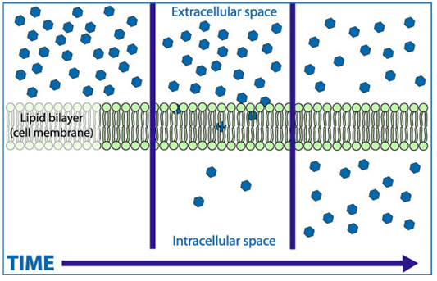
In biology, diffusion often happens across a partially permeable or a semi-permeable membrane.
High Concentration
Outside of the cell
Low Concentration
Inside the cell
(cytoplasm)

These membranes only let some substances pass through (e.g. small molecules) but not others (usually large molecules).
Small molecules that can pass across the membrane | Large molecules that cannot pass across the membrane
- Gases (e.g. oxygen and carbon dioxide)  - Urea  - Glucose | - Proteins  - Starch

Recall questions: Answer these in your book, use the information above to help you
- How do particles that are suspended in a liquid or gas move?
- Define 'diffusion'.
- What does it mean by 'net movement'?
Part 2 - Explain how the different factors influence the rate of diffusion.
Notes: Read the following notes
Factors that affect diffusion:
- Temperature
  - At higher temperatures, particles will have more kinetic energy.
  - Particles that have more kinetic energy will be able to move around faster.
- Concentration
Particles diffuse down a concentration gradient so the following can happen:
- Useful substances that are being used up are replaced
- Waste products do not build up in the cell

Substances all animal cells need to remove | Substances plant cells need to remove | Substances all cells need to take in | Substances plant cells need to take in
Carbon dioxide  Urea  Water | Oxygen | Oxygen  Water  Glucose | Carbon dioxide
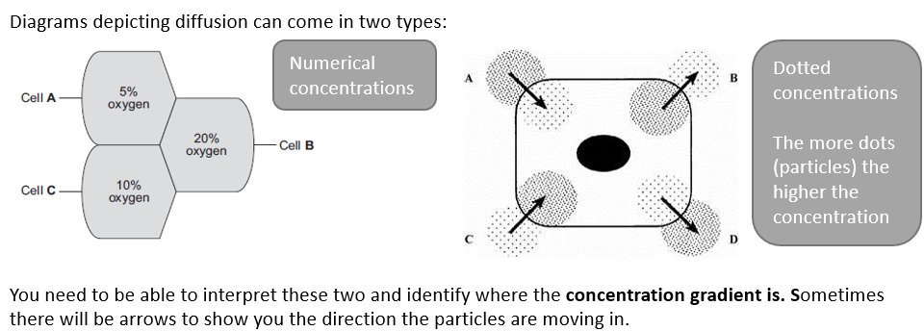
Remember if the arrows are leaving the cell, it must be a substance that needs to be removed!

Recall questions: Answer these in your book, use the information above to help you
- State three factors that affect the rate of diffusion.
- How does concentration difference affect the rate of diffusion?
- Explain why a higher temperature results in faster diffusion.
- Name a useful substance that diffuses into our cells
- Name a waste substance that diffuses out of our cells
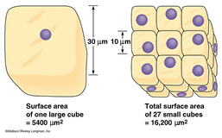
Part 3 - Explain the relationship between surface area and diffusion.
Notes: Read the following notes
Surface Area
Increasing the surface area of a membrane will increase the amount of diffusion that can happen across the membrane because there is more space for particles to move through.

Exchange surfaces/membranes where substances diffuse across are adapted for fast diffusion. These adaptations include:
- Being thin to reduce the diffusion distance
- Having a large surface area this increases the amount of membrane where diffusion can happen.
- Good supply of blood or air to maintain concentration gradients by transporting substances to and from the surface.
Recall questions: Answer these in your book, use the information above to help you
- Explain how each adaptation of exchange surfaces helps speed up diffusion.
Exam Questions
Q1. (a) The diagram shows four ways in which molecules may move into and out of a cell. The dots show the concentration of molecules.
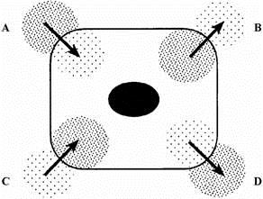
The cell is respiring aerobically.
Which arrow, A, B, C or D, represents:
(i) movement of oxygen molecules; __________
(ii) movement of carbon dioxide molecules? __________
(2)
(b) Name the process by which these gases move into and out of the cell.
____________________ (1)
Q2. (i) What is diffusion?
_________________________________________________________________________________ (2)

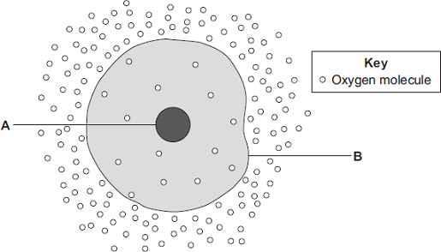
Q3. The diagram shows a cell.
(a) The cell in the diagram is an animal cell.
How can you tell it is an animal cell and not a plant cell?
Give two reasons.
____________________________________
_______________________________________ (2)
(b) Oxygen will diffuse into the cell in the diagram.
Explain why? Use information from the diagram.
___________________________________________________________ ___________________________________________________________
(1)

Q5. The diagram shows a cell from the lining of the lung. This cell is specialised to allow gases to pass through quickly.
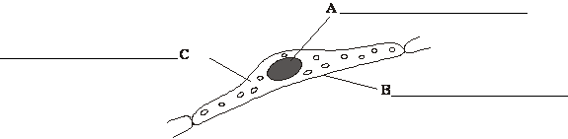
(a) Label structures A, B and C. (3)
(b) (i) Which feature of this cell allows oxygen to pass through quickly?
Put a tick () in the box next to your choice.

It is thin. | 
It has a large nucleus.
It has many mitochondria.
(ii) Complete the sentence by drawing a ring around the correct answer in the box.
Oxygen passes through this cell by | diffusion  osmosis  respiration
(1)
Q6. The digestive system breaks down food into small molecules.
The small molecules can be absorbed into the blood.
(b) Glucose is absorbed into the blood in the small intestine.
Most of the glucose is absorbed by diffusion.
How does the glucose concentration in the blood compare to the glucose concentration in the small intestine?

Tick (✔) one box.
The concentration in the blood is higher. | 
The concentration in the blood is lower.
The concentration in the blood is the same.
(c) In the human body, glucose is absorbed into the blood from the small intestine.
The small intestine contains many villi.
Which two of the following help the absorption of glucose in the small intestine?
Tick () two boxes.
Villi have a cell wall. | 
Villi are covered in thick mucus.
Villi give the small intestine a large surface area.
Villi have many blood capillaries.
(2)
Q7. (a) The diagrams show cells containing and surrounded by oxygen molecules.
Oxygen can move into cells or out of cells.
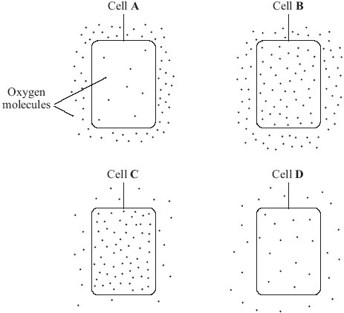
Into which cell, A, B, C or D, will oxygen move the fastest?
Write your answer, A, B, C or D, in the box. 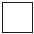
(1)
(b) Draw a ring around the correct word to complete each sentence.

(i) Oxygen is taken into cells by the process of | diffusion  osmosis  respiration | .
(1)

Lesson 2 Surface Area to Volume Ratio
CHECKLIST! – Have you…
- Read the notes and completed the recall questions
- Marked your recall questions using the answers
- Completed the exam questions

Key Words:
Diffusion | The movement of molecules from an area of higher concentration to an area of lower concentration
Surface area | refers to the outside area of an object, e.g. it is the area around the. outside of a cell. Unit = cm2.
Volume | Refers to the amount of space inside of the object, e.g. it is the space.

Part 1 - Calculate SA:V ratio

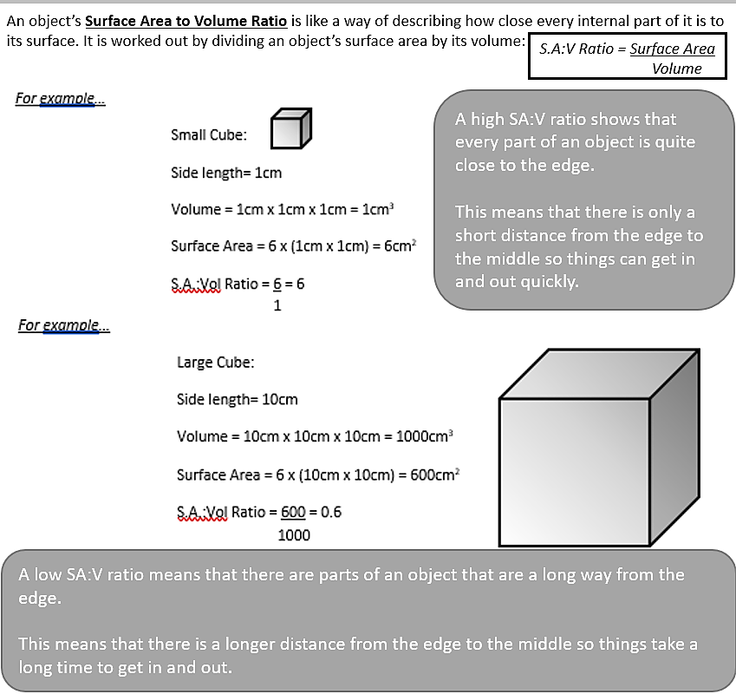
Practice Questions – you will need a ruler!
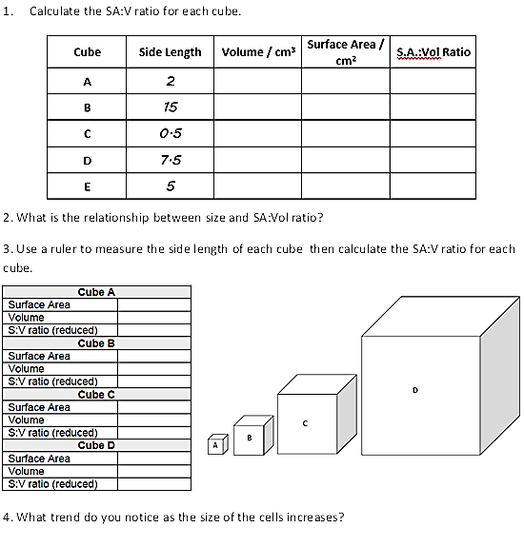

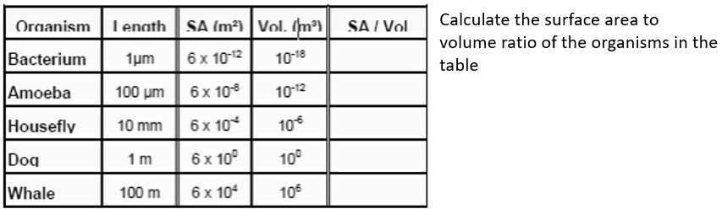
5.

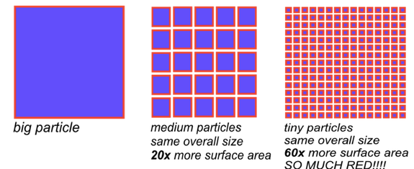
Part 2 - Compare SA:V ratio of different organisms
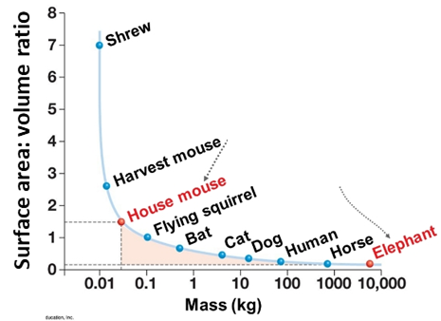
We can compare surface area to volume ratios even without calculating them by thinking about shape or size.

In terms of organisms the larger the organism gets the lower its SA:V.

Practice Questions – you will need a ruler!
1. Put these animals in order of their SA:V from largest to smallest
  - Cat
  - Horse
  - Dog
  - Mouse

- Calculate the SA:V for cells B and C. Into which cell will oxygen diffuse the fastest and why?
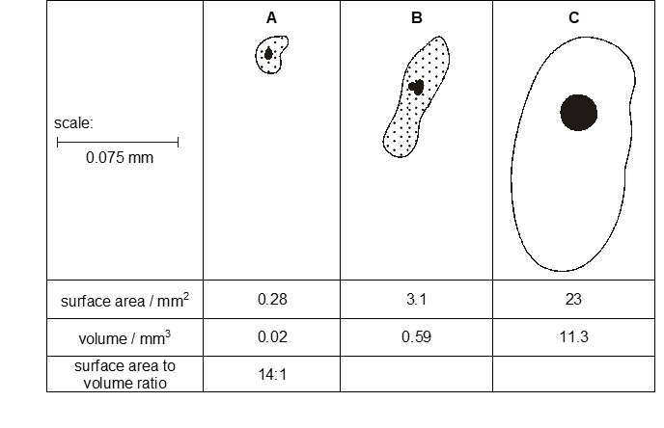
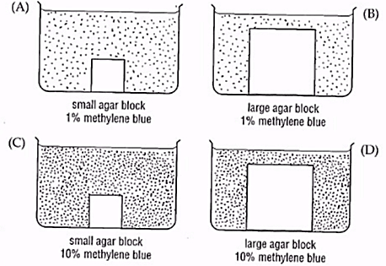
3. Four clear jelly blocks were placed into solutions of blue stain as shown. Which agar block will be the first to become completely stained?

Part 3 - Explain the importance of exchange structures as an adaptation in terms of SA:V

- The rate of exchange of substances depends on the surface area in contact with the surroundings.
- As organisms get bigger their surface area/volume ratio gets smaller so bigger organisms have more difficulty in exchanging materials with their surroundings.
Example: bacteria are all surface with not much volume, while whales are all volume without much surface.
- Have large SA:V  - Diffusion distance is short to get from outside to the the centre of the organism so diffusion is fast  - Advantage: can exchange materials directly with their environment as all of cell has surface exposed to the outside  - Disadvantage: Lose heat energy and dry out quickly | 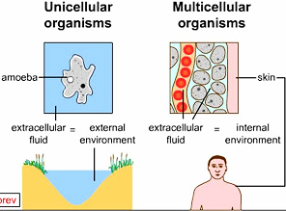 | - Have small SA:V  - Diffusion distance is large to get from outside to inside of all cells in the centre of the organism so diffusion from outside is too slow.  - Advantage: Lose less energy as heat, can survive in cold environments  - Disadvantage: some cells will have no surfaces exposed to the outside so have to have internal transport systems to get substances in and out to exchange with cells,

Practice Questions – Answer these in your book
1. Multicellular organisms often have complex structures, such as lungs, for gas exchange. Explain why single-celled organisms, like algae, do not need complex structures for gas exchange.

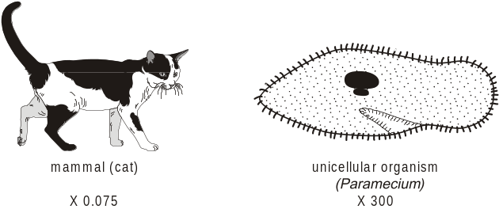
2. The diagram shows a mammal and a unicellular organism. The transport system in mammals is a double circulatory system driven by a pump (the heart), whilst unicellular organisms have no need for special transport systems.
Explain two reasons why mammals need a circulatory system whilst unicellular organisms, such as that shown in the diagram, do not.

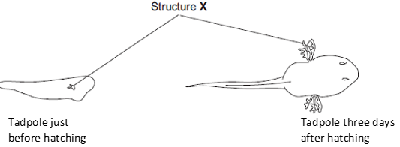
3. The young stages of frogs are called tadpoles. The tadpoles live in fresh water.
The drawings show a tadpole just before hatching and three days after hatching.
Structure X helps in the exchange of substances between the tadpole and the water. Suggest how the changes in structure X help the tadpole to survive as it grows larger.
Exam question practice: Answer these on this sheet, use the answers to your practice questions to help you
Q1. The diagram below shows two model cells.
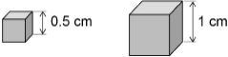
(b) Describe how the surface area to volume ratio changes as the length of the side of the model cell increases.
You should include calculations in your answer.
___________________________________________________________________
___________________________________________________________________
___________________________________________________________________
___________________________________________________________________
___________________________________________________________________
___________________________________________________________________
___________________________________________________________________
(3)
(c) Explain why a bacterium can rely on diffusion for gas exchange, but animals need a transport system.
___________________________________________________________________
___________________________________________________________________
___________________________________________________________________
___________________________________________________________________
___________________________________________________________________
___________________________________________________________________
(3)
Q2. The image below shows an epithelial cell from the lining of the small intestine.
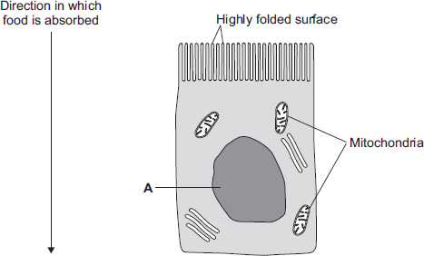
Suggest how the highly folded cell surface helps the epithelial cell to absorb soluble food.
_____________________________________
____________________________________
___________________________________
___________________________________
(1)
Lesson 3 Osmosis Theory
CHECKLIST! – Have you…
- Read the notes and completed the recall questions
- Marked your recall questions using the answers
- Completed the exam questions
Key Words:
Cell membrane | A selectively permeable membrane around the cell that controls the entry and exit of materials
Cell sap | The liquid found in the vacuole of plant cells, consisting of water with dissolved sugars, salts and amino acids
Cell wall | Outer structure which provides support and prevents the cell from bursting from the uptake of water by osmosis. Plant, fungal and bacterial cell walls are made of different molecules.
Cellulose | A carbohydrate. It forms the cell wall in plant cells.
Concentration | The concentration of a solution tells us how much of a substance is dissolved in water. The higher the concentration, the more particles of the substance are present.
Dilute | A solution with low concentration.
Flaccid | Lacking in stiffness or strength. Soft and floppy. The opposite of turgid.
Isotonic | Any solution that has the same water concentration as the cells/tissues.
Osmosis | The movement of water molecules across a selectively permeable membrane from a region of higher water concentration to a region of lower water concentration.
Plasmolysed | Description of a plant cell in which the vacuole has shrunk and the membrane has pulled away from the wall due to extreme water loss by osmosis.
Solute | The dissolved substance in a solution. E.g sugar or salt
Solution | Mixture formed by a solute and a solvent. E.g Salt water
Solvent | The liquid in which the solute dissolves to form a solution.
Turgid | Enlarged and swollen with water. The opposite of flaccid. Description of a plant cell in which the vacuole has swollen due to water gain by osmosis.
Vacuole | A space within the cytoplasm of plant cells that contains cell sap.
Part 1 - Define Osmosis
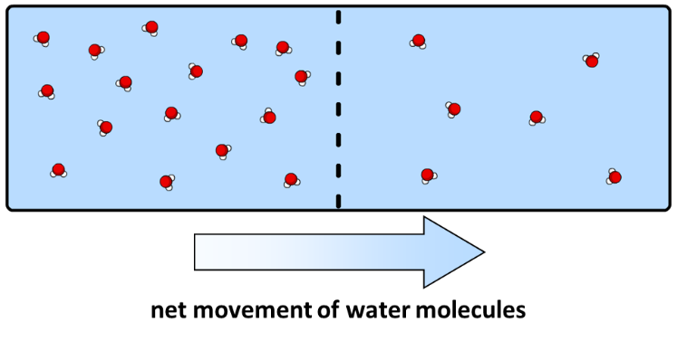
Information: Read the following notes
Osmosis is the diffusion of water and is the net movement of water molecules from an area of a high-water concentration to an area of a low water concentration, through a partially permeable membrane.

Dilute solutions have a high concentration of water molecules and a low solute concentration. Concentrated solutions have a lower concentration of water molecules and high solute concentration.

During osmosis, water molecules will diffuse from pure water or dilute solution to more concentrated solutions. It is a passive process and does not require energy.
Recall questions: Answer these in your book, use the information above to help you
- Define 'osmosis'.
- Define 'dilute'.
- Define 'concentrated'.
- Give two similarities and differences between diffusion and osmosis
Part 2 - Explain the effect of osmosis on animal and plant cells
Information: Read the following notes
Plant and animal cells behave differently in different solutions.

Both cells are surrounded by a partially permeable membrane, which allows water and other small molecules to diffuse in and out of cells.

Plant cells are surrounded by a strong, elastic cell wall made of cellulose that protects them from changes in water concentration.

 | Animal Cell | Plant Cell
Dilute solution/Pure water  There is a higher concentration of water outside of the cell than inside the cell so water will move into the cell by osmosis. | 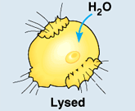  Animal cells swell up and will eventually burst as their cell membrane is not strong enough to withstand the pressure. | 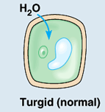  Plant cells swell up but do not burst because their cell wall protects them – their vacuoles expand, and they become turgid (swollen) as the cell membrane pushes on the cell wall.
Isotonic solution  There will be no net movement of water (no osmosis) because the concentrations of water inside and outside the cell are equal | 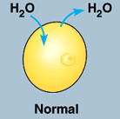 | 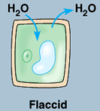
Concentrated solution  There is a lower concentration of water outside the cell than inside the cell so water will move out of the cell by osmosis | 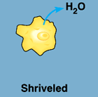  Animal cells will shrivel (shrink) as they lose water from their cytoplasm | 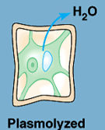  Plant cells are protected from shrinking, but their vacuoles shrink and eventually their cell membranes pull away from the cell walls, this is known as plasmolysis
Recall questions: Answer these in your book, use the information above to help you
- What is an isotonic solution?
- If a cell is in a dilute solution, water will ___ (enter/leave) the cell.
- If a cell is in a concentrated solution, water will ___ (enter/leave) the cell.
- What will happen to an animal cell if it is in a dilute solution?
- What will happen to an animal cell if it is in a concentrated solution?
- Why do animal cells burst in pure water?
- How do cell walls protect plant cells from the effects of osmosis?
- What will happen to a plant cell if it is in a dilute solution?
- What will happen to a plant cell if it is in an isotonic solution?
- What will happen to a plant cell if it is in a concentrated solution?
- What does 'plasmolysed' mean?

Exam question practice: Answer these on this sheet, use the answers to your recall questions to help you
Q1. Substances can move into cells and out of cells.
(a) Draw a ring around the correct answer to complete each sentence.

 | active transport.
Water moves into cells and out of cells by | osmosis.
 | reabsorption.

 | freely permeable
The water moves through a | non-permeable | membrane.
 | partially permeable
(2)
(b) Students put plant cells into two different strengths of sugar solutions, A and B.
The diagram below shows what the cells looked like after 1 hour.
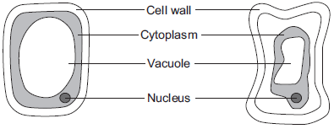
Cell in  sugar solution A  (after 1 hour) |  | Cell in  sugar solution B  (after 1 hour)
(i) Describe two ways in which the cell in sugar solution B is different from the cell in sugar solution A.
1. ____________________________________________________________
2. ____________________________________________________________
(2)
(ii) A student put red blood cells into water.
Suggest what would happen to the cells.
______________________________________________________________
______________________________________________________________
(1)
Q2. What is osmosis?
___________________________________________________________________
___________________________________________________________________
___________________________________________________________________
___________________________________________________________________
___________________________________________________________________
___________________________________________________________________
(3)
Q3. (a) The diagrams show what happens to the shape of a plant cell placed in distilled water.
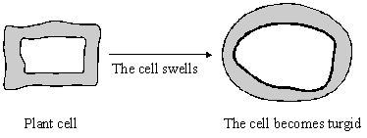
(i) Explain why the cell swells and becomes turgid. Name the process involved.
______________________________________________________________
______________________________________________________________
______________________________________________________________
(2)
(ii) Give one feature of the cell wall which allows the cell to become turgid.
______________________________________________________________
(1)

Q4. Cells contain a solution of salts and sugars. A student is investigating how cells change when they are put into water.

(a) The student:
• looks at a plant cell using a microscope
• adds water to the cell.

The plant cell swells up. Explain why, as fully as you can.
___________________________________________________________________
___________________________________________________________________
___________________________________________________________________
___________________________________________________________________
___________________________________________________________________
___________________________________________________________________ (3)
Challenge
Some students set up the equipment below to investigate osmosis.
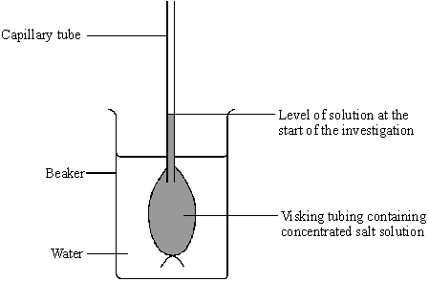
(b) (i) What will happen to the water level in the capillary tube during the investigation because of osmosis?
______________________________________________________________
(1)
(ii) Use your knowledge of osmosis to explain why this happens.
______________________________________________________________
______________________________________________________________
(2)

Lesson 4 Osmosis Practical

By the end of this lesson you should be able to:
- Predict how osmosis will affect the mass of a piece of plant tissue in different solutions
- Write a method to show how you could measure the effect of osmosis on a piece of plant tissue.
- Calculate % change in mass and use a line graph to estimate the cytoplasm concentration of a piece of tissue
Information: Read the following notes
Aim: to investigate the effect of the concentration of sugar solution on the mass of aubergine tissue.

Variables:
- Independent variable: this is what we change in the experiment.
- The independent variable is the concentration of the sugar solution.
- Dependent variable: this is what we measure.
- The dependent variable is the mass of the aubergine tissue.
- Control variable: this is what we keep the same in the experiment. Some of the control variables in this experiment include:
- Type of aubergine
- Length of aubergine cylinders
- Temperature of solutions (room temperature)
- Volume of aubergine cylinders
Method | Important points
- Use a cork borer to cut three aubergine cylinders of the same diameter. | Make sure all the skin is removed as this could affect results. It has a layer of waterproof membrane.
- Use a ruler to trim the cylinders so that they are the same length (3cm) and therefore have the same volume | HAZARD - Be careful when using a sharp knife to cut the potato.
- Dry the aubergine carefully by blotting it with a paper towel. | This will help to remove any liquid left on the outside of the plant tissue which would affect the mass.
- Accurately measure and record the length and mass of each aubergine cylinder.
- Measure 10cm³ of 1.0 M, 0.75 M, 0.5 M and 0.25 M sugar/salt solution into boiling tubes. Label each to show the concentration.
- Measure 10cm³ of distilled water into a fifth boiling tube
- Add 1 aubergine cylinder into each boiling tube. | You must know which cylinder is in which solution!
- Leave the tubes for 20 minutes
- Remove the cylinders, carefully blotting dry with a paper towel to remove extra solution. | This will help to remove any liquid left on the outside of the plant tissue which would affect the mass.
- Re-measure the length and mass of each cylinder. | If the cylinders have gained water by osmosis, they will have increased in mass. If water has left the cylinders by osmosis, they will have decreased in mass.
- Calculate the change in mass of each cylinder | This is done by subtracting the final mass from the initial mass – chips that have decreased in mass will have negative numbers.
- Calculate the percentage change in mass for each cylinder. | Calculating the percentage change means you can compare the effect of the sugar concentration on cylinders that didn’t have the same initial mass  Equation: % change in mass = change in mass ÷ starting mass
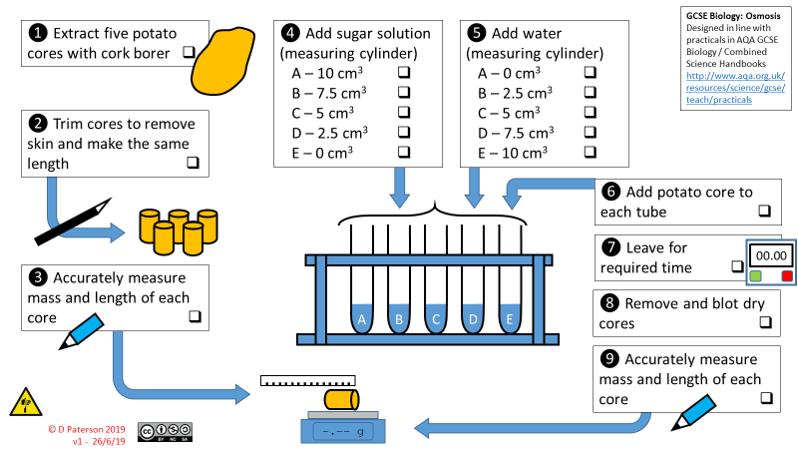
- Plot a graph to show how % change in mass (y axis) changed with concentration (x axis).  - Draw a line of best fit through the points – this can be a smooth curve or a straight line | 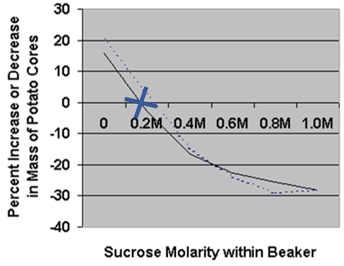  The point at which the line of best fit crosses the x axis (cross on the graph) shows no change in mass and will tell you the concentration of the solution that is the same as the chips. The isotonic solution.

Recall Questions
- Why does the potato skin need to be removed before putting the cylinders into the solutions?
- Why must we dry the chips before weighing them?
- How do we calculate % change in mass?
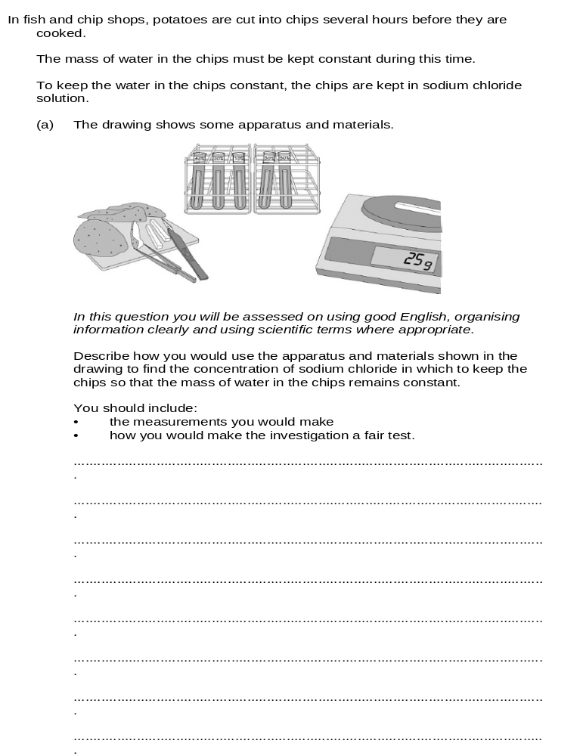
Exam question practice: Answer these on this sheet, use the answers to your recall questions to help you

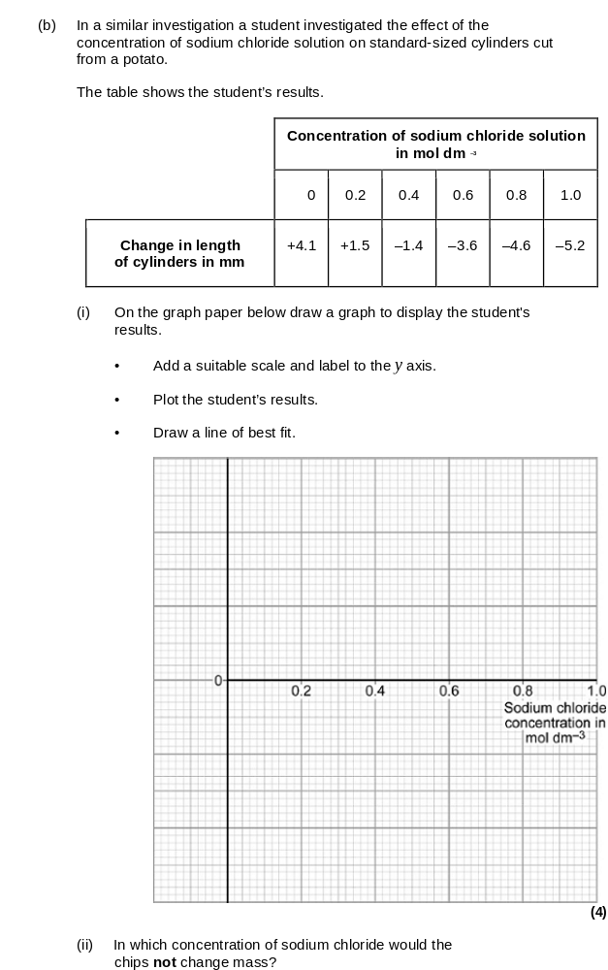
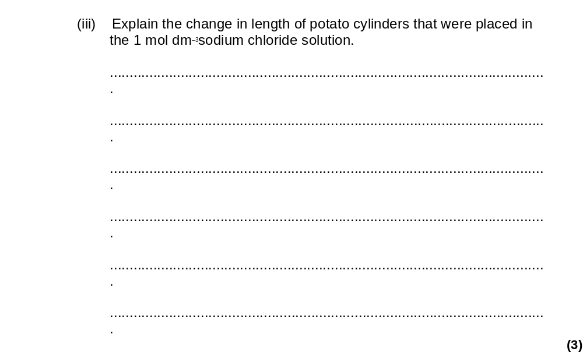
___________________________________________________________________
___________________________________________________________________
___________________________________________________________________
___________________________________________________________________
(3)
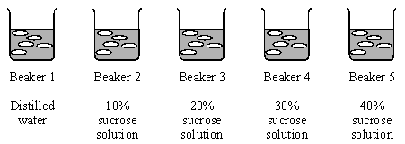
Q2. Some students set up an experiment using osmosis to find the concentration of sucrose solution in potato cell sap. They used discs of potato cut to the same size and weighing approximately 10 gms. The discs were put into each of five beakers.
(a) (i) After two hours they reweighed the discs after carefully blotting them first. Why did the students blot the potato before weighing it?
______________________________________________________________
______________________________________________________________
(1)
(ii) Their results are shown in the table below.

 | Beaker 1 | Beaker 2 | Beaker 3 | Beaker 4 | Beaker 5
Final mass in g | 13.0 | 12.2 | 9.0 | 7.9 | 7.3
Initial mass in g | 10.0 | 10.6 | 10.0 | 10.1 | 10.4
The students calculated the % gain or loss in mass of potato. Complete this table of results for Beakers 2, 4 and 5.

Beaker 1 | Beaker 2 | Beaker 3 | Beaker 4 | Beaker 5
13 – 10.0 = 3.0  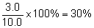 |  | 9.0 – 10.0 =  –1.0  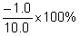  = –10%
Gain in mass = 30% |  | Loss in mass = 10%
(3)
Lesson 5 Active Transport and Review
CHECKLIST! – Have you…
- Read the notes and completed the recall questions
- Marked your recall questions using the answers
- Completed the exam questions
Key Words:
Active Transport | Movement of a substance from an area where it is in a low concentration to an area where it is in a high concentration. The process requires energy from respiration
Aerobic respiration | Respiration that requires oxygen.
Diffusion | The movement of molecules from an area of higher concentration to an area of lower concentration
Osmosis | The movement of water molecules across a selectively permeable membrane from a region of higher water concentration to a region of lower water concentration.
Passive transport | Transport of molecules that occurs as a result of the random movement of particles, so that there is a net movement from a higher to a lower concentration. Passive transport does not require energy.
Root hair cell | A specialised cell that increases the surface area of the root epidermis to improve the uptake of water and minerals

Part 1 - Define active transport
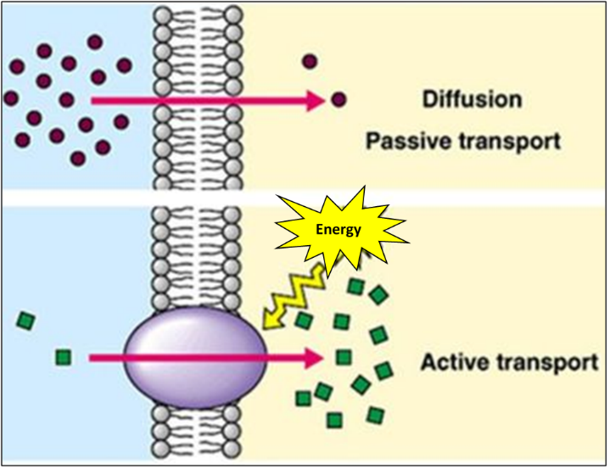
Information: Read the following notes
Diffusion and osmosis are passive processes – they do not need energy for particles to move down their concentration gradient.

Active transport is an active process because it moves particles from an area of a low concentration to an area of a high concentration (against a concentration gradient).
- This process requires energy.
- Energy comes from respiration in the mitochondria.
- The rate of active transport depends on the rate of respiration.
- Oxygen is therefore also required for active transport to occur.

Part 2 - Explain why active transport is important with an example in animals and plants
Cells that must carry out active transport often have lots of mitochondria to provide the energy from respiration, examples include:
- Cells lining the small intestine (epithelial cells) to ensure glucose can be transported against the gradient
- Root hair cells in plants which need to actively transport mineral ions from the soil
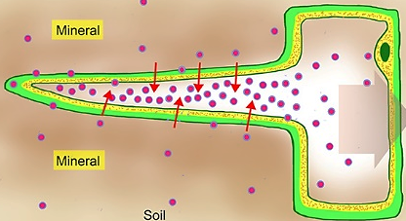
For healthy growth plants need mineral ions but they are often in low concentration in the soil.
Plant roots have specialised cells which have many mitochondria that provide the energy needed from respiration for the active transport of mineral ions against the concentration gradient into the root hair cells.
Recall questions: Answer these in your book, use the information above to help you
- Define 'active transport'.
- Why is active transport not a passive process?
- Give two examples of where active transport occurs in organisms
- Explain one adaptation of specialised root hair cells in plants.

Part 3 - Compare the three transport processes
Task: Complete the Venn diagram to compare the three cellular transport processes
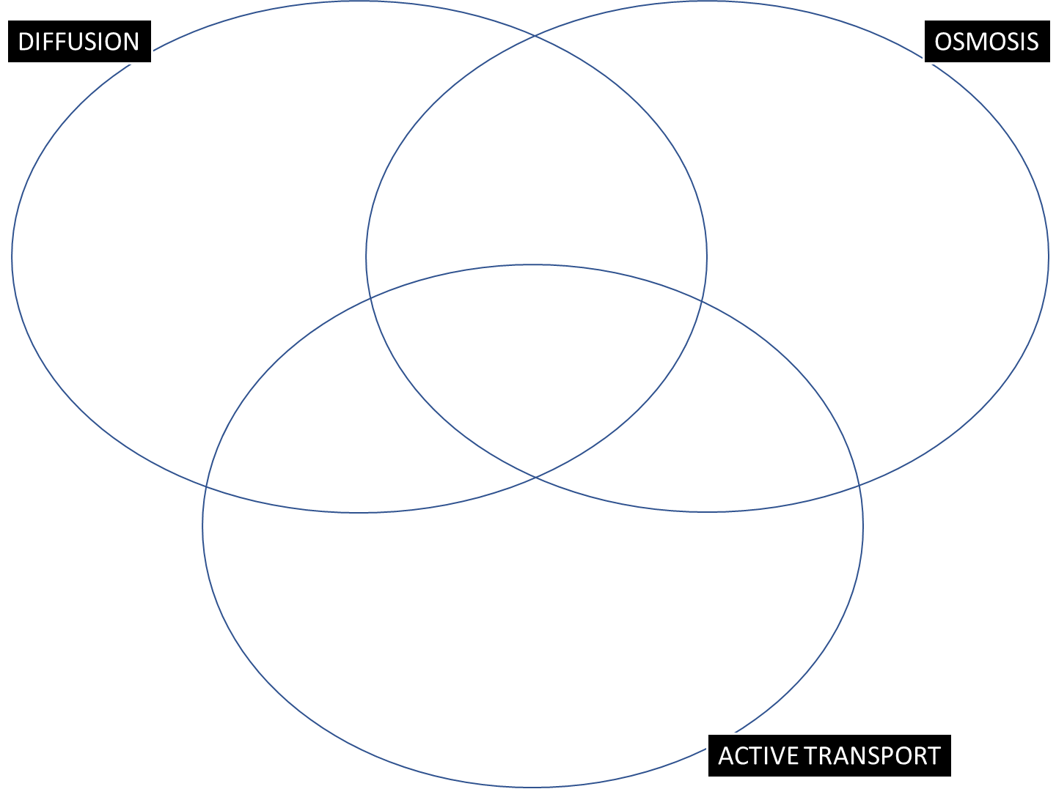

Recall Questions
- How does active transport differ from diffusion and osmosis?
- State two differences between diffusion and osmosis.
Worksheet
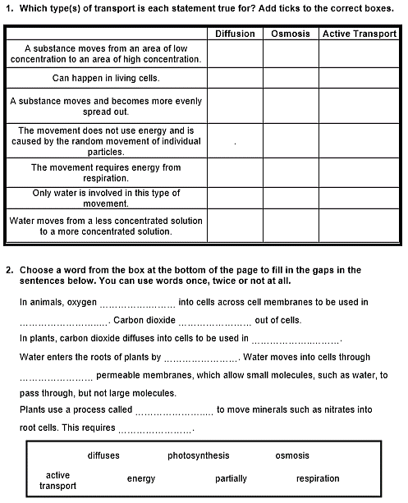

Exam question practice: Answer these on this sheet, use the answers to your recall questions to help you
Q1. The diagram shows four ways in which molecules may move into and out of a cell. The dots show the concentration of molecules.
(b) Which arrow, A, B, C or D, represents the active uptake of sugar molecules by the cell?
Explain the reason for your answer. ___________________________________________________________________
___________________________________________________________________ (2)
Q2. Some sugar molecules are absorbed from the small intestine into the blood by active transport.
Explain why the rate of absorption of these sugar molecules can depend on the concentration of oxygen in the cells lining the small intestine.
___________________________________________________________________
___________________________________________________________________
___________________________________________________________________
___________________________________________________________________
(3)
Q3. Plants must use active transport to move some substances from the soil into root hair cells.
(i) Active transport needs energy.
Which part of the cell releases most of this energy?
Tick (✓) one box.

mitochondria | 
nucleus
ribosome
(1)
(ii) Explain why active transport is necessary in root hair cells.
___________________________________________________________________
___________________________________________________________________ (2)
Q4. The image below shows an epithelial cell from the lining of the small intestine.
(a) In the image above, the part of the cell labelled A contains chromosomes.
What is the name of part A?
______________________________________________________________
(1)
(b) Suggest how the highly folded cell surface helps the epithelial cell to absorb soluble food.
___________________________________________________________________
___________________________________________________________________
(1)
(c) Epithelial cells also carry out active transport.
(i) Name one food molecule absorbed into epithelial cells by active transport.
______________________________________________________________
(1)
(ii) Why is it necessary to absorb some food molecules by active transport?
______________________________________________________________
______________________________________________________________
(1)
(ii) Suggest why epithelial cells have many mitochondria.
______________________________________________________________
______________________________________________________________
(2)

