AQA A Level Biology
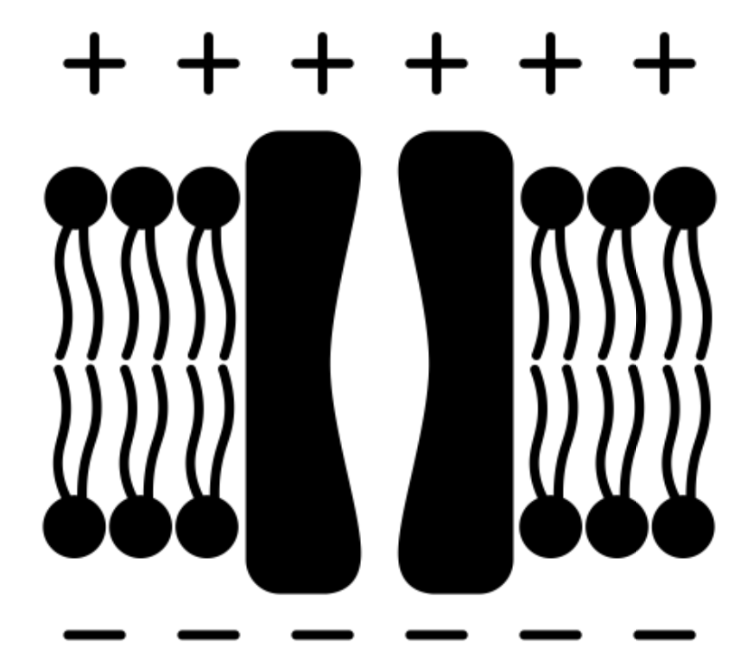
Transport Across Membranes
(3.2.3)

Name: ______________________

Lesson | My Marks | Total Exam Question Marks | Homework Checked | Date
Lesson 1 – Structure of Cell Membranes
Lesson 2 – Factors that affect Membranes
Lesson 3 – Diffusion
Lesson 4 - Osmosis
Lesson 5 – Investigating Water Potential
Lesson 6 – Active and Co-transport
End of Topic Test

Specification Section

3.2.3 Transport across cell membranes
Content | Opportunities for skills development
The basic structure of all cell membranes, including cell-surface membranes and the membranes around the cell organelles of eukaryotes, is the same.  The arrangement and any movement of phospholipids, proteins, glycoproteins and glycolipids in the fluid-mosaic model of membrane structure. Cholesterol may also be present in cell membranes where it restricts the movement of other molecules making up the membrane.  Movement across membranes occurs by:  - simple diffusion (involving limitations imposed by the nature of the phospholipid bilayer)  - facilitated diffusion (involving the roles of carrier proteins and channel proteins)  - osmosis (explained in terms of water potential)  - active transport (involving the role of carrier proteins and the importance of the hydrolysis of ATP)  - co-transport (illustrated by the absorption of sodium ions and glucose by cells lining the mammalian ileum).  Cells may be adapted for rapid transport across their internal or external membranes by an increase in surface area of, or by an increase in the number of protein channels and carrier molecules in, their membranes.  Students should be able to:  - explain the adaptations of specialised cells in relation to the rate of transport across their internal and external membranes  - explain how surface area, number of channel or carrier proteins and differences in gradients of concentration or water potential affect the rate of movement across cell membranes. | MS 3.2  Students could plot the data from their investigations in an appropriate format.  MS 3.4  Students could determine the water potential of plant tissues using the intercept of a graph of, eg, water potential of solution against gain/loss of mass.
Required practical 3: Production of a dilution series of a solute to produce a calibration curve with which to identify the water potential of plant tissue.
Required practical 4: Investigation into the effect of a named variable on the permeability of cell-surface membranes.
Lesson 1 – Structure of Cell Membranes
Key Words
Word | Definition
Active transport | Movement of a substance from a region where it is in a low concentration to a region where it is in a high concentration. The process requires the expenditure of metabolic energy in the form of ATP.
Bilayer | A membrane consisting of two layers of phospholipids.
Carrier Protein | A protein completely spanning the phospholipid bilayer which bind to ions or molecules then change shape in order to move these molecules across the membrane.
Cell membrane | A selectively permeable membrane surrounding the cell and controlling the entry and exit of materials
Cholesterol | Lipid that is an important component of cell-surface membranes because it adds strength. Excess in the blood can lead to atheroma.
Fluid mosaic model | The arrangement of the various molecules of the cell-surface membrane. Fluid because the individual phospholipid molecules can move relative to one another and mosaic because the proteins vary in shape, size and pattern.
Glycolipid | A carbohydrate covalently bonded with a lipid. They act as recognition sites, help maintain stability of the membrane and help cells attach to one another.
Glycoprotein | Carbohydrate chains attached to a protein (often extrinsic) which are part of the cell surface membrane. They act as recognition sites, help cells to attach to one another and allows cells to recognise one another.
Partially permeable | Also called semi-permeable. A partially permeable membrane allows water and other small molecules to pass through, but not larger molecules such as starch.
Permeability | How permeable a substance is depends on the size, polarity and charge of the molecule. If it is small, non-polar and fat soluble it is very permeable and can pass through the cell membrane.
Phospholipid | Triglyceride in which one of the three fatty acid molecules is replaced by a phosphate molecule. Phospholipids are important in the structure an functioning of plasma membranes.
Plasma Membrane | Membranes consisting of a phospholipid bilayer found around and within all cells. The cell-surface membrane is the plasma membrane that surrounds cells.
Protein Channel | A protein completely spanning the phospholipid bilayer which form water-filled tubes to allow water-soluble ions to diffuse across the membrane.

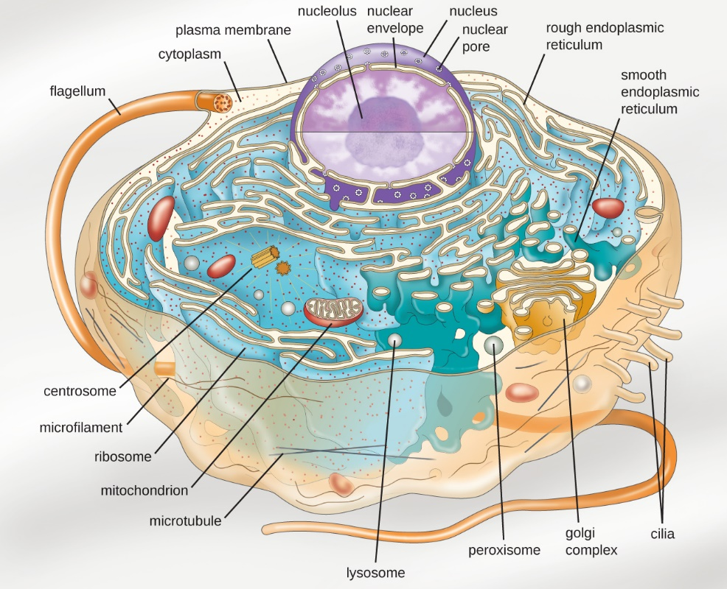
Notes
All cells are surrounded by a cell membrane (also called the plasma membrane). The basic structure of the plasma membranes, including cell-surface membranes and the membranes around the cell organelles of eukaryotes, is the same. It is also how cells communicate with eachother and their environment.
Plasma membranes are partially permeable and can control which substances can enter and leave the cell.
Plasma membranes act as barriers that can create separate environments: they keep the components of the cell isolated from the external environment and compartmentalize cellular functions by separating the inside of organelles from the cytoplasm.
Inside the cell, endoplasmic reticulum, golgi, lysosomes, vesicles and vacuoles are surrounded by a single membrane, but mitochondria and the nucleus are surrounded by a double membrane.
The structure and functions of the cell membrane have been defined by over a half a century of research using biochemical, physiological, cellular and molecular techniques. The arrangement of the bi-layer of phospholipids, integrated proteins, glycoproteins and glycolipids is known as the fluid-mosaic model.
- ‘fluid’ - because the phospholipids are constantly moving
- ‘mosaic’ – proteins are scattered through the bilayer like tiles in a mosaic
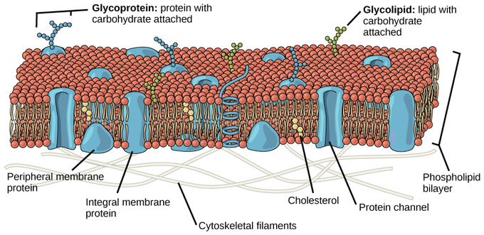
Component | Function | Examples
Phospholipid bilayer | Form a barrier to dissolved substances. The centre of the bilayer is hydrophobic so doesn’t allow water soluble substances (like ions and polar molecules) through it but does allow small, non-polar molecules like CO₂ to diffuse through. | Water is polar but can diffuse through the membrane by osmosis as it is so small.
Intrinsic proteins | Channel proteins and carrier proteins allow large molecules, polar molecules and ions to pass through the membrane | Molecules which need to travel through the membrane through active transport or facilitated diffusion are moved through these proteins.
Peripheral proteins | Can act as receptors and allow the cell to detect chemicals released from other cells so that they can respond. | The hormone insulin binds to receptor proteins on liver cells which tells the cell to start absorbing glucose.
Glycoproteins | Proteins with carbohydrate attached | Their role can be to act as antigens to facilitate cellular recognition, which is crucial to the immune response (recognising self). They play an important role in cell signalling and communication. They also help with cell adhesion – making connections that allow cells to connect to one another to form tissues.
Glycolipids | Lipids with a carbohydrate attached
Cholesterol | A type of lipid which fits between the phospholipids. Restricts the movement of other molecules in the membrane and gives it stability by binding to the tails of phospholipids and causing them to pack together more closely. Reduces their movement and makes the membrane less rigid. Has hydrophobic region so acts as a barrier to polar substances moving through the membrane. | Helps to maintain the shape of animal cells (which don’t have cell walls). This is particularly important in cells that aren’t supported by other cells e.g red and white blood cells which float freely in the blood.
Recall Questions
- What is the fluid mosaic model?
- State four functions of membranes at the surface of cells
- The principal design of the plasma membrane consists of two layers; what name is given to these two layers?
- Explain the orientation of phospholipids within the bilayer
- What is a glycolipid?
- What is a glycoprotein?
- Describe the function of glycoproteins and glycolipids in the phospholipid bilayer
- Give 2 examples of intrinsic proteins
- Channel proteins and carrier proteins have what main role within the membrane?
- Describe the position and role of cholesterol in the membrane
- Describe the structure of a phospholipid
- Which part of a phospholipid is hydrophobic?
- The centre of the bilayer is hydrophobic. So which type of molecules can diffuse through?
- How would chloride (Cl-) ions move across the membrane?
- Would you expect a red blood cell, or an epithelial cell of the small intestine, to contain more cholesterol in the plasma membrane?
Exam Questions
Q1. Describe how phospholipids are arranged in a plasma membrane.
___________________________________________________________________
___________________________________________________________________
___________________________________________________________________
___________________________________________________________________
(2)
Q2. The diagram shows the structure of the cell-surface membrane of a cell.
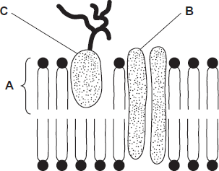
(a) Name A and B.
A _________________________________________________________________
B _________________________________________________________________ (2)
(b) (i) C is a protein with a carbohydrate attached to it. This carbohydrate is formed by joining monosaccharides together. Name the type of reaction that joins monosaccharides together.
Name the type of reaction that joins monosaccharides together.
______________________________________________________________
(1)
(ii) Some cells lining the bronchi of the lungs secrete large amounts of mucus. Mucus contains protein.
Name one organelle that you would expect to find in large numbers in a mucus-secreting cell and describe its role in the production of mucus.
Organelle______________________________________________________
Description of role _______________________________________________
______________________________________________________________
______________________________________________________________
______________________________________________________________
(2)
Q3. The diagram shows part of a plasma membrane.
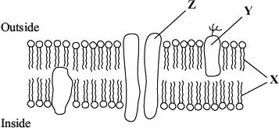
(a) Describe two functions of the structure made from the parts labelled X.
1. _________________________________________________________________
___________________________________________________________________
2. _________________________________________________________________
___________________________________________________________________
(2)
(b) Give one function of the molecule labelled Y.
___________________________________________________________________
___________________________________________________________________
(1)
Q4. The diagram shows the fluid-mosaic model of a cell surface membrane.
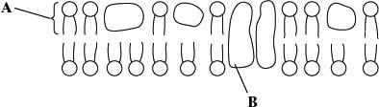
(i) Name the molecules labelled A and B.
A ____________________________________________________________
B ____________________________________________________________
(1)
(ii) How does the bilayer formed by substance A affect entry and exit of substances into and out of a cell?
______________________________________________________________
______________________________________________________________
______________________________________________________________
______________________________________________________________
(2)
Q5. The diagram shows part of a cell surface membrane.
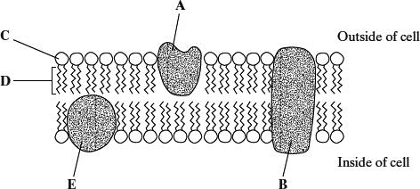
(a) Complete the table by writing the letter from the diagram which refers to each part of the membrane.

Part of membrane | Letter
Channel protein
Contains only the elements carbon and hydrogen
(2)
(b) Explain why the structure of a membrane is described as fluid-mosaic.
___________________________________________________________________
___________________________________________________________________
___________________________________________________________________
(2)
Q6.
(a) The structure of a plasma membrane is described as a fluid mosaic.
Explain why.
___________________________________________________________________
___________________________________________________________________
___________________________________________________________________
(2)
(b) Give two functions of proteins in plasma membranes.
1. _________________________________________________________________
2. _________________________________________________________________
(2)
Q7. Scientists investigated the percentages of different types of lipid in plasma membranes from different types of cell. The table shows some of their results.

Type of lipid | Percentage of lipid in plasma membrane by mass
Type of lipid | Cell lining ileum of  mammal | Red blood cell of  mammal | The bacterium  Escherichia coli
Cholesterol | 17 | 23 | 0
Glycolipid | 7 | 3 | 0
Phospholipid | 54 | 60 | 70
Others | 22 | 14 | 30
(e) The scientists expressed their results as Percentage of lipid in plasma membrane by mass. Explain how they would find these values.
___________________________________________________________________
___________________________________________________________________
___________________________________________________________________
___________________________________________________________________
(2)
Cholesterol increases the stability of plasma membranes. Cholesterol does this by making membranes less flexible.
(f) Suggest one advantage of the different percentage of cholesterol in red blood cells compared with cells lining the ileum.
___________________________________________________________________
___________________________________________________________________
___________________________________________________________________
(1)
(g) E. coli has no cholesterol in its cell-surface membrane. Despite this, the cell maintains a constant shape. Explain why.
___________________________________________________________________
___________________________________________________________________
___________________________________________________________________
___________________________________________________________________
(2)
Q9. Explain how three features of a plasma membrane adapt it for its functions.
___________________________________________________________________
___________________________________________________________________
___________________________________________________________________
___________________________________________________________________
___________________________________________________________________
___________________________________________________________________
___________________________________________________________________
___________________________________________________________________
___________________________________________________________________
___________________________________________________________________
___________________________________________________________________
___________________________________________________________________
(6)

Homework
1. Complete all exam questions from Lesson 1

2. Read notes and complete recall questions for lesson 2 as pre-learning
3. Complete the tasks below:
Task 1: Read the article and answer the questions
https://www.nature.com/scitable/topicpage/cell-membranes-14052567/
  - What percentage of the membrane is phospholipids compared to glycerol?
___________________________________________________________________
___________________________________________________________________

  - Which membranes do not include cholesterol?
___________________________________________________________________
___________________________________________________________________

  - Describe what a transmembrane protein is and give examples.
___________________________________________________________________
___________________________________________________________________

  - What is special about ER and Gogli membranes?
___________________________________________________________________
___________________________________________________________________

  - What can the membranes around mitochondria and chloroplasts tell us?
___________________________________________________________________
___________________________________________________________________

Task 2: Complete the sentences use the words in bold
active transport ATP bilayer cell acid flow fluid gen partially membrane channel concentration condensation energy ester facilitated fatty mosaic glycolipids hydrophilic hydrophobic large membranes opposite osmosis oxy permeable passive phospholipids polar proteins receptors same specific water

Cell ____________ are made of many different molecules. A way for us to understand the cell membrane is the ________ __________ model. The majority of the cell membrane is made of ___________. Phospholipids consist of a glycerol molecule with one attached phosphate group (known as the head) and two attached ________ __________ (known as the tail). Both the phosphate group and the fatty acids are attached by __________ bonds that formed by _______________ reactions.
The phosphate group is ___________ and is attracted to water molecules, so is called ______________. The fatty acid tails are non polar and repel water, so are called ______________. This means that the membrane is made up of a ___________ of phospholipids - one layer has the head group on the outside and tails pointing inward towards the tails of the second layer and their head groups on the inside of the membrane. This arrangement allows the phospholipids to '________' past one another, hence the term fluid in the fluid mosaic model. The membrane also consists of __________, these are usually involved in transport. There are also ________________ and glycoproteins that act as _______ and to identify the cell. These other molecules are rotten in and through the phospholipid bilayer, hence the term mosaic in the fluid mosaic model.
Cell membranes are described as ____________ _______________ since some things are able to pass through while others cannot. There are many ways in which substances can cross the ______ ________________. Some very small, uncharged molecules like _____________ and carbon dioxide can pass through by diffusion. Although ____________ is polar, it is very small so can also able to pass freely into the cell (the process of water moving from an area where there is a low solute concentration to an area where there is a high solute concentration, across a membrane, is called _______________). _____________ or highly charged particles are unable to pass into the cell by simple diffusion. These molecules are able to enter the cell with the help of ____________ proteins. Channel proteins are highly ____________ so only allow one substance through. The process requires no energy so it is _____________, and is called ______________ diffusion. Passive movement of substances can also occur via ___________ proteins which can move one or two particles at a time: symporters move one particle down its concentration gradient and another in the _________ direction but up its concentration gradient, antiporters do the same but the particles are moved in _____________ directions. In some circumstances it is necessary for the cell to move substances against a __________________ gradient using carrier proteins. This requires the input of _____________ in the form of _____, and is called ____________ _______________. Active transport normally involves only one type of particle moving in one direction.

Lesson 2 – Factors that Affect Membranes
Key Words
Word | Definition
Bilayer | A membrane consisting of two layers of phospholipids.
Carrier Protein | A protein completely spanning the phospholipid bilayer which bind to ions or molecules then change shape in order to move these molecules across the membrane.
Cell membrane | A selectively permeable membrane surrounding the cell and controlling the entry and exit of materials
Cholesterol | Lipid that is an important component of cell-surface membranes because it adds strength. Excess in the blood can lead to atheroma.
Concentration | The concentration of a solution tells us how much of a substance is dissolved in water. The higher the concentration, the more particles of the substance are present.
Diffusion | The net movement of molecules (or ions) from a region of high concentration to a region of low concentration. It is passive.
Partially permeable | Also called semi-permeable. A partially permeable membrane allows water and other small molecules to pass through, but not larger molecules such as starch.
Permeability | How permeable a substance is depends on the size, polarity and charge of the molecule. If it is small, non-polar and fat soluble it is very permeable and can pass through the cell membrane.
Phospholipid | Triglyceride in which one of the three fatty acid molecules is replaced by a phosphate molecule. Phospholipids are important in the structure an functioning of plasma membranes.
Plasma Membrane | Membranes consisting of a phospholipid bilayer found around and within all cells. The cell-surface membrane is the plasma membrane that surrounds cells.
Protein Channel | A protein completely spanning the phospholipid bilayer which form water-filled tubes to allow water-soluble ions to diffuse across the membrane.
Solvent | The liquid in which the solute dissolves to form a solution.

Notes
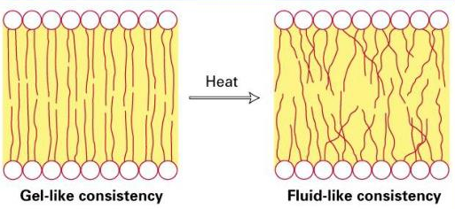
Plasma membranes are described as fluid because the phospholipids and proteins can move around. The amount of movement and gaps (and therefore permeability) can be affected by temperature and solvents.
Temperature
As temperature increases, phospholipids will have more kinetic energy, so they move faster making the bilayer less gel-like and more fluid.

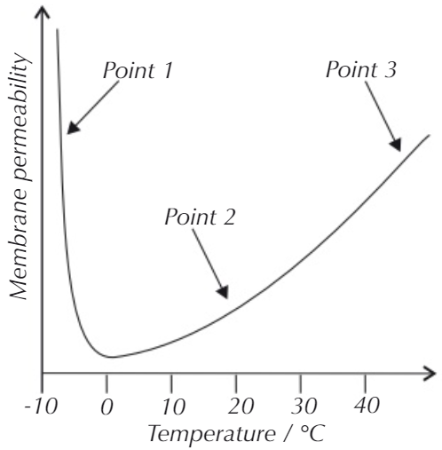
Point 1 – below zero. Phospholipids are packed closely together and the membrane is rigid. Channel and carrier proteins can denature which increases the permeability of the membrane. Ice crystals can also form and pierce the membrane making it more permeable when it thaws.
Point 2 – 0-45°C. Phospholipids can move around freely and the membrane is partially permeable. As the temperature increases the kinetic energy increases and makes the membrane more permeable.
Point 3 – above 45°C. The phospholipids start to melt and the membrane becomes more permeable. Water inside the cell expands putting pressure on the membrane. Channel proteins and carrier proteins in the membrane denature. This increases the permeability of the membrane.
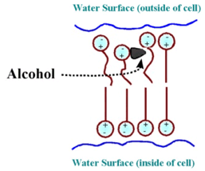
Solvents
Non-polar solvents such as alcohols or acetone can insert themselves into the bilayer. Ethanol molecules, for example, can form hydrogen bonds with a phospholipid molecule near the ester bonds. This pushes phospholipids out of their orderly placement and increases their movement. This disrupts the membrane structure increasing its permeability. Solvents can also denature proteins by disrupting bonds.
This is how alcohol works to breakdown bacterial cell membranes and kill the cells.
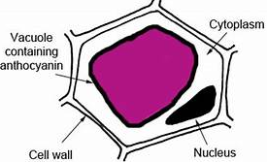
Investigating Membrane Permeability
You can investigate how different variables affect cell membrane permeability by doing experiments using beetroot. Beetroot cells contains red pigments called betalains, located within the cell vacuole. Normally the pigments can't pass through membranes, but they leak out when the beetroot is cooked. High temperatures increase membrane fluidity and cause the pigment to leak out of the cell, and the amount of pigment can be measured simply by using a colorimeter.

Using a colorimeter
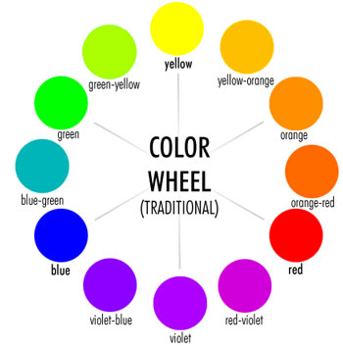
A colorimeter is a machine that passes light of a specific wavelength through a liquid and measures how much of that light is absorbed. If the concentration of the solution is greater, more light will be absorbed, which can be identified by measuring the difference between the amount of light at the start and that after passing through the solution.

A filter in the colorimeter is used to select the colour of light which the solute absorbs the most to maximize the accuracy of the experiment. Note that the colour of the absorbed light is the 'opposite' of the colour of the specimen, so a blue filter would be appropriate for an orange substance.

To determine the concentration of an unknown sample, several sample solutions of a known concentration are first prepared and tested. The concentrations are then plotted on a graph against absorbance, thereby generating a calibration curve. The results of the unknown sample are compared to that of the known sample on the curve to measure the concentration.
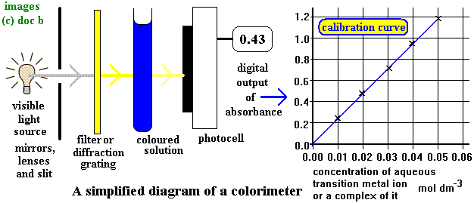
Recall Questions
- Describe the effects of temperature on membrane structure
- If high temperatures are applied to the plasma membrane, what happens?
- Describe the effects of ethanol on membrane structure
- Explain why alcohol is used in antiseptic wipes.
- Describe how a colorimeter works to measure the absorbance of a solution
- What is the relationship between the concentration of a sample and its absorbance?
- Explain why a colour filter is used in a colorimeter, and what filter would you use for a green solution?
- Explain how a calibration curve can be used to find the concentration of an unknown sample.
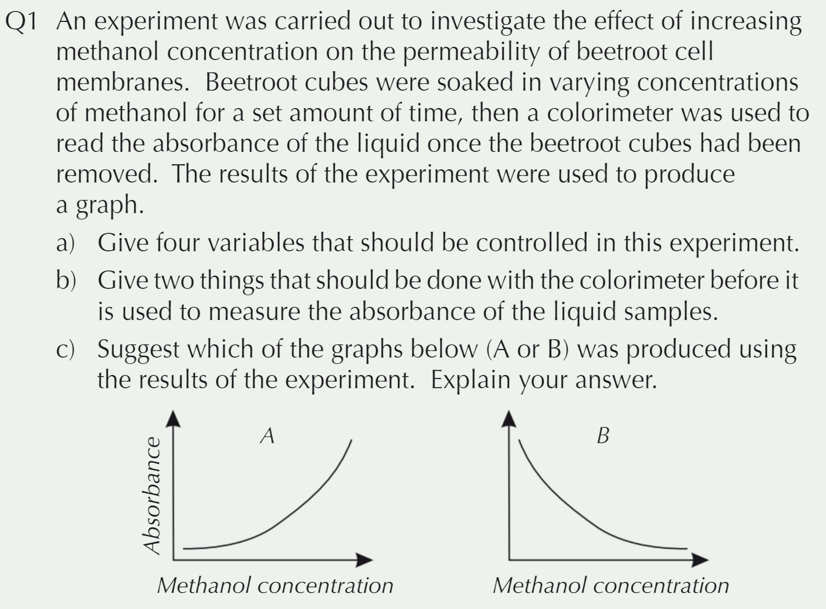
Exam Questions
___________________________________________________________________
___________________________________________________________________
___________________________________________________________________
___________________________________________________________________
___________________________________________________________________
___________________________________________________________________

___________________________________________________________________
___________________________________________________________________
___________________________________________________________________
___________________________________________________________________

Q2. Temperature also affects membrane permeability.
Temperatures that are too high can denature proteins in the membrane, increasing permeability.
How could temperature below 0°C affect cell membrane permeability?
___________________________________________________________________
___________________________________________________________________
___________________________________________________________________
___________________________________________________________________ (3 marks)
Q3.
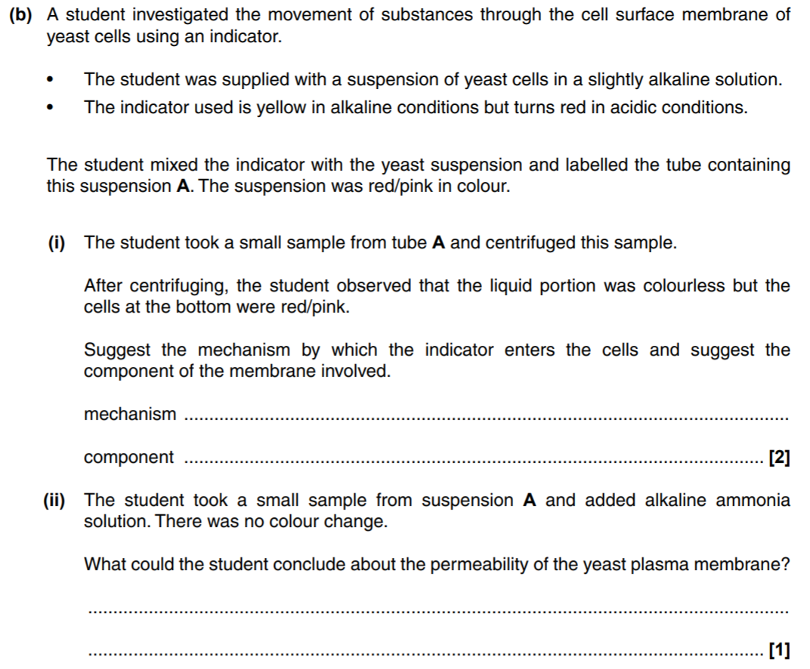
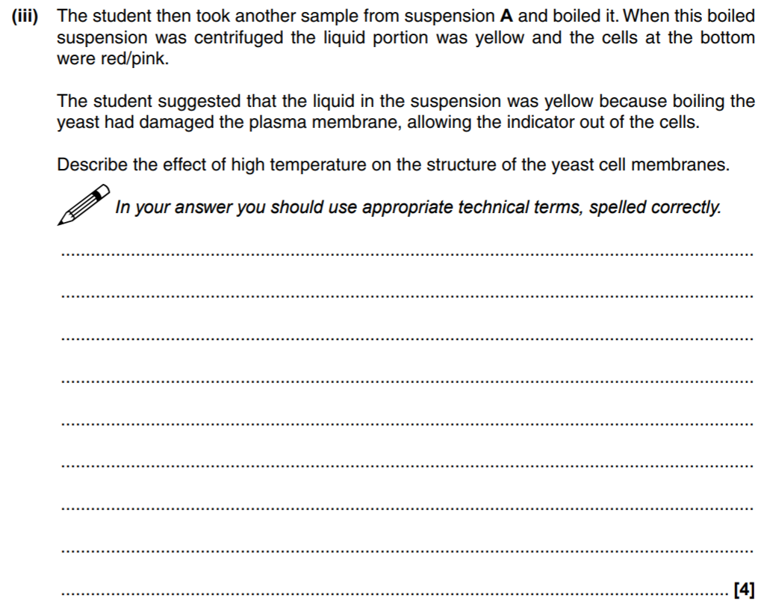
(3)
Q4.
The cells of beetroot contain a red pigment. A student investigated the effect of temperature on the loss of red pigment from beetroot. He put discs cut from beetroot into tubes containing water. He maintained each tube at a different temperature. After 25 minutes, he measured the percentage of light passing through the water in each tube.
(a) The student put the same volume of water in each tube.
Explain why it was important that he controlled this experimental variable.
___________________________________________________________________
___________________________________________________________________
___________________________________________________________________
___________________________________________________________________
___________________________________________________________________
___________________________________________________________________
___________________________________________________________________
(2)

(b) Describe a method the student could have used to monitor the temperature of the water in each tube.
___________________________________________________________________
___________________________________________________________________
___________________________________________________________________
___________________________________________________________________
(1)
The graph shows the student’s results.
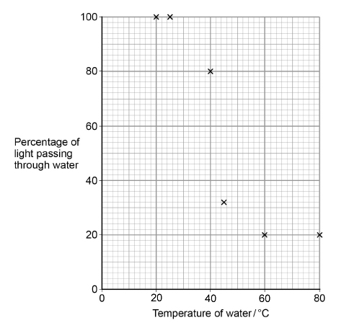
(c) Draw a suitable curve on the graph above.
(1)
(d) The decrease in the percentage of light passing through the water between 25 °C and 60 °C is caused by the release of the red pigment from cells of the beetroot.
Suggest how the increase in temperature of the water caused the release of the red pigment.
___________________________________________________________________
___________________________________________________________________
___________________________________________________________________
___________________________________________________________________
___________________________________________________________________ (2)
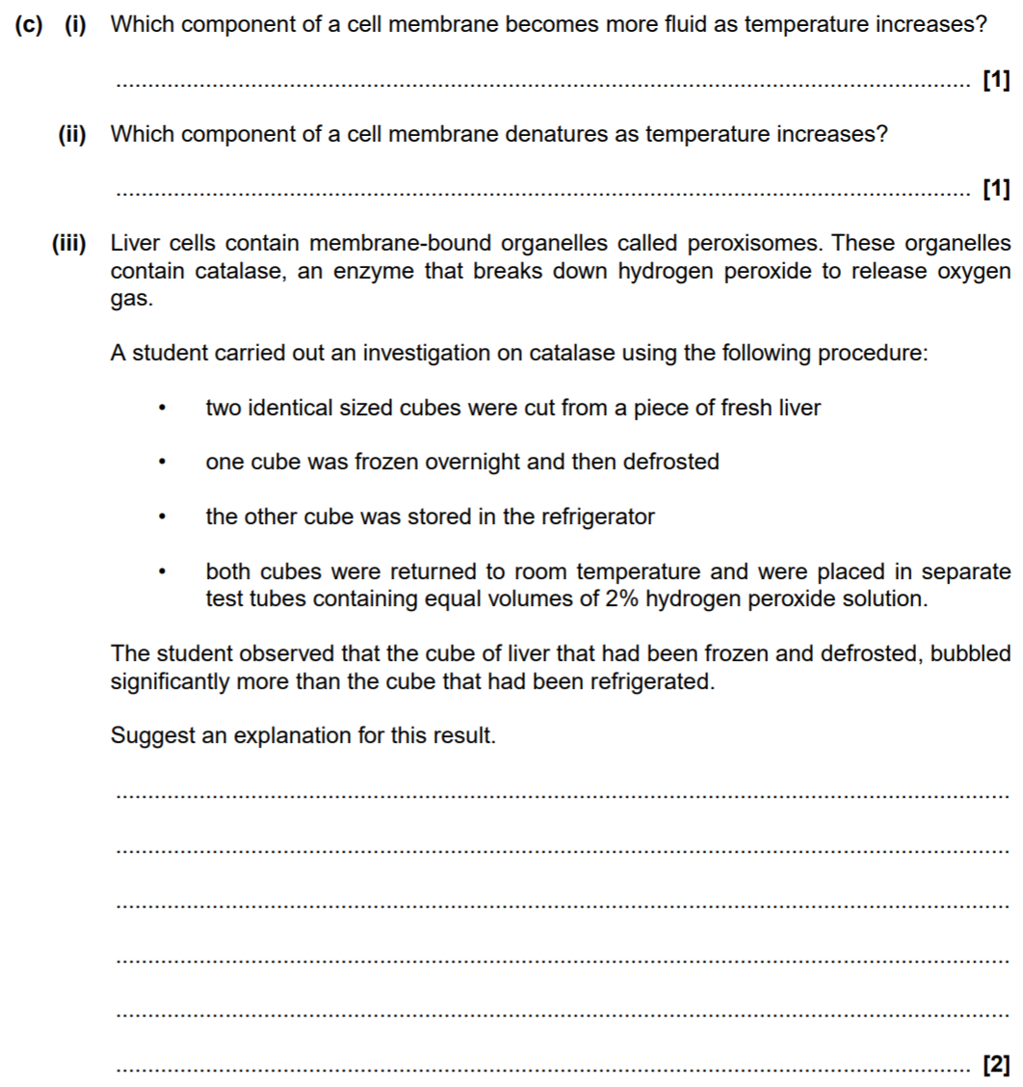
Q4.

Homework
1. Complete all exam questions from Lesson 2
2. Read notes and complete recall questions for lesson 3 as pre-learning
3. Prepare for your required practical investigating the effect of temperature on membrane permeability in beetroot.
In your lab book you will need to:
- Research and write out your risk assessment – remember you need to reference wherever you find your information using the URL and date accessed in your lab book!
- Identify your variables: independent, dependent and any control variables – make sure you include HOW you will control them!
Helpful websites:
For Hazards: http://science.cleapss.org.uk/resources/student-safety-sheets/
For Methods:
- https://www.birmingham.ac.uk/teachers/study-resources/stem/biology/stem-legacy-membranes.aspx
- https://pmt.physicsandmathstutor.com/download/Biology/A-level/Notes/AQA/Practical-Skills/RP%2004%20-%20Investigating%20Cell%20Membrane%20Permeability.pdf

Lesson 3 – Diffusion
Key Words
Word | Definition
Carrier Protein | A protein completely spanning the phospholipid bilayer which bind to ions or molecules then change shape in order to move these molecules across the membrane.
Cell membrane | A selectively permeable membrane surrounding the cell and controlling the entry and exit of materials
Channel  Proten | A protein completely spanning the phospholipid bilayer which form water-filled tubes to allow water-soluble ions to diffuse across the membrane.
Concentration | The concentration of a solution tells us how much of a substance is dissolved in water. The higher the concentration, the more particles of the substance are present.
Co-transport | The transport of one substance coupled with the transport of another substance across a plasma membrane in the same direction through the same protein carrier.
Diffusion | The net movement of molecules (or ions) from a region of high concentration to a region of low concentration. It is passive.
Facilitated diffusion | Diffusion involving the presence of protein carrier molecules to allow the passive movement of substances (normally large, polar or charged molecules) across plasma membrane.
Net | Overall.
Partially permeable | Also called semi-permeable. A partially permeable membrane allows water and other small molecules to pass through, but not larger molecules such as starch.
Passive transport | Transport of molecules that occurs as a result of the random movement of particles, so that there is a net movement from a higher to a lower concentration. Passive transport does not require energy.
Notes
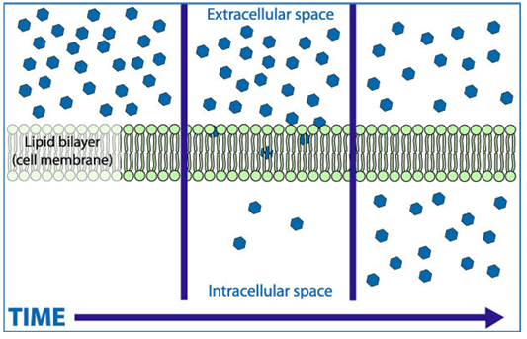
Simple Diffusion
High Concentration
Low Concentration
Inside the cell
(cytoplasm)
Outside of the cell
Diffusion is net movement of molecules or ions from an area of a high concentration to an area of a low concentration. Although all particles move in both directions there will always be an overall (net) movement of particles towards the lower concentration. It continues until equilibrium is reached. This is a passive process (does not require any energy as the particles are moving down their concentration gradient.

In biology, diffusion often happens across a partially permeable membrane. Molecules can diffuse simply through the membrane if they are not too large or polar e.g oxygen and carbon dioxide.
Factors affecting simple diffusion:
Factor | Relationship | Explanation
Concentration Gradient  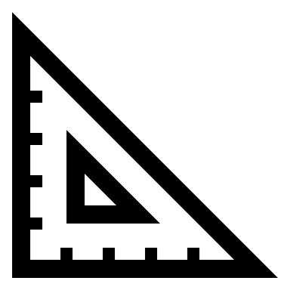 | The greater the concentration difference the faster the rate of diffusion | A good blood or air supply helps to maintain concentration gradients by transporting substances to and from the membrane. Otherwise diffusion slows down over time as equilibrium is reached.
Membrane Thickness   | The thinner the membrane the faster the rate of diffusion | Thin membranes reduce the distance the particles have to travel.
Surface Area  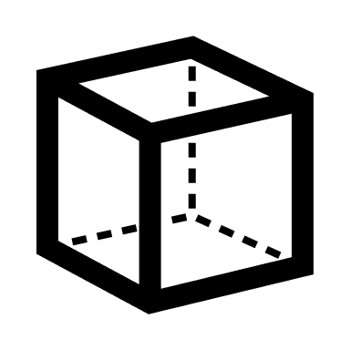 | The larger the surface area the faster the rate of diffusion | Increasing the surface area of a membrane (e.g by folding) means more particles can be exchanged in the same amount of time, increasing the rate of diffusion.
Temperature   | The higher the temperature the faster the rate of diffusion | At higher temperatures, particles will have more kinetic energy so they will be able to move around faster.

Facilitated Diffusion
Larger molecules (e.g amino acids, glucose) and charged particles (e.g ions and polar molecules) would move very slowly through the membrane so they need to diffuse through specialised carrier or channel proteins instead – this is facilitated diffusion. The proteins help to “facilitate” the movement of the particles through the membrane.

This is still diffusion as particles are still moving down their concentration gradient (from high to low concentration) and it is still a passive process as no energy is involved. Facilitated diffusion is much faster than simple diffusion (see the graph below). You need to know the difference between carrier and channel proteins:
Carrier Protein | Channel Protein
Move large molecules across the membrane | Form pores for charged particles to diffuse through
Different proteins facilitate the diffusion of different large molecules | Different protein channels facilitate the diffusion of different charged particles
Large molecules attach and then the protein changes shape releasing the molecule on the other side of the membrane | No changing shape, simple “tunnel” which allows charged particles to cross the membrane.
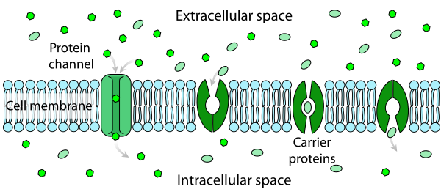

Factors affecting the rate of facilitated diffusion:
Factor | Relationship | Explanation
Concentration Gradient | The greater the concentration difference the faster the rate of facilitated diffusion | As particles are still moving down the concentration gradient.  This is true until all the proteins are in use (see below) OR once equilibrium is reached, then the rate will level off/slow down.
Number of channel or carrier proteins | The greater the number of channel or carrier proteins in the plasma membrane the faster the rate of facilitated diffusion. | 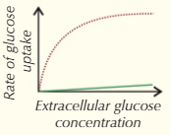  This is true up to a certain point, once all the proteins in the membrane are in use facilitated diffusion can’t happen any faster even if you increase the concentration gradient. So, it becomes a limiting factor.  The line at the bottom represents simple diffusion.

Recall Questions
- Define the term diffusion
- Is diffusion a passive or active process?
- Give an example of a molecule which can use simple diffusion to pass through the membrane.
- State 4 factors that affect the rate of simple diffusion
- Define the term facilitated diffusion
- Describe the role of a carrier protein.
- Which types of molecules would be transported using facilitated diffusion across the membrane?
- Describe the role of a channel protein.
- A graph showing the uptake of glucose by GLUT1 carrier proteins, shows that the rate increases as the number of glucose molecules increases. However the graph plateaus, why?
- How can the gradient of a straight line or tangent by calculated?
- Is facilitated diffusion a passive or active process?

Exam Questions
Q1. The diagram shows part of a plasma membrane. The arrows show the path taken by sodium ions and by substance X when they diffuse through the membrane into a cell.
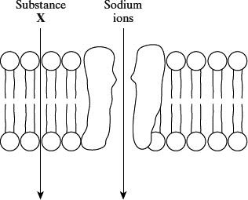
(a) An optical microscope cannot be used to see a plasma membrane. Explain why.
___________________________________________________________________
___________________________________________________________________
___________________________________________________________________
___________________________________________________________________
(2)
(b) Give one property of the molecules of substance X which allows them to diffuse through the membrane at the position shown.
___________________________________________________________________
___________________________________________________________________
(1)
(c) The effect of the concentration of sodium ions in the surrounding solution on their rate of diffusion across the membrane was investigated. The graph shows the results.
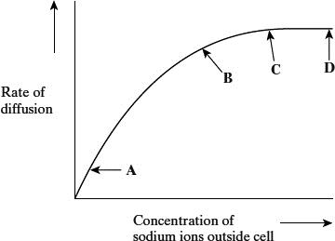
(i) What limits the diffusion of sodium ions across the membrane between
A and B on the graph? Give the evidence for your answer.
Limiting factor __________________________________________________
Evidence ______________________________________________________
______________________________________________________________
(2)
(ii) Explain the shape of the curve between C and D.
______________________________________________________________
______________________________________________________________
______________________________________________________________
______________________________________________________________
(2)
Q3. The image below shows the cell-surface membrane of a red blood cell seen with a transmission electron microscope.
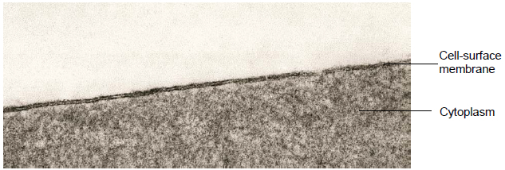

(a) The cell-surface membrane can be seen with a transmission electron microscope but not with an optical microscope.
Explain why.
___________________________________________________________________
___________________________________________________________________
___________________________________________________________________
(1)
(b) Before the cell was examined using the electron microscope, it was stained. This stain caused parts of the structure of the cell-surface membrane to appear as two dark lines.
Suggest an explanation for the appearance of the cell-surface membrane as two dark lines.
___________________________________________________________________
___________________________________________________________________
___________________________________________________________________
___________________________________________________________________
___________________________________________________________________
___________________________________________________________________
___________________________________________________________________
(3)
(c) Describe how substances move across cell-surface membranes by facilitated diffusion.
___________________________________________________________________
___________________________________________________________________
___________________________________________________________________
___________________________________________________________________
___________________________________________________________________
___________________________________________________________________
___________________________________________________________________
___________________________________________________________________
(3)
Q4. Explain why molecules of oxygen and carbon dioxide are able to diffuse across membranes.
___________________________________________________________________
___________________________________________________________________
___________________________________________________________________
___________________________________________________________________
___________________________________________________________________
(2)
Q5. A dialysis machine contains artificial membranes which enable urea to be removed from the blood of a person with kidney failure. The diagram shows a dialysis machine.
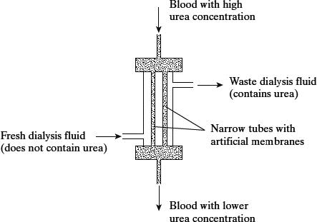
(i) By what process does urea pass from the blood into the dialysis fluid?
______________________________________________________________
(1)
(ii) Suggest two reasons for keeping the fluid in the dialysis machine at 40 °C rather than room temperature.
1. ____________________________________________________________
______________________________________________________________
2. ____________________________________________________________
______________________________________________________________
(2)
(iii) The blood and the dialysis fluid flow in opposite directions in the dialysis machine. Explain the advantage of this.
______________________________________________________________
______________________________________________________________
______________________________________________________________
______________________________________________________________
(2)
Q6. Read the following passage.

The plasma membrane plays a vital role in microorganisms. It forms a barrier between the cell and its environment, controlling the entry and exit of solutes.  This makes bacteria vulnerable to a range of antiseptics and antibiotics.  When bacteria are treated with antiseptics, the antiseptics bind to the proteins in the membrane and create tiny holes. Bacteria contain potassium ions at a concentration many times that outside the cell. Because of the small size of these ions and their concentration in the cell, the first observable sign of antiseptic damage to the plasma membrane is the leaking of potassium ions from the cell. Some antibiotics damage the plasma membrane in a similar way. One of these is tyrocidin. This is a cyclic polypeptide consisting of a ring of ten amino acids. Tyrocidin and other polypeptide antibiotics are of little use in medicine.  Other antibiotics also increase the rate of potassium movement from cells. It is thought that potassium ions are very important in energy release and protein synthesis, and a loss of potassium ions would lead to cell death. Gramicidin A coils to form a permanent pore passing through the plasma membrane. This pore enables potassium ions to be conducted from the inside of the cell into the surrounding medium. Vanilomycin also facilitates the passage of potassium ions from the cell.  A molecule of vanilomycin forms a complex with a potassium ion and transports it across the membrane. The potassium ion is released on the outside and the vanilomycin is free to return and pick up another potassium ion. Vanilomycin depends on the fluid nature of the plasma membrane in order to function.  Polyene antibiotics have flattened ring-shaped molecules. The two sides of the ring differ from each other. One side consists of an unsaturated carbon chain. This part is strongly hydrophobic and rigid. The opposite side is a flexible, strongly hydrophilic region. It has been shown that polyene antibiotics bind only to sterols. Sterols are lipids found in the membranes of eukaryotes but not in the membranes of prokaryotic organisms. It is thought that several sterol-polyene complexes come together.  The plasma membranes of eukaryotic cells treated with these polyene antibiotics lose the ability to act as selective barriers and small ions and molecules rapidly leak out. |  | 5  10  15  20  25
Use information in the passage and your own knowledge to answer the questions.
(a) By what process do potassium ions normally enter a bacterial cell? Explain the evidence for your answer.
___________________________________________________________________
___________________________________________________________________
___________________________________________________________________
___________________________________________________________________
(2)

(b) (i) Draw a peptide bond showing how the COOH group of one amino acid joins to the NH₂ group of another.

(1)
(ii) How many peptide bonds are there in a molecule of tyrocidin (lines 9 - 10)?
______________________________________________________________
(1)
(c) Experiments have shown that vanilomycin is unable to transport potassium ions across a membrane when it is cooled. Gramicidin A continues to facilitate the movement of potassium ions at these low temperatures. Explain these results.
___________________________________________________________________
___________________________________________________________________
___________________________________________________________________
___________________________________________________________________
___________________________________________________________________
___________________________________________________________________
(3)
Q7. Oxygen and chloride ions can diffuse across cell-surface membranes. The diffusion of chloride ions involves a membrane protein. The diffusion of oxygen does not involve a membrane protein.
Explain why the diffusion of chloride ions involves a membrane protein and the diffusion of oxygen does not.
___________________________________________________________________
___________________________________________________________________
___________________________________________________________________
___________________________________________________________________
___________________________________________________________________
___________________________________________________________________
___________________________________________________________________
___________________________________________________________________
___________________________________________________________________
___________________________________________________________________
(5)
Homework
1. Complete all exam questions from Lesson 3
2. Read notes and complete recall questions for lesson 4 as pre-learning
3. Complete the tasks below:

Task: Complete the sentences below using the words in bold:
carrier channel difference facilitated facilitated high kinetic large lower membrane opposite osmosis oxygen passive passive same same shorter small specific tails uncharged water

Diffusion is the movement of substances from an area where there is a _________ concentration to an area where there is a __________ concentration.
Simple diffusion does not require a membrane but can occur directly across a membrane if the particles are ________ and _____________ (like _____________ and carbon dioxide). This occurs because they are small enough to move directly between the phospholipid molecules and they are neither repelled nor attracted to the fatty acid ________ of the phospholipid bilayer. Although ____________ is polar, it is very small so can also able to pass freely into the cell (the process of water moving from an area where there is a low solute concentration to an area where there is a high solute concentration, across a membrane, is called _______________).
_____________ or highly charged particles (such as glucose and charged ions) are unable to pass into the cell by simple diffusion. These molecules are able to enter the cell with the help of ____________ proteins, which allow substances to pass directly through them. Channel proteins are, however, highly ____________ so only allow one substance through. Passive movement of substances can also occur via ___________ proteins which can move one or two particles at a time: symporters move one particle down its concentration gradient and another in the _________ direction but up its concentration gradient, antiporters do the same but the particles are moved in _____________ directions. None of these processes require energy so are _____________ movements but since they require additional proteins to allow them to take place they are known as ______________ diffusion.
Diffusion will continue until the concentration of the substance is the _________ in all areas. The speed of diffusion is influenced by a number of factors:
- Temperature - if the temperature is increased then the particles will have more __________ energy and will be moving faster, so diffusion happens faster.
- Surface area - if there is a greater surface area of ______________ across which the particles can move then diffusion will happen faster.
- Distance - the ____________ the distance the particles have to move the faster diffusion will happen.
- Concentration gradient - if the ______________ in concentration between the two areas is greater then diffusion will happen faster.

Task: Answer the questions:
- The diagrams below show substances at different concentrations, separated by a membrane. Out of each pair, say which one will have a faster diffusion rate, and explain why. [6]
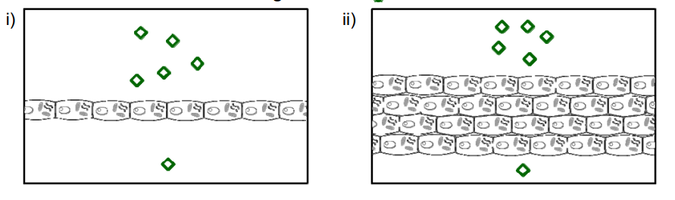
.......................................................................................................................................................................................................................................................................................................................................................... .........................
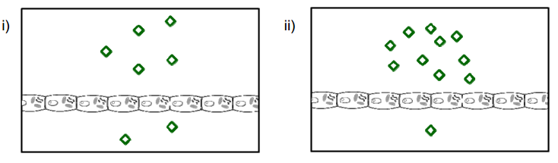
.......................................................................................................................................................................................................................................................................................................................................................... .........................
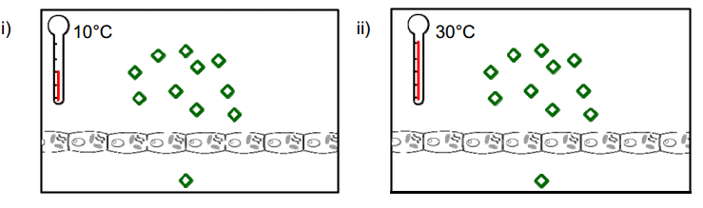
.......................................................................................................................................................................................................................................................................................................................................................... .........................
2. What other factor, not depicted in the diagrams above, can also increase the speed of diffusion in living organisms? [2]
.............................................................................................................................................................................
3. The alveoli in the lungs consist of a single layer of epithelial cells in contact with the air. Explain how this speeds up the rate of diffusion of gases. [2]
..........................................................................................................................................................................................................................................................................................................................................................
4. How do diffusion and facilitated diffusion differ? [2]
..........................................................................................................................................................................................................................................................................................................................................................
5. Which two factors determine whether a facilitated transport carrier protein molecule will allow entry/exit of a specific molecule into/out of a cell? [2]
..........................................................................................................................................................................................................................................................................................................................................................
6. Some substances pass through the plasma membrane of a milk-producing cell by diffusion. Describe the structure of a plasma membrane and explain how different substances are able to pass through the membrane by diffusion [6]
................................................................................................................................................................................................................................................................................................................................................................................................................................................................................................................................................................................................................................................................................................................................................................................................................................................................................................................................................................................................................................................................................................................................................................................................................................................................................................................................................................................................................................................................................................................................................................................................................................................................................................................................................................................................................................................................................................................................................................................................................................................................................................................................................................................................................................................................................................................................................
Lesson 4 – Osmosis
Key Words
Word | Definition
Cell sap | The liquid found in the vacuole of plant cells, consisting of water with dissolved sugars, salts and amino acids
Cell wall | Outer structure which provides support and prevents the cell from bursting from the uptake of water by osmosis. Plant, fungal and bacterial cell walls have different structures and chemical compositions.
Cellulose | A carbohydrate. It forms the cell wall in plant cells.
Concentration | The concentration of a solution tells us how much of a substance is dissolved in water. The higher the concentration, the more particles of the substance are present.
Cytoplasm | The living substance inside a cell (not including the nucleus).
Dilute | A solution with low concentration.
Dissolve | When a substance breaks up and mixes completely with a solvent to produce a solution.
Flaccid | Lacking turgor. Lacking in stiffness or strength. Soft and floppy.
Isotonic | A solution which has the same water potential as the cell within it.
Osmosis | The passage of water from a region where there is a higher water potential to a region where there is a lower water potential through a partially permeable membrane.
Plasmolysed | Description of a plant cell in which the vacuole has shrunk and the membrane has pulled away from the wall due to water loss by osmosis.
Solute | The dissolved substance in a solution.
Solution | Mixture formed by a solute and a solvent.
Solvent | The liquid in which the solute dissolves to form a solution.
Sucrose | A disaccharide made from glucose and fructose. It is used as table sugar.
Turgid | Enlarged and swollen with water. Having turgor. Description of a plant cell in which the vacuole has swollen due to water gain by osmosis.
Vacuole | A space within the cytoplasm of plant cells that contains cell sap.
Volume | Refers to the amount of space inside of the object, e.g. it is the space.
Water potential | The pressure created by water molecules. It is the measure of the extent to which a solution gives out water. The greater the number of water molecules present, the higher (less negative) the water potential. Pure water has a water potential of zero.

Notes
Osmosis is the diffusion of water molecules across a partially permeable membrane. Just as with diffusion osmosis is the movement of water molecules from an area of high water concentration to an area of low water concentration.
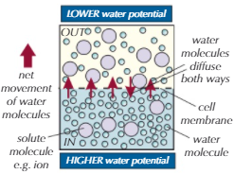
We describe water concentration using the term water potential (ψ). Water potential is the potential or likelihood of water molecules to diffuse out of or into a solution.
Pure water has a water potential of zero (0ψ) because no water will diffuse into this solution but there is a high chance that water will leave. Any solution that contains a solvent dissolved in water will have a lower (more negative) water potential than the pure water.
The more negative the water potential the more concentrated the solution is.
Two solutions with the same water potential are said to be isotonic.

 | Animal Cell | Plant Cell | Water potential decreases
Dilute solution/Pure water  Higher water potential  Hypotonic solution  The solution has a higher water potential than the inside of the cell so water will move into the cell by osmosis. | Animal cells swell up and will eventually burst as their cell membrane is not strong enough to withstand the pressure.  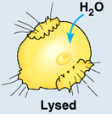 | Plant cells swell up but do not burst because their cell wall protects them – their vacuoles expand, and they become turgid (swollen) as the cell membrane pushes on the cell wall.  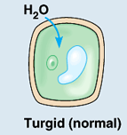 | Water potential decreases
Isotonic solution  There will be no net movement of water (no osmosis) because there is no difference in water potential between the cell and the surrounding solution | 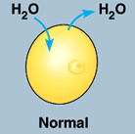 | 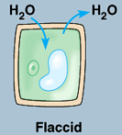 | Water potential decreases
Concentrated solution  Lower water potential  Hypertonic solution  The solution has a lower water potential than the inside of the cell so water will move out of the cell by osmosis | 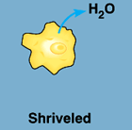  Animal cells will shrivel (shrink) as they lose water from their cytoplasm | 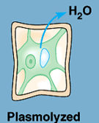  Plant cells are protected from shrinking, but their vacuoles shrink and eventually their cell membranes pull away from the cell walls, this is known as plasmolysis | Water potential decreases

Factors affecting the rate of osmosis – are very similar to diffusion!
Factor | Relationship | Explanation
Water Potential Gradient | The higher the water potential gradient (difference) the faster the rate of osmosis | As osmosis takes place the difference in water potential either side of the membrane decreases as the solutions become closer to being isotonic so the rate of osmosis levels off over time.
Membrane Thickness | The thinner the membrane the faster the rate of osmosis | Thin membranes reduce the distance the molecules have to travel.
Surface Area | The larger the surface area the faster the rate of osmosis | Increasing the surface area of a membrane (e.g by folding) means more molecules can move across in the same amount of time, increasing the rate of osmosis.

Recall Questions
- Define the term osmosis
- What is water potential?
- What is the water potential of pure water?
- If more of a solute (e.g. salt) is added to a beaker of water, what would happen to the water potential of the solution?
- Describe the term isotonic.
- Describe what would happen to a red blood cell placed in a solution with a more negative water potential than that of its cytoplasm
- Describe what would happen to a liver cell placed in a solution with a more positive water potential than its own cytoplasm
- Describe what would happen to a root hair cell placed in a solution with lower water potential than its own cytoplasm/vacuole
- Describe what would happen to a guard cell placed in a solution of less negative water potential than its own cytoplasm
- Describe how you would use a calibration curve to identify the water potential of a sample.
- Pieces of potato with a ψ of -350 kPa are placed into a solution with a ψ of -275 kPa. Explain what will happen to the potato.
- As more solute is added to a solution, what happens to the water potential?

Exam Questions
Q1. Give two similarities in the movement of substances by diffusion and by osmosis.
1. _________________________________________________________________
___________________________________________________________________
___________________________________________________________________
___________________________________________________________________
___________________________________________________________________
2. _________________________________________________________________
___________________________________________________________________
___________________________________________________________________
___________________________________________________________________
___________________________________________________________________
(2)

Q2. Glasswort is a plant that grows in salt marshes. The plants are covered by seawater at each high tide. The roots grow in mud which contains a high concentration of salt. The drawing shows a shoot of the plant.
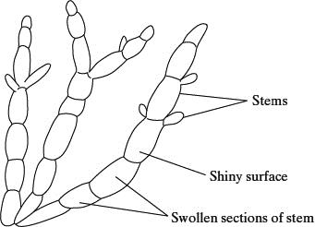
In glasswort cells, sodium ions are transported from the cytoplasm outwards across the cell surface membrane and also into the cell vacuole. The concentration of sodium ions is greater inside the vacuole than in the intercellular fluid, which is the fluid between the cells in tissues. High sodium ion concentrations would disrupt metabolic processes in the cytoplasm. This information is summarised in the diagram below.
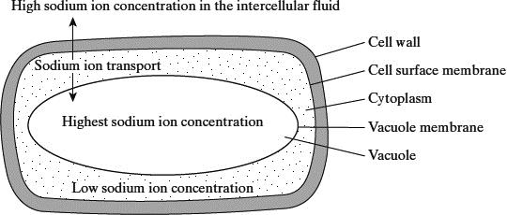
(a) The total concentration of all ions in the cytoplasm is higher than in the intercellular fluid. Explain how this allows the cell to take up water.
___________________________________________________________________
___________________________________________________________________
___________________________________________________________________
___________________________________________________________________
(2)
(b) (i) Explain how sodium ions are transported through the membranes.
______________________________________________________________
______________________________________________________________
______________________________________________________________
______________________________________________________________
(2)
(ii) There is a higher concentration gradient between the cytoplasm and the vacuole than between the cytoplasm and the intercellular fluid. Suggest how the vacuole membrane maintains this higher concentration gradient.
______________________________________________________________
______________________________________________________________
______________________________________________________________
______________________________________________________________
(2)
Q3. Tradescantia is a house plant. There are small hairs on its flowers. These hairs are made of cells.
Figure 1 shows the appearance of cells from one of these hairs after 20 minutes in distilled water. 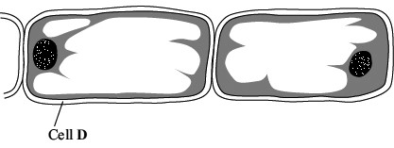
Figure 2 shows cells from another hair after 20 minutes in a solution of potassium nitrate.
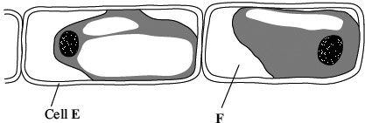
(a) What does Figure 2 suggest about the permeability of the plasma membranes surrounding these cells?
___________________________________________________________________
___________________________________________________________________
(1)
(b) How would the water potential of the sap in the vacuole of cell E differ from the water potential of the sap in the vacuole of cell D? Explain your answer.
___________________________________________________________________
___________________________________________________________________
___________________________________________________________________
___________________________________________________________________
___________________________________________________________________
___________________________________________________________________
(3)
Q4. Compare and contrast the processes by which water and inorganic ions enter cells.
___________________________________________________________________
___________________________________________________________________
___________________________________________________________________
___________________________________________________________________
___________________________________________________________________
___________________________________________________________________
___________________________________________________________________
(3)
Q5.
(a) A student investigated the effect of pH on the activity of the enzyme amylase.
She set up the apparatus shown in the diagram.
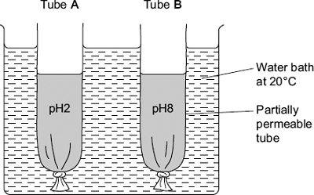
The tubes were made from Visking tubing. Visking tubing is partially permeable.
She added an equal volume of amylase solution and starch to each tube.
• She added a buffer solution at pH2 to tube A.
• She added an equal volume of buffer solution at pH8 to tube B.
After 30 minutes, she measured the height of the solutions in both tubes.
She then tested the solutions in tubes A and B for the presence of reducing sugars.
Describe how the student would show that reducing sugars were present in a solution.
___________________________________________________________________
___________________________________________________________________
___________________________________________________________________
___________________________________________________________________
___________________________________________________________________
___________________________________________________________________
(3)
(b) After 30 minutes, the solution in tube B was higher than the solution in tube A.
(i) Explain why the solution in tube B was higher.
______________________________________________________________
______________________________________________________________
______________________________________________________________
______________________________________________________________
______________________________________________________________
______________________________________________________________
(3)
(ii) The student concluded from her investigation that the optimum pH of amylase was pH8. Is this conclusion valid? Explain your answer.
______________________________________________________________
______________________________________________________________
______________________________________________________________
(1)

Homework
1. Complete all exam questions from Lesson 4
2. Read notes and complete recall questions for lesson 5 as pre-learning
3. Complete the tasks below:

Task 1: Complete the sentences below using the words in bold
carrier channel difference facilitated facilitated high kinetic large lower membrane opposite osmosis oxygen passive passive same same shorter small specific tails uncharged water 0 animal both burst dissolved distorted does not equilibrium hypertonic hypotonic isotonic less lower membrane more negative net normal plant rigidity same turgid water water potential
Osmosis
Osmosis describes the movement of __________ only; water _______ ______ move by diffusion or active transport; osmosis can only occur across a ____________. _________ _____________ describes the likelihood that water will move to or from a location due to the pressure it is exerting; the maximum water potential is ____ - the water potential of pure water.
When substances (the solutes) are ____________ in water (the solvent) they _________ the water potential, thus making it a ___________ value. The more solutes that are dissolved, the more negative the value becomes.
Water will always move across a membrane from an area with a ________ negative (higher) water potential to an area with a _________ negative (lower) water potential. However, at any one time there will be movement of water in ________ directions across the membrane but the ______ movement will be towards the area with a more negative water potential (net movement = gross movement in one direction - gross movement in the other direction). The net movement of water will continue until the _______ water potential occurs on either side of the membrane, known as the ______________.
We refer to the solution around a cell as ___________ if it is the same solute concentration as the cell, ____________ if it has a higher solute concentration (i.e. has a more negative/lower water potential) than the cell and ____________ if it has a lower solute concentration (i.e. has a less negative/higher water potential) than the cell. When ___________ cells are placed in a hypertonic solution they shrivel (crenation); when ____________ cells are placed in a hypertonic solution they will first become flaccid and then the cell membrane peels away from the cell wall (plasmolysis). When animal cells are placed in a hypotonic solution they _________ (lysis); when plant cells are placed in a hypotonic solution they become __________ as the cell wall prevents bursting. Plant cells rely on turgor pressure in their cells (the high pressure resulting in cells, or their vacuoles, when water is forced to move in by osmosis) since it helps to provide ___________ and for them to remain upright. Most animal cells require isotonic surroundings so that the shape of the cell is not ____________ and chemical reactions can take place under '___________' conditions.
Task 2: Answer the questions
1. In terms of the solute concentration, in what direction does water move? [1]
……………………………………………………………………………………………………………………………………………………………………….
2. In terms of water potential, in what direction does water move? [1]
………………………………………………………………………………………………………………………………………………………………………...
3. If the concentration of a solution is increased, what would happen to the water potential? [1]
…………………………………………………………………………………………………………………………………………………………………...

4. If the water potential on each side of a cell membrane is equal, what will be reached? [1]
……………………………………………………………………………………………………………………………………………………………………
5. What term refers to a solution with the same water potential as cell cytoplasm? [1]
……………………………………………………………………………………………………………………………………………………………………
6. If an animal cell is placed in pure water, what would happen? [1]
……………………………………………………………………………………………………………………………………………………………………
7. What feature of a plant cell allows the term turgid to be used when describing their state after absorbing water? [1]
……………………………………………………………………………………………………………………………………………………………………
8. If a potato core is allowed to dehydrate by sitting in open air, would the water potential of the potato cells decrease or increase? [1]

……………………………………………………………………………………………………………………………………………………………………
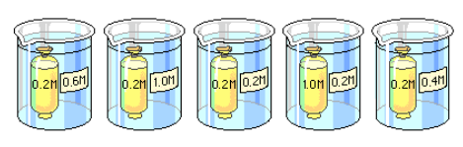
9. Which beaker(s) contain(s) a solution that is hypertonic to the bag? [1]

……………………………………………………………………………………………………………………………………………………………………
10. Arrange the beakers above in order of the mass of the bags inside them after the experiment has run for 30 minutes. List the bag that loses the most mass first. [1]

……………………………………………………………………………………………………………………………………………………………………

Lesson 5 – Investigating Water Potential
Key Words
Word | Definition
Calibration Curve | A general method for determining the concentration of a substance in an unknown sample by comparing the unknown to a set of standard samples of known concentration
Concentration | The concentration of a solution tells us how much of a substance is dissolved in water. The higher the concentration, the more particles of the substance are present.
Dilute | A solution with low concentration.
Serial Dilution | A set of solutions which increase/decrease in concentration by the same factor each time e.g 2, 5 or 10
Solute | The dissolved substance in a solution.
Solution | Mixture formed by a solute and a solvent.
Solvent | The liquid in which the solute dissolves to form a solution.
Volume | Refers to the amount of space inside of the object, e.g. it is the space.

Notes
Serial Dilutions
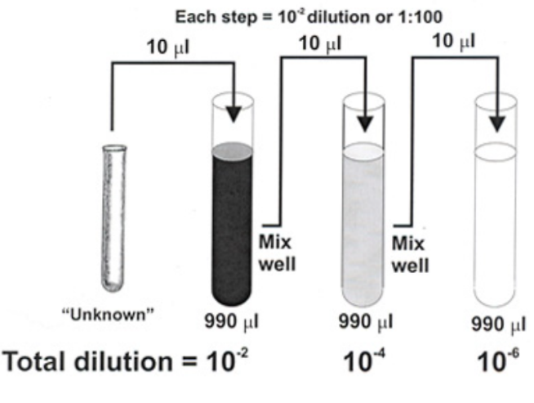
A serial dilution is any dilution in which the concentration decreases by the same factor in each successive step. The dilution factor can be calculated using the initial volume of stock solution (Vi) divided by the final solution volume (Vf).
$$DF= \frac{Vi}{Vf}$$

For example, if you add a 1 cm³ sample to 9 ml of water to get 10 cm³ of solution:

$$DF= \frac{1ml}{10ml}= \frac{1}{10}$$

this is a 1 in 10 dilution or the solution has been diluted by a factor of 10, it is 10x more dilute than the original.

Example: Make five serial dilutions of sucrose solution starting with an initial stock solution of 2M with a dilution factor of 2 (2x as dilute as the original or half as concentrated).
  - Fill a test tube with 10 cm³ of the 2M sucrose solution
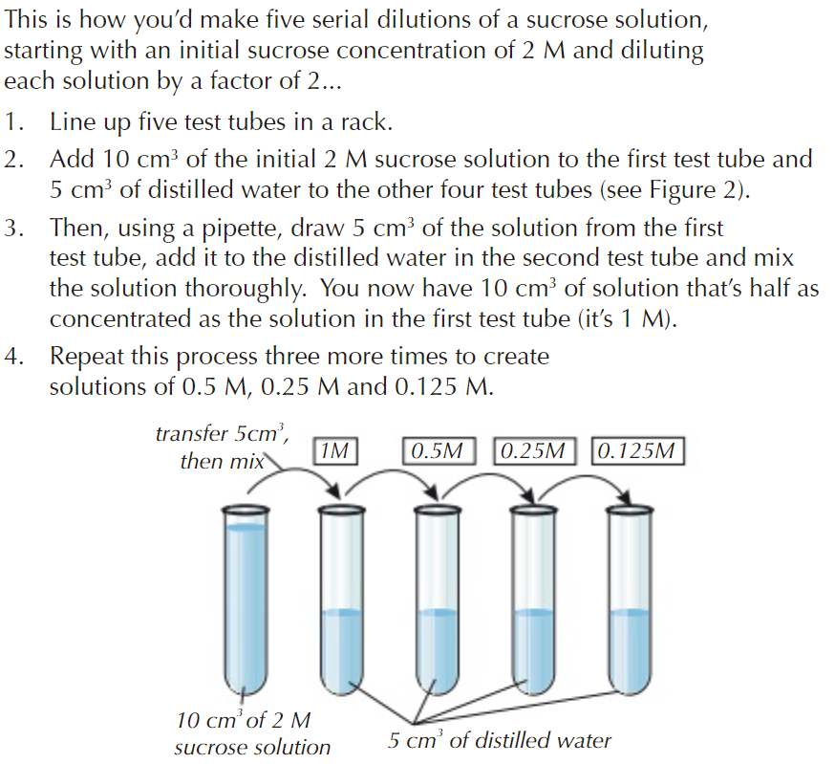
  - Fill 5 test tubes with 5 cm³ of distilled water.
  - Using a pipette transfer 5 cm³ of the sucrose solution from the test tube to the first tube of 5 cm³ of water.
  - Mix the solution thoroughly. You now have 10 cm³ of sucrose solution that is half as concentrated as the solution in the stock solution (1M).
This make sense as the dilution factor is 5ml/10ml = 1/2 or 1:2 dilution
  - Repeat the process by transferring 5 cm³ from the 1M solution and adding it to the next tube containing distilled water to make a 10 cm³ solution which is now half as concentrated again (0.5M)
  - Repeat to create 0.25M and 0.125M solutions
Making Solutions
Units | Conversions
L or dm³ = units of volume (1 dm^{–3} = 1 Litre)
ml or cm³ = units of volume (1 cm^{–3} = 1ml)
M = the unit for concentration (A 0.1M solution = 0.1 mol dm^{–3}) | 0.0974 M means 0.0974 mol dm^{–3} or 0.0974 mmol cm^{–3}
mol dm^{–3} = unit of concentration units of moles per cubic decimetre (or per L)
mol cm^{–3} = unit of concentration units of moles per cubic centimetre (or per ml) | To convert mol dm^{–3} mol cm^{–3} (x1000)  0.0974 mol dm^{–3} = 97.4 mol cm^{–3}

You can apply this method to making any solution as long as you know the volume of the solution you want to make and the concentration of the final and original/stock solution.
e.g if you want to make 15 cm³ of 0.4 mol dm^{–3} sucrose solution using a stock of 1M or 1 mol dm^{–3} solution.
15 cm³ of 1M sucrose solution
Transfer 6cm³
9cm³ distilled water
0.4M

First find the dilution factor:
$DF= \frac{Concentration of stock solution}{Concentration of final solution}$DF = $\frac{1M}{0.4M}$= 2.5

So we need to make a solution which is 2.5 times weaker than the stock solution
If we had 15 cm³ of 1M to make it 2.5x weaker we would need to use 15/2.5 = 6 cm³
Then we would need to dilute it with 9 cm³ of water to keep the volume 15 cm³.

Measuring percentage change in mass of plant tissue
Once you have made a set of serial dilutions of sucrose you can use them to find the water potential of a type of plant tissue by calculating how much mass it loses or gains when placed in each solution.
Method | Important points
- Use a cork borer to cut cylinders of the same diameter. | Make sure all the skin is removed as this could affect results. It has a layer of waterproof membrane.
- Use a ruler to trim the cylinders so that they are the same length (3cm) and therefore have the same volume | HAZARD - Be careful when using a sharp object to cut the tissue
- Dry the tissue carefully by blotting it with a paper towel. | This will help to remove any liquid left on the outside of the plant tissue which would affect the mass.
- Accurately measure and record the length and mass of each cylinder.
- Make sure you have 10cm³ of each of your serial dilutions in tubes. Label each to show the concentration.
- Measure 10cm³ of distilled water into a fifth tube
- Add one cylinder into each tube. | You must know which cylinder is in which solution!
- Leave the tubes for 20 minutes
- Remove the cylinders, carefully blotting dry with a paper towel to remove extra solution. | This will help to remove any liquid left on the outside of the plant tissue which would affect the mass.
- Re-measure the length and mass of each cylinder. | If the cylinders have gained water by osmosis, they will have increased in mass. If water has left the cylinders by osmosis, they will have decreased in mass.
- Calculate the change in mass of each cylinder | This is done by subtracting the final mass from the initial mass – chips that have decreased in mass will have negative numbers.
- Calculate the percentage change in mass for each cylinder. | Calculating the percentage change means you can compare the effect of the sugar concentration on cylinders that didn’t have the same initial mass  Equation: % change in mass = change in mass ÷ starting mass
- Plot a graph to show how % change in mass (y axis) changed with concentration (x axis).  - Draw a line of best fit through the points – this can be a smooth curve or a straight line | 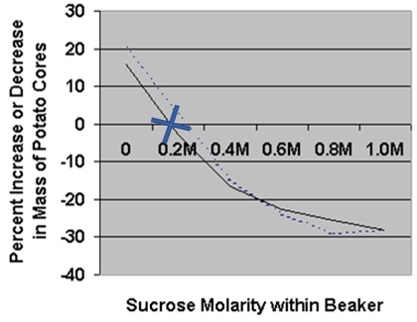
The point at which the line of best fit crosses the x axis (cross on the graph) shows no change in mass and will tell you the concentration of the solution that is the same as the chips. The isotonic solution.
You can then look up the water potential for that concentration of sucrose in a known table.

Recall Questions
- You are provided with 0.2mol dm⁻³ sucrose solution and some distilled water. How would you make up a 10cm³ solution of 0.15 mol dm⁻³?
- To dilute a bacterial culture, 500 μl of a 16 hour culture is mixed with fresh culture media to a final volume of 5 ml. What is the dilution factor?
- Given a stock protein solution with a concentration of 10 mg/ml, what is the concentration of a solution made by mixing 2 μl of the stock with 8 μl of a buffer.
- Why must we dry the cylinders before weighing them?
- Why do we calculate percentage change mass?
- How do we calculate % change in mass?
- What control variables for the experiment?
- What would you predict would happen to the cylinder in the pure distilled water? Explain why.

Exam Questions
Q1. The water potential of leaf cells is affected by the water content of the soil.
Scientists grew sunflower plants. They supplied different plants with different volumes of water.
After two days, they determined the water potential in the leaf cells by using an instrument that gave a voltage reading.
The scientists generated a calibration curve to convert the voltage readings to water potential.
(a) The scientists needed solutions of known water potential to generate their calibration curve.
Table 1 shows how to make a sodium chloride solution with a water potential of −1.95 MPa
Complete Table 1 by giving all headings, units and volumes required to make 20 cm³ of this sodium chloride solution.
Table 1

Water potential / MPa | Concentration of sodium chloride solution / mol dm⁻³ | Volume of 1 mol dm⁻³ sodium chloride solution /  _________________ | ________________  ___________/ ____
−1.95 | 0.04 | _________________ | ________________
(2)
Q2. A student used a dilution series to investigate the number of cells present in a liquid culture of bacteria.
Describe how he made a 1 in 10 dilution and then used this to make a 1 in 1000 dilution of the original liquid culture of bacteria.
___________________________________________________________________
___________________________________________________________________
___________________________________________________________________
___________________________________________________________________
___________________________________________________________________
___________________________________________________________________
___________________________________________________________________
___________________________________________________________________
___________________________________________________________________
___________________________________________________________________
___________________________________________________________________ (3)
Q3. Scientists investigated the effect of different concentrations of a kinesin inhibitor (KI) on mitosis of human bone-cancer cells grown in a culture.
The following table shows the scientists’ results.

Concentration of kinesin  inhibitor / nmol dm⁻³ | Percentage of dividing human bone-cancer cells showing a monopolar mitotic spindle
0 | 0
1 | 0
10 | 8
100 | 93
1000 | 100
10 000 | 100
At the start of their investigation, the scientists made a solution of kinesin inhibitor (KI) with a concentration of 10 000 nmol dm⁻³. They used this to make the other concentrations by a series of dilutions with water.
Describe how they made 100 cm³ of 1000 nmol dm⁻³ solution of kinesin inhibitor.
___________________________________________________________________
___________________________________________________________________
___________________________________________________________________
___________________________________________________________________
___________________________________________________________________
(2)
Q4. Strawberries may be dehydrated by removing most of the water they contain. Dehydrated strawberries have many different uses in the food industry.
Food scientists investigated the effect of using osmosis to dehydrate strawberries.
1. The scientists weighed a sample of strawberries and then cut them into 10 mm thick slices.
2. They put the strawberry slices into a 1.2 mol dm^{–3} solution of sucrose at a temperature of 25 °C.
3. After 1 hour, they removed the slices from the sucrose solution and washed them in water. They dried the slices by blotting them and then weighed them.
4. They also measured the texture of the strawberry slices.
5. The scientists repeated steps 1 to 4, but they left the strawberry slices in the sucrose solution for different amounts of time.

The results of the investigation are shown in the table.

Length of time in  sucrose solution / hours | Percentage loss in mass | Texture / arbitrary units
0 | Not applicable | 1.2
1 | 15.96 | 0.9
2 | 22.88 | 0.7
4 | 32.36 | 0.7
6 | 38.78 | 0.7
(a) (i) In this investigation, the scientists cut the strawberries into slices (step 1).
Explain the advantage of this.
______________________________________________________________
______________________________________________________________
______________________________________________________________
______________________________________________________________
(2)
(ii) The scientists blotted the strawberry slices dry before weighing them (step 3).
Explain why.
______________________________________________________________
______________________________________________________________
______________________________________________________________
______________________________________________________________
(2)
(b) In the second column of the table, the percentage loss in mass for one of the values has been recorded as not applicable. Explain why.
___________________________________________________________________
___________________________________________________________________
(1)
(c) Use the table to describe how the length of time in the sucrose solution affected the strawberries.
___________________________________________________________________
___________________________________________________________________
___________________________________________________________________
___________________________________________________________________
(3)
Q5. Six cylinders of a standard size were cut from a single large potato. One cylinder was placed in distilled water and the others were placed in sucrose solutions of different concentrations. The length of each cylinder was measured every 5 minutes for the next 50 minutes.
The graph shows the changes in length at each sucrose concentration.
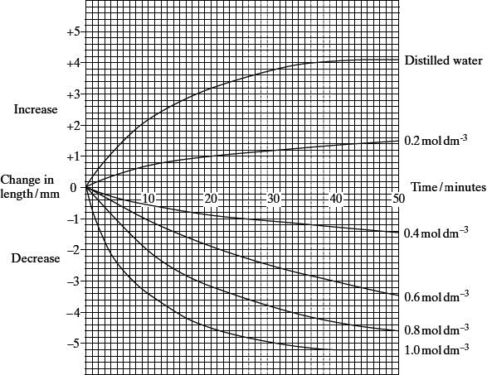
(a) Explain why
(i) the potato cylinder in distilled water increased in length;
______________________________________________________________
______________________________________________________________
______________________________________________________________
______________________________________________________________
(2)
(ii) the potato cylinder in the 1.0 mol dm^{–3} sucrose solution showed no further
decrease in length after 40 minutes.
______________________________________________________________
______________________________________________________________
______________________________________________________________
______________________________________________________________
(2)
(b) (i) Describe the difference in the rate of decrease in length during the first 10 minutes between the cylinder in the 0.4 mol dm^{–3} and the cylinder in
the 0.8 mol dm^{–3} solution.
______________________________________________________________
______________________________________________________________
(1)
(ii) Use your knowledge of water potential to explain this difference.
______________________________________________________________
______________________________________________________________
(1)
Q6.
A student investigated the effect of putting cylinders cut from a potato into sodium chloride solutions of different concentration. He cut cylinders from a potato and weighed each cylinder. He then placed each cylinder in a test tube. Each test tube contained a different concentration of sodium chloride solution. The tubes were left overnight. He then removed the cylinders from the solutions and reweighed them.
(a) Before reweighing, the student blotted dry the outside of each cylinder. Explain why.
___________________________________________________________________
___________________________________________________________________
___________________________________________________________________
___________________________________________________________________
___________________________________________________________________
___________________________________________________________________
(2)
(b) The student made up all the sodium chloride solutions using a 1.0 mol dm^{–3} sodium chloride solution and distilled water.
Complete the table to show how he made 20 cm³ of a 0.2 mol dm^{–3} sodium chloride solution.

Volume of 1.0 mol dm^{–3} sodium chloride solution | Volume of distilled water
(1)

The student repeated the experiment several times at each concentration of sodium chloride solution. His results are shown in the graph.
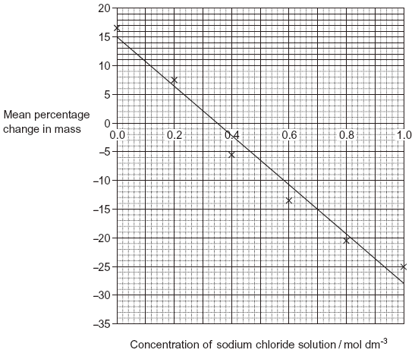
(c) The student calculated the percentage change in mass rather than the change in mass. Explain the advantage of this.
___________________________________________________________________
___________________________________________________________________
___________________________________________________________________
___________________________________________________________________ (2)
(d) The student carried out several repeats at each concentration of sodium chloride solution. Explain why the repeats were important.
___________________________________________________________________
___________________________________________________________________
___________________________________________________________________
___________________________________________________________________ (2)
(e) Use the graph to find the concentration of sodium chloride solution that has the same water potential as the potato cylinders.
____________________ mol dm^{–3}
(1)
Lesson 6 – Active and Co-transport
Key Words
Word | Definition
Active transport | Movement of a substance from a region where it is in a low concentration to a region where it is in a high concentration. The process requires the expenditure of metabolic energy in the form of ATP.
Carrier Protein | A protein completely spanning the phospholipid bilayer which bind to ions or molecules then change shape in order to move these molecules across the membrane.
Concentration | The concentration of a solution tells us how much of a substance is dissolved in water. The higher the concentration, the more particles of the substance are present.
Co-transport | The transport of one substance coupled with the transport of another substance across a plasma membrane in the same direction through the same protein carrier.
Cytoplasm | The living substance inside a cell (not including the nucleus).
Endocytosis | The taking in of substances by a living cell through invagination of its membrane to form a vesicle.
Exocytosis | The process by which a cell secretes substances using vesicles. Uses energy.
Facilitated diffusion | Diffusion involving the presence of protein carrier molecules to allow the passive movement of substances (normally large, polar or charged molecules) across plasma membrane.
Glucose | A monosaccharide.
Sucrose | A disaccharide made from glucose and fructose. It is used as table sugar.

Notes
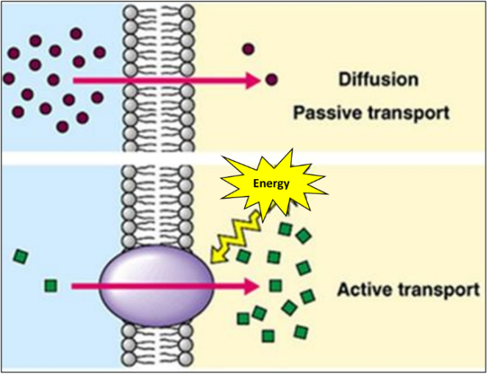
Active Transport
Diffusion and osmosis are passive processes – they do not need energy for molecules to move across a plasma membrane down their concentration gradient.

Active transport is an active process because it moves molecules across plasma membranes from an area of a low concentration to an area of a high concentration (against the concentration gradient).
- This process requires energy from ATP
- ATP is produced by aerobic respiration in the mitochondria.

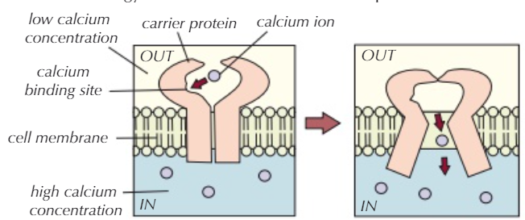
Like facilitated diffusion active transport requires carrier proteins which change shape and move a molecule across the membrane, but they move molecules from low to high concentration and they require energy to change shape. A molecule of ATP is used (it is hydrolysed into ADP and a phosphate molecule) which releases energy so that the molecule can be transported.
Co-Transport
Unlike facilitated diffusion active transport does not use channel proteins but does use special carrier proteins called co-transporters. They bind two molecules at a time, one moves down its concentration gradient and this is used to move the other molecule across the membrane against its concentration gradient.
The best example of this is the co-transport of glucose in the small intestine (specifically the final part called the ileum). Sodium ions move across the membrane down their concentration gradient by binding to co-transporters. Glucose binds along with the sodium so it is moved across the membrane too, against its concentration gradient.

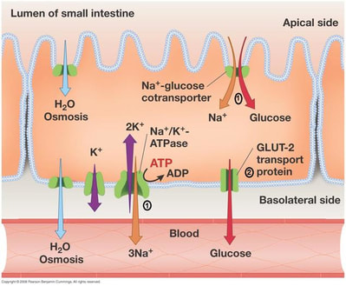
(1) Na+ ions are actively transported out of the epithelial cells in the ileum into the blood by the sodium-potassium (Na+/K+) pump. This creates a concentration gradient as there are more sodium ions in the lumen of the ileum than inside the epithelial cell.


(2) The concentration gradient causes Na+ ions to diffuse from the lumen of the ileum into the epithelial cell down their concentration gradient. They do this through the Na⁺-glucose cotransporter protein. Glucose enters the cell with the sodium.
(3) There is a higher concentration of glucose inside the epithelial cell than in the blood so glucose diffuses into the blood down its concentration gradient through a protein channel by facilitated diffusion.

Factors affecting the rate of active transport
Factor | Relationship | Explanation
Speed of Carrier Proteins   | The faster they work the faster the rate of active transport | Decreasing the concentration gradient will have no effect on the rate of active transport but proteins moving slowly can!
Number of Carrier Proteins | The greater the number of carrier proteins in the plasma membrane the faster the rate of active transport | Cells which are specially adapted to carry out a lot of active transport e.g ileum epithelial cells or root hair cells in plants will have large numbers of carrier proteins to help speed up the rate of active transport.
Rate of Respiration   | The greater the rate of respiration the more ATP there will be available for active transport to take place | ATP is produced by aerobic respiration in the mitochondria. The rate of active transport therefore depends on the rate of respiration. Oxygen is therefore also required for active transport to occur. If respiration is inhibited, e.g due to lack of oxygen then active transport cannot take place.

Bulk Transport – Endocytosis and Exocytosis
This is another type of transport that requires energy. It involves the transport of large amounts of small particles at once or the movement of very large particles across the cell membrane. Lots of ATP is required to move the vesicles.
Endocytosis (endo = internal) is the term used for the various types of active transport that move particles into a cell by enclosing them in a vesicle made out of plasma membrane. First, the plasma membrane of the cell invaginates (folds inward), forming a pocket around the target particle or particles. The pocket then pinches off with the help of specialized proteins, leaving the particle trapped in a newly created vesicle or vacuole inside the cell.
Exocytosis (Exo = external) is the term used to describe how cells transport signalling chemicals or waste products from inside of the cell to the outside of the cell in vesicles which fuse with the plasma membrane.

Examples of Endocytosis:
Pinocytosis = “cell drinking”. It is something cells do regularly to sample their environment by taking in small amounts of extracellular fluid.
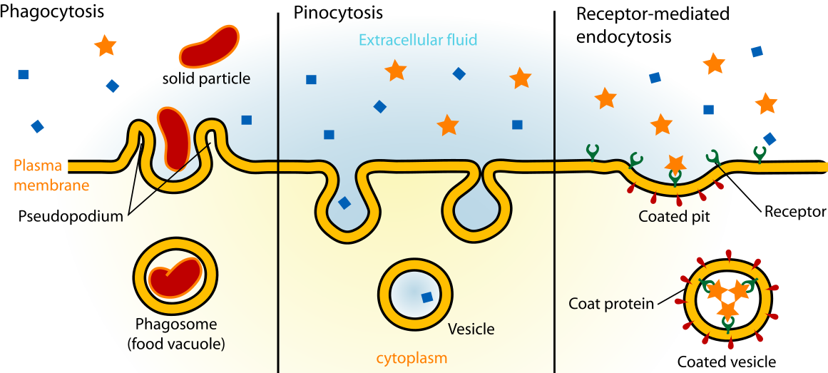
Receptor-mediated endocytosis = uses receptor proteins on the cell surface to capture a specific target molecule. When the receptor binds to the target molecule endocytosis is triggered, usually to take up large molecules which are in low concentration outside cells but this can be abused by pathogens such as flu viruses and cholera toxins to gain cell entry.
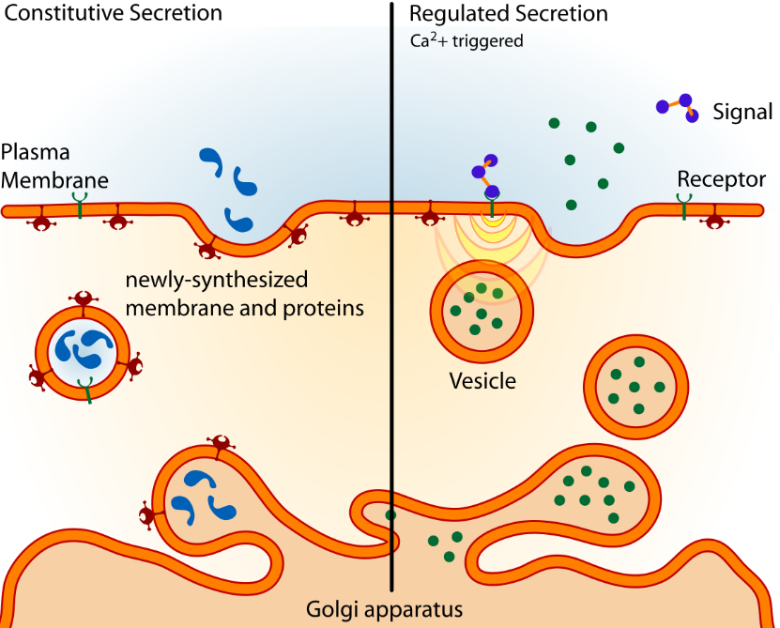
Examples of Exocytosis
Most vesicles come from the golgi and contain proteins made to be released outside such as signalling molecules or proteins which need to be embedded in the plasma membrane.
Other vesicles contain waste products that cells need to remove e.g leftovers of digested pathogens after phagocytosis.
Signalling molecules (like neurotransmitters from neurones) are not constantly released, exocytosis is triggered by chemicals binding to receptors. This causes the release of Ca2+ ions which trigger the movement of vesicles towards the membrane.

Recall Questions
- Define the term active transport
- How does ATP release energy to a cell?
- What are co-transporters?
- Describe how carrier proteins are used in active transport
- What is the main difference between active transport and facilitated diffusion?
- Will the rate of active transport increase or decrease if the number of carrier proteins in the membrane is increased?
- Describe the importance of sodium ions in the transport of glucose from the ileum into the blood.
- Define bulk transport and give two examples
- Define and describe exocytosis
- Describe the role of ATP in bulk transport

Exam Questions
Q1. Describe two differences between active transport and facilitated diffusion.
1. _________________________________________________________________
___________________________________________________________________
2. _________________________________________________________________
___________________________________________________________________ (2)
Q2. Scientists investigated the movement of calcium ions across the plasma membrane of human cells. They placed human cells in a solution of calcium ions. At regular intervals, they measured the concentration of calcium ions in the external solution and the concentration of calcium ions inside the cells. Their results are shown in the graph.
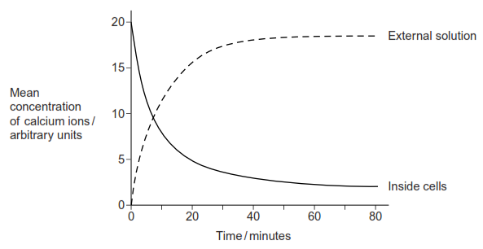
(c) By what process did the calcium ions leave the cells after 10 minutes? Use evidence from the graph to support your answer.
___________________________________________________________________
___________________________________________________________________
___________________________________________________________________ (2)
Q3. (a) Oxygen and water move through plasma membranes into cells. Describe two ways in which these movements are similar.
1. _________________________________________________________________
___________________________________________________________________
2. _________________________________________________________________
___________________________________________________________________
(2)
The graph shows the effect of concentration on the rate of uptake of magnesium ions by root hair cells.
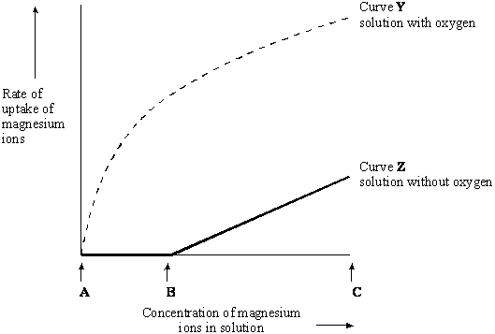
(b) For curve Y name the process the cells are using to absorb magnesium ions between concentrations A and B. Use information in the graph to explain your answer.
Name of process _____________________________________________________
Explanation _________________________________________________________
___________________________________________________________________
___________________________________________________________________
(2)
(c) In the solution without oxygen, explain why no magnesium ions are taken up between concentrations A and B.
___________________________________________________________________
___________________________________________________________________
(1)
(d) For curve Z explain why the rate of uptake increases between B and C.
___________________________________________________________________
___________________________________________________________________
(1)

Q4. An investigation was carried out to compare the uptake of sulphate ions by barley roots in aerobic and in anaerobic conditions. The results are shown in the graph.
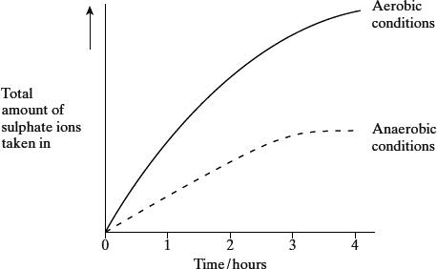
(i) Explain the evidence from the graph that active transport is involved in the uptake of sulphate ions.
___________________________________________________________________
___________________________________________________________________
___________________________________________________________________
(2)
(ii) Suggest why the uptake of sulphate ions by the roots in anaerobic conditions stopped after 3 hours.
___________________________________________________________________
___________________________________________________________________
(1)
Q5. The diagram shows part of a plasma membrane.
(c) The part labelled Z is involved in facilitated diffusion of substances across the membrane.
(i) Give one similarity in the way in which active transport and facilitated diffusion transport substances across the membrane.
______________________________________________________________
______________________________________________________________
(ii) Give one way in which active transport differs from facilitated diffusion.
______________________________________________________________
______________________________________________________________ (2)
Q6. Vitamin D deficiency reduces the uptake of calcium ions by epithelial cells lining the small intestine. The diagrams show how calcium ions are transported through normal epithelial cells and those deficient in vitamin D.
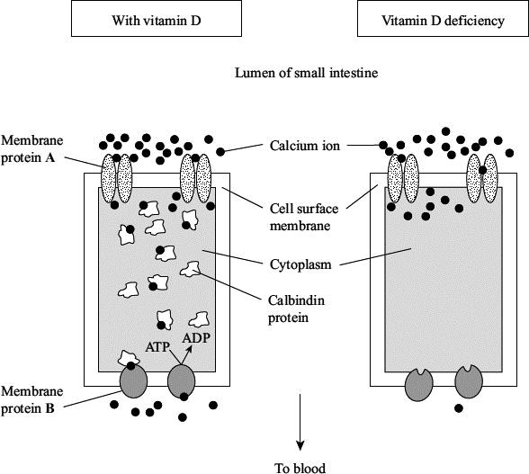
(i) Use the information in the diagrams to explain how vitamin D deficiency reduces calcium ion uptake through gut epithelial cells.
___________________________________________________________________
___________________________________________________________________
___________________________________________________________________
___________________________________________________________________
(2)
(ii) Membrane proteins A and B transport calcium ions through cell surface membranes. Explain how each type of membrane protein transports calcium ions.
Protein A ___________________________________________________________
___________________________________________________________________
___________________________________________________________________
___________________________________________________________________
Protein B ___________________________________________________________
___________________________________________________________________
___________________________________________________________________
___________________________________________________________________
(4)
Q7. A scientist investigated the effect of cyanide on the uptake of sodium ions by animal tissue.
He set up two beakers, J and K.
He put equal volumes of a solution containing sodium ions and equal masses of an animal tissue in each beaker.
• He added cyanide to beaker J.
• He did not add cyanide to beaker K.
He measured the concentration of sodium ions remaining in the solution in each beaker, for 80 minutes. The graph shows his results.
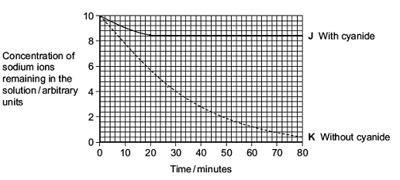
(a) Calculate the rate of uptake of sodium ions by the tissue in beaker K for the first 30 minutes. Show your working.

Answer ____________________ arbitrary units per minute
(2)
(b) Adding cyanide affects the uptake of sodium ions by the tissue. Use the graph to describe how.
___________________________________________________________________
___________________________________________________________________
___________________________________________________________________
___________________________________________________________________ (2)

(c) Cyanide is a substance which affects respiration.
Use information in the question to explain the effect of cyanide on the uptake of sodium ions by the tissue.
___________________________________________________________________
___________________________________________________________________
___________________________________________________________________
___________________________________________________________________
___________________________________________________________________ (3)
Q8. Some substances can cross the cell-surface membrane of a cell by simple diffusion through the phospholipid bilayer. Describe other ways by which substances cross this membrane.
_______________________________________________________________________
_______________________________________________________________________
_______________________________________________________________________
_______________________________________________________________________
_______________________________________________________________________
_______________________________________________________________________
_______________________________________________________________________
_______________________________________________________________________
_______________________________________________________________________
_______________________________________________________________________ (5)

Homework
1. Complete all exam questions from Lesson 6
2. Revise for end of topic test!
3. Complete the tasks below:

Task 1: Complete the sentences using the words in bold
against ATP blood capillary concentration conformational energy free high lumen membrane microvilli original passive Pi small intestine villi
Active transport is the movement of substances ____________ their concentration gradient (i.e. from an area of low concentration to an area of high concentration) and so requires energy. This movement must be across a ______________ since it requires a carrier protein to move the particles. For movement to take place, a molecule of ______ must also be bound to the carrier protein as this provides the __________ for movement. When a particle of the substance being moved binds to an activated carrier protein it causes a __________________ change that results in the ATP being converted into ADP + ____, which are then released, and the carrier protein moving the particle of substance across the membrane in a 'ping pong' motion. When another molecule of ATP binds it cause the carrier protein to change back to its ____________ shape, ready to transport another particle of the substance.
Absorption of glucose across the epithelial cells lining the ________ _____________ occurs in a three stage process:
- A sodium/potassium antiport cotransporter on the _____________ side of the epithelial cell transports sodium ions out of the epithelial cell and potassium ions into the epithelial cell. This process requires energy from ATP since both ions are moving against their _______________ gradient.
- A glucose/sodium symport cotransporter on the __________ side of the epithelial cell transports both glucose and sodium into the epithelial cell from the gut lumen. This is a __________ process; although glucose is moving against the concentration gradient, the sodium ions are moving to an area of lower concentration and their facilitated diffusion allows the '_______' movement of glucose.
- The glucose, that is now at a relatively _______ concentration in the epithelial cell, moves by facilitated diffusion through carrier proteins into the _________ plasma on the capillary side of the epithelial cell.
To increase the efficiency of this process the epithelial cells lining the small intestine have many thousands of the transporter proteins in the cell membrane. In addition, the cells have hundreds of finger-like protrusions from the cell membrane, known as _____________, and the tissue is also folded into larger protrusions, known as _______, both of which increase the surface area over which transport can take place.

Task 2: Answer the questions
- State two differences between active transport and facilitated diffusion. [2]
............................................................................................................................................................................................................................................................................................................................................. ....................................... ..

- Describe the role of proteins in the movement of molecules and ions across cell surface membranes. [4]
................................................................................................................................................................................................................................................................................................................................................................................................................................................................................................................................................................................................................................................................................................................................................................................................................................................................................................. ....................................... .................................
- Draw an epithelial cell in the gut lumen to show the three-stage movement of glucose, including all relevant labels. [6]

- A pupil states that “Glucose moves into epithelial cells of the small intestine by active transport”. Explain why this is a misleading statement. [4]
................................................................................................................................................................................................................................................................................................................................................................................................................................................................................................................................................................................................................................................................................................................................................................................................................................................................................................. ....................................... .................................
- Describe how the small intestine epithelial cells are adapted for absorption. [4]
................................................................................................................................................................................................................................................................................................................................................................................................................................................................................................................................................................................................................................................................................................................................................................................................................................................................................................. ....................................... .................................

