AQA Biology GCSE
The Circulatory System

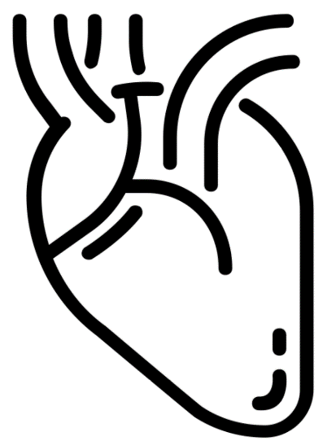
Name: ______________________

Week | Homework Task | SCAN CODE | Due
1 | Task 1: Watch the Arteries and Veins video, complete the questions in the Kay Science video and mark them and complete the quiz set on teams.  Task 2: Complete any unanswered exam questions from L1 in your booklet | 
2 | Task 1: Watch the Heart Structure video, complete the questions in the Kay Science video and mark them and complete the quiz set on teams.  Task 2: Complete any unanswered exam questions from L 2/3 in your booklet | 
3 | Task 1: Watch the Artificial Hearts and Valves video, complete the questions in the Kay Science video and mark them and complete the quiz set on teams.  Task 2: Complete any unanswered exam questions from L4 in your booklet | 

Lesson | My Marks | Exam Question Total |  |  | 
1 – Blood |  | /27
2 – Blood Vessels |  | /27
3 - Structure of the Heart |  | /21
4 - Coronary Heart Disease |  | /28

Paper 1 – Circulation Fact Sheet
Fold page here
To revise these facts, fold this sheet in half and try to write the answers down from memory. Repeat!
- What is plasma in the blood? | Yellow liquid that carries blood cells, proteins and dissolved substances around the body
- What are red blood cells? | Biconcave cells that have haemoglobin - carry oxygen
- Name the pigment found in red blood cells that binds to oxygen. | Haemoglobin
- Which organ system transports substances to and from body cells? | Circulatory system
- State the functions of white blood cells. | Engulf pathogens, produce antibodies and antitoxins
- How does being biconcave help red blood cells with their function? | Increase SA:V for efficient diffusion
- How is not having a nucleus good for red blood cells? | More space to pack more haemoglobin
- State the function of platelets. | Blood clotting
- Name the blood vessel type that carries blood from the heart to other parts of the body. | Artery
- Name the blood vessel type that carries blood from the organs back to the heart. | Vein
- Name the blood vessel type that is found within organs that link arteries and veins. | Capillaries
- State a difference in the blood flowing in arteries and veins. | A: oxygenated, more nutrients, less wastes; V: deoxygenated, less nutrients, more wastes
- The flow of blood in veins relies on ……………… | Skeletal muscle contraction
- Why can substances diffuse easily between capillaries and the cells? | Thin capillary walls (one cell thick)
- What is the double circulatory system? | One part carries blood between heart and lungs; the other carries blood between heart and the rest of the body. Blood goes through the heart twice.
- Name the vessels that supply oxygen to the heart muscles. | Coronary arteries
- Name the large vessel that brings deoxygenated blood back into the heart. | Vena cava
- Name the upper chambers of the heart. | Atria
- Name the lower chambers of the heart. | Ventricles
- Name the vessel that brings deoxygenated blood from the heart to the lungs. | Pulmonary artery
- Name the vessel that brings oxygenated blood from the lungs to the heart. | Pulmonary vein
- Which side of the heart has deoxygenated blood - right or left? | Right
- Describe the flow of blood as atria of the heart contract. | Blood flows from atria down to ventricles
- Name the large vessel that brings oxygenated blood out of the heart to the body. | Aorta
- Why is the muscle wall of the left ventricle thicker than the right ventricle? | To generate more pressure to force blood all over the body (left side only to lungs)
- What is the function of heart valves? | Prevent backflow of blood
- Describe two structural features of arteries | Thick muscular walls, elastic layer in walls, narrow lumen,
- Describe two structural features of veins | Wide lumen, valves,
- Describe two structural features of capillaries | Narrow, walls only one cell thick
- Why do arteries have thicker muscle walls than veins? | To withstand high blood pressure
- Why do veins have valves? | To prevent backflow of blood
- Capillaries have thin walls, why is this important? | To allow for faster diffusion of substances (short distance)
- Name a method to unblock a coronary artery in the heart. | Stent
- Name a drug that reduces blood cholesterol levels. | Statins
- What can be used to replace a damaged heart valve? | Biological or mechanical valves
- What is a natural pacemaker? | A group of cells in the right atrium that controls the resting heart rate
- Briefly describe how an artificial pacemaker works. | Sends strong, regular electrical signals to the heart to stimulate it to contract properly
- How are artificial hearts used to treat patients with a damaged heart? | A temporary treatment while waiting for heart transplant
- What causes arteries to narrow when somebody is suffering from coronary heart disease | Build up of fatty deposits in the coronary arteries
- What is considered a risk factor for coronary heart disease? | Obesity, lack of exercise, high fat diet
- Why is the narrowing of arteries a problem? | Reduces amount of oxygen going to the heart muscle cells which could lead to heart attack.
- Other than taking drugs like statins, what else could a person do to reduce the risk of coronary heart disease? | Exercise, reduce fat intake
- What are potential risks of having stents fitted? | Infection from surgery
- What are possible negative consequences of taking statins? | Being on medication for life, side effects.
- Specifically, what condition does an artificial pacemaker treat? | Arrythmia/irregular heartbeat


Lesson 1 Title: Blood
CHECKLIST! – Have you…
- Read the notes and completed the recall questions
- Marked your recall questions using the answers
- Completed the exam questions
Key Words:
Blood | The red liquid that circulates in the blood vessels of the circulatory system
Haemoglobin | The red protein found in red blood cells that transports oxygen round the body.
Lymphocyte | A type of white blood cell which produces antibodies or antitoxins
Oxygen | Gaseous element making up about 20% of the air, which is needed by living organisms for respiration.
Phagocyte | A type of white blood cell which engulfs and digests pathogens
Plasma | The liquid part of the blood containing dissolved substances like glucose, amino acids, minerals, vitamins (nutrients) and hormones, as well as waste materials such as urea.
Platelets | Small colourless cell fragments with no nucleus, found in blood and involved in clotting
Red blood cell | The blood cell which contains the pigment haemoglobin responsible for the transport of oxygen.
Scab | A dry, rough protective crust that forms over a cut or wound during healing
White blood Cell | A colourless cell which circulates in the blood and body fluids and is involved in counteracting foreign substances and disease

Notes: Instruction: Read the notes below.
Part 1 - State the components of blood
Blood is the liquid that transports important substances around the body. It has some other important roles:
- It helps defend the body against microorganisms which can cause disease
- It helps control the body temperature
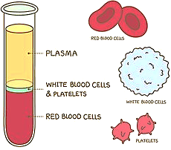
Blood contains types of cells: red blood cells, white blood cells, platelets all of which are carried in a fluid called plasma. Within the plasma dissolved substances like oxygen and glucose (plus other products of digestion), urea and carbon dioxide will also be transported around the body. The plasma is a yellow colour, blood is only red because of the haemoglobin in red blood cells.
Part 2 - Describe the role of the components of blood in the body
Red blood cells carry the oxygen from the air in our lungs to our respiring cells.
White blood cells form part of the immune system. Some white blood cells (lymphocytes) produce antibodies or antitoxins and others (phagocytes) engulf and digest invading microorganisms.
Platelets are small fragments of cells without a nucleus. They are involved in the clotting of blood. The clotting process forms a network of fibres that traps more platelets and red blood cells to form a scab which protects the new skin as it grows underneath. Scabs also prevent microorganisms from getting into the cut, so it stops infection.
Recall questions: Answer these in your book, use the information above to help you
- What is plasma in the blood?
- What are red blood cells?
- State the function of platelets.
- State the functions of white blood cells.
Part 3 - Explain how the red blood cell is adapted for its function
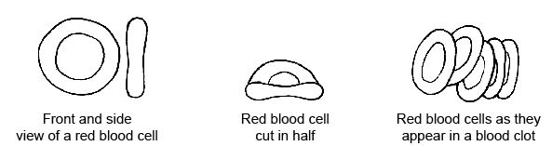
Red blood cells have certain adaptations that make them efficient at their job:
- Their biconcave disks increases their surface area which increase diffusion of oxygen across the cell membrane.
- They are packed with haemoglobin which binds to oxygen. It contains an atom of iron (Fe) which gives the pigment it’s red colour it is brightest when there is lots of oxygen bound to the haemoglobin.
- They also have no nucleus which allows more space for more haemoglobin.
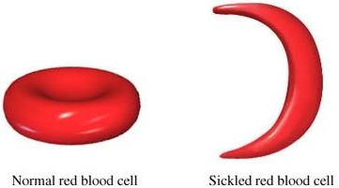
People who suffer with sickle cell anaemia have misshapen red blood cells, they have a smaller volume so they cannot hold as much haemoglobin which means they cannot carry as much oxygen. The shape also causes diffusion of oxygen to be slower as it has a smaller surface area. The shape can also cause blood vessels to block blood vessels which can slow blood flow.
Sufferers can get breathless quickly and are often tired. They are also less able to do exercise as their muscles get tired or fatigued quickly.
Recall questions: Answer these in your book, use the information above to help you
- Name the pigment found in red blood cells that binds to oxygen.
- How does being biconcave help red blood cells with their function?
- How is not having a nucleus good for red blood cells?
Exam question practice: Answer these on this sheet, use the answers to your recall questions to help you
Q1. Complete the table to show which part of the blood carries out each function. (4)

Function | Part of the blood
Transports most of the carbon dioxide | plasma
Transports most of the oxygen
Helps blood to clot at a wound
Defends the body against microorganisms
Transports the products of digestion
Q2. Blood contains plasma, platelets, red cells and white cells. Each has one or more important functions.
In the table below draw a line from each part to its function.
One part has two functions. Draw lines from this part to both functions. (5)
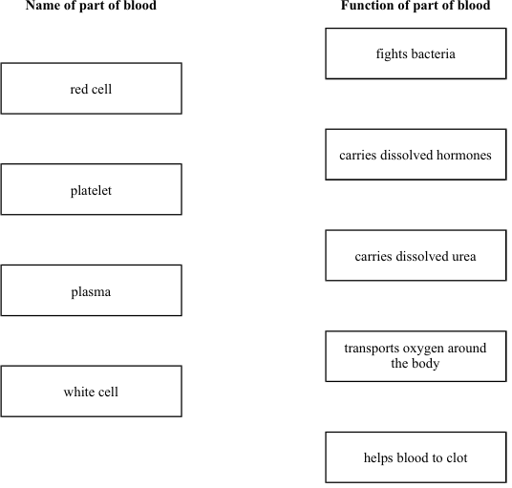
Q3. The photograph shows a red blood cell in part of a blood clot. The fibres labelled X are produced in the early stages of the clotting process.
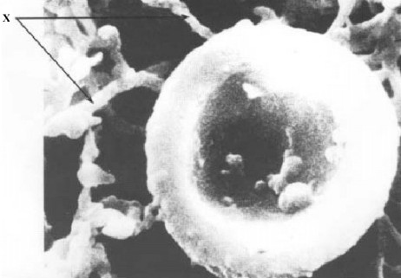
(a) Suggest how the fibres labelled X help in blood clot formation.
___________________________________________________________________ (1)
(b) On the photograph, the diameter of the red blood cell is 100 millimetres.
Calculate the magnification of the photograph.
___________________________________________________________________
___________________________________________________________________
Magnification = _______________________________ (2)
Q4. Which part of the blood:
(i) transports most carbon dioxide; __________________________________
(ii) transports most oxygen? ________________________________________ (2)
Q5. Figure 1 shows one type of white blood cell.
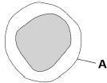
(a) What is structure A?
Tick one box.

Cell membrane | 
Cell wall
Cytoplasm
Nucleus
(1)
(b) White blood cells help to defend the body against pathogens.
How do the white blood cells do this?
Tick three boxes.

Engulf pathogens
Produce antibiotics
Produce antibodies
Produce antitoxins

Q6. List three things that are carried around the body in the blood plasma.
1. _________________________________________________________________
2. _________________________________________________________________
3. _________________________________________________________________
(3)
Q7. (a) (i) Name the red pigment found in red blood cells.
______________________________________________________________
(1)
(ii) Describe, in detail, the function of this red pigment.
______________________________________________________________
______________________________________________________________
______________________________________________________________
______________________________________________________________
(2)
(b) Describe one other way in which the structure of a red blood cell is different from the structure of a white blood cell.
___________________________________________________________________
___________________________________________________________________
(1)
Q8. Figure 1 shows an image of blood viewed with a microscope.
(a) Label Figure 1.
Figure 1
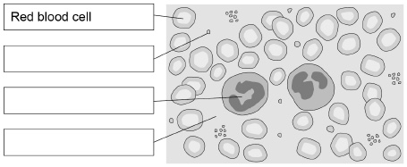
(3)

Challenge: Sickle cell disease is an inherited disorder that causes some red blood cells to have a sickle shape.
Figure 2 shows two red blood cells.
Figure 2
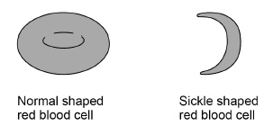
(b) A person only has sickle cell disease if two copies of the sickle cell allele are inherited.
What does this tell us about the sickle cell allele?
___________________________________________________________________
___________________________________________________________________
(1)
(c) Explain how the shape of the red blood cells in a person with sickle cell disease could affect how much oxygen reaches their muscles.
___________________________________________________________________
___________________________________________________________________
___________________________________________________________________
___________________________________________________________________
___________________________________________________________________
___________________________________________________________________
___________________________________________________________________
___________________________________________________________________
___________________________________________________________________
___________________________________________________________________
___________________________________________________________________
___________________________________________________________________
(6)
(d) Suggest one symptom of sickle cell disease.
___________________________________________________________________
___________________________________________________________________
(1)

Lesson 2 Title: Blood Vessels
CHECKLIST! – Have you…
- Read the notes and completed the recall questions
- Marked your recall questions using the answers
- Completed the exam questions
Key Words:
Arteries | Blood vessels that carry blood away from the heart.
Blood | The red liquid that circulates in the blood vessels of the circulatory system
Capillary | Tiny blood vessels with walls one cell thick where exchange of materials occurs.
Circulatory System | The system that circulates blood through the body, consisting of the heart, blood vessels, and blood.
Heart | Muscular organ that pumps blood around the body.
Vein | A blood vessel with valves that transports blood to the heart.
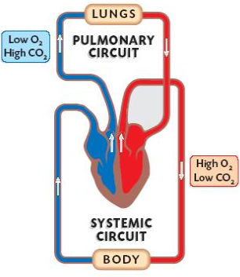
Notes: Instruction: Read the notes below.
Part 1 - State the three types of blood vessels in the body
Most animals have a closed circulatory system. In a closed circulatory system, the blood stays inside blood vessels as it travels around the body. Humans have a double circulation system because blood moves through the heart twice. The right side of the heart and blood vessels carries blood from your heart to the lungs and back again (pulmonary) and the left side of the heart pumps blood from to all other organs of your body and back again (systemic). The double circulation system allows lots of oxygenated blood to be transported quickly.
Part 2 – Describe and explain the structure of each blood vessel type
Blood Vessel | Structure | Function
Artery  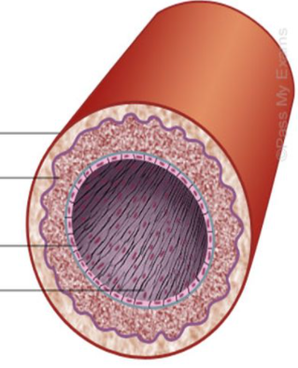 | Thick layers of muscle in walls to allow them to stretch to withstand the high blood pressure and elastic fibres recoil back to their original shape.  Small lumen to help maintain high blood pressure. | Carry blood with high oxygen away from the heart to the organs or body.
Vein  Elastic layer  Smooth muscle layer  Lumen  Endothelial cells  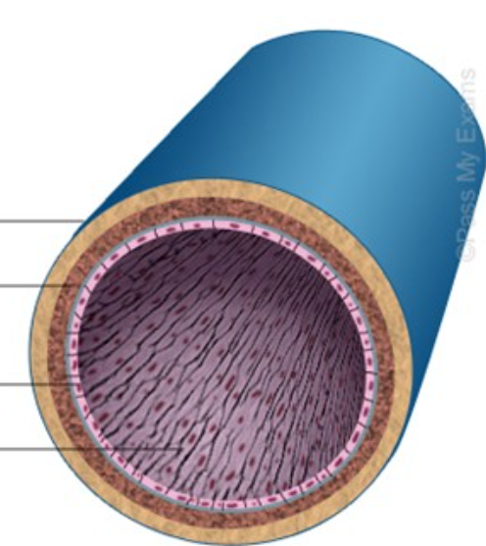  Elastic layer  Smooth muscle layer  Lumen  Endothelial cells | Thinner muscular and elastic walls because blood is under low pressure. Large lumen as well.  Valves to prevent blood flowing backwards due to gravity.  Veins go through muscles in legs and arms which help push the blood along veins when they contract. | Carry blood with low oxygen from organs towards the heart.
Capillary  Endothelial cells  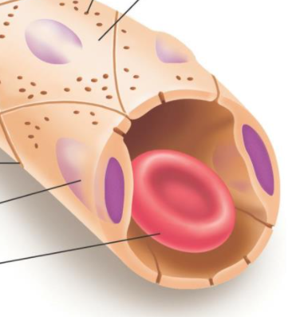  Nucleus  Red blood cell | Very thin walls that are only one cell thick to make sure there is a short diffusion distance for oxygen.  Very narrow lumens which only allow one red blood cell to pass through at a time, this slows blood flow to increase the time that oxygen and glucose can diffuse into cells. | Capillaries connect arteries and veins. They are found close to all cells and where substances to easily diffuse between the blood and cells.
Task: Label the diagram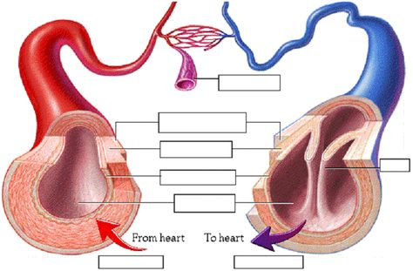
Recall questions: Answer these in your book, use the information above to help you
- Name the blood vessel type that carries blood from the heart to other parts of the body.
- Name the blood vessel type that carries blood from the organs back to the heart.
- Name the blood vessel type that is found within organs that link arteries and veins.
- State a difference in the blood flowing in arteries and veins.
- The flow of blood in veins relies on ………………
- Why can substances diffuse easily between capillaries and the cells?
- What is the double circulatory system?
- Describe two structural features of arteries
- Describe two structural features of veins
- Describe two structural features of capillaries
- Why do arteries have thicker muscle walls than veins?
- Why do veins have valves?
- Capillaries have thin walls, why is this important?
Exam question practice: Answer these on this sheet, use the answers to your recall questions to help you
Q1. Draw a ring around one word to answer each of the following questions.
(i) Which type of blood vessel carries blood out of the heart?
artery capillary vein
(1)
(ii) Which type of blood vessel allows substances to enter and leave the blood?
artery capillary vein
(1)
Q2. The drawings show the structure of three types of blood vessel, A, B and C. They are drawn to the scales indicated.
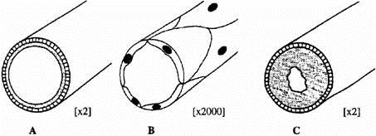
(a) Name the three types of blood vessel.
A _______________________________
B _______________________________
C _______________________________
(3)
(b) Describe the job of blood vessel B.
___________________________________________________________________
___________________________________________________________________
___________________________________________________________________
___________________________________________________________________
(2)
Q3. The following sentences are about the blood system. Choose words from the list in the box to complete these sentences. You may use a word once or not at all.

diffuse lowered narrow one
raised spread two wide
Capillaries have thin walls which are __________________ .cell thick. This allows
nutrients from digested food to __________________ through and reach the cells
of organs. Capillaries are very ________________ .and so blood flow through an
organ is slowed down and blood pressure is ____________________ .
(Total 4 marks)

Q4. (c) Figure 2 shows three types of blood vessel, F, G and H.
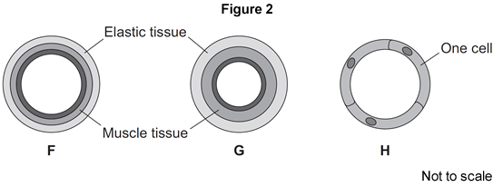
(i) What type of blood vessel is F?

Tick (✔) one box.
an artery | 
a capillary
a vein
(1)
(ii) A man needs to have a stent fitted to prevent a heart attack.
In which type of blood vessel would the stent be placed?

Tick (✔) one box.
an artery
a capillary
a vein
(1)
Q5. The circulatory system contains arteries and veins.
(a) (i) Describe how the structure of an artery is different from the structure of a vein.
______________________________________________________________
______________________________________________________________
______________________________________________________________
______________________________________________________________
(2)
(ii) A comparison is made between blood taken from an artery in the leg and blood taken from a vein in the leg.
Give two differences in the composition of the blood.
1. ____________________________________________________________
______________________________________________________________
2. ____________________________________________________________
______________________________________________________________
(2)
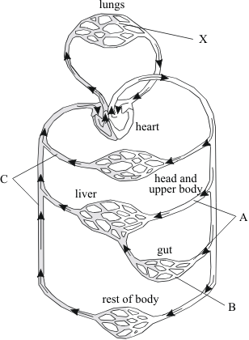
Q6. The diagram shows part of the circulatory system.

(a) Name the types of blood vessel labelled A, B and C on the diagram.
A ________________________________
B ________________________________
C _______________________________ (3)

(b) What is the job of the circulatory system?
_________________________________
__________________________________
___________________________________
________________________________ (1)

Q7. Arteries and veins have different structures and different functions.
Explain how the different structure of arteries and veins relates to their different functions.
___________________________________________________________________
___________________________________________________________________
___________________________________________________________________
___________________________________________________________________
___________________________________________________________________
___________________________________________________________________
___________________________________________________________________
___________________________________________________________________ (6)


Lesson 3 Title: Structure of the Heart
CHECKLIST! – Have you…
- Read the notes and completed the recall questions
- Marked your recall questions using the answers
- Completed the exam questions
Key Words:
Aorta | Main artery which carries oxygenated blood from the heart in mammals.
Arteries | Blood vessels that carry blood away from the heart.
Atrium | In the heart, the atria (plural) are the upper chambers which collect blood returning from the body (right atrium) or from the lungs (left atrium).
Coronary artery | One of the arteries that supplies the heart muscle with oxygen and glucose so that it can respire
Heart | Muscular organ that pumps blood around the body.
Organ | A group of different tissues that work together to carry out a particular function, eg heart and lungs.
Pulmonary artery | The artery which carries deoxygenated blood from the heart to the lungs.
Pulmonary vein | One of the four veins that carries oxygenated blood to the heart from the lungs.
Vein | A blood vessel with valves that transports blood to the heart.
Vena cava | One of the two veins that carries deoxygenated blood to the heart from the body systems.
Ventricle | The lower chamber of the heart that receives blood from the atrium and pumps it into arteries.
Notes: Instruction: Read the notes below.
Part 1 - Explain how the heart muscle functions
Your heart is the organ that pumps (pushes) blood round our body. It is described as a double pump because the right-side pumps blood to the lungs and the left-side pumps blood to the body, blood flows through the heart twice.
The walls of your heart are made of muscle, the blood vessel that supplies the heart muscle cells with oxygen is called the coronary artery. The heart beats continuously for your whole life so it requires a constant supply of oxygen and glucose from the blood.
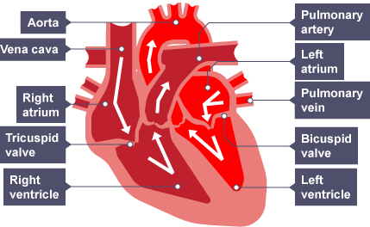
Part 2 - Identify the main chambers and blood vessels of the heart on a diagram
6

4
1

Atrioventricular valve
Atrioventricular valve
2
5
3

It is easy to tell which side is left and right because the muscle wall of the left ventricle is thicker than the right ventricle. This allows the left ventricle to contract with more force so the blood is pushed at the high pressure needed to pump it round the body.
Part 3 - Describe the path of blood through the heart
- Blood enters the right atrium through the vena cava (a vein that brings deoxygenated blood back to the heart from the body).
- Blood will then travel from the right atrium into the right ventricle. The atrioventricular (AV) valve will then close to prevent backflow.
- When the right ventricle contracts deoxygenated blood is forced through into the pulmonary artery which travels to the lungs to pick up oxygen.
- This newly oxygenated blood is returned to the heart by the pulmonary vein into the left atrium.
- Blood flows into the left ventricle, the atrioventricular (AV) valve closes to prevent backflow.
- The left ventricle pumps oxygenated blood around the body via the aorta.
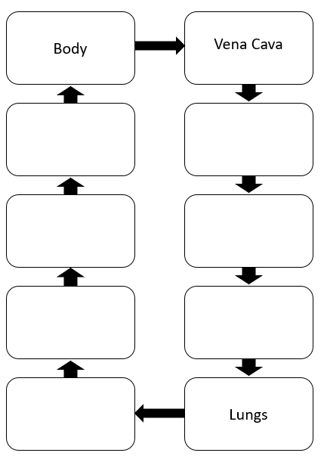
Recall questions: Answer these in your book, use the information above to help you
- Name the vessels that supply oxygen to the heart muscles.
- Name the large vessel that brings deoxygenated blood back into the heart.
- Name the upper chambers of the heart.
- Name the lower chambers of the heart.
- Name the vessel that brings deoxygenated blood from the heart to the lungs.
- Name the vessel that brings oxygenated blood from the lungs to the heart.
- Which side of the heart has deoxygenated blood - right or left?
- Describe the flow of blood as atria of the heart contract.
- Name the large vessel that brings oxygenated blood out of the heart to the body.
- Why is the muscle wall of the left ventricle thicker than the right ventricle?
- What is the function of heart valves?
Exam question practice: Answer these on this sheet, use the answers to your recall questions to help you
Q1. The diagram shows the human circulation system.
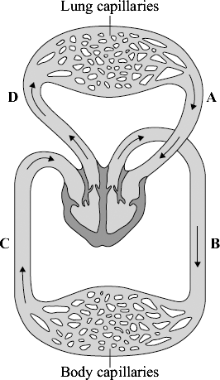

 | (a) | (i) | Give the letter of one blood vessel that is an artery. | 
(1)

 | (ii) | Give the letter of one blood vessel that carries oxygenated blood.
(1)
Q4. Some animals have a single circulatory system.
(a) Why is the human heart referred to as part of a dual circulatory system?
___________________________________________________________________
___________________________________________________________________
(1)

Below is a diagram of a human heart.
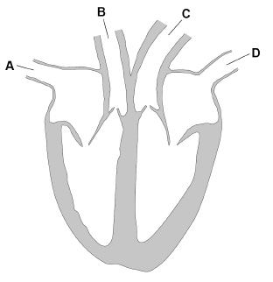
(b) Which label shows the pulmonary vein?
Tick one box.

A | 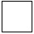 | B |  | C |  | D
(1)
(c) Which blood vessel takes oxygenated blood away from the heart?
Tick one box.

A |  | B |  | C |  | D
(1)
(d) Name the blood vessels that deliver oxygen to the capillaries in heart muscle.
___________________________________________________________________
(1)
Q5. Diagram 1 shows a section through the heart.
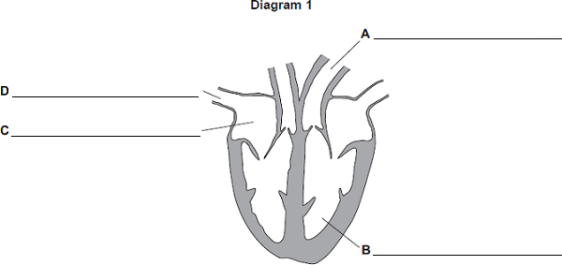
(a) On the diagram, name the parts labelled A, B, C and D. (4)

Q6. The heart is part of the circulatory system.
(a) (i) Name one substance transported by the blood in the circulatory system.
______________________________________________________________
(1)
(ii) What is the main type of tissue in the heart wall?
______________________________________________________________
(1)
(b) Figure 1 shows the human heart.
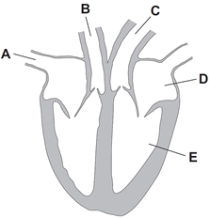
(i) Which blood vessel, A, B or C, takes blood to the lungs?

(ii) Name parts D and E shown in Figure 1.
D _______________________________________
E _______________________________________ (3)

Q7. Diagram 1 shows a section through the heart
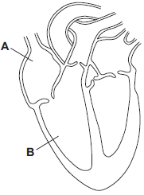
(a) Use words from the box to name the structures labelled A and B on Diagram 1.

aorta | atrium | pulmonary artery | ventricle
A ___________________________________________________________
B ___________________________________________________________
(2)
(b) The tissue in the wall of the heart contracts.
(i) What type of tissue is this?
Tick () one box.
muscular
glandular
epithelial
(1)
(ii) What does the heart do when this tissue contracts?
______________________________________________________________
______________________________________________________________
(1)
(c) Draw arrows on Diagram 2 to complete the route taken by deoxygenated blood through the heart.
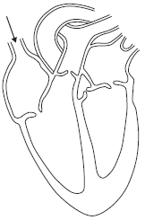
(2)

Lesson 4 Title: Heart Disease
CHECKLIST! – Have you…
- Read the notes and completed the recall questions
- Marked your recall questions using the answers
- Completed the exam questions
Key Words:
Arteries | Blood vessels that carry blood away from the heart.
Cholesterol | A type of lipid (fatty substance).
Coronary heart disease | A form of heart disease in which one or more of the coronary arteries become blocked, depriving the heart muscle of oxygen.
Donor | A person or organism providing an organ or tissue for transplant.
Heart transplant | An operation to replace a damaged heart with a healthy heart from a donor.
Pacemaker | A medical device that uses electrical impulses to regulate heart beats.
Stent | A device, consisting of a wire mesh tube, used to keep a narrowed or blocked coronary artery open.
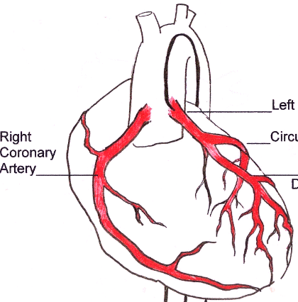
Notes: Instruction: Read the notes below.
Part 1 - Describe the effects of coronary heart disease on the heart and blood vessels
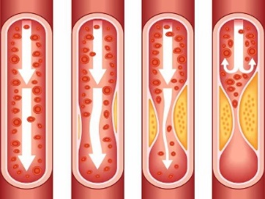
Coronary heart disease is caused by the narrowing the coronary arteries that supply the heart. This is caused by a build-up of fatty material on the lining of the coronary arteries which reduces the supply of oxygen to the heart muscle.
If the coronary arteries become blocked this can cause a heart attack! This is because oxygen and glucose cannot reach the heart muscle cells so they have no energy to beat.
Exercise and a low-fat diet can help prevent CHD by reducing cholesterol. Obesity increases the risk of suffering with CHD.
Part 2 - Describe some methods for treating patients with damaged heart or blood vessels
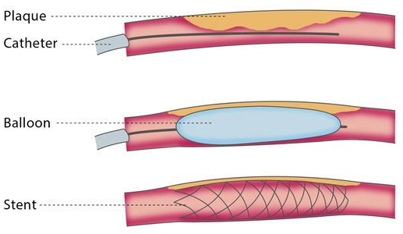
Statins and Stents
Statins are drugs which can slow down CHD by reducing blood cholesterol levels and slow down the rate at which fatty material is deposited.
A stent is a metal mesh placed in the artery. A tiny balloon is then inflated to open the blood vessel and the stent. The balloon is then removed but the stent is left to make sure the blood vessel remains open.
Leaky Valves
Heart valves have to withstand a lot of pressure. As such they may start to leak. Doctors can operate and replace faulty valves with mechanical valves made of titanium or biological valves are based on valves from pigs or human donors.
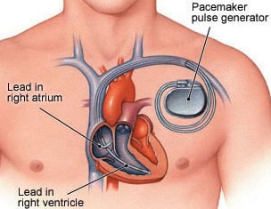
Arrythmia
The beating of the heart is controlled by pacemaker cells in the walls of the right atrium. This cluster of cells can stop working causing arrhythmia (abnormal heartbeat), they can be replaced with an artificial pacemaker.
An artificial pacemaker is an electronic device that is connected to your heart by wires which controls the heartbeat by sending out strong, regular electronic signals to make the heart contract.
Part 3 - Evaluate different methods for treating CHD
Symptom | Treatment | Pros | Cons
Narrowed arteries caused by fatty deposits (early CHD) | Statins | Reduces fatty deposits in arteries.  No surgery, can prevent the need for surgery in future. | Can’t be used to treat already affected arteries. Drug has to be taken regularly and long-term.  Could be side-effects of taking the drug.
CHD - Blocked arteries | Stents | Improves blood flow  Doesn’t require general anaesthetic.  Can be placed anywhere in the body. | Risk of infection from operation  Risk of blood clots
CHD - Blocked arteries | Bypass surgery | Removes blocked artery and increases blood flow.  Can be used on extremely blocked arteries where stents can’t help | This requires major surgery and general anaesthetic – risk of dying of heart attack
Leaky Valves | Mechanical Valves | Long lasting | Require medication to prevent blood clots
Leaky Valves | Biological Valves | Only last 12-15 years | Do not require any medication
Arrythmia | Artificial Pacemaker | Maintains regular heart rhythm  Can stimulate the heart to beat faster when you exercise | Requires regular check-ups throughout your life
Total heart malfunction | Artificial Heart | Keeps patient alive whilst waiting for a donor heart to be found for transplant. | Requires surgery  Risk of blood clots

Recall questions: Answer these in your book, use the information above to help you
- Name a method to unblock a coronary artery in the heart.
- Name a drug that reduces blood cholesterol levels.
- What can be used to replace a damaged heart valve?
- What is a natural pacemaker?
- Briefly describe how an artificial pacemaker works.
- How are artificial hearts used to treat patients with a damaged heart?
- What causes arteries to narrow when somebody is suffering from coronary heart disease
- What is considered a risk factor for coronary heart disease?
- Why is the narrowing of arteries a problem?
- Other than taking drugs like statins, what else could a person do to reduce the risk of coronary heart disease?
- What are potential risks of having stents fitted?
- What are possible negative consequences of taking statins?
- Specifically, what condition does an artificial pacemaker treat?
Exam Questions: Answer these questions on this sheet – you can use the notes to help you
Q1. CHD is caused when fatty material builds up in the coronary arteries.
The diagram below shows a coronary artery of someone with CHD.
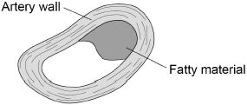
(b) Explain how CHD can cause a heart attack.
___________________________________________________________________
___________________________________________________________________
___________________________________________________________________
___________________________________________________________________
___________________________________________________________________
___________________________________________________________________
(3)
Q2. (c) A person’s coronary artery has become narrower.
The person has a heart attack.
A doctor puts a stent into the person’s coronary artery.
Figure 2 shows a stent inside a coronary artery.
Figure 2
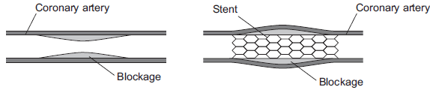
(i) How does the stent help to prevent another heart attack?
Give one way.
______________________________________________________________
______________________________________________________________
(1)

(ii) Figure 3 shows a surgeon putting a stent into a patient.
Figure 3
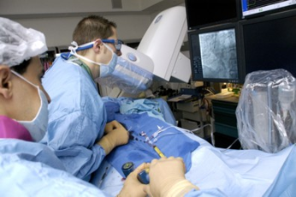
© Science Photo Library
The surgeon puts the stent into an artery in the leg. He moves the stent through the artery to the coronary artery.
Suggest two possible risks of this operation.
1. ____________________________________________________________
______________________________________________________________
2. ____________________________________________________________
______________________________________________________________ (2)

Q3. Coronary heart disease (CHD) can be caused by many factors.
Describe how statins can help to reduce deaths from CHD.
___________________________________________________________________
___________________________________________________________________
___________________________________________________________________
___________________________________________________________________
(2)
Q4. (e) Pacemaker cells are a group of cells that control heart rate.
Where in the heart are the pacemaker cells located?
___________________________________________________________________
(1)
(f) What type of signal is sent from the pacemaker cells to the heart muscle?
___________________________________________________________________
___________________________________________________________________ (1)
Q5. This question is about the circulatory system.
Figure 1 shows a human heart.
Figure 1
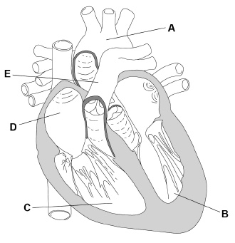
(a) What is the name of vessel E?
Tick one box.

Aorta
Pulmonary artery
Pulmonary vein
Vena cava
(1)
(b) Heart rate is controlled by a natural pacemaker.
Where in Figure 1 is the heart’s natural pacemaker?
Tick one box.

A |  | B |  | C |  | D
(1)

Q6. Diagram 2 shows the blood vessels that supply the heart muscle.
Part of one of the blood vessels has become narrower.
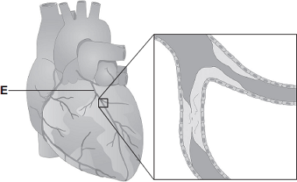
© Peter Gardiner/Science Photo Library
(i) Name blood vessel E.
______________________________________________________________ (1)
(ii) Give one method of treating the narrowed part of blood vessel E.
______________________________________________________________ (1)
(iii) Explain how the method of treatment works.
______________________________________________________________
______________________________________________________________
______________________________________________________________
______________________________________________________________ (2)
Q7. Every year, many patients need to have heart valve replacements. The table gives information about two types of heart valve.

Living human heart valve | Cow tissue heart valve
• It has been used for transplants for  more than 12 years. | • It has been used since 2011.
• It can take many years to find a suitable  human donor. | • It is made from the artery tissue of a  cow.
• It is transplanted during an operation  after a donor has been found. | • It is attached to a stent and inserted  inside the existing faulty valve.
• During the operation, the patient's chest  is opened and the old valve is removed  before the new valve is transplanted. | • A doctor inserts the stent into a blood  vessel in the leg and pushes it through  the blood vessel to the heart.

A patient needs a heart valve replacement.
Give the advantages and disadvantages of using a cow tissue heart valve compared with using a living human heart valve.
Use information from the table and your own knowledge in your answer.
___________________________________________________________________
___________________________________________________________________
___________________________________________________________________
___________________________________________________________________
___________________________________________________________________
___________________________________________________________________
___________________________________________________________________
___________________________________________________________________
___________________________________________________________________ (6)

Q8. In coronary heart disease (CHD) layers of fatty material build up inside the coronary arteries. This can cause a heart attack.
Statins and stents can be used to reduce the risk of a heart attack in people with CHD.
Evaluate the use of statins and stents in people with CHD.
Remember ‘evaluate’ means to argue which one is better and why. You must include a justified conclusion.
___________________________________________________________________
___________________________________________________________________
___________________________________________________________________
___________________________________________________________________
___________________________________________________________________
___________________________________________________________________
___________________________________________________________________
___________________________________________________________________
___________________________________________________________________
___________________________________________________________________
(6)

