AQA Biology
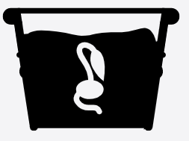
3.6.1.1 Survival and Response

Name: ______________________

Lesson | Exam Question Marks | Homework Checked | Date
Lesson 1 – Taxes and Kineses

Lesson 2 – Investigating Animal Responses

Lesson 3 – Plant Responses

Lesson 4 – Investigating Plant Responses

EOTT

Specification Section

Survival and response (A-level only)

Content | Opportunities for skills development
Organisms increase their chance of survival by responding to changes in their environment.  In flowering plants, specific growth factors move from growing regions to other tissues, where they regulate growth in response to directional stimuli.  The effect of different concentrations of indoleacetic acid (IAA) on cell elongation in the roots and shoots of flowering plants as an explanation of gravitropism and phototropism in flowering plants.  Taxes and kineses as simple responses that can maintain a mobile organism in a favourable environment.  The protective effect of a simple reflex, exemplified by a three-neurone simple reflex. Details of spinal cord and dorsal and ventral roots are not required. | AT h  Students could design and carry out investigations into the effects of indoleacetic acid on root growth in seedlings.
Required practical 10: Investigation into the effect of an environmental variable on the movement of an animal using either a choice chamber or a maze. | AT h

Lesson 1 – Taxes and Kineses
Key Words:
Taxis | A simple response whose direction is determined by the direction of the stimulus
Kinesis | A non-directional response to a stimulus which brings about increased random movements
Stimulus | A change in the external or internal environment of an organism
Photo- | A prefix meaning light
Geo- | A prefix meaning gravity
Chemo- | A prefix meaning chemical
Rheo- | A prefix meaning movement
Notes:
Organisms must respond to changes in their environment (stimuli) so that they can increase their chances of survival by avoiding predation and abiotic stress, or by increasing access to essential resources. Animals and mobile organisms including some bacteria can physically move away from unfavourable or dangerous environments. They can also move towards more favourable conditions. Plants cannot physically move themselves, but they can change how they grow in order to try and improve their environmental conditions.
Organisms must also respond to changes in their internal environment in order to maintain stable internal conditions which are optimised for them to carry out chemical reactions (homeostasis).
Types of Response
There are two types of simple (automatic) response that can occur in mobile organisms to keep them in a favourable environment: Taxes and Kineses. These movements are not choices made by the organism they are automatic responses to stimuli. The prefix before these indicates the type of stimulus. E.g photo = light
Taxis | Kinesis
A tactic response is directional. The direction of the stimulus determines the direction of the movement in response. If an organism moves towards the stimulus it is a positive response, if it moves away it is a negative response. | A kinetic response ©s random (non-directional). The intensity of the stimulus affects the speed of the movement in response.
Examples: | Examples:
Phototaxis in woodlice – woodlice show negative phototaxis which means that they will move away from a light source. This behaviour may be helpful because woodlice require a moist environment, and a sunny, light, spot is more likely to be warm and dry.  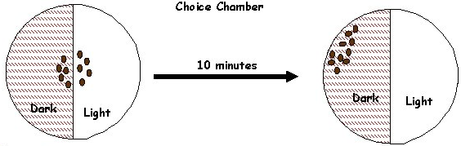 | Orthokinesis in woodlice – When an organism is in a favourable environment it slows down, and when in an unfavourable environment, it speeds up. Overall, this leads to an organism spending more time in the favourable environments and less in the unfavourable. This can be seen with woodlice and humidity.  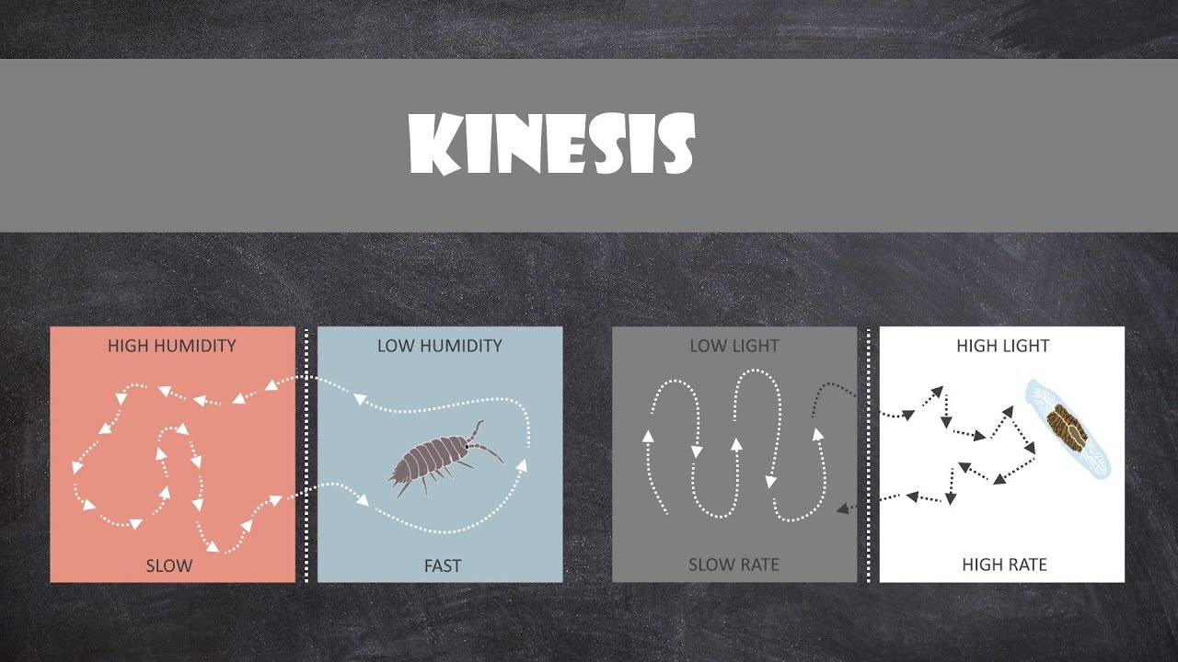
Chemotaxis in bacteria – It is the movement of an organism in response to a chemical stimulus. This is important for bacteria to find food (e.g. positive chemotaxis for glucose) by swimming toward the highest concentration of food molecules, or to flee from poisons (e.g. negative chemotaxis for phenol). 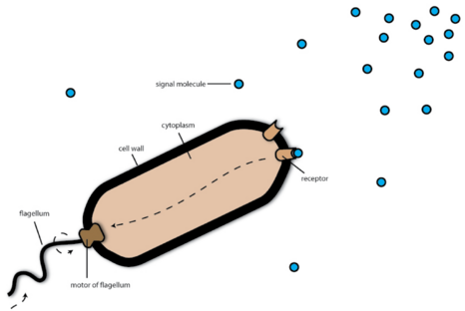 | Klinokinesis in flatworms – When an organism is in an unfavourable environment the frequency or rate of turning increases with stimulus intensity. For example, the flatworm Dendrocoelum lacteum turns more frequently in response to increasing light intensity thus ensuring that it spends more time in dark areas which are more likely to be moist and easier to hide from predators.
Chemotaxis in phagocytes – Phagocytes move towards pathogens as they are attracted to chemicals released by the pathogen such as histamines. They show positive chemotaxis by moving down the concentration gradient towards the pathogen. They are then able to squeeze through holes in the capillary endothelium into the infected tissues to begin engulfing pathogens.  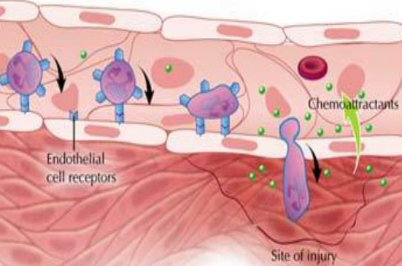 | Chemokinesis in cells – It is a movement response of organisms to chemicals that cause the cell to make some kind of change in their migratory/swimming behaviour. Changes involve an increase or decrease of speed, alterations of amplitude or frequency of movements, or direction of migration. However, in contrast to chemotaxis, chemokinesis is random.  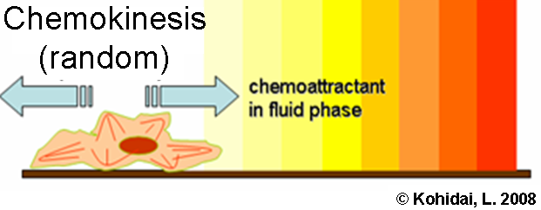
Rheotaxis in fish – positive rheotaxis keeps trout facing the current in rivers as this is the direction from which the most food will come it also increases the rate of flow of oxygenated water over their gills. These both lower the amount of energy the fish needs to use.  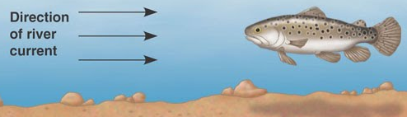 | 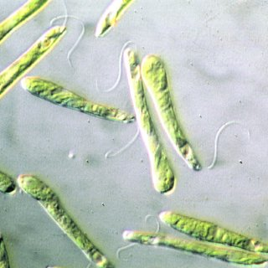  Photokinesis in photosynthetic prokaryotes –It is when organisms change the speed of their movement in response to changes in light intensity. The change in speed is unrelated to the direction of the light. This may help organisms avoid predation (not staying in the light too long), or in single celled photosynthetic organisms, (e.g Euglena) an increase in light intensity results in increased photosynthesis which enables an increase in metabolic activity.
Recall Questions
- Why must organisms respond to changes in their environment?
- What can plants do to respond to stimuli?
- What are the two types of simple response in organisms?
- Define a taxis
- Define a kinesis
- How could you tell if a response was positive or negative?
- How can you tell if a response is kinetic or tactic?
- Explain why negative phototaxis is beneficial to woodlice
- Explain why klinokinesis is beneficial to woodlice
- How does a phagocyte use chemotaxis?
- How does rheotaxis in fish increase survival?

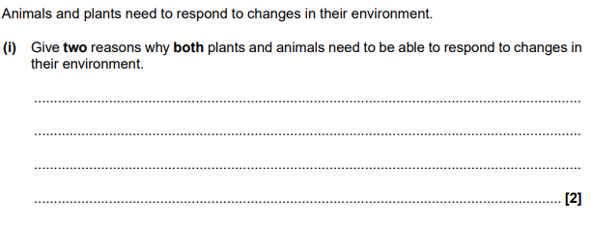
Exam Questions
Q1.

Q2. The human body-louse is an insect which lives and feeds on the surface of the skin. A louse was placed in a chamber, half of which was kept at 35 °C and half at 30 °C. The diagram shows the pattern of movement of the louse.
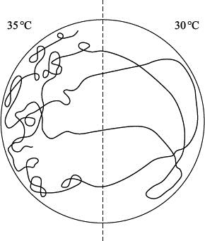
(a) Name the type of behavioural response shown by the body-louse in this investigation.
Give evidence for your answer.
___________________________________________________________________
___________________________________________________________________
(2)
(b) Suggest and explain one advantage of this behaviour to the human body-louse.
___________________________________________________________________
___________________________________________________________________
(2)
Q3. Termites are insects. Some species live in colonies in the soil. Although most termites are wingless, winged termites are sometimes produced. The winged termites fly from the soil, mate and start new colonies.
A scientist studied the behaviour of winged termites. He divided these termites into three groups.
• Group A had their eyes covered.
• Group B had their antennae removed.
• Group C was the control group.
He put individual winged termites on a sloping board that was illuminated from one side. The diagram shows the direction of movement of a typical termite from each of the three groups.
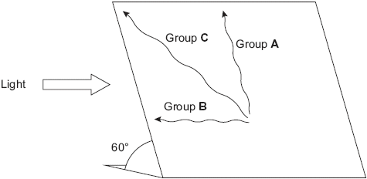
(a) (i) What type of behaviour was shown by the termite from group B?
______________________________________________________________
(1)
(ii) Give the evidence for your answer.
______________________________________________________________
______________________________________________________________ (1)
(b) Explain what the results from group A suggest about the factors controlling the behaviour of winged termites.
___________________________________________________________________
___________________________________________________________________
___________________________________________________________________
___________________________________________________________________
___________________________________________________________________
(3)
(c) Suggest one advantage to the termites from group C of the behaviour shown in the investigation.
___________________________________________________________________
___________________________________________________________________
___________________________________________________________________
(2)
Q4.
A flatworm is a simple soft-bodied animal. The diagram shows the movements of an aquatic flatworm in light and in shade. The path followed by the flatworm over a period of three minutes was traced on the side of a tank.
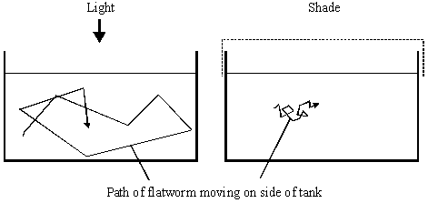
(i) Name the type of behaviour shown. Give a reason for your answer.
Type of behaviour ____________________________________________________
Reason ____________________________________________________________
___________________________________________________________________
(2)
(ii) Suggest one advantage of the behaviour shown in the diagram.
___________________________________________________________________
___________________________________________________________________ (1)
Q5. A biologist investigated the behaviour of a species of worm that lives in soil.
He cultured three samples of worms in three separate trays of soil for many days.
Each culture:
• contained a food supply
• was kept at a different temperature.
The temperatures of the cultures were 17 °C, 20 °C and 23 °C.
The biologist then removed food from the trays for several hours. Then he transferred each sample of worms onto a glass surface where there was no food. Each surface had a temperature gradient across it. After 1 hour, the biologist recorded the position of each worm.
The figure below shows his results. On each diagram,  marks where he released the worms onto the glass surface.
Temperature gradient
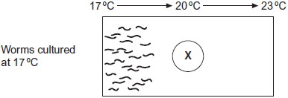
Temperature gradient
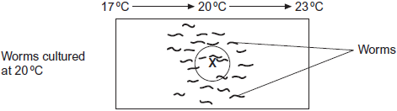
Temperature gradient
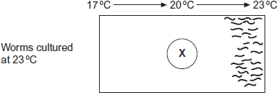
(a) The biologist concluded that the worms’ behaviour demonstrated taxis.
How do these results support this conclusion?
___________________________________________________________________
___________________________________________________________________
___________________________________________________________________
(2)
(b) Using the information provided, suggest an explanation for the worms’ behaviour on the glass surfaces in the absence of food.
___________________________________________________________________
___________________________________________________________________
___________________________________________________________________
___________________________________________________________________
(3)
(c) In each experiment, the biologist exposed the surfaces to light that was dim and even, so he could see where the worms went.
Apart from seeing where the worms went, suggest two reasons why it was important that the light was dim and even.
1. _________________________________________________________________
___________________________________________________________________
2. _________________________________________________________________
___________________________________________________________________
(2)
Q6. Scientists investigated the effect of humidity on the movement of the insect, Tenebrio molitor.
The insects were placed in choice chambers with one side kept at 100% humidity and the other side kept at 30% humidity.
The insects were used one at a time and the path the insect followed recorded on paper.
Figure 1 shows a typical result. The solid dot shows the final recorded position of the insect.
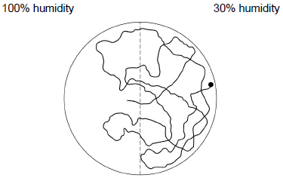
(a) What type of behaviour was shown by the insect in Figure 1?
Give evidence from Figure 1 to support your answer.
___________________________________________________________________
___________________________________________________________________
___________________________________________________________________
(2)
(b) The scientists found that the insects moved for 94% of the time in the more humid side, but in the drier side they moved only 20% of the time. The scientists concluded that reduced movement in the drier side was an adaptation that reduced water loss.
Use your knowledge of gas exchange in insects to explain how this behaviour would reduce water loss in the insects.
___________________________________________________________________
___________________________________________________________________
___________________________________________________________________
(2)
(c) Tenebrio molitor has two antennae on its head. These are sense organs.
The scientists found that one insect stopped when it reached the boundary between the two sides of the choice chamber and seemed to perform various movements with its antennae. The insect then moved to the drier side.
This behaviour can be seen in Figure 2. The points marked with a Q indicate where the insect showed this behaviour.
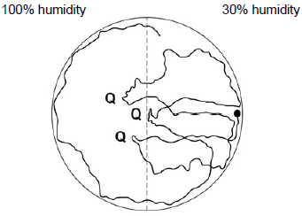
What type of behaviour did the scientists conclude that the insect in Figure 2 was showing?
___________________________________________________________________
(1)
Q7. The body temperature of desert-living lizards is greatly affected by the temperature of their environment. A lizard was placed in a chamber where one half was maintained at 20 °C and the other at 40 °C. The lizard was free to move from one half to the other.
The lizard’s behaviour was observed using an infra-red camera, which records 20 °C surfaces as black and 40 °C surfaces as white. Temperatures between 20 °C and 40 °C appear as shades of grey. A series of photographs was taken.
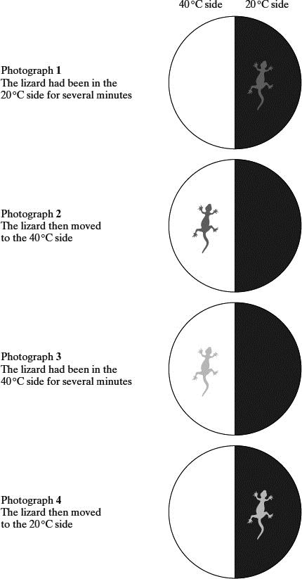
(a) The position and appearance of the lizard, as recorded by the infra-red camera, changed during the experiment. Describe and explain these changes.
___________________________________________________________________
___________________________________________________________________
___________________________________________________________________
___________________________________________________________________
(3)
(b) Suggest the advantage to the lizard of the behaviour shown.
___________________________________________________________________
___________________________________________________________________
___________________________________________________________________
(2)
Homework
Task 1: Complete the sentences using the words in bold
cells direction effectors energy intense negative positive rate simple stimulus survival

A ____________ is a detectable change in the internal or external environment of an organism that produces a response. The ability to respond to a stimulus increases an organism’s chances of _____________. Receptors transfer the ____________ of a stimulus into a form that can be processed by the organism and leads to a response. Animals often have specialised ________ that are dedicated receptors and connected to the nervous system, while plants mostly have receptor molecules within the majority of their cells that mostly produce responses via chemical mediation. The response is carried out by ______________ which can include cells, tissues, organs and systems.

Complex animals display a complex array of behaviours, while in more ____________ animals there are only two main types of response that lead to behaviours:
Taxis – The direction of movement is determined by the _____________ of the stimulus. An organism can respond directly to a change in the environment by moving its body either:
- Toward the stimulus (_____________ taxis)
- Away from the stimulus (_____________ taxis)
Kinesis – Results in an increase of ________ movements:
- The organism does not move towards/away from the stimulus.
- The more ____________ the stimulus, the more rapid the movements.
- Kinesis is important when the stimulus is ‘less’ directional such as heat or humidity.

Task 2: Answer the questions
- Define a taxis. [2]
………………………………………………………………………………………………………………………………………………………………………………………………………………………………………………………………………………………………………………………………………………
- Define a kinesis. [2]
………………………………………………………………………………………………………………………………………………………………………………………………………………………………………………………………………………………………………………………………………………
- Identify which of the pictures show a taxis and which show a kinesis. [4]
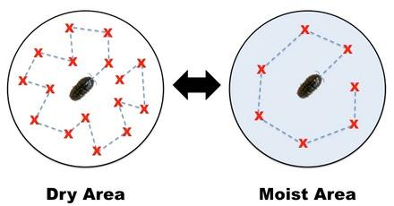 | 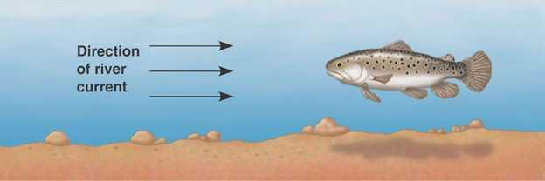
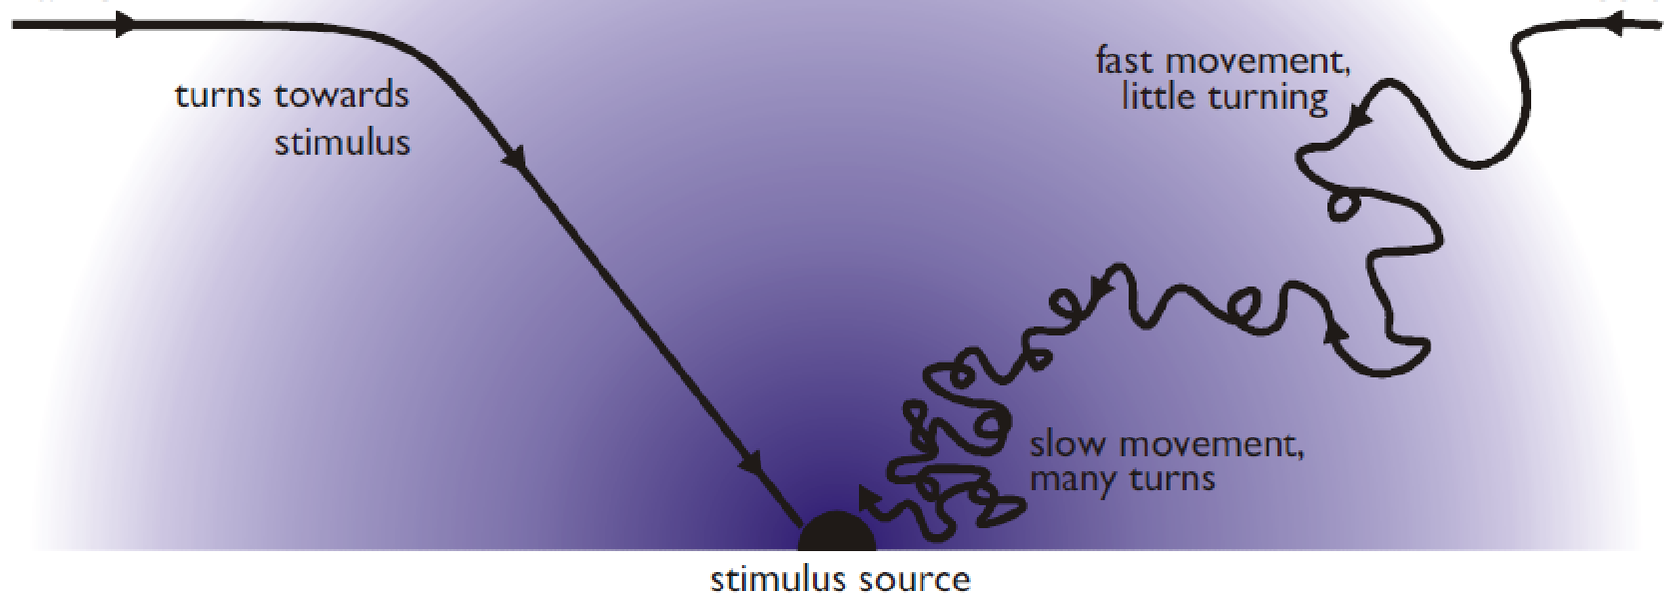 | 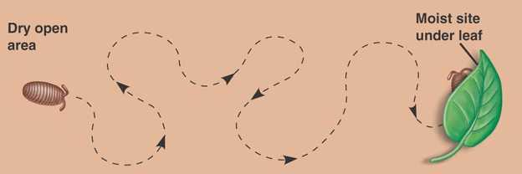

Lesson 2: Investigating Animal Responses
Required practical 10: Investigation into the effect of an environmental variable on the movement of an animal using either a choice chamber or a maze.
Apparatus and technique to be assessed:
ATh - Safely and ethically use organisms to measure: plant or animal responses or physiological functions.
It is important that living organisms are treated with respect and nothing is done that could harm them or cause them to suffer. Using soft and plastic implements like plastic spoons and soft paintbrushes to move and manipulate the organisms prevents them from being injured. Animals should be returned promptly to their natural environment or a suitable holding tank after being tested. This supports ethical approaches in field work where animals are returned to their habitat after observations have been made.
Hazards/Risks:
Take sensible hygiene precautions after handling organisms and the soil in which organisms have been kept. If using drying agent take precautions as they can irritate eyes and skin. Anhydrous calcium chloride can heat up with water.
Option 1: Choice chamber with maggots or woodlice
Independent variables (stimuli) you can create in the chamber could be two or four conditions:
- Light intensity – cover half the chamber with black paper and use a lamp on the other side.
- Humidity – place wet paper towels or cotton wool on one side and use a drying agent e.g silica gel or anhydrous calcium chloride on the other side which absorbs moisture.
Control Variables
- Number of animals in the chamber each time
- Where animals are placed into the chamber e.g middle every time
- Time allowed for animals to choose before recording numbers
Possible Predictions
When in unfavourable environments the organisms move faster and change direction more frequently to increase their chances of finding more suitable surroundings so after the allotted time more organisms will be found in the favourable environment than less favourable.
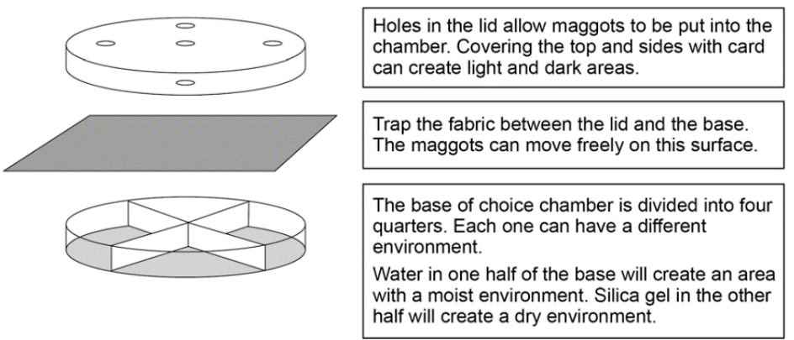
Woodlice and maggots demonstrate negative phototaxis so they should move away from areas of higher light intensity into darker areas. This means that after the allotted time more organisms would be expected to be found in the dark/shaded side of the choice chamber.
Method:
- Set up the choice chamber as a control with nothing but the muslin.
- Place 10 organisms through the central hole using a plastic spoon and/or soft paintbrush
- Leave them for 10 minutes then record the number of organisms in each half/quadrant of the chamber.
- Set up the choice chamber to have four quadrants as follows: dark and dry, dark and damp, light and dry, light and damp.
- Place 10 organisms in the centre of the choice chamber using the spoon.
- Leave for 10 minutes then record how many woodlice are in each quadrant. Repeat and take a mean.
Option 2: Maze with maggots
Can be used to investigate turning behaviour – if there is no effect on behaviour then equal numbers should move left or right at the junction Y. Many animals show behaviour called turn alternation. This means if the animal is forced to turn in one direction it is more likely to turn in the opposite direction next time it has a choice. The maze can be used to allow you to investigate whether maggots show turn alternation.
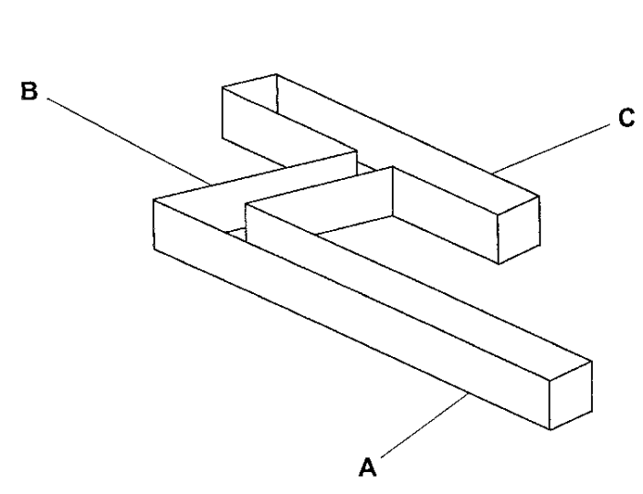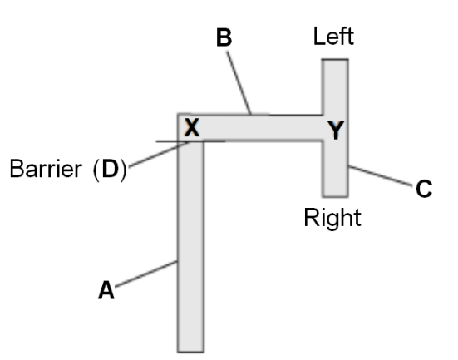
Independent variables (stimuli) you can create in the chamber could be two or four conditions:
- Light intensity – cover half of corridor C with cardboard/black paper and use a lamp on the other side.
- Humidity – place wet paper towels or cotton wool on one side of column C and use a drying agent e.g silica gel or anhydrous calcium chloride on the other side which absorbs moisture.
Control Variables
- Wipe the inside of the maze with a cotton wool bud between each maggot to remove any trace of a trail that could be followed and affect the movement.
- If a maggot stops moving remove it and choose a different one.
Method
- Place a maggot at point X using the plastic teaspoon.
- Record in a table whether the maggot turns left or right when it reaches the junction at Y.
- Remove the maggot from the maze.
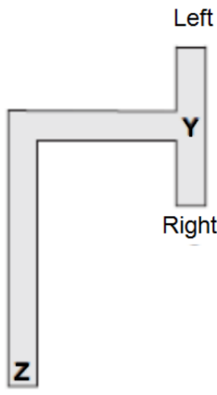
- Wipe the inside of the maze with a cotton wool bud.
- Repeat steps five to eight until you have results for 10 maggots.
- Repeat with the different conditions at the left and right for Y.
OR
- Use the maze you made in Task 1, with barrier D removed.
- Place a maggot at point Z in the maze.
- Record whether the maggot turns left or right when it reaches the junction at Y.
- Repeat steps two and three another 9 times.

Data Analysis: Chi Squared Test
A statistical test (Chi squared) can be used to determine if the observed distribution of the organisms at the end of the time is different from the expected (which would be no difference in the number of organisms in each zone). This will tell you if your results were likely due to chance or not. If not (P >0.05) then something is causing them to behave this way.
Example chi-squared test scenario:
Students carried out a similar experiment to determine the effects of light and dark on the movement of woodlice.
Expected results: We would expect more woodlice to be found on the dark side of the choice chamber than the light side.
Observed results: 10 woodlice were used in each experiment and on average 8 ended up on the dark side of the choice chamber and 2 on the light side of the choice chamber
Null hypothesis: The null hypothesis for the χ² test always states that there will be no significant difference between the observed results and the expected results. So in this case it is that light and dark has no effect on movement so the same number of woodlice should be expected to be found in each half. The alternate hypothesis is that woodlice prefer the dark condition so more would be expected found there.
In this case the chi squared test would be:
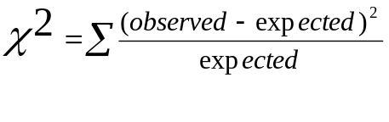
χ² = (number found in dark – number expected in dark)² + (number found in light – number expected in the light)²
number found in dark number found in dark
χ² = (8-5)² + (2-5)² = 1.8 + 1.8 = 3.6
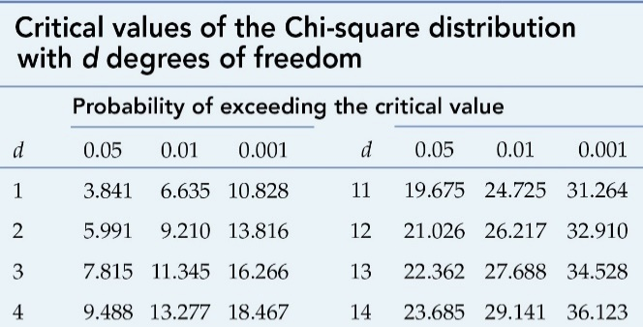
5 5
To find whether or not a chi-squared of 3.6 is significant it is compared to the numbers found in a chi-squared table at the 95% confidence level (p=0.05).
Because there are only 2 conditions the number of degrees of freedom is 2-1 = 1.
If the calculated value for χ² is greater than or equal to the critical value (found from the table below), then we can reject the null hypothesis and because there is a less than 5% probability that the difference between the observed and expected values are due to chance.
However, if the calculated value for χ² is less than the critical value, then we accept the null hypothesis because there is a more than 5% probability that the difference between the observed and expected values are due to chance.
Critical value for 0.05 in the table is 3.84, 3.6 is less than 3.84 so we accept the null hypothesis because there is a more than 5% probability that the difference between the observed and expected values are due to chance. So there is no significant difference between the observed and expected number of woodlice in each environment here.
REMEMBER: You won’t be asked to calculate χ² in the exam but you may be asked to look up critical values and explain results.

Exam Questions
Q1. Students investigated the response of beetle larvae to light. They marked sectors on a large circular sheet of cardboard. A lamp with a 100 W bulb was placed close to the cardboard sheet at position X. The larvae were released, one at a time, in the centre of the sheet. The direction in which each larva moved was determined by recording the sector into which it first crawled.
The results of 300 trials are shown in the diagram. The length of the bars indicates the number of larvae moving into each sector.
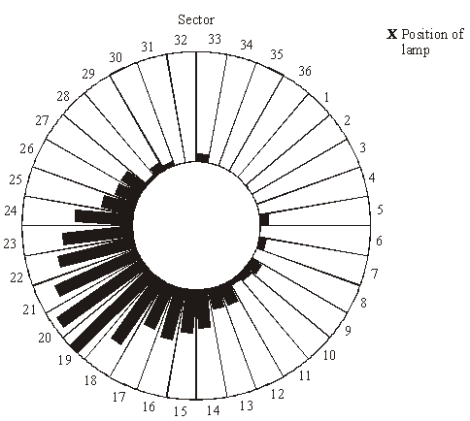
(a) The students concluded that the larvae respond by moving away from light.
(i) What is the evidence for this conclusion?
______________________________________________________________
______________________________________________________________
(1)
(ii) Suggest one precaution that would ensure the response really was due to light.
______________________________________________________________
______________________________________________________________
(1)
(iii) The larvae moved to a wide range of different sectors. Suggest an explanation for this.
______________________________________________________________
______________________________________________________________
(1)
(b) The sector which gave the median result was sector 20. Explain how the median result would be calculated.
___________________________________________________________________
___________________________________________________________________
___________________________________________________________________
___________________________________________________________________
___________________________________________________________________
(2)
Q2. In an investigation by a student into the responses of maggots, the bottom of a large box was marked with six coloured segments, as shown in the diagram.
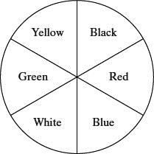
30 maggots were placed on each segment in the box. A transparent cover was put on the box and light bulbs were positioned so that the segments were evenly illuminated. The positions of the maggots were recorded after one hour. The intensity of the light reflected by each segment was measured.
The experiment was repeated three more times. The total number of maggots in each segment from the four experiments is shown in the table.

Colour of segment | Intensity of reflected light / arbitrary units | Total number of maggots
Black | 4 | 154
Red | 25 | 229
Blue | 10 | 178
White | 44 | 47
Green | 25 | 48
Yellow | 40 | 64
(a) Give one conclusion about the responses of maggots which is supported by these results.
___________________________________________________________________
___________________________________________________________________
Give the evidence from the table for your conclusion.
___________________________________________________________________
___________________________________________________________________
(2)
(b) The chi-squared test was used to analyse the data. For the results obtained, suggest one null hypothesis which might be analysed by a chi-squared test.
___________________________________________________________________
___________________________________________________________________
(1)
(c) It was suggested that the movement of the maggots might have been influenced by the Earth’s magnetic field. Suggest one simple way of repeating the investigation which would avoid this possibility.
___________________________________________________________________
___________________________________________________________________
(1)
Q3. Scientists investigated the effect of relative humidity on the activity of woodlice. They set up a Petri dish as shown in Figure 1.
In the bottom half they put a substance which absorbs water. Different concentrations of this substance produced different humidities in the air above the mesh.
Figure 1
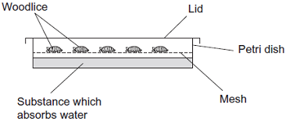
The scientists
• placed 10 woodlice in the top half of the dish
• replaced the lid and left the apparatus for 15 minutes in the laboratory
• recorded the number of woodlice not moving during the next 30 seconds
• repeated the experiment to obtain data for 100 woodlice
• repeated the experiment at different humidities.
The results are shown in Figure 2.
Figure 2
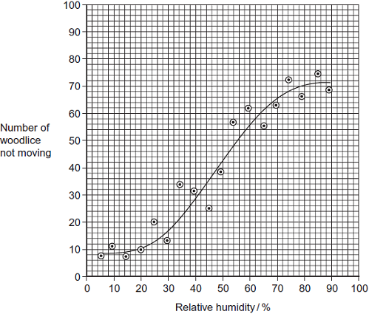
The movement of the woodlice in low relative humidity is an advantage to their survival.
Explain how.
_______________________________________________________________________
_______________________________________________________________________
_______________________________________________________________________
_______________________________________________________________________
_______________________________________________________________________
(Total 2 marks)
Q4. A student investigated the effect of distance from a forced turn on the direction woodlice turned when next given a choice. The following figure shows her results.
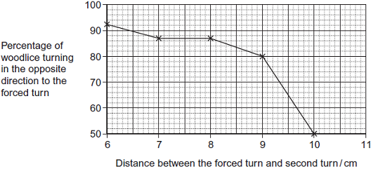
(a) Describe the response of woodlice to increased distance between turns.
___________________________________________________________________
___________________________________________________________________
___________________________________________________________________
___________________________________________________________________
(2)
(b) Can you conclude that woodlice show turn alternation behaviour when the distance between the forced turn and the second turn was 10 cm?
Explain your answer.
___________________________________________________________________
___________________________________________________________________
___________________________________________________________________
___________________________________________________________________
(2)
(c) The student suggested that the difference in turning behaviour of the woodlice in her investigation was due to the distance between the first and second turn. Her friend suggested that it was due to the time taken to get from the first to the second turn and not the distance. Suggest how you could investigate which of these two possibilities is more likely.
___________________________________________________________________
___________________________________________________________________
___________________________________________________________________
___________________________________________________________________
___________________________________________________________________
(3)
(d) Woodlice usually live in areas where stones and twigs form obstacles. Obstacles in the path of woodlice cause them to make forced turns. The more obstacles there are in the path, the shorter the distance between the forced turns.
Use the data in the figure above to explain how the behaviour of woodlice results in them moving rapidly out of unfavourable areas.
___________________________________________________________________
___________________________________________________________________
___________________________________________________________________
___________________________________________________________________
___________________________________________________________________
(2)
Q5. Woodlice use gills for gas exchange. These gills are situated on the outside of the animal so water loss occurs from the gill surface. When a number of woodlice occur together they often form a ‘clump’ with individual woodlice touching each other.
A student investigated the effect of clumping on the rate of water loss from the woodlice. The student divided the 12 woodlice into two groups. He allowed the woodlice in group A to clump together, but kept the woodlice in group B separate from each other.
The following table shows the mean mass of the woodlice in each group.

Time / minutes | Mean mass of woodlice / g
Time / minutes | Group A | Group B
0 | 0.180 | 0.175
20 | 0.170 | 0.130
40 | 0.165 | 0.110
60 | 0.160 | 0.090
80 | 0.160 | 0.080
(a) Calculate the percentage loss in the mean mass of the woodlice in Group A during the investigation. Show your working.

Answer ____________________
(2)
(b) Woodlice in Group B had a greater percentage loss in mean mass during the investigation than woodlice in Group A. Explain why.
___________________________________________________________________
___________________________________________________________________
___________________________________________________________________
___________________________________________________________________
___________________________________________________________________
___________________________________________________________________
(3)
(c) It would be useful to give the loss in mean mass as a percentage in this investigation.
Explain why.
___________________________________________________________________
___________________________________________________________________ (1)
Q6. Scientists investigated the effect of relative humidity on the activity of woodlice. They set up a Petri dish as shown in Figure 1.
In the bottom half they put a substance which absorbs water. Different concentrations of this substance produced different humidities in the air above the mesh.
Figure 1
The scientists
• placed 10 woodlice in the top half of the dish
• replaced the lid and left the apparatus for 15 minutes in the laboratory
• recorded the number of woodlice not moving during the next 30 seconds
• repeated the experiment to obtain data for 100 woodlice
• repeated the experiment at different humidities.
The results are shown in Figure 2.
Figure 2

(a) The woodlice were left for 15 minutes before their movement was recorded. Give two reasons for this.
1. _________________________________________________________________
___________________________________________________________________
2. _________________________________________________________________
___________________________________________________________________
(2)
(b) It is not possible to conclude that the change in the behaviour of the woodlice shown in Figure 2 is caused by changes in humidity. Explain why.
___________________________________________________________________
___________________________________________________________________
___________________________________________________________________
___________________________________________________________________
___________________________________________________________________
(2)
(c) The points in Figure 2 do not all fall on the curve. Suggest why.
___________________________________________________________________
___________________________________________________________________
___________________________________________________________________
___________________________________________________________________
___________________________________________________________________
___________________________________________________________________
(3)

Lesson 3: Plant Responses
Key Words
Tropism | A growth movement of a part of a plant in response to a directional stimulus
IAA | Indoleacetic acid (IAA) is an auxin – a plant growth factor which is produced in small quantities. It controls plant cell elongation. It causes elongation of shoot cells but inhibits elongation in root cells.
Plant growth factors | Hormone-like substances which control plant responses to external stimuli. They exert their influence by affecting growth and they may be made by cells located throughout the plant rather than in particular organs. They can affect the tissues that release them. eg indoleacetic acid (IAA)

Notes
Plants change the way they grow in response to changes in their environment in order to increase their chances of survival they show responses similar to taxes and kineses. Plant tactic responses are known as tropisms – they either result in growth towards (positive) or away (negative) from a directional stimulus.
Examples (also include chemotropism (chemical stimulus) and hydrotropism (water stimulus) in roots):
Phototropism  The growth response of a plant to light. Shoots are positively phototropic and grow towards the light. They are able to sense the direction of light and grow towards it in order to maximise light absorption for photosynthesis.  Roots are negatively phototropic and grow away from light. This makes sure the grow downwards into soil. |  | Shoots = positive, Roots = negative  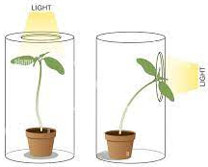
Gravitropism (geotropism)  The growth response of a plant to gravity. Shoots are negatively gravitropic and grow upwards. This ensures they are more likely to grow out of the ground where there will be more light.  Roots are positively gravitropic and grow downwards. This ensures they grow deeper into the ground in order to get more water and mineral ions. |  | Shoots = negative, Roots = positive  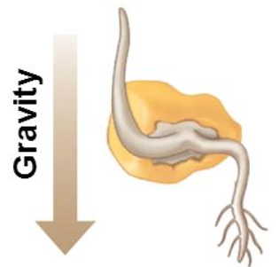
Thigmotropism  Climbing plants have a sense of touch, when they sense an object their growth changes to curl around the object which is touching the plant. This allows plants to climb up above others to receive more light for photosynthesis. Specialised shoots called tendrils are positively thigmotropic. Roots tend to grow away from objects they touch so they are negatively thigmotropic. | 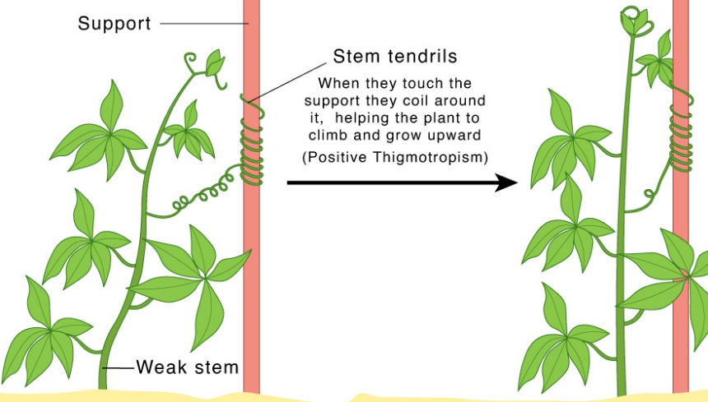
Extra Info: Plants also have nastic responses which are similar to kineses as they are non-directional responses to stimuli. The rate or frequency of these responses increases as intensity of the stimulus increases. They can be growth responses or changes in turgor pressure to swell or shrink tissues.
Examples include: flowers closing at night in response to temperature, the shutting of venus flytrap leaves in response to an insect landing on it, leaves bending toward the stem in plants that “sleep” at night.
Plant Growth Factors
Plants do not have a nervous system so their responses to stimuli are controlled by growth factors which are hormone-like chemicals that speed up or decrease plant growth. These growth factors are produced in meristems at the tips of roots and shoots where growth (cell division) is happening, but they travel to where they are needed in other parts of the plant between cells by diffusion or active transport or in the phloem over long distances.
There are different classes of growth factors including: auxins which promote cell elongation, gibberellins which promote seed germination and flowering, abscisic acid which inhibits seeds germination and causes closing of stomata and ethene which is a gas that promotes ripening of fruit.
Auxin Example: IAA – Indoleacetic acid
IAA is an auxin that is produced in shoots and roots of flowering plants but is transported to different parts of the plant to control tropisms. This means that distribution of IAA is uneven as different parts of the plant will be growing in different ways in response to directional stimuli.
Phototropism in Roots - IAA moves to the more shaded side of roots. Increased concentration of IAA on the shaded side inhibits growth so the unshaded side elongates more, so the root bends away from the light. | Phototropism in Shoots - IAA moves to the more shaded part of shoots. Increased concentration of IAA on the shaded side promotes growth, causing those cells to elongate so the shoot bends towards the light.
Gravitropism in Roots – same IAA moves to lower side of roots and growth is inhibited | Gravitropism in Shoots – same IAA moves to lower side of shoots and cells elongate
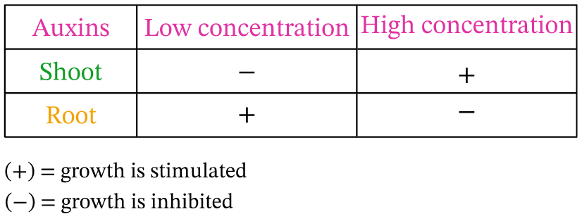
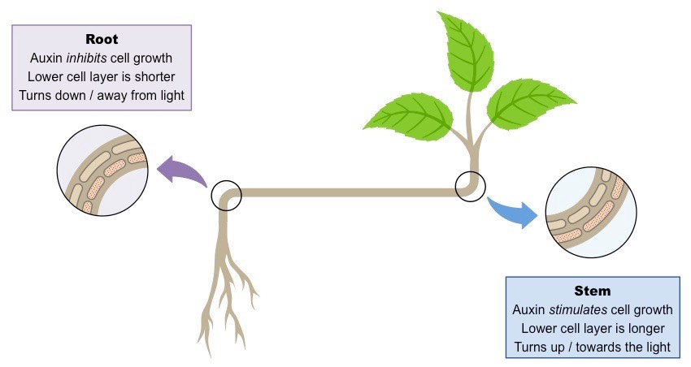

Recall Questions
- How do plants respond to their environment? Give examples
- What are tropisms?
- What controls plant responses?
- What is the importance of shoot and root tips in plant responses?
- What are auxins?
- What is an important auxin that is produced in the tip of shoots in flowering plants?
- How does indoleacetic acid move around the plant to control tropisms?
- What happens when different parts of the plants have different amounts of IAA?
- What is the difference in effect of IAA in shoots and roots?
- Describe how IAA is involved in phototropism

Exam Questions
Q1.
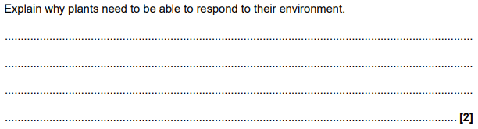
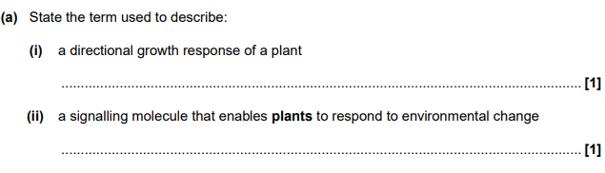
(iii)

Q2. IAA is a specific growth factor.
(a) Name the process by which IAA moves from the growing regions of a plant shoot to other tissues.
___________________________________________________________________
(1)
(b) When a young shoot is illuminated from one side, IAA stimulates growth on the shaded side. Explain why growth on the shaded side helps to maintain the leaves in a favourable environment.
___________________________________________________________________
___________________________________________________________________
___________________________________________________________________ (2)
Q3. (a) Give one similarity and one difference between a taxis and a tropism.
Similarity ___________________________________________________________
___________________________________________________________________
Difference __________________________________________________________
___________________________________________________________________ (2)
Scientists investigated tropisms in the roots of tomato plants. They grew tomato plants from seeds on vertical agar plates, as shown in Figure 1. The top of each plate was made of agar gel containing no salt. The bottom of each plate was made of one of the following:
• agar gel containing no salt
• agar gel containing salt.
Typical results for growth of the roots are shown in Figure 1.

Figure 1
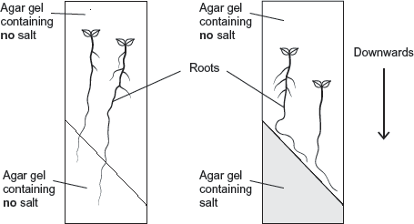
(b) What do these results show about the responses of the roots of tomato plants to gravity and salt?
___________________________________________________________________
___________________________________________________________________
___________________________________________________________________
___________________________________________________________________
___________________________________________________________________
___________________________________________________________________
(3)

(c) In root tips of tomatoes, IAA is transported out of the cells by a carrier protein. In roots of tomatoes, high concentrations of IAA inhibit cell elongation.
The scientists’ hypothesis was that salt causes a change in the number of IAA carrier proteins in cells in different parts of the root tip.
Figure 2 shows two cells, L and R, in the root tip of a tomato plant.
Figure 2
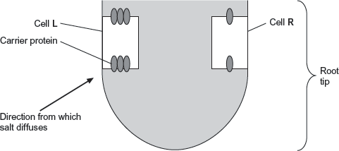

Explain why this root tip would grow away from salt.
___________________________________________________________________
___________________________________________________________________
___________________________________________________________________
___________________________________________________________________
___________________________________________________________________ (3)

Q4. Scientists investigated the response of lateral roots to gravity. Lateral roots grow from the side of main roots.
The diagrams show four stages, A to D, in the growth of a lateral root and typical cells from the tip of the lateral root in each stage. All of the cells are drawn with the bottom of the cell towards the bottom of the page.
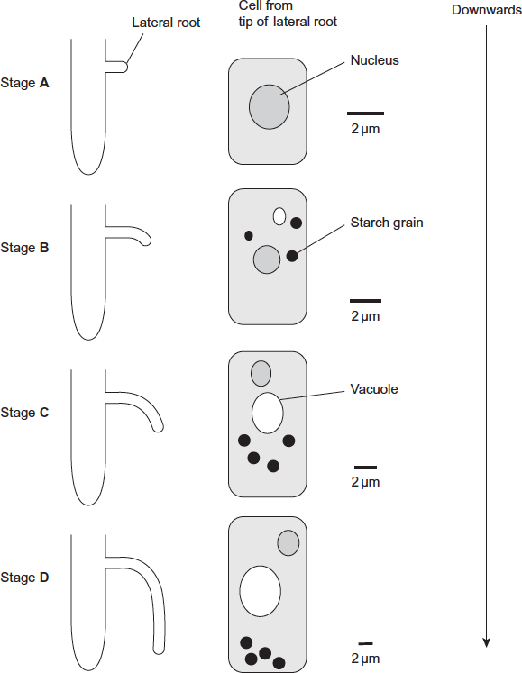

(a) Describe three changes in the root tip cells between stages A and D.
1. _________________________________________________________________
___________________________________________________________________
2. _________________________________________________________________
___________________________________________________________________
3. _________________________________________________________________
___________________________________________________________________ (3)

(b) The scientists’ hypothesis was that there was a relationship between the starch grains in the root tip cells and the bending and direction of growth of lateral roots.
Does the information in the diagram support this hypothesis? Give reasons for your answer.
___________________________________________________________________
___________________________________________________________________
___________________________________________________________________
___________________________________________________________________
___________________________________________________________________
___________________________________________________________________
(3)
(c) The diagram shows the distribution of indoleacetic acid (IAA) in the lateral root at Stage B.
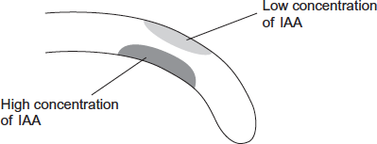
Explain how this distribution of IAA causes the root to bend.
___________________________________________________________________
___________________________________________________________________
___________________________________________________________________
___________________________________________________________________
___________________________________________________________________
(2)

Lesson 4: Investigating Plant Responses
Various experiments have been carried out over the years to demonstrate that the stimulus of light is detected by the shoot tip, which is where the growth factors are produced and that these are then transported down and across to the shaded side in order to make the shoots bend towards the light. This was discovered by doing the following treatments:
- Removing the tip of the shoot – therefore removing the source of IAA
- Covering the tip of the shoot – no light can be detected by receptors in the shoot tip so IAA is distributed evenly. Shoots will grow straight up and fast in darkness or when they can’t detect light in order to increase their chances of finding light.
- Cutting the tip but replacing it on top of a substance that allows diffusion. This demonstrates that the tip is required for IAA to be produced and the substance must be able to diffuse down in order to have uneven growth. When this is done with an insoluble barrier the shoot does not bend.
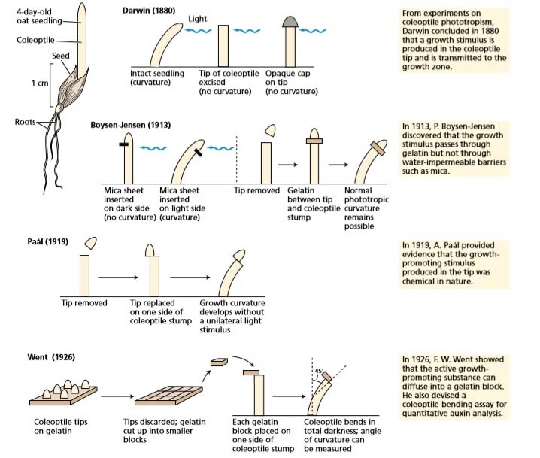
These experiments were then developed to look at how distribution of the IAA effects growth. Removing the tip and replacing it offset shows bending of shoot in the dark. In the light the IAA would move to the shaded side so we would expect it to bend towards the light, but there is no uneven distribution if there is no light.
Removing the tip allows IAA to diffuse into an agar block and this block can be replaced on its own to just be a source of IAA that can be controlled and to show that distribution of IAA is due to light sensing cells in the shoot tissue.
In any experiments in the dark the plants must be provided with some nutrients in order to ensure growth continues as photosynthesis cannot occur. In agar experiments glucose can be added to the block in order to provide an energy source to make sure this does not affect growth.
Controls should be used to make sure that it is only IAA causing observed effects. Making sure a negative control is used e.g tip removed and agar soaked in water added.
Other effects of plant growth factors
Auxins also prevents lateral buds growing below the tip, this is known as apical dominance. It ensures the plant focuses energy on growing upwards towards the light in order to make sure it outcompetes other plants. The further away from the meristem tip the inhibition of auxins decreases as the concentration lowers. If the tip is removed then more lateral buds will grow as the source of auxins has been removed so the concentration drops and inhibitor is removed.
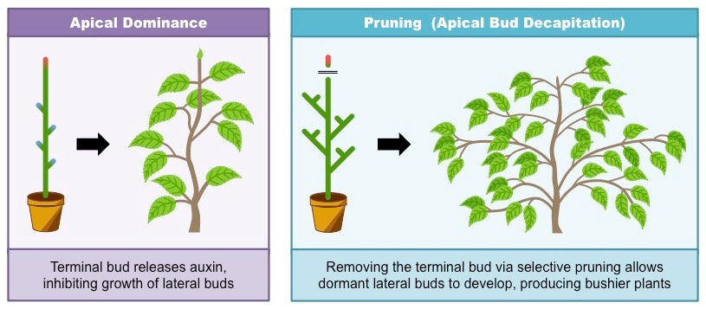
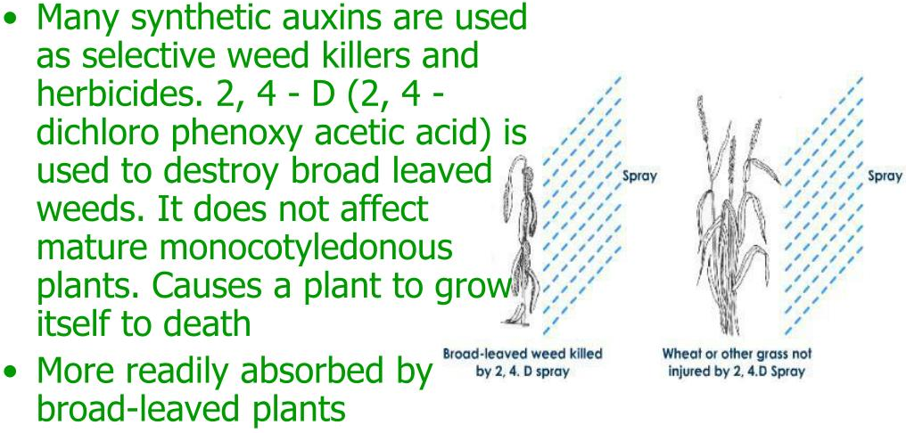
Synthetic auxins were discovered and have been used as herbicides (weed-killers) since the 1940’s. Auxins specifically target broadleaf plants, which make it effective for killing particular weeds with a low risk of killing non-target crops because most weeds have broader leaves than grass or wheat, the weedkiller is absorbed in larger quantities by the weeds. These are therefore often known as selective weedkillers.
The selective weedkiller contains a synthetic auxin that causes the weeds to grow too quickly and die. The killing action of synthetic auxins is not caused by any single factor but rather by the disruption of several growth processes e.g cell wall elasticity, nucleic acid metabolism, protein synthesis, cell division and growth.

Practice Questions
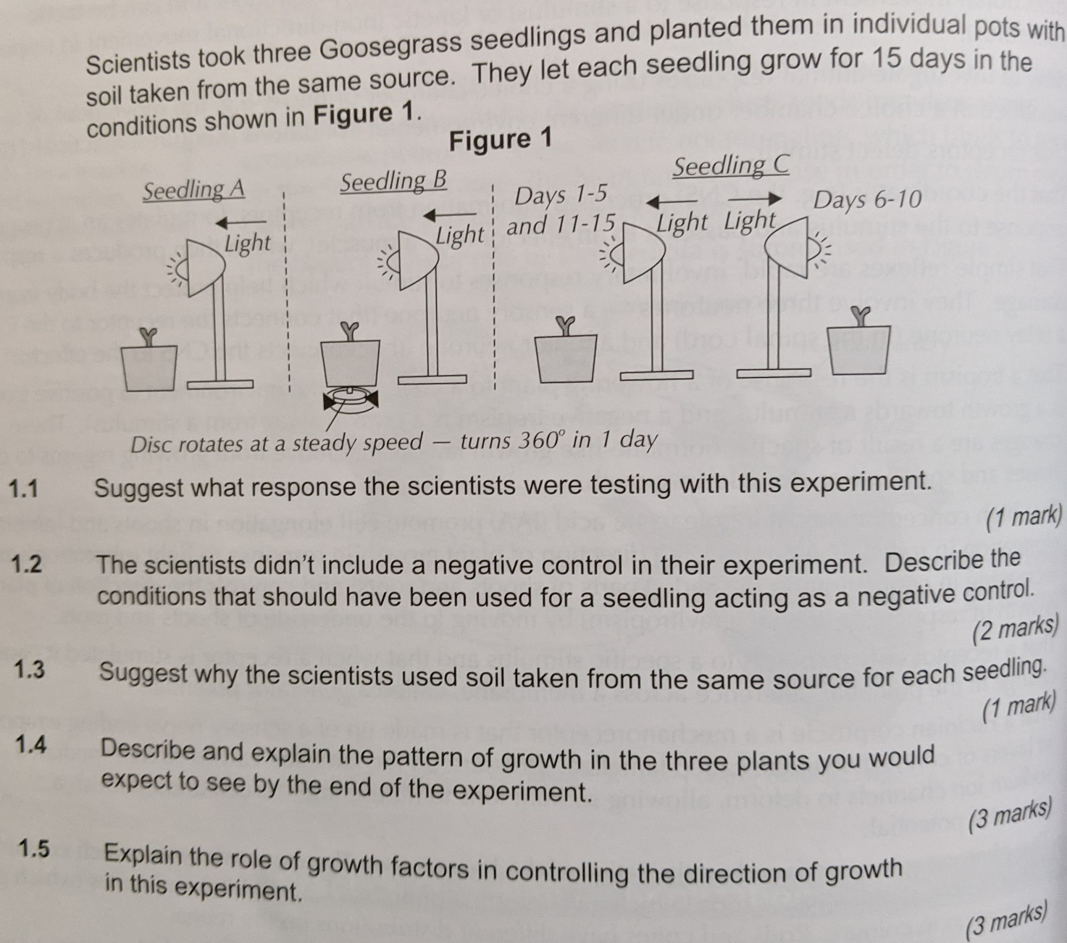

Exam Questions
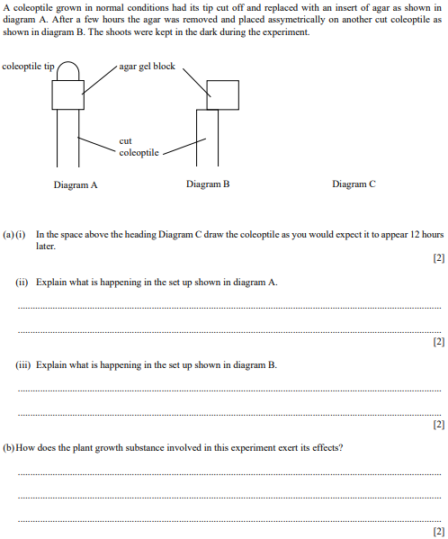
Q1.

Q2.
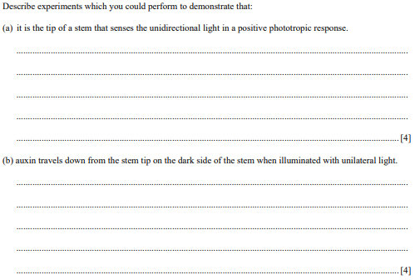
Q3. A student investigated the effects of indoleacetic acid (IAA) on the growth of oat seedlings (young plants).
The student:
• removed the shoot tip from each seedling and cut out a 10 mm length of shoot
• placed 10 lengths of shoot into each of 5 Petri dishes
• added to each Petri dish an identical volume of 5% glucose solution
• added to each Petri dish 40 cm³ of a different concentration of IAA solution
• left the Petri dishes at 20 °C in the dark with their lids on for 5 days
• removed the shoots after 5 days and measured them
• determined the mean change in length of shoot at each concentration of IAA.
Table 1 shows her results.
Table 1

IAA concentration added to Petri dish / parts per million | 10⁻⁵ | 10⁻³ | 10⁻¹ | 1 | 10
Mean change in length of shoot / mm | 0.0 | 0.1 | 1.3 | 2.4 | 3.1

(a) Explain why the student removed the shoot tip from each seedling.
___________________________________________________________________
___________________________________________________________________
___________________________________________________________________
___________________________________________________________________
___________________________________________________________________
___________________________________________________________________
___________________________________________________________________
___________________________________________________________________
___________________________________________________________________
___________________________________________________________________
___________________________________________________________________
___________________________________________________________________
(2)
(b) Explain why the student added glucose solution to each Petri dish.
___________________________________________________________________
___________________________________________________________________
___________________________________________________________________
___________________________________________________________________
___________________________________________________________________
___________________________________________________________________
(2)
(c) Explain why the lids were kept on the Petri dishes.
___________________________________________________________________
___________________________________________________________________
___________________________________________________________________
___________________________________________________________________
___________________________________________________________________
___________________________________________________________________
(2)

(d) Describe and explain the results shown in Table 1 above and suggest how the results might have differed if lengths of root had been used.
___________________________________________________________________
___________________________________________________________________
___________________________________________________________________
___________________________________________________________________
___________________________________________________________________
___________________________________________________________________
___________________________________________________________________
___________________________________________________________________
___________________________________________________________________
(3)
Q4. Scientists investigated the response of the roots of pea seedlings to gravity.
They took three samples of seedlings, A, B, and C, and placed them so that their roots were growing horizontally. The root tips of each sample had been given different treatments. After a set time, the scientists recorded whether the roots of the seedlings had grown upwards or downwards and the amount of curvature. The table shows the treatment they gave to each sample and their results.

Treatment | Results
Treatment | Direction of growth | Mean amount of curvature  / degrees
A None   | Downwards | 60
B Root tip removed   | Continues to grow  horizontally | 0
C Upper half of root tip removed  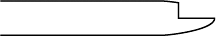 | Downwards | 30

(a) The pea seedlings were kept in the dark after each treatment. Explain why this was necessary.
___________________________________________________________________
___________________________________________________________________
___________________________________________________________________
(1)
(b) What conclusion can be made from the results for treatment B?
___________________________________________________________________
___________________________________________________________________
___________________________________________________________________
(1)
(c) Suggest how indoleacetic acid (IAA) could have caused the results for
(i) treatment A
______________________________________________________________
______________________________________________________________
______________________________________________________________
______________________________________________________________
______________________________________________________________
(2)
(ii) treatment C.
______________________________________________________________
______________________________________________________________
______________________________________________________________
______________________________________________________________
______________________________________________________________
(2)

Q5.
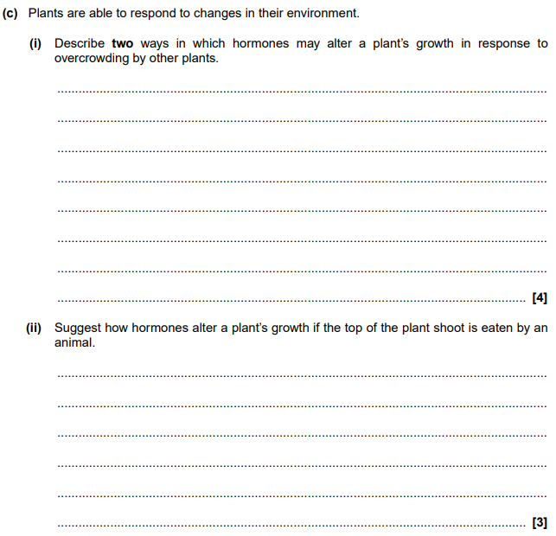

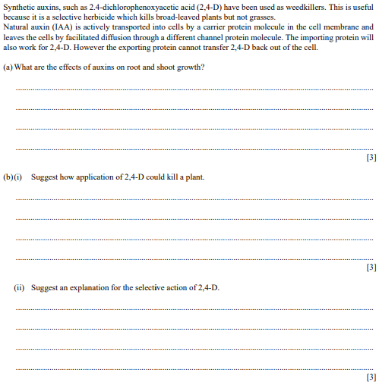
Q6.

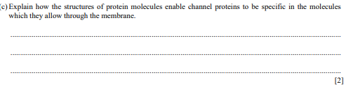
Homework
Task 1: Complete the sentences using the words in bold:
auxins darker decreases diffuses elongate gravitropism hormones increases inhibits location organs phototropism synthesised tropism
A __________ is a growth movement of part of a plant in response to a directional stimulus. There are many examples, including positive _______________ where shoots and leaves respond by growing towards the light, and positive _______________ where roots respond by growing against gravity down into the soil.
Plants are able to respond to external stimuli by means of plant growth factors, which are plant ______________. Plant growth factors:
• Exert their influence by affecting speed or _____________ of growth.
• Are not produced by a particular __________, but are instead produced by all cells.
• Affect the tissues that actually produce them, rather than other t_______ in a different area of the plant.
The plant growth factor IAA is one of a family of hormones (called __________) and causes plant cells to elongate. These discoveries are summarised in the Cholodny-Went theory, which states that:
- Auxin is ________________ in the shoot tip.
- Asymmetric illumination is detected by the shoot tip, causing auxin to move into the _____________ side.
- Auxin _____________ down the stem according to the distribution in the shoot tip.
- The auxin causes cells to _____________ on the darker side and the stem to bend toward the light.
IAA can also effect the bending of roots towards gravity. However in this case it ___________ growth rather than speeding it up. Thus IAA _____________ root growth and _____________ shoot growth.

Task 2: Answer the questions

- Draw a series of four labelled diagrams with annotations to show the process of phototropism. [8]

1. | 2.
3. | 4.

- Explain the results of the experiments below. [6]
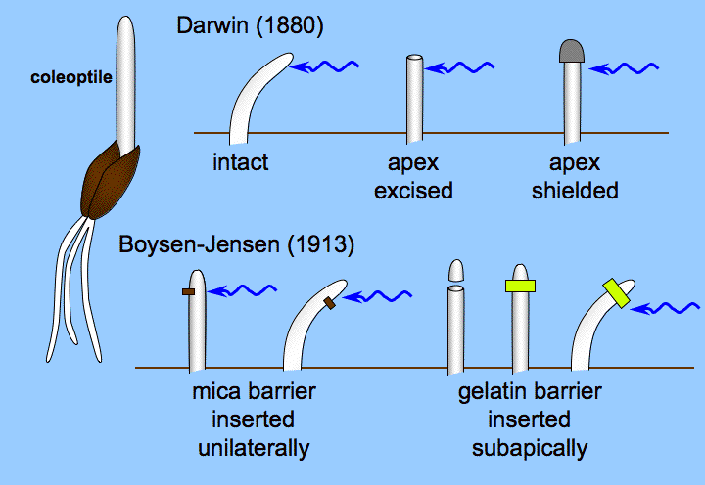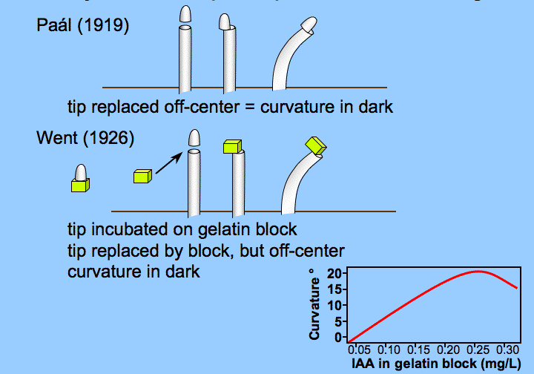
Darwin - Intact coleoptile: …………………………………………………………………………………………………..……………………….. ………………………………………………………………………………………………………………………………………………………………………………………………………………………………………………………………………………………………………………………………………………
Darwin - Apex excised from coleoptile: …………………………………………………………….………………………………………….. ………………………………………………………………………………………………………………………………………………………………………………………………………………………………………………………………………………………………………………………………………………
Darwin - Apex shielded on coleoptile: …………………………………………………………………………………………………………… ………………………………………………………………………………………………….……………………………………………………………………………………………………………………………………………………………………………………………………………………………………………
Boysen-Jensen - Mica barrier on shaded side: …………………………………….…………………………………………….………….. ………………………………………………………………………………………………………………………………………………………………………………………………………………………………………………………………………………………………………………………………………………
Boysen-Jensen - Mica barrier on lit side: …………………………………………………….……………………………………….……….. ………………………………………………………………………………………………………………………………………………………………………………………………………………………………………………………………………………………………………………………………………………
Paal/Went - Tip or auxin-soaked agar block replaced off centre (in the dark): …………………………………….……….. ……………………………………………………………………………………………………………………………………………………………………………………………………………………………………………………………………………………………………………………………………………

