  Induction Test
  Biological Molecules
  Name: | ________________________
  Date: | ________________________

Time: | 50 minutes
Marks: | 44 marks
Question | My Mark | Total Mark | Feedback
1 – Lipids |  | 5
2 – proteins |  | 5
3 - proteins |  | 5
4 - Factors affecting enzymes |  | 5
5- Enzyme structure and inhibition |  | 4
6 – Polymers and Food Tests |  | 5
7 - Carbohydrates |  | 6
8 -Factors affecting enzymes and |  | 9
Total | 44

Q1. (a) Describe how you would test a piece of food for the presence of lipid.
___________________________________________________________________
___________________________________________________________________
___________________________________________________________________
(2)
The figure below shows a phospholipid.
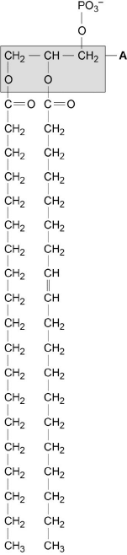
X Y
(b) The part of the phospholipid labelled A is formed from a particular molecule. Name this molecule.
___________________________________________________________________
(1)
(c) Name the type of bond between A and fatty acid X.
___________________________________________________________________
(1)
(d) Which of the fatty acids, X or Y, in the figure above is unsaturated? Explain your answer.
___________________________________________________________________
___________________________________________________________________
___________________________________________________________________
___________________________________________________________________
(1)
Q2. Describe the structure of proteins.
___________________________________________________________________
___________________________________________________________________
___________________________________________________________________
___________________________________________________________________
___________________________________________________________________
___________________________________________________________________
___________________________________________________________________
___________________________________________________________________
___________________________________________________________________
___________________________________________________________________
(5)

Q3. The diagram shows the structure of two amino acid molecules, tyrosine and phenylalanine.
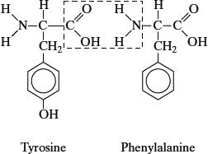
(b) Copy from the diagram the R group in the phenylalanine molecule.

(1)
(c) (i) In the space below, draw the chemical bond formed when these two amino acids are joined by condensation. You need only draw the parts of the molecules shown in the box.

(2)
(ii) Name this bond.
______________________________________________________________
(1)
(d) Tyrosine can be made in the body by hydroxylating phenylalanine. Use the diagram to explain the meaning of hydroxylating.
___________________________________________________________________
___________________________________________________________________
(1)

Q4.
A student carried out an investigation into the mass of product formed in an enzyme-controlled reaction at three different temperatures. Only the temperature was different for each experiment. The results are shown in the graph.
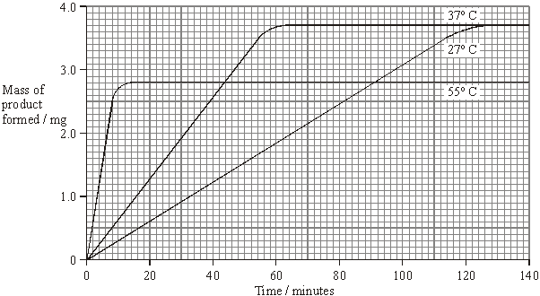
(a) Use your knowledge of enzymes to explain
(i) why the initial rate of reaction was highest at 55 °C;
______________________________________________________________
______________________________________________________________
______________________________________________________________
______________________________________________________________
(2)
(ii) the shape of the curve for 55 °C after 20 minutes.
______________________________________________________________
______________________________________________________________
______________________________________________________________
______________________________________________________________
______________________________________________________________
______________________________________________________________
(3)

Q5. The diagram represents an enzyme molecule and three other molecules that could combine with it.
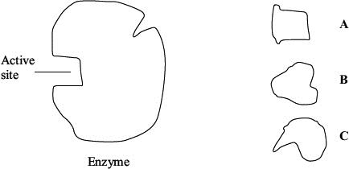
(a) Which molecule is the substrate for the enzyme? Give a reason for your answer.
___________________________________________________________________
___________________________________________________________________
___________________________________________________________________
(1)
(b) Use the diagram to explain how a non-competitive inhibitor would decrease the rate of the reaction catalysed by this enzyme.
___________________________________________________________________
___________________________________________________________________
___________________________________________________________________
___________________________________________________________________
___________________________________________________________________
___________________________________________________________________
(3)
Q6. (a) Starch and protein are biologically important polymers.
(i) Explain what is meant by a polymer.
______________________________________________________________
______________________________________________________________
(1)
(ii) Give one example of a biologically important polymer other than starch or protein.
______________________________________________________________
(1)
(b) In an investigation, the enzyme amylase was mixed in a test tube with a buffer solution and a suspension of starch. The amylase broke down the starch to maltose. When all the starch had been broken down, a sample was removed from the test tube and tested with biuret reagent.
(i) What colour would you expect the sample to go when tested with biuret reagent?
______________________________________________________________
(1)
(ii) Give an explanation for your answer to part (ii)
______________________________________________________________
______________________________________________________________
______________________________________________________________
(2)
Q7. Describe the structure of a cellulose molecule and explain how cellulose is adapted for its function in cells.
___________________________________________________________________
___________________________________________________________________
___________________________________________________________________
___________________________________________________________________
___________________________________________________________________
___________________________________________________________________
___________________________________________________________________
___________________________________________________________________
___________________________________________________________________
___________________________________________________________________
___________________________________________________________________
___________________________________________________________________
___________________________________________________________________
___________________________________________________________________
(6)

Q8. The graph shows the effect of substrate concentration on the rate of an enzyme-controlled reaction.
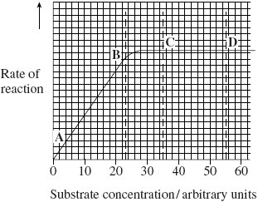
(a) (i) Describe what the graph shows about the effect of substrate concentration on the rate of this enzyme-controlled reaction.
______________________________________________________________
______________________________________________________________
______________________________________________________________
______________________________________________________________
(2)
(ii) What limits the rate of this reaction between points A and B? Give the evidence from the graph for this.
______________________________________________________________
______________________________________________________________
______________________________________________________________
______________________________________________________________
(2)
(iii) Suggest a reason for the shape of the curve between points C and D.
______________________________________________________________
______________________________________________________________
(1)
(b) Sketch a curve on the graph to show the rate of this reaction in the presence of a competitive inhibitor.
(1)

(c) Methotrexate is a drug used in the treatment of cancer. It is a competitive inhibitor and affects the enzyme folate reductase.
(i) Explain how the drug lowers the rate of reaction controlled by folate reductase.
______________________________________________________________
______________________________________________________________
______________________________________________________________
______________________________________________________________
______________________________________________________________
(2)
(ii) Methotrexate only affects the rate of the reaction controlled by folate reductase.
Explain why this drug does not affect other enzymes.
______________________________________________________________
______________________________________________________________
(1)

End of Test

