Cell Transport End of Topic Test
Name _____________________________________________ Score _____/48 Percentage _____

1. Which of these procedures would produce a sodium chloride solution of 0.2% from a stock solution of 20% sodium chloride?
A dilute 10cm³ with 100cm³ water then dilute 10cm³ of resulting solution with 100cm³ water
B dilute 1cm³ with 10cm³ water then dilute 1cm³ of resulting solution with 10cm³ water
C dilute 10cm³ with 90cm³ water then dilute 10cm³ of resulting solution with 90cm³ water
D dilute 1cm³ in 90cm³ water then dilute 1cm³ of resulting solution in 90cm³ water

2. The diagram below represents the structure of a plasma (cell surface) membrane.
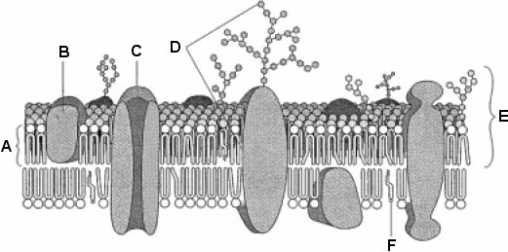
(a) Name molecules A, B and F.
A ............................................................................................................
B ............................................................................................................
F .............................................................................................................
[3]
(b) (i) Describe the structure of molecule A.
................................................................................................................
................................................................................................................
................................................................................................................
[2]
(ii) State one function of molecule C.
................................................................................................................
................................................................................................................ [1]
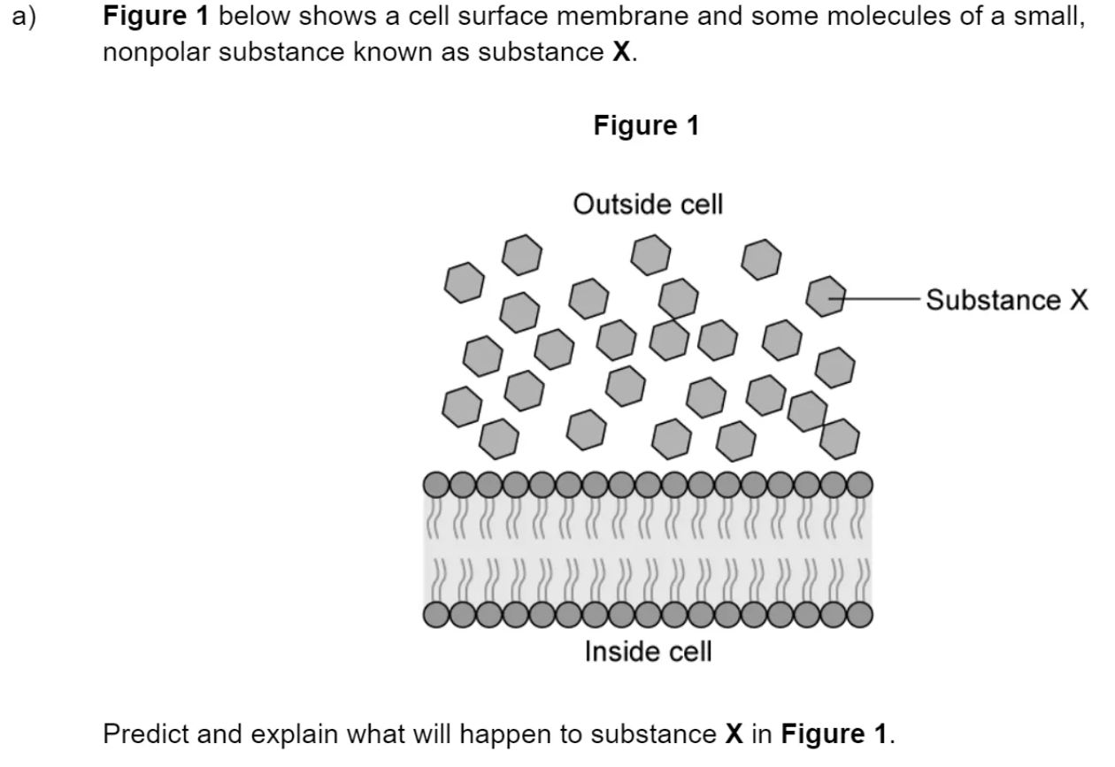3.

................................................................................................................
................................................................................................................
................................................................................................................ (3)

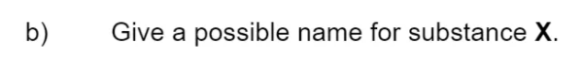
................................................................................................................
................................................................................................................ [1]
................................................................................................................
................................................................................................................
................................................................................................................ [2]
................................................................................................................
................................................................................................................
................................................................................................................ [2]

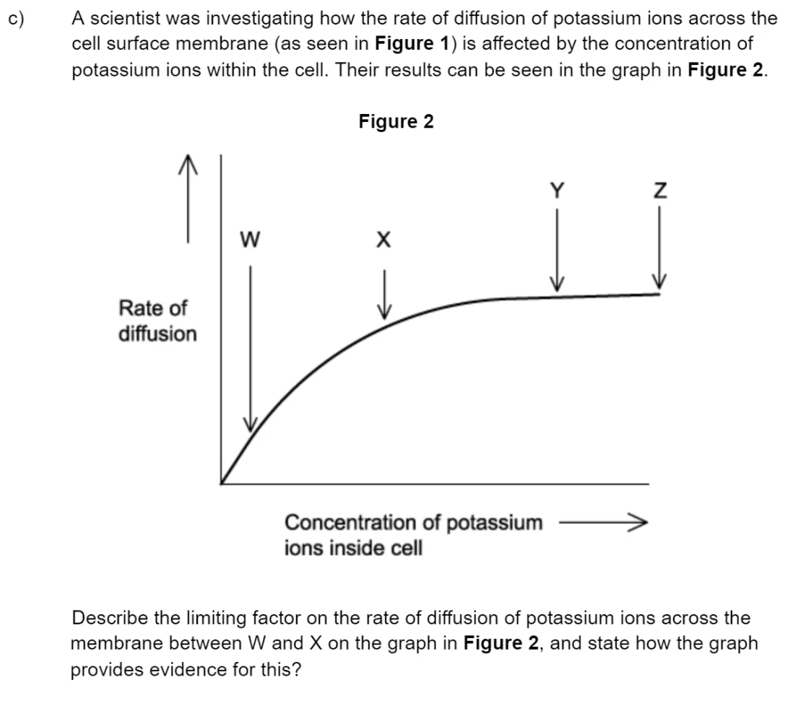4.(a)

................................................................................................................................
..................................................................................................................................
..................................................................................................................................
..................................................................................................................................
..................................................................................................................................
.................................................................................................................................. (3)

(b) Explain why the graph in Figure 2 plateaus between points Y and Z.

................................................................................................................
................................................................................................................
................................................................................................................ [2]

5. Endocytosis is one method by which substances enter cells.
Describe the process of endocytosis.
..................................................................................................................................
..................................................................................................................................
..................................................................................................................................
..................................................................................................................................
..................................................................................................................................
..................................................................................................................................
..................................................................................................................................
[Total 3 marks]
6. (a) Fig. 1 represents the appearance of a plant cell in salt solutions of three different concentrations.
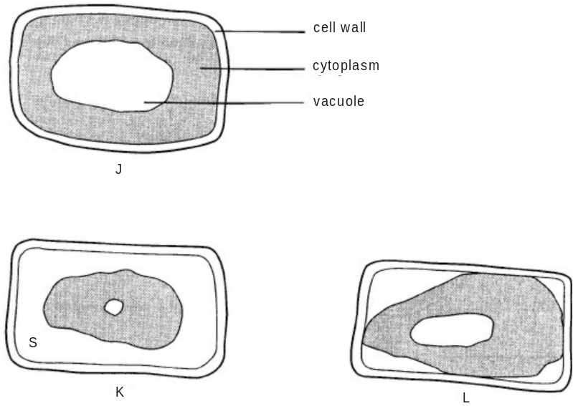
(i) State which of the diagrams, J to L, represents a fully plasmolysed cell.
................................................................................................................
[1]
(ii) Suggest why the vacuole in K is smaller than that in L.
................................................................................................................
................................................................................................................ [1]
(iii) Region S contains salt solution. State what this indicates about the permeability of the cell wall.
................................................................................................................
................................................................................................................
[1]

(b)
(i) The list below shows three different values for water potential (ψ) in plant cells. Circle the water potential (ψ) which has the lowest value.
ψ = 0 ψ = –1300 kPa ψ = –1150 kPa
[1]
(ii) Fig. 2 is a diagram that shows four neighbouring spongy mesophyll cells from the leaf of a dicotyledonous plant. The water potential of the cytoplasm of the cells is shown in each case.
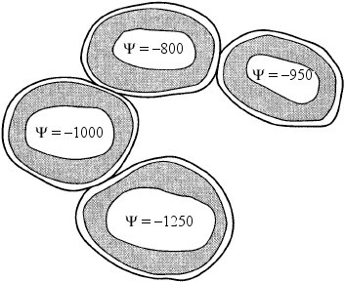
Fig. 2
Draw arrows on Fig. 2 to show the net flow of water between the cells.
[3]
7. The water potential of a plant cell is -400 kPa. The cell is put in a solution with a water potential of -650 kPa. Describe and explain what will happen to the cell.
................................................................................................................................
..................................................................................................................................
..................................................................................................................................
..................................................................................................................................
..................................................................................................................................
.................................................................................................................................. (3)

8. An experiment was carried out in which an artificial membrane was used to form the boundary of a model of a cell. A solution of different sugars was placed inside this ‘cell’, which was then placed in a beaker containing a solution of sucrose and glucose.
The artificial membrane is:
• permeable to monosaccharides (e.g. glucose and fructose) and water;
• not permeable to disaccharides (e.g. maltose and sucrose);
• flexible.
The diagram below shows the ‘cell’, together with the concentrations of the sugars inside the ‘cell’ and in the surrounding solution. The figures represent the concentration in mol dm-3.
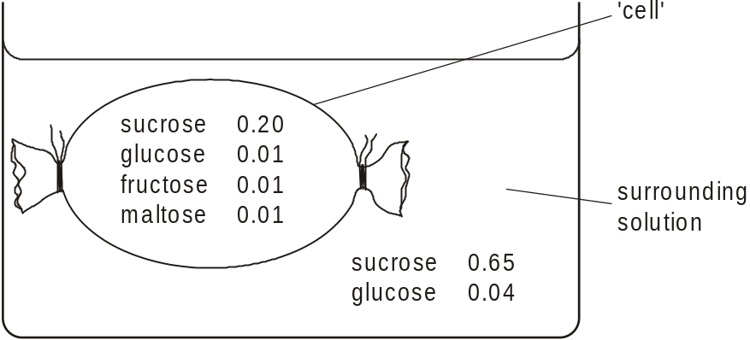

(a) (i) State which sugar or sugars will show a net movement out of the ‘cell’.
................................................................................................................
[1]
(ii) State which sugar or sugars will show a net movement into the ‘cell’.
................................................................................................................
[1]
(iii) Name the method by which these sugars cross the membrane.
................................................................................................................
[1]
(iv) Explain why the volume of the ‘cell’ would change during the experiment.
................................................................................................................
................................................................................................................
................................................................................................................
................................................................................................................
................................................................................................................
................................................................................................................
................................................................................................................
................................................................................................................ [4]
(b) The artificial membrane used in this experiment does not resemble a plasma
(cell surface) membrane in all respects.
State one method by which substances would be unable to cross the artificial membrane.
................................................................................................................
[1]
9. A group of students investigated the effect of sucrose concentration on the change in length of cylinders of tissue cut from a young carrot. They measured the initial lengths of the carrot cylinders, then placed one in each of a number of sucrose solutions. After 18 hours, they removed the carrot cylinders and measured their final lengths.

Explain how you would use a graph to predict the concentration of sucrose that would result in no change in length of the carrot cylinders
................................................................................................................
................................................................................................................
................................................................................................................ [2]

10. An experiment was carried out to investigate the uptake of potassium ions by carrot tissue. The experiment was carried out as follows:
• a carrot was cut into discs of uniform size
• the discs were divided into four groups
• equal volumes of a solution containing potassium ions were added.
The temperature remained constant at 21 °C and the experiment was carried out for the same length of time in each case. The experiment was carried out in different oxygen concentrations. The results are shown in the table below.
Oxygen concentration /  arbitrary units | 0 | 4 | 11 | 20
rate of uptake of potassium ions/  arbitrary units | 7 | 27 | 92 | 100

(i) Using the information given in the table, state the main process by which potassium ions enter the carrot cells.
…......................................................................................................................
[1]
(ii) Give a reason for your answer to (i).
…......................................................................................................................
…......................................................................................................................
…......................................................................................................................
[1]

11. The diagram shows the co-transport mechanism for the absorption of amino acids into the blood by a cell lining the ileum.
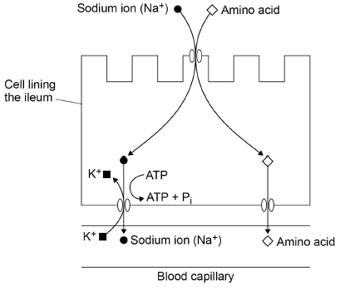
The addition of a respiratory inhibitor stops the absorption of amino acids.
Use the diagram to explain why.
___________________________________________________________________
___________________________________________________________________
___________________________________________________________________
___________________________________________________________________
___________________________________________________________________
___________________________________________________________________
___________________________________________________________________
___________________________________________________________________
___________________________________________________________________ (3)

Questions + Topic | My Marks | Total Marks | What to improve/revise
1 - Dilutions |  | 1
2 - Membranes |  | 6
3-4 Diffusion |  | 13
5 – Bulk Transport |  | 3
6-9 Osmosis |  | 18
10-11 Active Transport |  | 7

