AQA A Level Biology Biodiversity Assessment
Name: ___________________

Question | Mark | Total Mark | Feedback
1 – Simpsons Index Calculation |  | 7
2 – Human Impact on Biodiversity |  | 8
3 – Transect/Practical Techniques/Standard Deviation |  | 7
4 – Genetic Diversity/Phylogenetics/Taxonomy/Standard Deviation |  | 9
5 – Statistical Tests |  | 1
Total |  | 32

Q1. (a) A student investigated the diversity of plants at several sites on a golf course. At each site she took a large number of random samples.
(i) Explain the importance of taking a large number of samples at each site.
______________________________________________________________
______________________________________________________________
_____________________________________________________________ (1)
(ii) Explain the importance of taking samples at random.
______________________________________________________________
______________________________________________________________
______________________________________________________________ (1)
The student collected data from one part of the golf course and calculated an index of diversity.

Species | Number of plants per m²
Sheep’s fescue | 11
Creeping buttercup | 6
Clover | 5
Dandelion | 2
Sheep’s sorrel | 1
Lady’s bedstraw | 7
Stemless thistle | 4
The index of diversity can be calculated from the formula
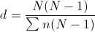
where
d = index of diversity
N = total number of organisms of all species
n = total number of organisms of each species
(b) Use the formula to calculate the index of diversity for the plants on this part of the golf course. Show your working.

Answer ____________________
(2)
(c) The golf course was surrounded by undeveloped grassland from which it had been produced.
The golf course had
• some areas of very short grass which was cut frequently
• some areas of longer grass which was cut less frequently
• some areas of long grass and shrubs which were never cut.
The index of diversity for the insects on the golf course was higher than that for the surrounding undeveloped grassland.
Explain the effect of developing this golf course on the index of diversity of insects.
___________________________________________________________________
___________________________________________________________________
___________________________________________________________________
___________________________________________________________________
___________________________________________________________________
___________________________________________________________________
(3)
Q2. (a) What two measurements are needed to calculate an index of diversity?
1. _________________________________________________________________
2. _________________________________________________________________ (2)
(b) A herbicide is a chemical used to kill weeds. Ecologists investigated the effect of a herbicide on crop yield and the diversity of insects. They sprayed different fields with the same volume of different concentrations of the herbicide. At harvest, the ecologists determined the mean crop yield and the mean index of diversity of insects for fields that had received the same concentration of the herbicide.
The figure below shows their results.
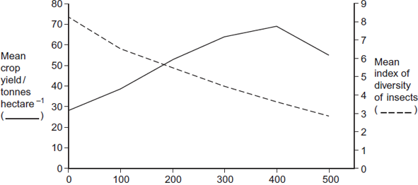
Concentration of herbicide sprayed on field / mg dm⁻³
(i) Some fields acted as controls. They were sprayed with a solution that did not contain the herbicide. Explain the purpose of these control fields.
______________________________________________________________
______________________________________________________________
______________________________________________________________
(1)
(ii) Suggest an explanation for the relationship between the concentration of herbicide and the mean crop yield.
______________________________________________________________
______________________________________________________________
______________________________________________________________
______________________________________________________________
(2)
(iii) Explain the relationship between the concentration of herbicide and the mean index of diversity of insects.
______________________________________________________________
______________________________________________________________
______________________________________________________________
______________________________________________________________
______________________________________________________________
______________________________________________________________
(3)

Q3. Climatic factors, such as temperature and rainfall, vary greatly over short distances across mountain ranges. In an investigation, populations of the plant, Achillea lanulosa, were sampled from several sites on a transect across a mountain range. At each sampling site, seeds were collected at random. Each batch of seeds was germinated and grown to maturity under the same experimental conditions.
The diagram shows
• a profile indicating the position and altitude of the sampling sites
• the mean height of mature plants grown from each sample of seeds
• the standard deviation of heights of the mature plants grown from each sample of seeds.
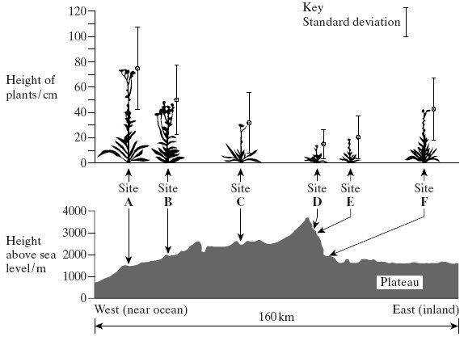
(a) (i) Give one limitation of using a line transect to collect these data.
______________________________________________________________
______________________________________________________________ (1)
(ii) Suggest how plants should be chosen at each sampling site to avoid bias and to be representative.
______________________________________________________________
______________________________________________________________
______________________________________________________________
______________________________________________________________ (2)
(b) (i) What information does the bar representing standard deviation give about the plants in a sample?
______________________________________________________________
______________________________________________________________ (1)
(ii) Describe what the results show about the variation of the height of the plants in relation to altitude.
______________________________________________________________
______________________________________________________________
______________________________________________________________
______________________________________________________________
(2)
(iii) There was a significant difference between the mean heights of the plants grown from seeds taken from sites A and D. Describe the evidence from the information given which shows that this is likely to be due to genetic differences between the two populations.
______________________________________________________________
______________________________________________________________
(1)
Q4. (a) There are many different species of field mouse in Europe. Using a phylogenetic classification, all of these species have names that start with Apodemus.
What information does this give about field mice?
___________________________________________________________________
___________________________________________________________________
___________________________________________________________________
___________________________________________________________________
(2)
The long-tailed field mouse, Apodemus sylvaticus, is a small mammal common in mainland Britain.
(b) Complete Table 1 to show the classification of the long-tailed field mouse.

Table 1
Taxon | Name of Taxon
 | Eukarya
Kingdom | Animalia
 | Chordata
 | Mammalia
Order | Rodentia
Family | Muridae
(2)
The St. Kilda field mouse lives only on one island off the coast of Scotland. It is very similar in appearance to the long-tailed field mouse but is larger and has lighter coloured fur.
Biologists wanted to find out if the St. Kilda field mouse and the long-tailed field mouse populations belonged to different species. They measured the length of the same features of a large number of individuals from the two populations.
The results are shown in Table 2.

Table 2
Population | Mean length (±SD) / mm
Population | Head and body | Tail
St. Kilda field mouse | 112.3 (±9.3) | 105.5 (±8.4)
Long-tailed field mouse | 95.2 (±8.2) | 90.2 (±7.3)
(c) Do the data in Table 2 provide evidence that the two populations belong to different species? Use calculations of head and body:tail ratios to support your answer.
___________________________________________________________________
___________________________________________________________________
___________________________________________________________________
___________________________________________________________________
___________________________________________________________________
___________________________________________________________________
___________________________________________________________________
___________________________________________________________________
(3)
(d) Describe how breeding experiments could determine whether the two populations are from the same species.
___________________________________________________________________
___________________________________________________________________
___________________________________________________________________
___________________________________________________________________
(2)

Q5. Human papilloma virus (HPV) is the main cause of cervical cancer. A vaccine has been developed to protect girls and women from HPV.
(b) Doctors investigated whether it was better to give two or three doses of the HPV vaccine. They determined the mean concentration of antibody against HPV in blood samples from girls who were given either two or three doses of the vaccine.
• Girls given two doses received an initial vaccination, followed by a second at 6 months.
• Girls given three doses received an initial vaccination, followed by a second at 1 month and a third at 6 months.
The doctors measured the concentration of antibody each month.
The results are shown below.
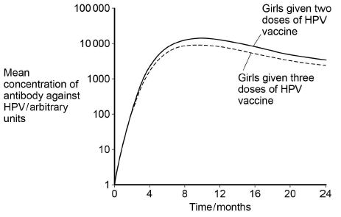
(c) The doctors carried out a statistical test to determine whether the antibody concentrations were significantly different in girls given two doses of the vaccine, compared with those given three doses. They determined the mean concentrations of antibody 9 months after the first dose of vaccine.
What statistical test should the doctors have used? Give the reason for your choice.
Test _______________________________________________________________
Reason ____________________________________________________________
___________________________________________________________________
(1)

