Gas Exchange End of topic Test
Question | My Marks | Total Marks | Feedback
1 - Digestion |  | 10
2 – Insect Gas Exchange |  | 5
3 + 4 – Fish Gas Exchange |  | 5
5+ 6 – Human Gas Exchange |  | 13
Total |  | 33
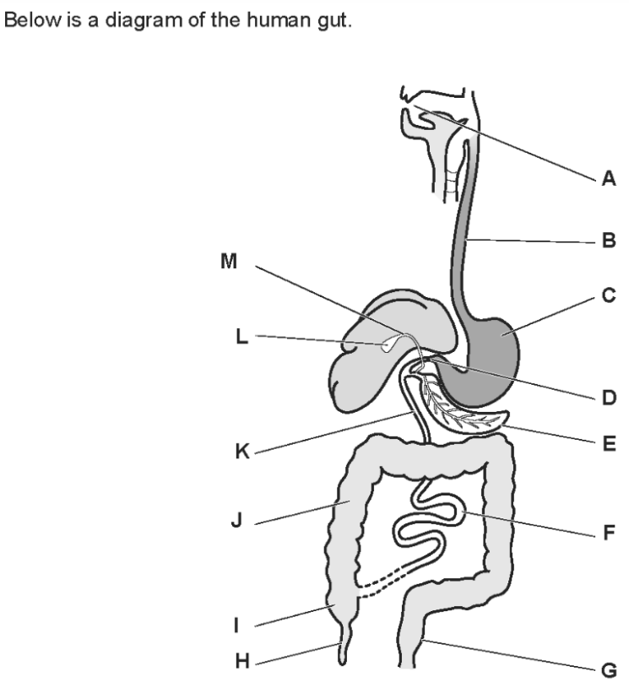
Q1.

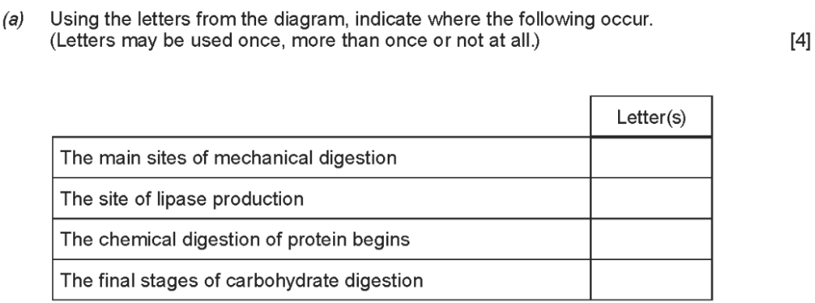

(b) Label the structures in the small intestine (4)
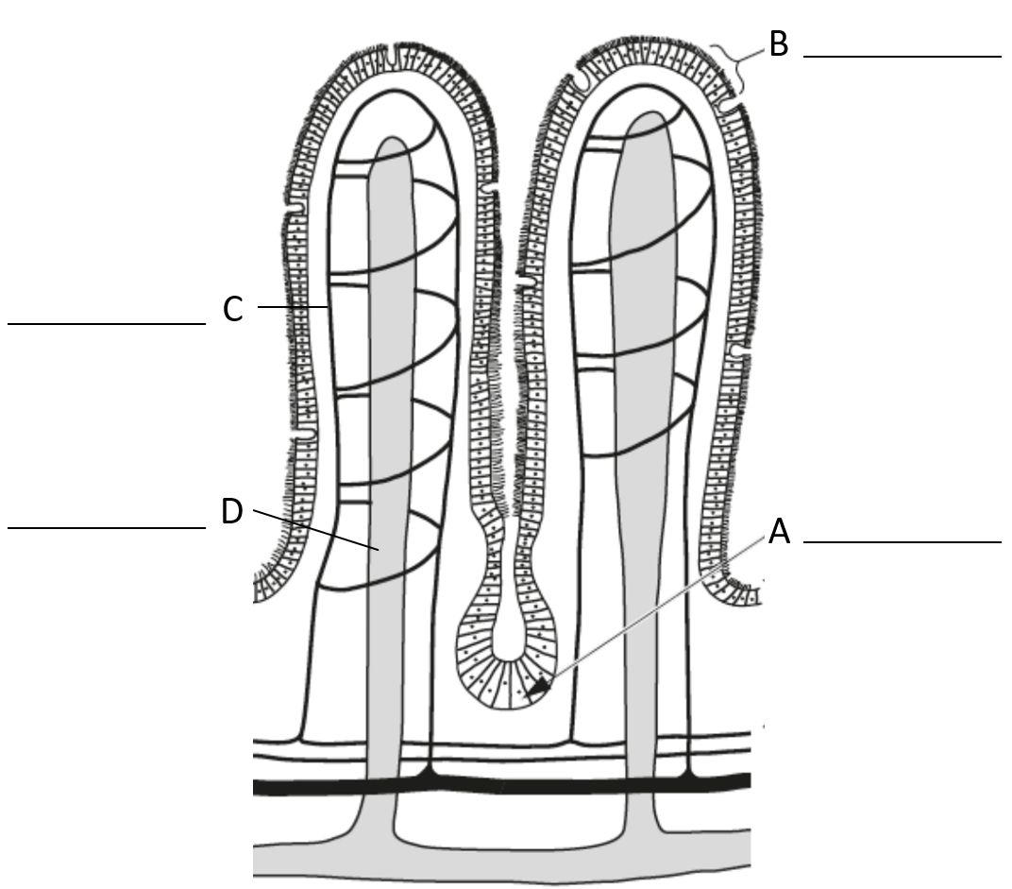
(c) 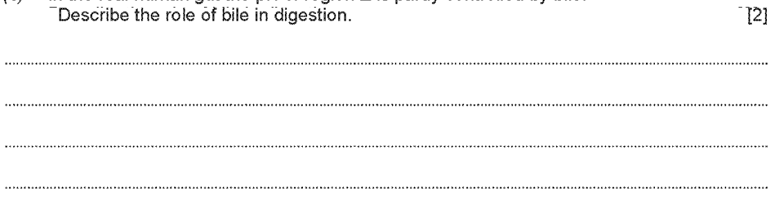
Q2. Large insects contract muscles associated with the abdomen to force air in and out of the spiracles. This is known as ‘abdominal pumping’. The table shows the mean rate of abdominal pumping of an insect before and during flight.

Stage of flight | Mean rate of abdominal pumping/dm³ of air kg⁻¹ hour⁻¹
Before | 42
During | 186
(a) Abdominal pumping increases the efficiency of gas exchange between the tracheoles and muscle tissue of the insect. Explain why.
___________________________________________________________________
___________________________________________________________________
___________________________________________________________________
___________________________________________________________________
___________________________________________________________________(2)
(b) Abdominal pumping is an adaptation not found in many small insects. These small insects obtain sufficient oxygen by diffusion.
Explain how their small size enables gas exchange to be efficient without the need for abdominal pumping.
___________________________________________________________________
___________________________________________________________________
___________________________________________________________________
(1)
The graph shows the concentration of oxygen inside the tracheoles of an insect when at rest. It also shows when the spiracles are fully open.
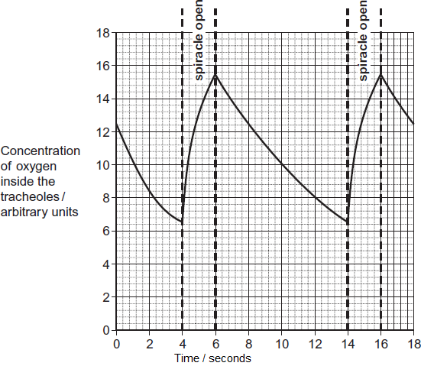
(c) The insect opens its spiracles at a lower frequency in very dry conditions. Suggest one advantage of this.
___________________________________________________________________
___________________________________________________________________
___________________________________________________________________
(1)
(d) The ends of tracheoles connect directly with the insect’s muscle tissue and are filled with water. When flying, water is absorbed into the muscle tissue. Removal of water from the tracheoles increases the rate of diffusion of oxygen between the tracheoles and muscle tissue. Suggest one reason why.
___________________________________________________________________
___________________________________________________________________
___________________________________________________________________ (1)
Q3.
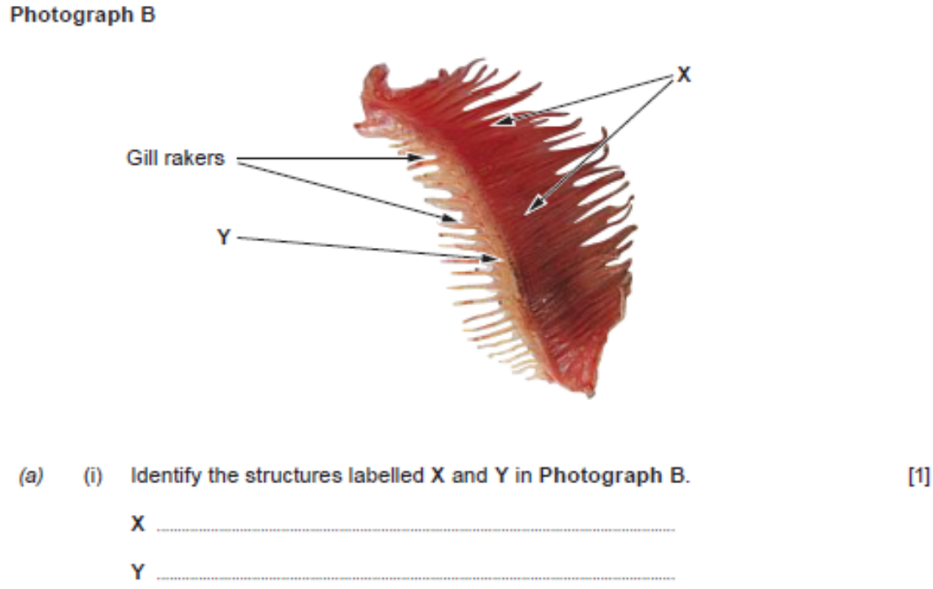

(b) Describe and explain two features of fish gills which allow them to achieve efficient gas exchange. (2)
1. ___________________________________________________________________
___________________________________________________________________
2. ___________________________________________________________________
___________________________________________________________________
Q4. The diagram represents the flow of water and blood through the gills of a fish. The figures give relative oxygen concentrations.
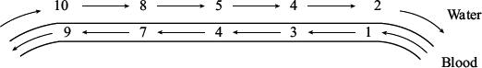
Use the information in the diagram to explain the advantage of the countercurrent flow.
___________________________________________________________________
___________________________________________________________________
___________________________________________________________________
___________________________________________________________________
(2)

Q5. The diagram shows the position of the diaphragm at times P and Q.
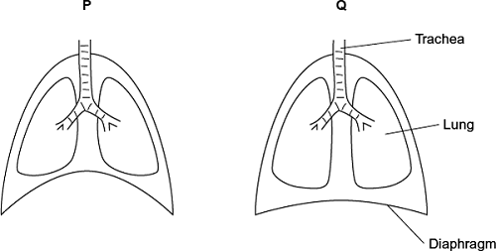
(a) Describe what happens to the diaphragm between times P and Q to bring about the change in its shape.
___________________________________________________________________
___________________________________________________________________
___________________________________________________________________
___________________________________________________________________
___________________________________________________________________
(2)
(b) Air moves into the lungs between times P and Q. Explain how the diaphragm causes this.
___________________________________________________________________
___________________________________________________________________
___________________________________________________________________
___________________________________________________________________
___________________________________________________________________
(3)
(c) Describe how oxygen in air in the alveoli enters the blood in capillaries.
___________________________________________________________________
___________________________________________________________________
___________________________________________________________________
___________________________________________________________________
(2)

Q6.
(a) Describe two adaptations of the structure of alveoli for efficient gas exchange.
1. ____________________________________________________________
______________________________________________________________
2. ____________________________________________________________
______________________________________________________________
(2)
(b)
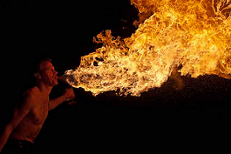
© iStock/Thinkstock
The photograph shows a fire-breather creating a ball of fire. Fire-breathers do this by blowing a fine mist of paraffin oil onto a flame. Some of this mist can be inhaled and may eventually lead to fibrosis.
People who have been fire-breathers for many years often find they cannot breathe out properly. Explain why.
___________________________________________________________________
___________________________________________________________________
___________________________________________________________________
___________________________________________________________________
___________________________________________________________________
(2)

