Name ________________________________
Homeostasis End of Topic Test
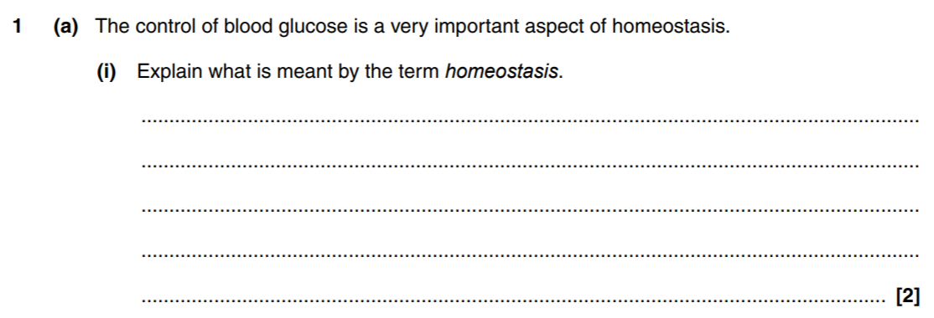

[5 marks]
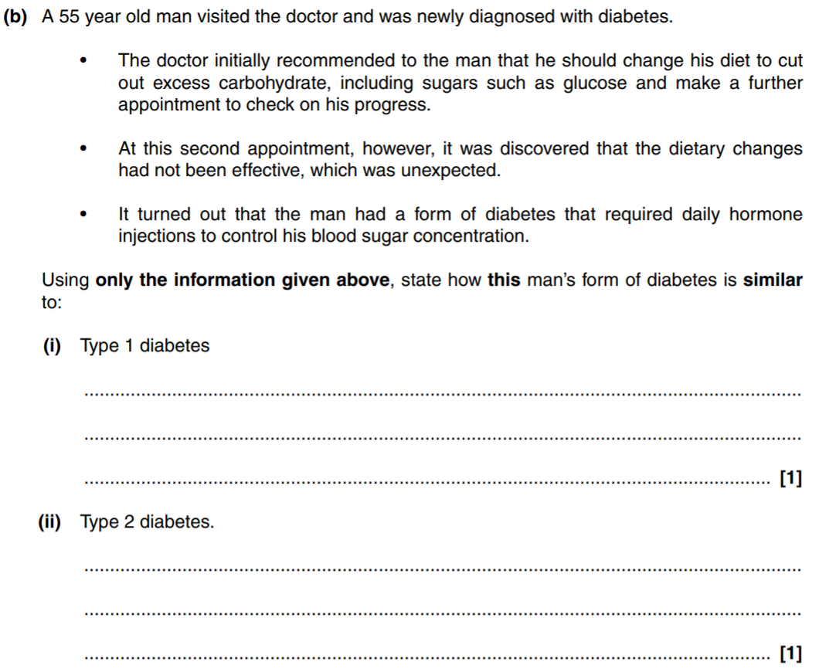
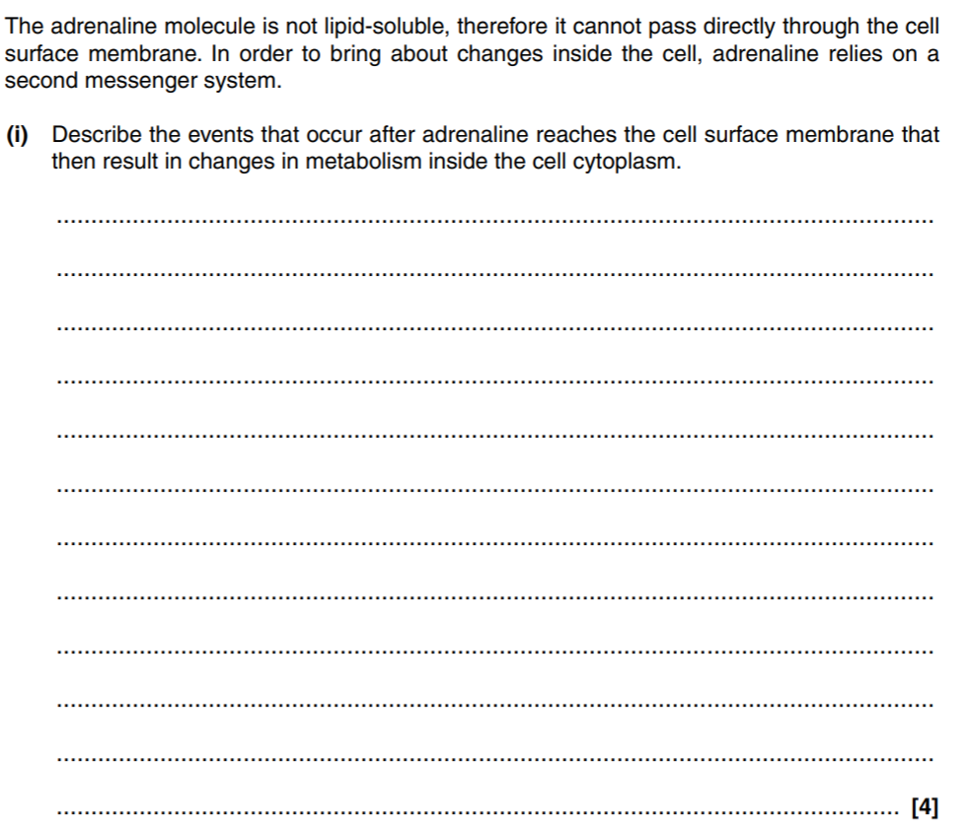
Q2.

Q3.
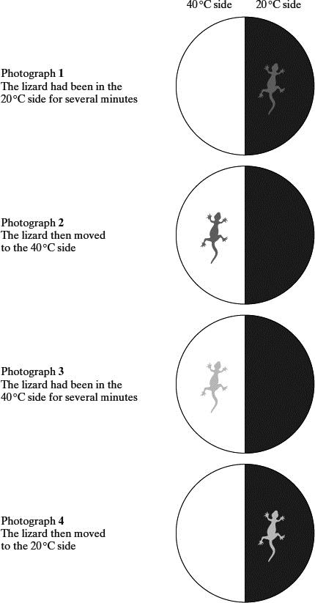
The body temperature of desert-living lizards is greatly affected by the temperature of their environment.
A lizard was placed in a chamber where one half was maintained at 20 °C and the other at 40 °C. The lizard was free to move from one half to the other.
The lizard’s behaviour was observed using an infra-red camera, which records 20 °C surfaces as black and 40 °C surfaces as white.
Temperatures between 20 °C and 40 °C appear as shades of grey. A series of photographs was taken.

(a) The position and appearance of the lizard, as recorded by the infra-red camera, changed during the experiment. Describe and explain these changes.
___________________________________________________________________
___________________________________________________________________
___________________________________________________________________
___________________________________________________________________
(3)
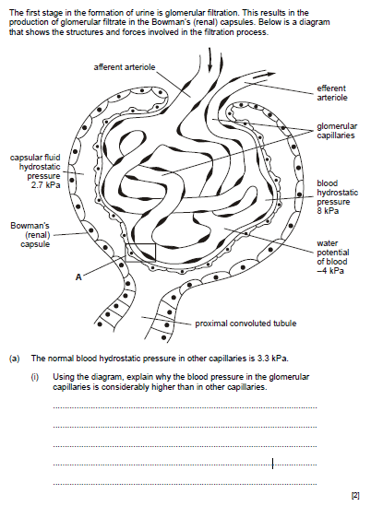
Q4.

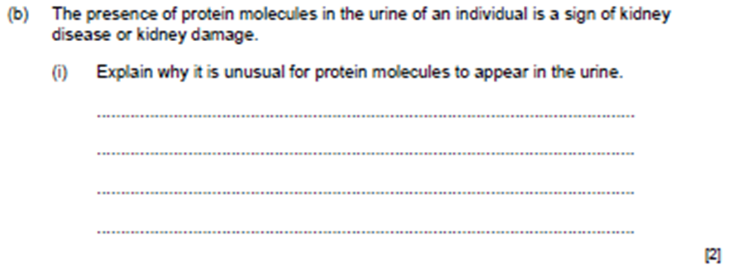

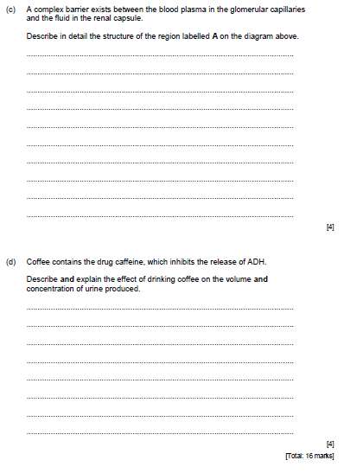
Q5.
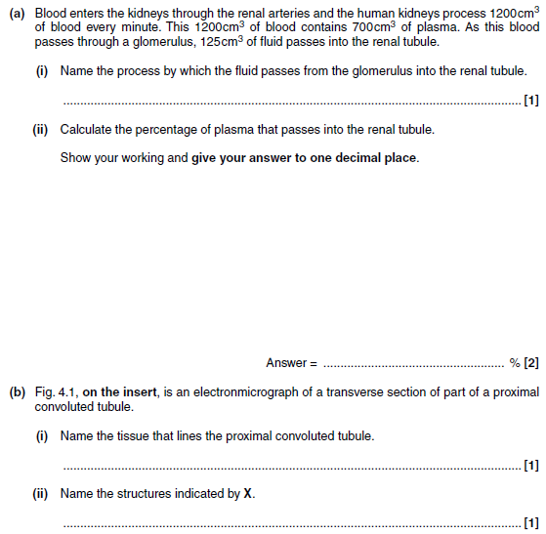
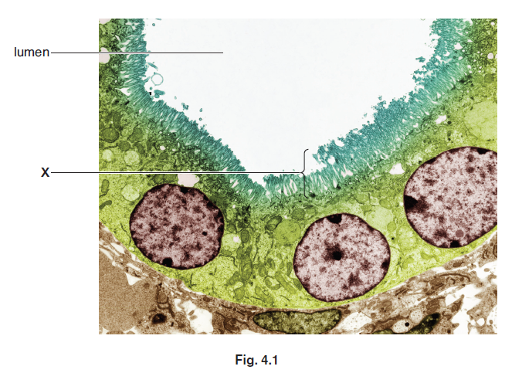
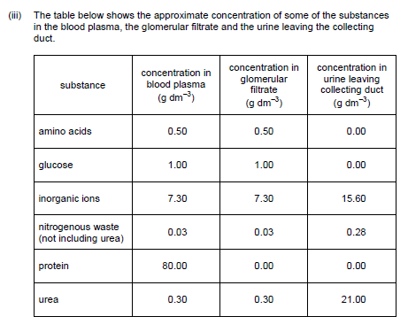
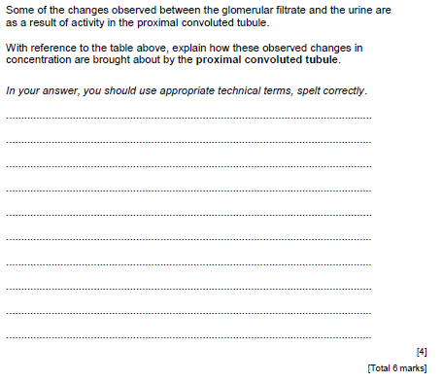

[3]
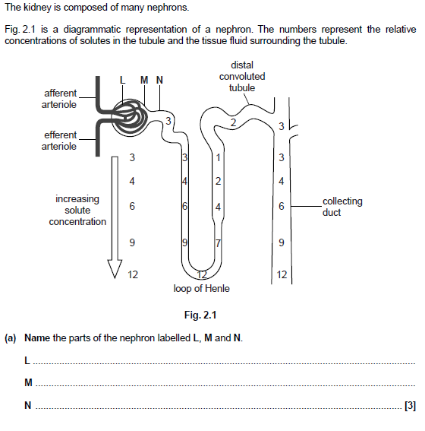
Q6.

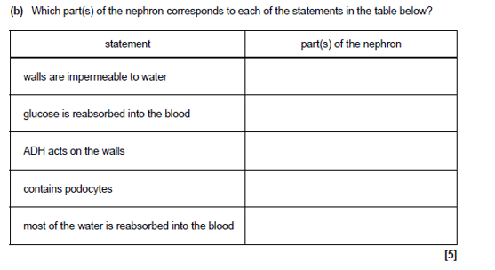


Question | My Marks | Total Marks | Feedback
1 – Blood Glucose Control |  | 9
2 – Secondary Messengers |  | 4
3 – Temp Regulation |  | 3
4 – Ultrafiltration |  | 12
5 – PCT + Reabsorption |  | 6
6 – Nephron and ADH |  | 13
Total |  | 47

