Immunity End Of Topic Test
Question Number | Question Topic | Total Marks | My Mark | How can I Improve?
1 | Phagocytes and Antibodies | 7
2 | HIV | 8
3 | Vaccines and Antibodies | 9
4 | Comprehension | 10
5 | HIV stricture and effect | 9
6 | Monoclonal Antibodies | 9
 | Total | 61
Q1.
(a) What is a pathogen?
___________________________________________________________________
(1)
(b) When a pathogen enters the body it may be destroyed by phagocytosis.
Describe how.
___________________________________________________________________
___________________________________________________________________
___________________________________________________________________
___________________________________________________________________
___________________________________________________________________
___________________________________________________________________
___________________________________________________________________
___________________________________________________________________
(4)

(c) When a pathogen causes an infection, plasma cells secrete antibodies which destroy this pathogen.
Explain why these antibodies are only effective against a specific pathogen.
___________________________________________________________________
___________________________________________________________________
___________________________________________________________________
___________________________________________________________________
___________________________________________________________________
(2)
Q2.
(a) The table below shows features of a bacterium and the human immunodeficiency virus (HIV) particle.
Complete the table by putting a tick (✔) where a feature is present.

Feature | Bacterium | Human immunodeficiency virus (HIV) particle
RNA
Cell wall
Enzyme molecules
Capsid
(2)
(b) When HIV infects a human cell, the following events occur.
• A single-stranded length of HIV DNA is made.
• The human cell then makes a complementary strand to the HIV DNA.
The complementary strand is made in the same way as a new complementary strand is made during semi-conservative replication of human DNA.
Describe how the complementary strand of HIV DNA is made.
___________________________________________________________________
___________________________________________________________________
___________________________________________________________________
___________________________________________________________________
___________________________________________________________________
___________________________________________________________________
___________________________________________________________________
___________________________________________________________________
(3)
(c) Contrast the structures of DNA and mRNA molecules to give three differences.
1. _________________________________________________________________
___________________________________________________________________
2. _________________________________________________________________
___________________________________________________________________
3. _________________________________________________________________
___________________________________________________________________
(3)
Q3.
(a) Human papilloma virus (HPV) is the main cause of cervical cancer. A vaccine has been developed to protect girls and women from HPV.
Describe how giving this vaccine leads to production of antibody against HPV.
___________________________________________________________________
___________________________________________________________________
___________________________________________________________________
___________________________________________________________________
___________________________________________________________________
___________________________________________________________________
___________________________________________________________________
___________________________________________________________________
___________________________________________________________________
___________________________________________________________________
(4)

(b) Doctors investigated whether it was better to give two or three doses of the HPV vaccine. They determined the mean concentration of antibody against HPV in blood samples from girls who were given either two or three doses of the vaccine.
• Girls given two doses received an initial vaccination, followed by a second at 6 months.
• Girls given three doses received an initial vaccination, followed by a second at 1 month and a third at 6 months.
The doctors measured the concentration of antibody each month.
The results are shown below.
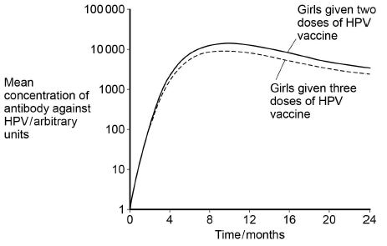
What do these results suggest about whether it is better to give two or three doses of the vaccine? Give reasons for your answer.
___________________________________________________________________
___________________________________________________________________
___________________________________________________________________
___________________________________________________________________
___________________________________________________________________
(2)
(c) The doctors carried out a statistical test to determine whether the antibody concentrations were significantly different in girls given two doses of the vaccine, compared with those given three doses. They determined the mean concentrations of antibody 9 months after the first dose of vaccine.
What statistical test should the doctors have used? Give the reason for your choice.
Test _______________________________________________________________
Reason ____________________________________________________________
___________________________________________________________________(1)
(d) There is genetic diversity within HPV.
Give two ways doctors could use base sequences to compare different types of HPV.
1. _________________________________________________________________
___________________________________________________________________
2. _________________________________________________________________
___________________________________________________________________
(2)
Q4.
Ebola is a disease caused by a virus. The Ebola virus has a glycoprotein on its surface  which binds to a specific receptor protein in the cell-surface membranes of human cells.  When it binds to this receptor protein, the virus can enter the cell. Some people do not  produce this receptor protein. These people may become infected with the Ebola virus  but do not develop the disease.  A blood test can be used to determine whether a person has Ebola. People with Ebola  have large numbers of specific plasma cells and a specific antibody in their blood.  Some scientists have suggested treating people suffering from Ebola by using  transfusions of blood plasma from people who have recently recovered from the  disease. | 5  10
The Ebola virus has a high mutation rate. This makes it difficult to develop a vaccine.
(a) People who do not have the specific receptor protein in their cell-surface membranes may be infected with the Ebola virus but do not develop the disease (lines 1–5).
Explain why they do not develop the disease.
___________________________________________________________________
___________________________________________________________________
___________________________________________________________________
___________________________________________________________________
___________________________________________________________________
(2)

(b) Explain the increase in specific plasma cells and antibody in people infected with the Ebola virus.
___________________________________________________________________
___________________________________________________________________
___________________________________________________________________
___________________________________________________________________
___________________________________________________________________
(2)
(c) Explain how a blood transfusion from a patient recently recovered from Ebola may be an effective treatment (lines 8–10).
___________________________________________________________________
___________________________________________________________________
___________________________________________________________________
___________________________________________________________________
___________________________________________________________________
___________________________________________________________________
___________________________________________________________________
___________________________________________________________________
___________________________________________________________________
___________________________________________________________________
(3)
(d) A high mutation rate makes it difficult to develop a vaccine (line 11).
Explain why.
___________________________________________________________________
___________________________________________________________________
___________________________________________________________________
___________________________________________________________________
___________________________________________________________________
___________________________________________________________________
___________________________________________________________________
___________________________________________________________________
___________________________________________________________________(3)
Q5.
The diagram shows the human immunodeficiency virus (HIV).
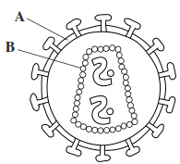
(a) Name
A ______________________________________________________________
B ______________________________________________________________
(2)
The graph shows changes in the number of T-cells and HIV particles in the blood of a person following infection.
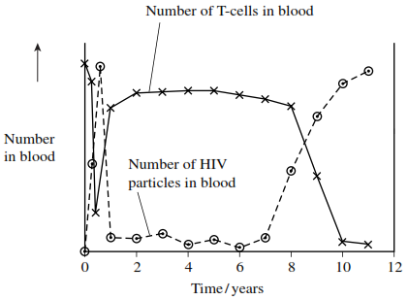
(b) Explain why the number of HIV particles in the blood
(i) rises during the first few months after infection
______________________________________________________________
______________________________________________________________
______________________________________________________________
______________________________________________________________
(2)
(ii) remains low between 1 and 7 years after infection.
______________________________________________________________
______________________________________________________________
(1)
(c) This person developed a large number of infections about 9 years after he first became infected with HIV. Using information from the graph, explain why.
___________________________________________________________________
___________________________________________________________________
___________________________________________________________________
___________________________________________________________________
___________________________________________________________________
___________________________________________________________________
___________________________________________________________________
___________________________________________________________________
(Extra space) ________________________________________________________
___________________________________________________________________
___________________________________________________________________
___________________________________________________________________
(4)
Q6.
(a) NMO is a disease that leads to damage to nerve cells in the spinal cord.
A person with NMO produces anti-AQP4 antibody that attacks only these nerve cells.
Explain why the anti-AQP4 antibody only damages these cells.
___________________________________________________________________
___________________________________________________________________
___________________________________________________________________
___________________________________________________________________
___________________________________________________________________
___________________________________________________________________
___________________________________________________________________
___________________________________________________________________
(4)
(b) Scientists measured the concentration of anti-AQP4 antibody in the blood of people with NMO.
The spinal cord is surrounded by small bones called vertebrae. For each person, the scientists also determined the number of vertebrae surrounding damaged nerve cells.
Their results are shown in the graph.
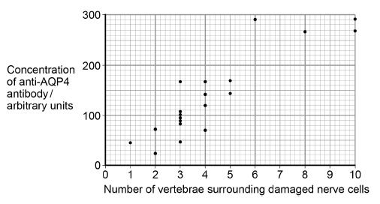
A scientist suggested that the concentration of anti-AQP4 antibody in a person’s blood could be used to predict the number of vertebrae surrounding damaged nerve cells they are likely to have.
Use the graph above to suggest reasons why this suggestion might not be valid.
___________________________________________________________________
___________________________________________________________________
___________________________________________________________________
___________________________________________________________________
___________________________________________________________________
___________________________________________________________________
___________________________________________________________________
___________________________________________________________________
(3)
(c) A new treatment for NMO involves using a monoclonal antibody. The structure of the variable region of this monoclonal antibody is identical to the variable region of an anti-AQP4 antibody, but the rest of its structure is different.
Use this information and your knowledge of antigen-antibody complexes to suggest how this monoclonal antibody prevents anti-AQP4 damaging nerve cells.
___________________________________________________________________
___________________________________________________________________
___________________________________________________________________
___________________________________________________________________
___________________________________________________________________ (2)

