Cells and Microscopes End of Topic Test
Recall Questions:
- What is the equation for calculating magnification? (1)

- What is the function of the SER? (1)

- What is the function of the mitochondria? (1)

- What is the difference between the smooth and rough ER? (1)

- What is the function of a lysosome? (1)

- What kind of radiation is used in electron microscopes? (1)

- Describe why you would use a TEM instead of an SEM (1)

- Why is a stain used when preparing a slide for a light microscope? (1)

- What are 2 disadvantages of using an TEM? (2)

Exam Questions:

Q1. Below is a drawing of an animal cell as seen under an electron microscope. (5)
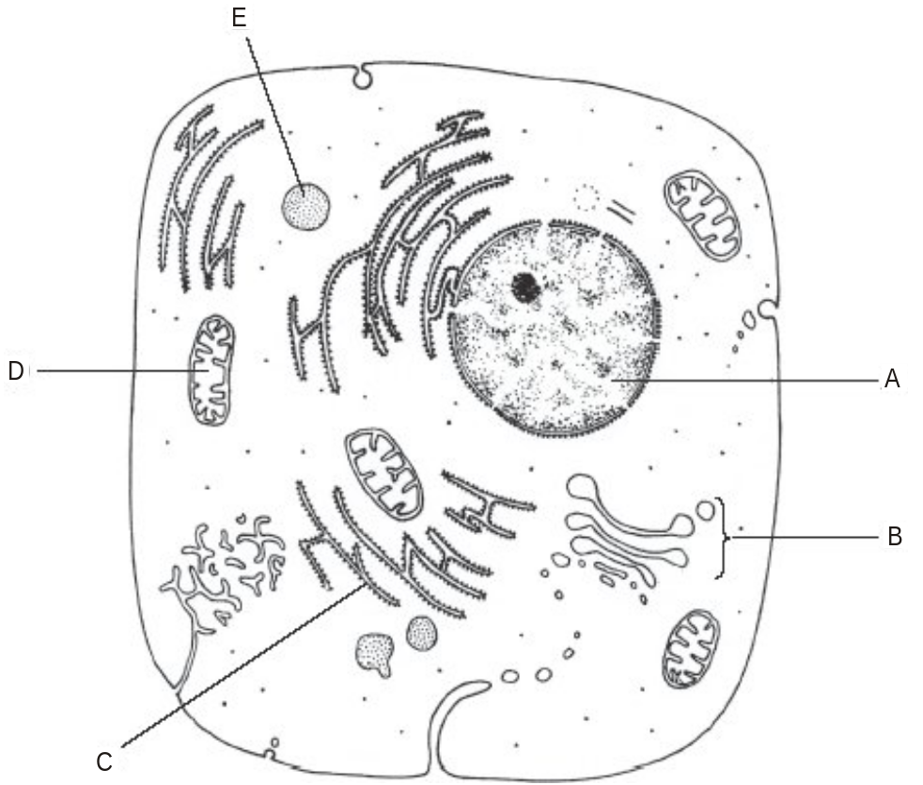

Complete the following table by:
• identifying the parts of the cell labelled A to E
• naming the part of the cell responsible for the function stated.

Function | part of cell | letter
controls activities of the
cell
carries out aerobic
respiration
attaches to mRNA in
protein synthesis
produces
vesicles
contains digestive
enzymes

Q2. The diagram shows a eukaryotic cell.
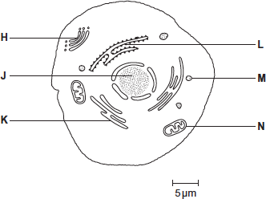
(a) Complete the table by giving the letter labelling the organelle that matches the function.

Function of organelle | Letter
Protein synthesis
Modifies protein (for example, adds carbohydrate to protein)
Aerobic respiration
(3)
(b) Calculate the magnification of the drawing.
Show your working.

Answer = ____________________
(2)

Q3. The image below shows an electron micrograph of an animal cell.
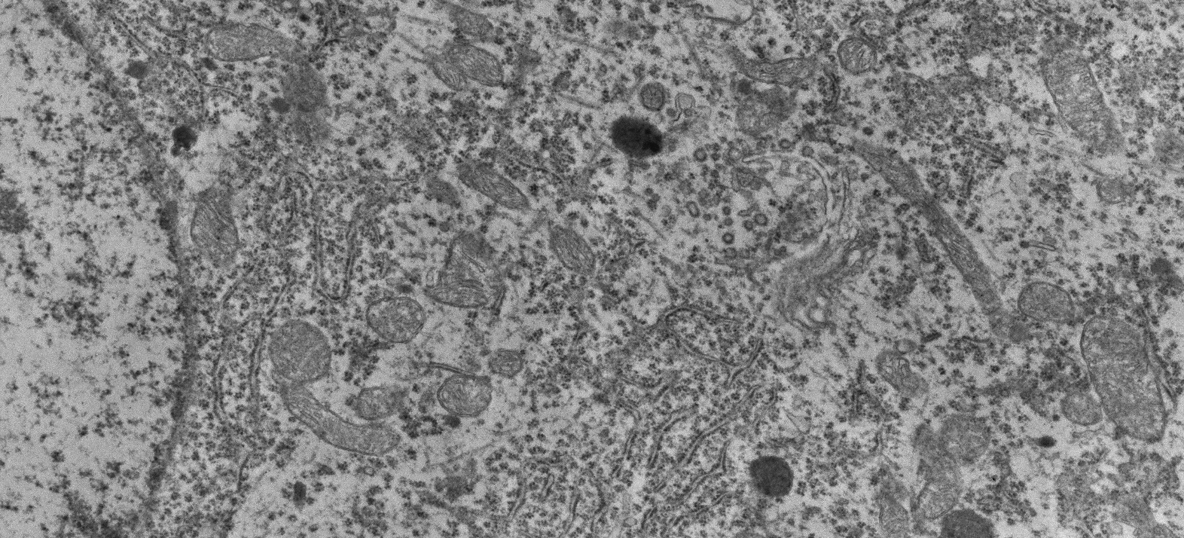
B
C
A
- What microscope was used to take this image?

___________________________________________________________________
Explain your answer

___________________________________________________________________
___________________________________________________________________
(2)
- Identify the organelles A-C
A____________________________
B ___________________________
C____________________________
(3)

Q4.
(a) Contrast how an optical microscope and a transmission electron microscope work and contrast the limitations of their use when studying cells.
___________________________________________________________________
___________________________________________________________________
___________________________________________________________________
___________________________________________________________________
___________________________________________________________________
___________________________________________________________________
___________________________________________________________________
___________________________________________________________________
___________________________________________________________________
___________________________________________________________________
___________________________________________________________________
___________________________________________________________________
(6)

