Mitosis End Of Topic Test
Q1.
(a) Mitosis is important in the life of an organism. Give two reasons why.
___________________________________________________________________
___________________________________________________________________
___________________________________________________________________
___________________________________________________________________
(2)
A biologist used a microscope to investigate plant tissue where some of the cells were dividing by mitosis. She examined 200 cells and counted the number of cells in interphase and in each stage of mitosis.
The table shows some of the cells she saw, and the percentage of cells in interphase and in two stages of mitosis, A and B.

Stage of cell cycle |  | Percentage of cells
Interphase | 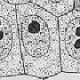 | 90
Stage A | 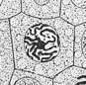 | 3
Stage B | 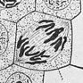 | 1
Images by Edmund Beecher Wilson [Public domain], via Wikimedia Commons
(b) (i) Explain why the biologist chose to examine 200 cells.
______________________________________________________________
______________________________________________________________
______________________________________________________________
(1)
(ii) Name Stage A and Stage B. Give the evidence from the photograph that you used to identify the stage.
Name of Stage A________________________________________________
Evidence ______________________________________________________
______________________________________________________________
Name of Stage B________________________________________________
Evidence ______________________________________________________
______________________________________________________________
(4)
Q5. The diagrams show four stages of mitosis.
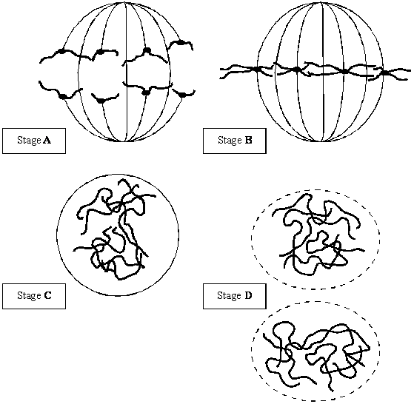
(a) (i) Name stage A.
______________________________________________________________
(1)
(ii) Starting with stage C, give the stages A to D in the correct order.
C ______ ______ ______
(1)
(iii) Describe and explain the appearance of one of the chromosomes in stage B.
______________________________________________________________
______________________________________________________________
______________________________________________________________
______________________________________________________________
(2)
(b) Colchicine is a substance that prevents the formation of the spindle in mitosis. Dividing cells were treated with colchicine. This stopped them dividing. After a few hours, the colchicine was removed and the cells began to divide again. The diagram shows the chromosomes from one of the treated cells at stage B after the cell began dividing again.
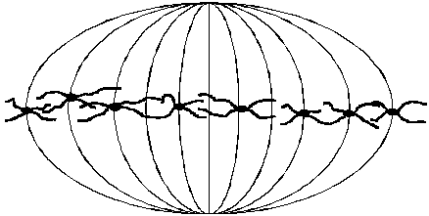
(i) What has happened to the chromosome number?
______________________________________________________________
(1)
(ii) Suggest an explanation for the change in the chromosome number.
______________________________________________________________
______________________________________________________________
(1)
Q2. A student investigated the stages of mitosis in a garlic root. The root tip was placed on a microscope slide with a stain. A cover slip was placed on top and the root tip was firmly squashed.
(a) Explain why
(i) a root tip was used;
______________________________________________________________
______________________________________________________________
(1)
(ii) a stain was used;
______________________________________________________________
______________________________________________________________
(1)
(iii) the root tip was firmly squashed.
______________________________________________________________
____________________________________________________________(1)
Q6. Scientists investigated the effect of bromelain on cancer cells. They took cells from skin cancers in mice and added them to a liquid growth medium in two dishes.
Four hours later they added a solution of bromelain to one of the dishes. They left the other dish as a control. They also added a substance to both dishes that is turned purple by respiring cells.
Both dishes were placed in an incubator. The scientists measured the intensity of the purple colour at intervals over a period of 100 hours.
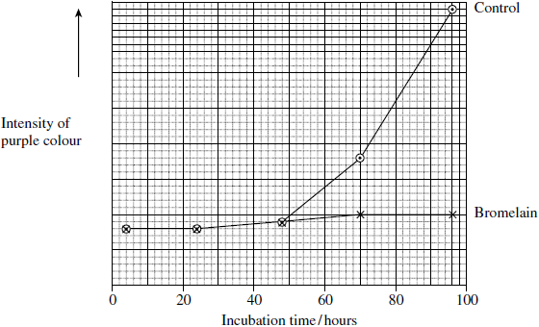
(a) The scientists put the same number of skin tumour cells in each dish at the start of this investigation. Explain why it was important to put the same number of cells in each dish.
___________________________________________________________________
___________________________________________________________________ (1)
(b) The scientists concluded that bromelain did not kill cancer cells but stopped them dividing. Does the graph support this conclusion? Explain your answer.
___________________________________________________________________
___________________________________________________________________
___________________________________________________________________
___________________________________________________________________ (2)

(d) The rate of cell division is important in investigations into cancer. Suggest why.
___________________________________________________________________
___________________________________________________________________
___________________________________________________________________
___________________________________________________________________ (2)
(e) Scientists have investigated the effects of bromelain on cancer growth in humans. Suggest why they gave bromelain in addition to, rather than instead of, the usual treatment.
___________________________________________________________________
___________________________________________________________________
___________________________________________________________________ (2)
Q9. (a) Describe how DNA is replicated.
___________________________________________________________________
___________________________________________________________________
___________________________________________________________________
___________________________________________________________________
___________________________________________________________________
___________________________________________________________________
___________________________________________________________________
___________________________________________________________________
___________________________________________________________________
___________________________________________________________________ (6)

(b) The graph shows information about the movement of chromatids in a cell that has just started metaphase of mitosis.
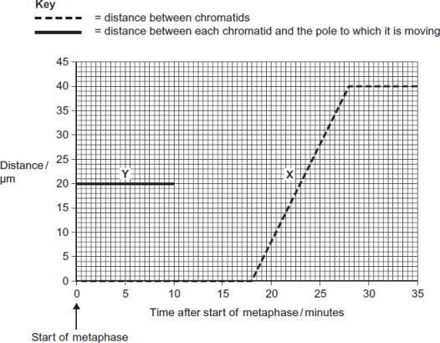
(i) What was the duration of metaphase in this cell?
 minutes
(1)
(ii) Use line X to calculate the duration of anaphase in this cell.
minutes
(1)
(iii) Complete line Y on the graph.
(2)

(c) A doctor investigated the number of cells in different stages of the cell cycle in two tissue samples, C and D. One tissue sample was taken from a cancerous tumour. The other was taken from non-cancerous tissue. The table shows his results.

 | Percentage of cells in each stage of the cell cycle
Stage of the cell cycle | Tissue sample C | Tissue sample D
Interphase | 82 | 45
Prophase | 4 | 16
Metaphase | 5 | 18
Anaphase | 5 | 12
Telophase | 4 | 9
(i) In tissue sample C, one cell cycle took 24 hours. Use the data in the table to calculate the time in which these cells were in interphase during one cell cycle. Show your working.

Time cells in interphase ____________________ hours
(2)
(ii) Explain how the doctor could have recognised which cells were in interphase when looking at the tissue samples.
______________________________________________________________
______________________________________________________________
______________________________________________________________ (1)
(iii) Which tissue sample, C or D, was taken from a cancerous tumour?
Use information in the table to explain your answer.
______________________________________________________________
______________________________________________________________
______________________________________________________________
______________________________________________________________
______________________________________________________________
(2)

