Nerves and Muscles EOTT
Question | My Marks | Total Marks | Feedback
1 Action potential |  | 2
2. Synapses |  | 3
3. Muscle Structure and Contraction |  | 7
4. Slow and Fast Twitch |  | 4
5. Synapse |  | 3
6 + 7 Drugs and Synapses |  | 4
8. Neuromuscular junction and muscle contraction |  | 8
Total |  | 32
Q1. Describe how the resting potential is established in an axon by the movement of ions across the membrane.

___________________________________________________________________

___________________________________________________________________

___________________________________________________________________

___________________________________________________________________

(2)

Q2.
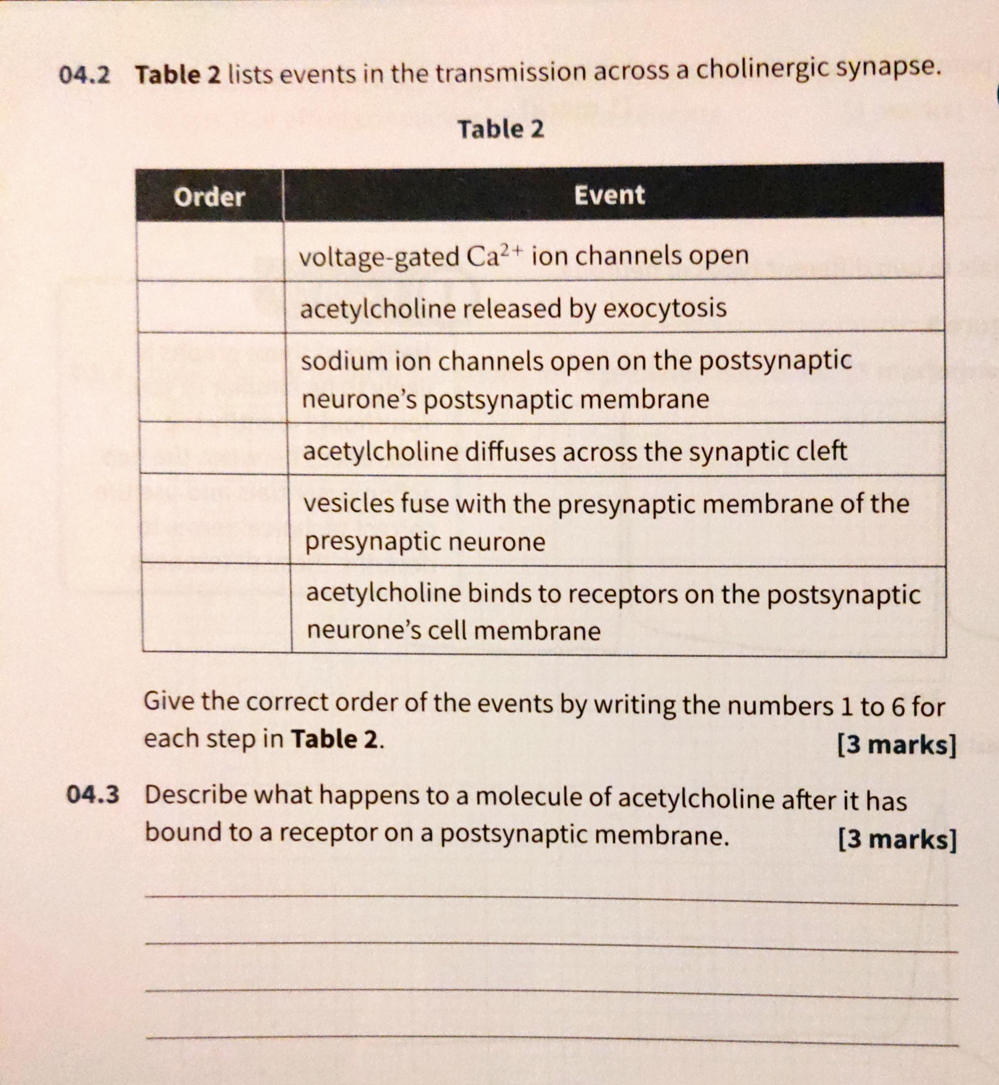

Q3. The diagram shows the appearance of part of a myofibril from a skeletal muscle fibre when viewed with a light microscope.
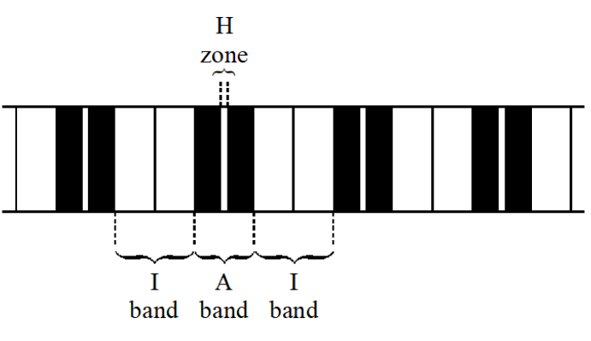
(a) The muscle fibre is relaxed. When the muscle contracts, what happens to the appearance of:
(i) the A band;.......................................................................................................
(ii) the I band;.........................................................................................................
(iii) the H zone....................................................................................................... (2)
(b) In which of the regions labelled in the diagram would the following be present?
(i) Myosin......................................................................................................
(ii) Actin......................................................................................................... (2)
(c) Describe the events that occur within a myofibril which enable it to contract.
…................................................................................................................
…................................................................................................................
…................................................................................................................
…................................................................................................................ (3)
Q4. (a) The table shows some differences between slow and fast muscle fibres.
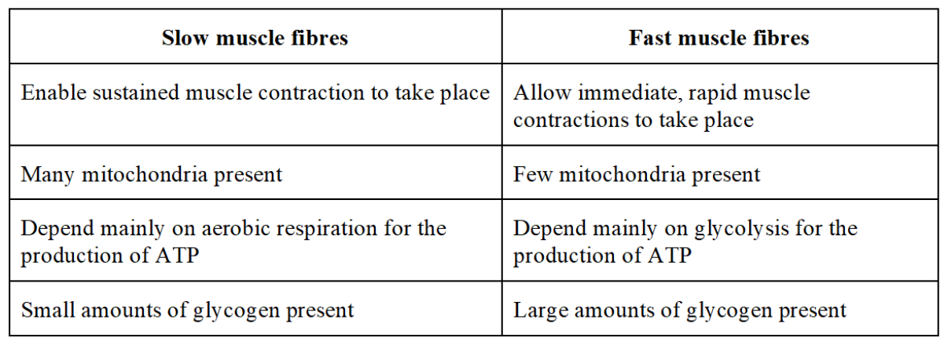

(i) Explain the advantage of having large amounts of glycogen in fast muscle fibres.
…................................................................................................................
…................................................................................................................
…................................................................................................................
…................................................................................................................ (2)
(ii) Slow muscle fibres have capillaries in close contact. Explain the advantage of this arrangement.
…................................................................................................................
…................................................................................................................
…................................................................................................................
…................................................................................................................ (2)
Q5. Describe what happens to a molecule of acetylcholine after it has bound to a receptor on a postsynaptic membrane.
…................................................................................................................
…................................................................................................................
…................................................................................................................
…................................................................................................................ (2)
Q6. Tetrodotoxin is a toxin produced by pufferfish. Tetrodotoxin inhibits Na+ ion channels. Suggest and explain the effect of tetrodotoxin on the nervous system.
…................................................................................................................
…................................................................................................................
…................................................................................................................
…................................................................................................................ (2)
Q7. Curare is a poisonous substance found in various South American plants. A molecule in curare, d-tubocurarine, blocks acetylcholine receptors on postsynaptic membrane. Suggest and explain the effect of curare on the nervous system.
…................................................................................................................
…................................................................................................................
…................................................................................................................
…................................................................................................................ (2)
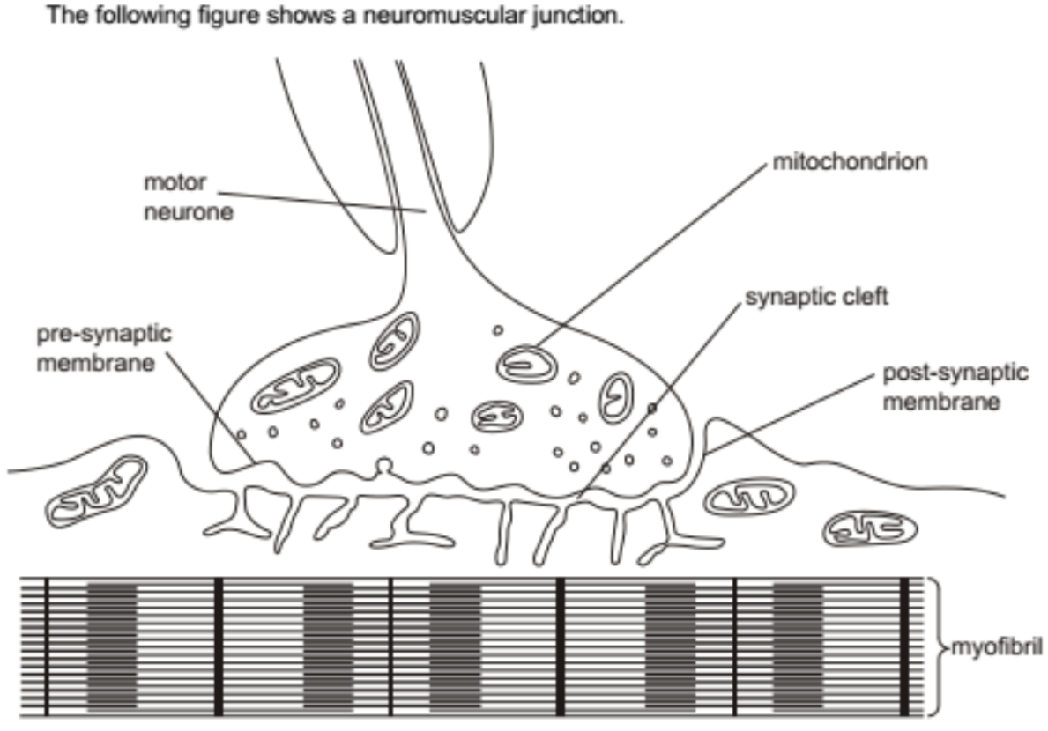
Q8.
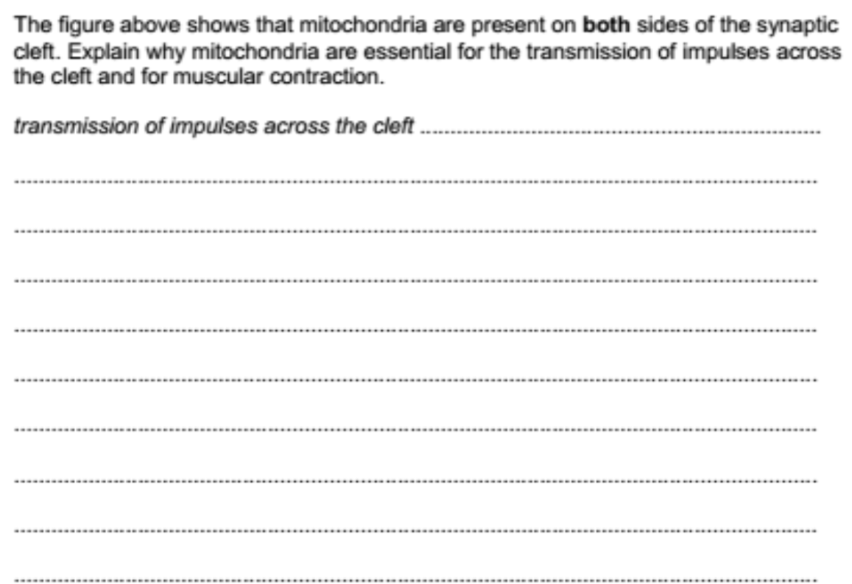
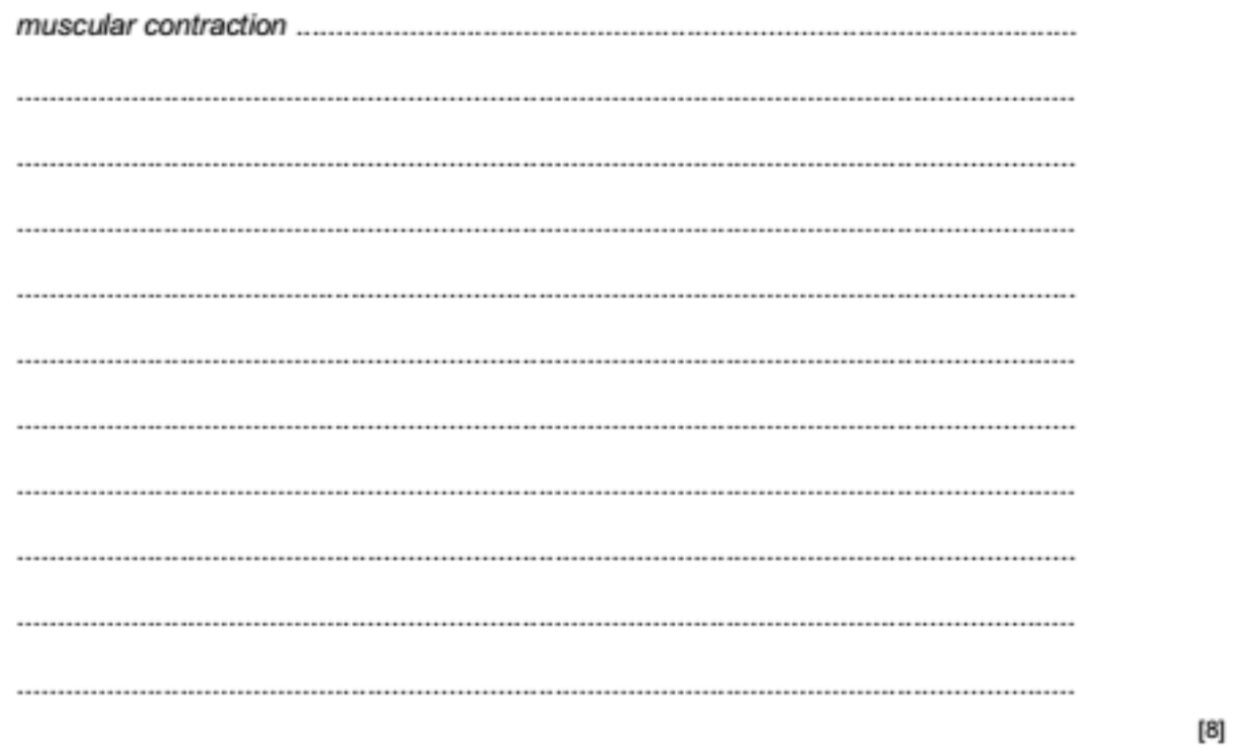

1. active transport / pump of Na⁺ out of axon;
diffusion of K⁺ out of axon / little diffusion of Na⁺ into the axon;

2.
3. 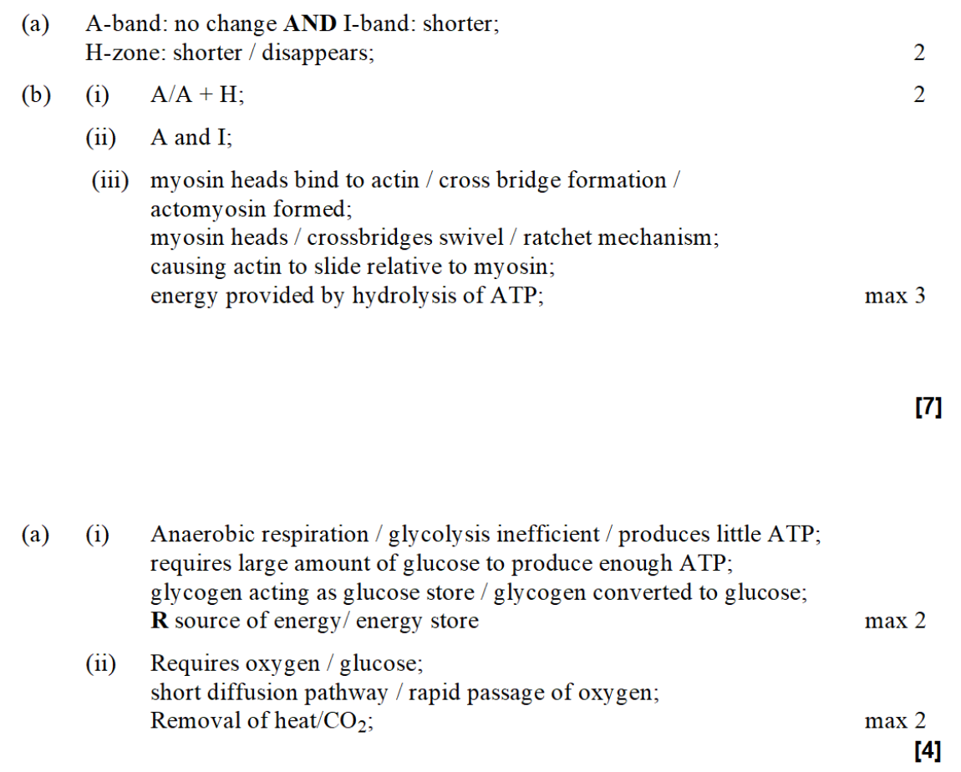
4.

5. acetylcholinesterase; hydrolyses / breaks down , acetylcholine; (which) diffuse back into presynaptic neurone;
6. fewer acetylcholine molecules can to postsynaptic receptors; fewer action potentials in postsynaptic neurones;
7. no / fewer , nerve impulses; stops , sodium ions diffusing into neurones / depolarisation of neurones; no action potentials;
8.