Respiration End Of Topic Test
Question | My Mark | Total Mark | Feedback
1 ATP Structure
2 Mitochondria Structure
3 Glycolysis
4 Krebs Cycle
5 ETC
6 Application Qs
Total
Q1.
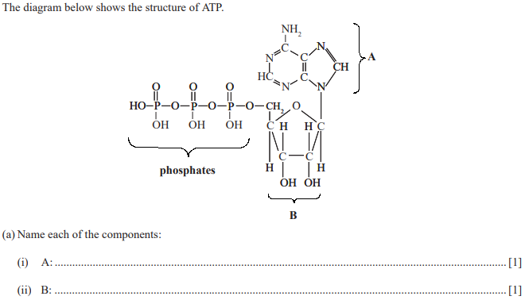
Q2.
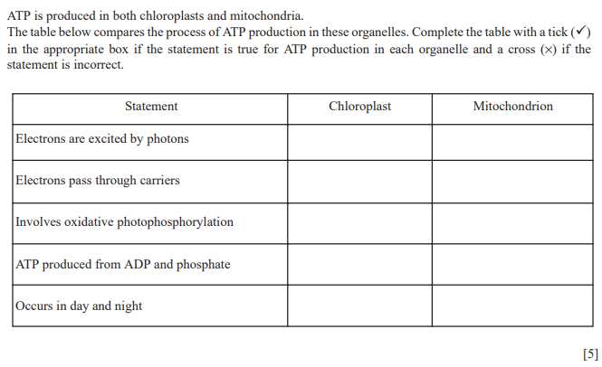
Q3.
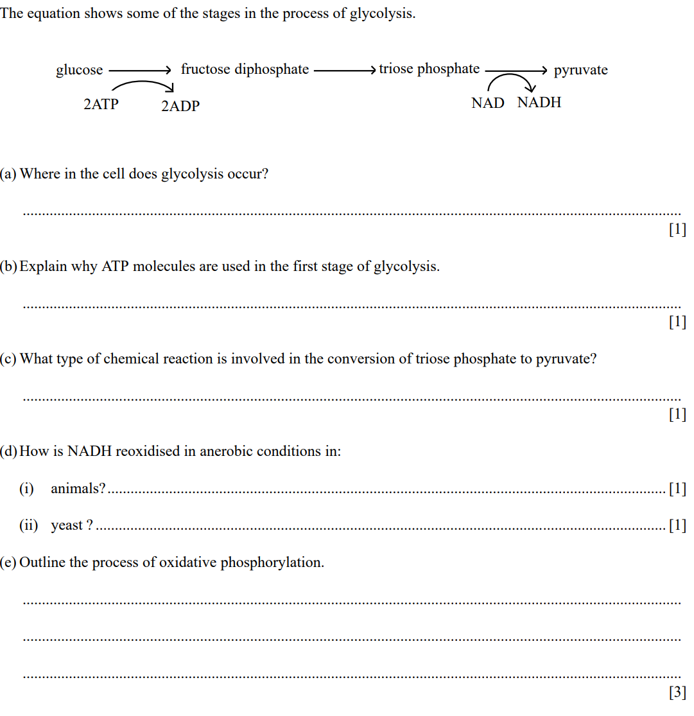

Q4.
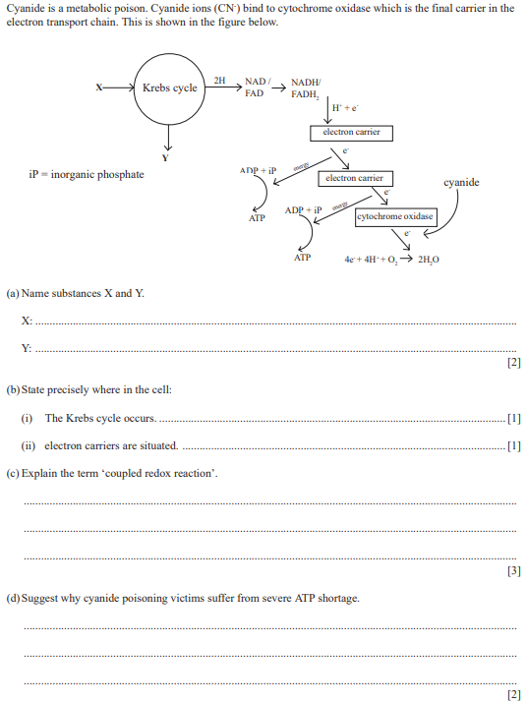

Q5.
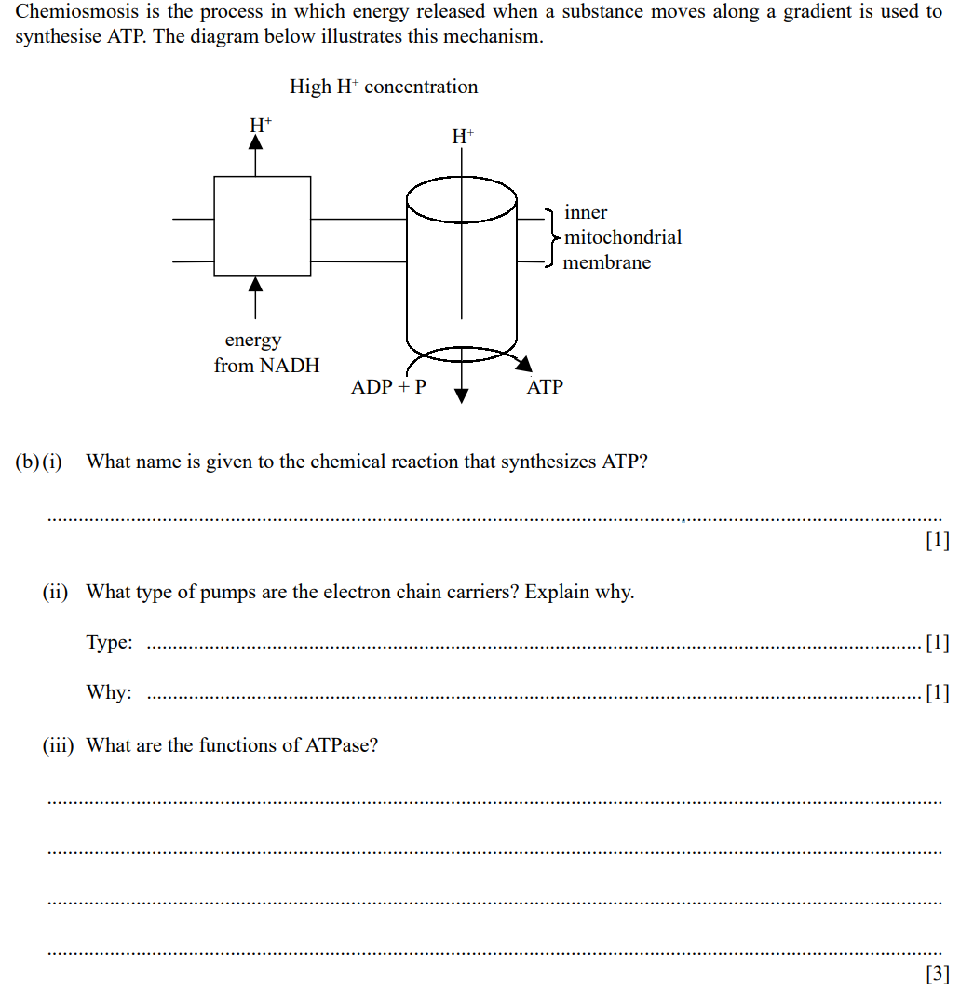

Q6.
