Digestion End of Topic Test
Recall Questions
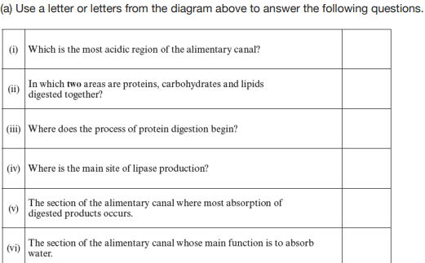
1. The diagram below shows the human alimentary canal (digestive system) (6)

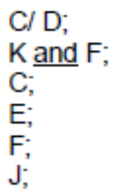

2. What reaction breaks down polymers into monomers?

hydrolysis

3. What molecules secreted by the liver which help break down lipids?

Bile salts

4. What enzyme is secreted by the stomach? What is the optimum pH for this enzyme?

Pepsin, pH2

5. What enzymes are secreted by the pancreas? What is the optimum pH for these enzymes?

All 3, pH7

6. What is the name given to the small spheres of lipids that aid absorption in the small intestine?

miclles
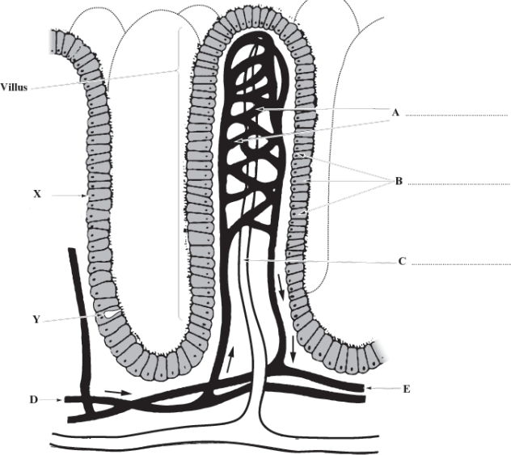
Exam Questions
7.

- Complete the diagram by labelling structures A, B and C. (3)
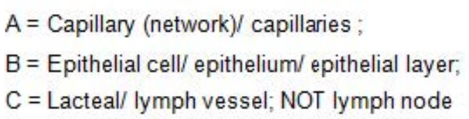
- With reference to the diagram only, describe and explain two features that are important in the functioning of the villi. (2)
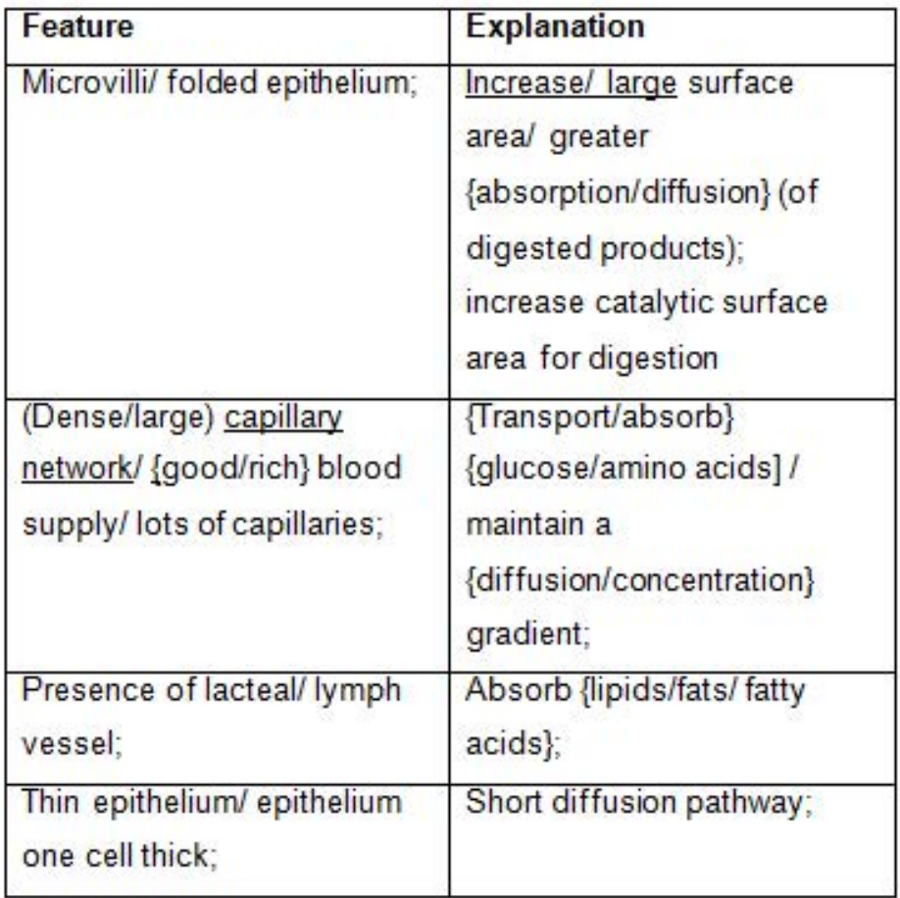
- Describe two features associated with cell X and explain why each is important for the cell to function efficiently. (2)
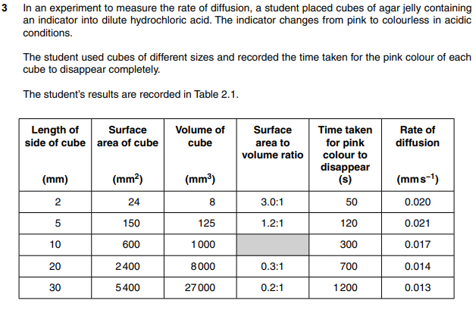
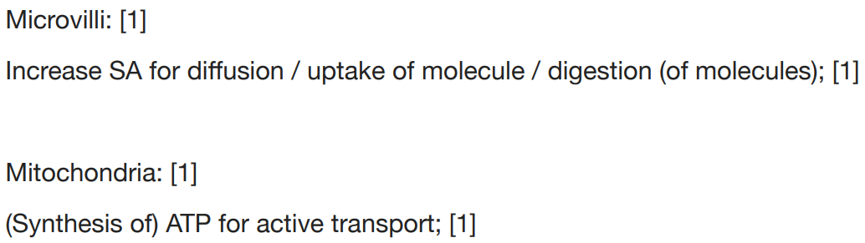
8.

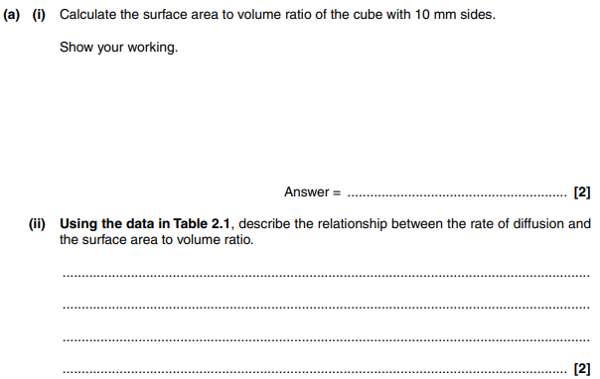
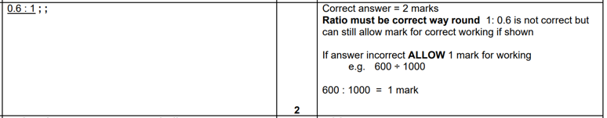
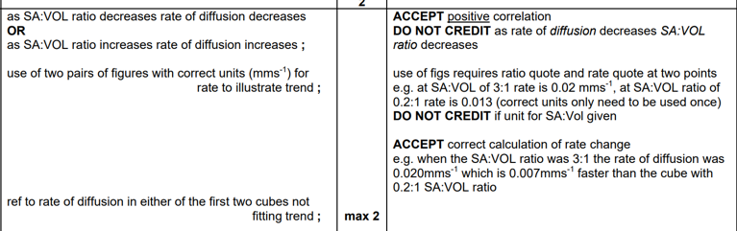

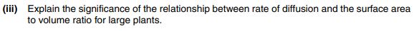
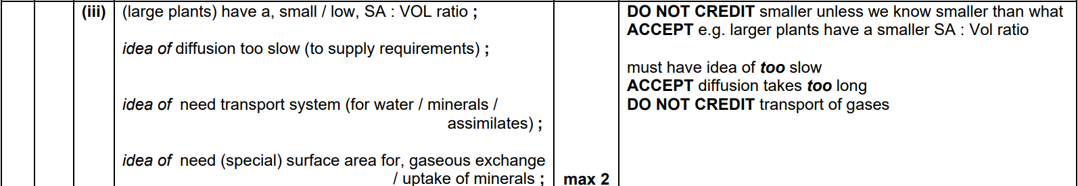
9. 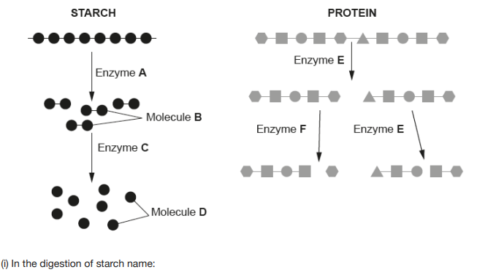
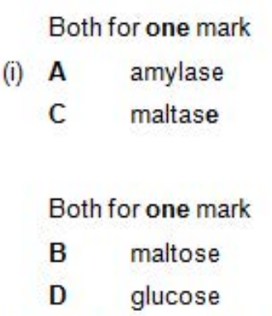

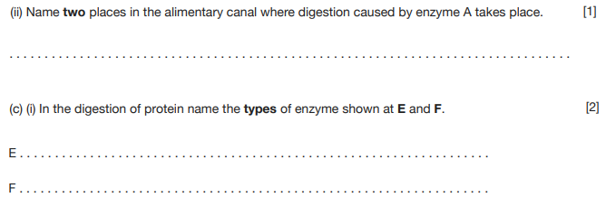
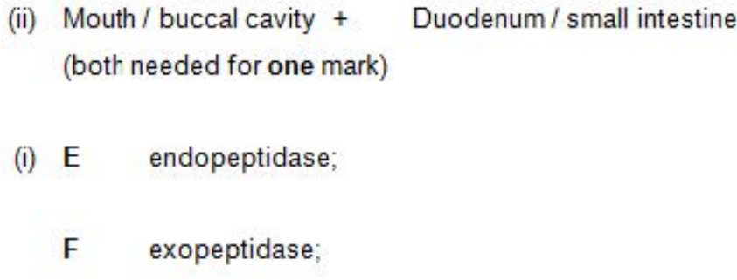

10.
