Name: ___________
Nucleic Acids , DNA Replication and Protein Synthesis – End of Topic Test
1. (a) The drawing shows part of a DNA molecule.
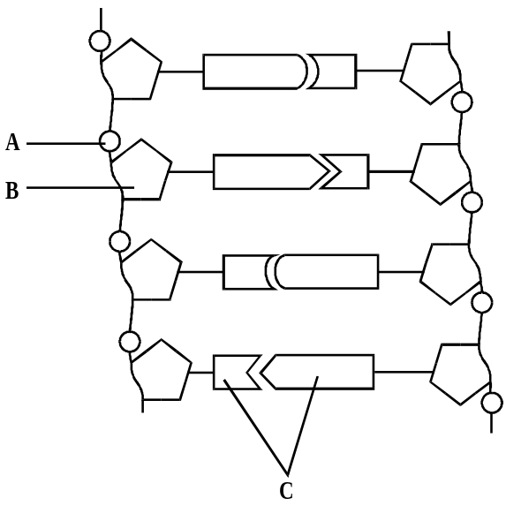
A
B
C
D
Name the parts labeled A B and C (3)
(b) The diagram below shows the sequence of bases in a short length of mRNA.
A U G G C C U C G A U A A C G G C C A C C A U G
(i) What is the maximum number of amino acids in the polypeptide for which this piece of mRNA could code? (1)

(ii) How many different types of tRNA molecule would be used to produce a polypeptide from this piece of mRNA? (1)

(iii) Give the DNA sequence which would be complementary to the first five bases in this piece of mRNA. (1)

(c) Name the process by which mRNA is formed in the nucleus. (1)

(d) Give two ways in which the structure of a molecule of tRNA differs from the structure of a molecule of mRNA. (2)

2. The diagram shows part of a DNA molecule in the process of replication.
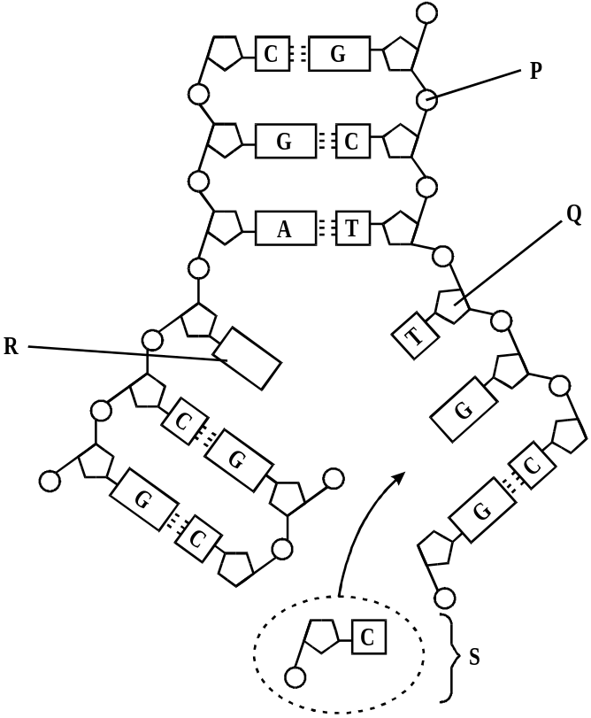
(a) Name parts P to S. (4)

(b) Which enzyme joins part S to the new DNA strand? (1)

3. The diagram below shows the semi-conservative replication of a DNA molecule.
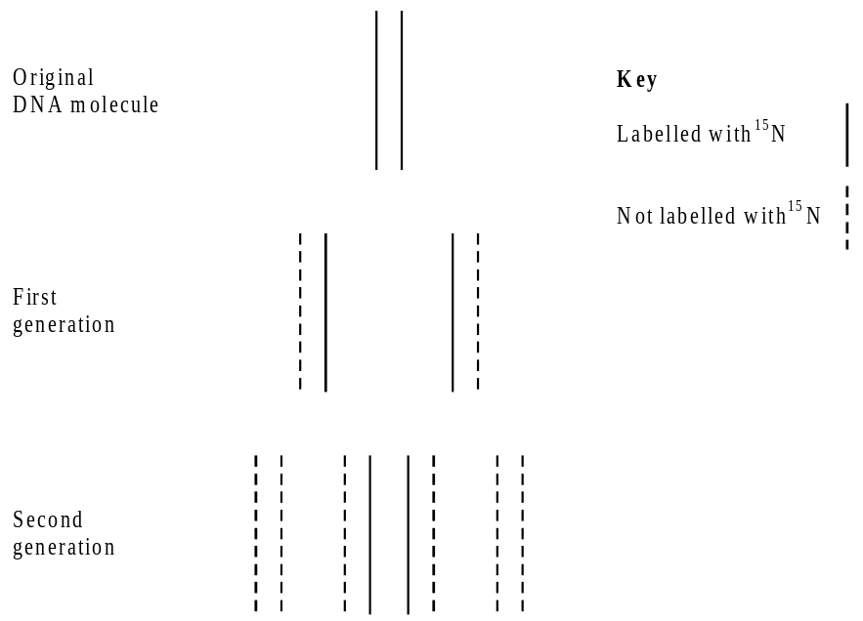
(a) The original DNA molecule was labelled with a form of nitrogen called 15N.
(i) Which part of the DNA molecule contains nitrogen which would be labelled with 15N? (1)

(ii) Explain why all the DNA in the first generation had 15N in it. (1)

(iii) Explain why only half of the DNA in the second generation had 15N in it. (1)

(b) Explain why the replication of DNA is described as semi-conservative. (2)

4.There are two forms of nitrogen. 15N is a heavier isotope than the normal isotope 14N.
In an investigation, a culture of the bacterium Escherichia coli was obtained in which all the nitrogen in the DNA was of the 15N form. The bacteria were transferred to a medium containing only the normal isotope. ‘4N, and allowed to divide once. A sample of this first generation was removed. The DNA was then extracted and spun in a high-speed centrifuge. This was done again with samples of the second and third generations.
The diagram shows the results of this investigation.

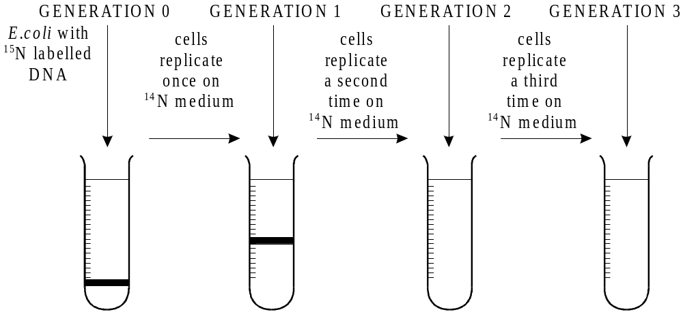
- Which part of a DNA nucleotide contains nitrogen? (1)

- Explain why the DNA from generation 1 is found in the position shown. (2)

(c) Complete the diagram to show the positions of the DNA from generations 2 and 3. (2)
5. The drawing shows part of a DNA molecule.
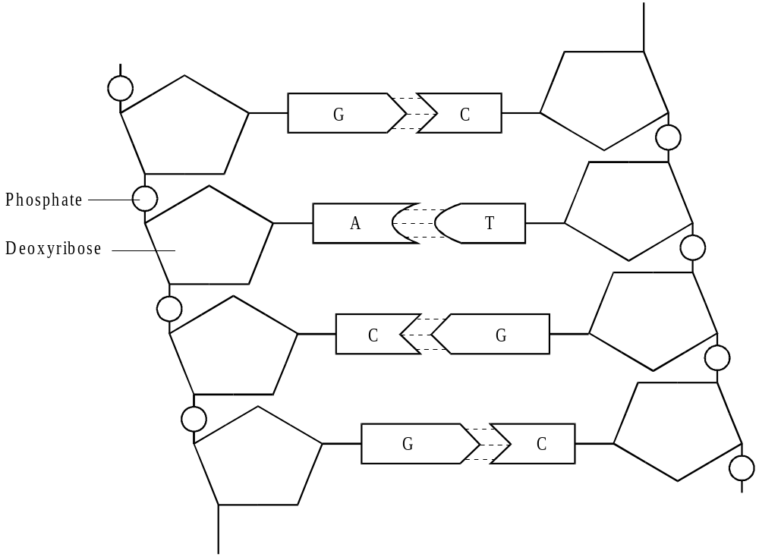
- Describe the structural features shown in the drawing which account for the ability of the molecule to replicate itself. (2)

(b) One piece of experimental evidence for the semi-conservative mechanism for replication of DNA
involves the use of bacteria labelled with the heavy isotope of nitrogen, 15N.

(i) Which component of DNA would be labelled with 15N? (1)

(ii) Explain how DNA labelled with 15N could be separated and distinguished from DNA containing 14N. (3)

6. AIDS is caused by a retrovirus, HIV. This virus has RNA as its genetic material. The viral core has two strands of RNA, each containing about 9200 nucleotide bases. The viral core also contains an enzyme called reverse transcriptase which transcribes the viral RNA into DNA once the virus has entered a cell.
(a) Draw a labelled diagram to show the structure of an RNA nucleotide.(3)

(b) Explain how DNA is formed from viral RNA once the virus has entered a host cell. (2)

(c) Describe how a protein is made from the information coded in DNA. (7)

(d) Rapidly dividing cells were allowed to grow in a solution containing unlabelled thymine. Some of these cells were transferred to a second solution in which all the thymine molecules were radioactively labelled. Samples of cells were removed from the radioactive solution after one division. Chromosomes from the cells were tested for radioactivity. The results are shown in the table.
A | Chromosomes from cells dividing in unlabelled thymine. | No radioactivity
B | Chromosomes from cells that divided once in radioactive thymine. | All chromosomes radioactive

Use your knowledge of the semi-conservative mechanism of DNA replication to explain why all the chromosomes in B were radioactive. (4)

7. The diagram shows a molecule of an enzyme called ribonuclease. Each amino acid in the protein is indicated by a 3-letter symbol e.g. Arg = arginine.
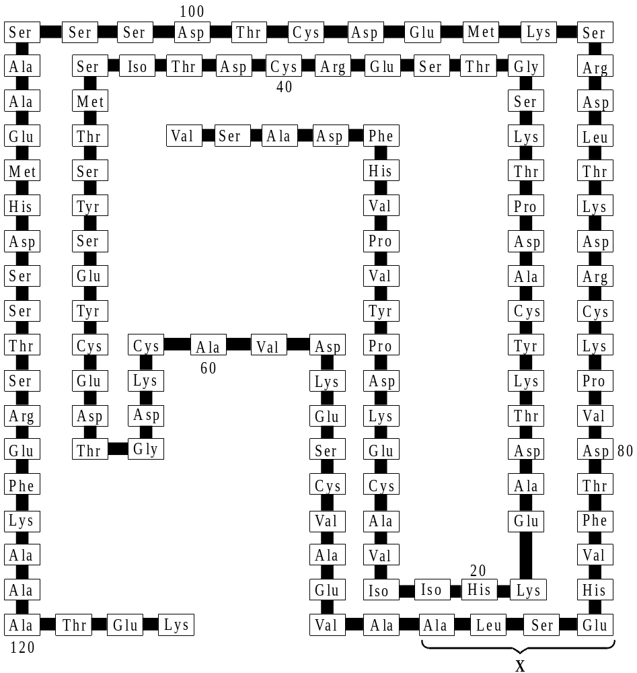
(i) How many nucleotides are there in the mRNA molecule that codes for this enzyme? (1)

(ii) The table gives the mRNA code for the four amino acids in the part of the enzyme labelled X.
Amino Acid | Symbol | mRNA code
Alanine | Ala | GCU
Glutamine | Glu | GAG
Leucine | Leu | UUA
Serine | Ser | AGU
Give the DNA code for the part of the enzyme labelled X.(1)
(c) (i) Where does translation occur in a cell? (1)

(ii) Describe what happens during translation. (3)

(d) Explain how the structure of DNA is related to its function. (6)

