Gas Exchange EOTT MS
Q1.
a) 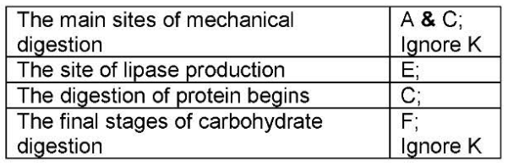
b) A = epithelial cells, B = microvilli, C = capillaries, D = lacteal/lymph vessel
c) 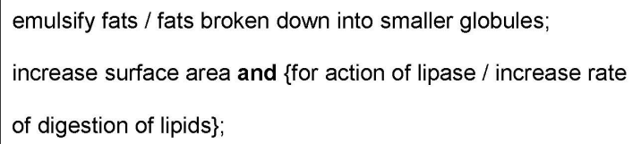
Q2.
(a) 1. More air / oxygen enters / air / oxygen enters quickly / quicker;
1. Accept: converse for carbon dioxide
1. Can be in any correct context eg insect, tracheoles, muscle
1. Neutral: air / oxygen enters
(So) maintains / greater diffusion or concentration gradient;
2
(b) Large(r) SA:VOL / short(er) diffusion distance (to tissues);
Accept: thin diffusion pathway
1
c) Less / no water lost / (more) water retained;
Accept: less dehydration / less evaporation
Q Reject: less ‘transpiration’
Q Reject: less water lost by osmosis
1
(d) 1. Greater surface area exposed to air;
Neutral: shorter diffusion distance
2. Gases move / diffuse faster in air than through water;
2. Q Neutral: ‘harder to diffuse’
2. Accept gases diffuse directly, rather than through water
3. Increases volume / amount of air;
1 max
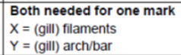
Q3.
(a)

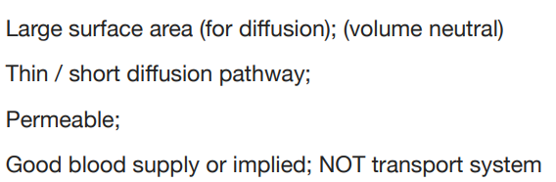
(b)

Q4.
(a) (diffusion) gradient will be maintained all the way along the gill / the amount of oxygen in the water is always higher than in the blood / the numbers in the water are always higher than in the blood;
more oxygen will diffuse into the blood;
2
Q5.
(a) 1. Flatten / moves down;
1. Ignore: additional information about rib movements
2. (Diaphragm muscle) contracts;
2
(b) 1. Diaphragm contracts / moves down / flattens;
Ignore refs to rib movement
2. Increases volume (of thorax) and decrease in pressure;
2. Accept pressure lower than atmospheric pressure
3. Air moves from high to lower pressure / down pressure gradient;
3. Reject: by diffusion
3
(c) 1. Diffusion;
Accept down diffusion gradient
2. Across (alveoli) epithelium / (capillary) endothelium;
2. Accept: capillary epithelium / squamous cell
2 max
Q2. (a) 1. Thin walls / cells;
1. ‘Short diffusion pathway’ alone is an explanation not a description
1. Accept squamous epithelia / one cell thick
2. (Total) surface area is large;
2. Ignore references to ‘volume ratio’
2
(b) 1. Loss of elasticity / elastic tissue / increase in scar tissue;
2. Less recoil;
2

