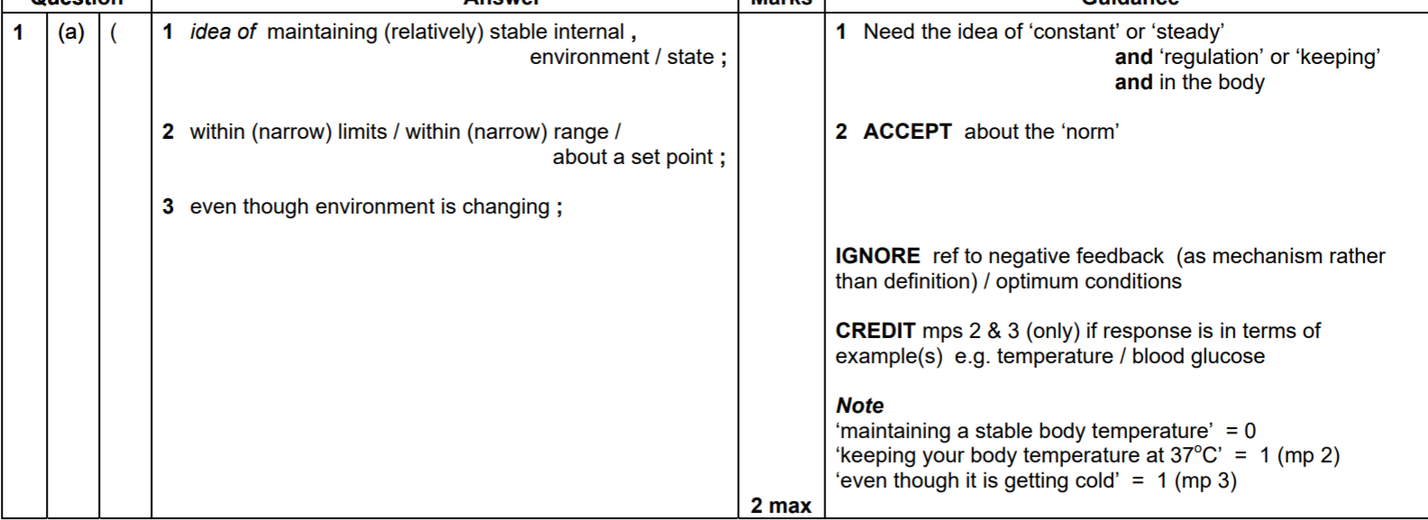
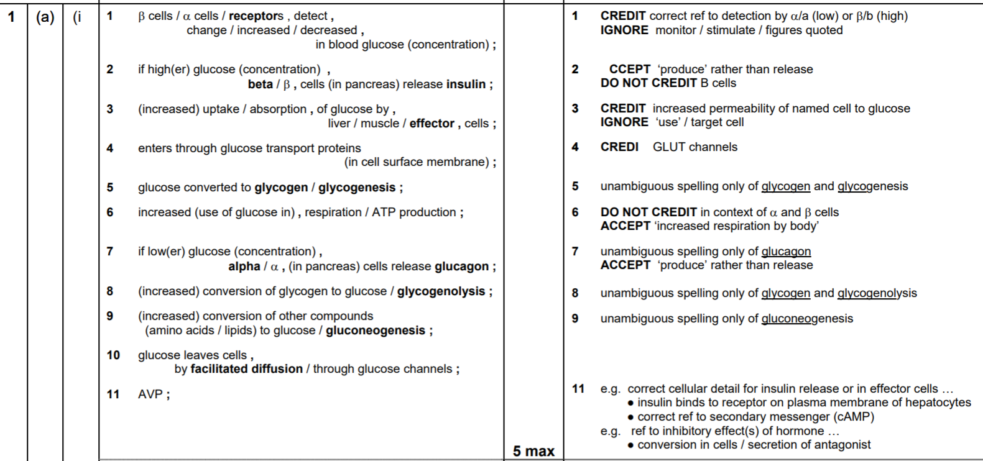
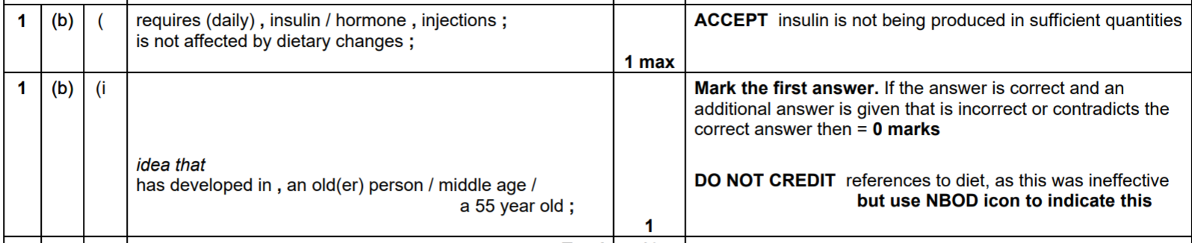
2.
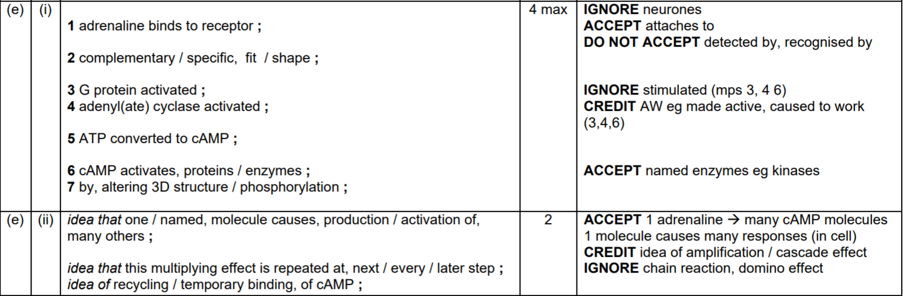
3.
(a) moves to 40 °C side, then later to 20 °C;
gets lighter in hot side and darker in cool side;
lighter as it absorbs heat / darker as it loses heat;
by conduction / convection / radiation;
4.
(a)
(i) wide / large, afferent arteriole ;narrow / small, efferent arteriole ;
afferent arteriole, wider / larger, than efferent arteriole – 2 marks
ref build up pressure on own to achieve filtration - 2 max
(b)
(i) (too) large
to pass through basement membrane ; 2
(ii) glomerular blood pressure is greater;
proteins forced through;
damage to capillaries;
damage to basement membrane ; 2 max
(c) 1 endothelium of capillaries ;
2 large / many, fenestrations / gaps / holes ;
3 modified epithelial cells of capsule / podocytes ;
4 slit pores / foot-like processes ;
5 A finger like basement membrane ;
6 made up of, collagen / glycoproteins / molecular mesh ;
accept annotated diagrams 4 max

(d)
- the volume of urine will increase
- the concentration will decrease, urine will be much more dilute
- as less water will be reabsorbed by osmosis
- as collecting duct will be more impermeable to water as fewer aquaporins

5.
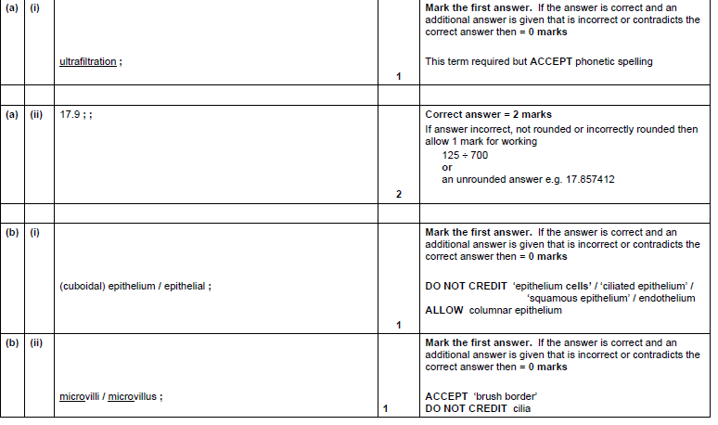
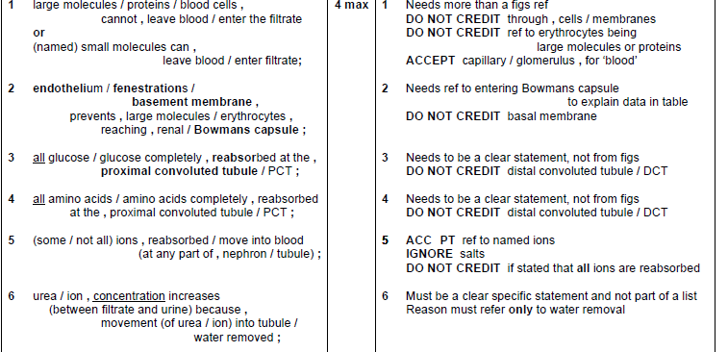

6.

