1. look at and credit any annotations on diagram
if sequence gets lost do not award the marking points that follow and
are directly linked, but give any general ones
1 atrial systole / atria contract;
2 blood passes into ventricles;
3 veins / blood vessels, entering heart closed / AW;
4 atrioventricular / alternative names, valves open;
5 ventricular systole / ventricles contract;
6 blood to, the arteries / named arteries;
7 (via) open, semilunar / AW, valves;
8 atrioventricular valves shut to stop backflow;
9 relaxation / diastole, of ventricles (and atria);
10 semilunar / AW, valves shut to stop backflow;
may be mentioned at X – only credit once
11 ref to X,Y and Z; X = 1-4 Y = 5-8 Z = 9-10 6

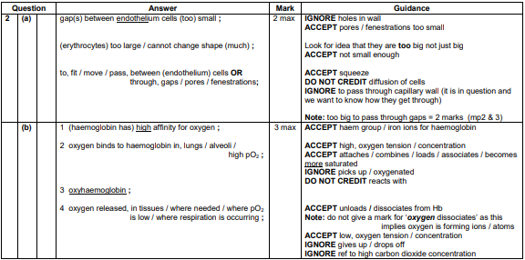
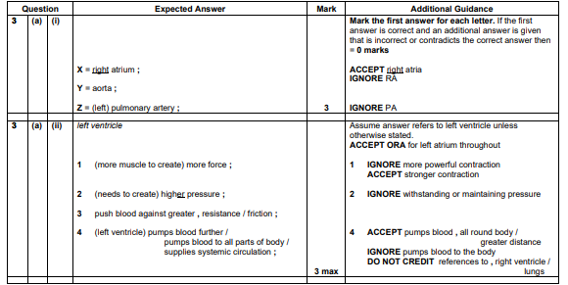

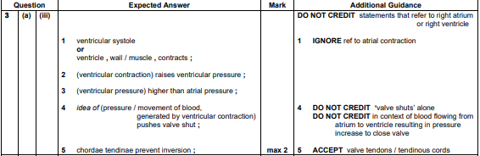

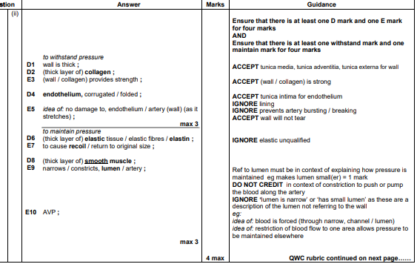

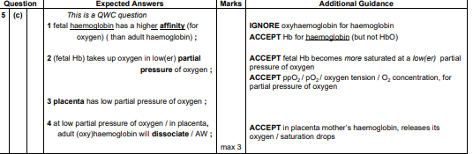
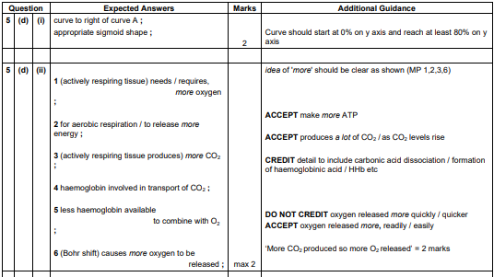

143. (a) (i) tissue fluid blood
no red blood cells R Hb red blood cells;
few / no, (plasma) proteins (plasma) proteins;
a few white blood cells R none full range / more, white blood cells;
no platelets platelets;
always low pressure pressure higher / variable;
some fats more fats;
not in vessels / AW contained in vessels;
qualified ref. to differences in dissolved gas levels;
AVP; e.g. qualified ref. to, difference in, speed of flow / water
potential / ion content
functional difference, such as exchange medium
v. transport medium; 3 max
(ii) lymphatic / lymph; A lacteal 1
Page Break
(b) 1 pressure high at R / AW;
2 ref. to heart action causing (hydrostatic) pressure;
3 greater than, osmotic effect / water potential effect / AW;
A solute potential
4 capillary wall, is leaky / has pores / AW;
5 lets, fluid / water / plasma / liquid, through and dissolved
substances / named substance(s);
6 red blood cells / proteins / some WBC’s, cannot get out
because too large;
7 pressure low(er) at S;
8 ref. to osmotic effect / water potential effect; A solute potential
9 due to plasma proteins;
10 return of fluid / AW, at S / AW;
11 valves / pores, at T / lymph vessel / AW; R semi lunar valve
12 allow, fluid / water / liquid, into lymph vessel / out
of tissue fluid;
13 allow proteins out of tissue fluid; 6 max

6
